Supplementary Material for: Expiry Moves the Close, Not the Day: Natural Experiments from India’s Changing Options Expiry Calendar
This supplement reports the full expiry calendar and additional results referred to in the main text. All estimates use the specifications of the main text unless stated otherwise. Standard errors clustered by calendar week are in parentheses; *, ** and *** denote significance at the 10%, 5% and 1% levels.

S1. Expiry rules of Indian index options, 2014–2026
Table S1. Expiry rules by product
Product | From | Weekly | Monthly | Note
NIFTY | before 2014 | - | last Thu | monthly contracts only
NIFTY | 2019-02-11 | Thu | last Thu | weekly options launched 11 Feb 2019 (Thursday)
NIFTY | 2025-09-01 | Tue | last Tue | NSE moves all expiries to Tuesday (last Thursday expiry 28 Aug 2025)
BANKNIFTY | before 2014 | - | last Thu | monthly contracts only
BANKNIFTY | 2016-05-27 | Thu | last Thu | weekly options launched 27 May 2016 (Thursday)
BANKNIFTY | 2023-09-04 | Wed | last Thu | weekly moved to Wednesday (first 6 Sep 2023); monthly stays last Thursday
BANKNIFTY | 2024-03-01 | Wed | last Wed | monthly moved to last Wednesday (first 27 Mar 2024)
BANKNIFTY | 2024-11-20 | - | last Wed | weekly contracts discontinued (SEBI; last weekly 13 Nov 2024)
BANKNIFTY | 2025-01-02 | - | last Thu | monthly moved to last Thursday (NSE circular, 29 Nov 2024)
BANKNIFTY | 2025-09-01 | - | last Tue | monthly moved to last Tuesday
SENSEX | 2023-05-15 | Fri | last Fri | relaunched 15 May 2023 with Friday expiry
SENSEX | 2025-01-04 | Tue | last Tue | moved to Tuesday from 1 Jan 2025 (last Friday expiry 3 Jan, first Tuesday 7 Jan)
SENSEX | 2025-09-01 | Thu | last Thu | moved to Thursday from 1 Sep 2025
FINNIFTY | 2021-01-11 | Thu | last Thu | launched 11 Jan 2021 (Thursday)
FINNIFTY | 2021-10-15 | Tue | last Tue | moved to Tuesday (first 19 Oct 2021)
FINNIFTY | 2024-11-20 | - | last Tue | weekly contracts discontinued (last weekly 19 Nov 2024)
FINNIFTY | 2025-01-02 | - | last Thu | monthly moved to last Thursday
FINNIFTY | 2025-09-01 | - | last Tue | monthly moved to last Tuesday
MIDCPNIFTY | 2022-01-24 | Tue | last Tue | launched 24 Jan 2022 (Tuesday)
MIDCPNIFTY | 2023-08-17 | Mon | last Mon | moved to Monday (first 21 Aug 2023)
MIDCPNIFTY | 2024-11-19 | - | last Mon | weekly contracts discontinued (last weekly 18 Nov 2024)
MIDCPNIFTY | 2025-01-02 | - | last Thu | monthly moved to last Thursday
MIDCPNIFTY | 2025-09-01 | - | last Tue | monthly moved to last Tuesday
BANKEX | 2023-05-15 | Fri | last Fri | relaunched 15 May 2023 with Friday expiry
BANKEX | 2023-10-16 | Mon | last Mon | moved to Monday from 16 Oct 2023
BANKEX | 2024-11-19 | - | last Mon | weekly contracts discontinued (last weekly 18 Nov 2024)
BANKEX | 2025-01-01 | - | last Tue | monthly moved to last Tuesday
BANKEX | 2025-09-01 | - | last Thu | monthly moved to last Thursday
Note. NIFTY, BANKNIFTY, FINNIFTY (Nifty Financial Services) and MIDCPNIFTY (Nifty Midcap Select) trade on NSE; SENSEX and BANKEX on BSE. Each rule applies from its start date until the next rule of the same product. If the scheduled day is a holiday, contracts expire on the previous trading day. In the week of a monthly expiry, no separate weekly contract is listed.

S2. Alternative whole-session volatility measures
Table S2. Pooled estimates of equation (1) for alternative outcomes (daily data, 2014–2026)
 | Garman-Klass | Parkinson | Rogers-Satchell | open-to-close return | close-to-close (incl. overnight) | overnight gap
Own weekly expiry | −0.024 | −0.007 | −0.042 | 0.161* | −0.007 | 0.051
 | (0.032) | (0.036) | (0.033) | (0.086) | (0.032) | (0.076)
Own monthly expiry | 0.055 | 0.048 | 0.058 | 0.103 | −0.007 | −0.299**
 | (0.049) | (0.053) | (0.052) | (0.116) | (0.050) | (0.121)
Another large index expires | −0.062* | −0.049 | −0.074** | 0.015 | −0.065* | −0.033
 | (0.034) | (0.038) | (0.037) | (0.084) | (0.037) | (0.082)
Small index expires | −0.094* | −0.120** | −0.073 | −0.251** | −0.086* | 0.052
 | (0.048) | (0.053) | (0.050) | (0.110) | (0.048) | (0.106)
Note. Parkinson and Rogers–Satchell are range-based variance estimators (Parkinson, 1980; Rogers & Satchell, 1991); open-to-close is the squared session return; close-to-close adds the squared overnight gap; overnight gap is the squared return from the previous close to the open.

S3. Pinning
Table S3. Closing values near strikes, and moves toward the largest open-interest strike
Index | Strike step | Share near a strike: expiry days | Other days | Weekly expiry coefficient | Monthly expiry coefficient
Nifty 50 | 50 | 0.208 | 0.195 | −0.003 | −0.022
 |  |  |  | (0.033) | (0.042)
Nifty 50 | 100 | 0.211 | 0.184 | 0.028 | −0.048
 |  |  |  | (0.034) | (0.041)
Bank Nifty | 100 | 0.228 | 0.199 | 0.075** | 0.107**
 |  |  |  | (0.032) | (0.044)
Bank Nifty | 500 | 0.228 | 0.185 | 0.015 | 0.064
 |  |  |  | (0.033) | (0.047)
Sensex | 100 | 0.244 | 0.201 | 0.042 | 0.038
 |  |  |  | (0.047) | (0.080)
Sensex | 500 | 0.202 | 0.187 | −0.005 | −0.111
 |  |  |  | (0.043) | (0.071)

Index | Expiry days | Mean move, expiry days (%) | Mean move, other days (%) | Difference, controlling for distance at open
Bank Nifty | 486 | 0.222 | 0.152 | 0.098
 |  |  |  | (0.066)
Nifty 50 | 443 | 0.201 | 0.110 | 0.107**
 |  |  |  | (0.052)
Note. Top panel: share of official closing values whose distance to the nearest strike (a multiple of the strike step) is less than 10% of the step. Without pinning this share is about 0.20. The coefficients are from linear-probability versions of equation (1) for each index. Bottom panel (Nifty 50 and Bank Nifty, NSE contract files 2014 – June 2026): change during the day in the distance, in percent of the index level, between the index and the strike with the largest open interest (calls plus puts) at the previous close in the nearest-expiry series. Positive values mean the index moved away from that strike. The difference controls for the distance at the open, with weekday and year fixed effects.

S4. Intraday reversals
Table S4. Reversal of earlier moves on expiry days (one-minute data)
Sample | Afternoon on morning × expiry | Last half hour on rest of day × expiry | Days
All | 0.090 | 0.007 | 3,428
 | (0.078) | (0.019)
Nifty 50 | 0.091 | −0.004 | 1,248
 | (0.112) | (0.029)
Bank Nifty | 0.072 | 0.031 | 1,252
 | (0.102) | (0.030)
Sensex | 0.158 | −0.025 | 928
 | (0.109) | (0.029)
Bank Nifty, Jan 2023 – Mar 2025 | −0.001 | −0.094*** | 551
 | (0.128) | (0.035)
Note. First column: coefficient on the interaction of the morning return (09:15–12:30) with own expiry in a regression of the afternoon return (12:30–15:30). Second column: coefficient on the interaction of the return from the open to 15:00 with own expiry in a regression of the return from 15:00 to 15:30. Negative values indicate stronger reversal on expiry days. The final row covers the period of the allegations in SEBI’s interim order of 3 July 2025.

S5. Settlement-window effects by period
Table S5. Expiry effects on 15:00–15:30 log realized variance by period
Period | Own weekly | Own monthly | Another large index
2019-23 (minute data: 2021-23) | 0.192*** | 0.383*** | −0.000
 | (0.056) | (0.093) | (0.075)
2024 to SEBI measures | 0.603*** | 0.714*** | 0.226
 | (0.186) | (0.180) | (0.190)
SEBI measures to interim order | 0.494** | 0.312** | 0.258
 | (0.187) | (0.131) | (0.152)
after interim order | 0.921*** | 0.396*** | 0.489***
 | (0.169) | (0.106) | (0.162)

Period | Nifty 50 | Bank Nifty | Sensex
2019-23 (minute data: 2021-23) | 0.011 [136] | 0.151** [136] | 0.512*** [33]
 | (0.051) | (0.066) | (0.131)
2024 to SEBI measures | 0.360* [46] | 0.521*** [46] | 1.037*** [46]
 | (0.192) | (0.161) | (0.182)
SEBI measures to interim order | 0.230 [32] | 0.615** [8] | 0.566*** [33]
 | (0.195) | (0.263) | (0.152)
after interim order | 0.552*** [51] | 0.188 [12] | 1.121*** [51]
 | (0.152) | (0.220) | (0.157)
Note. Top panel: pooled estimates. Bottom panel: own-expiry effect for each index (number of own expiry days in brackets). Both compare indices with each other on the same weekday and week (index-by-week and common weekday fixed effects). SEBI’s measures took effect on 20 November 2024; the interim order is dated 3 July 2025. One-minute data start in May 2021, so the first period covers 2021–2023.

S6. Forecasting next-day volatility
Table S6. Does the expiry calendar improve volatility forecasts?
Index | Forecast days | QLIKE, HAR | QLIKE, HAR + calendar | Change (%) | Diebold–Mariano p
Nifty 50 | 2,107 | 0.3702 | 0.3754 | +1.4 | 0.039
Bank Nifty | 2,109 | 0.3581 | 0.3645 | +1.8 | 0.062
Sensex | 2,105 | 0.3756 | 0.3792 | +1.0 | 0.013
Midcap 50 | 2,100 | 0.3468 | 0.3474 | +0.2 | 0.803
Note. Walk-forward forecasts of next-day close-to-close variance from January 2018 to July 2026, with an expanding estimation window re-fitted every 22 trading days. The HAR model (Corsi, 2009) uses log variance over the last day, week and month and the calendar days to the next session, and is estimated with the Gamma loss, which is consistent with the QLIKE criterion (Patton, 2011). Diebold–Mariano tests (Diebold & Mariano, 1995) use Newey–West standard errors. “+ calendar” adds the next day’s own weekly, own monthly and other-large-index expiry indicators, which are known in advance. Lower QLIKE is better.

S7. The closing auction: a first look
Table S7. Expiry effects in the hourly bar starting at 15:15 (the last bar of the session), before and after the closing auction
 | Own expiry | Another large index expires | Own expiry × after 3 Aug 2026 | Expiry days after
All | 0.38*** | 0.21*** | 0.99** | 21
 | (0.08) | (0.07) | (0.41)
Nifty 50 | 0.44*** | 0.29*** | 0.16 | 10
 | (0.10) | (0.07) | (0.74)
Bank Nifty | 0.61*** | 0.13 | 0.35 | 2
 | (0.10) | (0.10) | (1.30)
Sensex | 0.22 | 0.17 | 1.97*** | 9
 | (0.16) | (0.14) | (0.74)
Note. Log Parkinson variance of the hourly bar starting at 15:15, October 2023 – September 2026 (Yahoo Finance). “After 3 Aug 2026” covers about two months. The hourly bar may not capture the auction price itself, and few expiry days fall after the change, so the test has little power.

S8. Total weekly volatility
Table S8. Weekly options and total weekly variance
Measure | Weekly-options regime | p | Index-weeks
close-to-close | 0.054 | 0.002 | 2,510
 | (0.017)
session (Garman-Klass) | 0.056 | 0.001 | 2,510
 | (0.017)
close-to-close, + index-specific trends | −0.018 | 0.299 | 2,510
 | (0.017)
Note. Index-week panel. The outcome is the log of average daily variance in the week; the regressor indicates that the index’s own options had weekly contracts. Index and week fixed effects; the last row adds index-specific linear trends.

S9. Expiry-day option trading
Table S9. Share of each year’s option contracts traded on expiry day in the expiring series (%)
Year | Nifty 50 | Bank Nifty
2014 | 9.1 | 13.7
2015 | 9.3 | 12.7
2016 | 10.5 | 34.3
2017 | 11.1 | 41.5
2018 | 10.0 | 43.7
2019 | 25.4 | 44.5
2020 | 32.8 | 45.9
2021 | 32.0 | 41.4
2022 | 36.0 | 43.9
2023 | 45.3 | 50.0
2024 | 59.0 | 62.6
2025 | 46.5 | 38.5
Source. NSE F&O contract files.

S10. Additional robustness checks
Table S10. Additional checks of the settlement-window result
Check | Outcome | Coefficient | p | Observations
stacked events, no control — weekday gaining an expiry | 15:00–15:30, 1-min RV | 0.503*** | 0.000 | 1,366
 |  | (0.087)
stacked events, no control — weekday losing an expiry | 15:00–15:30, 1-min RV | −0.375*** | 0.000 | 1,366
 |  | (0.102)
stacked events, + other large index expires — weekday gaining an expiry | 15:00–15:30, 1-min RV | 0.560*** | 0.000 | 1,366
 |  | (0.099)
stacked events, + other large index expires — weekday losing an expiry | 15:00–15:30, 1-min RV | −0.442*** | 0.000 | 1,366
 |  | (0.109)
stacked events, no control — weekday gaining an expiry | whole session, 5-min RV | 0.143** | 0.040 | 1,366
 |  | (0.069)
stacked events, no control — weekday losing an expiry | whole session, 5-min RV | −0.038 | 0.698 | 1,366
 |  | (0.098)
stacked events, + other large index expires — weekday gaining an expiry | whole session, 5-min RV | 0.160** | 0.035 | 1,366
 |  | (0.075)
stacked events, + other large index expires — weekday losing an expiry | whole session, 5-min RV | −0.058 | 0.613 | 1,366
 |  | (0.114)
leave out nifty50 — own weekly expiry | 15:00–15:30, 1-min RV | 0.568*** | 0.000 | 2,180
 |  | (0.048)
leave out nifty50 — own monthly expiry | 15:00–15:30, 1-min RV | 0.534*** | 0.000 | 2,180
 |  | (0.065)
leave out banknifty — own weekly expiry | 15:00–15:30, 1-min RV | 0.514*** | 0.000 | 2,176
 |  | (0.054)
leave out banknifty — own monthly expiry | 15:00–15:30, 1-min RV | 0.635*** | 0.000 | 2,176
 |  | (0.084)
leave out sensex — own weekly expiry | 15:00–15:30, 1-min RV | 0.185*** | 0.000 | 2,500
 |  | (0.050)
leave out sensex — own monthly expiry | 15:00–15:30, 1-min RV | 0.344*** | 0.000 | 2,500
 |  | (0.078)
settlement window from 5-minute returns — own weekly expiry | 15:00–15:30, 5-min RV | 0.193*** | 0.001 | 3,428
 |  | (0.058)
settlement window from 5-minute returns — own monthly expiry | 15:00–15:30, 5-min RV | 0.466*** | 0.000 | 3,428
 |  | (0.097)
settlement window from 5-minute returns — another large index expires | 15:00–15:30, 5-min RV | 0.121** | 0.038 | 3,428
 |  | (0.058)
dose-response: own expiry x expiring-series contracts (std.) — own expiry (at average volume) | 15:00–15:30, 1-min RV | 0.183*** | 0.000 | 2,494
 |  | (0.043)
dose-response: own expiry x expiring-series contracts (std.) — own expiry × expiring-series contracts (1 s.d.) | 15:00–15:30, 1-min RV | 0.209*** | 0.000 | 2,494
 |  | (0.045)
Note. Stacked events: equation (2) pooled over the six calendar changes with one-minute data, without and with a control for the expiry of other large indices. Leave-one-out: pooled equation (1) without the named index. Five-minute returns: settlement-window realized variance from the six five-minute returns between 15:00 and 15:30. Dose–response (Nifty 50 and Bank Nifty, to June 2026): own expiry interacted with the standardized log number of contracts traded in the expiring series on the expiry day.

S11. Share of session variance in the settlement window
Table S11. Mean share of session realized variance in 15:00–15:30 (%)
Index | Own expiry days | Other days
Nifty 50 | 10.3 | 8.5
Bank Nifty | 11.7 | 8.6
Sensex | 21.1 | 8.9

S12. Additional figures
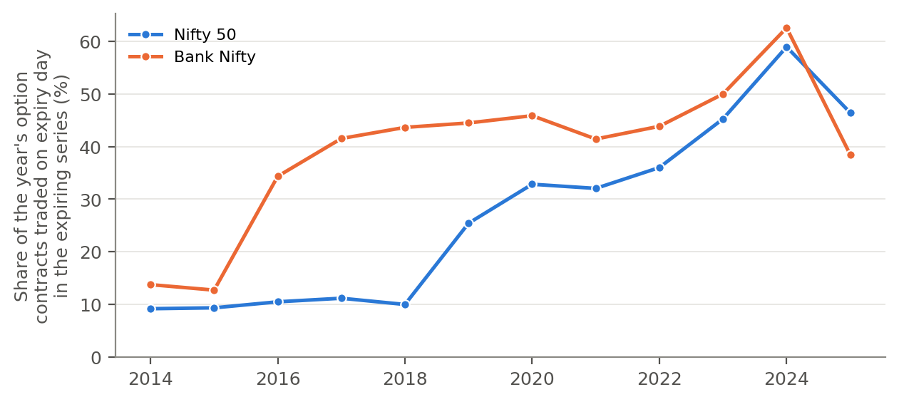
Figure S1. Share of each year’s option contracts traded on expiry day in the expiring series, Nifty 50 and Bank Nifty options.
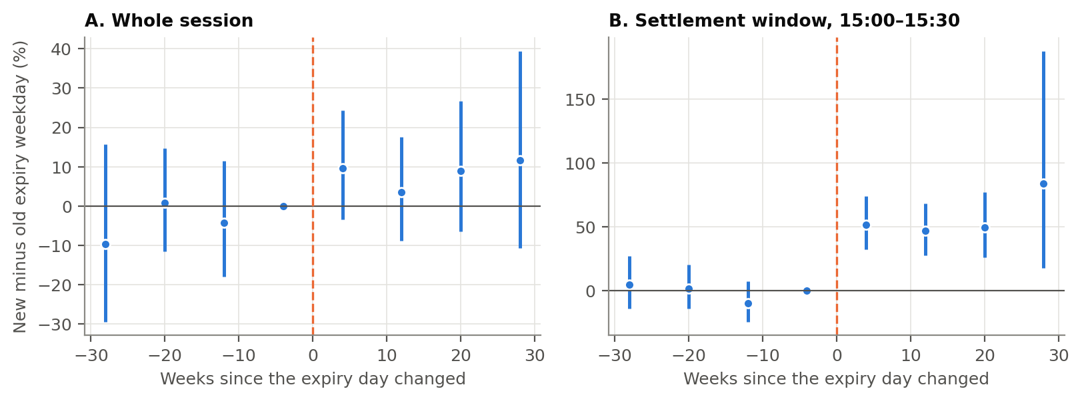
Figure S2. Event-time profile, stacked over the six calendar changes with one-minute data: difference between the new and the old expiry weekday in eight-week bins (the bin before the change is the reference), with 95% confidence intervals. A: whole session (five-minute realized variance). B: 15:00–15:30.
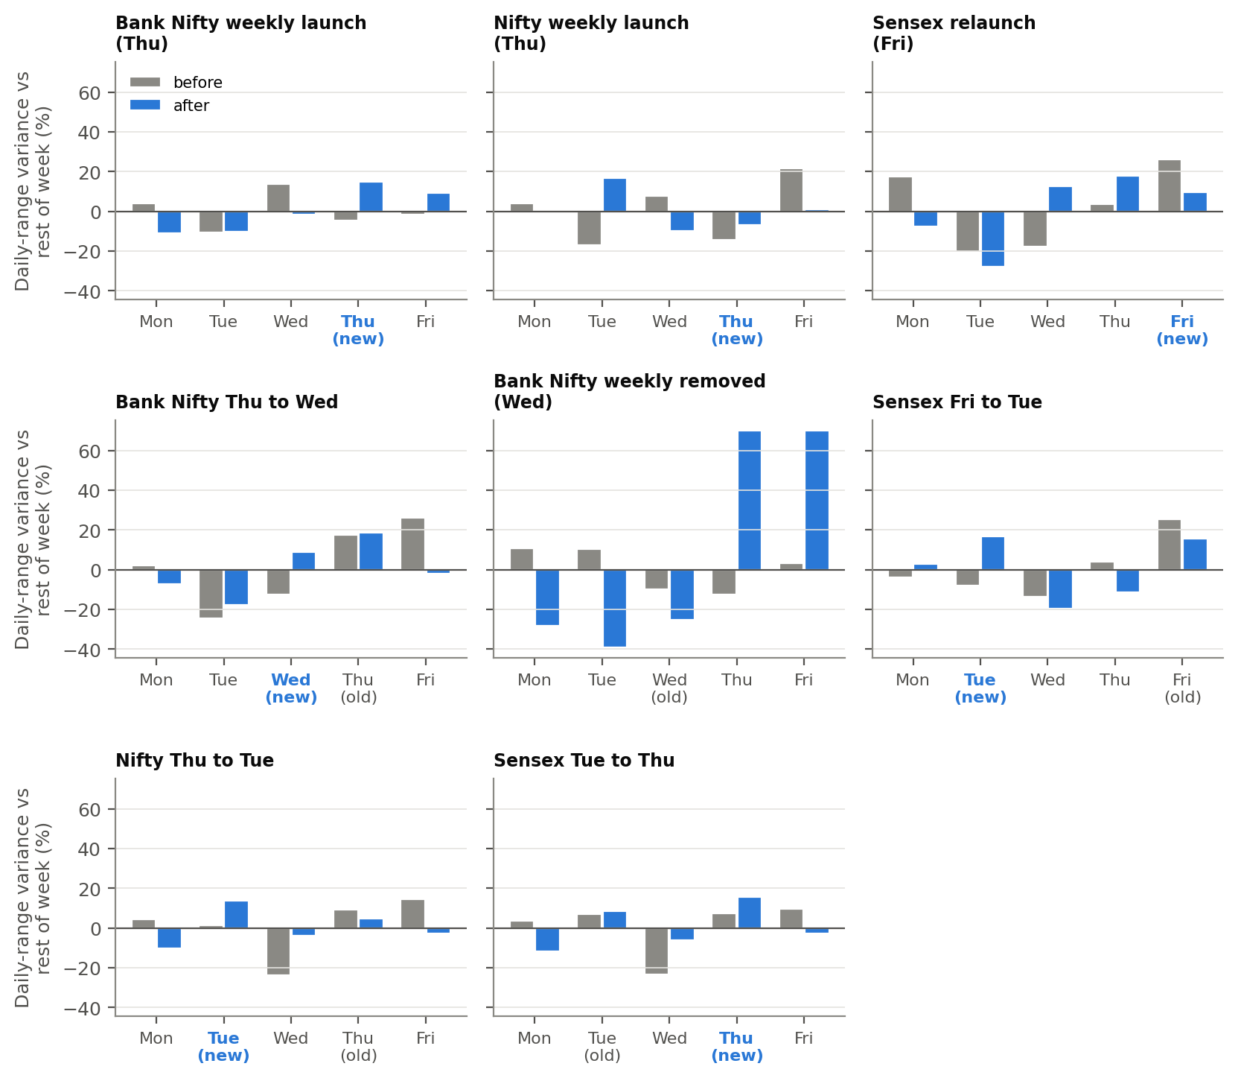
Figure S3. Whole-session volatility (log Garman–Klass variance) on each weekday relative to the rest of its week, 26 weeks before and after the eight major calendar changes. Unlike the settlement window (main text, Figure 1), the weekday profile does not consistently follow the expiry day.
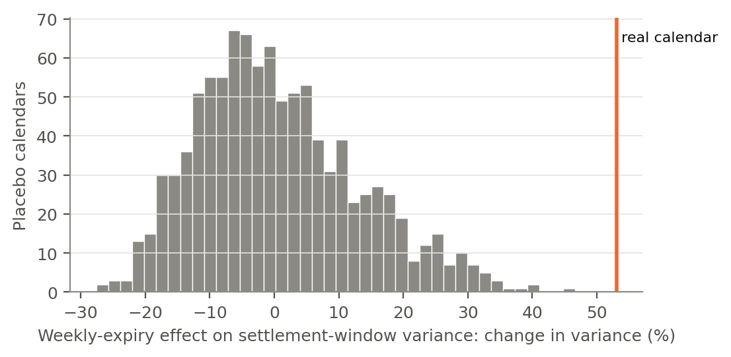
Figure S4. Distribution of the weekly-expiry effect on 15:00–15:30 variance under 1,000 placebo calendars; the vertical line is the estimate under the true calendar.

References
Corsi, F. (2009). A simple approximate long-memory model of realized volatility. Journal of Financial Econometrics, 7(2), 174–196. https://doi.org/10.1093/jjfinec/nbp001
Diebold, F. X., & Mariano, R. S. (1995). Comparing predictive accuracy. Journal of Business & Economic Statistics, 13(3), 253–263. https://doi.org/10.1080/07350015.1995.10524599
Parkinson, M. (1980). The extreme value method for estimating the variance of the rate of return. Journal of Business, 53(1), 61–65. https://doi.org/10.1086/296071
Patton, A. J. (2011). Volatility forecast comparison using imperfect volatility proxies. Journal of Econometrics, 160(1), 246–256. https://doi.org/10.1016/j.jeconom.2010.03.034
Rogers, L. C. G., & Satchell, S. E. (1991). Estimating variance from high, low and closing prices. Annals of Applied Probability, 1(4), 504–512. https://doi.org/10.1214/aoap/1177005835

