NAME: VIGNESH.A
REG NO: 23MIS0612
COURSE NAME: Agile Development Process and Devops Lab
COURSE CODE: ISWE406P
SLOT: L51 + L52

Create an HTML file for your profile and complete the following:
- Create a repository in GIT and create the following files:
  - index.html
  - Dockerfile
  - Deployment.yaml

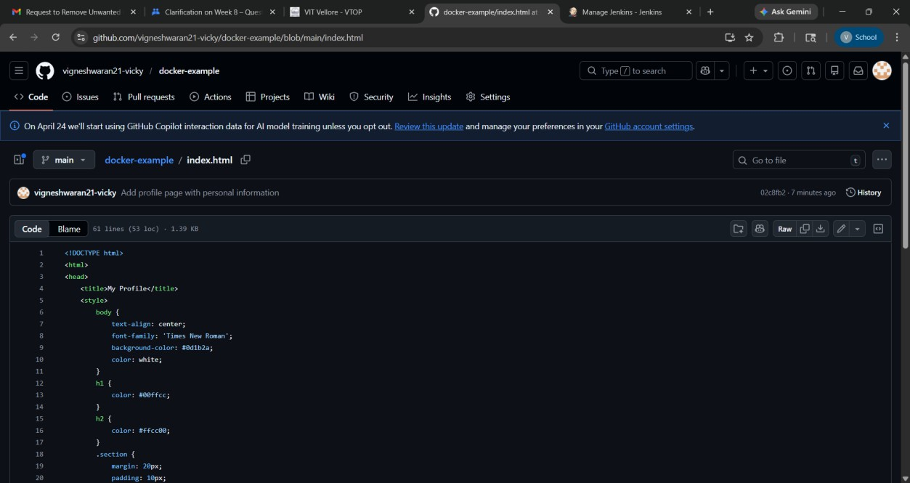

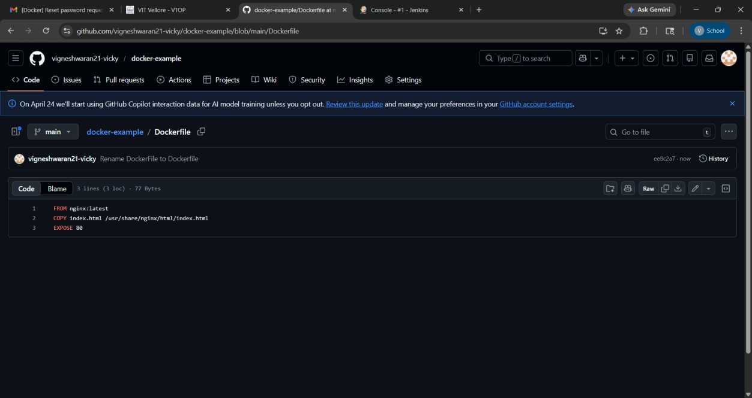

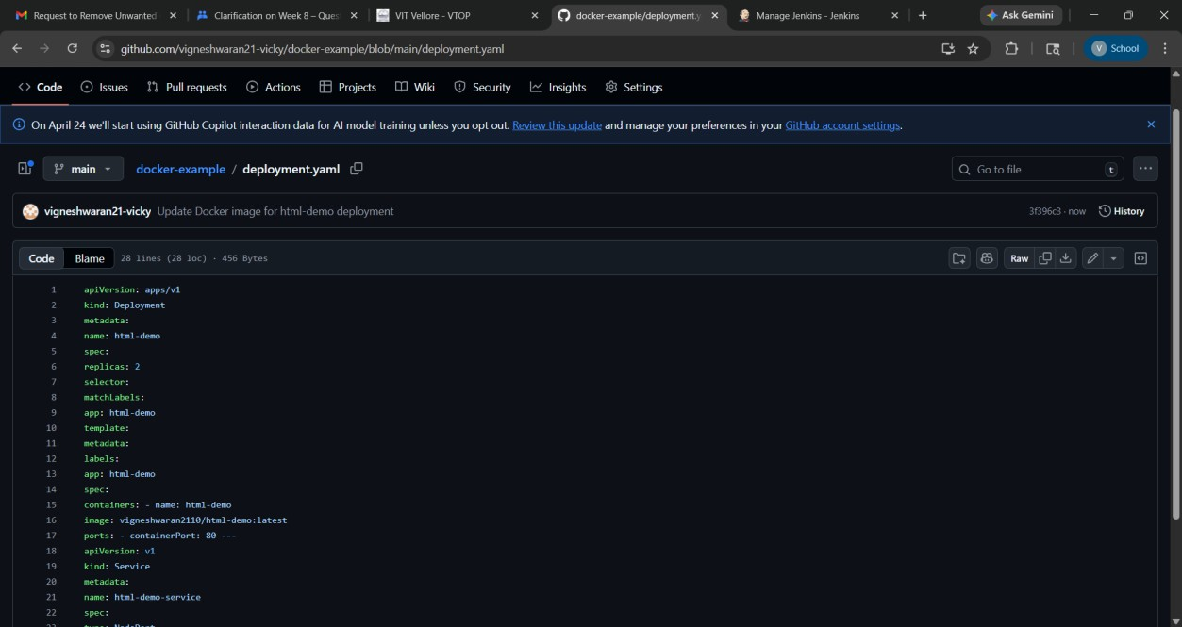

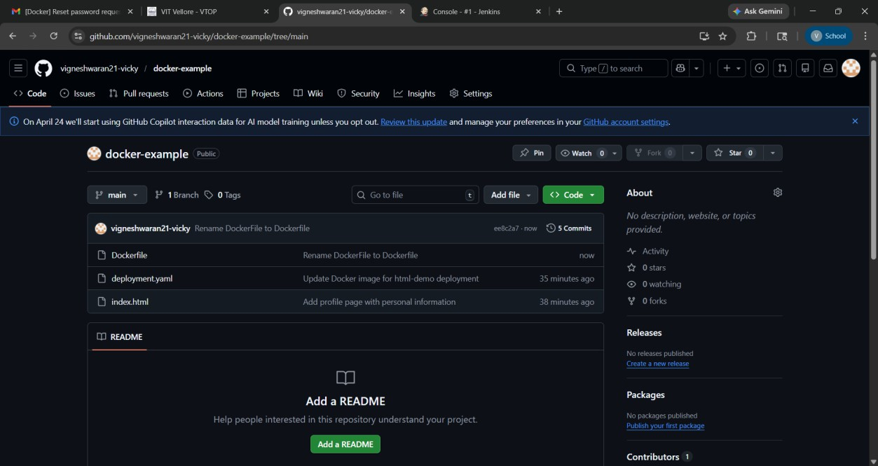

- Enable Kubernetes

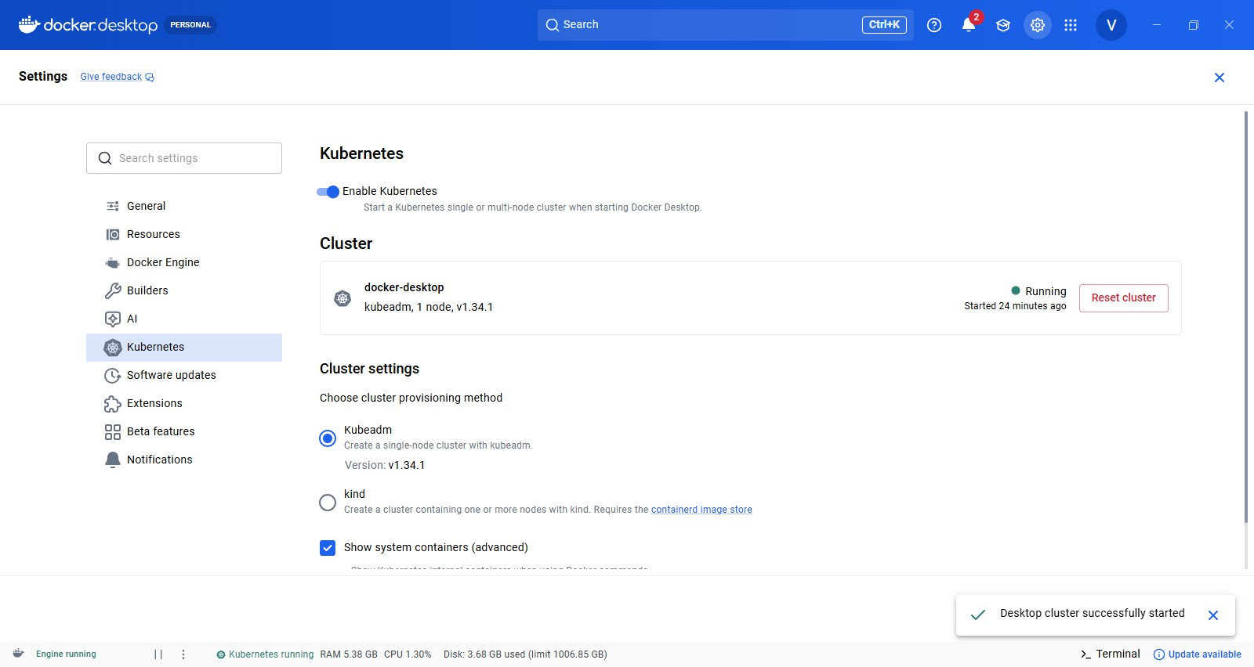

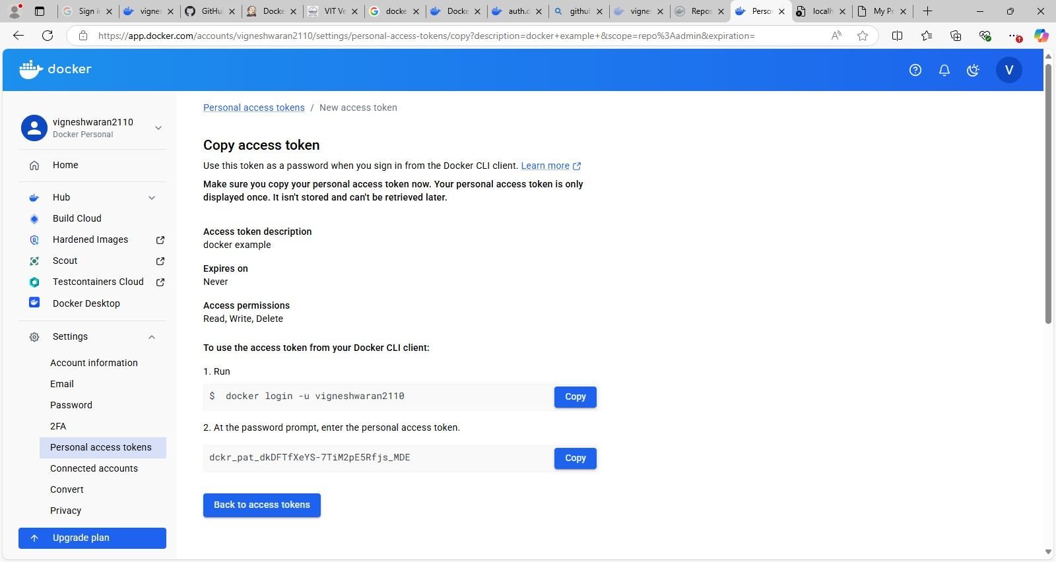

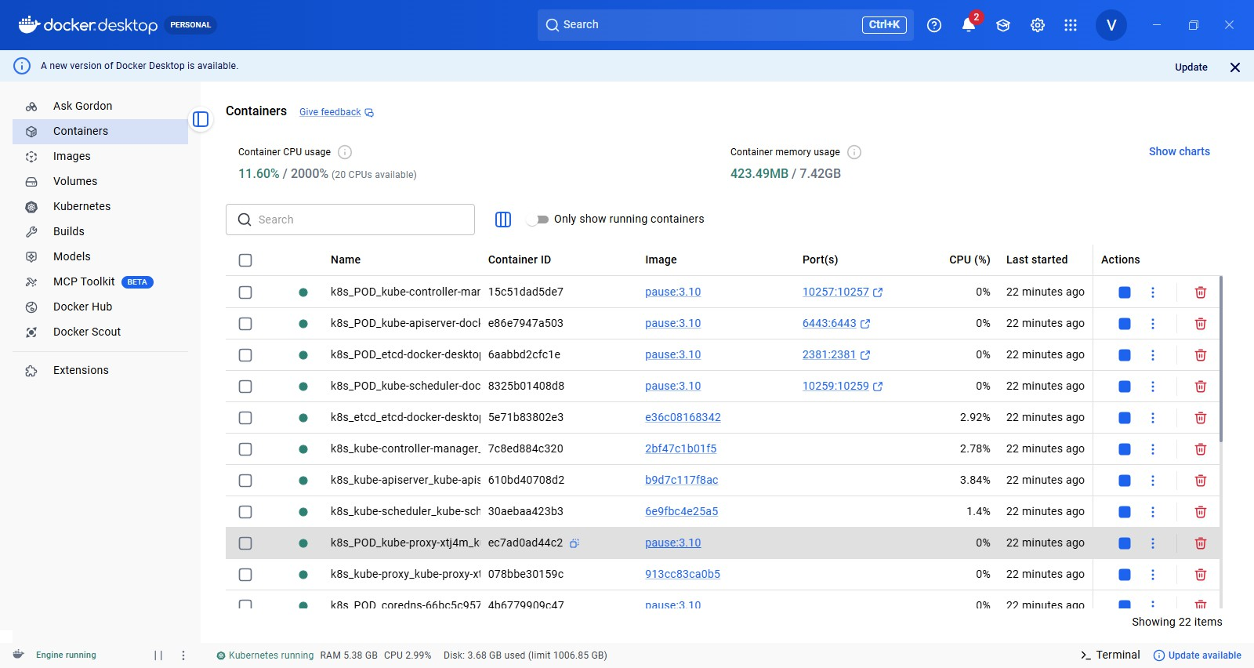

- Open Jenkins In Jenkins

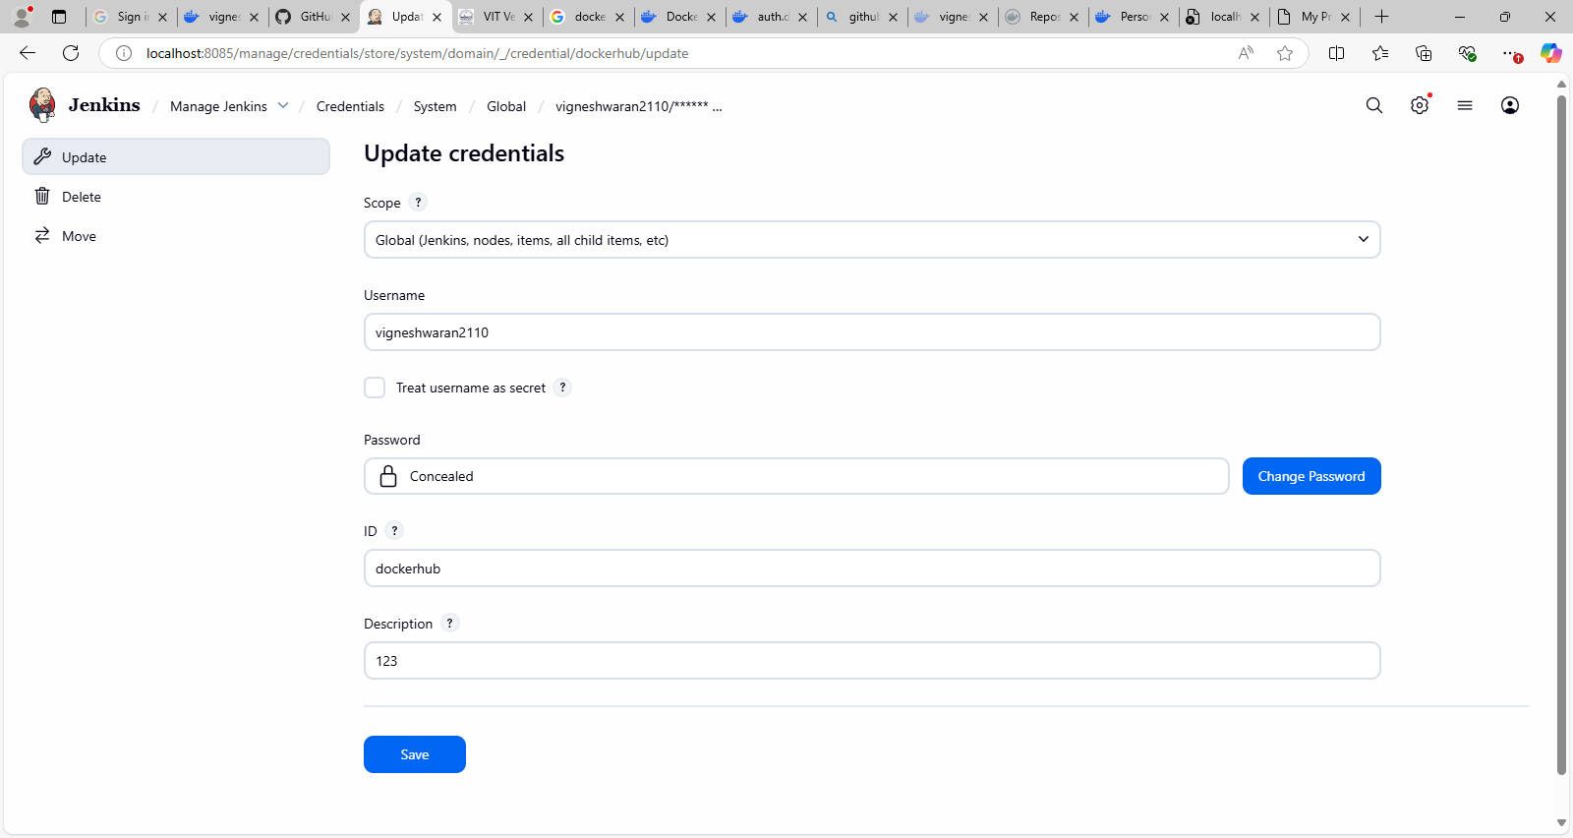

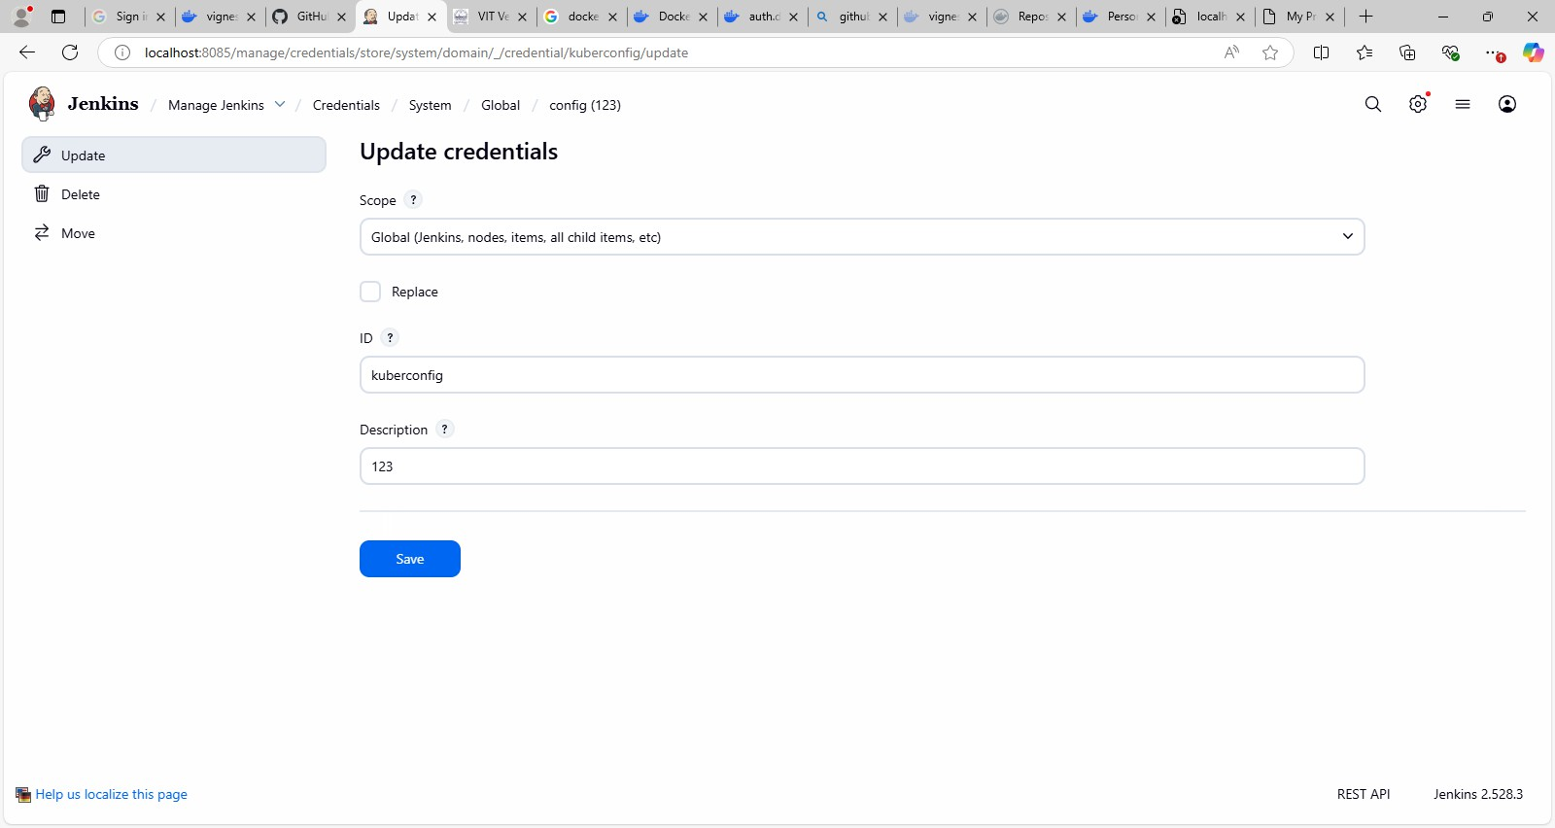

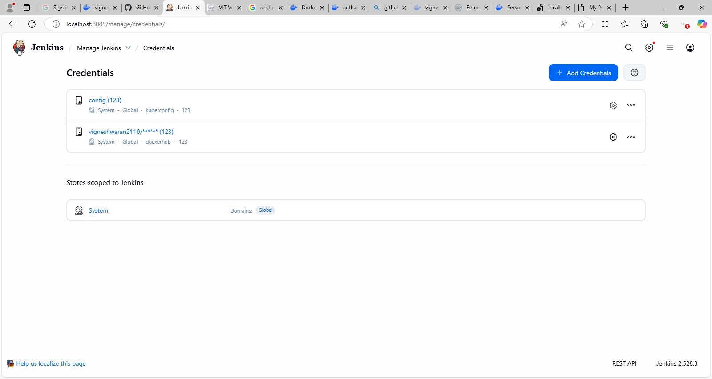

- Create New Item -> Pipeline Paste the code in pipeline script

Pipeline:
pipeline { agent any environment {
DOCKER_IMAGE = "vigneshwaran2110/html-demo"
}
stages {
stage('Clone Code') { steps {
git branch: 'main',
url: 'https://github.com/vigneshwaran21-vicky/docker-example.git'
}
}
stage('Build Docker Image') { steps {
bat 'docker build -t %DOCKER_IMAGE% .'
}

}
stage('Push Image') { steps {
withCredentials([usernamePassword(credentialsId: 'dockerhub', usernameVariable: 'USER', passwordVariable: 'PASS')]) {
bat 'docker login -u %USER% -p %PASS%' bat 'docker push %DOCKER_IMAGE%'
}
}
}
stage('Deploy to Kubernetes') { steps {
withCredentials([file(credentialsId: 'kuberconfig', variable: 'KUBECONFIG')]) {
bat '''
set KUBECONFIG=%KUBECONFIG%
kubectl apply -f deployment.yaml --validate=false '''
}
}
}
}
}
OTUPUT:-

