----- Read-me -----

**File System Configuration**

File Format for this requires a folder named "Proj" and within this folder you need four folders:

* Client_Dir
* Dir_01
* Dir_02
* Dir_03

So that the file path ends up being Proj/Client_Dir, Proj/Dir_01, Proj/Dir_02, Proj/Dir_03

**Example:**

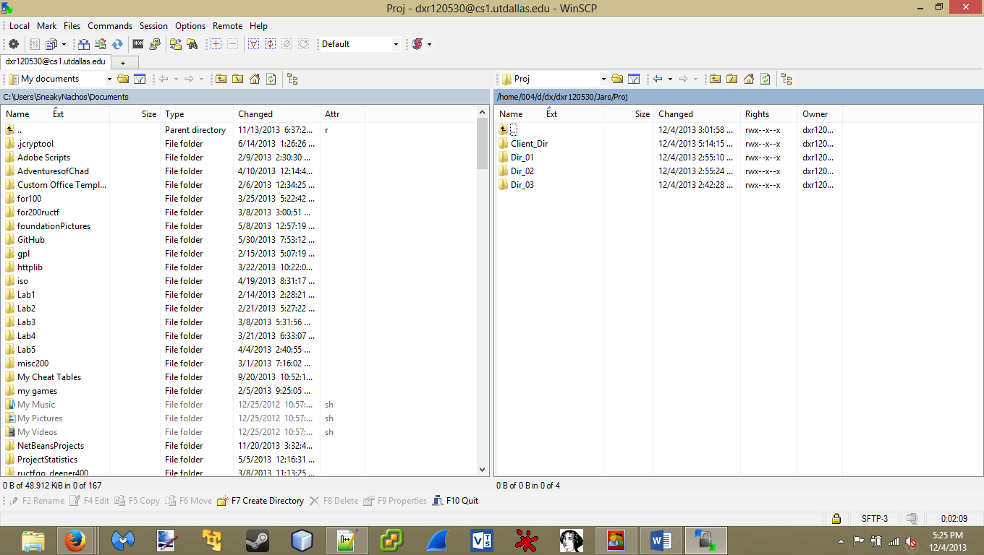

**Jars Configuration**

Next is to download and place all the jars on the servers.

* Authentication Server(Auth.jar), net01.utdallas.edu
* Client Application(Client.jar), net02.utdallas.edu
* Enterprise Server(Ent.jar), net03.utdallas.edu
* Department Server(Dept.jar), net04.utdallas.edu

Have the jars in the same Folder as the "Proj" Folder

**Example:**

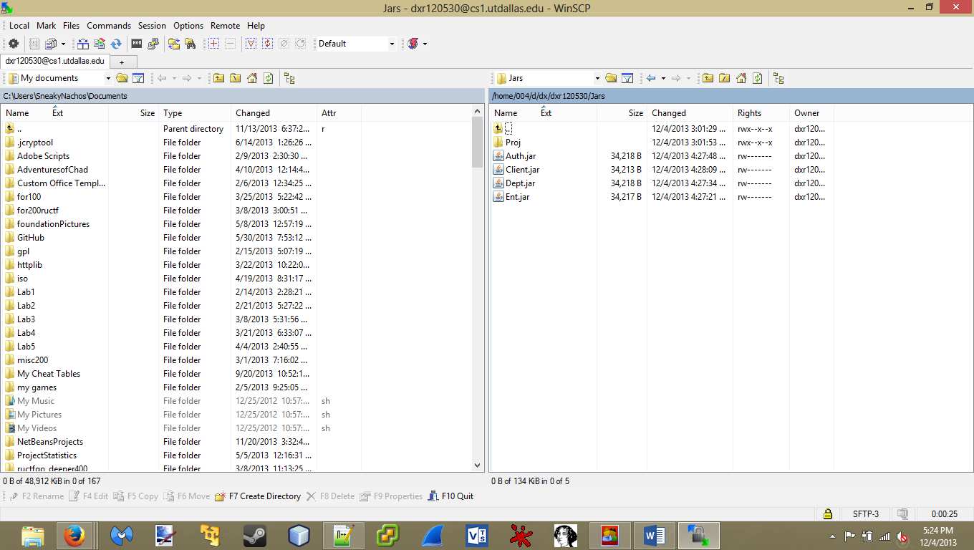

**Running the Jars**

Each jar is executed by

* java –jar Auth.jar
* java –jar Dept.jar
* java –jar Ent.jar
* java –jar Client.jar

The Department jar will ask for the department number that represents its value just input a value that is 1,2 or 3.

**Example:**

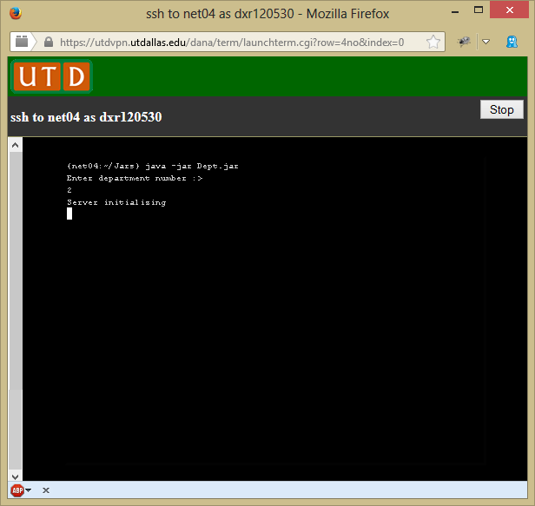

The Authentication and Enterprise do not need any input.

The Client application will require two input. The file that is being transferred and the department number of the Department Server.

**Example:**

