SIMPLIFIED CDC Architecture
Dynamic Table on _LOG Table (Not Stream)

━━━━━━━━━━━━━━━━━━━━━━━━━━━━━━━━━━━━━━━━━━━━━━

✅ SIMPLEST PATTERN - No Task, No Stored Procedure
Dynamic Table directly on _LOG table works!

🚀 IMMUTABLE WHERE Optimization Explained
Snowflake 2024/2025 feature for cost-efficient incremental processing

Version 4.0 | December 2025

1. Why Dynamic Table on _LOG Works

1.1 Understanding Your Bronze Objects
Object | Type | How IDMC Uses It
TRAIN_PLAN_LEG_BASE | Regular Table | One-time historical snapshot
TRAIN_PLAN_LEG_BASE_LOG | Regular Table | IDMC INSERTs CDC changes here
TRAIN_PLAN_LEG_BASE_STREAM | Stream | Tracks changes on _LOG (problematic)

1.2 Why _LOG Works but _STREAM Doesn't
Source for DT | Works? | Reason
_BASE_LOG | ✅ YES | Regular table → Single change tracking layer
_BASE_STREAM | ❌ NO | Stream uses CHANGES internally → Double tracking blocked
Key Insight: The _LOG table is just a regular table that IDMC populates with INSERT statements. IDMC never UPDATEs or DELETEs rows in _LOG—it only appends new change records. This makes it perfect for IMMUTABLE WHERE optimization.

2. IMMUTABLE WHERE - Deep Dive

2.1 What IMMUTABLE WHERE Does
IMMUTABLE WHERE is a Snowflake 2024/2025 Dynamic Table optimization that tells Snowflake: "Rows matching this condition will NEVER change again—skip them during incremental refresh."
Without IMMUTABLE WHERE:
- Dynamic Table scans ALL rows to detect changes
- For 100M row table, every refresh scans 100M rows
- High compute cost, slow refresh
With IMMUTABLE WHERE:
- Snowflake skips rows matching the condition
- Only scans "mutable" (recent) data
- Dramatically reduces compute cost

2.2 Why _LOG Tables Are Perfect for IMMUTABLE WHERE
CDC _LOG Table Characteristic | Why It Enables IMMUTABLE WHERE
IDMC only INSERTs into _LOG | Once a row is written, it never changes
Each row is a CDC event (I/U/D) | Historical events are immutable by nature
OP_LAST_REPLICATED is the event timestamp | Old timestamps = guaranteed immutable rows
Append-only pattern | Perfect fit for IMMUTABLE WHERE optimization

2.3 IMMUTABLE WHERE Syntax
CREATE DYNAMIC TABLE ...
REFRESH_MODE = INCREMENTAL
IMMUTABLE WHERE (OP_LAST_REPLICATED < CURRENT_TIMESTAMP() - INTERVAL '1 day')
AS ...
This tells Snowflake:
- "Any row with OP_LAST_REPLICATED older than 1 day will never change"
- "During incremental refresh, only scan rows from the last day"
- "Skip scanning historical data—it's immutable"

2.4 Choosing the Right IMMUTABLE WHERE Window
Window | Use Case | Considerations
INTERVAL '1 hour' | High CDC volume, tight SLA | Scans more data each refresh
INTERVAL '1 day' | Recommended default | Good balance cost vs safety
INTERVAL '7 days' | Low CDC volume, cost priority | Less frequent full scans
⚠️ Important: The IMMUTABLE WHERE condition should be based on a timestamp column that indicates when the row was written. For IDMC CDC, use OP_LAST_REPLICATED or OP_CMT_TIME.

3. Complete Implementation (Production-Ready)

3.1 Simplified Architecture Diagram
┌─────────────────────────────────────────────────────────────────────────────────┐
│ BRONZE (D_BRONZE.SADB) │
│ ┌─────────────────────┐ ┌─────────────────────────────────┐ │
│ │ TRAIN_PLAN_LEG_BASE │ │ TRAIN_PLAN_LEG_BASE_LOG │ │
│ │ (Historical) │ │ (CDC changes - append only) │ │
│ │ One-time snapshot │ │ IDMC INSERTs here continuously │ │
│ └──────────┬──────────┘ └────────────────┬────────────────┘ │
└──────────────│────────────────────────────────────────────│────────────────────┘
│ │
│ One-Time INSERT │ Dynamic Table
│ (historical bootstrap) │ INCREMENTAL mode
│ │ + IMMUTABLE WHERE
▼ ▼
┌─────────────────────────────────────────────────────────────────────────────────┐
│ SILVER (D_SILVER.SADB) │
│ ┌─────────────────────┐ ┌─────────────────────────────────┐ │
│ │ TRAIN_PLAN_LEG │ │ TRAIN_PLAN_LEG_CDC_DT │ │
│ │ (BASE records) │ │ (CDC changes from _LOG) │ │
│ │ RECORD_SOURCE='BASE'│ │ Dynamic Table - INCREMENTAL │ │
│ │ Regular Table │ │ IMMUTABLE WHERE (> 1 day) │ │
│ └──────────┬──────────┘ └────────────────┬────────────────┘ │
│ │ │ │
│ └───────────────────┬───────────────────────┘ │
│ │ │
│ ▼ │
│ ┌─────────────────────────────────────────────────────────┐ │
│ │ TRAIN_PLAN_LEG_CURR_DT │ │
│ │ (Current State - UNIONs BASE table + CDC_DT) │ │
│ │ Dynamic Table - INCREMENTAL │ │
│ │ ROW_NUMBER() deduplication by PK │ │
│ └─────────────────────────────────────────────────────────┘ │
└─────────────────────────────────────────────────────────────────────────────────┘
│
│ TARGET_LAG = DOWNSTREAM
▼
┌─────────────────────────────────────────────────────────────────────────────────┐
│ (Downstream Consumers) │
│ Fact Tables, Dimension Tables, Analytics │
└─────────────────────────────────────────────────────────────────────────────────┘

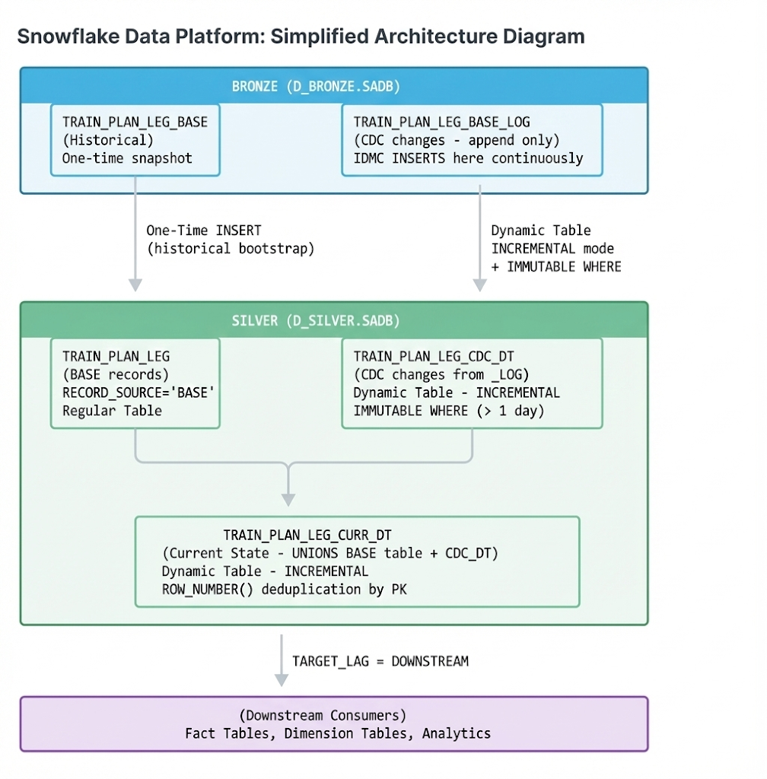

3.2 Step 1: Create Silver Base Table
-- Silver table for BASE records
-- This stores the historical snapshot from _BASE
CREATE OR REPLACE TABLE D_SILVER.SADB.TRAIN_PLAN_LEG (
TRAIN_PLAN_LEG_ID NUMBER(18,0) NOT NULL,
TRAIN_PLAN_ID NUMBER(18,0),
TRAIN_DRCTN_CD VARCHAR(20),
TRAIN_PLAN_LEG_NM VARCHAR(32),
MTP_TITAN_NBR NUMBER(6,0),
RECORD_CREATE_TMS TIMESTAMP_NTZ(0),
RECORD_UPDATE_TMS TIMESTAMP_NTZ(0),
CREATE_USER_ID VARCHAR(32),
UPDATE_USER_ID VARCHAR(32),
TURN_LEG_SQNC_NBR NUMBER(1,0),
TYES_TRAIN_ID NUMBER(18,0),
MTP_TOTAL_RTPNT_SENT_QTY NUMBER(4,0),
MTP_ROUTE_CMPLT_CD VARCHAR(4),
MTP_TRAIN_STATE_CD VARCHAR(4),
IS_DELETED BOOLEAN DEFAULT FALSE,
EFFECTIVE_TS TIMESTAMP_NTZ(9) NOT NULL,
LOAD_TS TIMESTAMP_NTZ(9) DEFAULT CURRENT_TIMESTAMP(),
RECORD_SOURCE VARCHAR(10) NOT NULL
)
CLUSTER BY (TRAIN_PLAN_LEG_ID)
CHANGE_TRACKING = TRUE
DATA_RETENTION_TIME_IN_DAYS = 7;

3.3 Step 2: Load Historical Data (One-Time)
-- One-time bootstrap from _BASE
INSERT INTO D_SILVER.SADB.TRAIN_PLAN_LEG
SELECT
TRAIN_PLAN_LEG_ID, TRAIN_PLAN_ID, TRAIN_DRCTN_CD, TRAIN_PLAN_LEG_NM,
MTP_TITAN_NBR, RECORD_CREATE_TMS, RECORD_UPDATE_TMS, CREATE_USER_ID,
UPDATE_USER_ID, TURN_LEG_SQNC_NBR, TYES_TRAIN_ID, MTP_TOTAL_RTPNT_SENT_QTY,
MTP_ROUTE_CMPLT_CD, MTP_TRAIN_STATE_CD,
FALSE AS IS_DELETED,
COALESCE(SNW_LAST_REPLICATED, RECORD_UPDATE_TMS, RECORD_CREATE_TMS) AS EFFECTIVE_TS,
CURRENT_TIMESTAMP() AS LOAD_TS,
'BASE' AS RECORD_SOURCE
FROM D_BRONZE.SADB.TRAIN_PLAN_LEG_BASE;

3.4 Step 3: Create CDC Dynamic Table on _LOG (WITH IMMUTABLE WHERE)
✅ THIS IS THE KEY: Dynamic Table directly on _LOG table with IMMUTABLE WHERE optimization
-- CDC Dynamic Table on _LOG table (NOT Stream!)
-- INCREMENTAL mode works because _LOG is a regular table
-- IMMUTABLE WHERE optimizes by skipping old (immutable) rows

CREATE OR REPLACE DYNAMIC TABLE D_SILVER.SADB.TRAIN_PLAN_LEG_CDC_DT
TARGET_LAG = '5 minutes'
WAREHOUSE = CDC_WH_XS
REFRESH_MODE = INCREMENTAL
INITIALIZE = ON_CREATE
DATA_RETENTION_TIME_IN_DAYS = 7

-- CRITICAL: IMMUTABLE WHERE optimization
-- Tells Snowflake: rows older than 1 day will never change
-- Snowflake skips scanning these rows during incremental refresh
IMMUTABLE WHERE (OP_LAST_REPLICATED < CURRENT_TIMESTAMP() - INTERVAL '1 day')

COMMENT = 'CDC changes from _LOG table with IMMUTABLE WHERE optimization'
AS
SELECT
-- Use _NEW columns for current values
-- For DELETE (OP_CODE='D'), _NEW may be null, so COALESCE with _OLD
COALESCE(TRAIN_PLAN_LEG_ID_NEW, TRAIN_PLAN_LEG_ID_OLD) AS TRAIN_PLAN_LEG_ID,
TRAIN_PLAN_ID_NEW AS TRAIN_PLAN_ID,
TRAIN_DRCTN_CD_NEW AS TRAIN_DRCTN_CD,
TRAIN_PLAN_LEG_NM_NEW AS TRAIN_PLAN_LEG_NM,
MTP_TITAN_NBR_NEW AS MTP_TITAN_NBR,
RECORD_CREATE_TMS_NEW AS RECORD_CREATE_TMS,
RECORD_UPDATE_TMS_NEW AS RECORD_UPDATE_TMS,
CREATE_USER_ID_NEW AS CREATE_USER_ID,
UPDATE_USER_ID_NEW AS UPDATE_USER_ID,
TURN_LEG_SQNC_NBR_NEW AS TURN_LEG_SQNC_NBR,
TYES_TRAIN_ID_NEW AS TYES_TRAIN_ID,
MTP_TOTAL_RTPNT_SENT_QTY_NEW AS MTP_TOTAL_RTPNT_SENT_QTY,
MTP_ROUTE_CMPLT_CD_NEW AS MTP_ROUTE_CMPLT_CD,
MTP_TRAIN_STATE_CD_NEW AS MTP_TRAIN_STATE_CD,

-- Delete handling
CASE WHEN OP_CODE = 'D' THEN TRUE ELSE FALSE END AS IS_DELETED,

-- Timestamps
OP_LAST_REPLICATED AS EFFECTIVE_TS,
CURRENT_TIMESTAMP() AS LOAD_TS,
'CDC' AS RECORD_SOURCE

FROM D_BRONZE.SADB.TRAIN_PLAN_LEG_BASE_LOG; -- _LOG table, NOT Stream!

3.5 Step 4: Create Current State Dynamic Table
-- Current State Dynamic Table
-- UNIONs BASE table + CDC_DT, deduplicates by PK
-- Latest EFFECTIVE_TS wins

CREATE OR REPLACE DYNAMIC TABLE D_SILVER.SADB.TRAIN_PLAN_LEG_CURR_DT
TARGET_LAG = '5 minutes'
WAREHOUSE = CDC_WH_XS
REFRESH_MODE = INCREMENTAL
INITIALIZE = ON_CREATE
DATA_RETENTION_TIME_IN_DAYS = 7
COMMENT = 'Current state - deduplicates BASE + CDC'
AS
SELECT
TRAIN_PLAN_LEG_ID,
TRAIN_PLAN_ID,
TRAIN_DRCTN_CD,
TRAIN_PLAN_LEG_NM,
MTP_TITAN_NBR,
RECORD_CREATE_TMS,
RECORD_UPDATE_TMS,
CREATE_USER_ID,
UPDATE_USER_ID,
TURN_LEG_SQNC_NBR,
TYES_TRAIN_ID,
MTP_TOTAL_RTPNT_SENT_QTY,
MTP_ROUTE_CMPLT_CD,
MTP_TRAIN_STATE_CD,
IS_DELETED,
EFFECTIVE_TS,
LOAD_TS
FROM (
SELECT
*,
ROW_NUMBER() OVER (
PARTITION BY TRAIN_PLAN_LEG_ID
ORDER BY EFFECTIVE_TS DESC, LOAD_TS DESC
) AS RN
FROM (
-- BASE records from Silver table
SELECT
TRAIN_PLAN_LEG_ID, TRAIN_PLAN_ID, TRAIN_DRCTN_CD, TRAIN_PLAN_LEG_NM,
MTP_TITAN_NBR, RECORD_CREATE_TMS, RECORD_UPDATE_TMS, CREATE_USER_ID,
UPDATE_USER_ID, TURN_LEG_SQNC_NBR, TYES_TRAIN_ID, MTP_TOTAL_RTPNT_SENT_QTY,
MTP_ROUTE_CMPLT_CD, MTP_TRAIN_STATE_CD,
IS_DELETED, EFFECTIVE_TS, LOAD_TS
FROM D_SILVER.SADB.TRAIN_PLAN_LEG
WHERE RECORD_SOURCE = 'BASE'

UNION ALL

-- CDC records from CDC_DT
SELECT
TRAIN_PLAN_LEG_ID, TRAIN_PLAN_ID, TRAIN_DRCTN_CD, TRAIN_PLAN_LEG_NM,
MTP_TITAN_NBR, RECORD_CREATE_TMS, RECORD_UPDATE_TMS, CREATE_USER_ID,
UPDATE_USER_ID, TURN_LEG_SQNC_NBR, TYES_TRAIN_ID, MTP_TOTAL_RTPNT_SENT_QTY,
MTP_ROUTE_CMPLT_CD, MTP_TRAIN_STATE_CD,
IS_DELETED, EFFECTIVE_TS, LOAD_TS
FROM D_SILVER.SADB.TRAIN_PLAN_LEG_CDC_DT
)
)
WHERE RN = 1; -- Latest version per PK

4. Will This Track CDC Changes? (YES)

4.1 How CDC Tracking Works with _LOG Table
Step | What Happens | Result
1 | IDMC captures change in Oracle | Oracle redo log event captured
2 | IDMC INSERTs row into _LOG table | New row in TRAIN_PLAN_LEG_BASE_LOG
3 | _LOG table has change tracking enabled | Snowflake marks row as "new" for change tracking
4 | CDC_DT refresh triggered (5 min) | DT detects new rows via change tracking
5 | IMMUTABLE WHERE skips old rows | Only processes rows from last 1 day
6 | New row added to CDC_DT | CDC change captured in Silver! ✅
7 | CURR_DT refresh triggered | Current state updated! ✅

4.2 Key Point: _LOG Table Change Tracking
Requirement: The TRAIN_PLAN_LEG_BASE_LOG table must have CHANGE_TRACKING = TRUE for the Dynamic Table INCREMENTAL mode to work.
-- Check if change tracking is enabled on _LOG table
SHOW TABLES LIKE 'TRAIN_PLAN_LEG_BASE_LOG' IN SCHEMA D_BRONZE.SADB;
-- Look at CHANGE_TRACKING column

-- If not enabled, enable it:
ALTER TABLE D_BRONZE.SADB.TRAIN_PLAN_LEG_BASE_LOG SET CHANGE_TRACKING = TRUE;
💡 Good News: If your modified script created the Dynamic Table successfully, it means change tracking is already enabled on the _LOG table (either explicitly or inherited from database/schema default).

5. Verification: Confirm CDC Is Working

5.1 Check Dynamic Table Status
-- Verify Dynamic Tables are running
SELECT
NAME,
SCHEDULING_STATE,
TARGET_LAG,
REFRESH_MODE,
DATA_TIMESTAMP AS LAST_REFRESH,
TIMESTAMPDIFF('minute', DATA_TIMESTAMP, CURRENT_TIMESTAMP()) AS LAG_MINUTES
FROM TABLE(INFORMATION_SCHEMA.DYNAMIC_TABLES())
WHERE NAME LIKE 'TRAIN_PLAN_LEG%'
ORDER BY NAME;

5.2 Check CDC Changes Are Flowing
-- Count records by source
SELECT RECORD_SOURCE, COUNT(*) AS RECORD_COUNT, MAX(EFFECTIVE_TS) AS LATEST_CHANGE
FROM D_SILVER.SADB.TRAIN_PLAN_LEG_CURR_DT
GROUP BY RECORD_SOURCE;

-- Compare with _LOG table
SELECT 'LOG Table' AS SOURCE, COUNT(*) AS ROWS FROM D_BRONZE.SADB.TRAIN_PLAN_LEG_BASE_LOG
UNION ALL
SELECT 'CDC_DT' AS SOURCE, COUNT(*) AS ROWS FROM D_SILVER.SADB.TRAIN_PLAN_LEG_CDC_DT;

5.3 Simulate a CDC Change (Test)
-- If you can trigger a change in Oracle, do that
-- Then wait 5-10 minutes and check:

-- Check _LOG for new records
SELECT * FROM D_BRONZE.SADB.TRAIN_PLAN_LEG_BASE_LOG
WHERE OP_LAST_REPLICATED > DATEADD('minute', -15, CURRENT_TIMESTAMP())
ORDER BY OP_LAST_REPLICATED DESC;

-- Check if CDC_DT picked them up
SELECT * FROM D_SILVER.SADB.TRAIN_PLAN_LEG_CDC_DT
WHERE EFFECTIVE_TS > DATEADD('minute', -15, CURRENT_TIMESTAMP())
ORDER BY EFFECTIVE_TS DESC;

sql--------------------------------------------------------------------------------
-- FULL LOAD PATTERN: CURRENT_TIMESTAMP() is ALLOWED with REFRESH_MODE = FULL
--------------------------------------------------------------------------------

CREATE OR REPLACE DYNAMIC TABLE D_SILVER.AZURE.TRAIN_PRODUCTIVITY_CPKC_GTM_TRN_FACT_DT
TARGET_LAG = '1 hour'
WAREHOUSE = CDC_WH_XS
REFRESH_MODE = FULL
INITIALIZE = ON_CREATE
DATA_RETENTION_TIME_IN_DAYS = 7
COMMENT = 'Silver layer - Train Productivity GTM Fact (Full Load pattern)'
AS
SELECT
TITAN_NBR,
SRC_SYS,
TRAIN_NAME,
ORG_STN_TRN_SCHD_CURR_NBR,
DST_STN_TRN_SCHD_CURR_NBR,
DEPART_FSAC,
ARRIVE_FSAC,
RECEIVING_DT,
EST_ARRIVAL_TMSTMP,
ACTL_ARR_DT,
EST_DEP_TMSTMP,
ACTL_DEP_DT,
RLCAR_EMPTY_CNT,
RLCAR_LOAD_CNT,
LIVE_LOCO_CNT,
DH_LOCO_CNT,
EQP_CONTENT_WGT,
DH_LOCO_TARE_TNS,
LIVE_LOCO_TARE_TNS,
EQP_GROSS_WGT,
MILES,
TRN_LGTH,
LIVE_LOCO_FT,
DH_LOCO_FT,
LIVE_LOCO_HP,
DH_LOCO_HP,
ORG_STN_IND,
DEST_STN_IND,
ORG_STN_TRN_SCHD_SEQ_NBR,
DST_STN_TRN_SCHD_SEQ_NBR,
ETL_CREATED_TIME,
ETL_UPDATED_TIME,

CURRENT_TIMESTAMP() AS LOAD_TS -- ✅ Works with FULL refresh

FROM D_BRONZE.AZURE.TRAIN_PRODUCTIVITY_CPKC_GTM_TRN_FACT;

3.2 Full Load Architecture (10 Tables)
┌─────────────────────────────────────────────────────────────────────────────┐
│ BRONZE (D_BRONZE.REF) │
│ ┌──────────────────────────────────────────────────────────────────────┐ │
│ │ {TABLE}_RAW │ │
│ │ (Full table loaded periodically by IDMC) │ │
│ │ No _LOG, No _STREAM │ │
│ └──────────────────────────────────────────────────────────────────────┘ │
└─────────────────────────────────────────────────────────────────────────────┘
│
│ Dynamic Table
│ REFRESH_MODE = FULL
│ TARGET_LAG = DOWNSTREAM or 1 hour
▼
┌─────────────────────────────────────────────────────────────────────────────┐
│ SILVER (D_SILVER.REF) │
│ ┌──────────────────────────────────────────────────────────────────────┐ │
│ │ {TABLE}_DT │ │
│ │ (Dynamic Table directly on Bronze raw) │ │
│ │ Adds: LOAD_TS, optional transformations │ │
│ └──────────────────────────────────────────────────────────────────────┘ │
└─────────────────────────────────────────────────────────────────────────────┘

6. Pattern Comparison: Stream vs _LOG Table
Aspect | Task+MERGE on Stream | DT on _LOG Table
Complexity | Higher (SP + Task) | Lower (single DT)
Objects to maintain | 3 (Table, SP, Task) | 1 (Dynamic Table)
Stream offset management | Handled by Stream | Not needed
Stale stream risk | Yes (if Task fails) | No
Compute efficiency | Good (only new) | Excellent (IMMUTABLE WHERE)
Error recovery | Task history | Auto-retry
Recommendation | Valid option | ✅ PREFERRED for simplicity
Final Recommendation: Use Dynamic Table on _LOG table with IMMUTABLE WHERE as the preferred pattern. It's simpler, has fewer moving parts, and the IMMUTABLE WHERE optimization makes it very compute-efficient.
━━━━━━━━━━━━━━━━━━━━━━━━━━━━━━━━━━━━━━━━━━━━━━
✅ YES - Your Modified Script Will Track CDC Changes!
Dynamic Table on _LOG table with IMMUTABLE WHERE is the optimal pattern
— END OF DOCUMENT —

