Step1 Query Flow:
Step1_dm_bmr.MVMNT_CNST_––EVENT_PRCS(Code-1)
- It has 4 different branches, grouped in two main branches Equipment event and Locomotive Event, subcategorised by “with and Without TITAN”
- 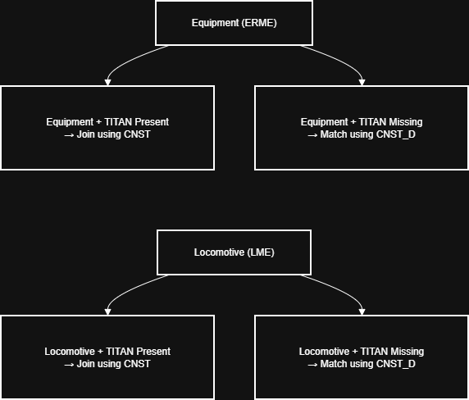
Quick notes / reading tips
- The query has four major branches:
  - Equipment events where titan_nbr exists (direct match).
  - Locomotive events where titan_nbr exists (direct match).
  - Equipment events where titan_nbr is NULL — try to match by last reported constituent details.
  - Locomotive events where titan_nbr is NULL — similar orphan-match logic.

Overall Flow
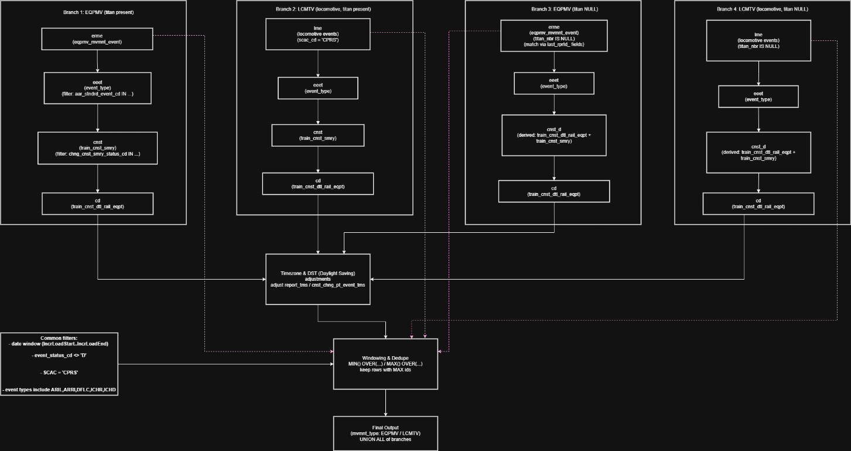

Common Filters:
- Time window (IncrLoadStart..IncrLoadEnd) (May be watermarking for last loaded time stamp)
- event_status_cd <> 'D'
- SCAC = 'CPRS'
- event types include ARIL,ARRI,DFLC,ICHR,ICHD

Time Zone Derivation:
Applicable for all the Branches.
It is a case statement used to derive standard time zone along with adjusting the Day light saving. The code is effectively converting all timezones into Pacific Time (PT).
What this code (case statement) does?
- For each cnst row it looks at cnst.cnst_chng_rprtng_tm_zn_cd (PT/MT/CT/ET/ST) and adjusts cnst_chng_pt_event_tms by a fixed number of hours.
- The offset depends on whether the cnst_chng_pt_event_tms falls inside the DST window for that year or outside it.
- DST window is computed using the second Sunday of March through the first Sunday of November (the typical North American DST period).
- Offsets applied (examples):
  - PT: during DST subtract 2 hours, otherwise subtract 3 hours
  - MT: during DST subtract 1 hour, otherwise subtract 2 hours
  - CT: during DST no change, otherwise subtract 1 hour
  - ET: during DST add 1 hour, otherwise no change
  - ST: always subtract 1 hour
- Result: cnst_chng_pt_event_tms is normalized by timezone + DST to a target time base (the original code appears to convert to some standardized hour — likely UTC or a system baseline).

2) How the DST window is computed (what those next_day(...) lines mean)
- next_day(trunc(to_date('01-MAR-'||year),'DD-MON-YYYY'),'MON')-1,'sun')+7 → yields the second Sunday of March (the +7 moves from the first Sunday to the second).
- next_day(trunc(to_date('01-NOV-'||year), ...),'MON')-1,'sun') → yields the first Sunday of November.
- The code then adds fractional day offsets like ((1/24)*5) to place the comparison at a particular hour (e.g. 5:00). So the BETWEEN check is: is event time between second-Sunday-of-March-at-X and first-Sunday-of-November-at-Y.

Windowing Function and Dedupes (Removing duplicates in event of multiple matching records in the joins):
Using Windowing function it is selecting the max train_cnst_smry_id and train_cnst_smry_vrsn_nbr if multiple records.
Code:
MAX(train_cnst_smry_id) OVER (PARTITION BY event_id)
AS max_train_cnst_smry_id,
MAX(train_cnst_smry_vrsn_nbr) OVER (PARTITION BY train_cnst_smry_id, event_id) AS max_train_cnst_smry_vrsn_nbr,
Filter:
WHERE NVL(train_cnst_smry_id,0) = NVL(max_train_cnst_smry_id,0) AND NVL(train_cnst_smry_vrsn_nbr,0) = NVL(max_train_cnst_smry_vrsn_nbr,0)

1) High-level summary
This SQL builds a single result set of movement events for trains/equipment by combining (via UNION ALL) four similar extracts (equipment movement and locomotive movement, each in two variants), normalizing times (time-zone & DST logic), joining event feeds with train-constituent (cnst) data, keeping only relevant event types and statuses, and then selecting the latest summary/version per event.

2) Simplified structure and step-by-step explanation
I’ll label the main building blocks so you can map them to the SQL.
Top level
-- top-level output
SELECT * FROM (<block A>) WHERE train_cnst_smry_id = max_train_cnst_smry_id AND train_cnst_smry_vrsn_nbr = max_train_cnst_smry_vrsn_nbr

UNION ALL
SELECT * FROM (<block B>) ...
UNION ALL
SELECT * FROM (<block C>) ...
UNION ALL
SELECT * FROM (<block D>) ...
There are four big blocks (A,B,C,D) unioned together. Each block returns the same columns so they can be combined. Blocks differ by source (equipment vs locomotive) and whether titan_nbr exists or is null. The final WHERE in each block keeps only the latest train summary id/version for each event.

Block A — Equipment movement joined to train detail (main path)
(Starts: SELECT 'EQPMV' mvmnt_type, ... FROM ( SELECT cnst.run_nbr, ... FROM ( SELECT /*+ full(erme) */ erme...)
What it does (plain):
- Reads equipment movement events (erme) and event type table (eeet), and joins the train summary (cnst) and the train detail equipment (cd) to get rows that describe equipment movements and the train/constituent they belong to.
- Applies time adjustments (big CASE / next_day logic) to convert and correct event timestamps based on reporting timezone and daylight-saving rules.
- Filters to a date window ($$IncrLoadStart / $$IncrLoadEnd), and only specific standard event codes (ARIL, ARRI, DFLC, ICHR, ICHD) and train statuses (ARRIVED/DEPARTED/PASSING.*).
- Computes a MIN(...) OVER (PARTITION BY ...) to identify the minimum change-point event time per group — used later to include earliest record when needed.
- Joins to train_cnst_dtl_rail_eqpt (cd) for equipment-specific detail and ensures the detail row has been updated in the incremental window.
- Keeps only rows where report_tms >= cnst_chng_pt_event_tms OR cnst_chng_pt_event_tms = min_cnst_chng_pt_event_tms — meaning: choose event records where the event report time is after (or equal to) the constituent change time, or if it's the earliest change for that group.
Why (purpose):
- To produce a normalized, timezone-corrected list of equipment movement events tied to a train constituent (so you know which car/equipment on which train moved, at what time).
Key columns produced: mvmnt_type='EQPMV', run_nbr, mark_cd (car id), eqpun_nbr (equipment number), aar_stndrd_event_cd (event code), report_tms (adjusted/normalized), cnst_chng_pt_event_tms (constituent change time), train_cnst_smry_id, train_cnst_smry_vrsn_nbr, titan_nbr, event_id, plus computed window fields max_train_cnst_smry_id, max_train_cnst_smry_vrsn_nbr, min_cnst_chng_pt_event_tms.

Block B — Locomotive movement joined to train detail (main path)
(Starts: SELECT 'LCMTV' mvmnt_type, ... FROM ( SELECT cnst.run_nbr, ... FROM ( SELECT /*+ full(lme) */ lme...)
What it does (plain):
- Same logic as Block A but uses locomotive movement events (lme) instead of equipment events.
- Also computes timezone adjustments for report_tms.
- Filters and joins to train constituent details and the same event codes/statuses.
- Adds mvmnt_type='LCMTV' so locomotives and equipment are distinguishable in the final output.
Why (purpose):
- To capture locomotive-level movement events (lead locomotive at a given time/location) and tie them to train constituent information.

Block C — Equipment movement where titan_nbr is NULL (alternate path)
(Starts similar to Block A but with erme.titan_nbr is null and different joins: a subquery builds cnst from train_cnst_dtl_rail_eqpt + train_cnst_smry and this is outer joined to erme)
What it does (plain):
- Handles equipment movement events that don’t have a titan_nbr (an ID that normally ties the event to a train summary). In that case it tries to match erme with the last reported constituent details (matching mark/eqpun/cycle etc.) using an outer join pattern.
- This path uses a pre-selected cnst subquery (from train_cnst_dtl_rail_eqpt + train_cnst_smry) to match the last reported events to the equipment event record.
- Applies the same time adjustments, filters, windowing and min/max logic as earlier.
Why (purpose):
- Some equipment events come without a direct match to the master titan_nbr; this block attempts to attach those orphaned events to the appropriate train constituent based on last known reported details.

Block D — Locomotive movement where titan_nbr is NULL (alternate path)
(Same idea as Block C but for locomotives — lme.titan_nbr IS NULL case, joining with the cnst subquery)
What it does & why: same reasoning as Block C but for locomotive events that lack titan_nbr.

Window / versioning logic (applies inside each block)
- The query calculates:
  - MIN(cnst_chng_pt_event_tms) OVER (PARTITION BY ...) — to identify earliest change time in a partition (used to include earliest records).
  - MAX(train_cnst_smry_id) OVER (PARTITION BY event_id) and MAX(train_cnst_smry_vrsn_nbr) OVER (PARTITION BY train_cnst_smry_id, event_id) — to compute the latest summary id and version for each event.
- Then outer WHERE train_cnst_smry_id = max_train_cnst_smry_id AND train_cnst_smry_vrsn_nbr = max_train_cnst_smry_vrsn_nbr keeps only the latest summary/version for an event (de-duplicates older versions).
Plain explanation: the query often has multiple versions of the same train-constituent event (updates). This logic finds the latest update and keeps just that one.

Timezone & DST adjustment block (the big CASE WHEN ... next_day(trunc( ... ) logic)
Inside each subquery there is a large CASE that adjusts the event time depending on the reporting timezone (PT, MT, CT, ET, ST) and whether the event falls into DST period. Concretely:
- It checks if the reported event timestamp falls between the DST start and end dates for that year (using next_day(trunc(to_date('01-MAR-'||year...), 'MON') - 1, 'sun') + 7 etc.).
- If inside DST window it modifies the event time by different offsets (1, 2 or 3 hours), otherwise different offsets — effectively normalizing all times into a consistent reference (so downstream logic sees comparable timestamps).
Plain explanation: because events are reported from different time zones and DST rules change the local time offset, the query corrects times so everything is comparable.

Filters (important ones to know)
- Date window: ... >= to_date('$$IncrLoadStart', 'DD-Mon-YYYY') and < to_date('$$IncrLoadEnd','DD-Mon-YYYY')
- Event types: eeet.aar_stndrd_event_cd IN ('ARIL','ARRI','DFLC','ICHR','ICHD') — only these kinds of events are relevant.
- Constituency statuses: cnst.chng_cnst_smry_status_cd IN ('ARRIVED','DEPARTED','PASSING-OUT','PASSING-IN')
- Only include non-deleted events: erme.event_status_cd <> 'D'
- Only include records for a specific SCAC value in some branches: e.g. ... = 'CPRS' — meaning “only events for the CPRS carrier”.
Plain explanation: the query intentionally narrows to recent changes and only the event types/statuses that matter for the downstream data model.

Plain-English pseudo-flow (short)
- Read equipment movement events (EQPMV) and locomotive movement events (LCMTV) from event feeds.
- For each event, compute a normalized report time (account for timezone + DST).
- Join each event to train summary and train constituent detail to find which train and which car/locomotive the event belongs to.
- Filter to only the events and statuses that matter and constrain to the incremental load window ($$IncrLoadStart—$$IncrLoadEnd).
- Compute window values to detect earliest change-times and the latest summary/version for each event.
- Keep only rows where the event is after the constituent change or is the earliest change for that grouping.
- Keep only the latest summary id/version for each event to avoid duplicates.
- Combine equipment and locomotive rows into a single final result via UNION ALL.

Query_2_ DM_BMR.BMR_FACT_CNST_MVMNT (Output of Query_1 – Input for Query_2):
Step3_DM_BMR.BMR_FACT_CNST_MVMNT(Code-2)
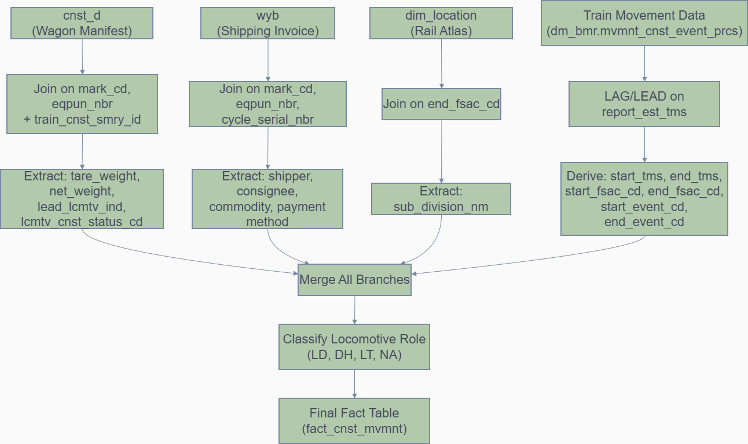
Explanation of the Query Using Laymen Term With Example
1. Subquery: cnst_d
sql
WITH cnst_d AS (
SELECT /*+ MATERIALIZE */ *
FROM atm_train.train_cnst_dtl_rail_eqpt
WHERE edw_update_tms BETWEEN to_date('$$IncrLoadStart','DD-Mon-YYYY')-10
AND to_date('$$IncrLoadEnd','DD-Mon-YYYY')+30
)
Layman’s Explanation
- Pulls rail equipment details (weights, locomotive flags, consist status).
- Think of it as the wagon manifest — like a trucking company’s sheet listing each truck’s weight and whether it’s the lead vehicle.

Example Data
mark_cd | eqpun_nbr | tare_weight_tons_qty | net_weight_tons_qty | lead_lcmtv_ind | lcmtv_cnst_status_cd
CP | 12345 | 30 | 75 | N | LOADED
CP | 54321 | 28 | 0 | Y | LEAD

2. Subquery: wyb
sql
wyb AS (
SELECT *
FROM (
SELECT cycle_serial_nbr, mark_cd, eqpun_nbr, origin_scac_cd, origin_fsac_cd, dstntn_scac_cd, dstntn_fsac_cd,
shpr_cprs_cstmr_id, cnsgn_cprs_cstmr_id, stcc_cd,
wybl_cntnt_weight_qty, wybl_create_local_tms,
wybl_nbr, method_of_pymnt_cd,
stnwyb_msg_vrsn_id, CPR_EQPMT_POOL_ID,
MAX(stnwyb_msg_vrsn_id) OVER (PARTITION BY cycle_serial_nbr) max_stnwyb_msg_vrsn_id
FROM atm_shpmt.stnwyb_msg_dn
WHERE wybl_create_local_tms BETWEEN to_date('$$IncrLoadStart','DD-Mon-YYYY')-30
AND to_date('$$IncrLoadEnd','DD-Mon-YYYY')
AND crnt_vrsn_cd = 'Y'
)
WHERE stnwyb_msg_vrsn_id = max_stnwyb_msg_vrsn_id
)
Layman’s Explanation
- Gets the latest waybill version for each shipment cycle.
- A waybill is like a shipping invoice — who is shipping, who is receiving, what commodity, and how payment is handled.
- The query ensures we only keep the most recent invoice.
Example Data
cycle_serial_nbr | mark_cd | eqpun_nbr | origin_scac_cd | dstntn_scac_cd | shipper | consignee | stcc_cd | wybl_nbr | method_of_pymnt_cd
CYCLE001 | CP | 12345 | TOR01 | MTL03 | SHIP001 | CONS001 | 2810 | WB123 | PREPAID
3. Subquery: Movement Derivation
sql
SELECT mark_cd, eqpun_nbr, cycle_serial_nbr,
LAG(report_tms) OVER (...) start_tms,
report_tms end_tms,
LAG(fsac_cd) OVER (...) start_fsac_cd,
fsac_cd end_fsac_cd,
LAG(aar_stndrd_event_cd) OVER (...) start_event_cd,
aar_stndrd_event_cd end_event_cd,
LEAD(offline_scac_cd) OVER (...) next_offline_scac_cd,
...
FROM dm_bmr.mvmnt_cnst_event_prcs
WHERE report_est_tms BETWEEN to_date('$$IncrLoadStart','DD-Mon-YYYY')
AND to_date('$$IncrLoadEnd','DD-Mon-YYYY')
Layman’s Explanation
- Derives start and end events for each wagon movement using LAG and LEAD.
- LAG looks backward → previous station/time (start).
- LEAD looks forward → next carrier handoff.
- Think of it as a GPS logbook for a truck:
  - “Left Toronto at 8:05” → start event.
  - “Arrived Ottawa at 12:05” → end event.
  - “Next carrier CN will take over” → handoff.
Example Data
mark_cd | eqpun_nbr | start_fsac_cd | end_fsac_cd | start_event_cd | end_event_cd | start_tms | end_tms | next_offline_scac_cd
CP | 12345 | TOR01 | OTT02 | DEPARTURE | ARRIVAL | 08:05 | 12:05 | CN

4. Subquery: Location Join
sql
dm_dim.dim_location lctn
WHERE 'CPRS' = lctn.scac_cd(+)
AND mvmnt.end_fsac_cd = lctn.fsac_cd(+)

Layman’s Explanation
- Maps FSAC codes (station codes) to subdivision names.
- Think of it as a Google Maps lookup: you type in “OTT02” and it tells you “Ottawa Subdivision.”
Example Data
scac_cd | fsac_cd | sub_division_nm
CPRS | TOR01 | Toronto Sub
CPRS | OTT02 | Ottawa Sub
5. Business Logic Transformation
sql
CASE WHEN mvmnt.mvmnt_type = 'LCMTV' THEN
CASE WHEN cnst_d.lead_lcmtv_ind = 'Y' THEN 'LD'
WHEN cnst_d.lcmtv_cnst_status_cd IN ('DEAD','DEADHEAD') THEN 'DH'
ELSE 'LT'
END
ELSE 'NA'
END lcmtv_lead_trail_ind
Layman’s Explanation
- Classifies locomotives as Lead (LD), Deadhead (DH), Trail (LT), or Not Applicable (NA).
- Analogy: In a convoy of trucks, you need to know which truck is leading, which is idling, and which is just attached.

6. Final Assembly
sql
SELECT rownum as fact_cnst_mvmnt_id, ...
FROM (...) a
WHERE a.train_nm <> 'UNDEFINE'
AND NOT EXISTS (
SELECT 'true'
FROM dm_bmr.mvmnt_cnst_event_prcs cep
WHERE cep.mark_cd = a.mark_cd
AND cep.eqpun_nbr = a.eqpun_nbr
AND cep.report_est_tms BETWEEN to_date('$$IncrLoadStart','DD-Mon-YYYY')-10
AND to_date('$$IncrLoadEnd','DD-Mon-YYYY')
AND cep.report_tms BETWEEN a.start_tms AND a.end_tms
AND cep.train_nm <> a.train_nm
)
Layman’s Explanation
- Builds the fact table of train consist movements.
- Filters out:
  - Undefined train names.
  - Duplicate/inconsistent movements (ensures one train assignment per time window).
- Analogy: Like quality control — if two logbooks claim the same wagon was on different trains at the same time, drop the conflicting record.
Final Fact Record Example
fact_cnst_mvmnt_id | mark_cd | eqpun_nbr | start_fsac_cd | end_fsac_cd | sub_division_nm | start_event_cd | end_event_cd | start_tms | end_tms | shipper | consignee | stcc_cd | wybl_nbr | net_weight_tons_qty
1 | CP | 12345 | TOR01 | OTT02 | Ottawa Sub | DEPARTURE | ARRIVAL | 08:05 | 12:05 | SHIP001 | CONS001 | 2810 | WB123 | 75
Real-World Analogy
Imagine tracking a truck shipment:
- Movement table = GPS log (when/where the truck moved).
- Location table = Google Maps (mapping station codes to subdivisions).
- Equipment table = Truck manifest (weights, whether it’s the lead vehicle).
- Waybill table = Shipping invoice (who’s shipping what, to whom).
- Final fact table = Integrated record of the journey, enriched with geography, shipment, and equipment details.

Query_3_ DM_BMR.BMR_FACT_CNST_MVMNT (Output of Query_2 – Input for Query_3):
Step _ 4 DM_BMR.BMR_FACT_CNST_MVMNT(Code-3)

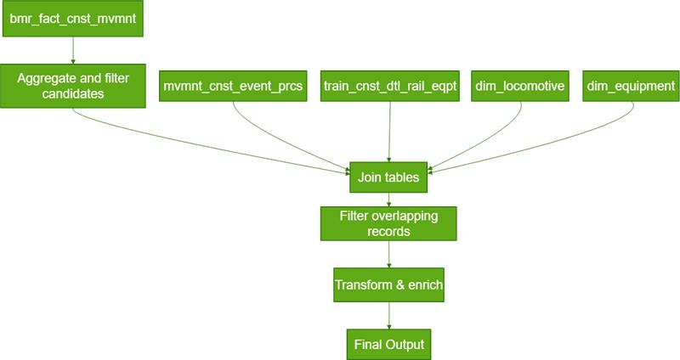
1. Query Block
SELECT rownum as FACT_CNST_MVMNT_ID,
NVL(FCM.DIM_TRAIN_ID, -999999) as DIM_TRAIN_ID,
NVL(FCM.DIM_LOCOMOTIVE_ID, -111111) as DIM_LOCOMOTIVE_ID,
FCM.DIM_DEPARTURE_LCTN_ID,
FCM.DIM_ARRIVAL_LCTN_ID,
NVL(FCM.DIM_EQUIPMENT_ID, -111111) as DIM_EQUIPMENT_ID,
ROUND(FCM.ARRIVAL_TMS-FCM.DEPARTURE_TMS, 6) as run_time,
...
FROM ( ... ) FCM
WHERE NOT EXISTS ( ... )
ORDER BY DIM_TRAIN_ID, TRAIN_NM, CONSIST_NBR, RUN_TIME DESC
What it does
- Creates the final dataset for train consist movements.
- Assigns a unique ID (rownum).
- Replaces missing values with defaults using NVL.
- Calculates run time (arrival minus departure).
- Sorts by train and longest trip first.

Real-Life Analogy
Imagine you are a railway operations manager preparing a daily summary report for trains:
- Each row in your report represents one train trip.
- If some details (like origin or customer) are missing, you fill them with “Unknown” so the report looks complete.
- You calculate how long each train ran (arrival time minus departure time).
- Finally, you sort the report so the longest trips appear first for quick review.

Data Example
Input:
Train | Departure | Arrival
T123 | 08:00 | 12:00
T124 | 09:00 | 11:00

Output:
FACT_ID | Train | Run_Time
1 | T123 | 4.00
2 | T124 | 2.00

2. Inner Derived Table (FCM)
Query
SELECT fct.fact_cnst_mvmnt_id,
fct.dim_train_id,
lcmtv.dim_locomotive_id,
eqpt.dim_equipment_id,
fct.departure_tms,
fct.arrival_tms,
cnst.sqnc_nbr,
CASE WHEN cnst.lead_lcmtv_ind = 'Y' THEN 'LD'
WHEN cnst.lcmtv_cnst_status_cd IN ('DEAD','DEADHEAD') THEN 'DH'
ELSE 'LT'
END lcmtv_lead_trail_ind,
...
FROM dm_bmr.bmr_fact_cnst_mvmnt fct,
dm_bmr.mvmnt_cnst_event_prcs stg,
(SELECT * FROM atm_train.train_cnst_dtl_rail_eqpt WHERE SUBSTR(aar_car_type_cd,1,1) = 'D') cnst,
(SELECT * FROM dm_dim.dim_locomotive WHERE edw_current_flg = 'Y') lcmtv,
(SELECT * FROM dm_dim.dim_equipment WHERE edw_current_flg = 'Y') eqpt
WHERE ...
What it does
- Joins fact table with:
  - Event staging
  - Consist details (only diesel locomotives)
  - Locomotive dimension (current records)
  - Equipment dimension (current records)
- Adds business logic for locomotive role:
  - LD = Lead
  - DH = Deadhead
  - LT = Trailing
Real-Life Analogy
You gather raw data from different sources:
- Trip logs (fact table): When and where trains moved.
- Event logs: Operational events.
- Consist details: Which locomotives and cars were in the train.
- Locomotive registry: Only active locomotives.
- Equipment registry: Only active equipment.
Then you classify locomotives:
- If marked as lead → Lead (LD).
- If deadhead → Deadhead (DH).
- Otherwise → Trailing (LT).

Data Example
Input:
eqpun_nbr | lead_lcmtv_ind | lcmtv_cnst_status_cd
L001 | Y | ACTIVE
L002 | N | DEADHEAD

Output:
Locomotive | Role
L001 | LD
L002 | DH

3. Subquery for Filtering
Query
AND fct.fact_cnst_mvmnt_id in (
SELECT MIN(fact_cnst_mvmnt_id)
FROM (
SELECT bmr.train_nm,
LISTAGG(NVL(bmr.lcmtv_lead_trail_ind,'x'), ',') OVER (...) AS lcmtv_lead_train_ind_list,
MIN(bmr.fact_cnst_mvmnt_id) fact_cnst_mvmnt_id
FROM dm_bmr.bmr_fact_cnst_mvmnt bmr
WHERE trunc(bmr.sadb_receiving_dt) BETWEEN to_date('$$IncrLoadStart','DD-Mon-YYYY') AND to_date('$$IncrLoadEnd','DD-Mon-YYYY')
GROUP BY ...
)
WHERE INSTR(lcmtv_lead_train_ind_list, 'LD') = 0
GROUP BY ...)
What it does
- Groups by train and consist.
- Creates a list of locomotive roles per train.
- Filters trains with no lead locomotive (‘LD’).
- Picks the earliest record.
Real-Life Analogy
You check:
- For each train, list all locomotive roles.
- If the list does not contain ‘LD’, this train has no lead locomotive.
- From those, pick the earliest trip (minimum ID).
Why? Because you want to identify trains that need a lead locomotive assigned.
Data Example
Input:
Train | Roles List
T123 | DH, LT
T124 | LD, LT

Output:
Train | Needs Lead?
T123 | Yes
T124 | No

4. NOT EXISTS Clause
Query
WHERE NOT EXISTS (
SELECT 'true'
FROM dm_bmr.bmr_fact_cnst_mvmnt a
WHERE a.mark_cd = fcm.mark_cd
AND a.eqpun_nbr = fcm.eqpun_nbr
AND a.train_nm = fcm.train_nm
AND fcm.departure_tms > a.departure_tms
AND fcm.arrival_tms < a.arrival_tms
)
What it does
- Removes overlapping trips for the same locomotive.

Real-Life Analogy
You ensure:
- If a locomotive is already scheduled in another trip during the same time window, skip it.
- This prevents double-booking.

Data Example
Input:
Locomotive | Trip 1 | Trip 2
L001 | 08-12 | 09-11
Output: Exclude Trip 2 because it overlaps with Trip 1.

Train Level Summery
Train_LEVEL_SUMMARY_With_Inline_Comments(Code-4)

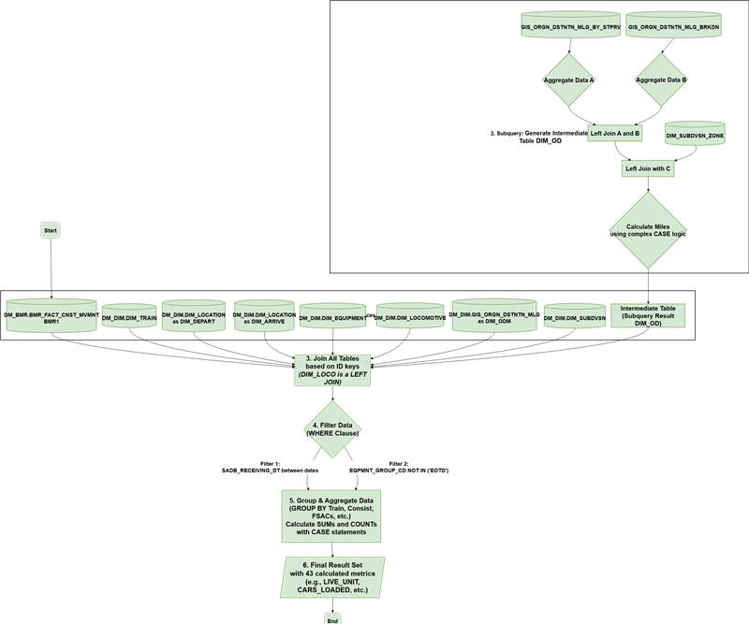

1. Query Block
Query
SELECT
BMR1.ARRIVAL_TMS,
BMR1.DEPARTURE_TMS,
BMR1.SADB_RECEIVING_DT,
DIM_TRAIN.TITAN_NBR,
BMR1.TRAIN_NM,
DIM_TRAIN.TRAIN_TYPE_CD,
DIM_TRAIN.TRAIN_KIND_CD,
BMR1.CONSIST_NBR,
DIM_DEPART.FSAC_CD AS DEPART_FSAC,
DIM_ARRIVE.FSAC_CD AS ARRIVE_FSAC,
...
FROM DM_BMR.BMR_FACT_CNST_MVMNT BMR1,
DM_DIM.DIM_TRAIN DIM_TRAIN,
DM_DIM.DIM_LOCATION DIM_DEPART,
DM_DIM.DIM_LOCATION DIM_ARRIVE,
DM_DIM.DIM_EQUIPMENT DIM_EQUIP,
DM_DIM.DIM_LOCOMOTIVE DIM_LOCO,
DM_DIM.GIS_ORGN_DSTNTN_MLG DIM_ODM,
(inline subquery DIM_OD) DIM_OD,
DM_DIM.DIM_SUBDVSN DIM_SBDVSN
WHERE ...
GROUP BY ...

What it does
- Builds the final dataset of train consist movements.
- Pulls timestamps, train identifiers, consist numbers, departure/arrival FSAC codes.
- Joins to equipment, locomotive, and GIS mileage dimensions.
- Computes aggregated KPIs like car counts, ton-miles, horsepower-miles, loco miles.
- Applies filters (exclude EOTD equipment, restrict to 30-day incremental window).
- Groups by train + subdivision context to roll up metrics.

Real-Life Analogy
Imagine you’re a railway operations manager preparing a performance dashboard:
- Each row is one train’s movement segment.
- You enrich it with details from registries: train registry, station directory, equipment catalog, locomotive specs, and maps.
- Then you calculate productivity metrics: how many cars were loaded, how many miles they traveled, how much horsepower was used.
- Finally, you filter out irrelevant devices (like end-of-train markers) and only keep recent trips.

Data Example
Input (simplified fact rows):
Train | Depart | Arrive | Indicator | Tons | Miles | Loco HP | Loco Weight | Car Code
T123 | 08:00 | 12:00 | LD | 0 | 118 | 4400 | 200 | L200
T123 | 08:00 | 12:00 | NA | 80 | 118 | – | 30 | H123
T123 | 08:00 | 12:00 | NA | 0 | 118 | – | 28 | H120
T123 | 08:00 | 12:00 | DH | 0 | 118 | 4400 | 200 | L210
Output (aggregated KPIs):
Train | Consist | Loaded Cars | Total Cars | Train Miles | Rev Car Miles Loaded | Rev Car Miles Empty | Live Loco Miles | DH Loco Miles | Content Ton-Miles | Tare Ton-Miles | HP-Miles
T123 | 1 | 1 | 2 | 118 | 118 | 118 | 118 | 118 | 9440 | 6844 | 1,038,400

2. Inline Derived Table (DIM_OD)
Query
SELECT
A.ORGN_DSTNTN_MLG_ID,
A.SBDVSN_NM,
A.SBDVSN_NBR,
C.REGION,
C.ZONE,
C.DIVISION_NM,
CASE
WHEN COUNT(*) OVER (...) = 1 THEN MILES
WHEN (B.MIN_MILES BETWEEN C.LOW_TRACK_MILE AND C.HIGH_TRACK_MILE) THEN ...
ELSE ...
END AS MILES
FROM (aggregate miles) A
LEFT JOIN (breakdown min/max miles) B
LEFT JOIN DIM_SUBDVSN_ZONE C
WHERE (min/max miles fall into zone ranges)

What it does
- Computes refined mileage for each origin-destination pair.
- Uses aggregated miles (A), reference mile markers (B), and subdivision zone boundaries (C).
- Applies CASE logic to avoid inflated/negative distances.
- Returns subdivision name, region, division, zone, and corrected miles.
Real-Life Analogy
Think of Google Maps recalculating a route:
- A = total distance between two cities.
- B = mile markers along the track.
- C = zone boundaries (like districts).
- The CASE logic ensures the reported distance matches the actual track segment, not an unrealistic shortcut or overshoot.
Data Example
Input (mile markers):
OD_ID | Subdivision | Aggregated Miles | Min Mile | Max Mile | Zone Low | Zone High
20001 | EAST SUB | 120 | 10 | 130 | 0 | 150
Output (refined miles):
OD_ID | Subdivision | Region | Division | Zone | Miles
20001 | EAST SUB | EAST | DELTA | Z1 | 118

3. Aggregations / KPIs
Query (examples)
SUM(CASE WHEN LCMTV_LEAD_TRAIL_IND = 'NA' THEN 1 END) AS CARS_TOTAL,
SUM(CASE WHEN CONTENT_TONS > 0 THEN 1 END) AS CARS_LOADED,
SUM(CONTENT_TONS * MILES) AS CONTENT_TON_MILES,
SUM(HRSPWR_QTY * MILES) AS LIVE_LOCO_HP_MILES,
What it does
- Counts cars and locomotives by role (lead, trail, deadhead).
- Calculates ton-miles (payload * miles).
- Calculates horsepower-miles (engine power * miles).
- Splits revenue miles into loaded vs empty cars.
- Tracks special car types (passenger, work, caboose).
Real-Life Analogy
It’s like a fleet performance dashboard:
- How many trucks carried cargo vs drove empty.
- How much cargo weight was moved per mile.
- How much engine power was consumed.
- How many passenger buses or maintenance vehicles were in service.
Data Example
Input (rows):
Indicator | Tons | Miles | HP | Car Code
NA | 80 | 118 | – | H123
NA | 0 | 118 | – | H120
LD | 0 | 118 | 4400 | L200
DH | 0 | 118 | 4400 | L210
Output (KPIs):
- CARS_TOTAL: 2
- CARS_LOADED: 1
- CONTENT_TON_MILES: 9440
- LIVE_LOCO_HP_MILES: 519,200
- DH_LOCO_HP_MILES: 519,200
- REV_CAR_MILES_LOADED: 118
- REV_CAR_MILES_EMPTY: 118
4. Filters & Grouping
Query
WHERE NVL(DIM_EQUIP.EQPMNT_GROUP_CD,'x') NOT IN ('EOTD')
AND SADB_RECEIVING_DT BETWEEN (IncrLoadStart - 30 days) AND IncrLoadEnd
GROUP BY ARRIVAL_TMS, DEPARTURE_TMS, TITAN_NBR, TRAIN_NM, CONSIST_NBR, ...
What it does
- Excludes end-of-train devices (EOTD).
- Keeps only rows received in the last 30 days (rolling window).
- Groups by train identifiers, consist, subdivision, and geography.
Real-Life Analogy
Like preparing a monthly report:
- Ignore irrelevant devices (like caboose cameras).
- Only include trips logged in the last month.
- Summarize by train and route segment.
Data Example
Input (rows):
Train | SADB_Receiving_DT | Equip Group
T123 | 2025-11-01 | CAR
T124 | 2025-09-01 | EOTD
Output (after filter):
| Train | Included

Final FLOW DIAGRAM (TB)
