 
-  Connect to the Store Sales Data and do the following: -

− Remove all the blank rows.
− Update the column header if they are not updated
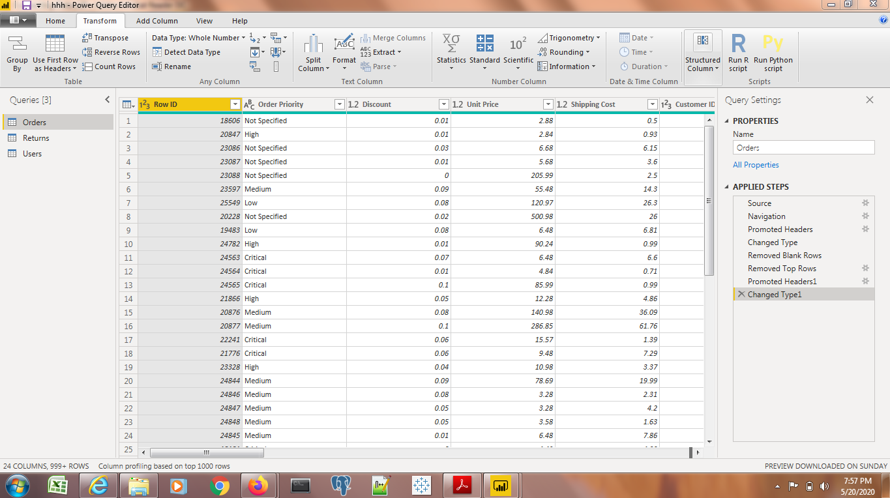

Create a text table and show the sales in terms of
  - o Customers
  - o Product Category
  - o Regions

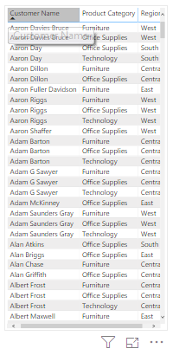

Create a line and Clustered Column Chart showing the Sales and Discount as per the State or Province
Format the bars and line with different colors
Which state has the highest sales in terms Technology
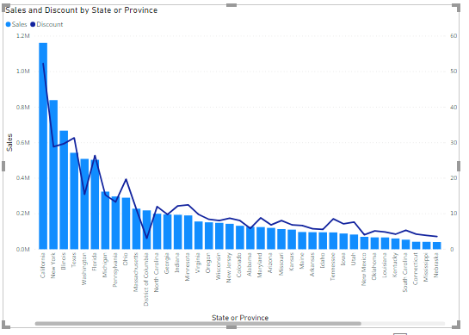Create a Donut Chart showing sales in terms of Product category
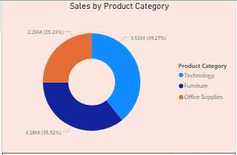
Create a Slicer and show the regions in dropdown. See how all the visuals mentioned above behaving when a particular region is selected.
