<http://localhost:8080/job/LearnAutomation/6/>

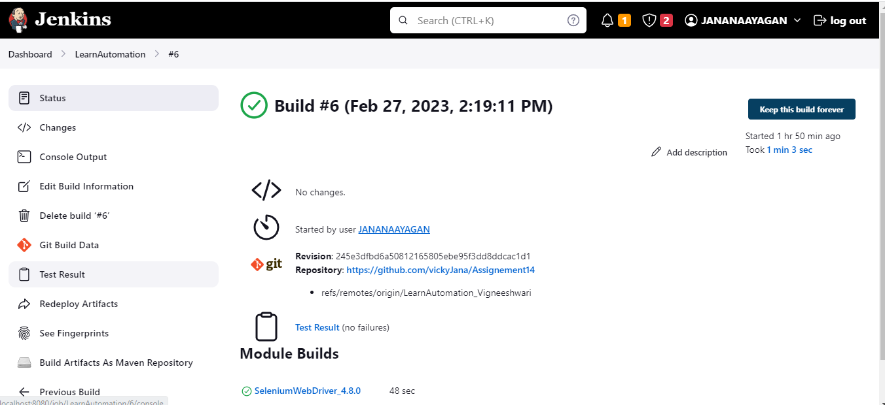

Started by user [JANANAAYAGAN](http://localhost:8080/user/necjana90)

Running as SYSTEM

Building in workspace C:\Users\Dell\.jenkins\workspace\LearnAutomation

The recommended git tool is: NONE

No credentials specified

> git.exe rev-parse --resolve-git-dir C:\Users\Dell\.jenkins\workspace\LearnAutomation\.git # timeout=10

Fetching changes from the remote Git repository

> git.exe config remote.origin.url <https://github.com/vickyJana/Assignement14> # timeout=10

Fetching upstream changes from <https://github.com/vickyJana/Assignement14>

> git.exe --version # timeout=10

> git --version # 'git version 2.38.1.windows.1'

> git.exe fetch --tags --force --progress -- <https://github.com/vickyJana/Assignement14> +refs/heads/*:refs/remotes/origin/* # timeout=10

> git.exe rev-parse "refs/remotes/origin/LearnAutomation_Vigneeshwari^{commit}" # timeout=10

Checking out Revision 245e3dfbd6a50812165805ebe95f3dd8ddcac1d1 (refs/remotes/origin/LearnAutomation_Vigneeshwari)

> git.exe config core.sparsecheckout # timeout=10

> git.exe checkout -f 245e3dfbd6a50812165805ebe95f3dd8ddcac1d1 # timeout=10

Commit message: ""Wait Added""

> git.exe rev-list --no-walk 245e3dfbd6a50812165805ebe95f3dd8ddcac1d1 # timeout=10

No emails were triggered.

Parsing POMs

Established TCP socket on 52230

[LearnAutomation] $ "C:\Program Files\Java\jdk-11.0.17/bin/java" -cp "C:\Users\Dell\.jenkins\plugins\maven-plugin\WEB-INF\lib\maven35-agent-1.14.jar;C:\Program Files\apache-maven-3.8.6-bin\apache-maven-3.8.6\boot\plexus-classworlds-2.6.0.jar;C:\Program Files\apache-maven-3.8.6-bin\apache-maven-3.8.6/conf/logging" jenkins.maven3.agent.Maven35Main "C:\Program Files\apache-maven-3.8.6-bin\apache-maven-3.8.6" C:\Users\Dell\.jenkins\war\WEB-INF\lib\remoting-3077.vd69cf116da_6f.jar C:\Users\Dell\.jenkins\plugins\maven-plugin\WEB-INF\lib\maven35-interceptor-1.14.jar C:\Users\Dell\.jenkins\plugins\maven-plugin\WEB-INF\lib\maven3-interceptor-commons-1.14.jar 52230

<===[JENKINS REMOTING CAPACITY]===>channel started

Executing Maven: -B -f C:\Users\Dell\.jenkins\workspace\LearnAutomation\pom.xml install

[INFO] Scanning for projects...

[INFO]

[INFO] ---------------< com.qa.WebApp:SeleniumWebDriver_4.8.0 >----------------

[INFO] Building SeleniumWebDriver_4.8.0 0.0.1-SNAPSHOT

[INFO] --------------------------------[ jar ]---------------------------------

[INFO]

[INFO] **--- maven-resources-plugin:2.6:resources (default-resources) @ SeleniumWebDriver_4.8.0 ---**

[WARNING] Using platform encoding (Cp1252 actually) to copy filtered resources, i.e. build is platform dependent!

[INFO] skip non existing resourceDirectory C:\Users\Dell\.jenkins\workspace\LearnAutomation\src\main\resources

[INFO]

[INFO] **--- maven-compiler-plugin:3.8.0:compile (default-compile) @ SeleniumWebDriver_4.8.0 ---**

[INFO] Changes detected - recompiling the module!

[WARNING] File encoding has not been set, using platform encoding Cp1252, i.e. build is platform dependent!

[INFO] Compiling 11 source files to C:\Users\Dell\.jenkins\workspace\LearnAutomation\target\classes

[INFO]

[INFO] **--- maven-resources-plugin:2.6:testResources (default-testResources) @ SeleniumWebDriver_4.8.0 ---**

[WARNING] Using platform encoding (Cp1252 actually) to copy filtered resources, i.e. build is platform dependent!

[INFO] skip non existing resourceDirectory C:\Users\Dell\.jenkins\workspace\LearnAutomation\src\test\resources

[INFO]

[INFO] **--- maven-compiler-plugin:3.8.0:testCompile (default-testCompile) @ SeleniumWebDriver_4.8.0 ---**

[INFO] Changes detected - recompiling the module!

[WARNING] File encoding has not been set, using platform encoding Cp1252, i.e. build is platform dependent!

[INFO] Compiling 2 source files to C:\Users\Dell\.jenkins\workspace\LearnAutomation\target\test-classes

[INFO]

[INFO] **--- maven-surefire-plugin:3.0.0-M7:test (default-test) @ SeleniumWebDriver_4.8.0 ---**

[INFO] Using auto detected provider org.apache.maven.surefire.testng.TestNGProvider

[INFO]

[INFO] -------------------------------------------------------

[INFO] T E S T S

[INFO] -------------------------------------------------------

[INFO] Running TestSuite

************ Loading Data From Excel *******************

ERROR StatusLogger Log4j2 could not find a logging implementation. Please add log4j-core to the classpath. Using SimpleLogger to log to the console...

admin@email.com

admin@123

Log Info - Setting Up Browser

SLF4J: Failed to load class "org.slf4j.impl.StaticLoggerBinder".

SLF4J: Defaulting to no-operation (NOP) logger implementation

SLF4J: See <http://www.slf4j.org/codes.html#StaticLoggerBinder> for further details.

Starting ChromeDriver 110.0.5481.77 (65ed616c6e8ee3fe0ad64fe83796c020644d42af-refs/branch-heads/5481@{#839}) on port 15581

Only local connections are allowed.

Please see <https://chromedriver.chromium.org/security-considerations> for suggestions on keeping ChromeDriver safe.

ChromeDriver was started successfully.

[1677487797.697][WARNING]: virtual void DevToolsClientImpl::AddListener(DevToolsEventListener *) subscribing a listener to the already connected DevToolsClient. Connection notification will not arrive.

Feb 27, 2023 2:19:58 PM org.openqa.selenium.devtools.CdpVersionFinder findNearestMatch

WARNING: Unable to find an exact match for CDP version 110, so returning the closest version found: 109

Log Info - Application is up and Running

true

Log Info - Closing the Browser

[INFO] Tests run: 1, Failures: 0, Errors: 0, Skipped: 0, Time elapsed: 24.126 s - in TestSuite

[INFO]

[INFO] Results:

[INFO]

[INFO] Tests run: 1, Failures: 0, Errors: 0, Skipped: 0

[INFO]

[JENKINS] Recording test results

[INFO]

[INFO] **--- maven-jar-plugin:2.4:jar (default-jar) @ SeleniumWebDriver_4.8.0 ---**

[INFO] Building jar: C:\Users\Dell\.jenkins\workspace\LearnAutomation\target\SeleniumWebDriver_4.8.0-0.0.1-SNAPSHOT.jar

[INFO]

[INFO] **--- maven-install-plugin:2.4:install (default-install) @ SeleniumWebDriver_4.8.0 ---**

[INFO] Installing C:\Users\Dell\.jenkins\workspace\LearnAutomation\target\SeleniumWebDriver_4.8.0-0.0.1-SNAPSHOT.jar to C:\Users\Dell\.m2\repository\com\qa\WebApp\SeleniumWebDriver_4.8.0\0.0.1-SNAPSHOT\SeleniumWebDriver_4.8.0-0.0.1-SNAPSHOT.jar

[INFO] Installing C:\Users\Dell\.jenkins\workspace\LearnAutomation\pom.xml to C:\Users\Dell\.m2\repository\com\qa\WebApp\SeleniumWebDriver_4.8.0\0.0.1-SNAPSHOT\SeleniumWebDriver_4.8.0-0.0.1-SNAPSHOT.pom

[INFO] ------------------------------------------------------------------------

[INFO] BUILD SUCCESS

[INFO] ------------------------------------------------------------------------

[INFO] Total time: 49.374 s

[INFO] Finished at: 2023-02-27T14:20:12+05:30

[INFO] ------------------------------------------------------------------------

Waiting for Jenkins to finish collecting data

[JENKINS] Archiving C:\Users\Dell\.jenkins\workspace\LearnAutomation\pom.xml to com.qa.WebApp/SeleniumWebDriver_4.8.0/0.0.1-SNAPSHOT/SeleniumWebDriver_4.8.0-0.0.1-SNAPSHOT.pom

[JENKINS] Archiving C:\Users\Dell\.jenkins\workspace\LearnAutomation\target\SeleniumWebDriver_4.8.0-0.0.1-SNAPSHOT.jar to com.qa.WebApp/SeleniumWebDriver_4.8.0/0.0.1-SNAPSHOT/SeleniumWebDriver_4.8.0-0.0.1-SNAPSHOT.jar

channel stopped

Email was triggered for: Always

Sending email for trigger: Always

ERROR: Could not send email as a part of the post-build publishers.

jakarta.mail.internet.AddressException: Local address contains control or whitespace in string ``Automation Team''

at jakarta.mail.internet.InternetAddress.checkAddress(InternetAddress.java:1343)

at jakarta.mail.internet.InternetAddress.parse(InternetAddress.java:1191)

at jakarta.mail.internet.InternetAddress.parse(InternetAddress.java:728)

at jakarta.mail.internet.InternetAddress.<init>(InternetAddress.java:95)

at hudson.plugins.emailext.ExtendedEmailPublisher.getFromAddress(ExtendedEmailPublisher.java:798)

at hudson.plugins.emailext.ExtendedEmailPublisher.sendMail(ExtendedEmailPublisher.java:454)

at hudson.plugins.emailext.ExtendedEmailPublisher._perform(ExtendedEmailPublisher.java:444)

at hudson.plugins.emailext.ExtendedEmailPublisher.perform(ExtendedEmailPublisher.java:354)

at hudson.tasks.BuildStepMonitor$1.perform(BuildStepMonitor.java:20)

at hudson.model.AbstractBuild$AbstractBuildExecution.perform(AbstractBuild.java:818)

at hudson.model.AbstractBuild$AbstractBuildExecution.performAllBuildSteps(AbstractBuild.java:767)

at hudson.maven.MavenModuleSetBuild$MavenModuleSetBuildExecution.cleanUp(MavenModuleSetBuild.java:1097)

at hudson.model.Run.execute(Run.java:1947)

at hudson.maven.MavenModuleSetBuild.run(MavenModuleSetBuild.java:543)

at hudson.model.ResourceController.execute(ResourceController.java:107)

at hudson.model.Executor.run(Executor.java:449)

Finished: SUCCESS