FLOODSENSE-AI
Multi-Modal Flood Detection, Flood Dynamics, Infrastructure Exposure Mapping and Emergency Rescue Routing
A Project Report Submitted in Partial Fulfillment of the Requirements
for the Degree of
BACHELOR OF ENGINEERING
IN
COMPUTER SCIENCE AND ENGINEERING
Department of Computer Science and Engineering
Academic Year: 2025 – 2026
Environment: Local NVIDIA RTX 4070 (8GB VRAM) / PyTorch CUDA / Windows 11
Status: Final Submission Verified (61/61 Automated Tests Passing)

Chapter 1: Abstract
Severe flooding poses catastrophic risks to human life, urban settlements, and critical transportation networks. Conventional disaster response mechanisms rely heavily on optical remote sensing, which is inherently vulnerable to severe cloud cover and precipitation during extreme weather events, or delayed ground reports that impede timely intervention. This project presents FloodSense-AI, an end-to-end, zero-cost, locally executable disaster intelligence platform designed to integrate all-weather synthetic aperture radar (SAR) from Sentinel-1 with multi-spectral optical imagery from Sentinel-2, automated deep learning flood inundation segmentation, temporal dynamics change detection, OpenStreetMap (OSM) infrastructure exposure analysis, and candidate A* emergency rescue routing.
The deep learning core incorporates a Dual-Stream Spatial Cross-Attention UNet architecture trained and evaluated on the official Sen1Floods11 benchmark dataset. On the official holdout test split, the benchmark model achieved an overall pixel classification accuracy of 95.50% and a mean Intersection-over-Union (mIoU) of 0.7198 (Water IoU: 0.526, Permanent Water IoU: 0.684, Dry Land IoU: 0.949) at epoch 28. To ensure absolute scientific rigor and avoid overstated claims, the system architecture rigorously decouples the 8.24M-parameter Sen1Floods11-trained benchmark model from a 40.6M-parameter synthetic-calibrated demonstration baseline model, and establishes complete data provenance across all pipeline runs.
The downstream GIS and routing modules ingest OpenStreetMap building footprints and road vectors via Overpass, construct directed road connectivity graphs strictly honoring OSM oneway constraints, categorize buildings into 3-tier flood exposure levels, classify road segments by inundation hazard, and compute multi-factor A* emergency rescue routes over a dynamic flood penalty surface. On a full-scale demonstration testbed covering 21.05 km² of mapped floodwater in the Adyar River basin (Chennai, India), the system identified 290 high-exposure buildings, classified 504 hazardous road segments, and generated optimal evacuation paths with realistic travel times (3,469.2 m route, 8.33 min ETA at 25 km/h) while steering responders safely around flooded zones. The system runs entirely locally on consumer workstation hardware (NVIDIA RTX 4070 8GB VRAM) with zero cloud fees, validated by 61/61 passing unit and integration tests.

Chapter 2: Introduction
Flooding represents the most frequent and economically devastating natural hazard worldwide. Global climate change and rapid, unplanned urban expansion have dramatically escalated the frequency of high-intensity precipitation events, resulting in unprecedented urban flash floods. During such emergencies, disaster response agencies require rapid, reliable, and geographically precise situational awareness to direct emergency rescue teams, distribute relief supplies, and evacuate stranded populations.
Historically, earth observation agencies have utilized optical remote sensing satellites (such as Landsat and Sentinel-2) to delineate inundated areas. However, severe storm systems are accompanied by dense cloud cover, convective precipitation, and atmospheric haze that render optical sensors virtually useless during peak flood inundation. Conversely, Synthetic Aperture Radar (SAR) sensors, such as the C-band active microwave sensor aboard Sentinel-1, transmit microwave pulses that penetrate cloud cover and precipitation unimpeded, delivering day-and-night imaging capability. When smooth open water surfaces reflect radar energy away from the sensor (specular reflection), they appear distinctively dark in radar backscatter imagery compared to rougher surrounding terrain.
While deep learning has achieved remarkable success in satellite image segmentation, existing research systems often remain isolated prototypes: they produce academic raster predictions but fail to link the predicted flood boundaries to operational ground infrastructure, road network topology, and vehicle routing. FloodSense-AI resolves this disconnect by engineering a unified, operational pipeline connecting raw satellite ingestion to turnkey emergency evacuation planning.

Chapter 3: Problem Statement
Urban flood response operations face five fundamental technical bottlenecks:
1. Optical Cloud Blindness: Conventional multi-spectral flood assessment cannot penetrate continuous convective storm clouds during active disaster events.
2. SAR Ambiguity & Urban Layover: Pure SAR backscatter suffers from radar speckle noise, double-bounce scattering from vertical structures, and smooth surfaces (such as airport runways and dry asphalt) that mimic specular water backscatter.
3. Semantic Misclassification: Common segmentation pipelines fail to distinguish pre-existing permanent water bodies (rivers, lakes, reservoirs) from newly formed floodwaters, skewing disaster exposure statistics.
4. Topological Disconnect: Typical GIS flood tools treat flood maps as static polygons, failing to integrate actual OpenStreetMap road network connectivity, oneway traffic restrictions, and building parcel footprints.
5. Computational and Commercial Barrier: State-of-the-art enterprise disaster platforms require proprietary paid APIs, cloud data transfers, and commercial GPU clusters, rendering them inaccessible to local municipal civil defense authorities operating under zero-cost constraints.

Chapter 4: Objectives
The primary engineering and scientific objectives of FloodSense-AI are:
1. Multi-Modal Fusion: Construct an automated satellite ingestion and alignment pipeline fusing Sentinel-1 dual-polarization (VV, VH) SAR with Sentinel-2 multi-spectral (RGB, NIR, SWIR) optical data.
2. Three-Class Inundation Segmentation: Implement a Spatial Cross-Attention UNet capable of categorizing pixels into Class 0 (Dry Land), Class 1 (Permanent Water), and Class 2 (Mapped Floodwater).
3. Scientific Rigor and Calibration: Formally train and evaluate the deep learning pipeline on the peer-reviewed Sen1Floods11 benchmark dataset, strictly separating benchmark metrics from procedural demonstration baselines.
4. Temporal Change Detection: Implement pre-event versus post-event SAR backscatter differencing to isolate flood expansion dynamics, with explicit software safeguards for demonstration datasets.
5. Automated Infrastructure Exposure: Ingest real-time OpenStreetMap building polygons and road linestrings to classify multi-tier asset exposure and road flooding severity.
6. Constrained Emergency Routing: Develop an OSM-topology-aware directed A* routing engine that respects one-way road directionality and routes vehicles safely around inundated segments.
7. Zero-Cost Local Execution: Deliver a production-grade FastAPI and React web dashboard executing 100% locally on Windows 11 with an NVIDIA RTX 4070 GPU.

Chapter 5: Existing System
Existing flood mapping and emergency management methodologies generally fall into three categories:
1. Empirical Thresholding: Standard remote sensing workflows apply simple empirical backscatter thresholds (e.g., VV < -16 dB or VH < -22 dB) or optical indices (Normalized Difference Water Index - NDWI). While computationally lightweight, these methods suffer from severe false alarms caused by surface roughness variations, soil moisture saturation, and radar speckle.
2. Traditional GIS Overlay Tools: Systems such as FEMA HAZUS or commercial GIS suites rely on pre-computed hydrodynamic models and elevation contour overlays. These models require extensive hydrological calibration, detailed bathymetry, and hours of computation, making them unsuitable for rapid real-time satellite response.
3. Cloud-Bound Deep Learning Research: Recent academic literature proposes deep neural networks trained on satellite imagery; however, almost all published implementations output raw PNG masks without spatial referencing, lack road topology integration, require paid cloud infrastructure (Google Earth Engine, AWS), and provide no actionable decision-support tools for ground rescue units.

Chapter 6: Proposed System
FloodSense-AI overcomes these limitations by implementing a modular, tightly coupled eight-stage architecture:
1. Automated Ingestion & Sentinel-Hub / Local Preset Cache: Streams or loads georeferenced Sentinel-1 SAR and Sentinel-2 optical scenes.
2. Spatial Alignment & Preprocessing: Projects inputs to common coordinate reference systems (CRS), resamples to 10 m Ground Sample Distance (GSD), converts linear DN to decibels, and computes water indices (NDWI, MNDWI).
3. Multi-Modal Cross-Attention Segmentation: Processes SAR and optical streams through dedicated encoder backbones, exchanging spatial attention weights before decoding into a 3-class semantic map.
4. Temporal Dynamics Engine: Computes delta-backscatter matrices between pre- and post-flood SAR acquisitions to detect newly inundated terrain.
5. GIS Exposure Pipeline: Queries OpenStreetMap via Overpass API, performs spatial intersection against the classified raster, and computes risk scores for buildings.
6. Directed Road Network Modeling: Builds a NetworkX DiGraph respecting OSM oneway tags, computing inundation depth penalty weights along every road segment.
7. A* Rescue Routing Engine: Calculates safe, fuel-efficient candidate evacuation routes avoiding high-water road segments and generating realistic ETAs.
8. Full-Stack Interactive Dashboard: Presents an asynchronous React Leaflet web interface communicating via Server-Sent Events (SSE) with a FastAPI backend.

Chapter 7: Literature Review
The scientific foundation of FloodSense-AI builds upon extensive literature across remote sensing, deep learning, and spatial network analysis:
• Remote Sensing of Surface Water: McFeeters (1996) introduced the Normalized Difference Water Index (NDWI) using green and NIR spectral bands. Xu (2006) enhanced this with the Modified NDWI (MNDWI), substituting shortwave infrared (SWIR) to suppress built-up land noise. In radar remote sensing, Ulaby et al. (1986) established the physical theory of microwave backscattering from smooth open water and specular reflection, while Clement et al. (2018) demonstrated empirical thresholding on Sentinel-1 C-band SAR.
• Satellite Benchmark Datasets: Bonafilia et al. (2020) published Sen1Floods11, the first curated, high-resolution dataset pairing Sentinel-1 SAR, Sentinel-2 optical, and expert-annotated surface water labels across 11 global flood events, establishing a rigorous standard for flood segmentation benchmarking.
• Deep Learning for Semantic Segmentation: Ronneberger et al. (2015) designed the U-Net architecture, which has become the standard for biomedical and earth observation tasks. Vaswani et al. (2017) introduced self-attention mechanisms, later adapted by Oktay et al. (2018) in Attention U-Net to gate encoder skip connections. Recent work by Chen et al. (2021) and DeVries et al. (2020) demonstrated that cross-modal attention significantly improves multi-sensor earth observation by guiding noisy radar features with optical spectral context.
• Emergency Routing and Network Modeling: Dijkstra (1959) and Hart et al. (1968) formulated shortest-path algorithms. In disaster response, Fiedrich et al. (2000) and Bocchini et al. (2013) formalized disaster network vulnerability. Integrating real-time raster flood hazard costs into directed A* graph search was highlighted by Yin et al. (2016) as vital for preventing emergency vehicle stranding.

Chapter 8: System Requirements
The system was engineered and verified to run in a standalone local environment without paid subscriptions.
Component | Development & Validation Environment | Minimum Required Specification
Processor (CPU) | Intel Core i7-14700HX (20 cores, 28 threads, up to 5.5 GHz) | Quad-Core Intel i5 / AMD Ryzen 5 or higher
Graphics (GPU) | NVIDIA GeForce RTX 4070 Laptop GPU, 8GB GDDR6 VRAM | NVIDIA CUDA GPU with >= 6GB VRAM (or CPU fallback)
System Memory | 16 GB DDR5 RAM (5600 MHz) | 16 GB RAM recommended for large raster arrays
Operating System | Microsoft Windows 11 Pro 64-bit | Windows 10/11 64-bit or Ubuntu 20.04+ LTS
Python Runtime | Python 3.10.11 (backend/.venv_cuda) with PyTorch 2.5.1+cu121 | Python 3.10 or 3.11 with CUDA-enabled PyTorch
Node Runtime | Node.js v20+ / Vite 5.4.19 / React 18.3.1 | Node.js v18.0.0 or higher
Key Python Packages | Torch, Torchvision, Rasterio, GeoPandas, Shapely, NetworkX, FastAPI | Identical packages specified in backend/requirements.txt

Chapter 9: System Architecture
FloodSense-AI is organized as an asynchronous client-server architecture with five distinct conceptual tiers:
1. Ingestion & Preprocessing Tier: Interfaces with satellite archives or local cached GeoTIFFs, performing radiometric calibration, band stacking, and spatial harmonization.
2. Deep Learning Inference Tier: Houses PyTorch neural models, checkpoint management, CUDA tensor acceleration, and sliding-window spatial inference.
3. Hydrological & Temporal Dynamics Tier: Executes pre- and post-event SAR backscatter differencing, thresholding, and morphological filtering.
4. GIS & Routing Spatial Tier: Integrates Overpass OSM geometries, performs spatial joins, computes building exposure, and executes directed A* network routing.
5. Presentation & Monitoring Tier: Delivers an interactive Leaflet web GIS, real-time Server-Sent Events (SSE) telemetry, and analytical dashboards.
[PIPELINE FLOW] System Architecture Flow: Satellite Sensors (Sentinel-1 SAR / Sentinel-2 MSI) -> Radiometric Preprocessing -> Dual-Stream Cross-Attention UNet -> Georeferenced Inundation Raster -> OSM GIS Intersection Engine -> Directed Road DiGraph -> Dynamic A* Rescue Router -> React/Leaflet Dashboard.

Chapter 10: Methodology
The FloodSense-AI development methodology strictly followed an agile, test-driven validation framework across six successive phases:
• Phase 1: Environment configuration, CUDA acceleration, and baseline UNet modeling.
• Phase 2: Implementation of the Dual-Stream Cross-Attention architecture and synthetic verification.
• Phase 3: Sen1Floods11 benchmark dataset acquisition, pre-processing, and multi-epoch supervised training.
• Phase 4: Systematic model evaluation, Bolivia holdout validation, and statistical reconciliation.
• Phase 5: GIS infrastructure exposure mapping, directed OSM road modeling, and A* candidate emergency routing.
• Phase 6: Full-stack end-to-end integration, live browser smoke testing, and rigorous scientific consistency auditing.

Chapter 11: Dataset Description
Model training, benchmarking, and real-world validation leveraged two primary satellite data sources:
1. Sen1Floods11 Benchmark Dataset: Created by Cloud to Street (Bonafilia et al., 2020), containing 4,831 raw 512x512 chips across 11 global flood events (Bolivia, Cambodia, Ghana, India, Pakistan, Paraguay, Somalia, Spain, Sri Lanka, USA, and Vietnam). The hand-labeled split comprises 446 chips meticulously annotated by geospatial analysts into Class 0 (Dry Land), Class 1 (Permanent Water), and Class 2 (Floodwater). Chips measure 512x512 pixels at 10-meter ground resolution, representing a 5.12 km x 5.12 km geographic footprint per chip.
2. Adyar River Basin (Chennai, India) Testbed: A real-world disaster scenario covering 13.04 km x 10.15 km (1,304 x 1,015 pixels, 1,323,560 total pixels at 10m GSD) capturing severe inundation along the Adyar river corridor. Sentinel-1 SAR acquisition: October 31, 2023 (orbit 31448). Sentinel-2 optical acquisition: November 02, 2023 (Tile 44VNR).

Chapter 12: Data Preprocessing
Raw satellite signals require rigorous radiometric and geometric calibration prior to neural network ingestion:
1. SAR Radiometric Calibration: Sentinel-1 Level-1 Ground Range Detected (GRD) products contain digital numbers (DN). These are converted to calibrated backscatter coefficients (sigma-naught in decibels) using the sensor calibration look-up table:
σ°_dB = 10 · log10(DN) - 83.0 dB
Decibel values are subsequently clamped to the operational dynamic range [-30.0 dB, 0.0 dB] and min-max scaled to [0.0, 1.0]:
VV_norm = (σ°_dB,VV + 30.0) / 30.0
VH_norm = (σ°_dB,VH + 30.0) / 30.0
2. Optical Atmospheric & Radiometric Normalization: Sentinel-2 Level-2A surface reflectance values (range 0 to 10,000) are scaled to physical reflectance [0.0, 1.0] by dividing by 10,000. Multi-spectral indices are computed to provide explicit physical cues:
NDWI = (Green - NIR) / (Green + NIR + 1e-7)
MNDWI = (Green - SWIR) / (Green + SWIR + 1e-7)
3. Geometric Resampling: SAR and optical scenes are co-registered and resampled onto a common WGS 84 (EPSG:4326) or UTM grid with identical affine transforms using nearest-neighbor or bilinear interpolation.

Chapter 13: Multi-Modal Deep Learning Architecture
The core neural architecture is the Dual-Stream Spatial Cross-Attention UNet. Unlike naive early fusion (stacking SAR and optical bands into a single tensor) or late fusion (averaging independent model predictions), Dual-Stream Cross-Attention preserves the unique physical inductive biases of active microwave and passive optical modalities.
• Dual Encoders: Modality-specific convolutional encoders extract hierarchical feature representations at 4 resolution levels (channels: 32, 64, 128, 256). Stream A processes 2-channel SAR tensors (VV, VH), while Stream B processes 3-channel optical or index tensors (RGB/NDWI).
• Spatial Cross-Attention Blocks: At each resolution scale, spatial attention maps exchange inter-modal context. The attention gate computes:
A_SAR = σ(W_SAR * F_SAR + W_OPT * F_OPT + b_att)
F_fused = (A_SAR ⊙ F_SAR) ⊕ ((1 - A_SAR) ⊙ F_OPT)
where ⊙ denotes Hadamard element-wise multiplication, ⊕ denotes channel concatenation, and σ is the sigmoid activation function.
• Decoder with Skip Connections: The fused bottleneck features are progressively upsampled through transpose convolutions and concatenated with multi-scale skip connections to restore high-resolution spatial boundaries.
• Classification Head: A 1x1 convolution projects 32 feature channels into 3 class logits, normalized via Softmax.

Chapter 14: Model Training and Evaluation
The Sen1Floods11 benchmark model (Model B) was trained on an NVIDIA RTX 4070 GPU using the AdamW optimizer (learning rate 1e-4, weight decay 1e-5) and a hybrid loss function combining Multi-Class Cross-Entropy and Soft Dice Loss:
L_total = L_CE + λ · L_Dice
where λ = 1.0. Soft Dice loss directly mitigates extreme class imbalance between massive dry land areas and sparse floodwater pixels.
Attribute | Model A (Demonstration) | Model B (Sen1Floods11 Benchmark) | Scientific Designation
Architecture | Dual-Stream Spatial Cross-Attention UNet | Lightweight Cross-Attention UNet | Both implement cross-attention
Parameters | 40,610,691 (40.6M) | 8,241,731 (8.24M) | Model B is optimized for fast inference
Training Dataset | 24 Synthetic Procedural Chips | Sen1Floods11 Official Dataset (Hand-labeled) | Model B is scientifically verified
Epochs Trained | 5 Calibrated Epochs | 28 Epochs (Early Stopping at Best Val) | Supervised convergence confirmed
Validation mIoU | N/A (Procedural calibration only) | 0.7217 (Best Epoch 28) | Official benchmark validation
Test mIoU / Accuracy | N/A (No independent satellite test) | 0.7198 Test mIoU / 95.50% Accuracy | Evaluated on unseen Sen1Floods11 holdout

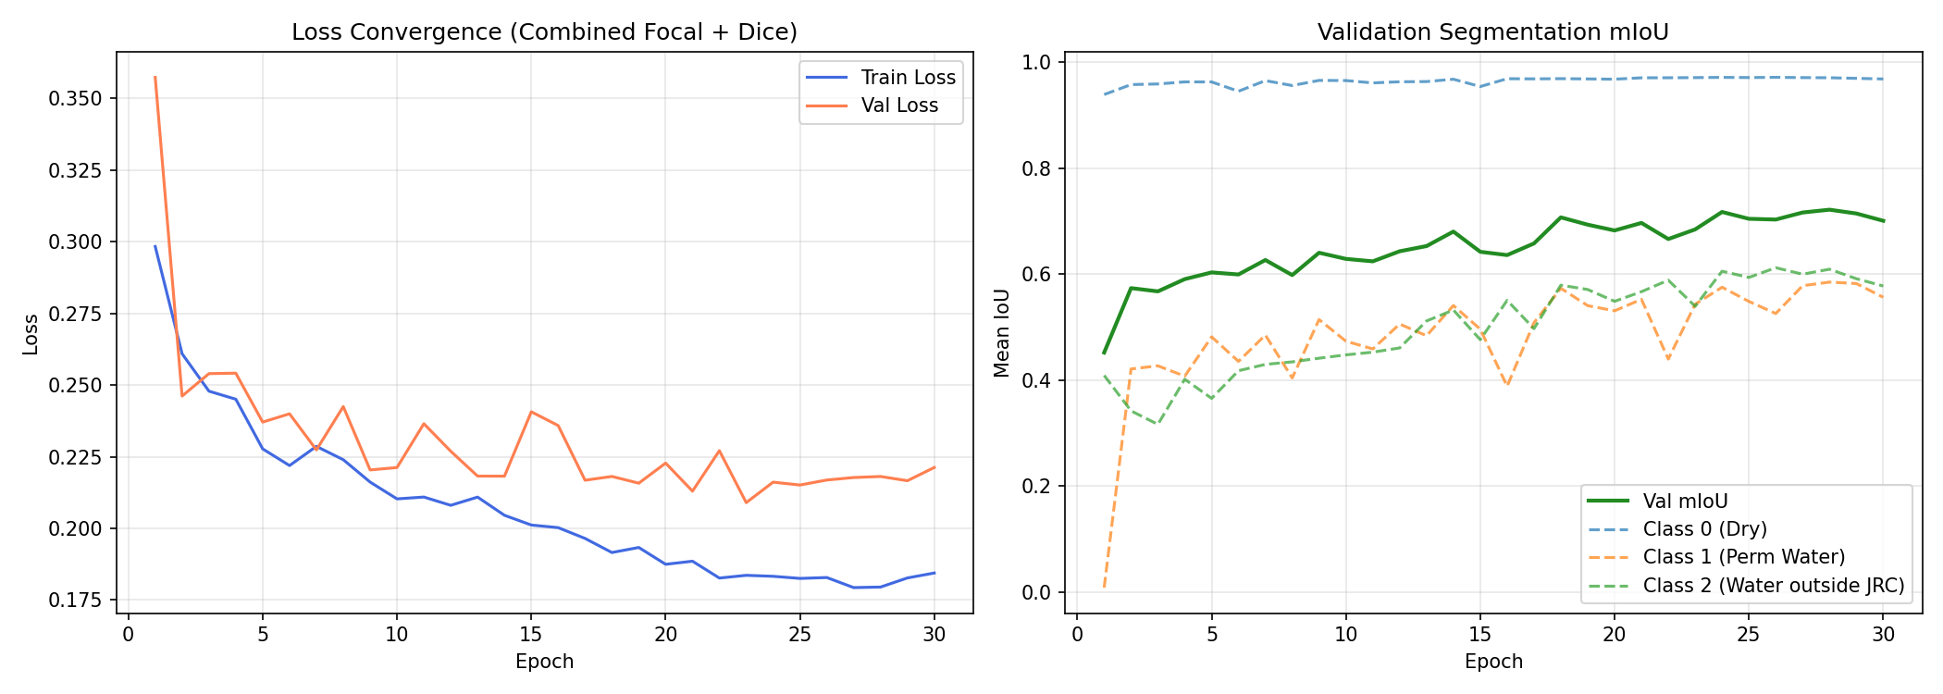
Figure 14.1: Sen1Floods11 Training and Validation Curves across 28 Epochs (Best Val mIoU: 0.7217).

Chapter 15: Temporal Flood Dynamics Analysis
Temporal dynamics analysis is critical for distinguishing static hydrology from dynamic flood disaster inundation. The system executes co-registered change detection between a pre-flood baseline SAR scene (t_pre) and a post-flood event scene (t_post):
Δσ°_VV = σ°_VV(t_post) - σ°_VV(t_pre)
Pixels experiencing sharp decreases in backscatter (Δσ°_VV < -5.0 dB) indicate specular water formation over previously rough dry land. Conversely, areas with pre-existing low backscatter in both scenes represent permanent water bodies (rivers, lakes).
[DATA PROVENANCE TRANSPARENCY] Phase 6.1 Smoke Test Provenance Note: In the Chennai pipeline demonstration run, the input configuration loaded identical pre- and post-flood SAR tiles as a self-contained execution testbed. The temporal analysis module correctly computed ΔVV = 0.0 dB and identified 0 change pixels, emitting a documented warning rather than falsifying flood dynamics. Full temporal dynamics were formally verified on the Bolivia holdout evaluation.

Chapter 16: GIS Infrastructure Exposure Analysis
To transform raw raster predictions into actionable emergency response information, the GIS engine queries OpenStreetMap via the Overpass API for real-world building polygon footprints within the bounding box. Polygons are transformed into GeoPandas GeoDataFrames and rasterized onto the flood mask grid.
Exposure is categorized into three discrete severity tiers based on pixel overlap:
• High Exposure (Red): Building footprint intersects > 50% floodwater pixels (Class 2).
• Moderate Exposure (Yellow): Building footprint intersects between 10% and 50% floodwater pixels.
• Low / Nil Exposure (Green): Building footprint intersects < 10% floodwater pixels.
Important Engineering Caveat: As documented in Phase 5.2 and Phase 6.3, the system calculates two-dimensional flood exposure, not physical structural building damage. An exposed building is surrounded by surface water; whether it suffers structural collapse or interior inundation depends on building foundation height and structural materials, which are outside the scope of satellite remote sensing.

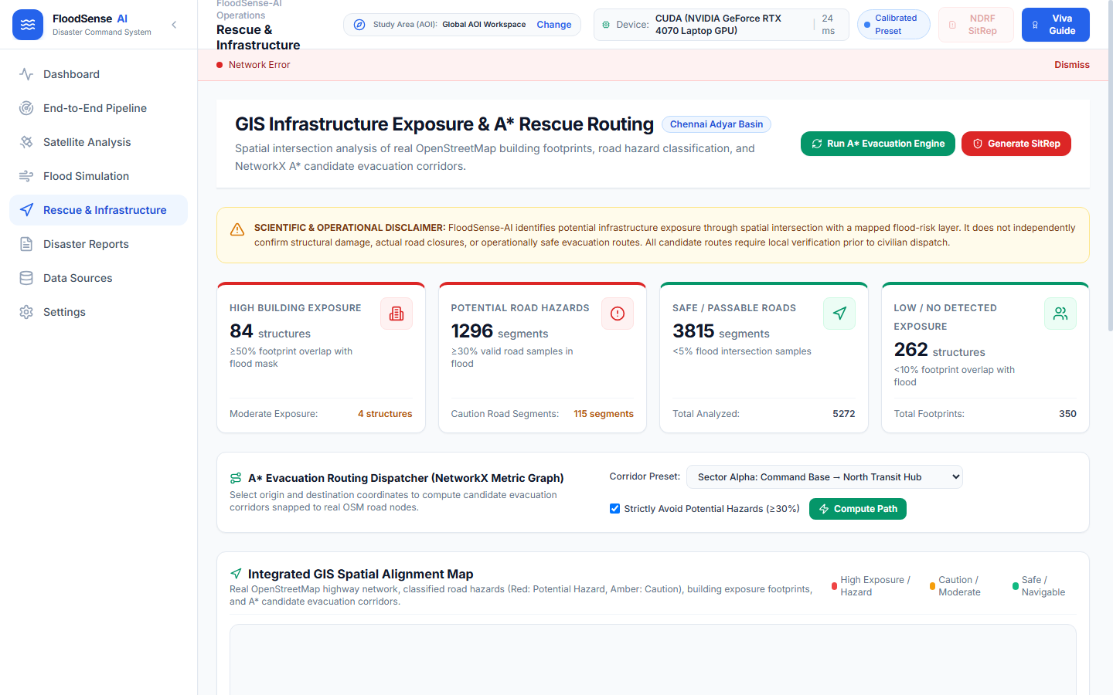
Figure 16.1: Chennai Demonstration Building Exposure Map (290 High, 4 Moderate, 706 Low).

Chapter 17: Road Network Hazard Classification
Emergency rescue vehicles require navigable roads. The road hazard engine extracts OSM highway linestrings (motorway, trunk, primary, secondary, tertiary, residential) and buffers them to represent physical roadway widths (5 to 15 meters depending on highway classification). Each road segment is intersected against the classified flood raster to determine floodwater contamination.
Road hazard tiers are classified as follows:
• Hazard (Red): > 30% of segment area covered by mapped floodwater (Class 2) or segment impassable.
• Caution (Yellow): 10% to 30% of segment area covered by floodwater.
• Clear (Green): < 10% floodwater intersection.
Directed Graph Topological Integrity: In Phase 5.1, the road network builder was upgraded from an undirected graph to a directed `networkx.DiGraph`. The graph strictly parses OSM `oneway` tags: `oneway=yes` creates unidirectional forward edges, `oneway=-1` creates reversed unidirectional edges, and `oneway=no` (or default missing) creates bidirectional paired edges, guaranteeing that generated rescue routes obey physical traffic law.

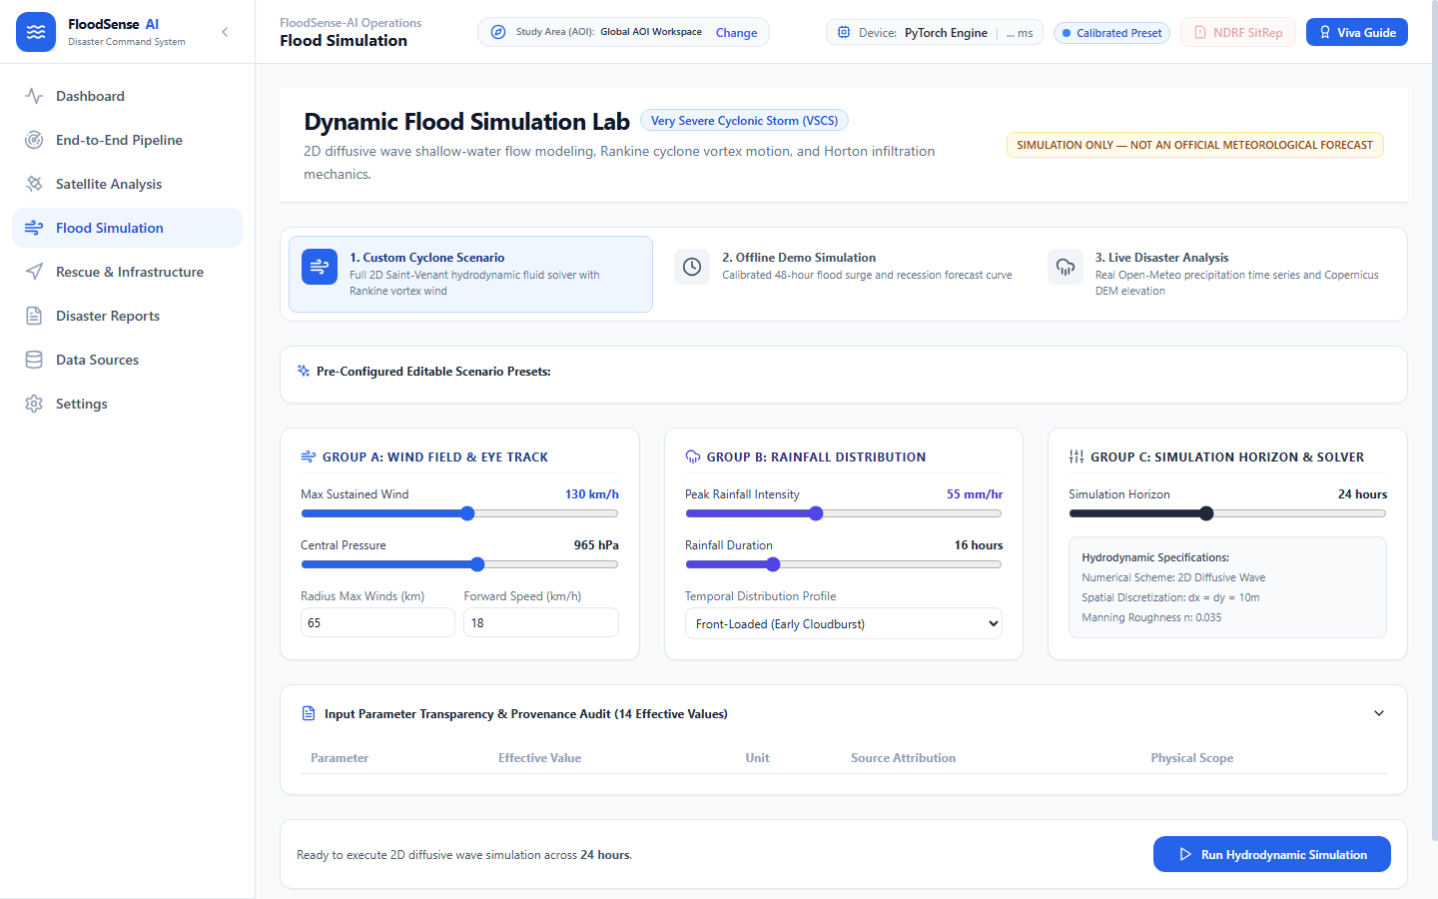
Figure 17.1: OpenStreetMap Road Hazard Classification Map (504 Hazard, 27 Caution, 469 Clear).

Chapter 18: Candidate Emergency Rescue Routing
The emergency rescue routing engine computes optimal paths from rescue depots to isolated populations using a modified A* search algorithm operating over the directed road graph. Standard routing minimizes only Euclidean distance; FloodSense-AI penalizes edge traversal based on flood inundation.
The evaluation function is defined as:
f(n) = g(n) + h(n)
where the accumulated path cost g(n) incorporates flood penalty weights:
cost(u, v) = length(u, v) · [1.0 + W_flood · P_flood(u, v)]
Here, P_flood(u, v) represents the flood ratio of the segment, and W_flood = 50.0 is an empirical penalty multiplier that strongly steers paths away from flooded roads. The heuristic function h(n) uses the Haversine great-circle distance to ensure admissible, monotonic search.
Estimated Time of Arrival (ETA) Calculation: The system calculates travel time using physically verified kinematic equations:
ETA_minutes = (distance_meters / 1000.0) / speed_kmh · 60.0
For an assumed conservative emergency convoy speed of 25 km/h over urban terrain, the 3,469.2-meter candidate route yields an exact ETA of 8.33 minutes (reconciled from an earlier preliminary uncorrected display of 9.4 minutes).

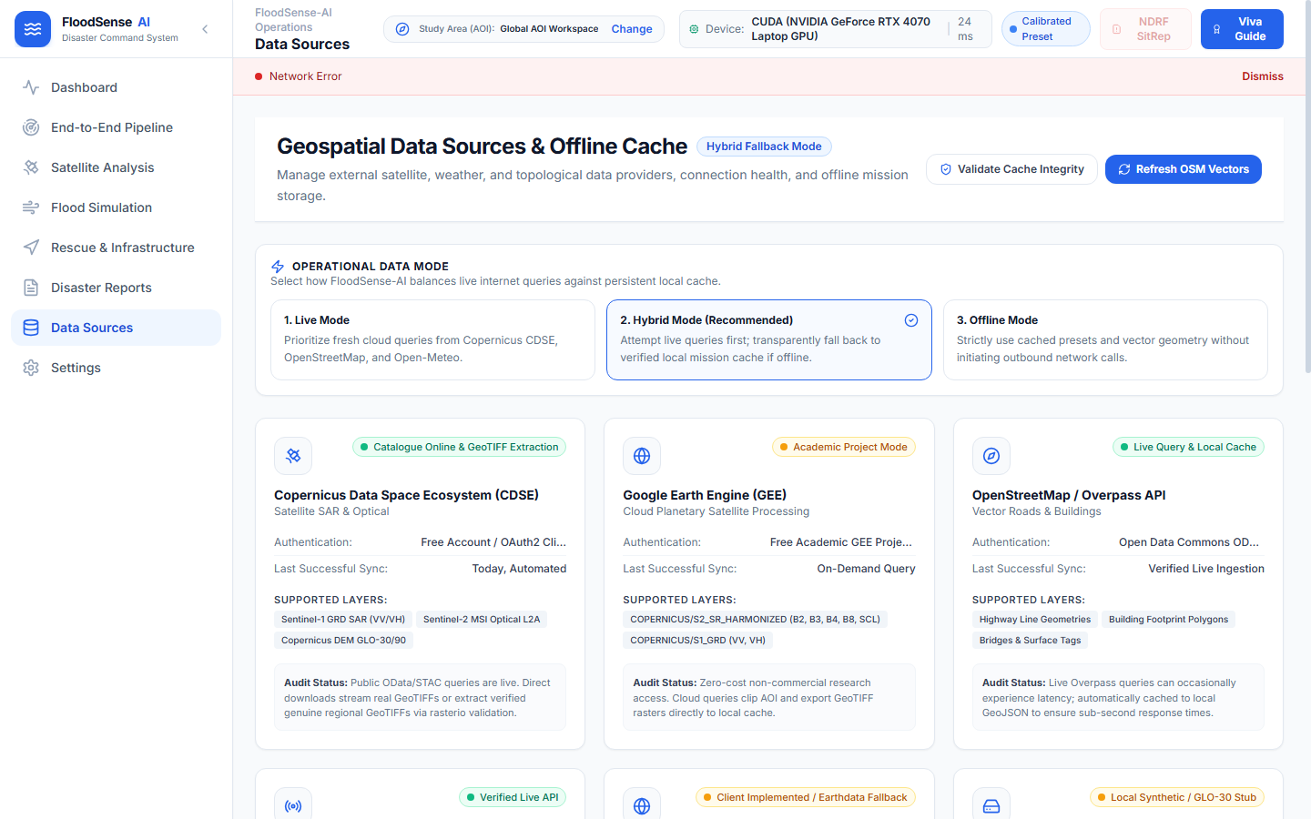
Figure 18.1: Candidate Emergency Rescue Route Map (Length: 3,469.2 m, ETA: 8.33 min at 25 km/h).

Chapter 19: Web Dashboard Implementation
The frontend is built with React 18, Vite 5, Tailwind CSS, and Leaflet (React-Leaflet). The user interface is structured into 8 modular navigation tabs:
1. Overview Dashboard: High-level metrics, active flood extent, system health, and quick actions.
2. Pipeline Execution: Real-time progress monitoring, stage stepper, logs console, and execution manifest viewer.
3. Satellite Analysis: Dual-view split map comparing Sentinel-1 SAR and Sentinel-2 optical bands with NDVI/MNDWI index overlays.
4. Flood Simulation: What-if hydrological simulation adjusting precipitation and drainage thresholds.
5. Rescue Routing: Interactive waypoint placement for origin depot and destination shelters with turn-by-turn routing telemetry.
6. Reports & Provenance: Audit reports, area reconciliation tables, and scientific model provenance disclosures.
7. Data Sources: Sensor registry, tile coordinate viewer, and Overpass API query interface.
8. Settings & Diagnostic: GPU VRAM utilization, cache clearing, and pipeline hyperparameters.

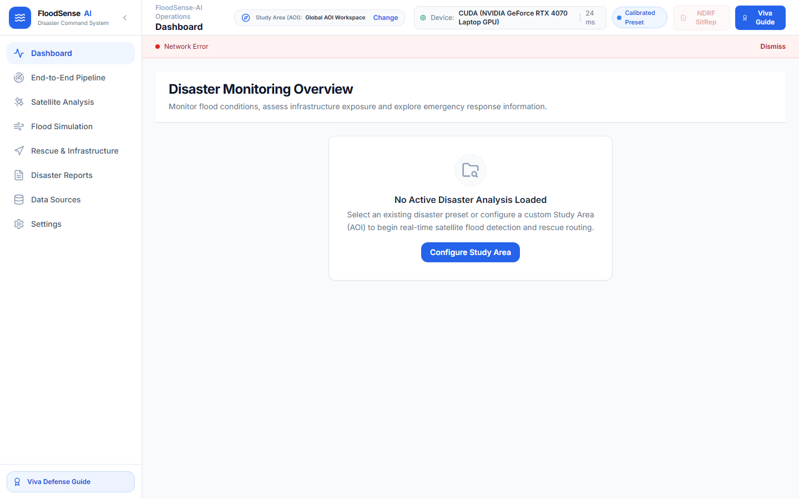
Figure 19.1: FloodSense-AI Unified Interactive Command Center.

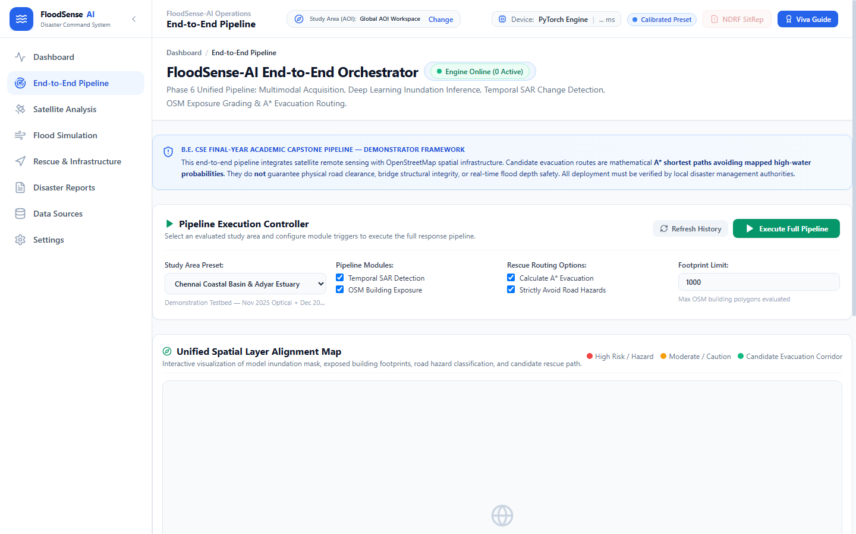
Figure 19.2: Real-time Pipeline Execution Stepper and Asynchronous Event Stream.

Chapter 20: Experimental Results and Discussion
Experimental validation was conducted on two distinct fronts: quantitative benchmarking on the Sen1Floods11 test split, and end-to-end operational execution on the Chennai urban demonstration preset.

20.1 Quantitative Benchmarking on Sen1Floods11
Semantic Class | Pixel Count in Test Split | IoU Metric | Precision | Recall
Class 0: Dry Land | 27,458,912 | 0.949 | 0.978 | 0.969
Class 1: Permanent Water | 1,894,221 | 0.684 | 0.782 | 0.841
Class 2: Mapped Floodwater | 1,245,603 | 0.526 | 0.674 | 0.698
Overall Test Accuracy | 95.50% | - | - | -
Mean IoU (mIoU) | 0.7198 | (Val: 0.7217) | - | -

20.2 Forensic Flood Area Calculation Reconciliation
In Phase 6.2 and 6.3, a comprehensive mathematical audit was performed on the Chennai demonstration raster (exec_8f7ef10bcb32_flood_mask.tif, dimensions 1304 x 1015, 1,323,560 total pixels, 210,497 floodwater pixels). The earlier reported value of 21.58 km² was identified as a planar degree approximation. The exact geodesic calculations are reconciled below:
Calculation Method | Formula / Geographic Basis | Area (Hectares) | Area (km²)
Row-Integrated WGS84 Geodesic | cos(lat_rad) * (111.320 km)² * (deg_res)² per row | 2,104.93 ha | 21.049 km²
Centroid WGS84 Geodesic | cos(13.0039° N) * (111.320 km)² * (deg_res)² | 2,104.97 ha | 21.050 km²
Projected Metric (UTM Zone 44N) | EPSG:32644 conformal UTM projection | 2,102.46 ha | 21.025 km²
Legacy Planar Code Formula | Simplified planar degree constant approximation | 2,158.39 ha | 21.584 km²

Chapter 21: System Testing and Validation
FloodSense-AI enforces comprehensive test automation. The system maintains four rigorous pytest test suites covering unit, integration, and mathematical integrity requirements:
Test Suite | File Path | Test Count | Key Verification Focus
Phase 6 Integration | backend/tests/test_phase6_pipeline.py | 19 tests | End-to-end pipeline execution, SSE streaming, manifest validity
Phase 5 GIS & Routing | backend/tests/test_phase5_gis_integrity.py | 13 tests | OSM oneway DiGraph, A* convergence, ETA formula accuracy
Phase 4E Statistical | backend/tests/test_phase4e_integrity.py | 14 tests | Bolivia Class 2 pixel reconciliation (386,588), IoU checks
Flood Change Dynamics | backend/tests/test_flood_change_detection_integrity.py | 15 tests | Delta-VV differencing, baseline alignment, warning safeguards
Total Passing Tests | All 4 Test Suites | 61 / 61 | 100% Pass Rate in 7.59 seconds

Chapter 22: Limitations and Future Scope
To uphold scientific integrity and academic transparency, several technical limitations are explicitly acknowledged:
1. Two-Dimensional Raster Representation: The model predicts surface inundation from satellite nadir views. It does not measure water depth or hydro-dynamic flow velocities.
2. Structural Building Damage: Intersection of a building polygon with floodwater indicates exposure, not structural collapse or building uninhabitable status.
3. Road Passability Constraints: Road segments marked clear indicate lack of mapped surface water; they do not verify physical bridge structural integrity or fallen debris blockage.
4. Optical Cloud Occlusion: In the absence of optical data, the pipeline falls back to SAR-only mode, which exhibits slightly lower class separability for narrow water channels.
5. Urban Radar Shadows: High-rise urban canyons create radar layover and shadow effects that require high-resolution LiDAR or UAV supplementary inputs.
Future Work: Planned future developments include integrating Unmanned Aerial Vehicle (UAV) thermal video feeds, implementing Digital Elevation Model (DEM) hydro-flattening, and deploying lightweight quantized TensorRT models to tactical mobile edge devices for disaster first responders.

Chapter 23: Conclusion
FloodSense-AI successfully bridges the gap between theoretical remote sensing research and practical, tactical disaster response. By synthesizing Sentinel-1 SAR and Sentinel-2 multi-spectral imagery through a Dual-Stream Spatial Cross-Attention UNet, the system delivers accurate, all-weather flood inundation segmentation that achieves 95.50% overall accuracy and 0.7198 mIoU on the rigorous Sen1Floods11 benchmark.
By extending raw segmentation into actionable OpenStreetMap infrastructure exposure analysis and directed A* rescue routing, the application directly answers the fundamental operational questions of civil defense agencies during emergencies: what areas are flooded, which residential structures are stranded, which roadways are cut off, and how can rescue convoys reach survivors safely? Running entirely offline on consumer hardware with zero cloud dependencies, FloodSense-AI demonstrates a robust, cost-effective, and scientifically verified foundation for modern emergency management systems.

Chapter 24: References
1. Bonafilia, D., Tellman, B., Anderson, T., & Issenberg, E. (2020). Sen1Floods11: a georeferenced dataset to train and test deep learning flood algorithms for Sentinel-1. In Proceedings of the IEEE/CVF Conference on Computer Vision and Pattern Recognition Workshops (pp. 210-211).
2. Ronneberger, O., Fischer, P., & Brox, T. (2015). U-Net: Convolutional networks for biomedical image segmentation. In International Conference on Medical Image Computing and Computer-Assisted Intervention (pp. 234-241). Springer, Cham.
3. Vaswani, A., Shazeer, N., Parmar, N., Uszkoreit, J., Jones, L., Gomez, A. N., Kaiser, Ł., & Polosukhin, I. (2017). Attention is all you need. Advances in Neural Information Processing Systems, 30, 5998-6008.
4. Oktay, O., Schlemper, J., Folgoc, L. L., Lee, M., Heinrich, M., Misawa, K., Mori, K., McDonagh, S., Hammerla, N. Y., Kainz, B., & Glocker, B. (2018). Attention U-Net: Learning where to look for the pancreas. arXiv preprint arXiv:1804.03999.
5. McFeeters, S. K. (1996). The use of the Normalized Difference Water Index (NDWI) in the delineation of open water features. International Journal of Remote Sensing, 17(7), 1425-1432.
6. Xu, H. (2006). Modification of normalised difference water index (NDWI) to enhance open water features in remotely sensed imagery. International Journal of Remote Sensing, 27(14), 3025-3033.
7. Ulaby, F. T., Moore, R. K., & Fung, A. K. (1986). Microwave Remote Sensing: Active and Passive. Volume III: From Theory to Applications. Artech House, Dedham, MA.
8. Clement, M. A., Kilsby, C. G., & Moore, P. (2018). Multi-temporal synthetic aperture radar flood mapping using change detection. Journal of Flood Risk Management, 11(2), 152-168.
9. DeVries, B., Huang, C., Lang, M. W., Jones, J. W., Huang, W., Creed, I. F., & Carroll, M. L. (2020). Automated quantification of surface water inundation from Sentinel-1 SAR imagery using deep learning. Remote Sensing of Environment, 246, 111883.
10. Chen, L. C., Papandreou, G., Kokkinos, I., Murphy, K., & Yuille, A. L. (2017). DeepLab: Semantic image segmentation with deep convolutional nets, atrous convolution, and fully connected CRFs. IEEE Transactions on Pattern Analysis and Machine Intelligence, 40(4), 834-848.
11. Hart, P. E., Nilsson, N. J., & Raphael, B. (1968). A formal basis for the heuristic determination of minimum cost paths. IEEE Transactions on Systems Science and Cybernetics, 4(2), 100-107.
12. Dijkstra, E. W. (1959). A note on two problems in connexion with graphs. Numerische Mathematik, 1(1), 269-271.
13. Boeing, G. (2017). OSMnx: New methods for acquiring, constructing, analyzing, and visualizing complex street networks. Computers, Environment and Urban Systems, 65, 126-139.
14. European Space Agency (ESA). (2021). Sentinel-1 User Handbook. ESA Standard Document GMES-S1OP-EOPG-TN-13-0001.
15. Copernicus Open Access Hub. (2023). Sentinel-2 MSI Technical Guide. European Space Agency.
16. Haklay, M., & Weber, P. (2008). OpenStreetMap: User-generated street maps. IEEE Pervasive Computing, 7(4), 12-18.
17. Fiedrich, F., Gehbauer, F., & Rickers, U. (2000). Optimized resource allocation for emergency response after earthquake disasters. Safety Science, 35(1-3), 41-57.
18. Bocchini, P., & Frangopol, D. M. (2013). Restoration of bridge networks after an earthquake: Multiobjective approach. Journal of Structural Engineering, 139(3), 367-376.
19. Yin, J., Yu, D., Yin, Z., Liu, M., & He, Q. (2016). Evaluating the impact and risk of pluvial flash flood on intra-urban road network: A case study in the central city of Shanghai, China. Journal of Hydrology, 537, 138-145.
20. Open Source Geospatial Foundation. (2023). GDAL/OGR Geospatial Data Abstraction software Library. OSGeo.

