**Species Distribution Model present and predicted of *Ensete ventricosum***

Vicky Beckers s1534629

**Introduction**

*Ensete ventricosum* is a banana-like plant that is, just as the banana (*Musa sp.)*, part of the Musaceae family. The order to which the Musaceae belong is the Zingiberales. This order of monocots also consists of the ginger family (Zingiberaceae)and the bird of paradise plant (Strelitziaceae). The genus of *Ensete* has 7-8 species. 4 species occur in Africa and 3-4 (dependent of what classification you use) are found in Asia. For this report, only the most widely cultivated *Ensete ventricosum* is used.

The *Ensete ventricosum* fruit is rich in carbohydrates and is widely cultivated, but the most yield it gets in Africa. Not only the fruit is eaten, the corm is used as well to make pancake-like food or porridge. Besides food, some of the plant’s tissue is used for medicinal use (Holscher and Schneider 1998) and a type of starch coming from enset plants can be used to make paper and textile (ESTC 2003) The plant is especially cultivated in Ethiopia, where 15 million Ethiopians cultivate and eat or use the products of *Ensete ventricosum* (Spring, 1996)*.*

This versatile crop is considered a sustainable way of agriculture in Africa because it can deal with brief droughts and it can be harvested on different moments of the year at different growth stages. This way, Enset products are a way of dealing with seasonal food shortage and helps providing a secure food production in Africa (Diro and Staden 2004).

**Methodology**

*Raw data and R*

The data has been downloaded from GBIF.org. In the downloaded data from GBIF, a couple of Musa species were found. These have been taken out of the dataset, resulting in 120 observations of *Ensete ventricosum*.

Next bioclimatic variables were downloaded from WorldClim. Data of present situation (1960-1990) were downloaded with a resolution of 5 minutes. Bioclimatic variables data of the future situation in 2050 was downloaded from climatic model HadGEM2-AO at a representative concentration pathway (rcp) of 45.

In R the bioclim rasters were stacked and with Spearman’s correlation test (with threshold of 0.7) correlations between 19 bioclimatic rasters were given. The bioclim variables that did not show correlation at a threshold of 0.7 were: bioclim2 (mean diurnal range), bioclim5 (maximum temperature of warmest month), bioclim7 (Temperature annual range), bioclim8 (mean temperature of wettest quarter), bioclim9 (mean temperature of driest quarter), bioclim18 (precipitation of warmest quarter) and bioclim19 (precipitation of coldest quarter. The interpretation of these variables will be discussed in ‘Biological interpretation’.

The bioclimatic variables mentioned above were used to make present and future species distribution models in MaxEnt.

*MaxEnt*

In previous steps, in R different layers were made from the bioclimatic variable raster: a present climate layer, a future climate layer and a training climate layer. The ‘ClimatePresent’ and ‘ClimateFuture’ layers were used as projection layers. ‘ClimateTraining’ was the environmental layer to which the projection layers were set. The occurrences of *Ensete ventricosum* (with spatial data) was used as input.

‘Remove duplicate presence records’ was set in settings, ‘random test percentage’ was set to zero and ‘maximum number of background points’ was set to 10,000 (which is way over the 120 observations on GBIF).

**Model output**

*MaxEnt*

The output AUC (Area Under the Curve) is 0.933. a AUC above 0.8 is considered good since the data is better at predicting the model than a random (AUC of 0.5) model fit.

A logistic threshold of 0.322 at description ‘Maximum training sensitivity plus specificity’ was used for further analysis with R. The output of MaxEnt also gives the relative contribution of each variable when making the model. For *Ensete ventricosum* bioclim7 (temperature annual range) and bioclim9 (Mean temperature of driest quarter were most relevant (see table 1).

*Table 1: contribution of each bioclimatic variable to species distribution model in MaxEnt.*

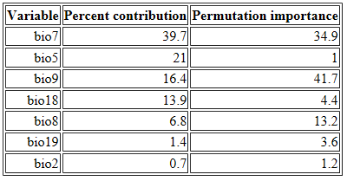

*Continuing in R*

When clipped to the used training area, the present occurrence of *Ensete ventricosum* was smaller than the total range. This has to do with the range at which *E. ventricosum* individuals were found. The training set only takes into account the range of latitude and longitude between which observations have been done. The figures that are shown from now onwards will only show the unclipped area (except for the last figure), since this gives an interesting view on the SDM of *Ensete ventricosum*.

Figure 1 shows the present SDM of *Ensete ventricosum*, whereas figure 2 shows the future SDM (at 2050) of *E. ventricosum*. What is surprising is that Europe has an excellent climate (with only a limited amount of climate variables) for *Ensete ventricosum*. Interpretation will be given at ‘Biological interpretation’.

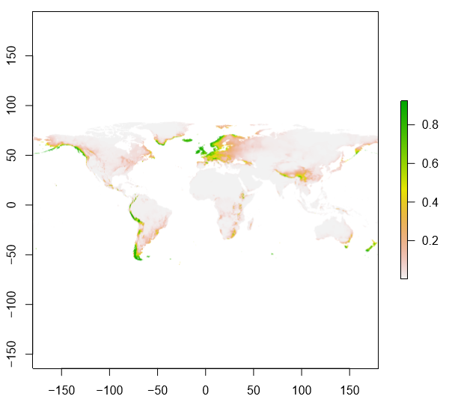

*Figure 1: chance of occurrence of Ensete ventricosum according to MaxEnt SDM output*

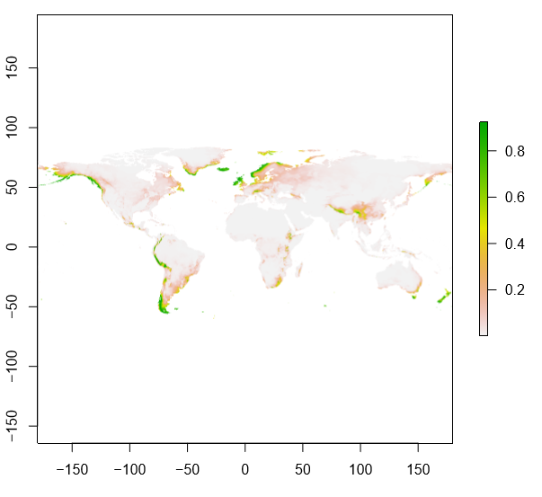

*Figure 2: change of occurrence of Ensete ventricosum in 2050.*

**Response to future scenario**

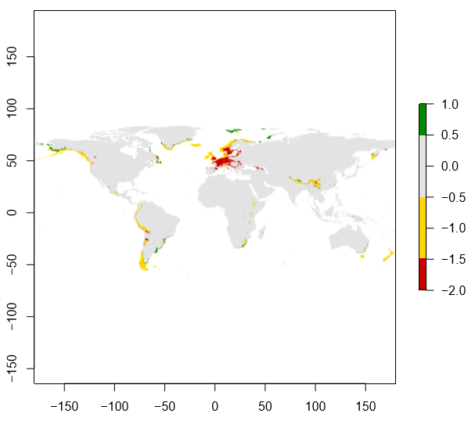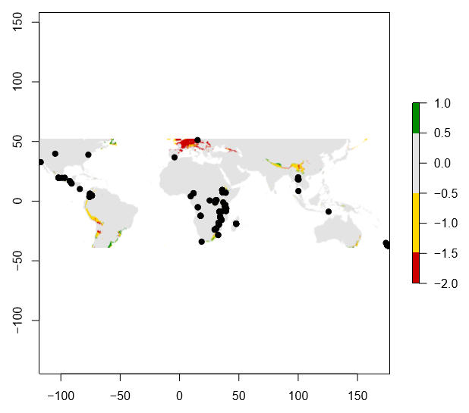Figure 3 shows the change in occurrence between present and future. The picture on the right is also given because the current observed occurrences (black dots) differ much from the predicted occurrence. Climate change will have a great effect on the future occurrence of *Ensete ventricosum*.

*Figure 3: left) response of Ensete ventricosum to future climatic conditions. Right) response of Ensete ventricosum to future climatic conditions to clipped data with current observations of E. ventricosum (black dots).*

**Biological interpretation**

There are multiple reasons why the results of the SDM’s is not trustworthy for *Ensete* ventricosum.

One, although the AUC with the output of MaxEnt is high, the few occurrences of *Ensete ventricosum* in Europe were very influential when making future predictions of where the *Ensete ventricosum* might thrive based on the seven, non-correlated climatic conditions given by WorldClim. Because of the very influential observations in Europe, I deem the future suitable places for *Ensete ventricosum* not trustworthy.

Two, a few climatic conditions were selected based on correlation with other climatic conditions. All of the conditions have to do with precipitation and temperate. These two aspects of the climatic conditions are often linked so I find it difficult to believe that there are variables that are not correlated. For example bioclim7 (temperature annual range: it is said to be not correlated but it is calculated with bioclim5 and 6.

Three, only looking at these climatic conditions will not suffice when making a proper species distribution model. Variables such as soil type, fungus interaction, predation, salinity level, etc. are also highly influential.

Four, *Ensete ventricosum* is a tropical plant and it needs a lot of sunlight and a high temperature. Just because the Enset can deal with brief droughts does not mean it will get through European winters. As shown in the present and future models, Norway apparently has very suitable climatic conditions for *Ensete ventricosum*.

However, since *Ensete ventricosum* is highly cultivated, it would not be strange that when the climate in Europe changes, *Ensete ventricosum* will be planted and used for agriculture. On the other hand, a natural spread in 2050 of *Ensete ventricosum* to Sweden is a bit strange. Considering that it took the conifers roughly 10,000 years after the last ice age to spread all the way to the north of Scandinavia, I think it is safe to say that the *Ensete ventricosum* will not die out as quickly as the SDM’s would like us to believe.

**Reference**

Spring A (1996) ‘Enset farming system in Southern Region, Ethiopia. Report on a rapid rural appraisal in Gurage, Hadiya and Sidama Zones’. Enset Need Assessment Project Phase I, Awasa, Ethiopia

ESTC (Ethiopian Science and Technology Commission) (2003) Commission awards individuals for outstanding achievements. Available at: http://www.capitalethiopia.com/archive/2003/july/ week3/index.htm

Holscher and Schneider 1998: so sorry, no further reference found in the article of Diro en van Staden

Diro M and van Staden J (2004). ‘Propagation of *Ensete in vitro*: a review’. *South African journal of botany* 70(4):497-501.