Name:- Vicky Dattu Bhoye
Roll No:- 04
Student Id:- 5135875
College:- B K BIRLA COLLEGE
Subject:- Data Engineering (Practical No :- 03)

Aim:
To perform single and multiple document insertion and retrieval using MongoDB shell (mongosh).

Step 1: Insert Single Document Query:
db.items.insertOne({ name: "laptop", price: 999 });

Output:
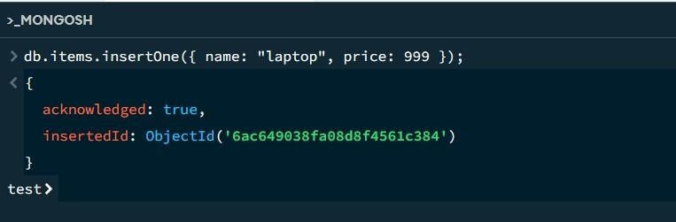

Step 2: View Inserted Document Query:
db.items.find();

Output:
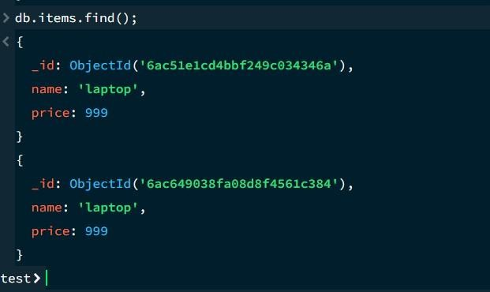

Step 3: Insert Multiple Documents Query: db.products.insertMany([
{ name: "phone", price: 500, stock: 10 },
{ name: "tablet", price: 300, stock: 5 },
{ name: "watch", price: 150, stock: 0 }
]);

Output:
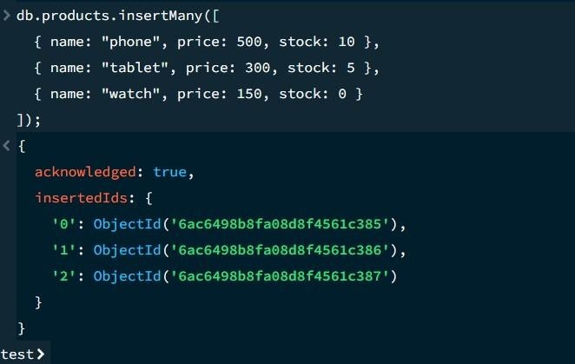

Step 4: View Products in Formatted JSON Query:
db.products.find().pretty();

Output:
