1. Amazon S3 (Simple Storage Service)
• Use Case:
- Object storage service for storing and retrieving any amount of data,
- ideal for backups, archives, big data analytics, and web hosting.
• Features:
- Scalable and highly durable (11 nines of durability).
- Supports versioning, lifecycle policies, and cross-region replication.
- Offers different storage classes (e.g., S3 Standard, S3 Intelligent-Tiering, S3 Glacier).

Creating an S3 Bucket Using the AWS Management Console
- Login to AWS Management Console:
  - Go to the AWS Management Console.
  - Sign in with your AWS credentials.
- Navigate to S3:
  - In the "Services" menu, search for "S3" and select it.
- Create a New Bucket:
  - Click on the "Create bucket" button.
- Configure Bucket Settings:
  - Bucket Name: Enter a unique name for your bucket (bucket names must be globally unique across all AWS accounts).
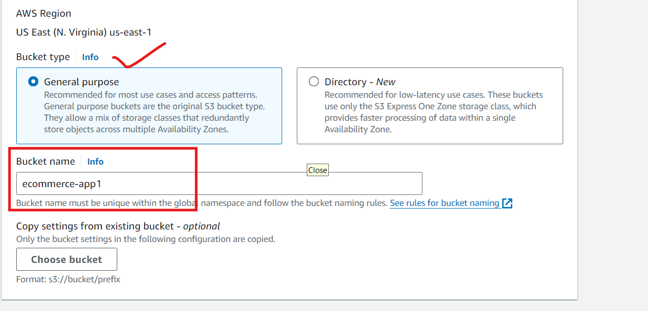
  - Region: Choose the AWS region where you want the bucket to reside. Selecting a region close to your users or applications can improve performance and reduce latency.
  - Object Ownership: Choose whether the bucket owner will control all objects (recommended for new buckets) or if it allows objects to be owned by other AWS accounts.
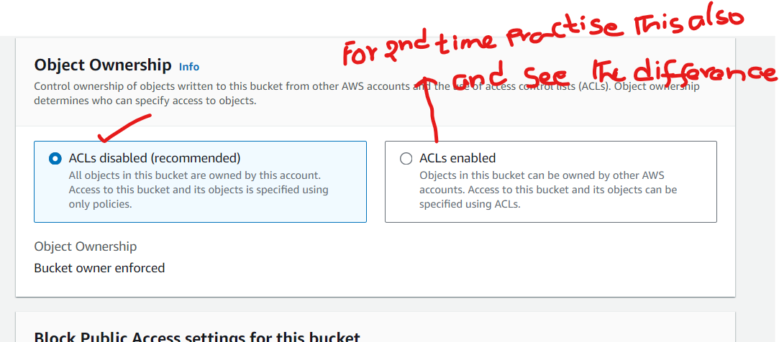
- Block Public Access Settings:
  - You can choose to block all public access (recommended for most use cases). If you want your bucket to be publicly accessible, you can modify these settings accordingly.
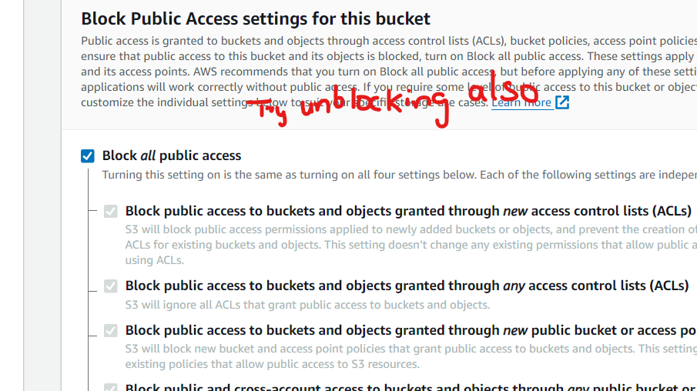
- Bucket Versioning (Optional):
  - Enable versioning if you want to keep multiple versions of objects in the bucket. This can be useful for data protection and recovery.
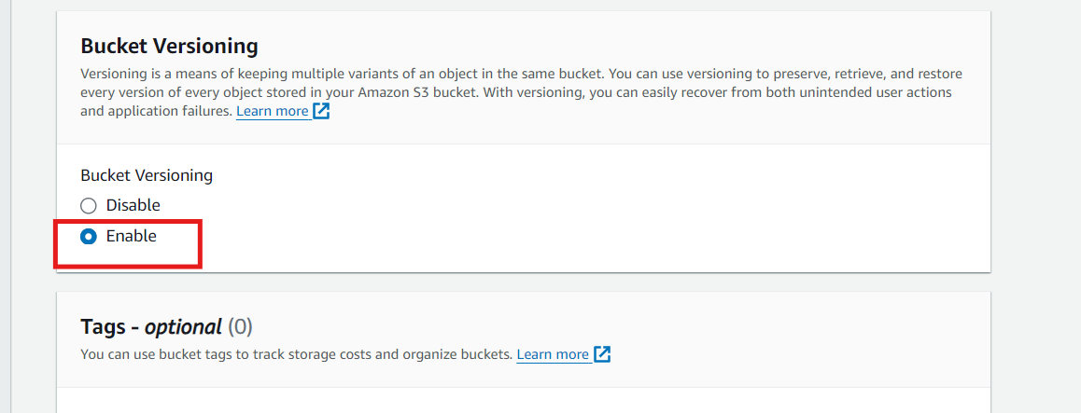
- Tags (Optional):
  - Add tags to categorize and organize your bucket resources.
- Default Encryption (Optional):
  - Enable server-side encryption to automatically encrypt objects when they are stored in S3.
- Advanced Settings (Optional):
  - You can configure additional settings like Object Lock, which helps protect objects from being deleted or overwritten.
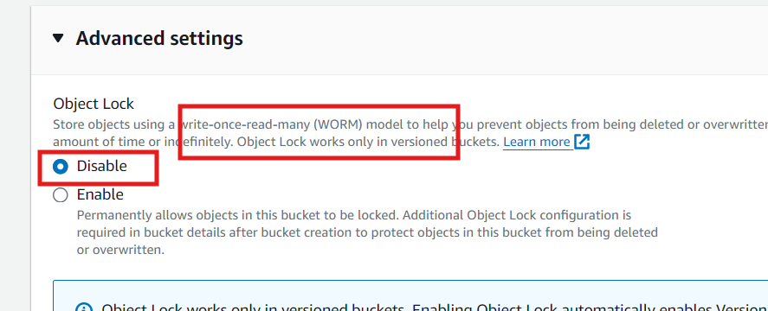
- Create the Bucket:
  - Review your settings and click "Create bucket" to finalize.

Upload Files and Folders to the S3 Bucket
- Navigate to Your S3 Bucket:
  - Go to the S3 service in the AWS Management Console.
  - Click on the bucket you created.
- Upload Files and Folders:
  - Click on the “Upload” button.
  - In the upload window, you can drag and drop files or click on the “Add files” or “Add folder” button to select the files and folders from your local machine.
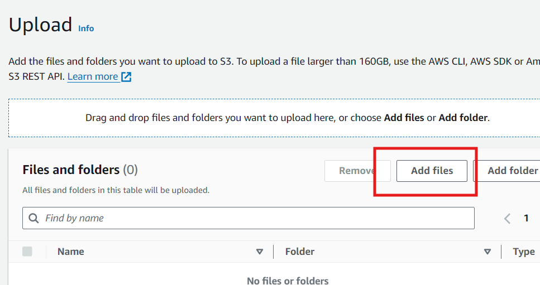

  - After selecting the files, click “Next.”
- Set Permissions:
  - By default, S3 blocks all public access to the bucket. To make the files publicly accessible:
    - Click on “Manage public permissions.”
    - Select “Grant public read access to this object(s).”
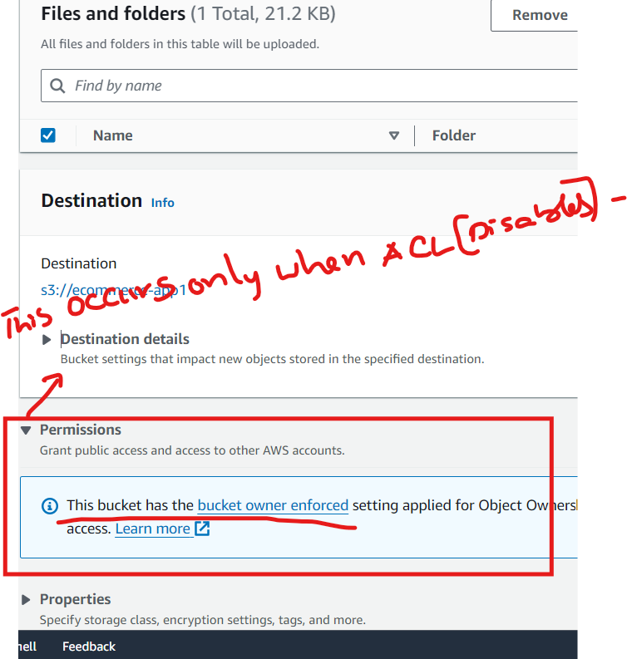

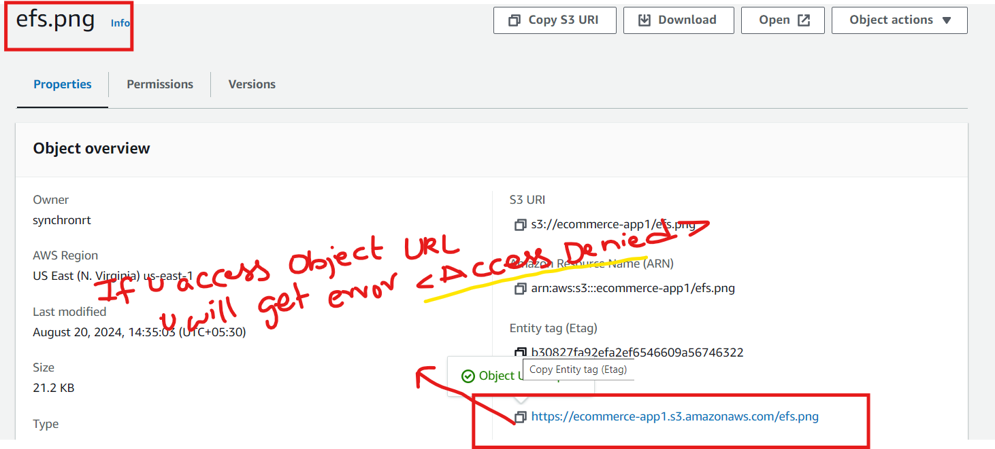
  - Click “Next” to review and confirm your settings.

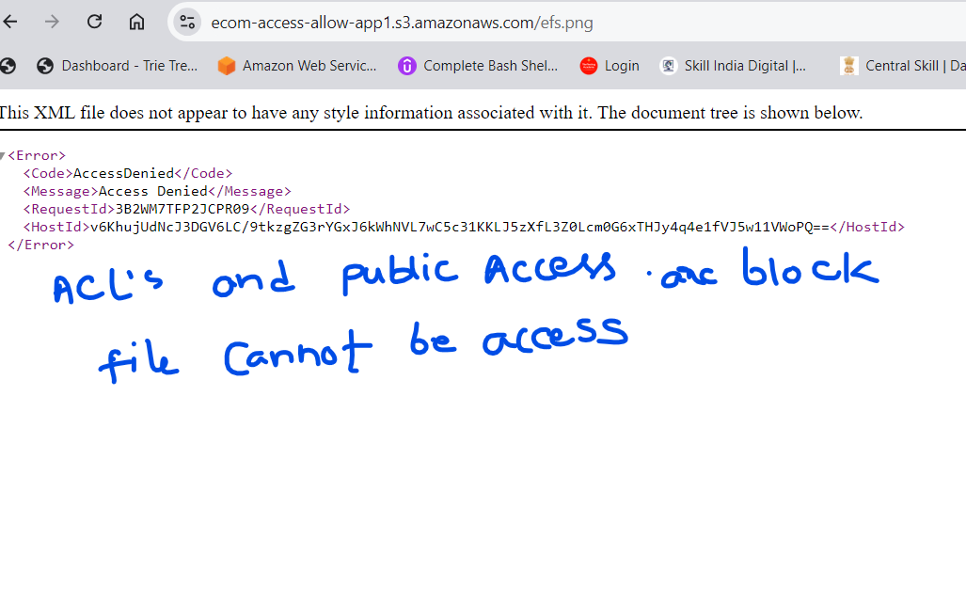
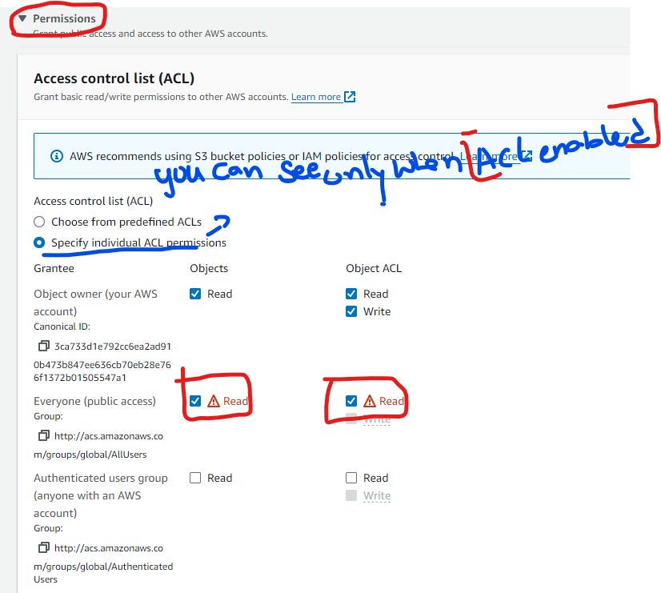
- Storage Class:
  - Choose the appropriate storage class based on your needs (e.g., S3 Standard for frequently accessed files).
  - Click “Next” and then “Upload” to complete the process.
Copy the URL and hit URL in the browser
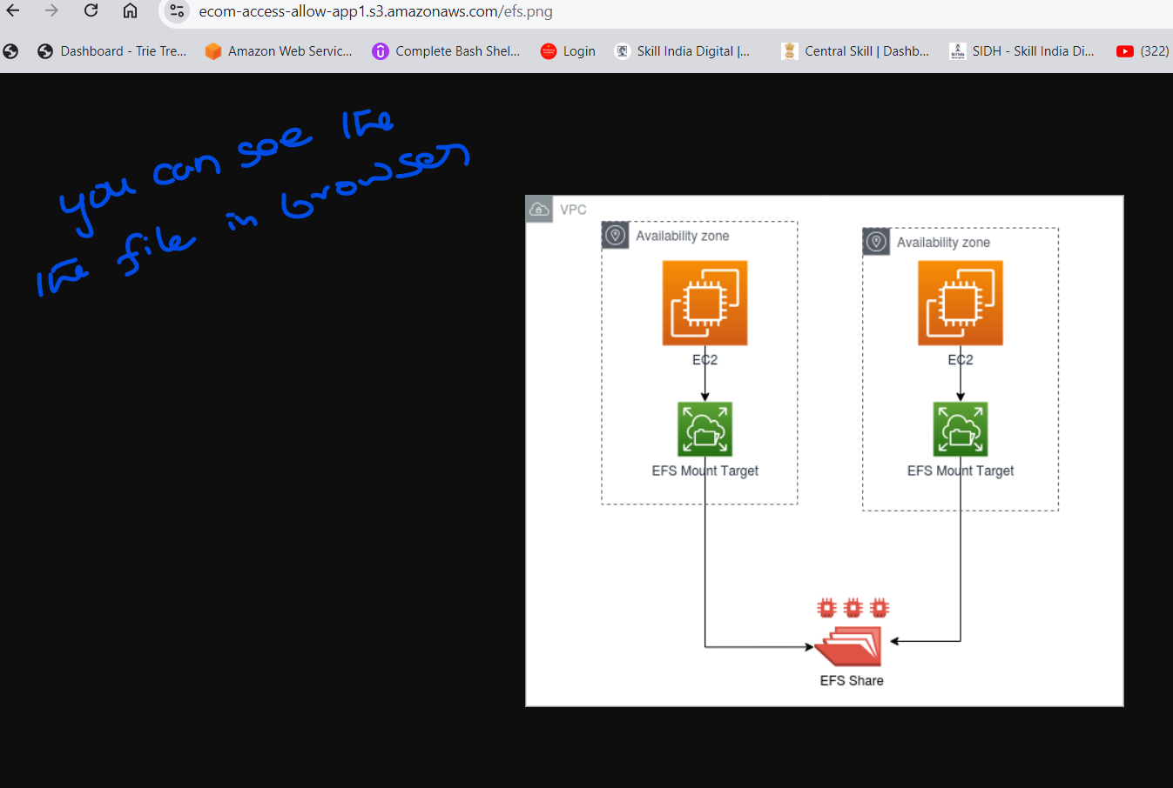

S3 Storage Classes Explained
Amazon S3 offers several storage classes, each designed for different use cases and cost requirements:
- S3 Standard:
  - Use Case: Frequently accessed data.
  - Features: High durability, availability, and low latency. Designed for data that requires immediate access.
  - Cost: The highest cost per GB but optimized for performance.
- S3 Intelligent-Tiering:
  - Use Case: Data with unpredictable access patterns.
  - Features: Automatically moves data between two access tiers (frequent and infrequent) based on changing access patterns, optimizing costs.
  - Cost: Slightly higher than S3 Standard when frequently accessed but lower for infrequent access.
- S3 Standard-IA (Infrequent Access):
  - Use Case: Data that is accessed less frequently but requires rapid access when needed.
  - Features: Lower storage cost compared to S3 Standard but higher retrieval costs. Ideal for backups and long-term storage of less frequently accessed data.
  - Cost: Lower storage cost with a per-GB retrieval fee.
- S3 One Zone-IA:
  - Use Case: Infrequently accessed data that doesn’t require the resilience of being stored across multiple availability zones.
  - Features: Lower cost than S3 Standard-IA but only stored in one availability zone, so it's less durable in the event of an AZ failure.
  - Cost: Even lower than Standard-IA but with less durability.
- S3 Glacier:
  - Use Case: Archival data that is rarely accessed and requires flexible retrieval times, ranging from minutes to hours.
  - Features: Very low-cost storage designed for long-term data archiving. Retrieval can take minutes to hours depending on the retrieval option selected.
  - Cost: Very low storage cost, but retrieval incurs additional costs based on retrieval time (expedited, standard, or bulk).
- S3 Glacier Deep Archive:
  - Use Case: Long-term data archiving with retrieval times in hours (typically 12 hours).
  - Features: The lowest-cost storage option available in S3. Retrieval times are longer, making it suitable for data that is rarely accessed and can withstand retrieval delays.
  - Cost: The lowest cost per GB, with higher retrieval costs and longer retrieval times.
- S3 Outposts:
  - Use Case: Storing S3 data on-premises using AWS Outposts.
  - Features: For workloads that require local data storage on AWS-managed infrastructure at on-premises locations.
  - Cost: Similar to S3 Standard, but designed for specific on-premises use cases.

Amazon Elastic Block Store (EBS):
- Use Cases:
  - High-performance databases: EBS is ideal for applications that require consistent, low-latency block storage, such as relational (e.g., MySQL, PostgreSQL) and NoSQL databases (e.g., MongoDB).
  - Transactional workloads: Applications that need to process high I/O operations per second (IOPS), like financial transaction systems.
  - Boot volumes for EC2 instances: EBS can be used as the root volume for an EC2 instance, storing the operating system and application data.
  - Data warehousing and Big Data analytics: When dealing with structured data that needs high throughput and low latency.
- Suitable Applications:
  - Relational databases (e.g., MySQL, Oracle)
  - NoSQL databases (e.g., Cassandra, MongoDB)
  - Enterprise applications (e.g., SAP, Microsoft Exchange)
  - Data warehousing solutions (e.g., Amazon Redshift)
2. Amazon Elastic File System (EFS):
- Use Cases:
  - Shared file storage: EFS is perfect for applications that require a common file system to be accessible by multiple EC2 instances simultaneously, such as content management systems.
  - Big Data and analytics: EFS can handle a large volume of data and can scale as data grows, making it suitable for processing large datasets.
  - Content management and web serving: Applications that need to store and serve content, such as media files, across multiple servers.
  - Container storage: EFS can be used to persist data for containerized applications in services like Amazon ECS or Kubernetes.
- Suitable Applications:
  - Content management systems (e.g., WordPress, Joomla)
  - Media processing (e.g., video rendering, image processing)
  - Web server farms (e.g., hosting web applications across multiple EC2 instances)
  - DevOps tools requiring shared storage (e.g., CI/CD pipelines)
3. Amazon Simple Storage Service (S3):
- Use Cases:
  - Backup and disaster recovery: S3 is widely used for storing backups due to its durability and scalability.
  - Data lakes and big data analytics: S3 can store vast amounts of unstructured data, making it ideal for big data applications and machine learning.
  - Content distribution: With integration to services like CloudFront, S3 is used to distribute content globally.
  - Static website hosting: S3 can host static websites, serving HTML, CSS, and JavaScript files directly from the bucket.
  - Archiving: S3's various storage classes, including S3 Glacier, are perfect for long-term archival of data.
- Suitable Applications:
  - Static website hosting
  - Media storage and distribution (e.g., videos, images, backups)
  - Big data storage (e.g., data lakes, analytics)
  - Backup and archiving solutions

