Project order

1. ACM amazon certificate manager - SSL

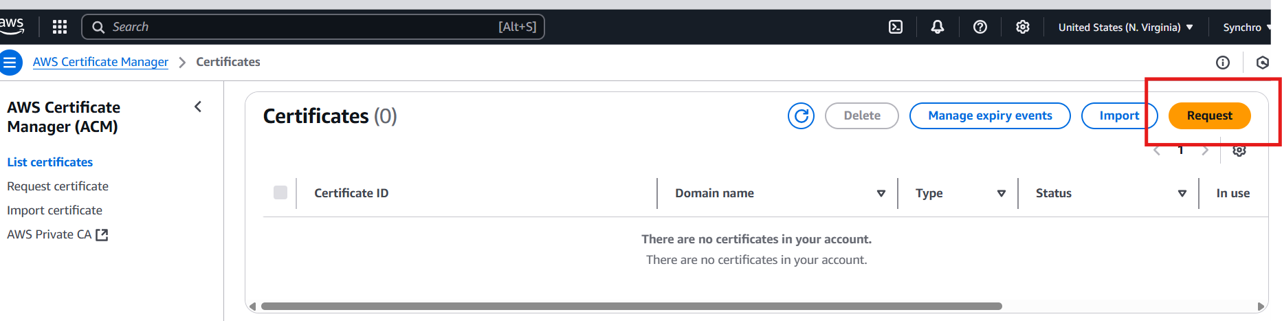

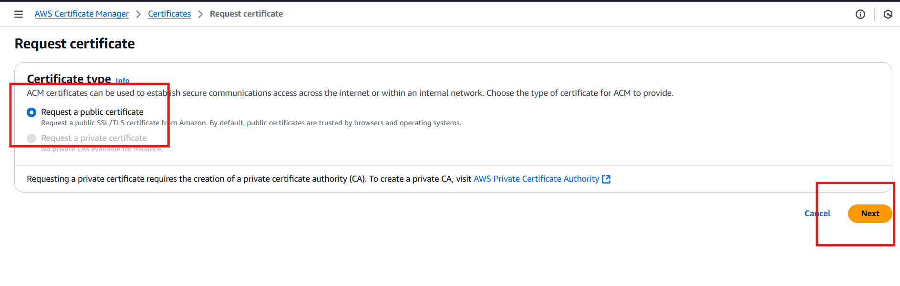

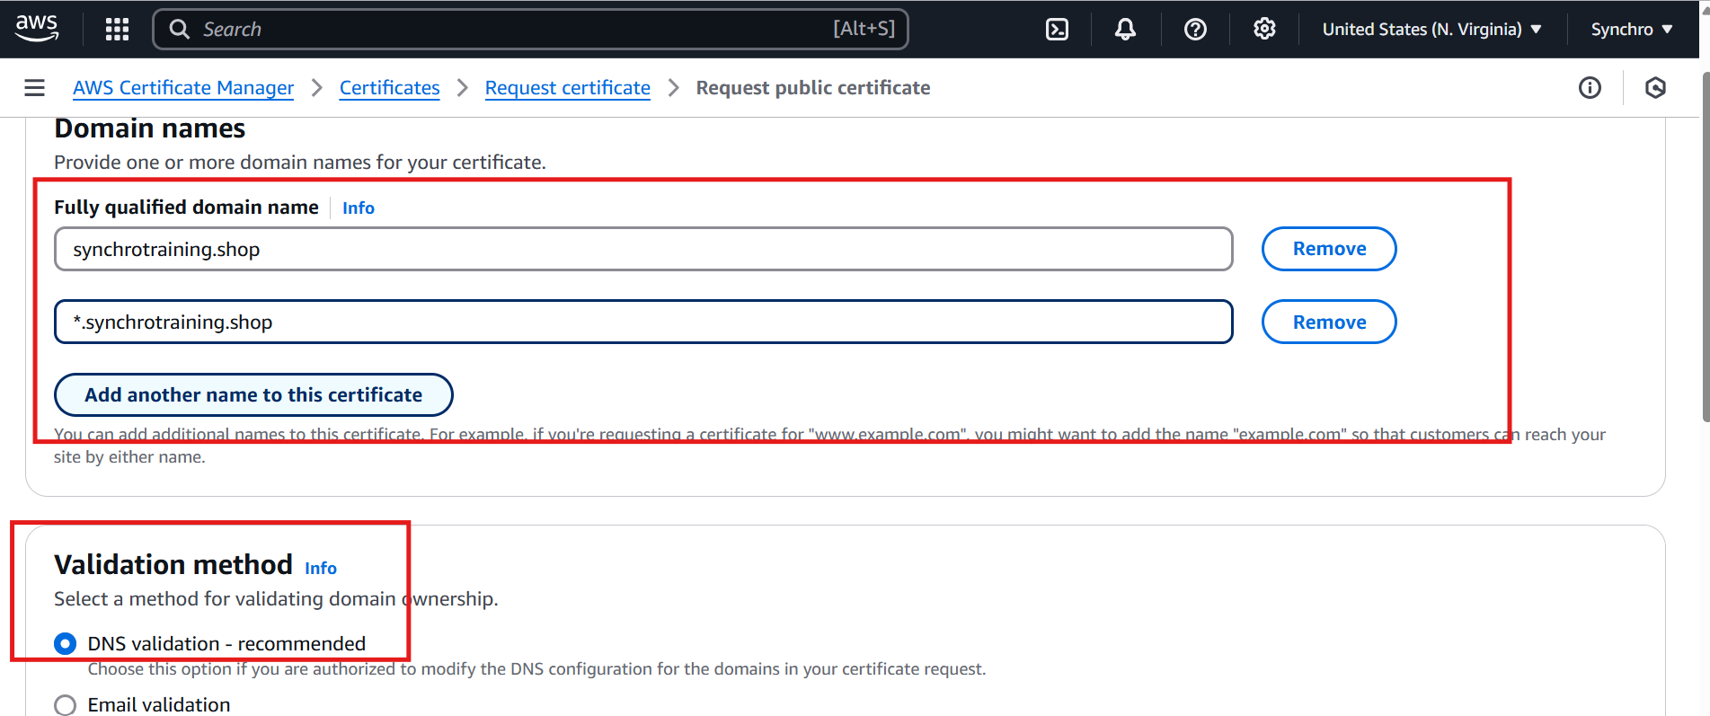

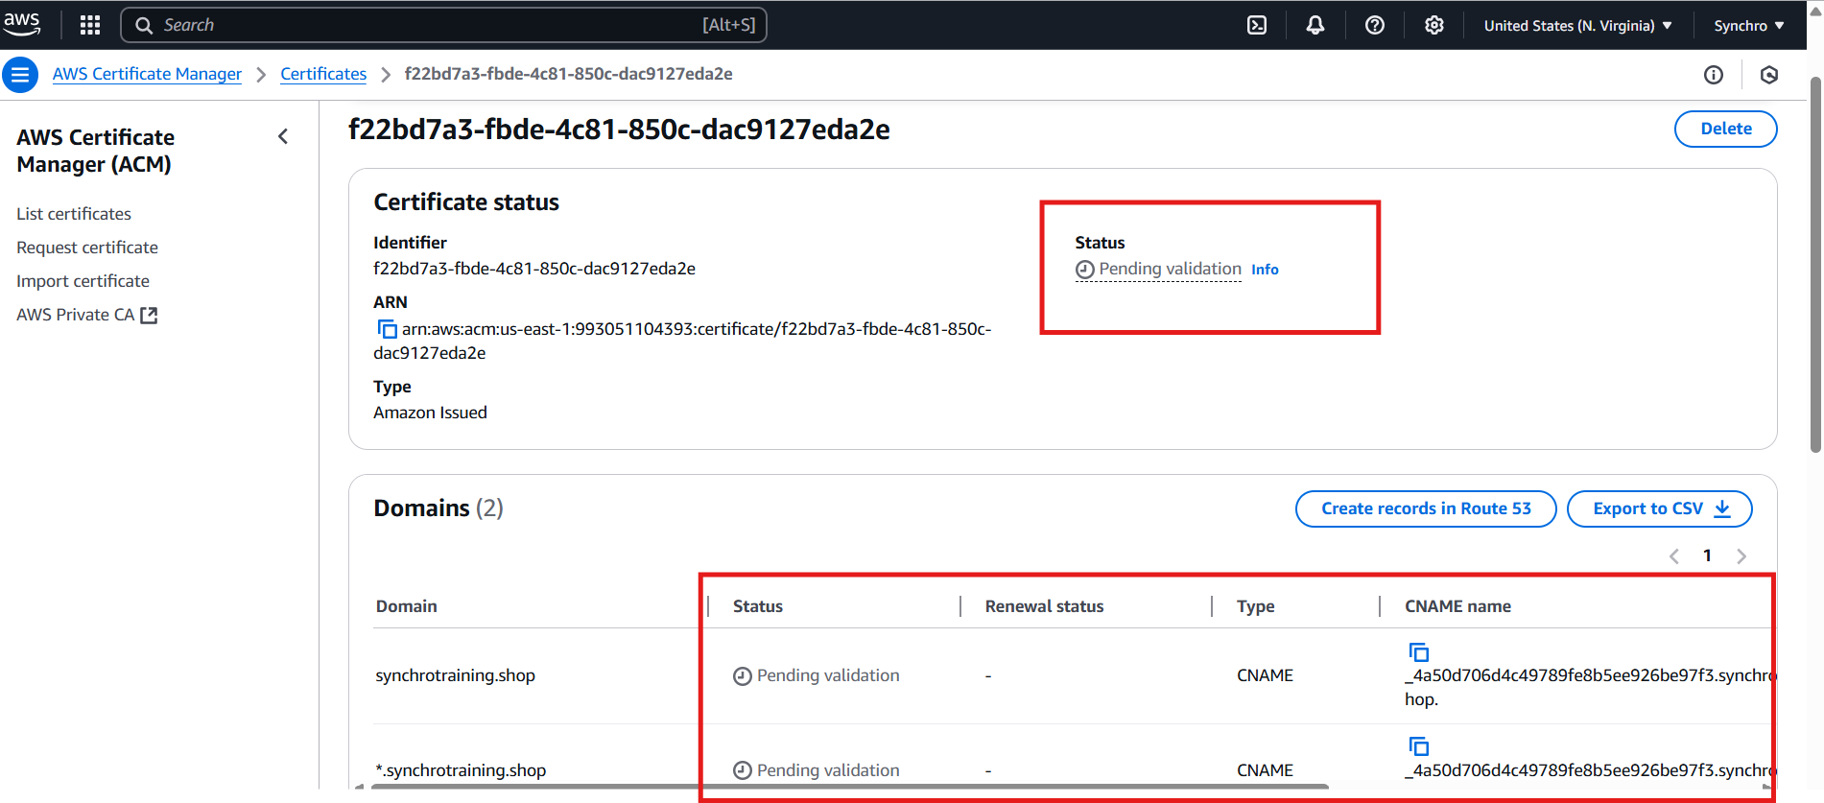

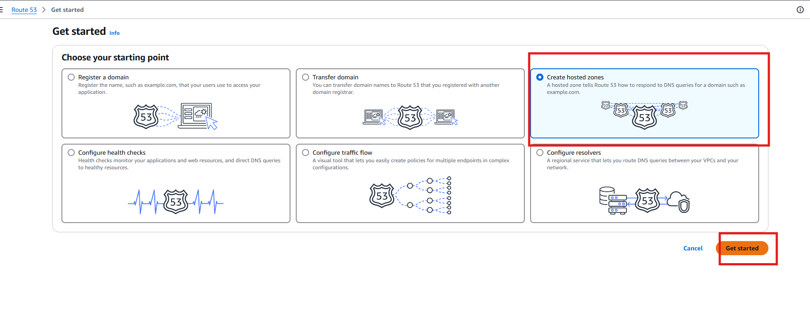

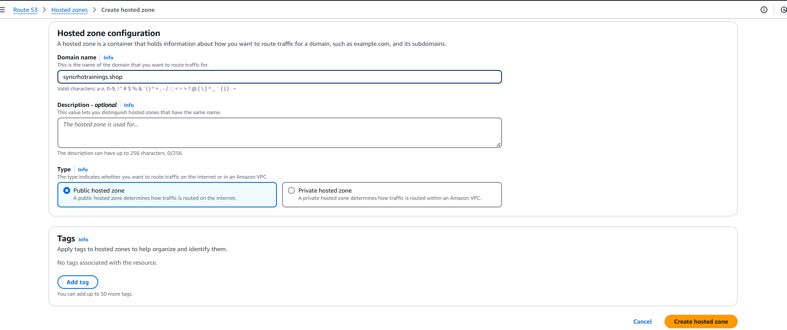

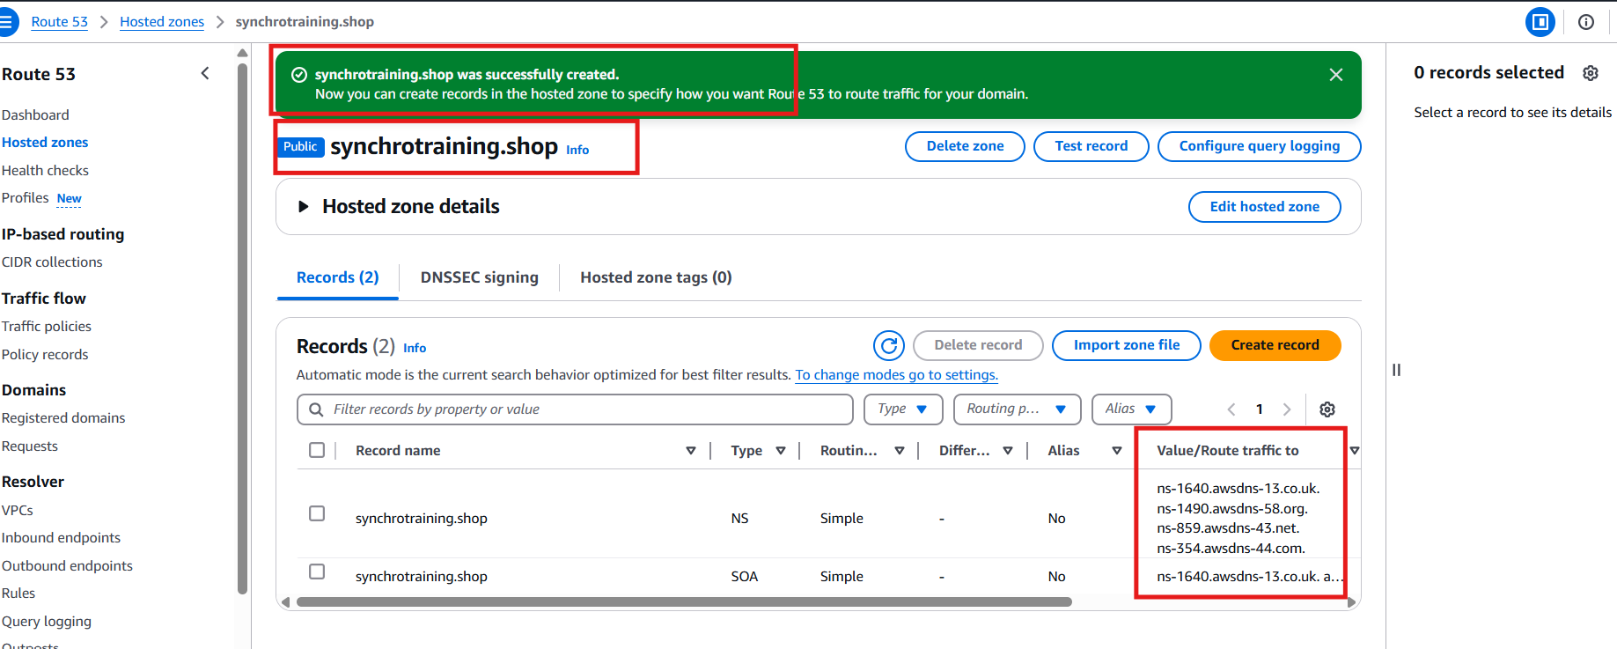

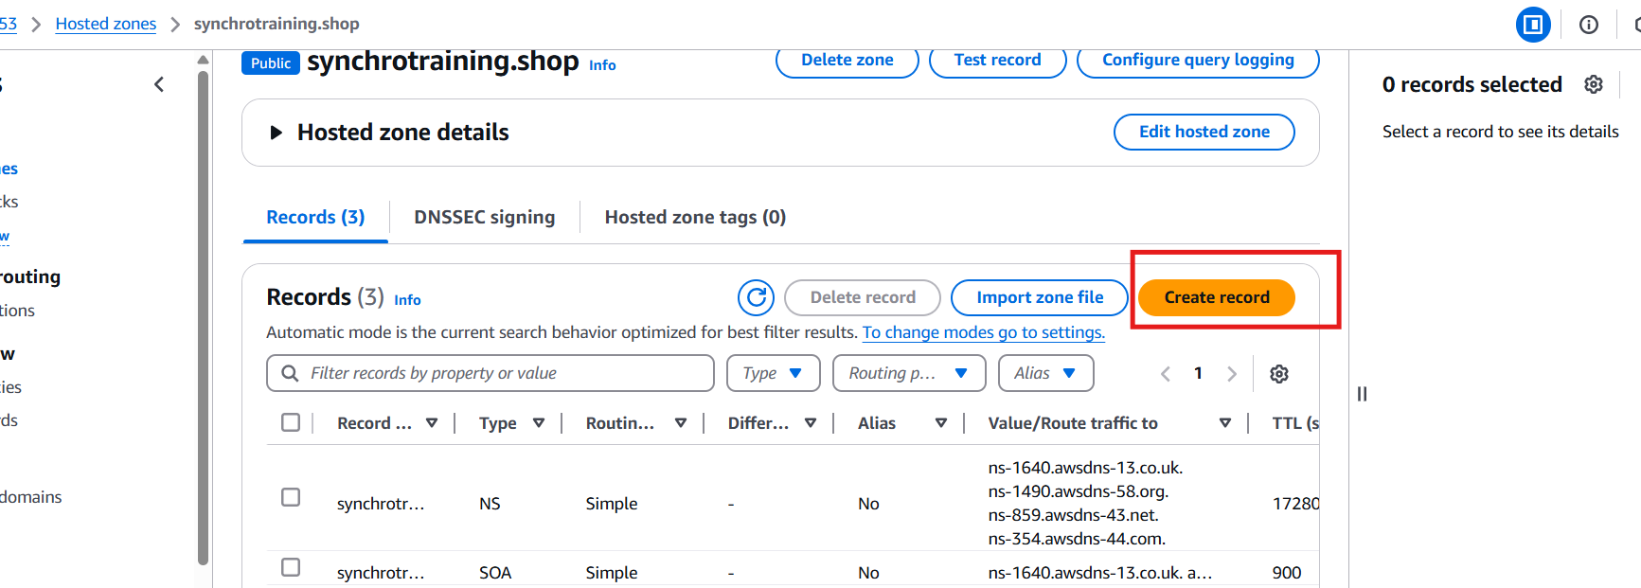

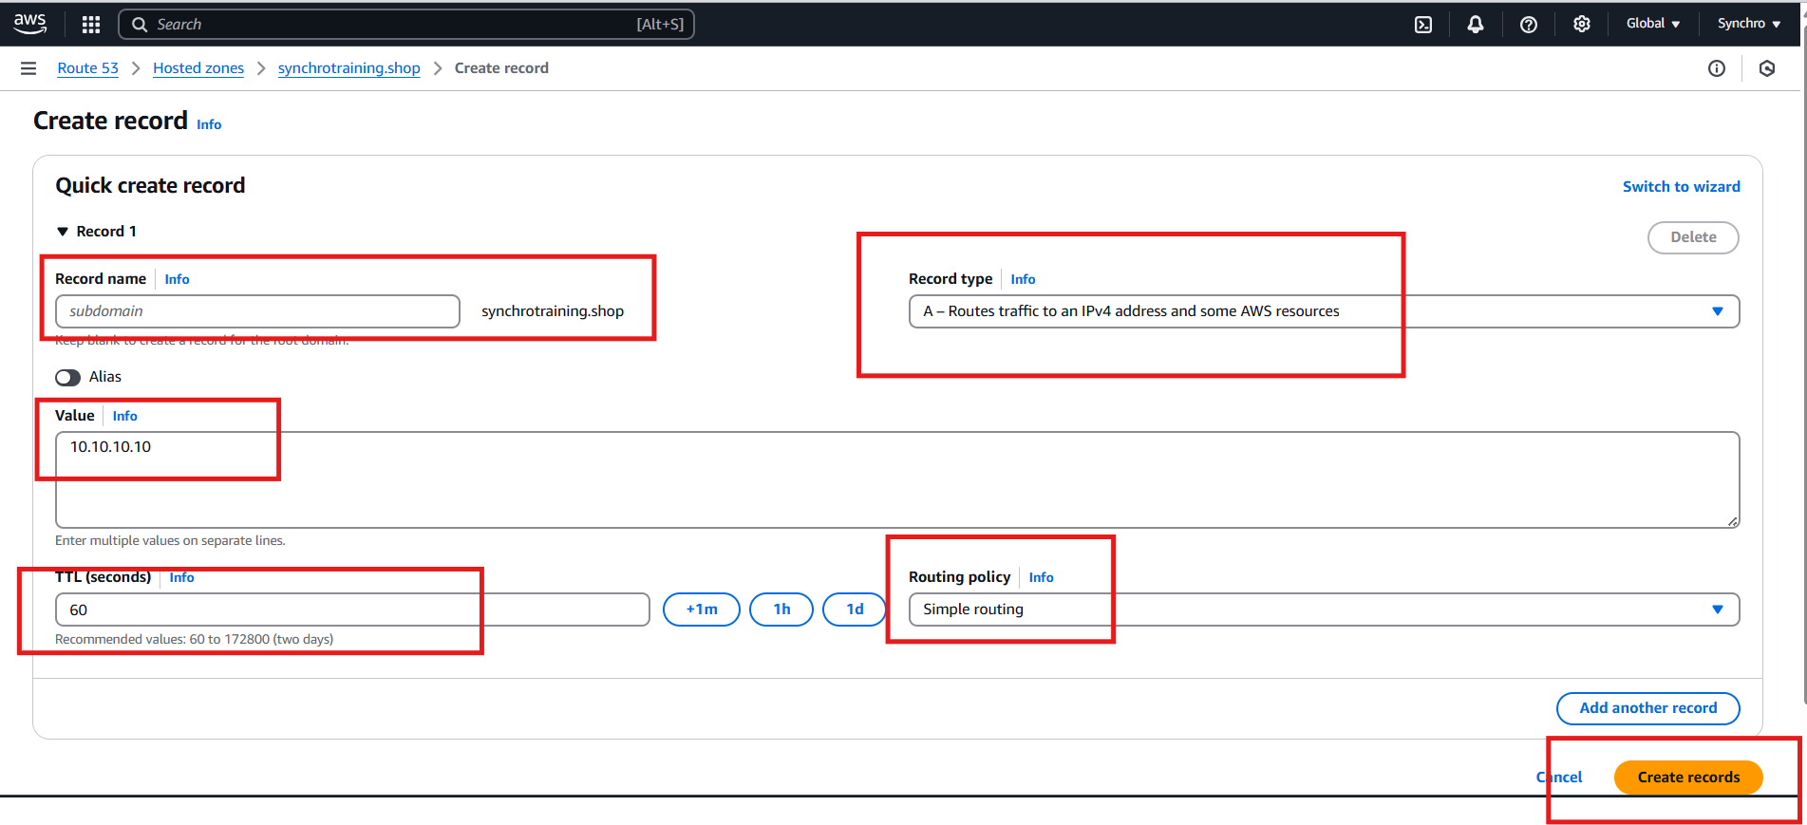

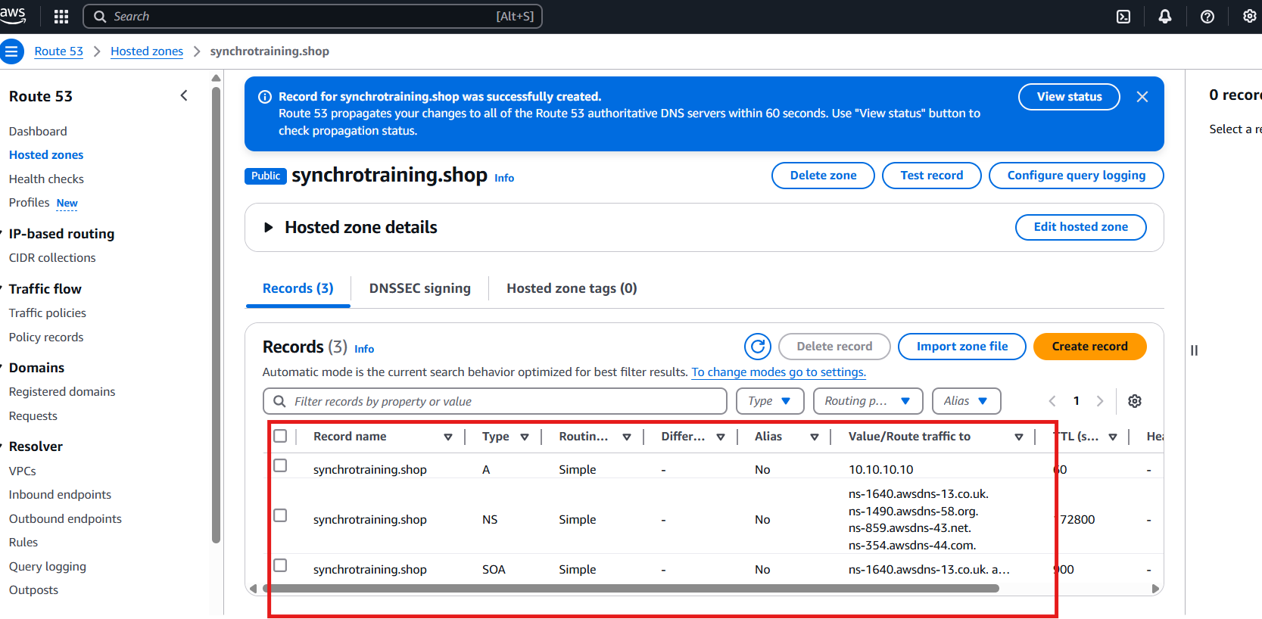

3.s3 static website

4. cloudfront CDN

A content delivery network (CDN) is a network of interconnected servers that speeds up webpage loading for data-heavy applications. CDN can stand for content delivery network or content distribution network. When a user visits a website, data from that website's server has to travel across the internet to reach the user's computer. If the user is located far from that server, it will take a long time to load a large file, such as a video or website image. Instead, the website content is stored on CDN servers geographically closer to the users and reaches their computers much faster.

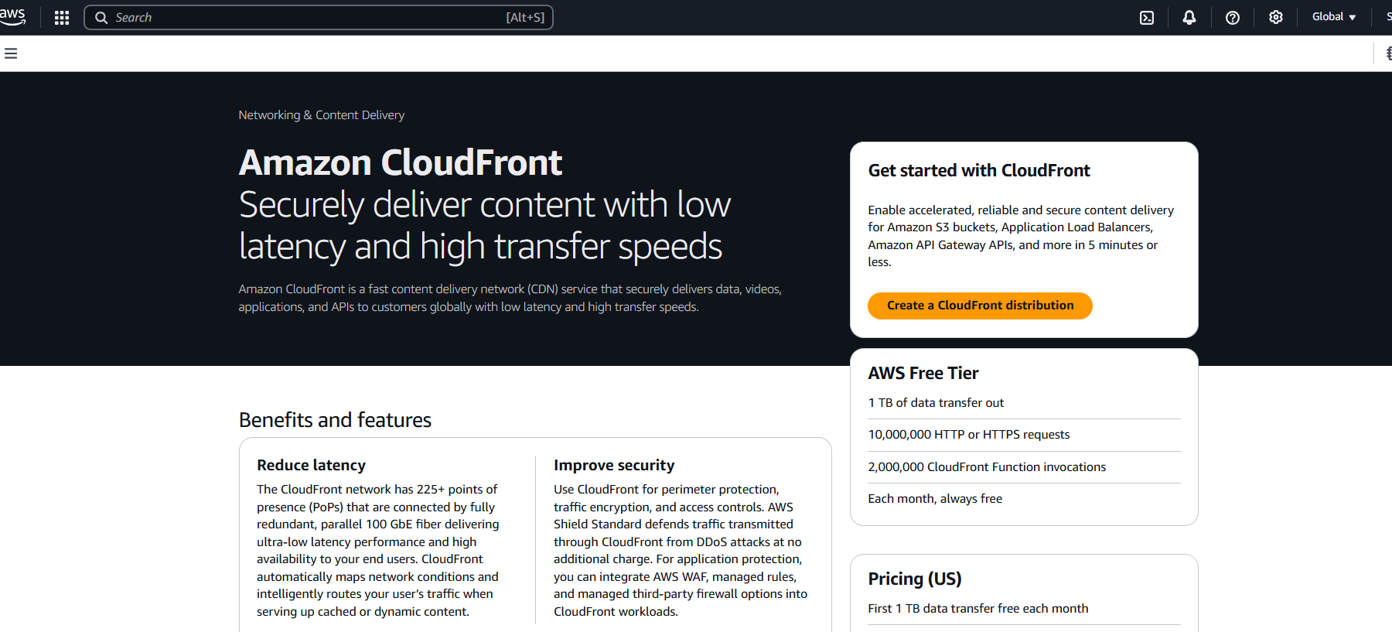

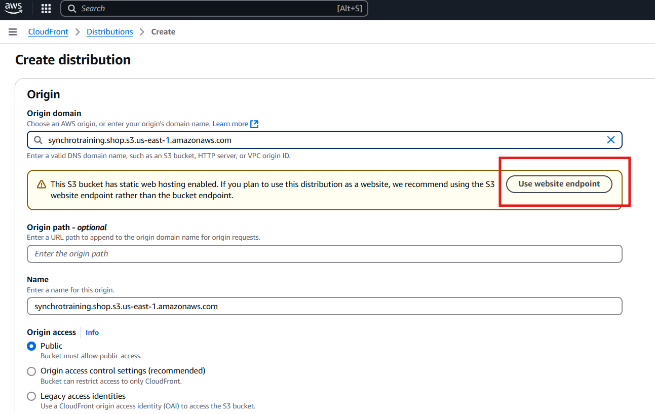

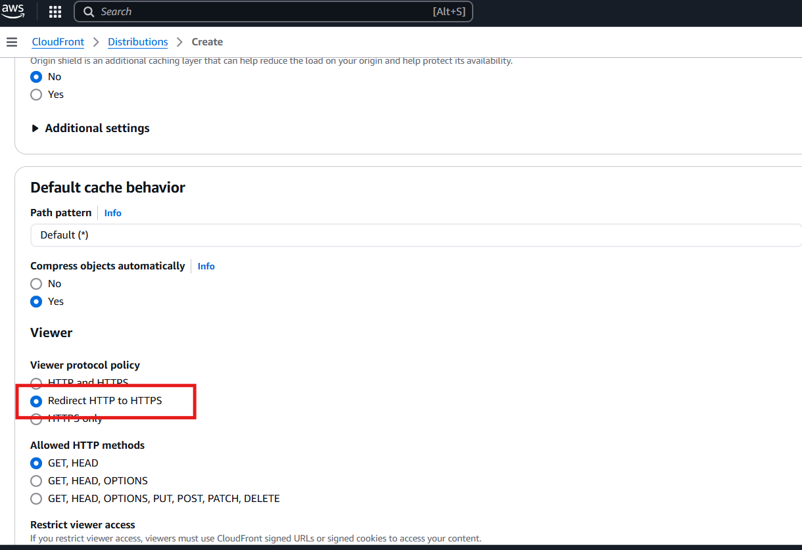  
  
  
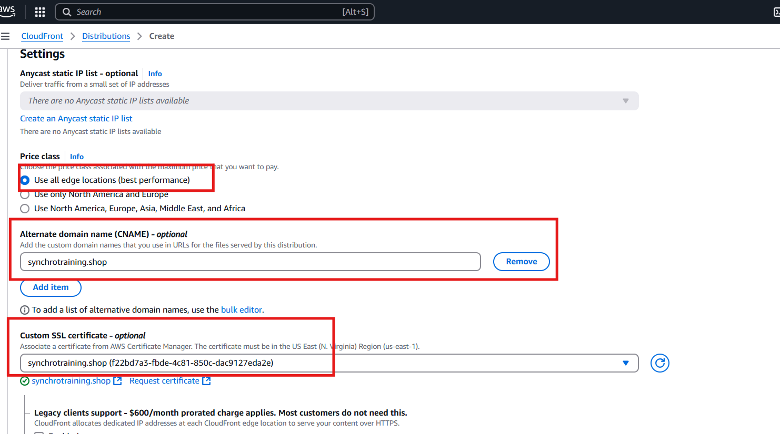

**AWS Static Website Hosting Project**

This guide outlines the steps to host a static website on AWS using S3, secure it with an SSL certificate from ACM, manage DNS with Route 53, and optimize content delivery with CloudFront. The project aims to attach a custom DNS from a registrar like GoDaddy to the AWS-hosted site.

**Step 1: Requesting an SSL Certificate with AWS Certificate Manager (ACM)**

**Amazon Certificate Manager (ACM)** is used to provision and manage SSL/TLS certificates for your website.

1. Navigate to the AWS Certificate Manager dashboard and click the **Request** button.
2. Select **Request a public certificate** and click **Next**.
3. On the **Domain names** page, enter your fully qualified domain name (e.g., synchrotraining.shop) and a wildcard domain name (e.g., *.synchrotraining.shop) to cover subdomains.
4. For the validation method, select **DNS validation**, then click **Next**.
5. After the request is submitted, the certificate status will show as

**Pending validation**. You will need to create CNAME records in your DNS to validate domain ownership.

**Step 2: Configuring DNS with Route 53**

**Route 53** is Amazon's scalable and highly available Domain Name System (DNS) web service.

1. In the Route 53 console, choose **Create hosted zones** to begin.
2. Enter your domain name (e.g., synchrotraining.shop) and select **Public hosted zone**. Then click **Create hosted zone**.
3. Once the hosted zone is created, Route 53 will provide a set of Name Server (NS) records. These are the records you'll need to update with your domain registrar (e.g., GoDaddy) to point your domain to AWS.
4. In the hosted zone, click **Create record** to add a new DNS record. The provided example shows creating an "A" record with a value of 10.10.10.10, which would be a placeholder for the website's IP address.

**Step 3: Setting Up a Static Website on S3**

This step involves configuring an S3 bucket to host your static website files.

1. Create an S3 bucket with the same name as your domain (e.g., synchrotraining.shop).
2. Enable **Static website hosting** in the bucket properties and specify your index and error documents (e.g., index.html and error.html).
3. Upload your website files to the bucket and ensure the bucket policy is set to allow public access.

**Step 4: Using CloudFront as a CDN**

A

**Content Delivery Network (CDN)** is a network of interconnected servers that caches website content closer to users, reducing latency and speeding up page loading times for data-heavy applications.

1. In the CloudFront console, select **Create a CloudFront distribution**.
2. For the **Origin domain**, enter the S3 static website hosting endpoint. Click on **Use website endpoint** to ensure it's configured correctly.
3. Under **Viewer protocol policy**, select **Redirect HTTP to HTTPS** to automatically redirect all non-secure traffic to the secure HTTPS protocol.
4. For optimal performance, select **Use all edge locations (best performance)** under **Price class**.
5. In the **Alternate domain name (CNAME)** field, enter your domain name (synchrotraining.shop).
6. For the **Custom SSL certificate**, associate the certificate you requested earlier from ACM.
7. Click **Create distribution** to complete the setup. CloudFront will then create a distribution that serves your website content globally via its edge locations.