4 STAGES IN THE GIT
-----------------------
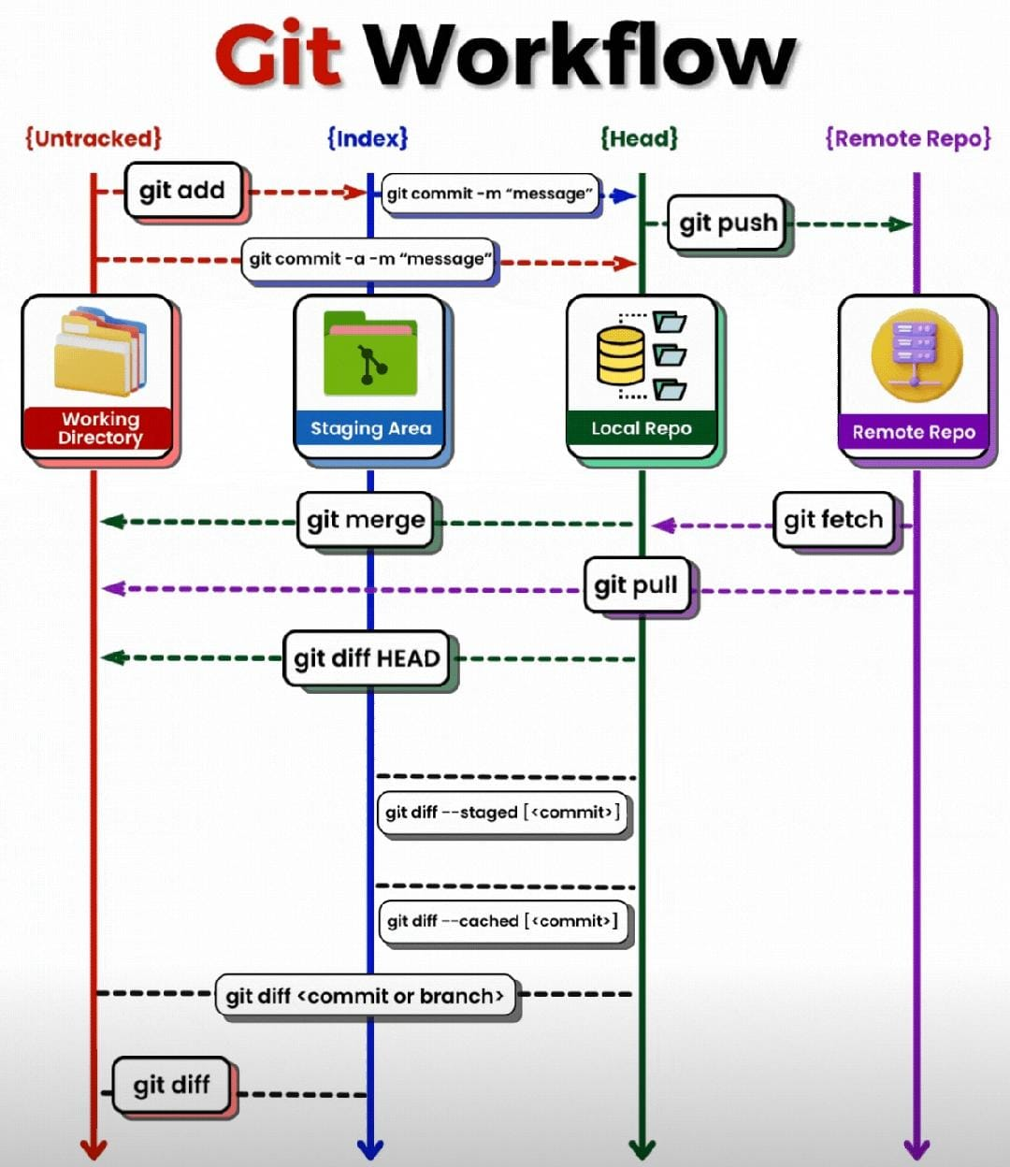

work area / untracked
git add .
staging area / tracked
git commit -m <message>
Local repo
git push
Remote repo

git log

# check for remote repository push or fetch
git remote # output #** origin
git remote -v

# make a copy of remote repo in local host
git clone <url>

# Git branch:
-----------
Different team will be available:
----------------------------------
Development team
Testing team
Devops team

Development --> some working code (production)
--> New requirement
--> we need to do some development
We should use different branches

# Branching stratergy:
--------------------
development branch
test branch
devops branch
production branch

# Create branch:
--------------
git branch <branch-name> --> create new branch
git branch --> branches available
# push new branch to remote repository
git push --set-upstream origin <branch-name>
git push -u origin qa [short version above command]
# Enter into new branch
git checkout <branch-name>
# if changes are made in new branch [feature/hotfix]
# these commit are not reflected in master
# to push these new change in new branch
use <git push > when HEAD is directing to new branch

# How to check commits in local:
# ------------------------------
git log
git log --oneline

# you will get remote branches to local repo]
git branch -r (remote)

then
# if you want to get changes from remote to local repo
git pull

