**4 STAGES IN THE GIT**

-----------------------

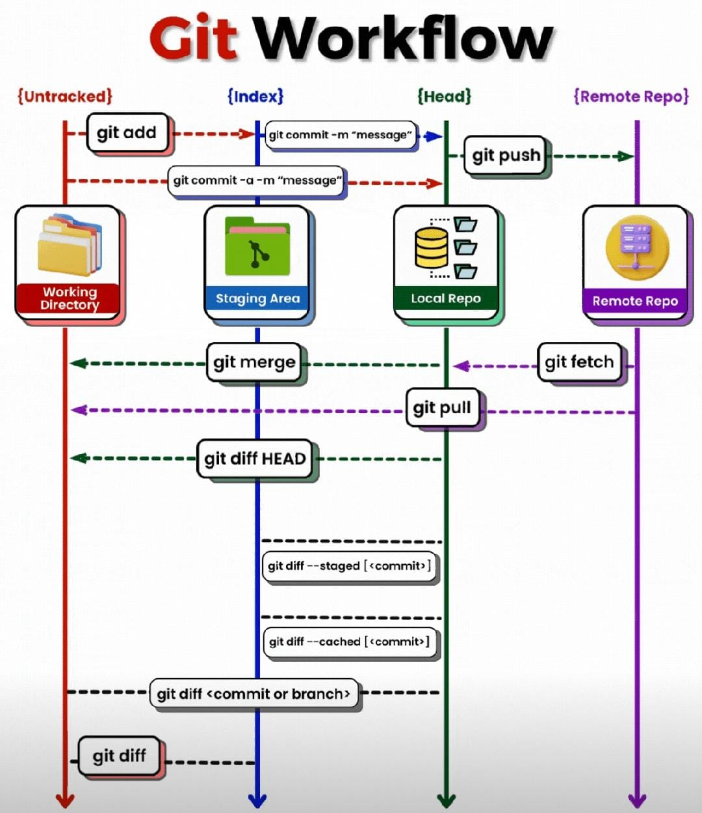

work area / untracked

    git add .

staging area / tracked

    git commit -m <message>

Local repo

    git push

Remote repo

git log

# check for remote repository push or fetch

git remote        # output #** origin

git remote -v

# make a copy of remote repo in local host

git clone <url>

# Git branch:

-----------

        Different team will be available:

        ----------------------------------

            Development team

            Testing team

            Devops team

        Development  -->  some working code  (production)

                    -->  New requirement

                    -->  we need to do some development

            We should use different branches

# Branching stratergy:

--------------------

    development branch

    test branch

    devops branch

    production branch

# Create branch:

--------------

    git branch <branch-name>  --> create new branch

    git branch --> branches available

# push new branch to remote repository

    git push --set-upstream origin <branch-name>

    git push -u origin qa   [short version above command]

# Enter into new branch

    git checkout <branch-name>

#  if changes are made in new branch [feature/hotfix]

#  these commit are not reflected in master

#  to push these new change in new branch

    use <git push >    when HEAD is directing to new branch

# How to check commits in local:

# ------------------------------

    git log

    git log --oneline

# you will get remote  branches to local repo]

    git branch -r (remote)

then

# if you want to get changes from remote to local repo

    git pull