**School Managemnet System**

**Project developed in windows Desktop Qt Creator 5.11.2 for kits MinGw 32 bit using C++11 all screen resolution for 1366*768.**

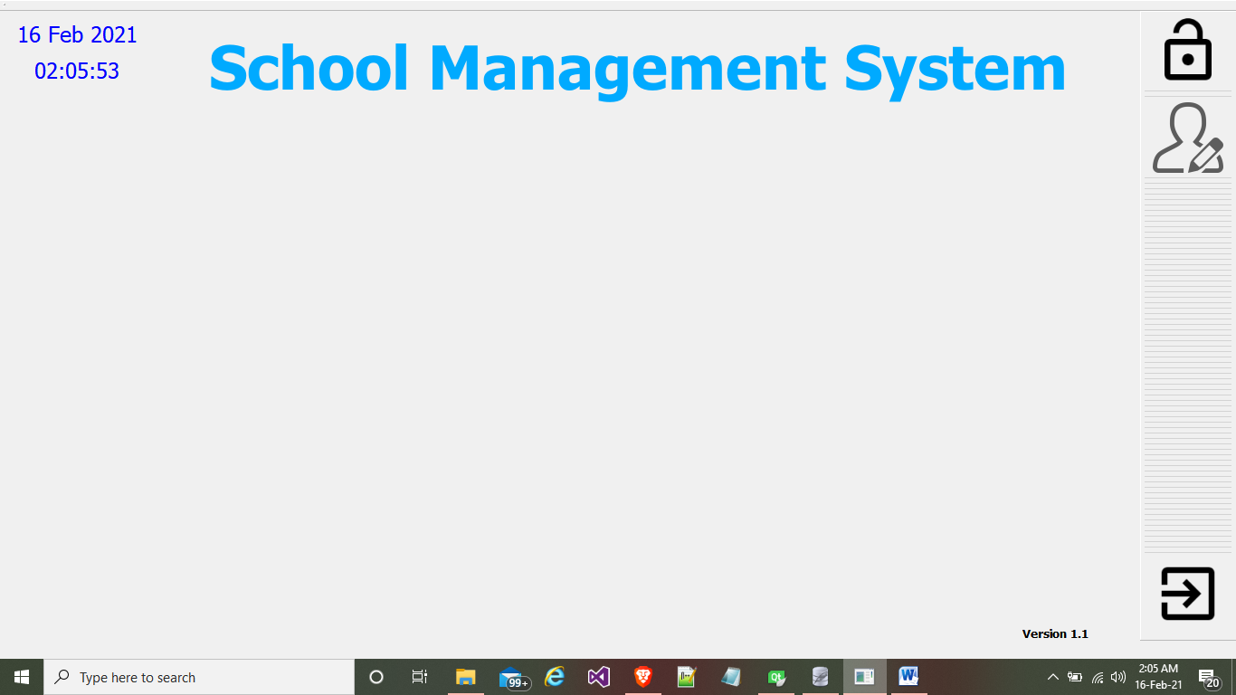

1. **Home Screen without login**

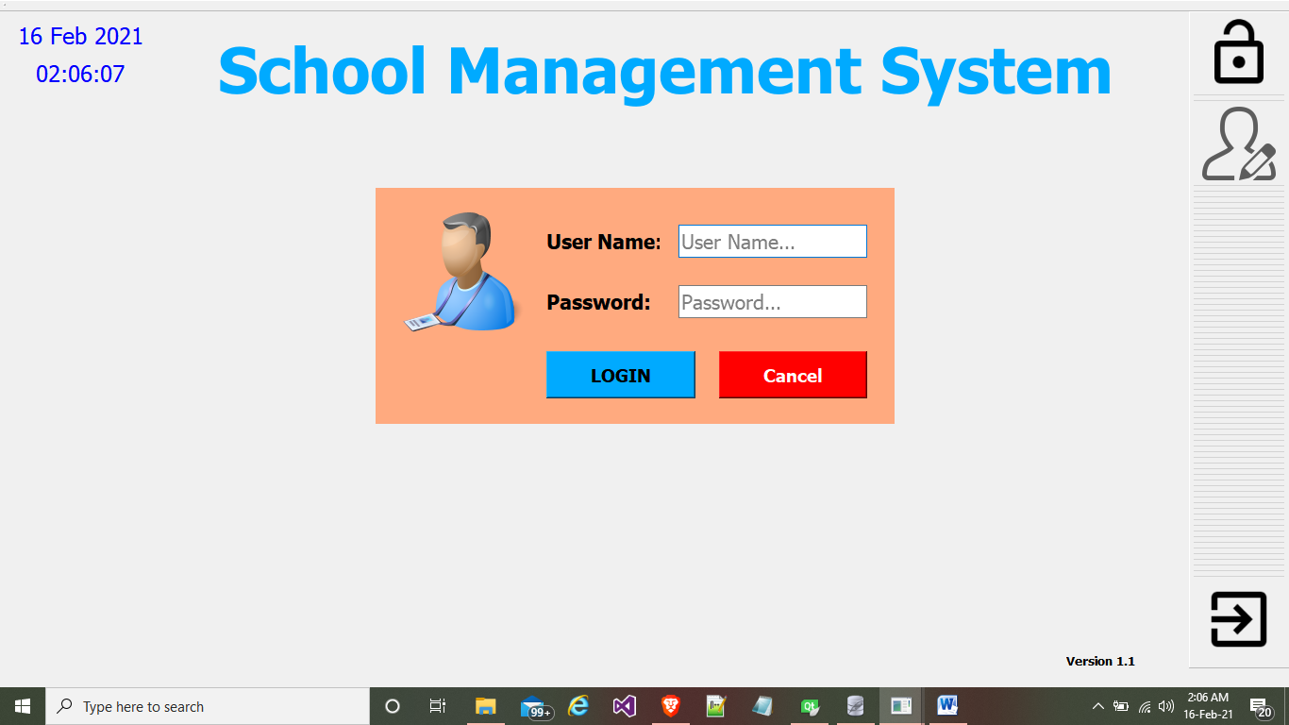

1. **Login Window**

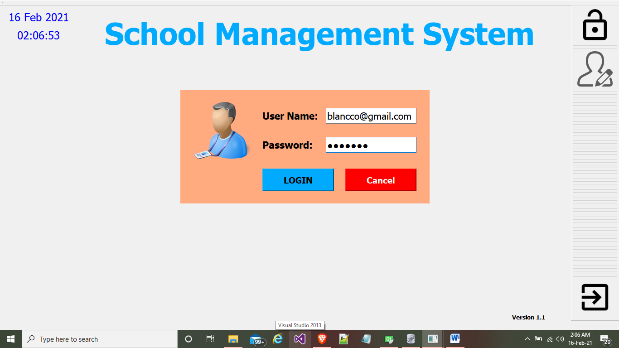

1. **Enter User name and password in login window**

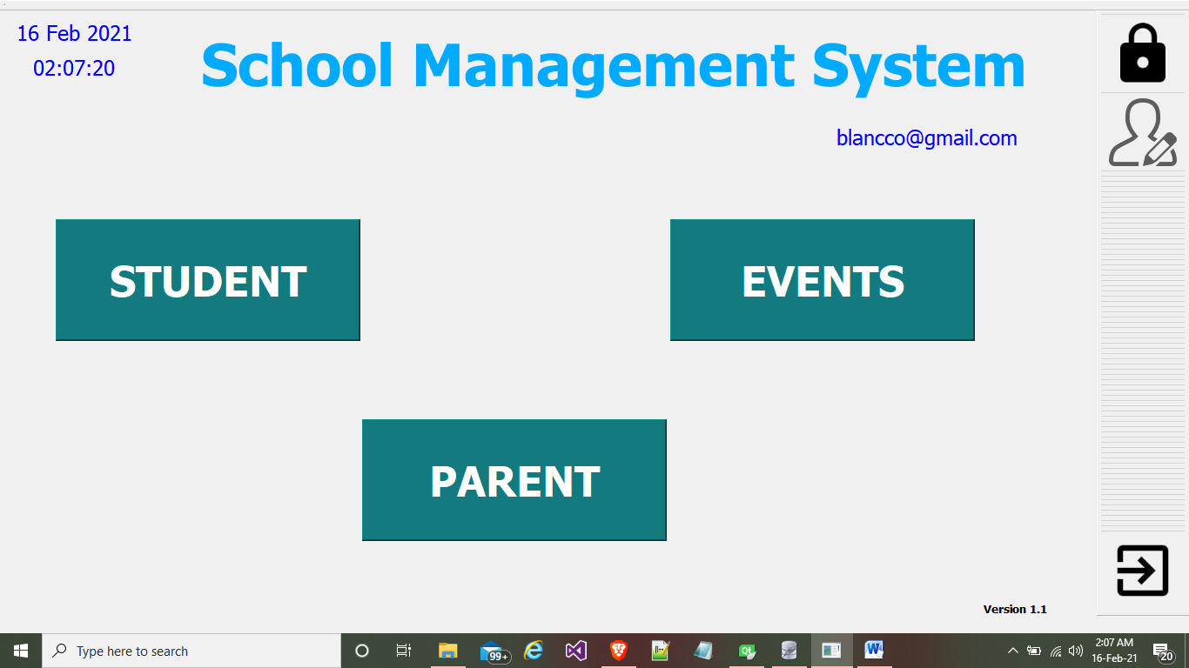

1. **Home screen after login**

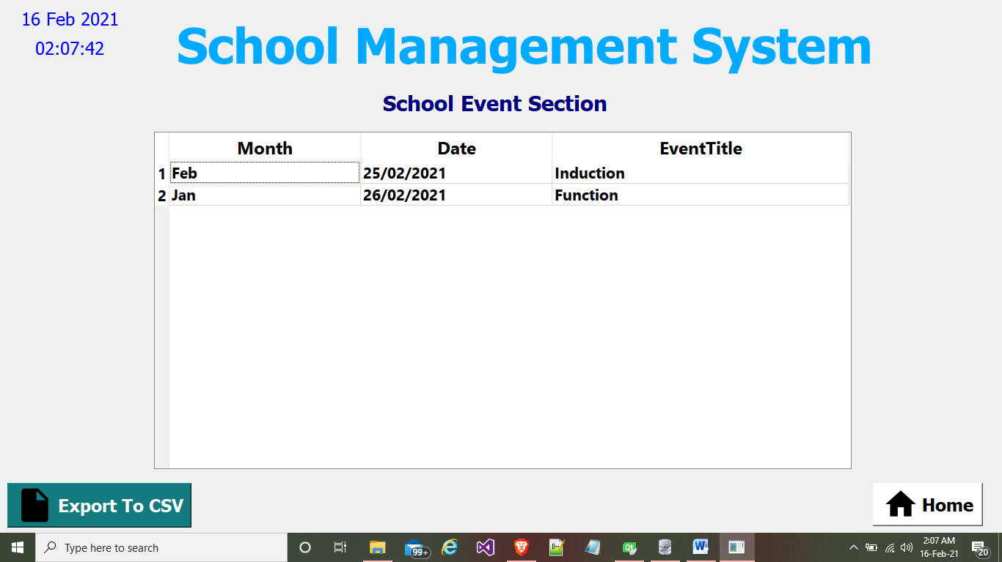

1. **Event Section Window**

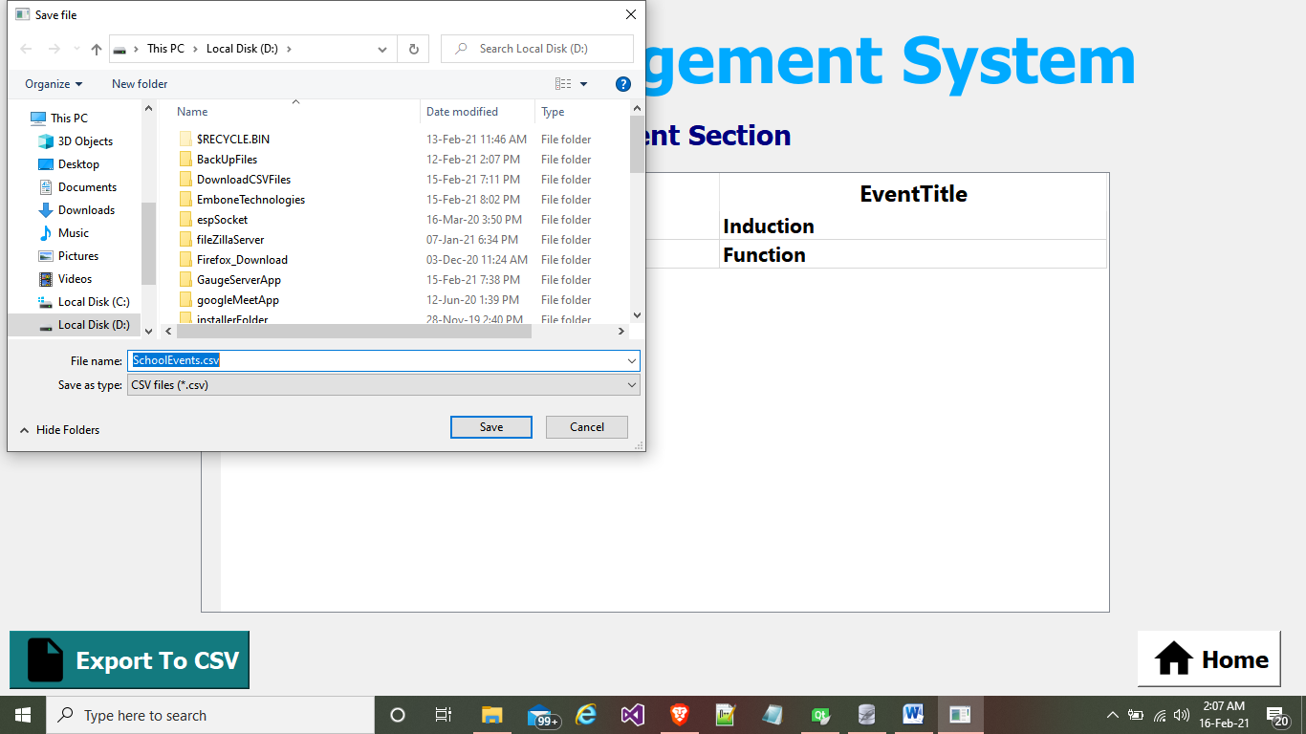

1. **For a print Purpose Export Event Section Data in CSV format**

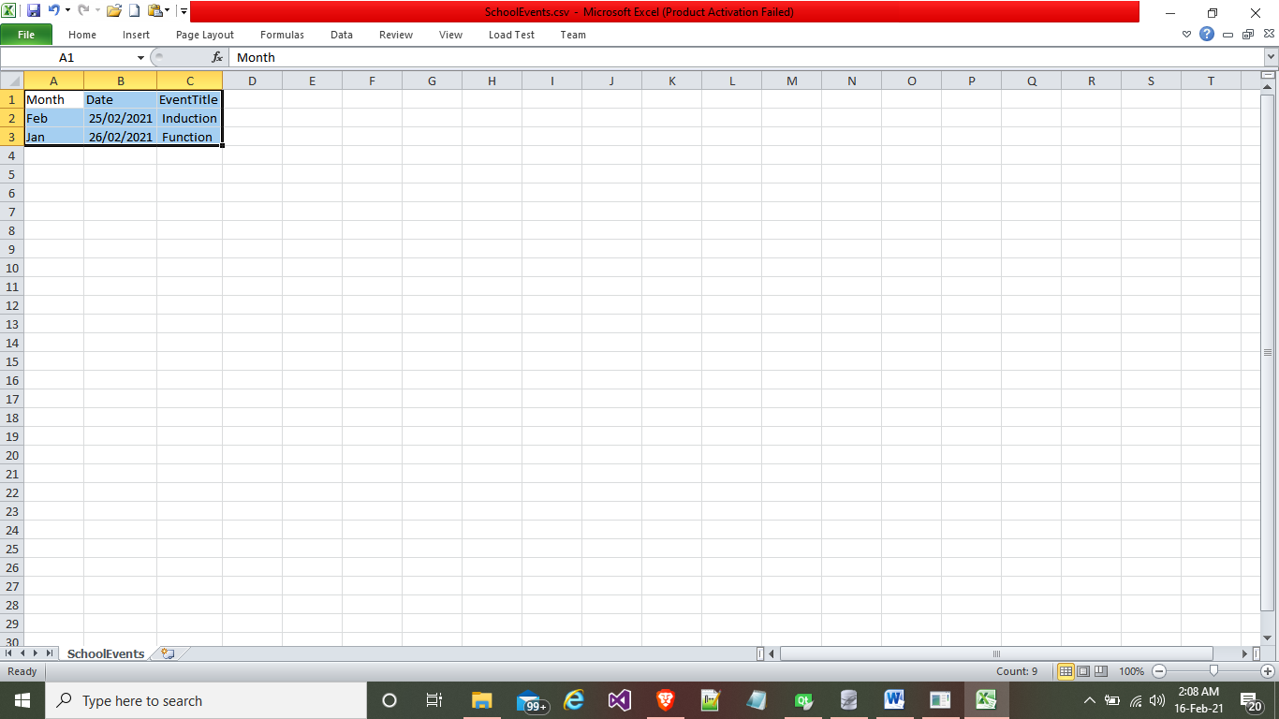

1. **Exported CSV format**

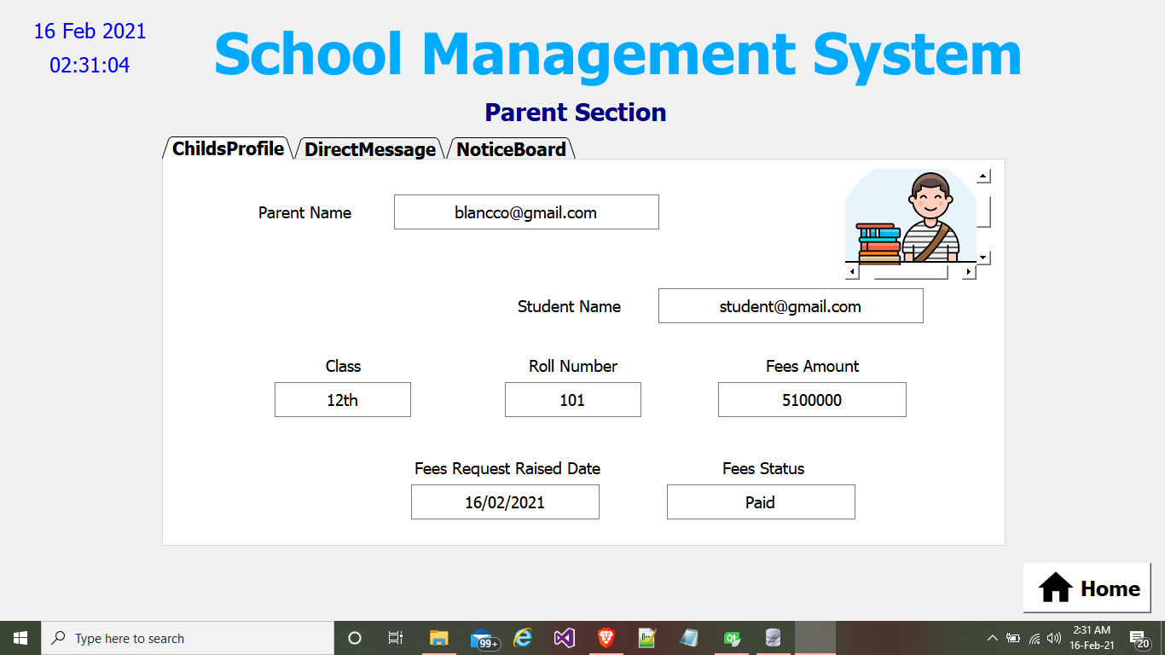

1. **Parent Section Child Profile**

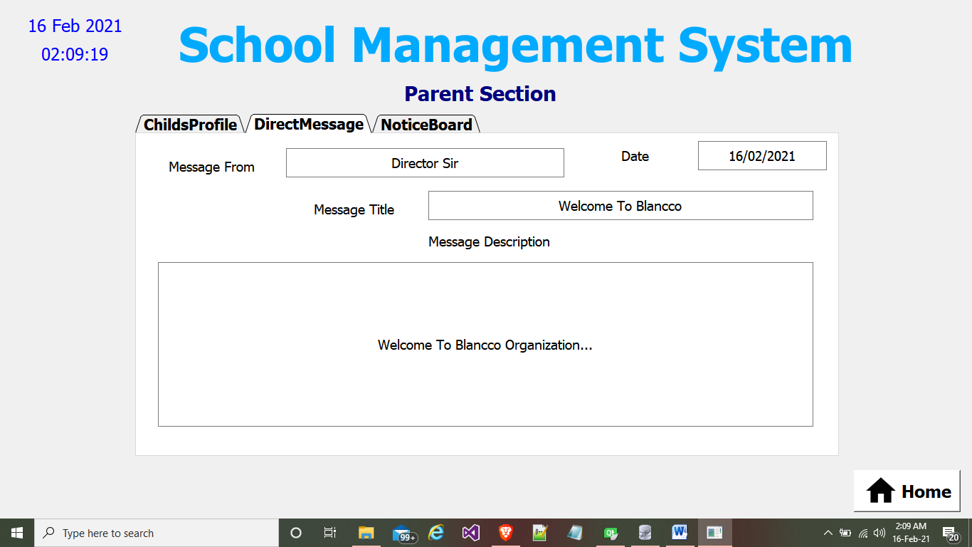

1. **Parent Section Direct Message**

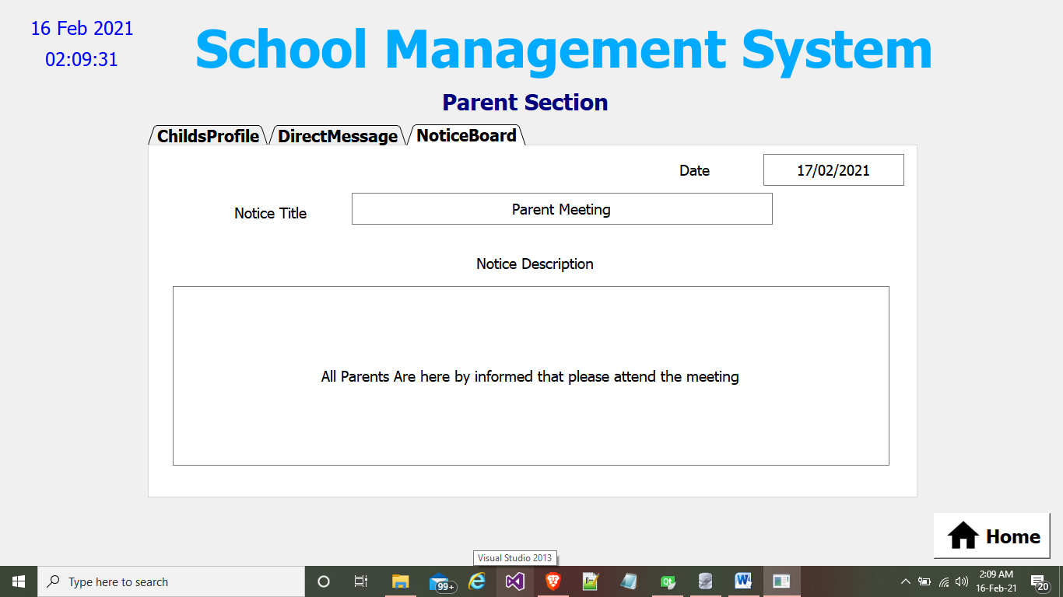

1. **Parent Section Notice Board**

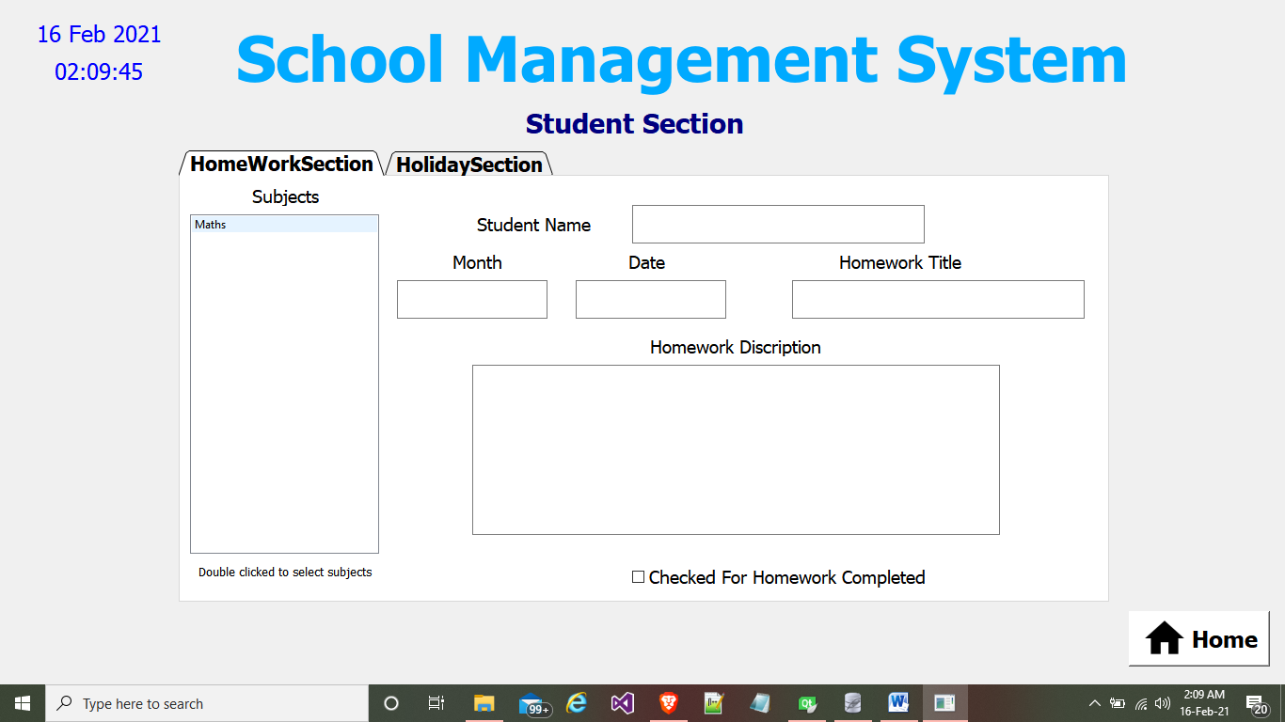

1. **Student Section Homework**

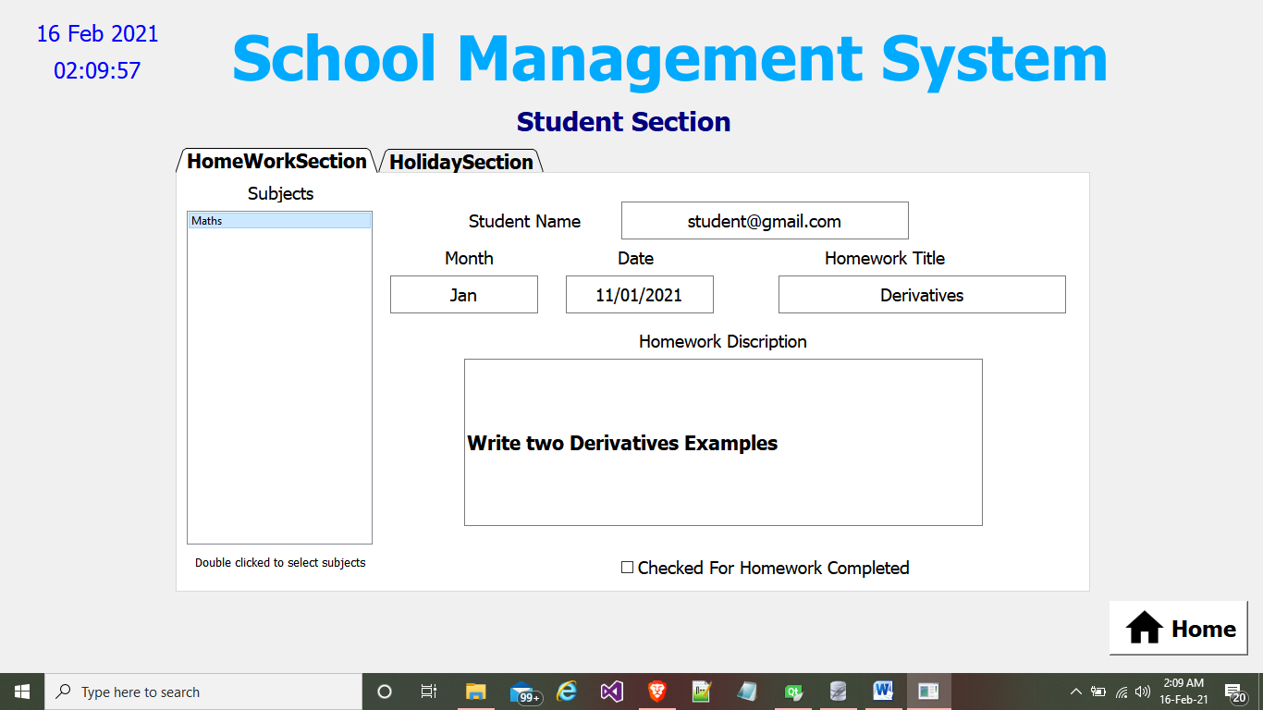

1. **Homework Details After double clicked on Subject Name**

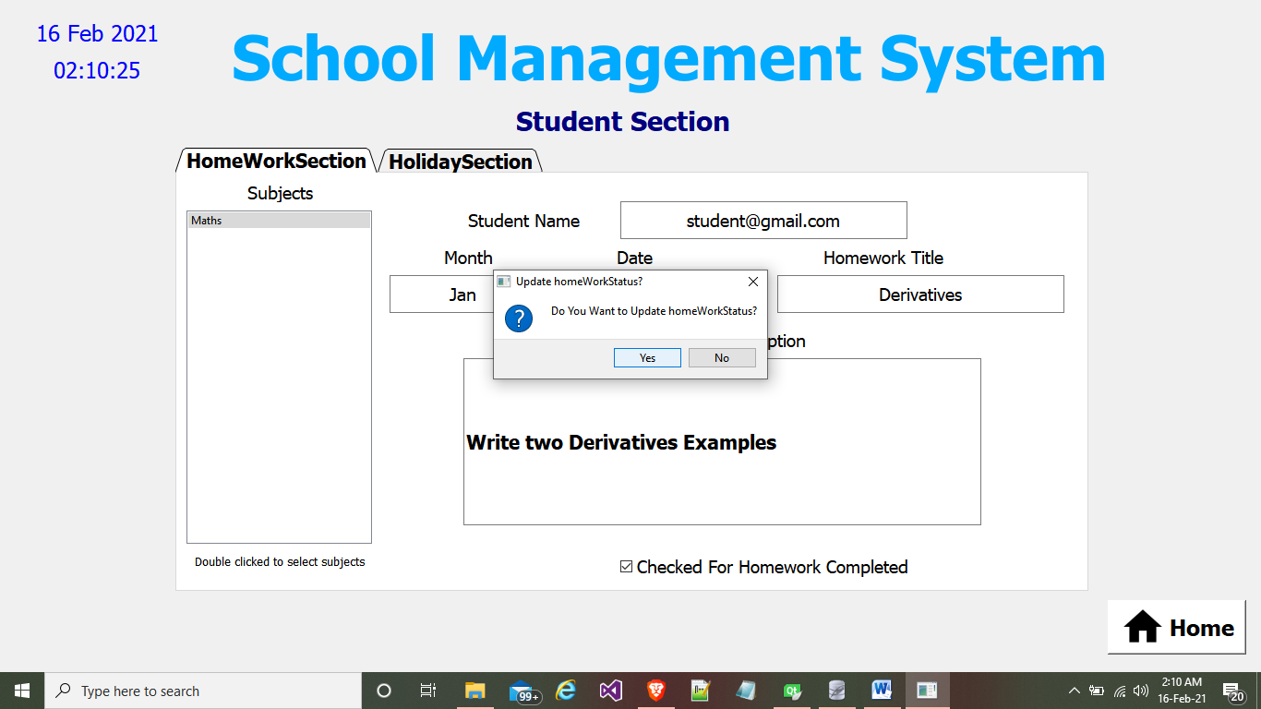

1. **Click checkBox for homework completed**

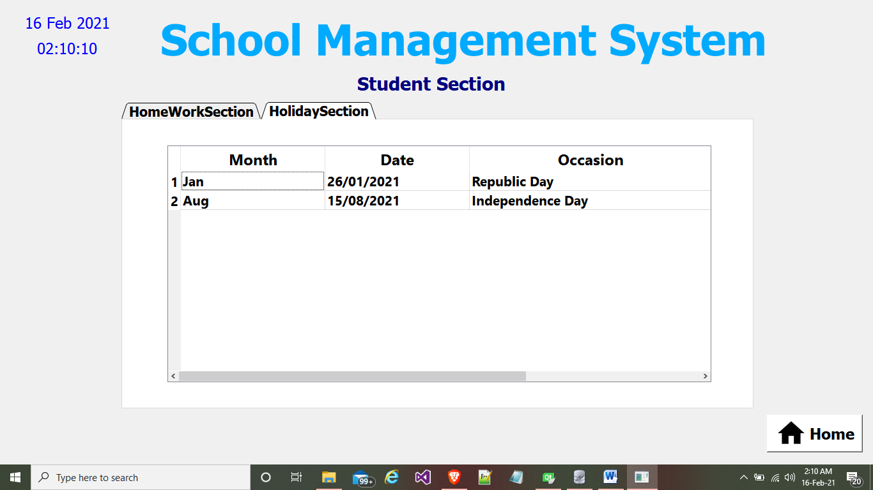

1. **Student Holiday Section**

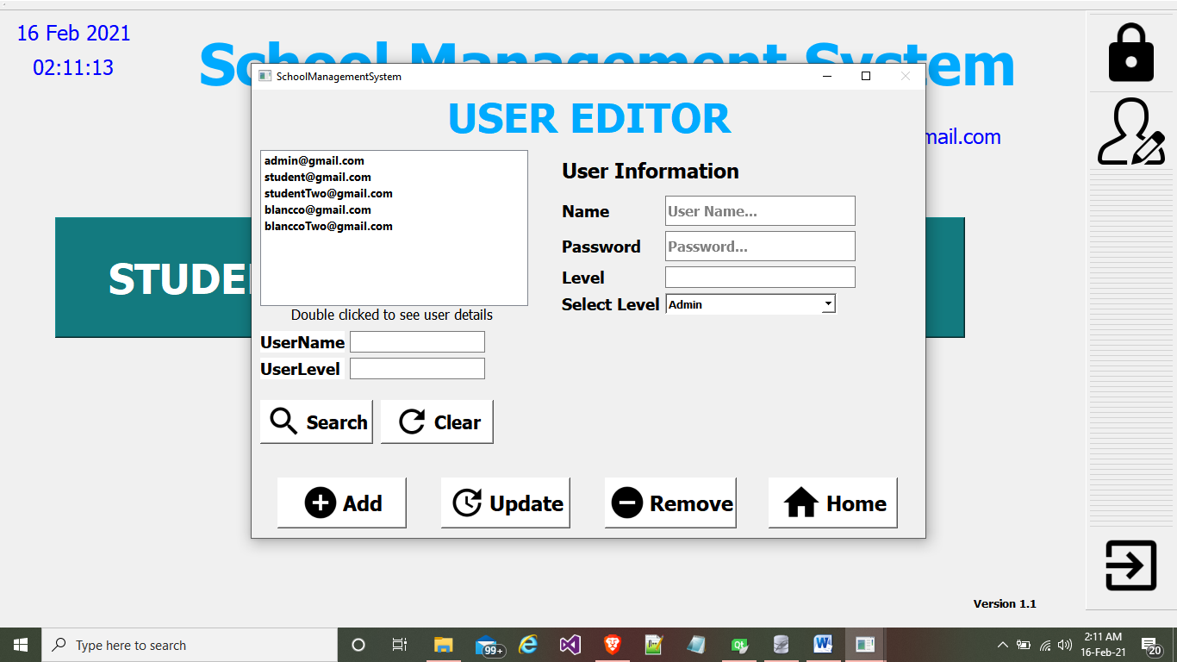

1. **User editor window**

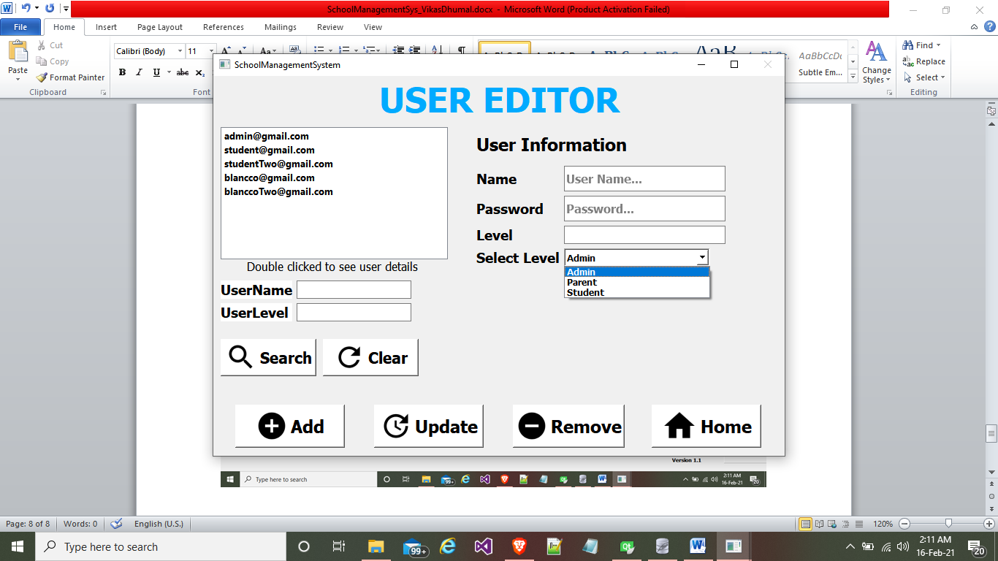

1. **Different User level for System Access**

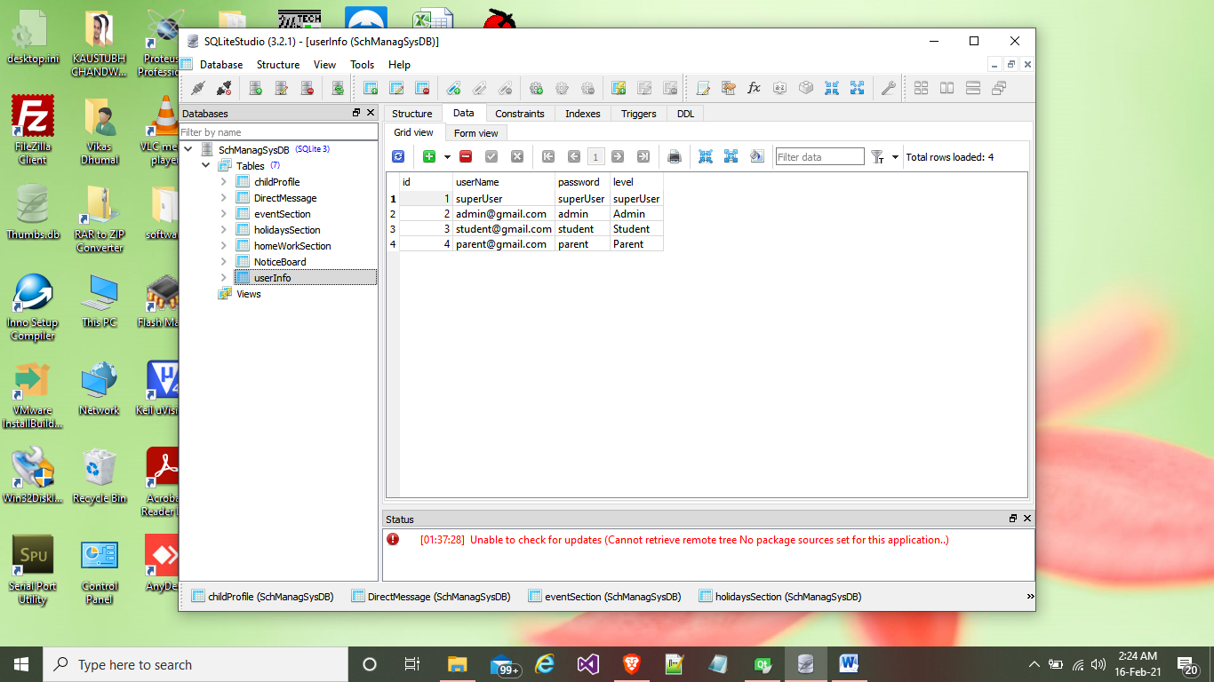

1. **Sqlite Database**