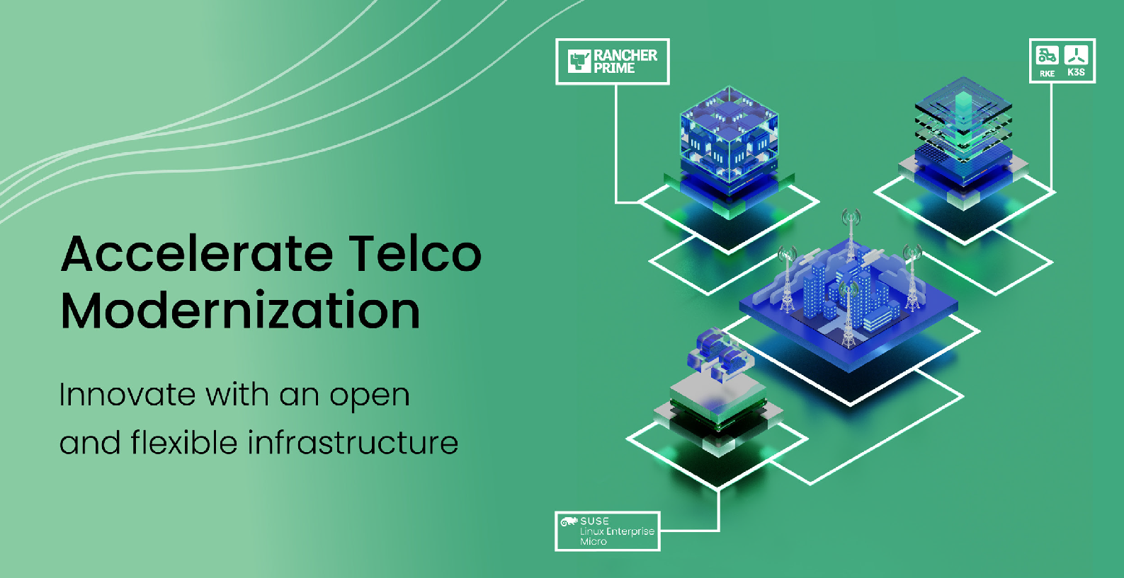SUSE Adaptive Telco Infrastructure Platform

An edge computing platform optimized for telecommunications.

# Benefits of...

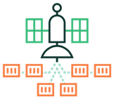

Future-proof

Telco-grade performance

Simplified operations at scale

# Product Overview

Key Features

SUSE Adaptive Telco Infrastructure Platform (ATIP) is a telco-optimized edge computing platform that enables telecom companies to innovate, modernize and future- proof their networks. It achieves this with an open and flexible solution architecture that adapts easily to future needs, is optimized for telco-grade performance, and simplifies operations at scale.

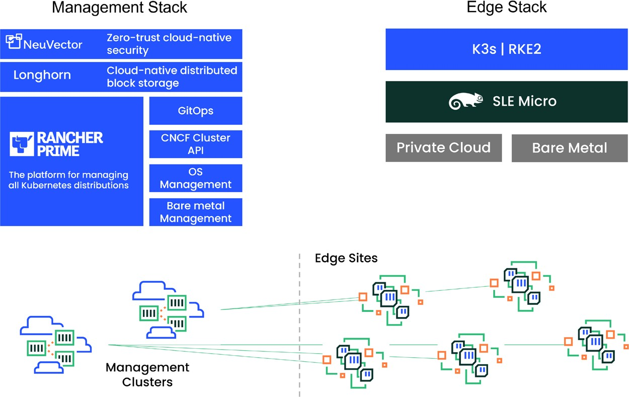

# Future-proof design minimizes risk and helps you thrive in a highly competitive environment

**Adaptable:** SUSE ATIP is a telco-optimized edge computing platform that packages the key infrastructure components – Linux, Kubernetes, security, management tools – in a customizable form, so Telco operators can easily adopt it for a broad range of use cases across mobile and fixed networks.

**Modular:** Designed to thrive in a multi-vendor environment, ATIP includes modules which can be used together or individually to suit operators’ requirements. As an example, ATIP is ideal to support and enable future looking cloud frameworks, such as LF Europe’s project Sylva.

**Support existing infrastructure:** The operators can minimize risk by using their existing infrastructure given ATIP’s support of a wide range of hardware. Choice of OS (SLE Micro, SLE Server) and management tools (SUSE Manager, Rancher Prime) enables you to manage your existing infrastructure or adopt cloud-native methods. SUSE can meet you wherever you are in your transformation journey.

# Telco-grade performance

SUSE ATIP delivers telco-grade performance attributes across the entire stack. Its Operating System layer provides low- latency, real-time performance, and fast data path. The Kubernetes layer ensures performance-sensitive applications run optimally, with full lifecycle container security delivered by SUSE NeuVector. Additional functional attributes include:

**Built for Edge from the ground up**, so customers can get optimal performance without the technical debt from legacy systems. SUSE ATIP delivers lightweight Kubernetes distributions fit for resource constrained or remote devices in strictly regulated environments. As an Immutable Linux, SLE Micro is optimized to support containers and microservices, making it an ideal container and virtualization host at the edge. With security seamlessly integrated across the full stack – from applications to Kubernetes to operating systems, datacenter level of security is made available to every device, wherever it is located.

**Optimized for Telco**. SUSE’s Kubernetes and Linux are optimized for Telco functions – workloads can be scheduled based on underlying hardware functionality, direct access is allowed to network interfaces from Kubernetes Pods, a broad range of telco-grade hardware is enabled out of the box and telecom specific protocols are supported.

# Simplified operations at scale

SUSE ATIP utilizes Rancher Prime, a market leading Kubernetes management solution that is known for its simplicity, robustness, and outstanding user experience. SUSE has made key enhancements to Rancher Prime to support telecom use cases, with the following benefits:

**Faster rollouts:** ATIP utilizes GitOps to help users manage and consistently deploy thousands of Kubernetes clusters easily. With integration of CNCF’s Cluster API, operators can further speed the process with programmatic APIs that also offer a vendor-neutral integration point.

**Unified management:** Manage Linux and Kubernetes from a single pane of glass. Save operating costs and administration overhead, while increasing the efficiency of lifecycle operations at scale.

**Zero-touch provisioning:** Save costs with simple zero touch onboarding of enterprise-grade edge hardware, eliminating the need for skilled technical staff onsite – connect power, network, and switch on device: software does the rest.

# Resources

About SUSE

Our vision for the next generation of telecom infrastructure is that 5G and Edge computing will enable a new class of novel applications and use cases. SUSE ATIP is purpose built to enable telecom operators in transforming their networks by delivering flexible, adaptable open source based infrastructure to support this new class of applications. SUSE helps solve the challenges of managing large numbers of diverse and varied clusters scattered across bare-metal infrastructure, public and private clouds. We do that while delivering the feature set and security posture you would expect from a vendor who has been delivering business- critical Linux solutions for more than 30 years.

* [Vision for Telecom at the Edge – White Paper](https://more.suse.com/Edge-Telco-Vision-Paper.html)
* [Future-Proof Telecom Modernization with an Open and](https://more.suse.com/Edge-Telco-Architecture-Paper.html)  [Flexible Infrastructure Platform – Architecture Paper](https://more.suse.com/Edge-Telco-Architecture-Paper.html)
* [SUSE Telecom Industry Solutions](https://www.suse.com/sector/telco/)
* [SUSE Edge Solutions](https://www.suse.com/solutions/edge-computing/)

With over 30 years of engineering excellence, exceptional service, and a worldwide partner ecosystem, SUSE is a global leader in Enterprise Linux, Kubernetes Management, and Edge solutions. We collaborate with partners and communities to empower our customers to innovate everywhere –- from core to cloud to edge and beyond. SUSE puts the “open” back in open source, giving customers the agility to tackle the innovation challenges today and the freedom to evolve their strategy and solutions tomorrow.

The company is headquartered in Nuremberg, Germany and is listed on the Frankfurt Stock Exchange. To learn more about SUSE’s products and solutions visit [www.suse.com](http://www.suse.com/).

SUSE Software Solutions Germany GmbH Frankenstraße 146 90461 Nürnberg Germany

[www.suse.com](http://www.suse.com/)

For more information, contact SUSE at:

+1 800 796 3700 (U.S./Canada)

+49 (0)911-740 53-0 (Worldwide)

SC0000412 | © 2023 SUSE LLC. All Rights Reserved. SUSE and the SUSE logo are registered trademarks of SUSE LLC in the United States and other countries. All third-party trademarks are the property of their respective owners.

[suse.com](https://www.suse.com/)