****

**COURSE NAME:-** OOPS WITH JAVA

**COURSE CODE:-** E1PY201B

**SCHOOL:-** COMPUTER SCIENCE AND ENGINEERING

**YEAR:-** 2024

**SEMESTER:-** 2ND

**PROGRAM:-** MASTER OF COMPUTER APPLICATION

**SECTION:-** 1ST

**SESSION:-** 2023-2025

|  |  |
| --- | --- |
| **SUBMITED BY:-** | **SUBMITED TO:-** |
| **Name:-**  Vicky kumar  **Admission No:-**  23SCSE2030030 | **DR NEETU SHARMA** |

|  |  |  |  |  |
| --- | --- | --- | --- | --- |
| **Index**  **NAME:**Ankit Kumar Singh**ADMISSION NO:** *23SCSE2030045* **CLASS :** *MCA SECTION-1 (SEM-2)* | | | | |
| **SN** | **Experiment Name** | **DATE** | **PAGE** | **TEACHER’S SIGN** | |
| 1 | Hello World | 27-02-2024 | 1 |  | |
| 2 | Addition of two numbers | 05-03-2024 | 2 |  | |
| **3** | **Finding factorial** | **12-03-2024** | **6** |  | |
| **4** | **Find Prime Number** | **12-03-2024** | **7** |  | |
|  |  |  |  |  | |
|  |  |  |  |  | |
|  |  |  |  |  | |
|  |  |  |  |  | |
|  |  |  |  |  | |
|  |  |  |  |  | |
|  |  |  |  |  | |
|  |  |  |  |  | |
|  |  |  |  |  | |
|  |  |  |  |  | |
|  |  |  |  |  | |
|  |  |  |  |  | |
|  |  |  |  |  | |
|  |  |  |  |  | |
|  |  |  |  |  | |
|  |  |  |  |  | |
|  |  |  |  |  | |

**1. A java program to print "Hello World."**

class HelloWorld {

public static void main(String[] args) {

System.out.println("Hello, World!");

}

}

Output:

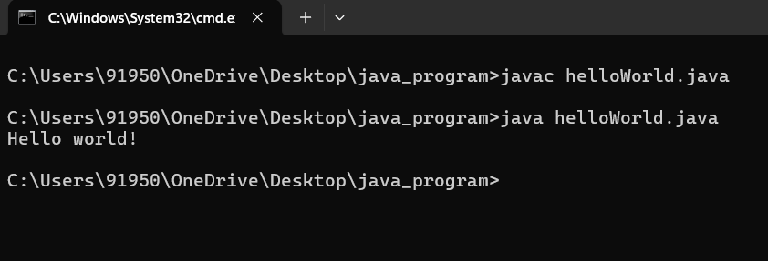

**2. A java program to find sum of two number**

import java.util.Scanner;

public class addition{

public static void main(String[] args){

int a,b,sum;

Scanner sc = new Scanner(System.in);

System.out.println("Enter first number");

a=sc.nextInt();

System.out.println("Enter second number");

b=sc.nextInt();

sum=a+b;

System.out.println("The sum of numbers " + a + " and " + b + " is: " +sum );

}

}

**Output:**

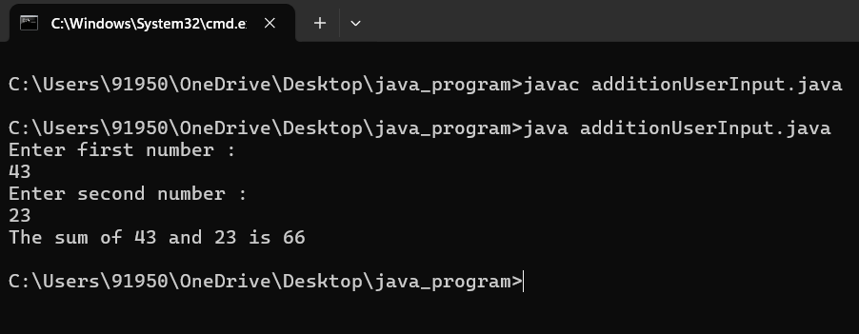

**// Calculate the Sum of First N Odd & Even Numbers in Java**

import java.util.Scanner;

public class SumofEvenOdd1 {

private static Scanner sc;

public static void main(String[] args)

{

int number, i, evenSum = 0, oddSum = 0;

sc = new Scanner(System.in);

System.out.print(" Please Enter any Number : ");

number = sc.nextInt();

for(i = 1; i <= number; i++)

{

if(i % 2 == 0)

{

evenSum = evenSum + i;

}

else

{

oddSum = oddSum + i;

}

}

System.out.println("\n The Sum of Even Numbers upto " + number + " = " + evenSum);

System.out.println("\n The Sum of Odd Numbers upto " + number + " = " + oddSum);

}

}

**OUTPUT:**

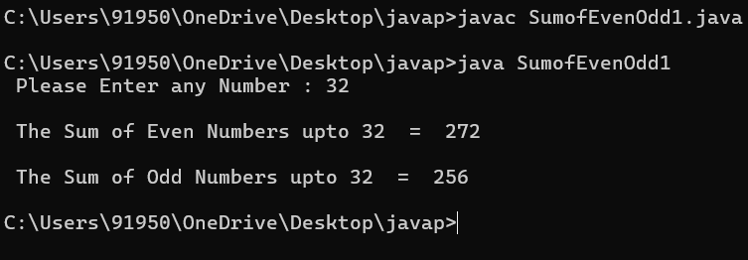

|  |  |
| --- | --- |
|  |  |
|  | **3. A java program to find factorial any of any given number using recursion.**  public class FactorialCalculator {  public static void main(String[] args) {  int number = 5;  long factorial = factorial(number);  System.out.println("Factorial of " + number + " is: " + factorial);  }  public static long factorial(int n) {  if (n == 0 || n == 1) {  return 1; // Base case: factorial of 0 or 1 is 1  } else {  return n \* factorial(n - 1);  }  }  }  OUTPUT:  C:\Users\91950\OneDrive\Desktop\java_program\12_march\Screenshot 2024-03-12 103112.png  **4.A java program to read an integer value through Scanner class and find prime number within given range.**  **import java.util.Scanner;**  **public class PrimeNumbersInRange {**  **public static void main(String[] args) {**  **Scanner scanner = new Scanner(System.in);**  **System.out.print("Enter the starting number of the range: ");**  **int start = scanner.nextInt();**  **System.out.print("Enter the ending number of the range: ");**  **int end = scanner.nextInt();**  **System.out.println("Prime numbers between " + start + " and " + end + ":");**  **for (int i = start; i <= end; i++) {**  **boolean isPrime = true;**  **if (i <= 1) {**  **isPrime = false;**  **}**  **for (int j = 2; j <= Math.sqrt(i); j++) {**  **if (i % j == 0) {**  **isPrime = false;**  **break;**  **}**  **}**  **if (isPrime) {**  **System.out.print(i + " ");**  **}**  **}**  **System.out.println();**  **scanner.close();**  **}**  **}**  **Output :**  **C:\Users\91950\OneDrive\Desktop\java_program\12_march\Screenshot 2024-03-12 103219.png** |
| **3** | **A java program to find factorial of any given number using recursion.** |
| **4** | **A java program to read an integer value through Scanner class and find prime number within given range.** |
| **5** | **A java program that uses length property for displaying any number of command line arguments.** |
| **6** | **A java program to sort n numbers using bubble sort/insertion sort/selection sort .** |
| **7** | **A java program to find addition and multiplication of two 2D Matrices.** |
| **8** | **A java program to find largest among n numbers.** |
| **9** | **A java program to implement getter and setter method.** |
| **10** | **A java program to create constructor of a class and initialize values in it and later print them.** |
| **11** | **A java program to implement the concept of method overloading and constructor overloading.** |
| **12** | **Create a class Shape and override area () method to calculate area of rectangle, square and circle.** |
| **13** | **A java program to implement the concept of abstract classes and interface.** |
| **14** | **A java code to implement the concept of simple inheritance, multilevel inheritance, and hierarchical inheritance.** |
| **15** | **A java program to implement multiple inheritances using interface.** |
| **16** | **A java programs for Exception handling using try, catch, throw, throws and finally.** |
| **17** | **A java program to implement the usage of customized exceptions.** |
| **18** | **Implement concept of multithreading in Java by** |