The CSS box-sizing property allows us to include the padding and border in an element's total width and height.

**float**:property specifies how an element should float.

Note: float property is used to display block element side by side, whenever we use float we mustclear it after that, that is why we use clearfix most often whenever we use float

**positioning**:

by default position is static where we cannot apply position properties like left right top bubttom

to apply position we need to give position properties like absolute,relative,fixed

Relative: position is applied with respect to place where html element actually sits

Absolute: position is applied wrt to positioned parent

**How to align center**

Using position

position: absolute;

    top: 50%;

    left: 50%;

    transform: translate(-50%, -50%);

Using flex – Add following property to parent

1. display: flex;
2.  justify-content: center; - horizontal
3.  align-items: center; - vertical

**Pseudo class**

**:**hover, :focus,:active,:nth-chil(5),:nth-child(4n+1)

Pseudo element

::before, ::after

**CSS specificity:** It decides which element to be given priority: inline styles >important> id >class>element

Visibility:hidden(occupy space no click) vs opacity: 0(occupy space and click) vs display: none(element completely removed)

**Transform and transition:**

**Transition is used for animations **

**Transform is used to change existing css values**

**Semantic element - header, footer,form,section,nav table, article they are mainly used for the accessibility purpose**

header and other semantics elements are used by search elements to rank the page

**A doctype** or document type declaration is an instruction which tells the web browser about the markup language in which the current page is written.

Every HTML document requires a document type declaration to ensure that the pages are displayed in the way they are intended to be displayed.

The document type definition (DTD) is responsible for specifying the rules for the Standard Generalized Markup Language(SGML) so that the browser processes the content correctly.

The **DOM** represents a document with a logical tree. And it provides us access to nodes of tree and also provides methods to manipulate the tree

**HTML5 vs HTML 4**

New semantic tags, new api’s like local storage and session storage and cookies(cookies used for data which we want to interact with backend), new tags like audio video

inline element doesnot forces line break(i.e that particular element will start from same line) and we cannot give height and width also

inline block - is inline element it doesnot forces line break at the same time we can give height and width

inline: only margin-left, margin-right, padding-left, padding-right is applicable

inline-block: margin, padding, height, width - everything applicable

margin vs padding

The simplest defenition is ; padding is a space given inside the border of the container element and margin is given outside. For a element which is not a container, padding may not make much sense, but margin defenitly will help to arrange it.

Note: use margin:auto to horizontally align center

after and before pseudo class content is must there is difference between ::after and :after

for responsive use% in width,margin,padding always

The overflow property specifies what should happen if content overflows an element's box.

NOTE: The overflow property only works for block elements with a specified height.

text-align: works not only for text it for all inline and inline-block element like image

difference between text-align and float

"text-align" applies to the content of a box, while "float" applies to the box itself

text-align doesnot remove item from dowument workflow,float left remove item from document workflow

Note: since float remove the item from document workflow so whenever we give float we must clear it after that very important

+--------------------+----------------+-----------------+

| Property | occupies space | consumes clicks |

+--------------------+----------------+-----------------+

| opacity: 0 | ✓ | ✓ |

+--------------------+----------------+-----------------+

| visibility: hidden | ✓ | ✗ |

+--------------------+----------------+-----------------+

| display: none | ✗ | ✗ |

+--------------------+----------------+-----------------+

✓: yes

✗: no

Span: purpose of span to just to style some text in different way

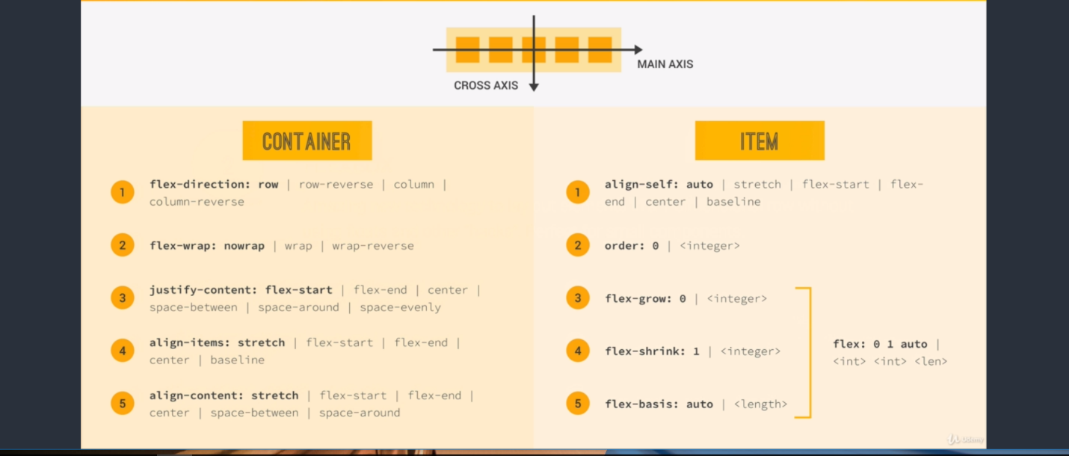

@keyframes animationname {keyframes-selector {css-styles;}}

keyframes-selector Required. Percentage of the animation duration.