Prometheus
Prometheus is an open-source system monitoring and alerting toolkit originally built at SoundCloud. It is now a standalone open source project . Prometheus joined the Cloud Native Computing Foundation in 2016 as the second hosted project, after Kubernetes.

Features
1. A multi-dimensional data model with time series data identified by metric name and
key/value pairs
2. PromQL, a flexible query language to leverage this dimensionality
3. No reliance on distributed storage; single server nodes are autonomous
4. Time series collection happens via a pull model over HTTP
5. Pushing time series is supported via an intermediary gateway
6. Targets are discovered via service discovery or static configuration
7. Multiple modes of graphing and dashboarding support

Components
The Prometheus ecosystem consists of multiple components, many of which are optional:

1. The main Prometheus server which scrapes and stores time series data
2. Client libraries for instrumenting application code
3. A push gateway for supporting short-lived jobs
4. Special-purpose exporters for services like HAProxy, StatsD, Graphite, etc.
5. An alertmanager to handle alerts
6. Various support tools.

Prometheus scrapes metrics from instrumented jobs, either directly or via an intermediary push gateway for short-lived jobs. It stores all scraped samples locally and runs rules over this data to either aggregate and record new time series from existing data or generate alerts. Grafana or other API consumers can be used to visualize the collected data.

When does it fit?

- Prometheus works well for recording any purely numeric time series.
- It fits both machine-centric monitoring as well as monitoring of highly dynamic service- oriented architectures.
- In a world of microservices, its support for multi-dimensional data collection and querying is a particular strength.
- Prometheus is designed for reliability, to be the system you go to during an outage to allow you to quickly diagnose problems.
- Each Prometheus server is standalone, not depending on network storage or other remote services.
- You can rely on it when other parts of your infrastructure are broken, and you do not need to setup extensive infrastructure to use it.

Architecture

Prometheus Installation.
Prometheus is a monitoring platform that collects metrics from monitored targets by scraping metrics HTTP endpoints on these targets.

Download the latest release of Prometheus for your platform, then extract it:
https://prometheus.io/download/
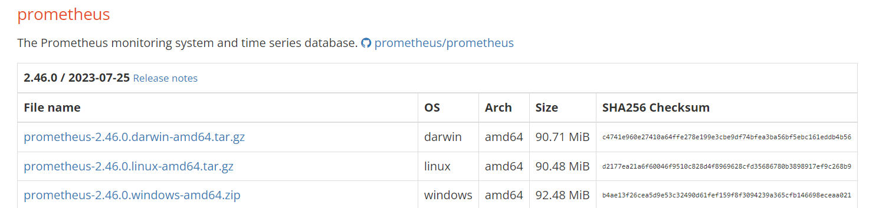

Download Prometheus

wget https://github.com/prometheus/prometheus/releases/download/v2.46.0/prometheus-2.46.0.linux-amd64.tar.gz

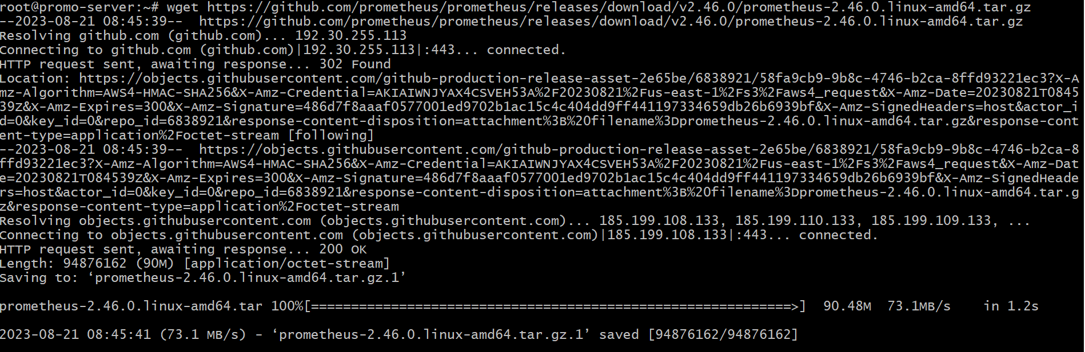

Extract the .tar.gz file
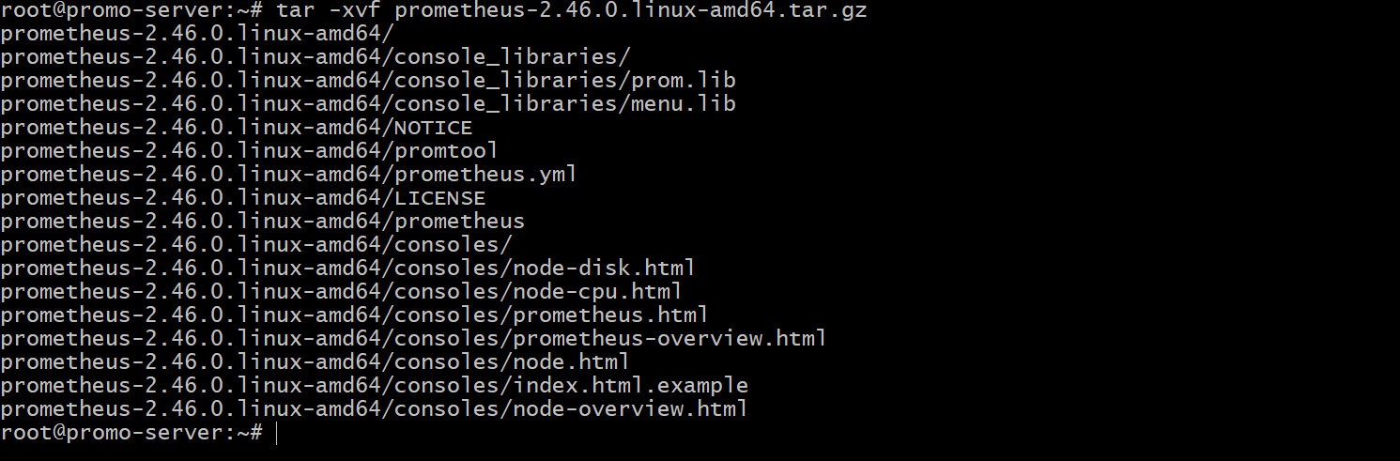

This will create a directory called prometheus-2.46.0.linux-amd64 containing two binary files (prometheus and promtool), consoles and console_libraries directories containing the web interface files, a license, a notice, and several example files.

Configuring Prometheus
Open the prometheus.yml will contain just enough information to run Prometheus for the first time.
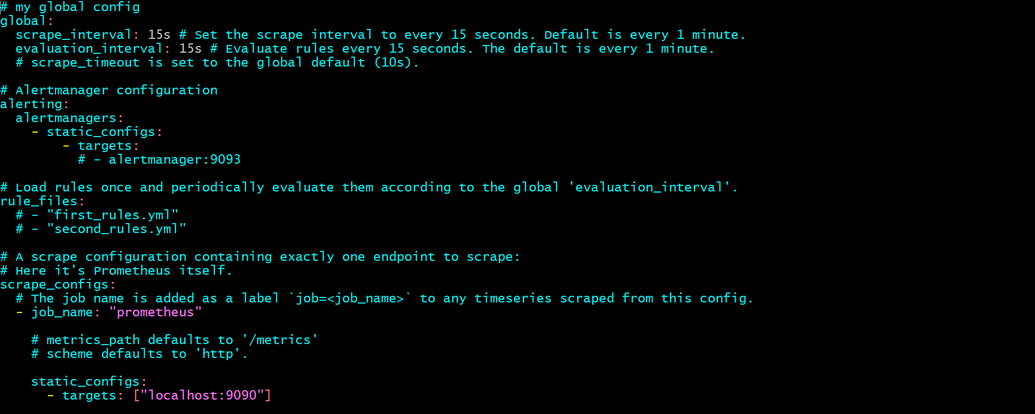

In the global settings, define the default interval for scraping metrics. Note that Prometheus will apply these settings to every exporter unless an individual exporter's own settings override the globals.
This scrape_interval value tells Prometheus to collect metrics from its exporters every 15 seconds, which is long enough for most exporters.
The evaluation_interval option controls how often Prometheus will evaluate rules. Prometheus uses rules to create new time series and to generate alerts.
The rule_files block specifies the location of any rules we want the Prometheus server to load. For now we've got no rules.
The last block, scrape_configs, controls what resources Prometheus monitors. Since Prometheus also exposes data about itself as an HTTP endpoint it can scrape and monitor its own health. In the default configuration there is a single job, called prometheus, which scrapes the time series data exposed by the Prometheus server. The job contains a single, statically configured, target, the localhost on port 9090. Prometheus expects metrics to be available on targets on a path of /metrics. So this default job is scraping via the URL: http://localhost:9090/metrics.

The time series data returned will detail the state and performance of the Prometheus server.

Starting Prometheus
~/prometheus-2.9.2.linux-amd64# ./prometheus --config.file=prometheus.yml &
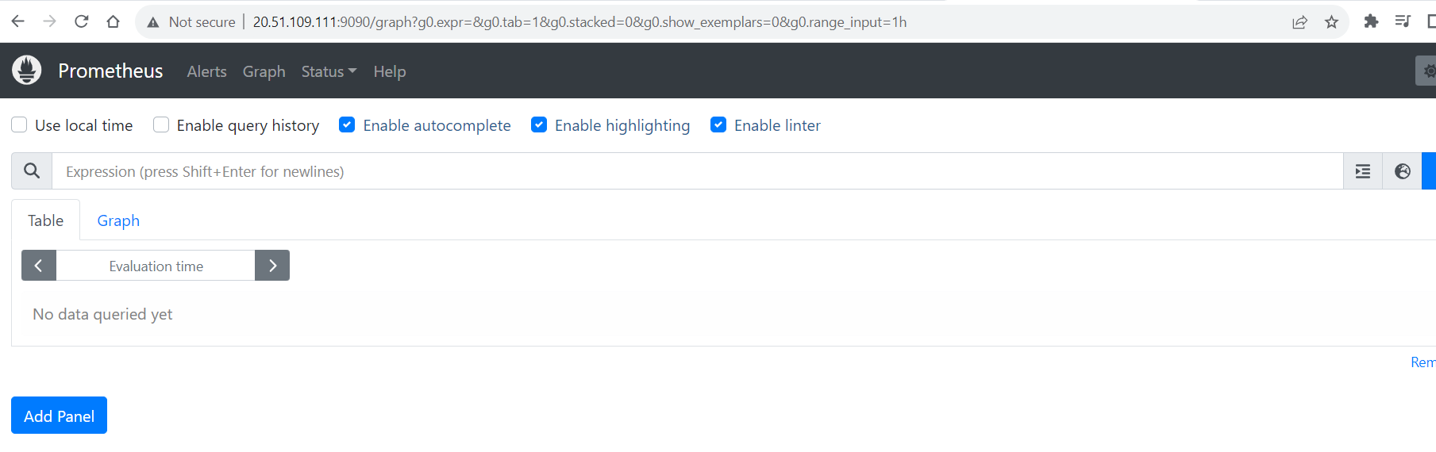

Prometheus should start up. You should also be able to browse to a status page about itself at http://20.51.109.111:9090. Give it about 30 seconds to collect data about itself from its own HTTP metrics endpoint.
Note: 20.51.109.111 -> Public IP of Virtual Machine where Prometheus is installed
You can also verify that Prometheus is serving metrics about itself by navigating to its own metrics endpoint: http://20.51.109.111:9090/metrics

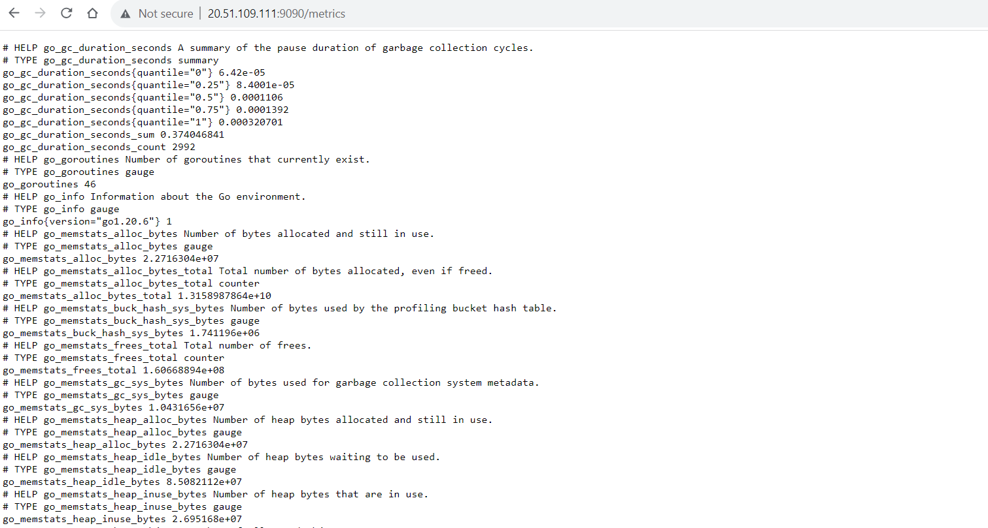

Using the expression browser

As you can gather from http://20.51.109.111:9090/metrics, one metric that Prometheus exports about itself is called promhttp_metric_handler_requests_total (the total number of /metrics requests the Prometheus server has served). Go ahead and enter this into the expression console

promhttp_metric_handler_requests_total

If we were only interested in requests that resulted in HTTP code 200, we could use this query to retrieve that information:
promhttp_metric_handler_requests_total{code="200"}

To count the number of returned time series, you could write:
count(promhttp_metric_handler_requests_total)

Using the graphing interface

To graph expressions, navigate to http://20.51.109.111:9090/graph and use the "Graph" tab.

For example, enter the following expression to graph the per-second HTTP request rate returning status code 200 happening in the self-scraped Prometheus.

rate(promhttp_metric_handler_requests_total{code="200"}[1m])

MONITORING LINUX HOST METRICS WITH THE NODE EXPORTER
The Prometheus Node Exporter exposes a wide variety of hardware- and kernel-related metrics.

NOTE: While the Prometheus Node Exporter is for *nix systems, there is a WMI exporter for Windows that serves an analogous purpose.

Installing and running the Node Exporter
The Prometheus Node Exporter is a single static binary that you can install via tarball.
https://prometheus.io/download/#node_exporter download from here.
wget https://github.com/prometheus/node_exporter/releases/download/v1.6.1/node_exporter-1.6.1.linux-amd64.tar.gz
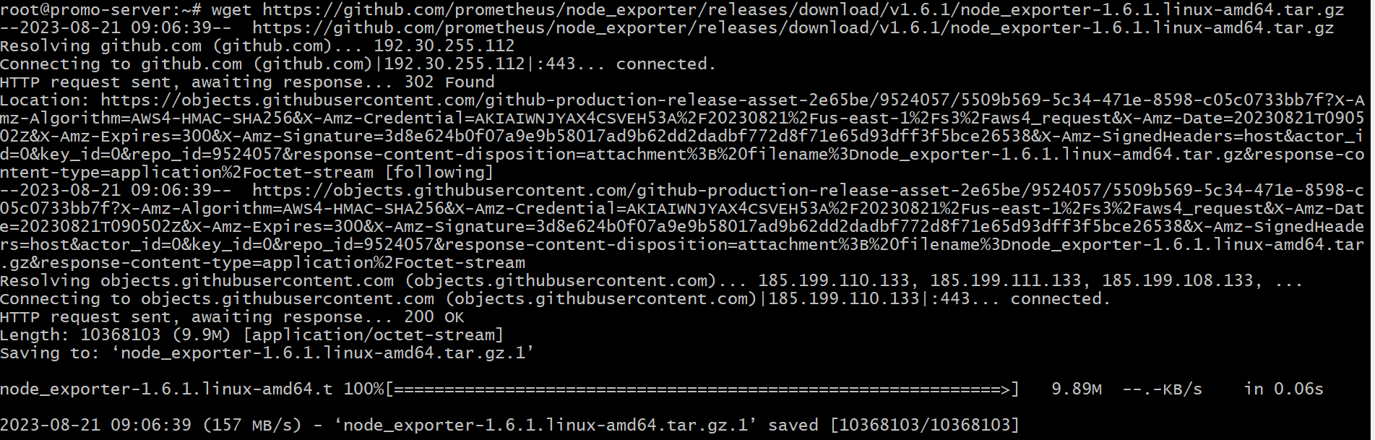
Then extract
$ tar xvzf node_exporter-1.6.1.linux-amd64.tar.gz
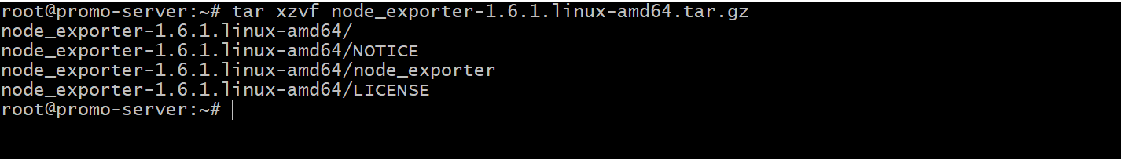
$ cd node_exporter-1.6.1.linux-amd64

$ ./node_exporter &

You should see output like this indicating that the Node Exporter is now running and exposing metrics on port 9100

Node Exporter metrics

Once the Node Exporter is installed and running, you can verify that metrics are being exported by cURLing the /metrics endpoint.
$ curl http://20.51.109.111:9100/metrics
You will the output like below

Done…! We are successfully installed node exporter. The Node Exporter is now exposing metrics that Prometheus can scrape, including a wide variety of system metrics further down in the output (prefixed with node_). To view those metrics (along with help and type information)

$ curl http:// 20.51.109.111:9100/metrics | grep "node_"
Configuring your Prometheus instances

Your locally running Prometheus instance needs to be properly configured in order to access Node Exporter metrics. The following scrape_config block (in a prometheus.yml configuration file) will tell the Prometheus instance to scrape from the Node Exporter via localhost:9100

Go to Prometheus installation directory and modify Prometheus.yml and run

$ ./prometheus --config.file=./prometheus.yml &

Exploring Node Exporter metrics through the Prometheus expression browser

Now that Prometheus is scraping metrics from a running Node Exporter instance, you can explore those metrics using the Prometheus UI (aka the expression browser). Navigate to localhost:9090/graph in your browser and use the main expression bar at the top of the page to enter expressions. The expression bar looks like this
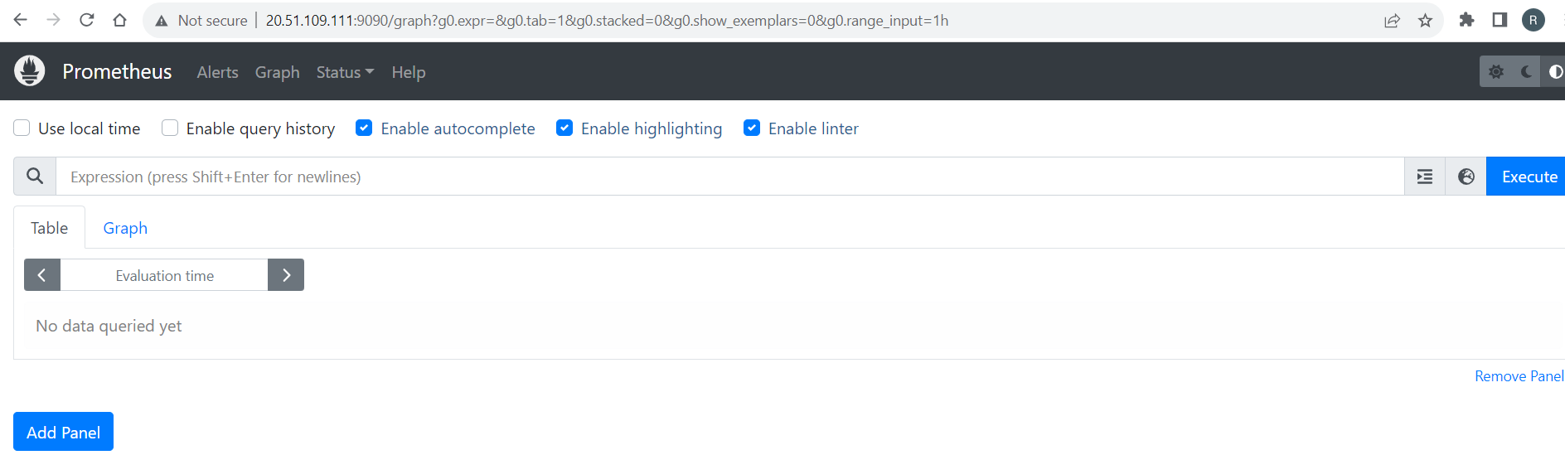

Metrics specific to the Node Exporter are prefixed with node_ and include metrics like
node_cpu_seconds_total and node_exporter_build_info

rate(node_cpu_seconds_total{mode="system"}[1m]) The average amount of CPU time spent in system mode, per second, over the last minute (in seconds)
node_filesystem_avail_bytes The filesystem space available to non-root users (in bytes)

rate(node_network_receive_bytes_total[1m]) The average network traffic received, per second, over the last minute (in bytes)

node_load15 load average in 15 seconds

If you want configure multiple hosts we can add in prometheus.yml like below

scrape_configs:
# The job name is added as a label `job=<job_name>` to any timeseries scraped from this config.
- job_name: 'node'

# metrics_path defaults to '/metrics' # scheme defaults to 'http'. static_configs:
- targets: ['192.168.x.x:9100']
- targets: ['192.168.x.y:9100']
- targets: ['192.168.x.z:9100']

GRAFANA
Grafana supports querying Prometheus. The Grafana data source for Prometheus is included since Grafana 2.5.0

Installing Grafana

Refer link - https://grafana.com/docs/grafana/latest/setup-grafana/installation/debian/

Complete the following steps to install Grafana from the APT repository:

- To install required packages and download the Grafana repository signing key, run the following commands:
    - sudo apt-get install -y apt-transport-https
    - sudo apt-get install -y software-properties-common wget
    - sudo wget -q -O /usr/share/keyrings/grafana.key https://apt.grafana.com/gpg.key

- To add a repository for stable releases, run the following command:
- echo "deb [signed-by=/usr/share/keyrings/grafana.key] https://apt.grafana.com stable main" | sudo tee -a /etc/apt/sources.list.d/grafana.list

- To add a repository for beta releases, run the following command:
- echo "deb [signed-by=/usr/share/keyrings/grafana.key] https://apt.grafana.com beta main" | sudo tee -a /etc/apt/sources.list.d/grafana.list

- Run the following command to update the list of available packages:
  - sudo apt update
  - sudo apt-get install Grafana

To Stop and Start system service for Grafana server

sudo systemctl stop grafana-server
sudo systemctl start grafana-server

By default, Grafana will be listening on http://localhost:3000. The default login is "admin" / "admin".

Creating a Prometheus data source

To create a Prometheus data source:
1. Click on the Grafana logo to open the sidebar menu.
2. Click on "Data Sources" in the sidebar.
3. Click on "Add New".
4. Select "Prometheus" as the type.
5. Set the appropriate Prometheus server URL (for example, http://localhost:9090/)
6. Adjust other data source settings as desired (for example, turning the proxy access off).
7. Click "Add" to save the new data source.

The following shows an example data source configuration:

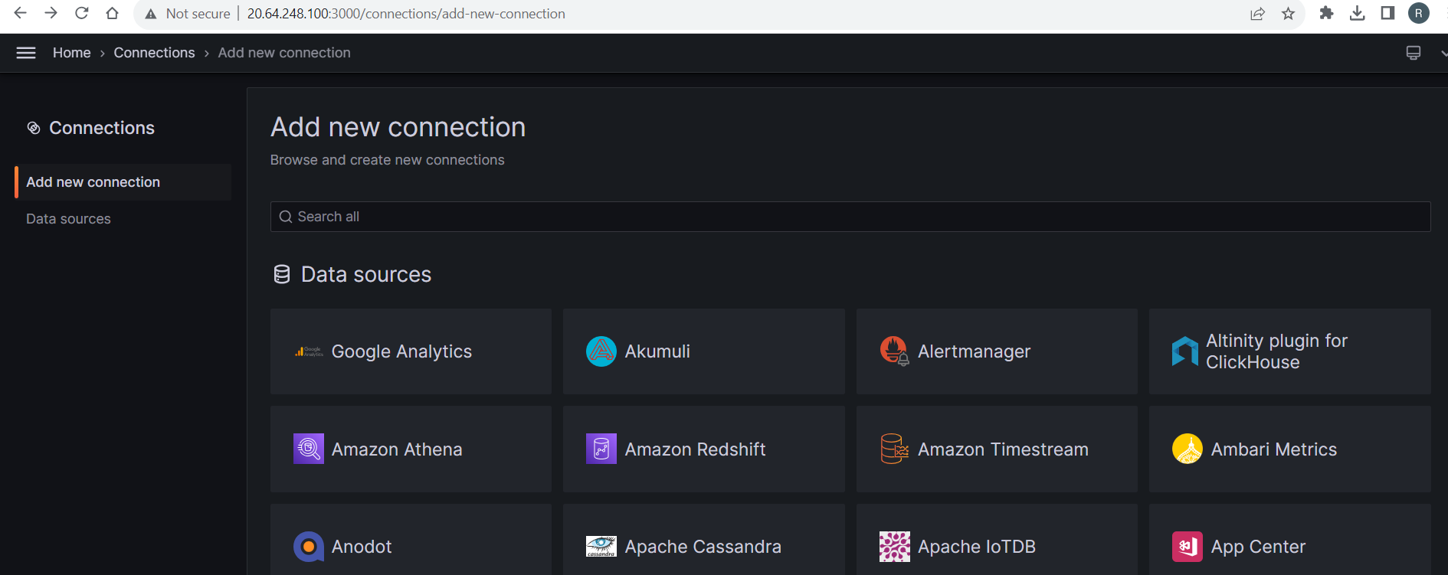

Once you select the Prometheus it will redirect the configuration page. Add necessary details click save and test.

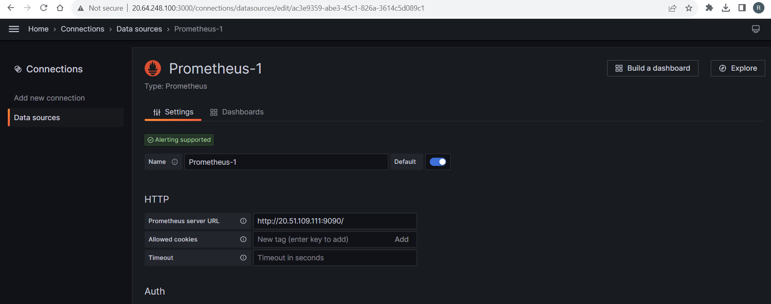

Creating a Prometheus graph

Follow the standard way of adding a new Grafana graph. Then:
1. Go to panel bar click + mark create dashboard.
2. Check on query.
3. Enter a query in query panel.
4. Under the "Metrics" tab, select your Prometheus data source (bottom right).
5. To format the legend names of time series, use the "Legend format" input. For example, to show only the method and status labels of a returned query result, separated by a dash, you could use the legend format string {{method}} - {{status}}.
6. Tune other graph settings until you have a working graph.

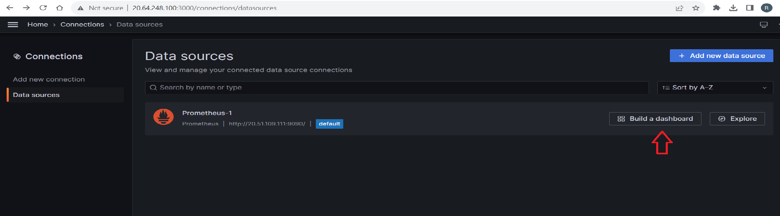

Then save the dash board

Now if you want node exporter dash boards into Grafana serach in google like “grafana node exporter metrics”. You will get some default dash boards like below.

https://grafana.com/dashboards/405
https://grafana.com/dashboards/1860
https://grafana.com/dashboards/5174
https://grafana.com/dashboards/9096

if we want add dash board of node exporter into Grafana goto dash board click + mark and click import

Then add dashboard id or url then click load.

And new page select data source to Prometheus and click import.

And see the dash board like below

If you want to troubleshoot, add big size file and check the graphs.

Run this command in your system .it will create 10gb file.

fallocate -l 10G gentoo_root.img

select last 5 min graph and go diskspace section and see the changes in disk space graph goto this Basic Net / Disk Info section.

Monitoring http/https endpoints using Prometheus BlackBox exporter

To monitor http/https endpoints , we need to install the BlackBox exporter, Blackbox exporter will be installed in the Prometheus server.

Installing and running the BlackBox Exporter
The Prometheus Blackbox Exporter is a single static binary that you can install via tarball.
https://prometheus.io/download/#blackbox_exporter download from here.
wget https://github.com/prometheus/blackbox_exporter/releases/download/v0.24.0/blackbox_exporter-0.24.0.linux-amd64.tar.gz

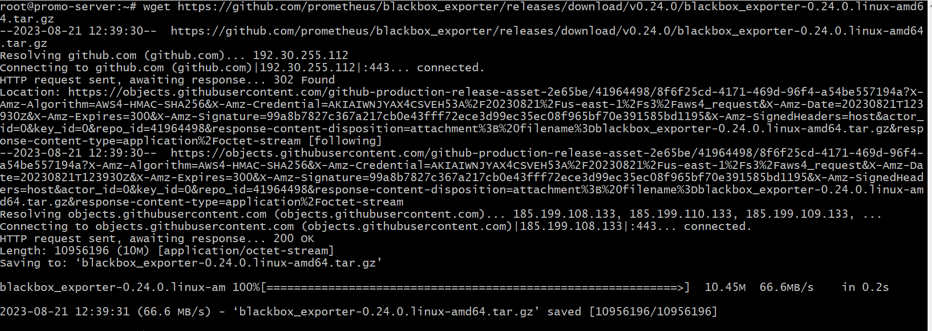
Then extract
$ tar xvzf blackbox_exporter-0.24.0.linux-amd64.tar.gz
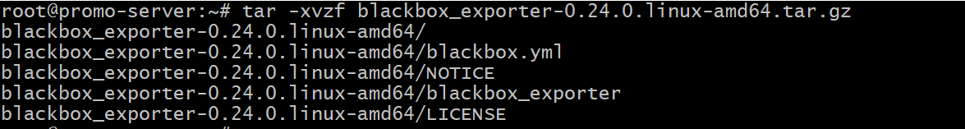
$ cd blackbox_exporter-0.24.0.linux-amd64

$ ./blackbox_exporter –config.file=blackbox.yml &> output.log &

You should see output like this indicating that the black exporter is now running and exposing metrics on port 9115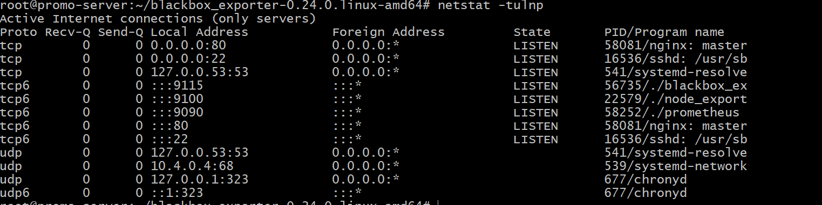
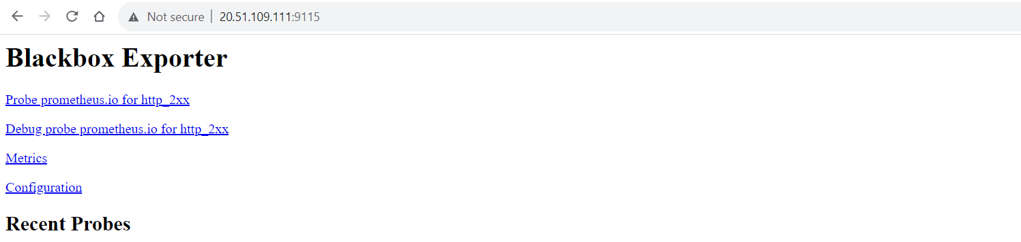

Configuring your Prometheus instances Prometheus.yml file

Your locally running Prometheus instance needs to be properly configured in order to access Blackbox exporter metrics. The following scrape_config block (in a prometheus.yml configuration file) will tell the Prometheus instance to scrape from the Blackbox Exporter via localhost:9115

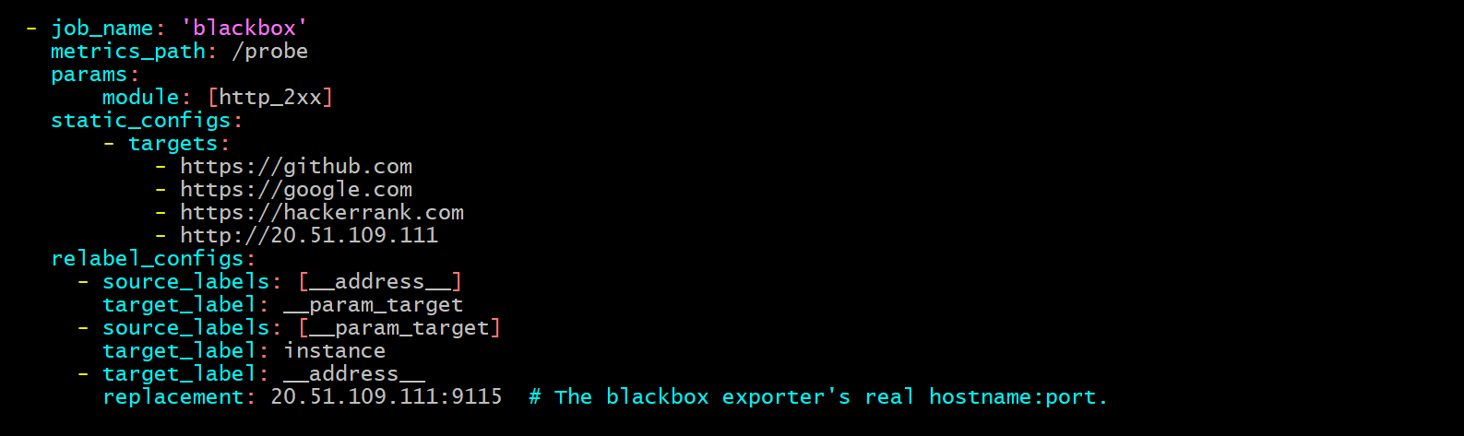
Go to Prometheus installation directory and modify Prometheus.yml and run

$ ./prometheus --config.file=./prometheus.yml &

To check if everything is working fine , we need to check in Prometheus targets.
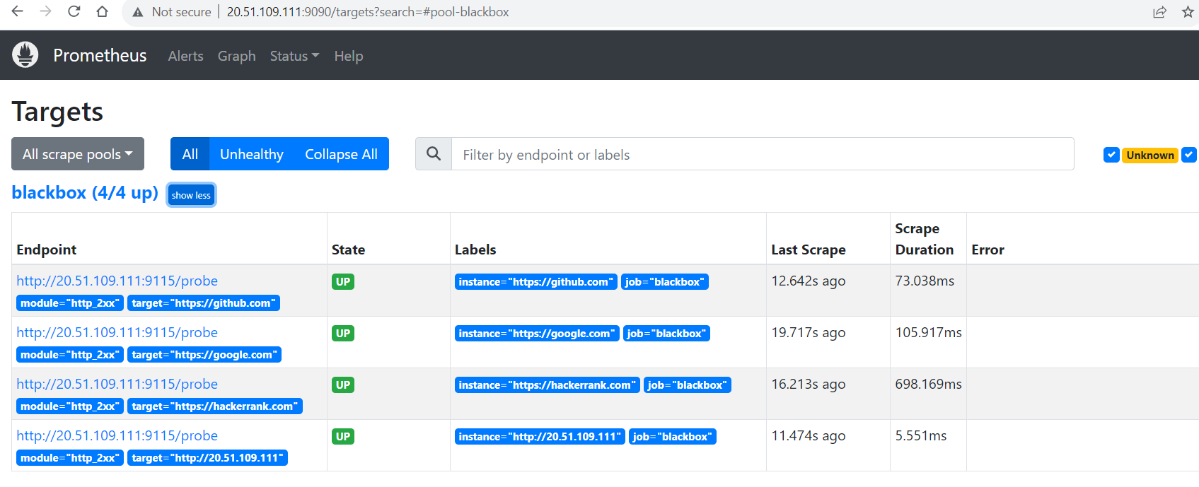

To display in Grafana , we need to write dashboard.json file which further will be uploaded in the Grafana to show as Dashboard, you can download the .json file and keep it in your local drive

Launch the http://20.64.248.100:3000/ in the browser again and click on Dashboards
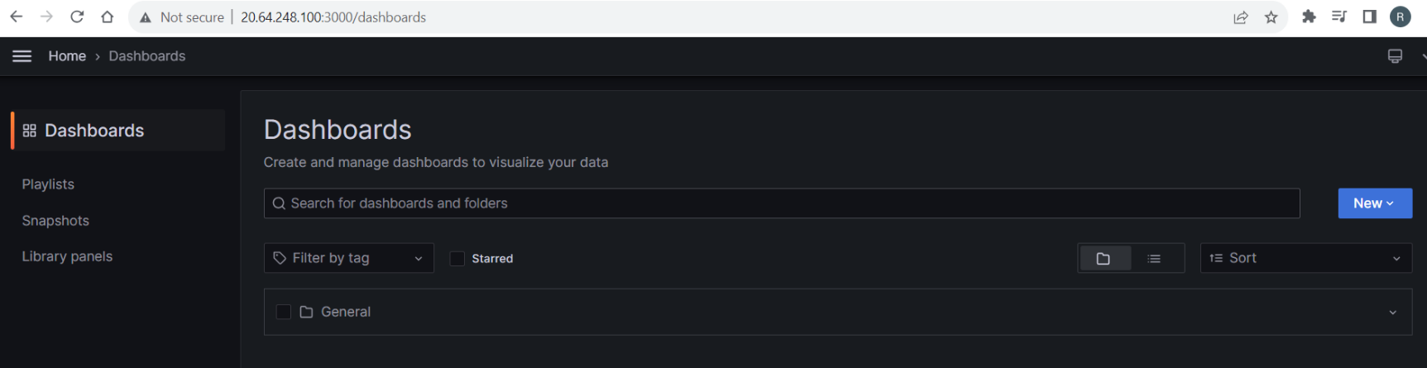
Click on the New , and select Import
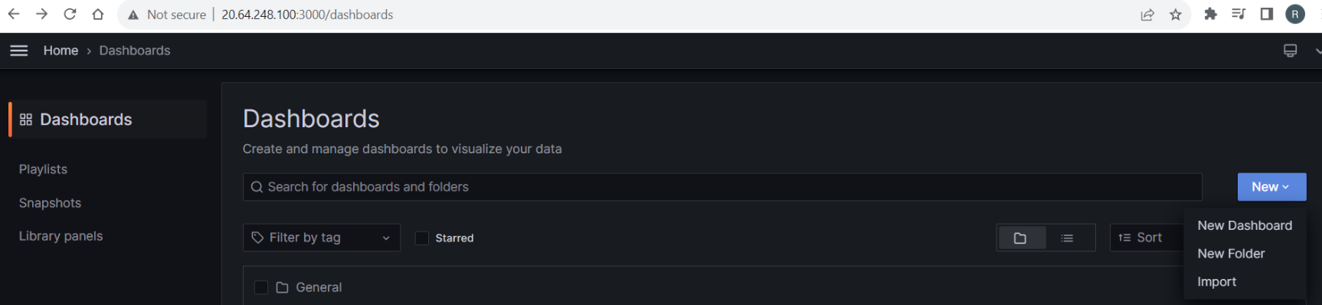
Click Import, it will prompt to import the dashboard.json file which is there in your local drive
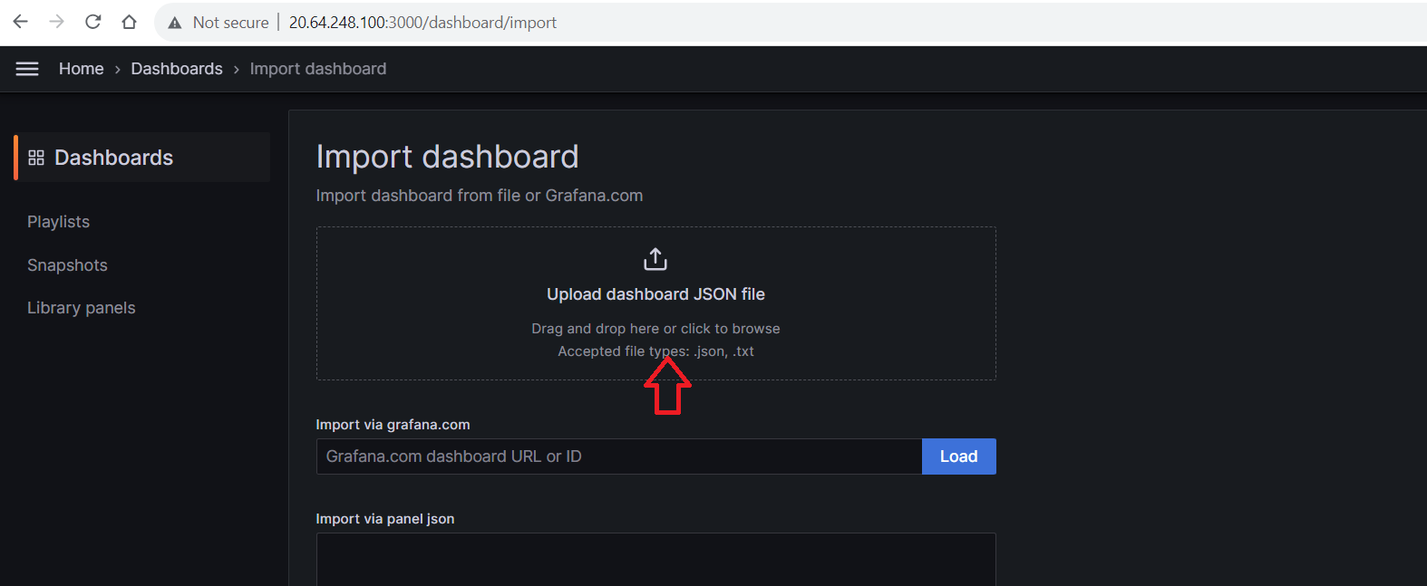

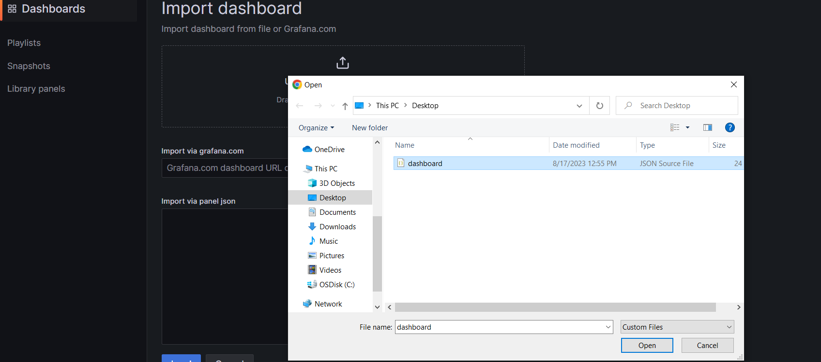

After the Dashboard.json is uploaded, you will be seeing the dashboard where you can monitor all http urls



