SYNOPSIS

TELE NETWORK SYSTEM

Computers have become an essential part of organizational information processing because of the power of technology and the volume of data to be processed. Through the technology, the manual process, defects and time consumption can be reduced. That’s in all the area of business, computer technology are widely been implemented. Hence the inception of computers had a great role in reducing large tasks to simpler one.
The project modules included are
- Customer Details
- Customer Connection Details
- Area Information Entry
- Booking Information
- Reading Details
- Connection and Disconnected Details
Thus, the daily manual process of the “Telephone Office” like Customer Allotment Details, Area Information, Booking details, Connection and Disconnected Details had been implemented which can be followed through the computer technology i.e., “Tele Network System”.
Visual basic 6.0 is used as the front-end tool and for maintaining the database MS-Access is used as the backend. Visual Basic is referred to as an “Event Driven” programming language because all the code is triggered by specific events that the user performs. This puts the user firmly in control of how the program flows and therefore increases user satisfaction with the program. The key portions of a Visual Basic project are the forms, controls, and code modules. A form or control has properties that you can alter. The program’s code is contained primarily in events mentioned below in various forms in order to keep track of the system.
PROJECT OBJECTIVE

- The Tele Networking Advantage works with your practice to design a system where your office will get us the information we need to do your billing in the fastest, most accurate way possible.
- Time Consuming and Easy to View
- This invention provides a means for reducing the widespread problem of the losses to businesses from (1) the use by employees of business telephones for personal long distance calls s well as (2) fraud by third parties. By use of _his invention telephone bills can be augmented with information about the telephone numbers called obtained from the directories and employees required to reimburse the business for their personal calls.
- The reports can be produced listing only long distance calls to telephone numbers not on a pre-authorized list and providing directory information for those calls. For example, the pre-authorized list could be composed of the telephone numbers of other offices of the business, customers of the business, and suppliers of the business.

Visual Basic 6.0
The visual part refers to the method used to create the graphical user interface (GUI). The ‘Basic’ part refers to the BASIC (Beginners All-Purpose Symbolic Instruction Code) Language, Visual Baisc has evolved from the original basic language and now contains several hundred statements functions and keyword, many of which relate directly to the window GUI.
The first tool to make windows based programming easy the Microsoft Visual Basic version 6.0 programming. System is now the leading tool for helping, developers create and use Active X Components, build Active Documents for intranet browsers, build client/sever or multi-tier solutions with high speed data access and built fast applications based on windows version 6.0 adds a native code compiler, implicit multi-threading and integration with Microsoft Transaction Server to bring a new level of scalability to server based components built with Visual Basic.
Visual Basic 6.0 also provides developers with a new interface for faster programming. The IDE now features Multiple Document Interface (MDI) with docking and linking. Window to elimination unnecessary, mouse and keyboard actions and the code editors offers Intelli Sense Technology such as Quick Tips, Data Tips, List Members and List Constants which elimination the need to memorize sysntax and learn object models.
Visual Basic 6.0 is an application development tool used in developing Client/Sever Applications. Before beginning with visual basic 6, let’s have a look at the Client/server architecture.

CLIENT/SERVER ACHITECTURE

Client/Server is an architecture, which can be used by multiple users simultaneously. The system also offers advanced tools that can be used for data security, data integrity and database administration. Business conditions are implemented as functions and procedures.
The data is processed in the Front End but stored and served by the powerful Back End. Client/Server programming is also called Distributed Application Processing and Co-Operative Application Processing. Client/Server has three components, each focusing on a specified job.
The data is processed in the Front End but stored and served by the powerful Back End. Client/Server programming is also called Distributed Application Processing and Co-Operative application processing. Client/Server has three components, each focusing on a specified job.

- A database Server.
- A Client Application.
- A Network for connecting the first two components.

DATABASE SERVER

The functions of the database are as follows.

- Managing a single table containing information among many concurrent users.
- Controlling database access and other security requirements.
- Protecting database table information with backup and recovery features.
- Enforcing global data integrity rules across all client applications.

CLIENT APPLICATION

- Presenting an interface to the user so that the data in the table can be manipulated with ease.
- Managing presentation logic, such as popup lists on a data entry form, bar graphs etc.
- Validating the data keyed in by the user.
- Requesting and receiving information to and from the database server.

IMPORTANT FEATURES:

- The application is graphical user interface.
- Event driven programming language where all the activities are triggered by one event or the other.
- Quick development of object based window database application with little coding.
- Built in database support.
- Client server architecture benefits.
- Provides simple debugging tools.

STATES OF VISUAL BASIC

Visual Basic applications can be viewed in three distinct states;

- Design
- Execution
- Break

In Design State, you can edit user interface or add code to the application. In Execution State, the application is running and only a few menu commands are available.

EVENT – DRIVEN PROGRAMMING

The two main themes in developing with Visual Basic are:

- Visual Design
- Event Driven Programming

Applications written in Visual Basic are Event Driven. It can be best understood by comparing it with Procedural programming. When we program in Visual Basic, it must be first decided how the application should interact with the user. In other words, we have to decide how each control reacts to user actions, such as the click of a mouse; keystrokes and these reactions must be programmed. This is called Event Driven Programming, as the event caused by the user determines the flow of application.

MS-Access 2003

MS-ACCESS 2003

Microsoft Access allows us to manage all our dimensions from a single database file. Microsoft Access is a relational database management system. It is a set of two-dimensional table in which data is represented in rows and columns. An access database consists of objects such as table, form, query and report.
Menus and toolbars are completely programmable. Move the mouse over a variable or expressions while your code is suspended and access will automatically display its current value. Access is a relational database, which means that it allows data that has been stored in different places to be linked.

FEATURES

- Access has VBA integrated development environment
- Access share Microsoft office programmability and data access object.
- Access form loads and executes faster.
- Use tools, toolbars, create and customize both menus and toolbar. When code is suspended place the mouse on expression and it will automatically display its current values.
- Controls are access objects that help you display, print and use your data.
- Macros are tools that can help to automate complex or time-consuming repetitive manual task.
- Command buttons are onscreen objects that you can click on to run macros.

SYSTEM STUDY
System analysis is a process of gathering the facts concerning the system breaking them into elements and relationship between elements. It provides a framework for visualizing the organizational and environmental factors that operate on a system. The quality of work performed by a machine is usually uniform, neat and more reliable when compared to doing the same operations manually.

EXISTING SYSTEM
In the existing system the billing alone is maintained in FoxPro. The bill details, the customer details and the booking Details are maintained manually. The study of the existing system revealed that the system has several drawbacks.

PROBLEMS
- The existing system has no security measure against logging in and no checks are made for authorized users.
- The end user has to remember a lot of command to make efficient use of the system.
- The system does not have any descriptive reports and thus did not help management in decision-making.
- The sales information per day is unable to find.
- Enormous amount of time is consumed

SYSTEM ENVIRONMENT:

HARDWARE CONFIGURATION:

PROCESSOR : PENTIUM IV
HARD DISK CAPACITY : 40 GB
MONITOR : 14 “SAMTRON MONITOR
FLOPPY DISK DRIVE : 1.44 MB
PRINTER : TVS 80 COLOR
INTERNAL MEMORY CAPACITY : 128 MB
KEYBOARD : LOGITECH OF 104 KEYS
CPU CLOCK : 1.08 GHz
MOUSE : LOGITECH MOUSE

SOFTWARE CONFIGURATION:

OPERATING SYSTEM : WINDOWS XP
FRONT END : VISUAL BASIC6.0
BACK END : MS-Access 2003

PROPOSED SYSTEM

The proposed system is been developed to maintain the Tele Network Information by the customers to maintain the booking details, bill details, sales details, Area Wise Details, Disconnect Details etc.
The proposed system is a computerized one, in which time is greatly reduced. Since this is a computerized one there will be no chance of human error to encounter. In the proposed system there will be a lot of improvement in the quality, speed and efficiency. Since it is user friendly any one can operate individually.
- The system will decrease the amount of time required to prepare the details, and generating reports.
- Security is provided to restrict system access by accessing user password.
- The system is user friendly, even a person without knowledge of the computer can work easily.

DESIGN NOTATIONS

DATA FLOW DIAGRAM

The first step is to draw a data flow diagram (DFD). The DFD was first developed by Larry Constantine as a way of expressing system requirements in graphical form.
A DFD also known as a “bubble chart” has the purpose of clarifying system requirements and identifying major transformations that will become programs in system design. So, it is the starting point of the design phase that functionally decomposes the requirements specifications down to the lowest level of detail. A DFD consists of series of bubbles join by the data flows in the system.

The purpose of data flow diagrams is to provide a semantic bridge between users and systems developers. The diagrams are:

• Graphical, eliminating thousands of words;

• Logical representations, modeling WHAT a system does, rather than physical models showing HOW it does it;

• Hierarchical, showing systems at any level of detail; and

• jargon less, allowing user understanding and reviewing.

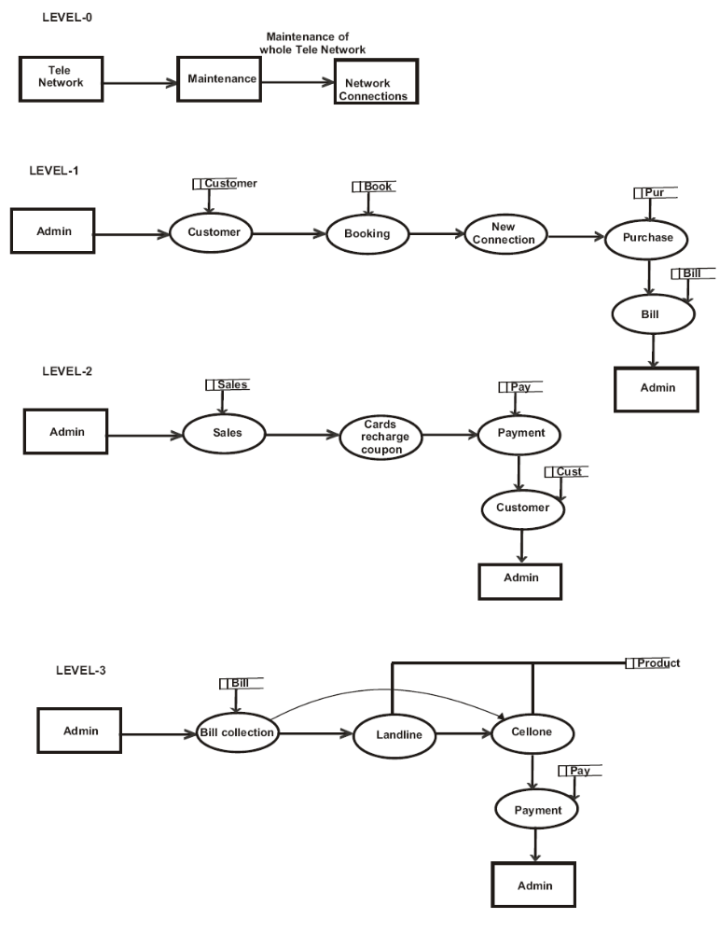

DATA MODEL

Entity Relationship Diagram is a model that describes the stored data layout of a system at high level of abstraction. Entity Relationship Diagram enables us to examine and highlight data structures and relationship independent of the processes or control flow. The participation of the entities in the relationship and cardinality ratio are indicated in the entity relationship diagram to provide further information .The Entity Relationship Diagram shows the relationship and types of relationship between the entities. The entity for the system “TELE NETWORKING SYSTEM” is shown in Fig 3.3.1.The major components are

Rectangle - represent the entity sets
- Ellipses - which represents attributes
- Diamond - which represent relationship set
- Line - which links the attributes to entity sets and entity sets to relationship
set

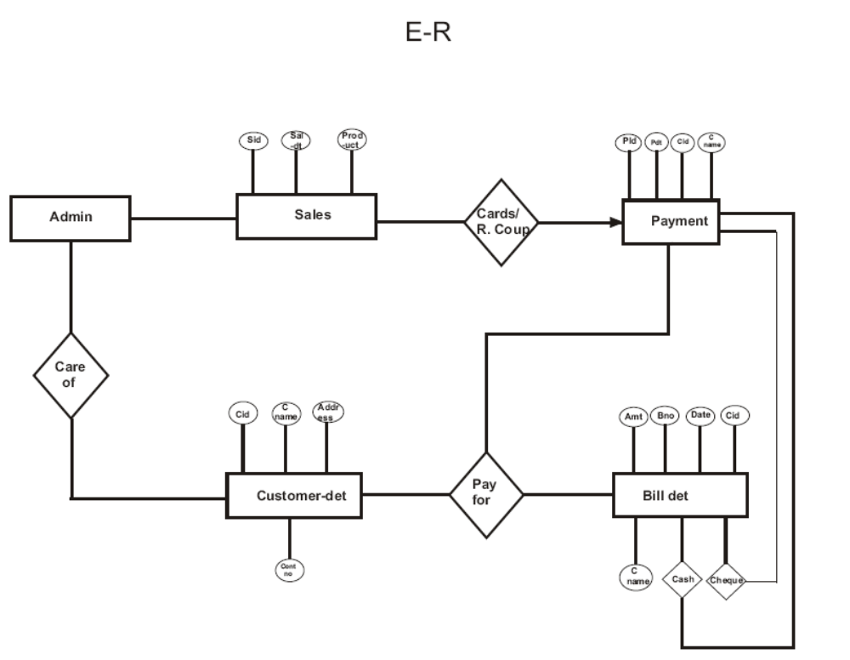

4. SYSTEM DESIGN

System design is the process of planning a new system to complement or altogether replace the old system. The purpose of the design phase is the first step in moving from the problem domain to the solution domain. The design of the system is the critical aspect that affects the quality of the software. System design is also called top-level design. The design phase translates the logical aspects of the system into physical aspects of the system.

4.1 TABLE DESIGN
Database design is a collection of interactive data store. It is an effective method of defining, storing and retrieving the information in the database. The database design is independent of any relational database management system and it is a logical model. The logical design is mapped according to RDBMS used for implementation. The data contained in the database can be multiple application and users. It prevents the unauthorized from accessing data and ensures the privacy of data.
The ERD to relational scheme mapping is done in order to make the most efficient use of table space. The relations of the scheme are converted into table and key attributes are converted into primary keys. The various tables that are used in the system are derived from the Entity Relationship Diagram. The tables maintained are customer table, purchase table, loan table, sales table, cash table, registration table, insurance table, employee pay slip table.

INPUT DESIGN:

Input design is the process of converting the user-oriented. Input to a computer based format. The goal of the input design is to make the data entry easier , logical and free error. Errors in the input data are controlled by the input design. The quality of the input determines the quality of the system output.
All the data entry screen are interactive in nature, so that the user can directly enter into data according to the prompted messages. The user are also can directly enter into data according to the prompted messages. The users are also provided with option of selecting an appropriate input from a list of values. This will reduce the number of error, which are otherwise likely to arise if they were to be entered by the user itself.
Input design is one of the most important phase of the system design. Input design is the process where the input received in the system are planned and designed, so as to get necessary information from the user, eliminating the information that is not required. The aim of the input design is to ensure the maximum possible levels of accuracy and also ensures that the input is accessible that understood by the user.
The input design is the part of overall system design, which requires very careful attention. if the data going into the system is incorrect then the processing and output will magnify the errors.

The objectives considered during input design are:
- Nature of input processing.
- Flexibility and thoroughness of validation rules.
- Handling of properties within the input documents.
- Screen design to ensure accuracy and efficiency of the input relationship with files.
- Careful design of the input also involves attention to error handling, controls, batching and validation procedures.

Input design features can ensure the reliability of the system and produce result from accurate data or they can result in the production of erroneous information. The input design of the system includes the following,

Form Designs

OUTPUT DESIGN

Output design is very important concept in the computerized system, without reliable output the user may feel the entire system is unnecessary and avoids using it. The proper output design is important in any system and facilitates effective decision-making. The output design of this system includes various reports.
Computer output is the most important and direct source of information the user. Efficient, intelligible output design should improve the system’s relationships with the user and help in decision making. A major form of output is the hardcopy from the printer.
Output requirements are designed during system analysis. A good starting point for the output design is the data flow diagram. Human factors reduce issues for design involved addressing internal controls to ensure readability.
An application is successful only when it can provide efficient and effective reports. Reports are actually presentable form of the data. The report generation should be useful to the management for future reference. The report are the main source of information for user’s operators and management. Report generated are a permanent record of the transaction occurred. After any valid transactions; have commenced the report of the same are generation and: filed for future reference. Great care has been taken when designation the report as it plays an important role in decision-marking.

Reports

TESTING AND IMPLEMENTATION

TESTING

Testing is a series of different tests that whose primary purpose is to fully exercise the computer based system. Although each test has a different purpose, all work should verify that all system element have been properly integrated and performed allocated function. Testing is the process of checking whether the developed system works according to the actual requirement and objectives of the system.
It is the stage of implementation, which ensures that system works accurately and effectively before the live operation Commences. It is a confirmation that all are correct and opportunity to show the users that the system must be tested with text data and show that the system will operate successfully and produce expected results under expected conditions.
Before implementation, the proposed system must be tested with raw data to ensure that the modules of the system work correctly and satisfactorily. The system must be tested with valid data to achieve its objective.
The philosophy behind testing is to find the errors. A good test is one that has a high probability of finding an undiscovered error. A successful test is one that uncovers the undiscovered error. Test cases are devised with this purpose in mind. A test case is a set of data that the system will process as an input. However the data are created with the intent of determining whether the system will process them correctly without any errors to produce the required output.

Unit Test
The first test in the development process is the unit test. The source code is normally divided into modules, which in turn are divided into smaller units called units. These units have specific behavior. The test done on these units of code is called unit test. Unit test depends upon the language on which the project is developed. Unit tests ensure that each unique path of the project performs accurately to the documented specifications and contains clearly defined inputs and expected results.

System Test
Several modules constitute a project. If the project is long-term project, several developers write the modules. Once all the modules are integrated, several errors may arise. The testing done at this stage is called system test.
System testing ensures that the entire integrated software system meets requirements. It tests a configuration to ensure known and predictable results. System testing is based on process descriptions and flows, emphasizing pre-driven process links and integration points.

Functional Test
Functional test can be defined as testing two or more modules together with the intent of finding defects, demonstrating that defects are not present, verifying that the module performs its intended functions as stated in the specification and establishing confidence that a program does what it is supposed to do.

Acceptance Testing
Testing the system with the intent of confirming readiness of the product and customer acceptance.

SYSTEM IMPLEMENTATION

The purpose of System Implementation can be summarized as follows:
It making the new system available to a prepared set of users (the deployment), and positioning on-going support and maintenance of the system within the Performing Organization (the transition). At a finer level of detail, deploying the system consists of executing all steps necessary to educate the Consumers on the use of the new system, placing the newly developed system into production, confirming that all data required at the start of operations is available and accurate, and validating that business functions that interact with the system are functioning properly. Transitioning the system support responsibilities involves changing from a system development to a system support and maintenance mode of operation, with ownership of the new system moving from the Project Team to the Performing Organization.
List of System implementation is the important stage of project when the theoretical design is tuned into practical system. The main stages in the implementation are as follows:

- Planning
- Training
- System testing and
- Changeover Planning

Planning is the first task in the system implementation. Planning means deciding on the method and the time scale to be adopted. At the time of implementation of any system people from different departments and system analysis involve. They are confirmed to practical problem of controlling various activities of people outside their own data processing departments. The line managers controlled through an implementation coordinating committee. The committee considers ideas, problems and complaints of user department, it must also consider;

- The implication of system environment
- Self selection and allocation form implementation tasks
- Consultation with unions and resources available
- Standby facilities and channels of communication
The following roles are involved in carrying out the processes of this phase. Detailed descriptions of these roles can be found in the Introductions to Sections I and III.
_ Project Manager
_ Project Sponsor
_ Business Analyst
_ Data/Process Modeler
_ Technical Lead/Architect
_ Application Developers
_ Software Quality Assurance (SQA) Lead
_ Technical Services (HW/SW, LAN/WAN, TelCom)
_ Information Security Officer (ISO)
_ Technical Support (Help Desk, Documentation, Trainers)
_ Customer Decision-Maker
_ Customer Representative
_ Consumer

The purpose of Prepare for System Implementation is to take all possible steps to ensure that the upcoming system deployment and transition occurs smoothly, efficiently, and flawlessly. In the implementation of any new system, it is necessary to ensure that the Consumer community is best positioned to utilize the system once deployment efforts have been validated. Therefore, all necessary training activities must be scheduled and coordinated. As this training is often the first exposure to the system for many individuals, it should be conducted as professionally and competently as possible. A positive training experience is a great first step towards Customer acceptance of the system.
During System Implementation it is essential that everyone involved be absolutely synchronized with the deployment plan and with each other. Often the performance of deployment efforts impacts many of the Performing Organization’s normal business operations. Examples of these impacts include:
_ Consumers may experience a period of time in which the systems that they depend on to perform their jobs are temporarily unavailable to them. They may be asked to maintain detailed manual records or logs of business functions that they perform to be entered into the new system once it is operational.
_ Technical Services personnel may be required to assume significant implementation responsibilities while at the same time having to continue current levels of service on other critical business systems.
_ Technical Support personnel may experience unusually high volumes of support requests due to the possible disruption of day-to-day processing.
Because of these and other impacts, the communication of planned deployment activities to all parties involved in the project is critical. A smooth deployment requires strong leadership, planning, and communications. By this point in the project lifecycle, the team will have spent countless hours devising and refining the steps to be followed. During this preparation process the Project Manager must verify that all conditions that
must be met prior to initiating deployment activities have been met, and that the final ‘green light’ is on for the team to proceed. The final process within the System Development Lifecycle is to transition ownership of the system support responsibilities to
the Performing Organization. In order for there to be an efficient and effective transition, the Project Manager should make sure that all involved parties are aware of the transition plan, the timing of the various transition activities, and their role in its execution.
Due to the number of project participants in this phase of the SDLC, many of the necessary conditions and activities may be beyond the direct control of the Project Manager. Consequently, all Project Team members with roles in the implementation efforts must understand the plan, acknowledge their responsibilities, recognize the extent to which other implementation efforts are dependent upon them, and confirm their commitment.

SYSTEM MAINTENANCE

All system is dynamic and subjects to constantly changing requirements. Effort must be devoted to adapting them and design must be flexible specified so that such changes can be easily implemented. This activity is called system maintains. It includes improvement of system functions and correction of errors.

Back up for the entire database files are taken and stored in secondary storage devices like magnetic tapes and disks so that is possible to restore the system at the earliest. If there is a breakdown or collapse, then the system gives provision to restore database files. Storing data in a separate secondary device leads to an effective and efficient maintains of the system.

The master file has flags for maintains. After the mentioned period, the rejection suppliers, unused data in the files will be deleted in the master file. This method is the increasing the memory to store the data.

CONCLUSION

The “TELE NETWORKING SYSTEM” has been developed to satisfy all proposed requirements. The process of customer, bill details is maintained more simple and easy. The system is highly scalable and user friendly. Almost all the system objectives have been met. The system has been tested under all criteria. The system minimizes the problem arising in the existing manual system and it eliminates the human errors to zero level. The design of the database is flexible ensuring that the system can be implemented. It is implemented and gone through all validation.
All phases of development were conceived using methodologies. User with little training can get the required report. The software executes successfully by fulfilling the objectives of the project. Further extensions to this system can be made required with minor modifications.

BIBLIOGRAPHY

1.Elias Awath, “SYSTEM ANALYSIS AND DESIGN”,Tata Mc Graw Hill Publication, Sixth Edition,2003
2.S.Ramachandran,”COMPUTER AIDED DESIGN”, Air Walk Publication, Third Edition,2003
3.Richard Fairley,”SOFTWARE ENGINEERING CONCEPTS”,Tata Mc Graw Hill Publication, Second Edition,1997
4.Alan Elisaon Ray Halarkey,”VISUAL BASIC 6.0 ENVIRONMENT, PRGRAMMING AND APPLICATION”.
5.PKMC Bride ,”PROGRAMMING IN VISUAL BASIC”,RBP Publication 1999.
6.Roger s. Pressman,” SOFTWARE ENGINEERING” Fifth Edition,Mc Graw-Hill Publications.
7.Bipin Desai C,”INTRODUCTION TO DATABASE SYSTEM”, Third Edition,Wert Publication Company,1996.

