Capstone Project – Part B
Project Log (Common Template)
Project Title: Comparative Analysis: HARS Framework vs. Existing Smart Home IoT Risk Assessment Applications
Student IDs | Student Names
240322 | Muhammad Waqas Malik
240219 | Asif Mahmud
250070 | Sujen Neupane
240176 | Sarwan Singh
Supervisor: ______________________________
Week: __________
Git Repository URL: https://github.com/expertswriteup-create/hars-project

1. Introduction and Rationale
The Household Adaptive Risk-Scoring (HARS) framework was introduced in Part A as the literature-based evidence-traceable risk assessment model for domestic IoT, but its practical effectiveness can be better showcased by comparison with existing tools already available in this field. To demonstrate the difference of the choices of design of HARS, this section compares it to four other applications that have similar functional requirements, but take place in different domains: consumer, enterprise, and academic.
The three applications were chosen to be broadly representative of the current landscape, not just in competition but also for coverage of other factors:
- Fing: Consumer network-discovery and device-scanning application
- SecureIoT.house Smart Home Security Scorecard: A consumer-browsed based risk assessment tool
- Palo Alto Networks Device Security: An enterprise-grade IoT risk-scoring platform
This spread enables a comparison between HARS, and tools developed for other party’s household users vs. enterprise users, different price points Free tools vs. commercial tools vs. research prototype tools and different methods of development network scanning tools vs. weighted scoring tools vs. firmware analysis tools.
2. Comparison of Methodology
Each application is compared to six criteria directly from HARS's design requirements (Part A, Table 6 and Table 7) so that the application is compared to the standards the same bar that HARS was designed to meet, rather than some arbitrary external standard:
Table 1: Comparison of Methodology criteria with definition
Criterion | Definition
Household usability | Can a non-expert use it without technical training?
Weighted composite scoring | Does it produce a single, quantified risk score, or only raw data/checklists?
Evidence traceability | Are its scoring decisions explicitly linked to cited security research?
Lightweight / no-cloud deployment | Does it avoid dependence on continuous cloud processing or ML infrastructure?
Device heterogeneity coverage | Does it account for different device categories with different risk profiles?
Cost | Is it free, freemium, or paid, and at what tier?

3. Individual Application Profiles
3.1 Fing: Consumer Network Scanner
How it works: The household WiFi/LAN is scanned, and the device recognition engine is based on a big historical device database and identifies each device based on the IP address, MAC address, vendor, and device type of connected devices. It identifies devices that are not the intended ones ("intruders"), checks the vulnerability of the router, does a port scan, and speed test. There is also a hardware add-on (Fingbox) that will automatically block devices.
Pricing: The basic mobile and desktop apps are free to download, and ad free. Extended event history and device blocking and multi-network monitoring are available with a Premium subscription ($7.99/month or $69.99/year).
Relevancy to HARS: Fing is used for device discovery which HARS takes as an input HARS also needs to be able to be automated to do device discovery, using Fing as an example. Fing, however, does not output a composite risk score, does not perform a data-sensitivity assessment, and does not output a compliance-status factor; that is, it does not report the raw technical findings such as open port, unknown device but instead reports it the way it is designed to report it to non-expert users: plain language, tiered guidance.
3.2 SecureIoT.house Smart Home Security Scorecard
How it works: An online, interactive testing tool that analyzes a household's IoT devices, network setup, and privacy settings without sending or storing any user data outside of the user's own browser.
Pricing: Free, where the provider is looking to use the free assessment tool as a gateway to their paid professional security assessment services for properties deemed to be premium properties.
Relevancy to HARS: The relevance to HARS is that both are browser based, do not require installation and process the data locally without sending it to the cloud, which is the privacy preserving architecture principle in Table 6, and the most similar existing analogue to HARS in this respect. But per its published description, it is a structured questionnaire/scorecard, not an algorithm derived from the literature that assigns weights to the security research that forms its risk categories or aggregates the multiple devices that HARS applies to form its overall household-level score. This is the most straight-to-the-point point of differentiation to make a case for HARS' evidence-traceability feature.
3.3 Palo Alto Networks Device Security
Description: An enterprise IoT/OT security platform which works by generating a numeric risk score for every device, device profile, site and organization, on a regular basis. The scores are based on two elements, the exposure score calculated with known vulnerabilities, security alerts and risk factors like unsupported OS, internet exposure etc. and impact factor which considers how critical the device is for the organization. Vulnerability information is retrieved through integration with third party scanning tools like Qualys, Rapid7 or Tenable.
Pricing: A commercial enterprise product not a 'free consumer' product.
Relevance to HARS: The Palo Alto model is conceptually the most similar one to HARS's weighted-scoring model; both include several dimensions of risk that are added together. Incorporating vulnerability scans into a continuous cycle, however, necessitates special infrastructure and continuous vulnerability scans, which is precisely what HARS's own design argues is not feasible for households (Table 6: "ML approaches infeasible for household deployment" citing Hussain et al., 2020). This is helpful not as a competitor, but as a sort of proof that simplicity is indeed an intentional and justifiable design compromise that HARS must make enterprise-class scoring does exist, but not something that can be copied into the home without the infrastructure that HARS was designed to save.
Table 2: Comparative Summary with three different frameworks
Criterion | HARS | Fing | SecureIoT.house Scorecard | Palo Alto Device Security
Household usability | Yes | Yes | Yes | No (requires IT expertise)
Weighted composite scoring | Yes (5-factor, explicit weights) | No | Unclear / checklist-style | Yes (exposure + impact)
Evidence traceability | Yes (every weight cited) | No | No | No
Lightweight / no-cloud | Yes | No (cloud-synced) | Yes | No
Device heterogeneity | Yes (9-category taxonomy) | Partial (identification only) | Unclear | Yes
Cost | Free / open | Free + $7.99–69.99/yr premium | Free | Enterprise / paid

5. Discussion: Where HARS Differentiates, and Where It Does Not
A comparison will show that no one currently has an application that encompasses all 6 criteria at once:
- Household-U and free (Fing, SecureIoT.house Scorecard) tools have no evidence-traceable and weighted scoring.
- Technical knowledge or infrastructure is needed for the tools to be rigorous, and this is not available for household users who use Palo Alto.
- No reviewed tool publishes evidence traceability for its logic at the citation level in a way that is easily accessible to the end user this seems to be HARS's most defensible, truly novel feature when compared to the market.
- This is a disclaimer and not an overclaim: HARS is composed of individual components discovery of devices, weighted scoring, local processing, plain-language output each of which are found in other tools. HARS doesn't invent any single technique; it is the unique combination of all four in one single household usable and literature traceable framework that makes HARS.
A fair comparison to admit: this comparison is based on publicly available documentation and marketing material of each tool, it's not a hands-on test of Fing, the SecureIoT.house Scorecard or Palo Alto Device Security is a research prototype that is not available for testing. If time allows, a more powerful version of this comparison would be to deploy and bring up Fing and the SecureIoT.house Scorecard with the same synthetic household device set that was used to validate HARS in Part B, then compare the actual results, rather than each vendor's description of what their tool can do.
6. Conclusion
HARS fills a real void against four applications consumers, enterprise, academic and is the only evaluated tool to provide a household friendly, evidence-traceable, weighted and no cloud (lightweight) risk scoring. The currently available tools address different aspects of the problem addressed by HARS, but don't solve all of it at once. This comparative evidence sustains the GAP analysis in Part A and gives Part B an empirical basis (not just literature-based) of the practical relevance of HARS.
7. Evidence Appendix
The main sources of the profiles for the applications listed below are also mentioned, and there are indications of what kinds of supporting information you should personally collect to enrich this section when you submit it. Evidence of a comparative analysis should include that you did not just copy and paste a marketing page for each tool, rather you looked at each tool — screenshots of the actual tool and not the tools' home pages are what markers will look for here!
7.1 Fing
Primary source: Please check the official website and App store for the following information
- https://www.fing.com/
- https://www.fing.com/faq/
- https://apps.apple.com/us/app/fing-network-scanner/id430921107
Evidence
Screenshot of the Fing home page with the feature list and "Download for free" caption:
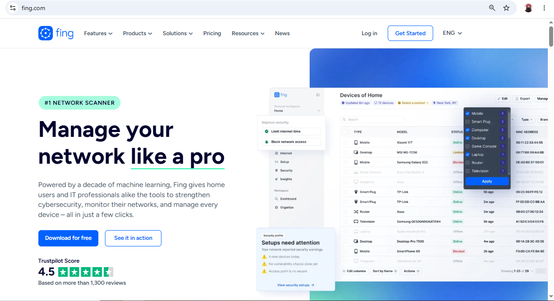
Figure 1: The core feature set for the Fing (device discovery, alerts, vulnerability checks) confirms that the product is free - however, there is no mention of a composite risk score.
A screen shot of the App Store pricing page, which shows the “Free” pricing model with “In-App Purchases” (IAP) , Premium at $69.99 per year
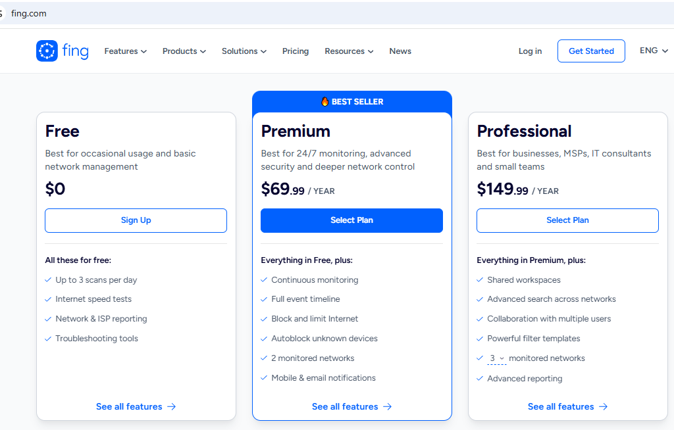

Figure 2: App Store pricing confirms freemium model and premium at $69.99 per year referred to in Section 3.1.
Screen shot of the One Fing account, total network visibility
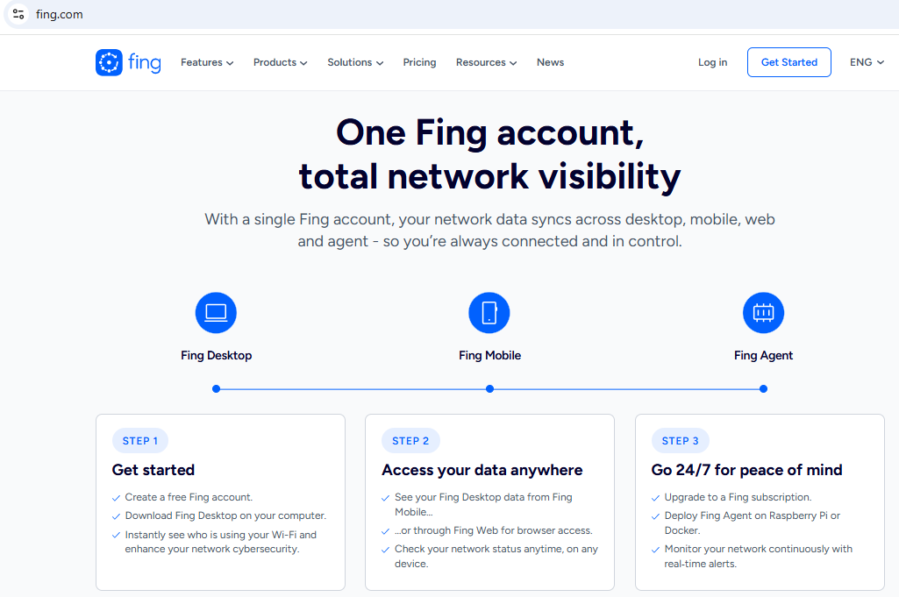
Figure 3: One Fing account, total network visibility step by step process

7.2 SecureIoT.house Smart Home Security Scorecard
Primary source:
- https://secureiot.house/smart-home-diy-risk-assessment-take-control-of-your-premium-property-security/
Evidence
Screenshot of the tool's landing page with the words "Comprehensive security assessment tool for premium smart homes" and the text "Processing is local/free"
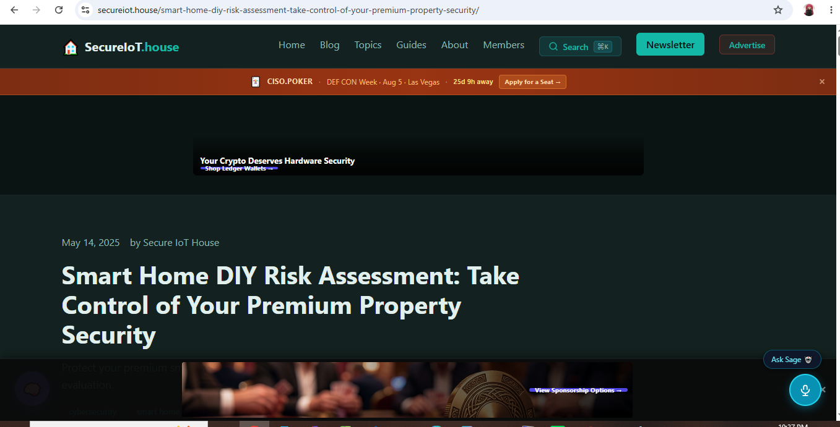
Figure 4: SecureIoT.house Scorecard landing page with the words "Comprehensive security assessment tool for premium smart homes" and the text "Processing is local/free
Smart home with a specialized security assessment and risk evaluation
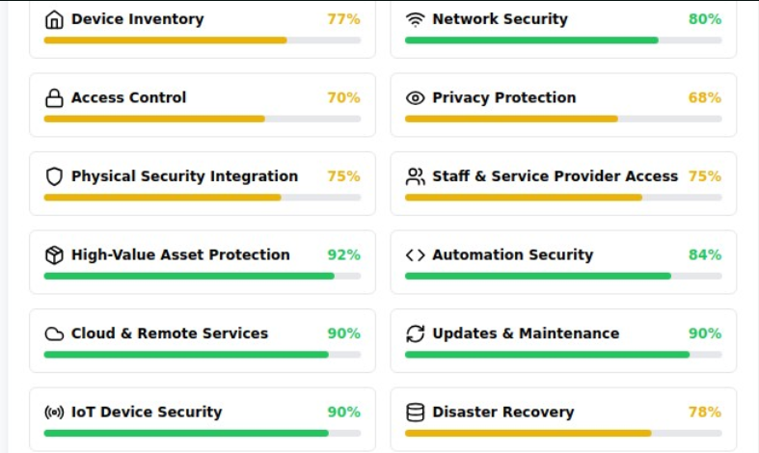
Figure 5: Smart home with a specialized security assessment and risk evaluation
Tools & Resources
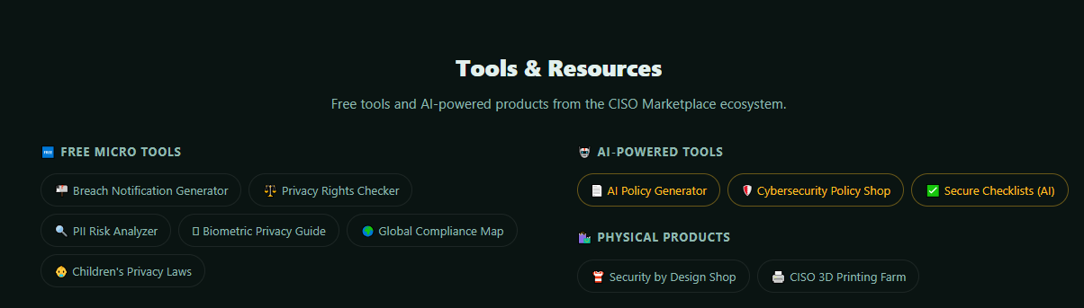
Figure 6: Free tools and AI-powered products from the CISO Marketplace ecosystem
7.3 Palo Alto Networks Device Security
Primary source: https://docs.paloaltonetworks.com/iot/iot-security-admin/detect-iot-device-vulnerabilities/iot-risk-assessment
Evidence
Capture of the official documentation page with the explanation of the exposure score / impact factor
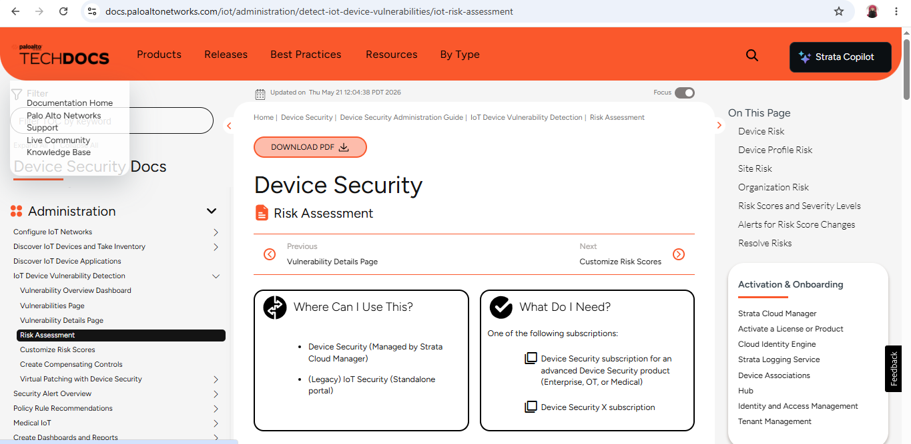
Figure 7: Palo Alto Device Security official documentation confirming 2 factors (exposure + impact) scoring methodology referenced in Section 3.3
Note: This is not a publicly available product in case it is an enterprise product. For enterprise-tool comparisons in academic work, it is standard to include documentation screenshots.

Device Risk
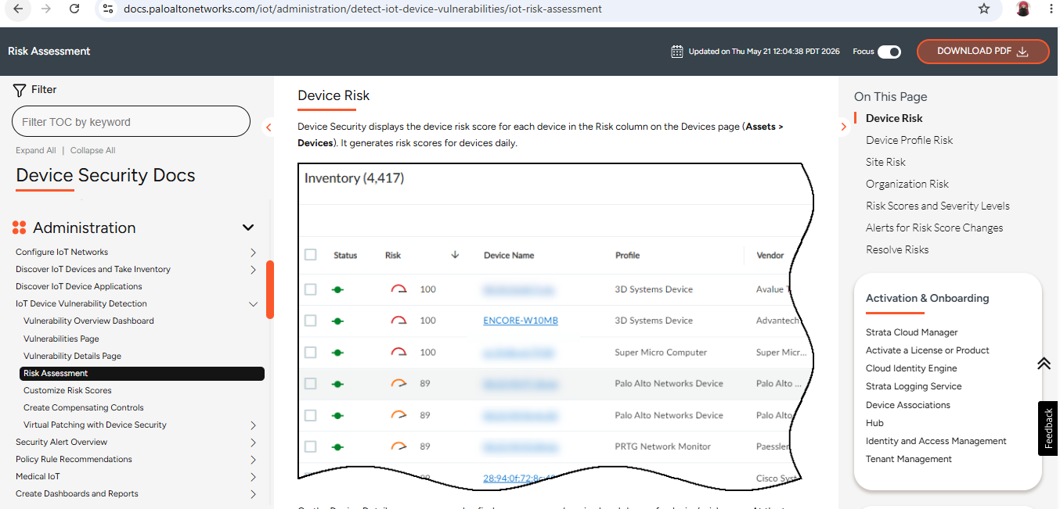
Figure 8: Device Security displays the device risk score for each device in the Risk column on the Devices page
Device Profile Risk
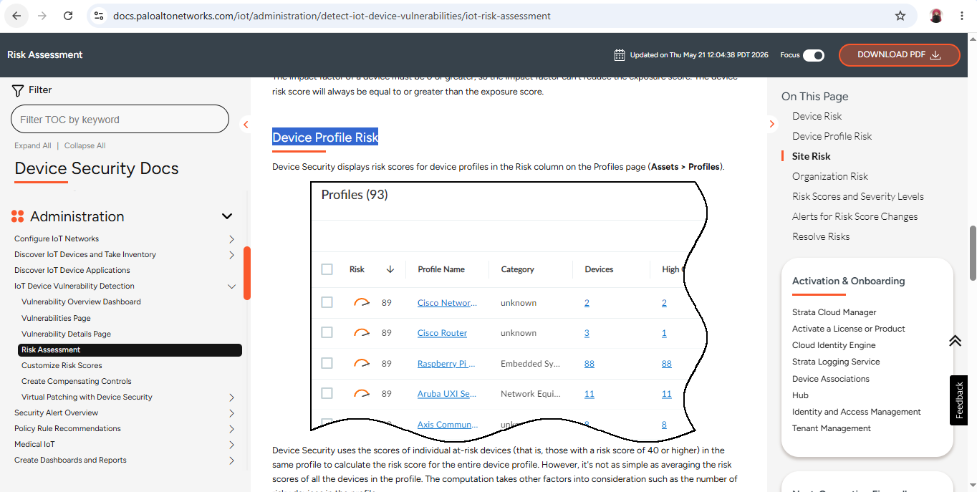
Figure 9: Device Security displays risk scores for device profiles in the Risk column on the Profiles page (AssetsProfiles)
Risk Scores and Severity Levels
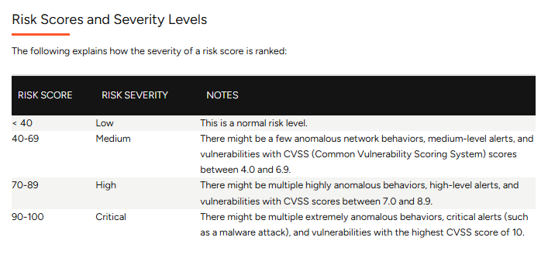
Figure 10: How the severity of a risk score is ranked

