Terraform:
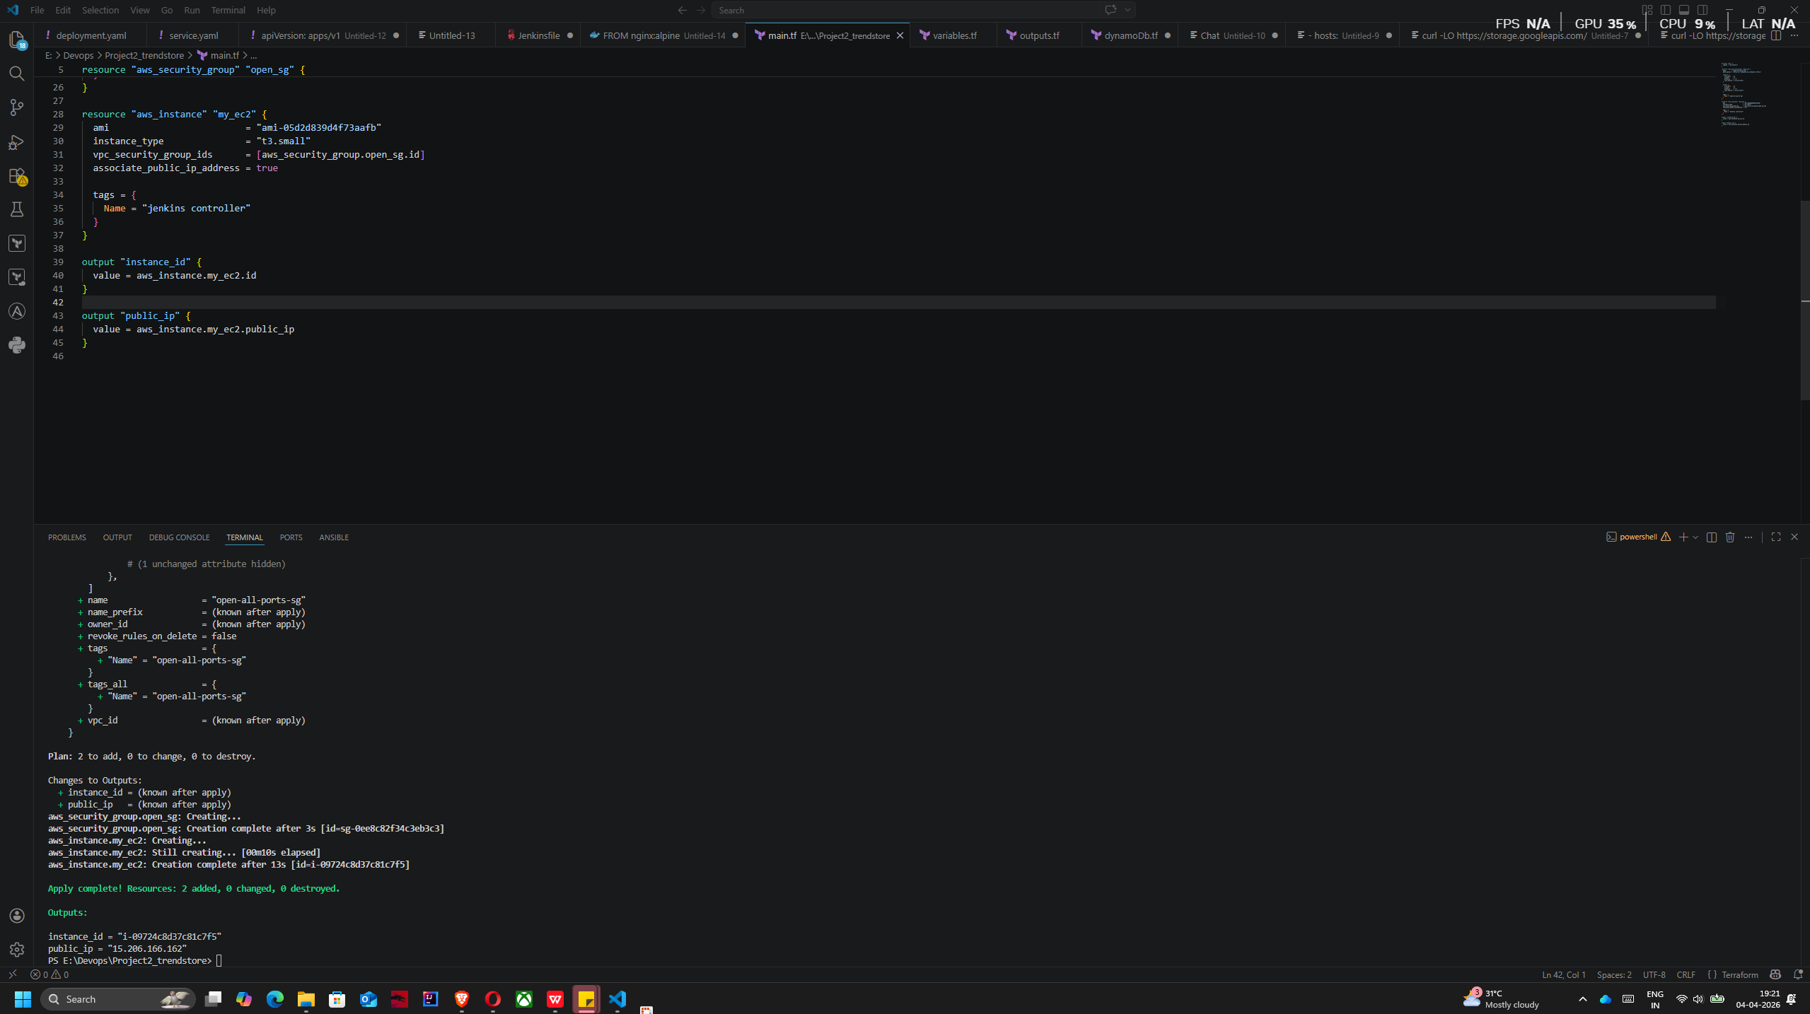
Docker:

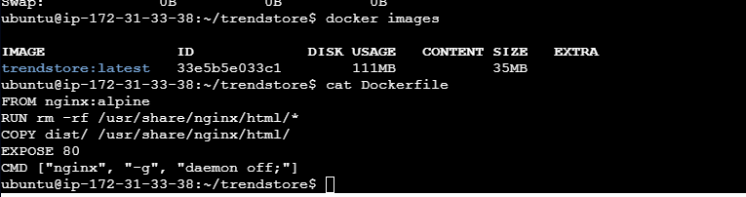
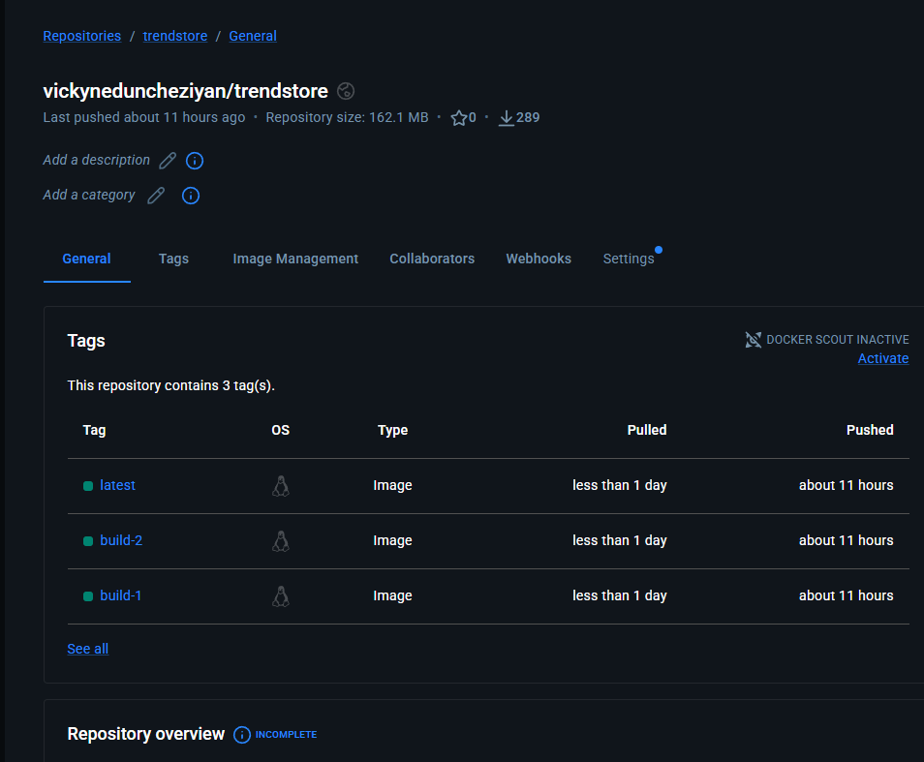

Jenkins status:
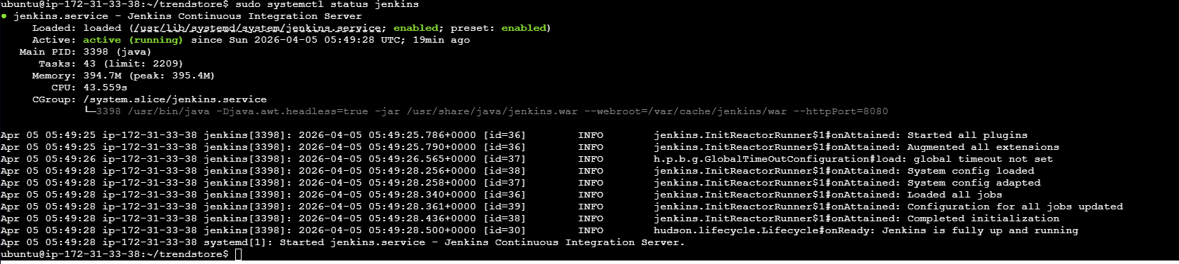

Git webhook:
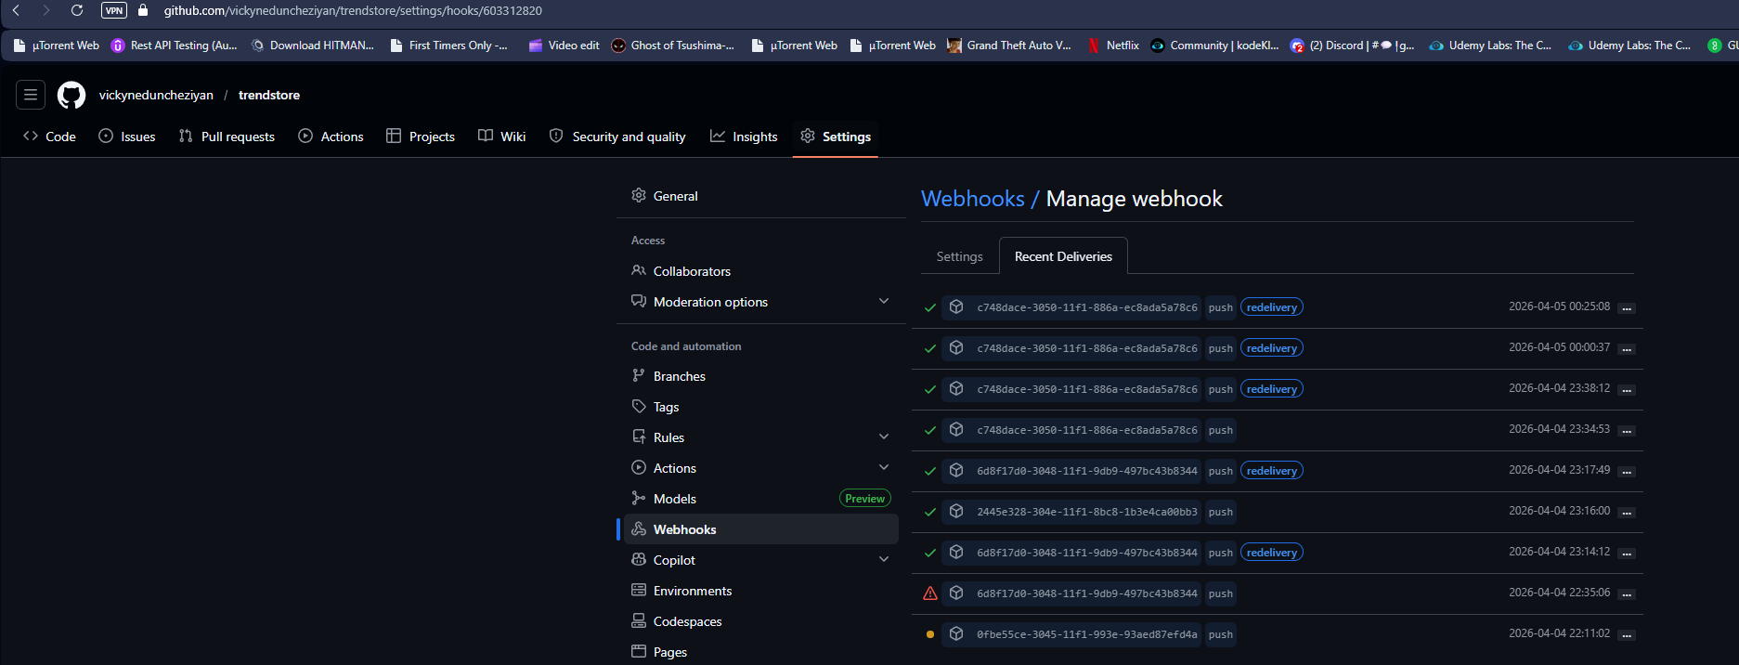
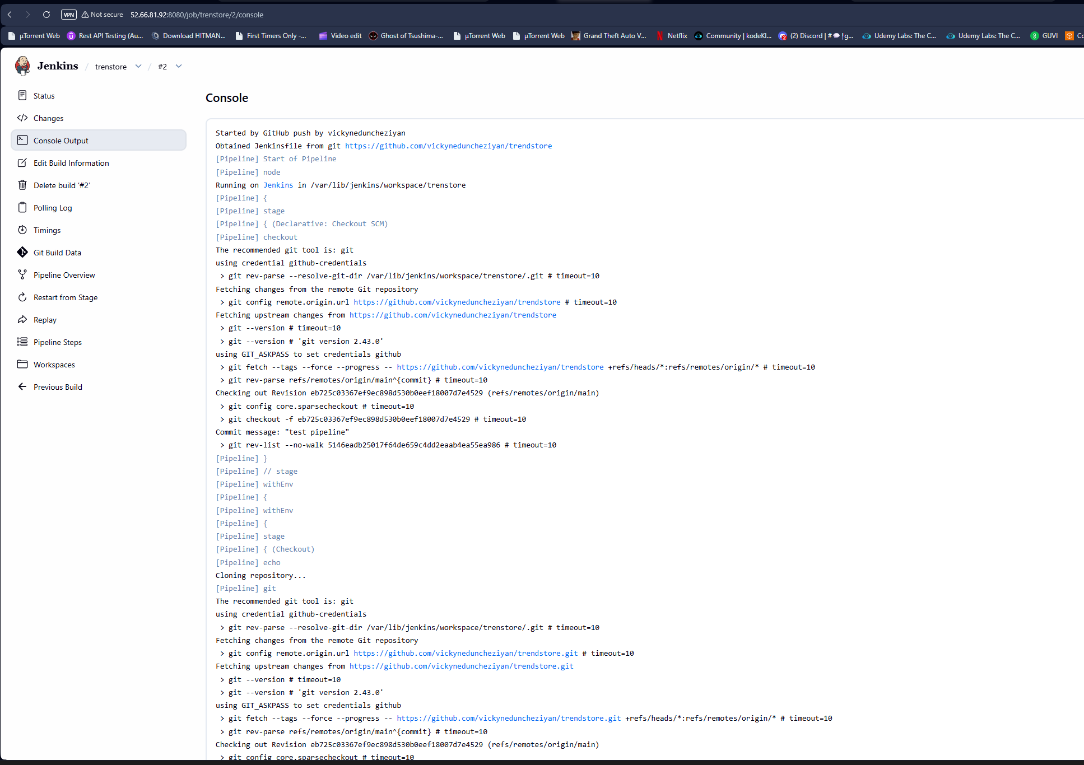
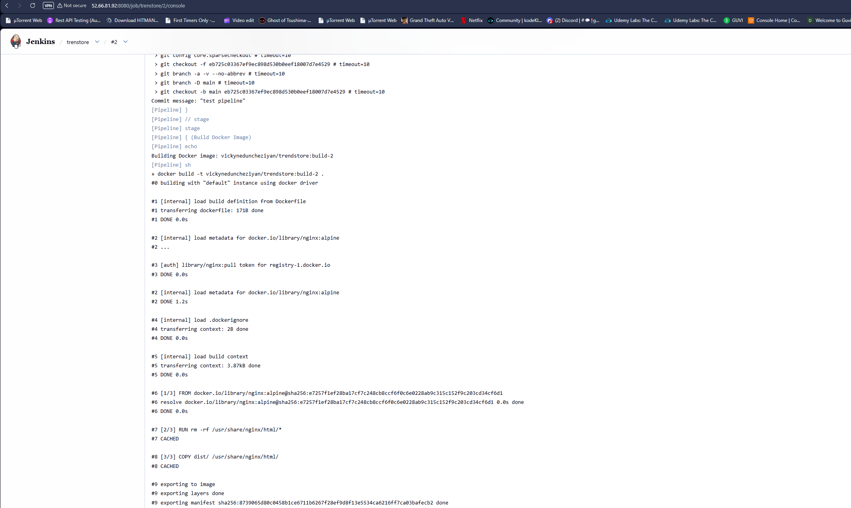
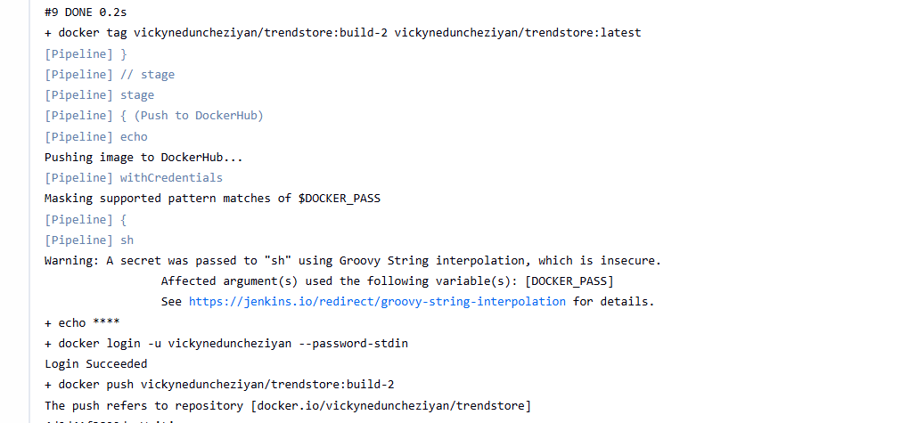

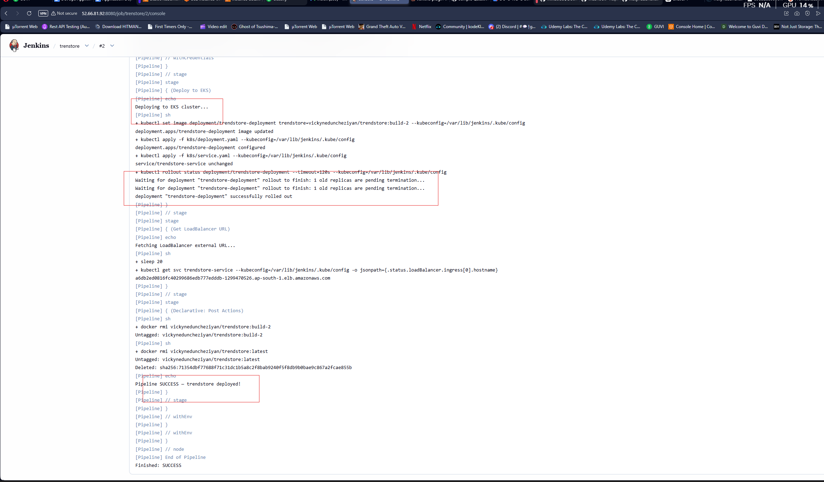

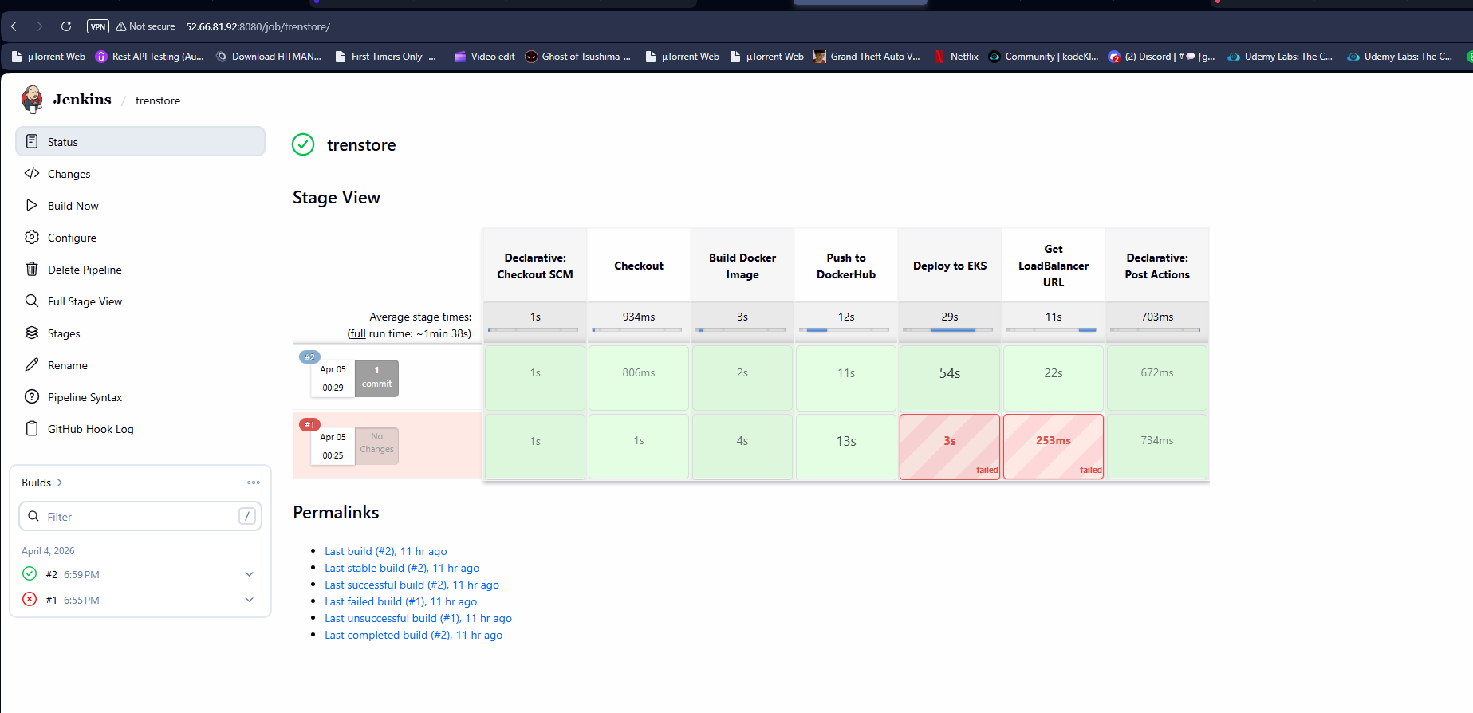
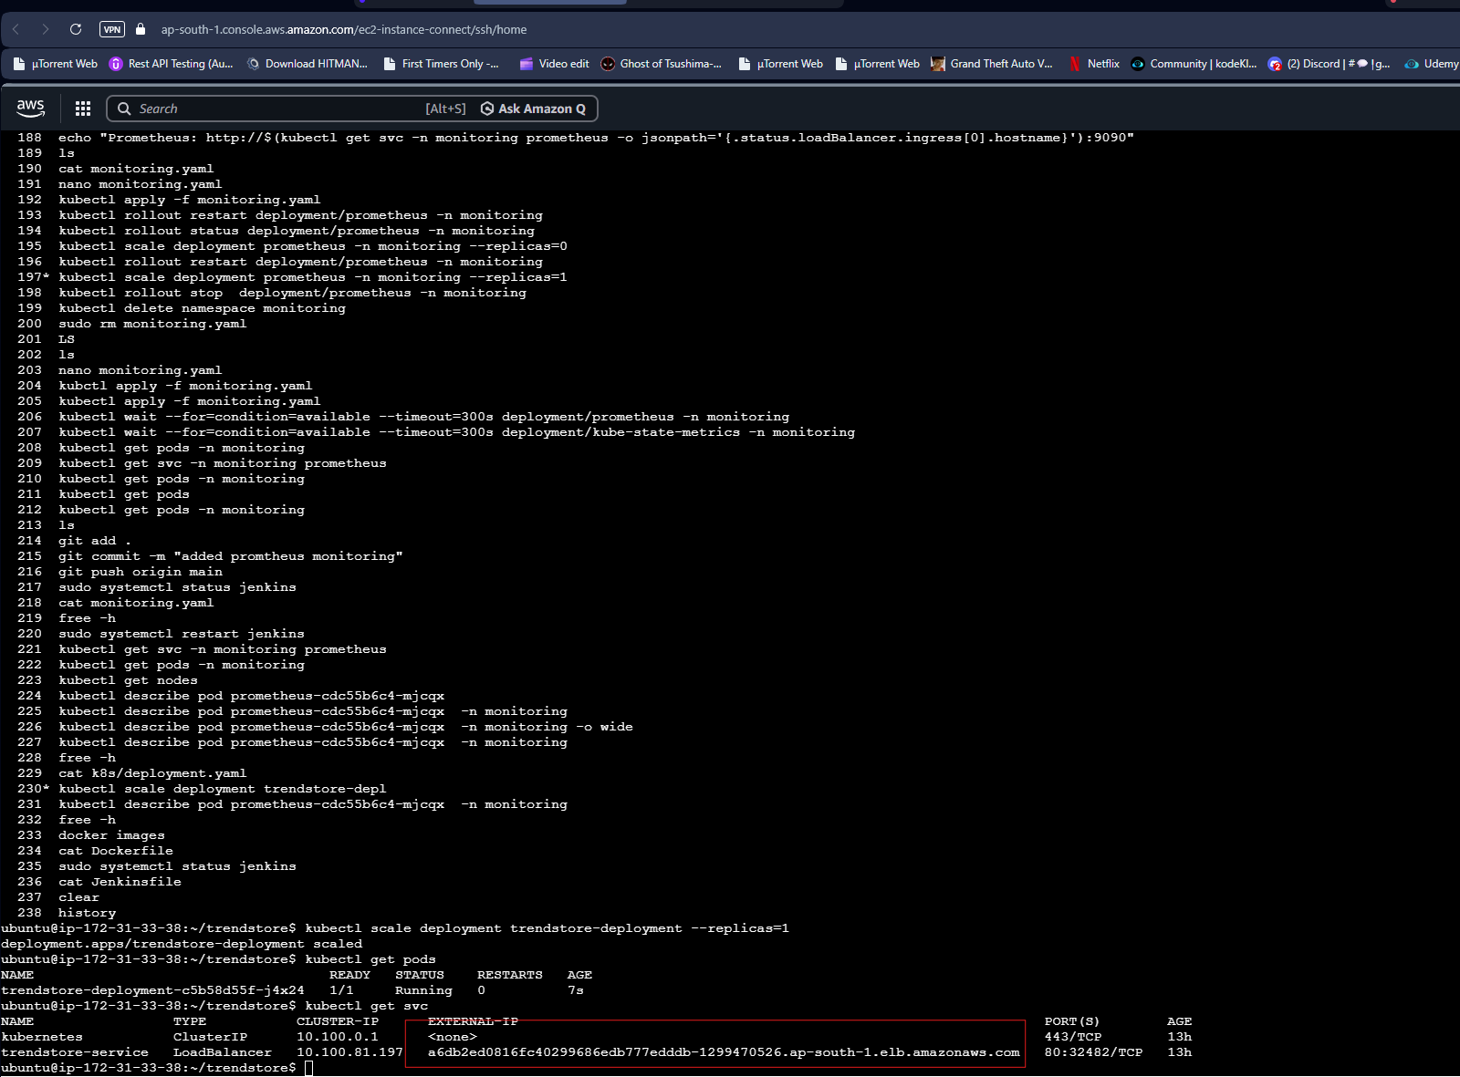

Application UI:
http://a6db2ed0816fc40299686edb777edddb-1299470526.ap-south-1.elb.amazonaws.com


Prometheus to check the cluster health:
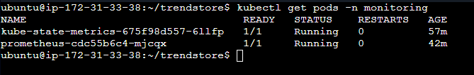

Link to monitoing.yaml: monitoring.yaml

Prometheus Service:

Prometheus UI:
http://a26276d1a5ec140f6bf0a5834dec889e-2060337109.ap-south-1.elb.amazonaws.com:9090/targets
