**Step1:**

Joe uploads the CSV file which gets saved into the database.

The main page displays the below details:

* Mean and Standard deviation of each company
* Shares purchased and sold by Joe
* Amount Spent by Joe
* No of companies as per the uploaded CSV file
* Status which indicates whether Joe has purchased or Sold shares
* Average market share price of each company
* Overall profit made by each company

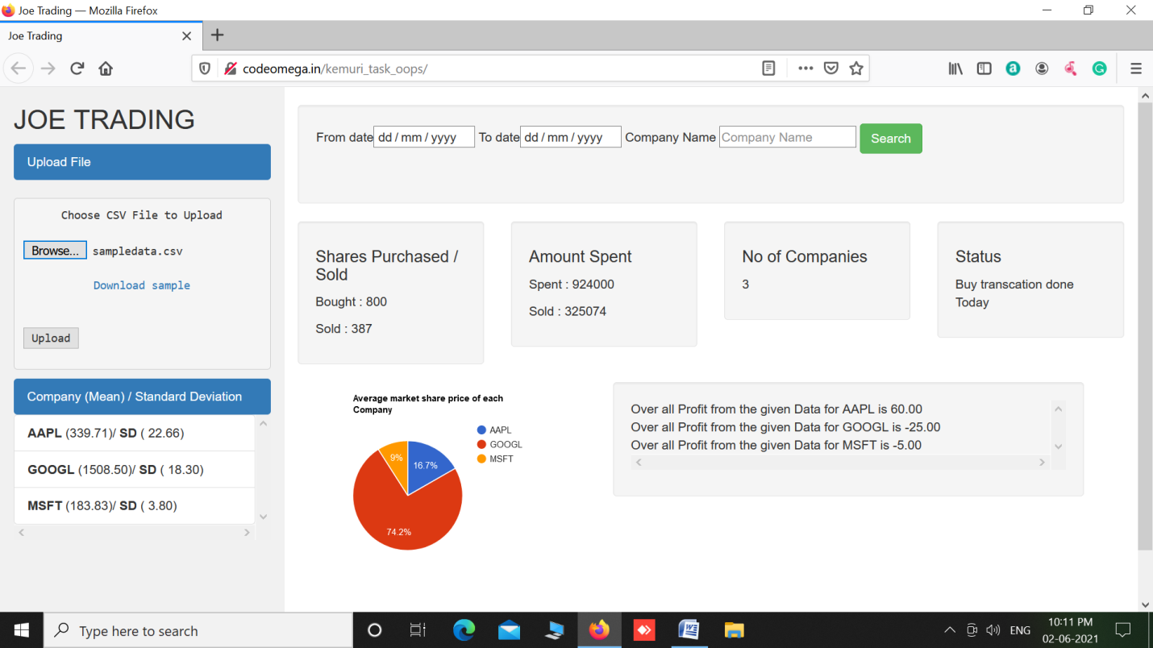

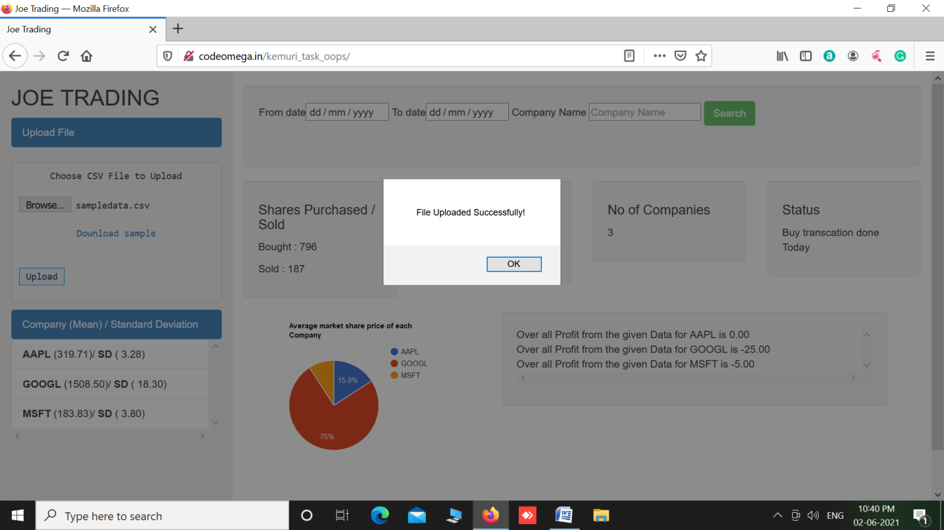

**Step2:**

Joe enters the date range and company name for which he needs to track and clicks on search.

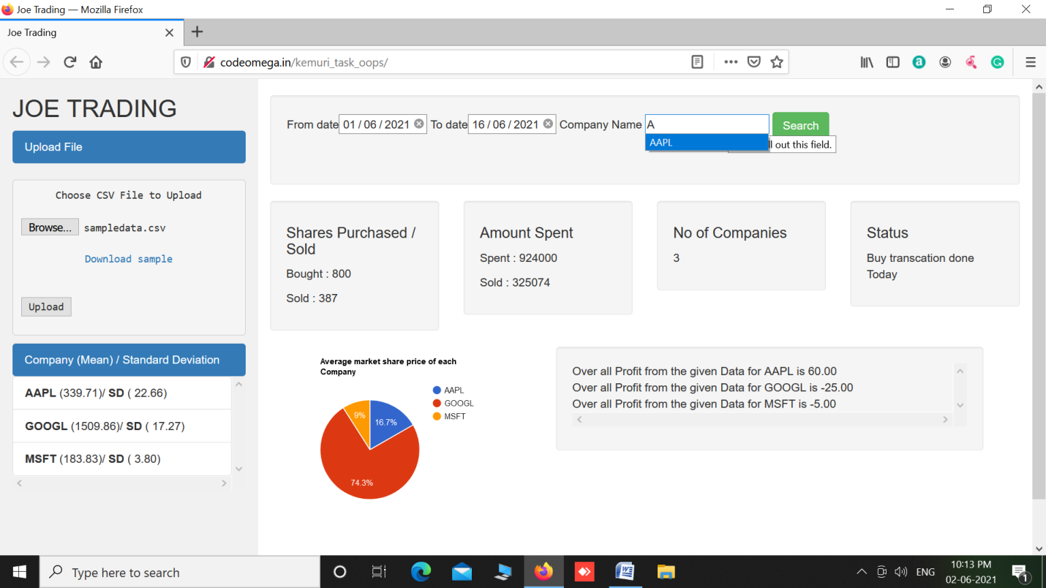

As per the problem statement only one transaction is allowed per day i.e., he can either buy or sell in a single day. In this case Joe has already bought shares(which is shown under the Status section). So the below screen pops up with the last 5 records for his information in tabular as well as in chart form.

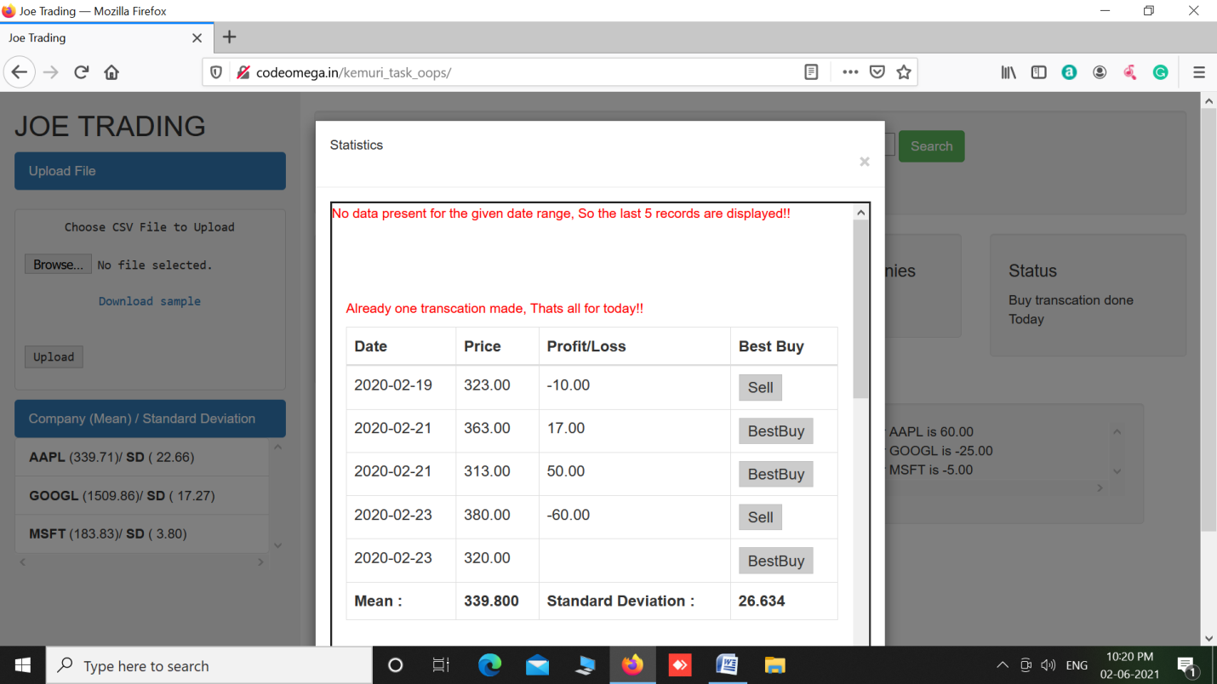

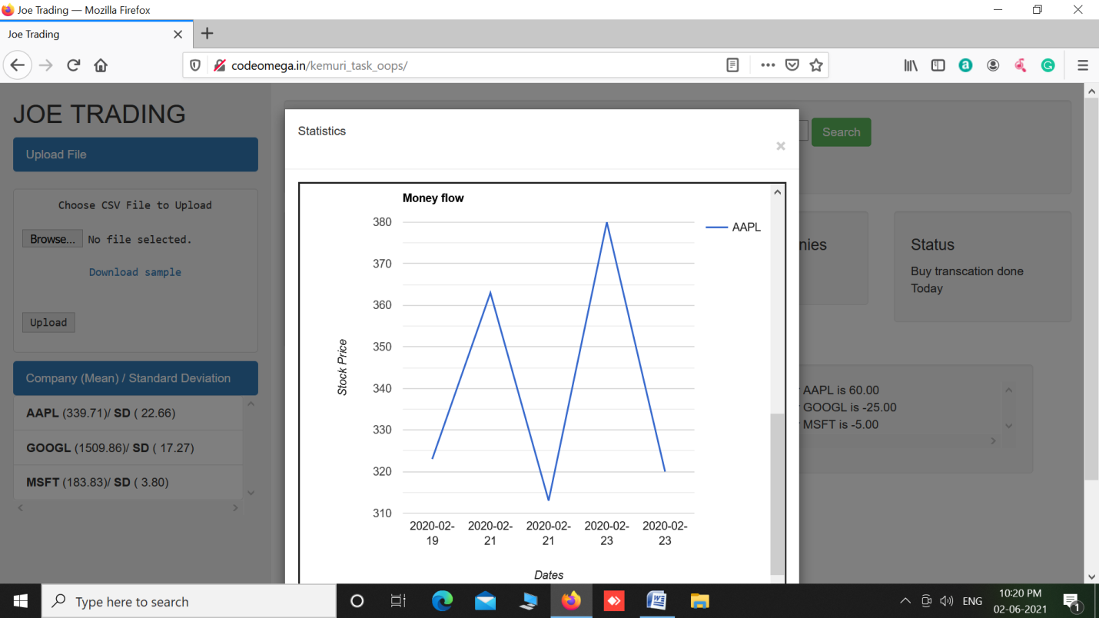

**Step3:**

When no transactions is done the below screen appears.

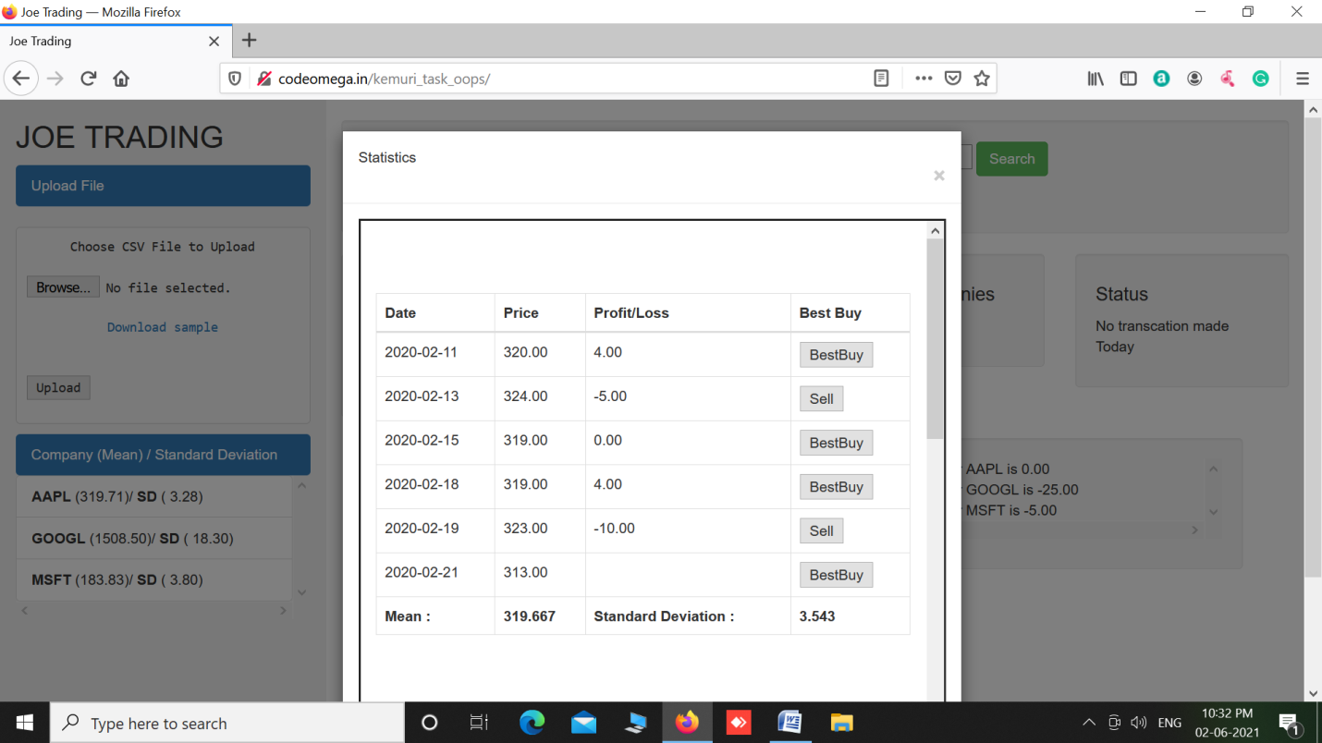

He can either buy or sell. First Joe needs to buy shares before selling. So when he tries to sell shares without buying the below screen appears.

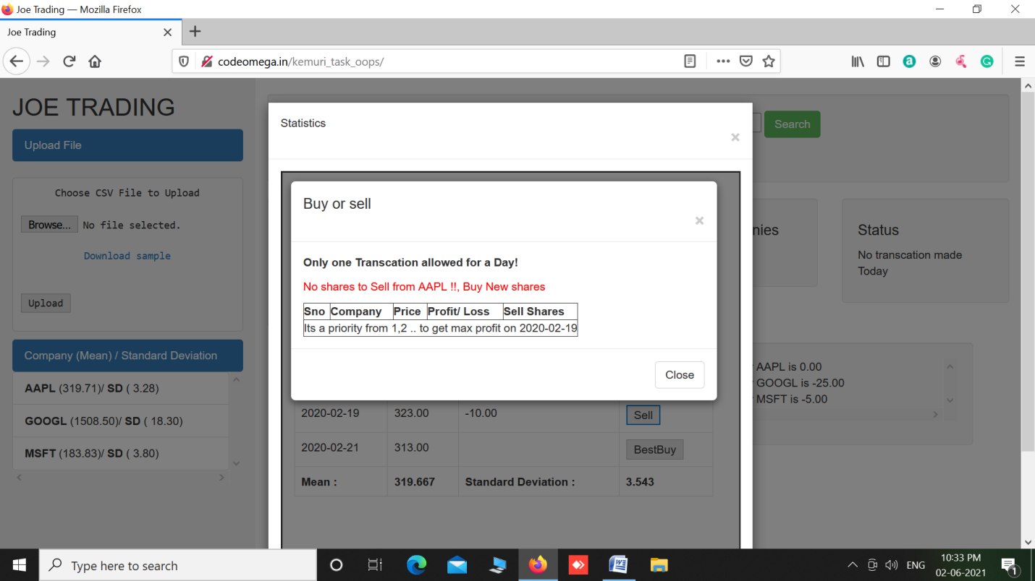

So Joe clicks on the best buy button and the below screen appears. It displays the best buying options for the given date range. In this case, even though Joe wishes to track AAPL company shares, the tool displays the best profitable shares for him. So Joe can either buy the shares of the best profitable company which is GOOGL in this case or he can proceed with AAPL or any other company also.

**Logic behind best buy option:**

The below query is used,

**select * from (SELECT distinct sName, sDate,sPrice,LEAD(sprice,1) OVER ( PARTITION BY sName ORDER BY sDate )-sPrice profit_or_loss FROM (select distinct sName,sPrice,sDate from shareprice)k)q where sDate='$dated' order by profit_or_loss DESC,sPrice asc;**

Used the analytic function, ***Lead*** to find the share price for the next date and compared it with the share price of current date to find the profit/loss amount.

The statistics page displays the profit/loss for the given date range.

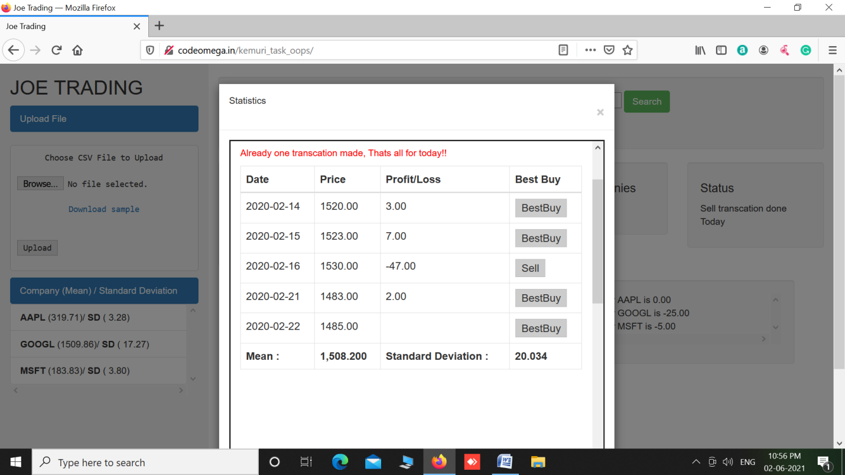

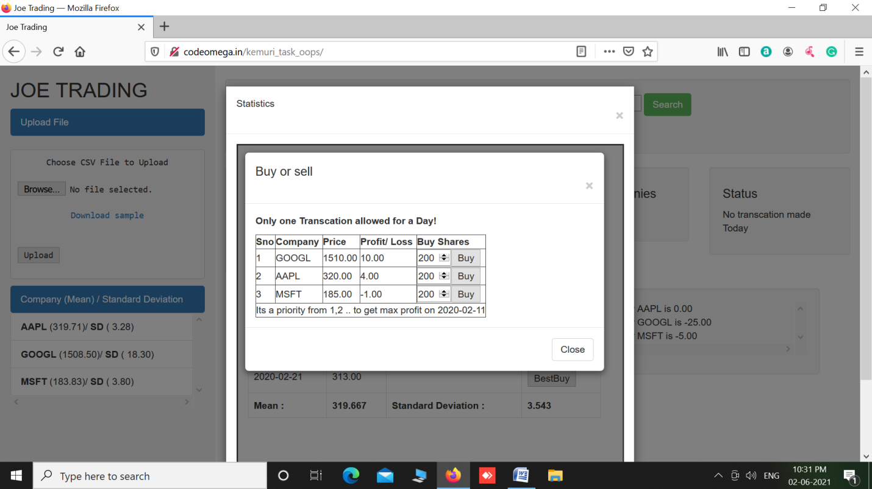

Joe enters the number of shares he wish to buy and clicks on the buy button which prompts for his confirmation as shown below.

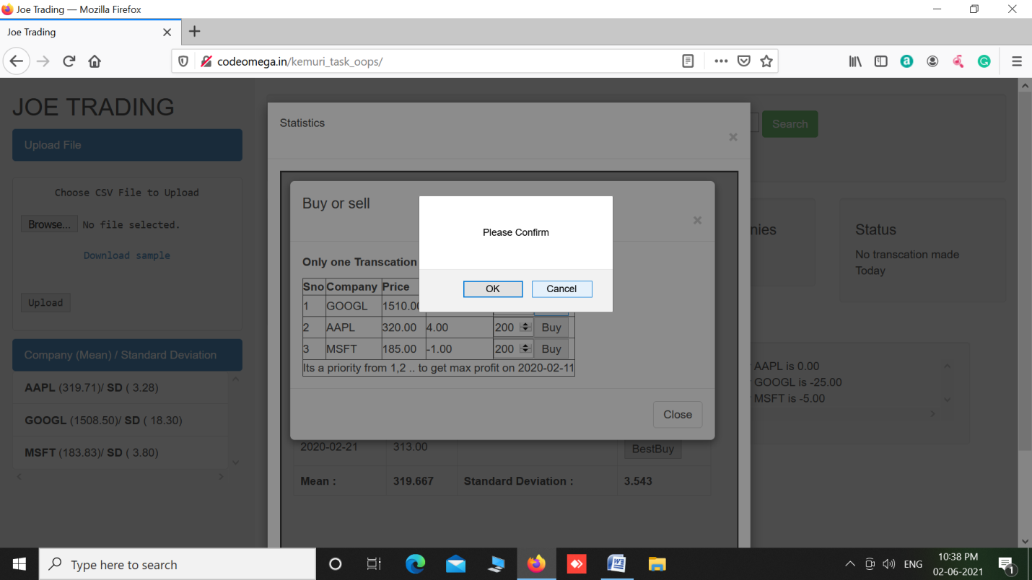

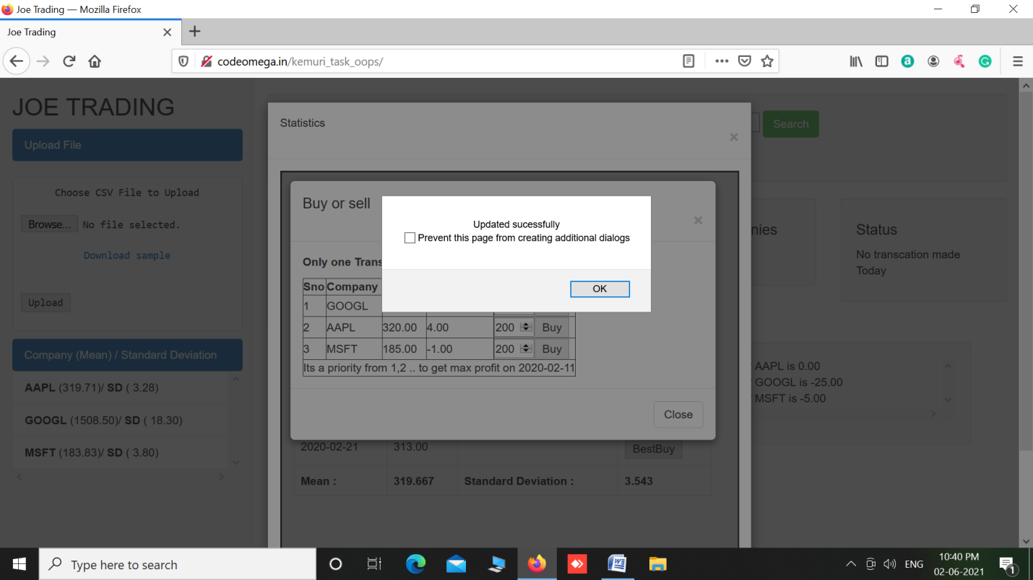

**Step4:**

When Joe wanted to sell his shares, he can click on the sell button and enter the number of shares he wish to sell which prompts for user confirmation.

