Shona Hemmady
CPSC 433
Assignment 4: TCP
README

My files can be run with the simulator using the command provided in the assignment:

perl fishnet.pl simulate 2 scripts/transfertest.fish

I use the transfertest.fish script to test. The emulator also works, though you will
open separate nodes to use that. Both parts 1 and 2 are implemented (together in the same TCP implementation) in the files Node.java, TCPManager.java, and TCPSock.java. The main ways to run them would be through the simulator and emulator.

The Design Doc and the Discussion Questions text files are also both in this folder (the main fishnetJava-1.8-link).

Below are screenshots of the test with script (the file transfertest.fish):

edge 0 1 lossRate 0.0 delay 5 bw 10000 bt 1000
time + 5
# server port backlog [servint workint sz]
0 server 21 2
time + 5
# transfer dest port localPort amount [interval sz]
1 transfer 0 21 40 50000
time + 1000000
time + 10
exit

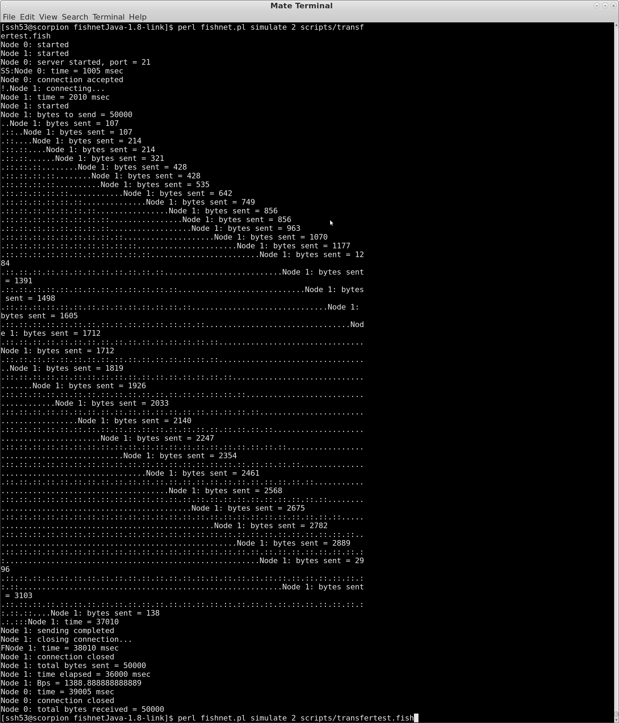
and then with this:
edge 0 1 lossRate 0.05 delay 5 bw 10000 bt 1000
time + 5
# server port backlog [servint workint sz]
0 server 21 2
time + 5
# transfer dest port localPort amount [interval sz]
1 transfer 0 21 40 50000
time + 1000000
time + 10
exit
