2. Property Buying and Rental

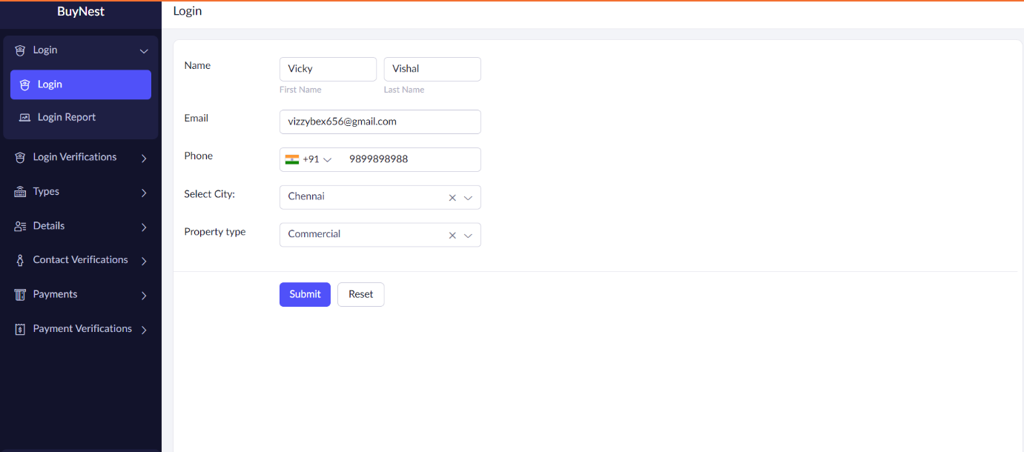

Step 1: Enter LOGIN Details.

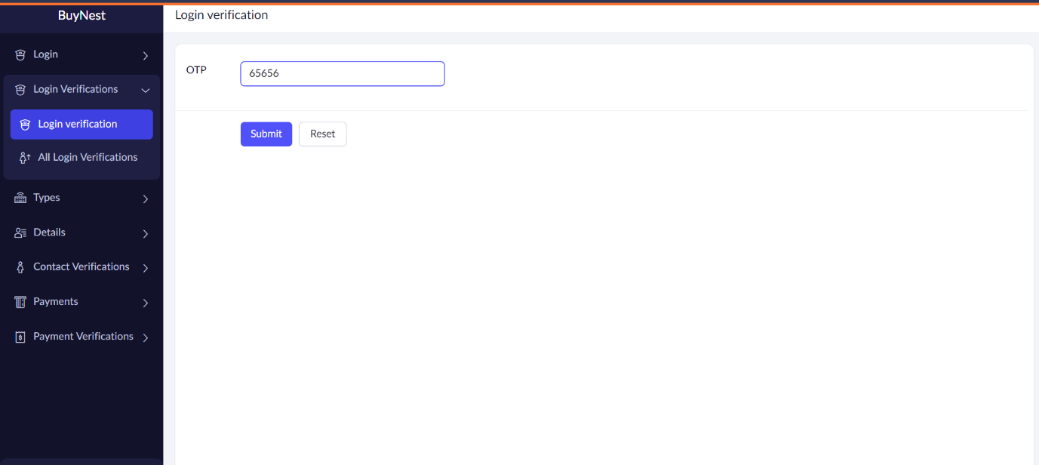

Step 2: Enter OTP for LOGIN verification.

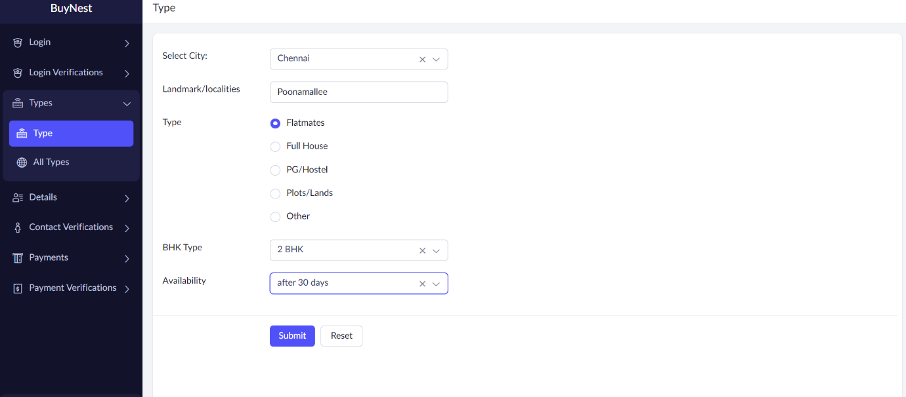

Step 3: Enter the type of the property.

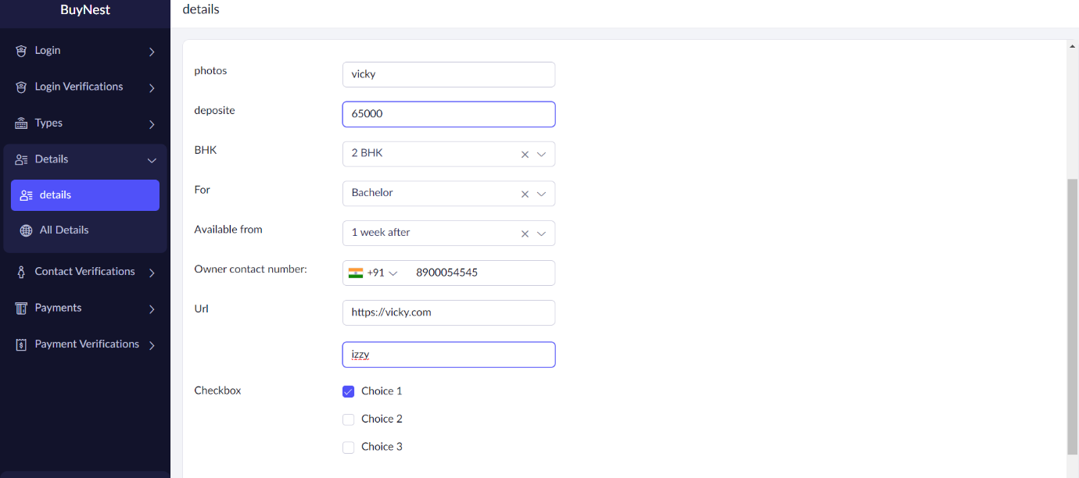

Step 4: Enter Personal Details.

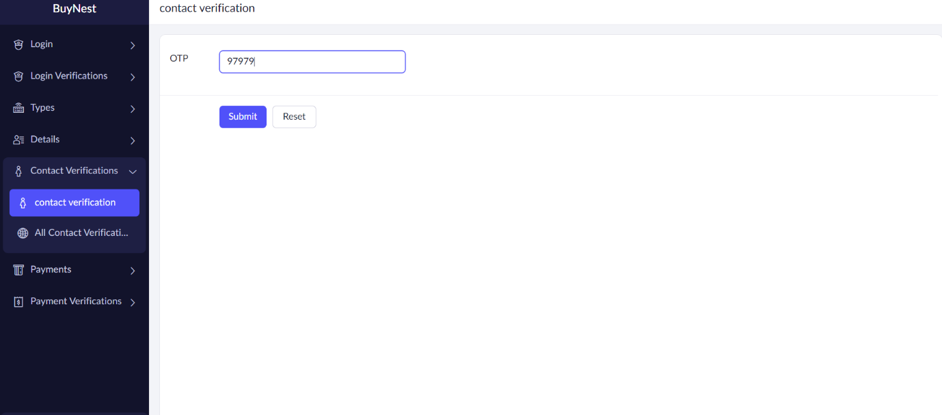

Step 6: OTP for contact verification.

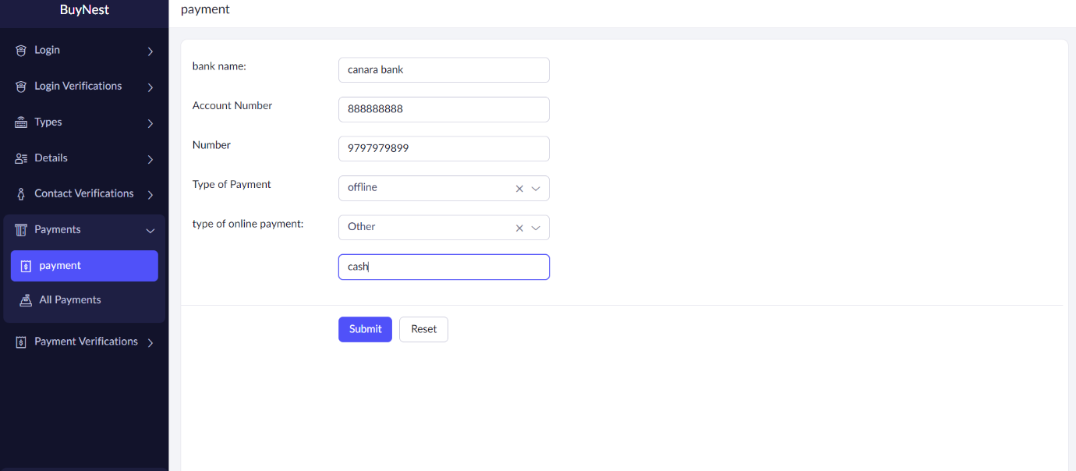

Step 7: Banking details.

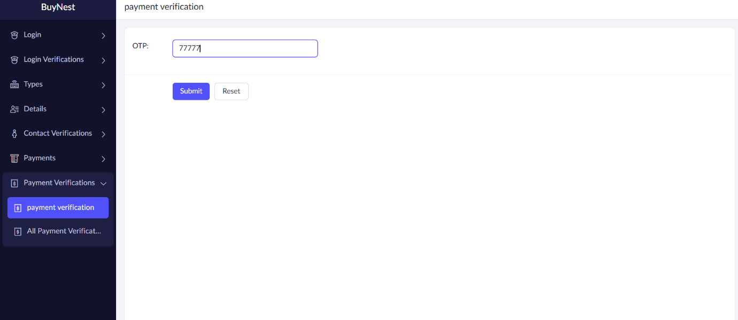

Step 8: OTP verification