5. Mark Sheet Processing System:

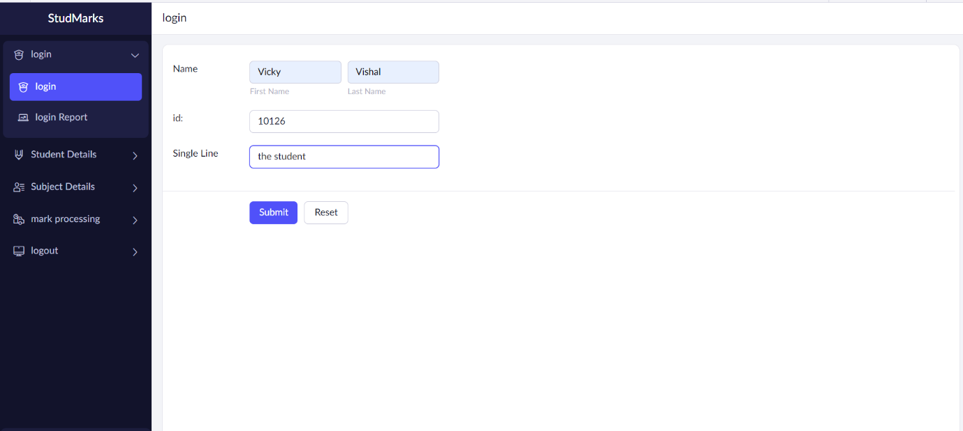

Form 1: Login Details.

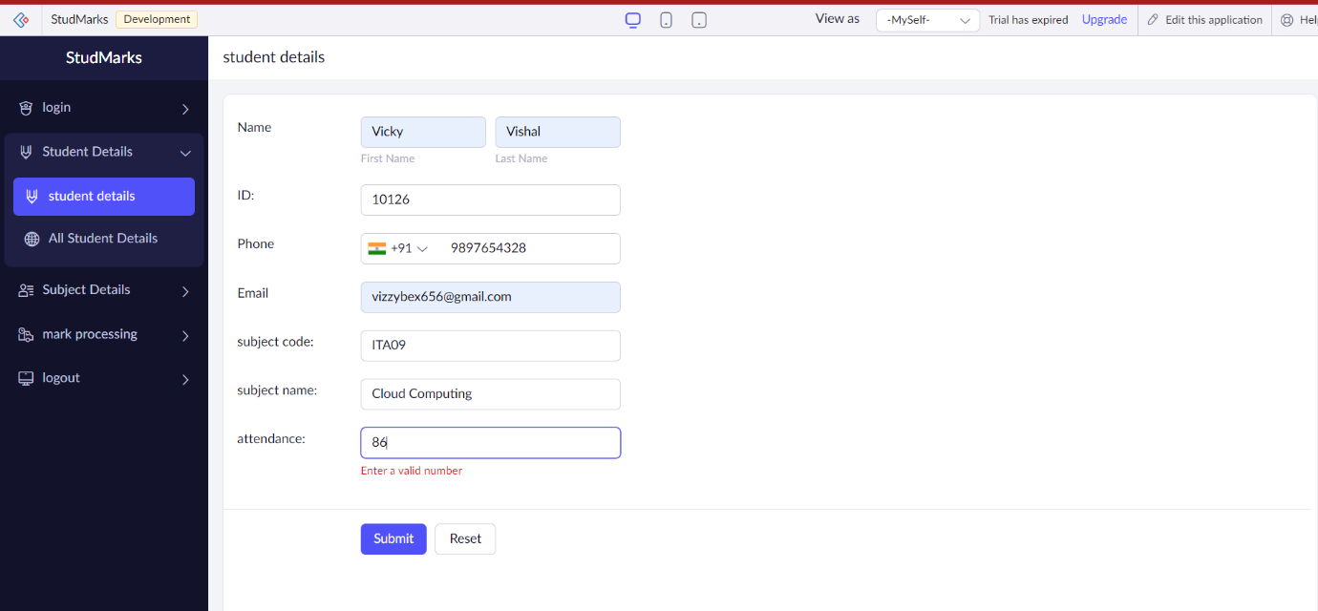

Form 2: Student Details.

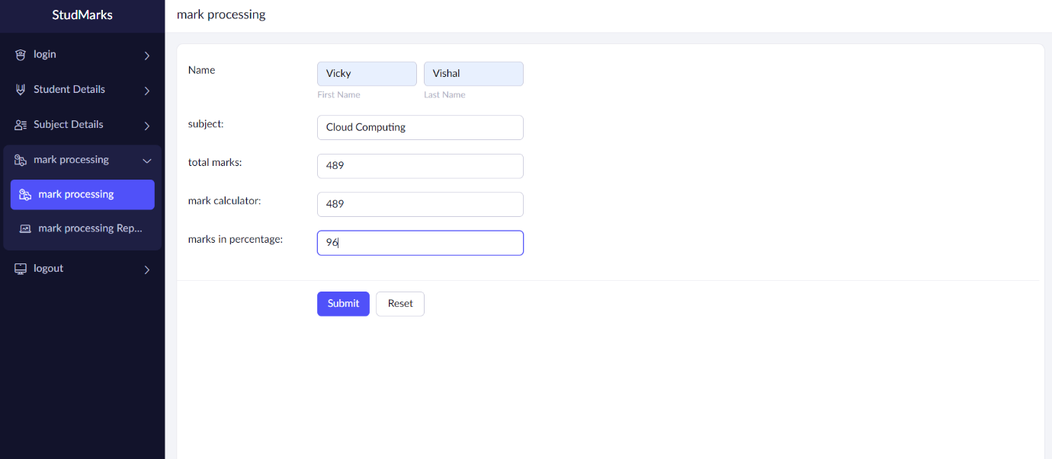

Form 3: Mark detais.

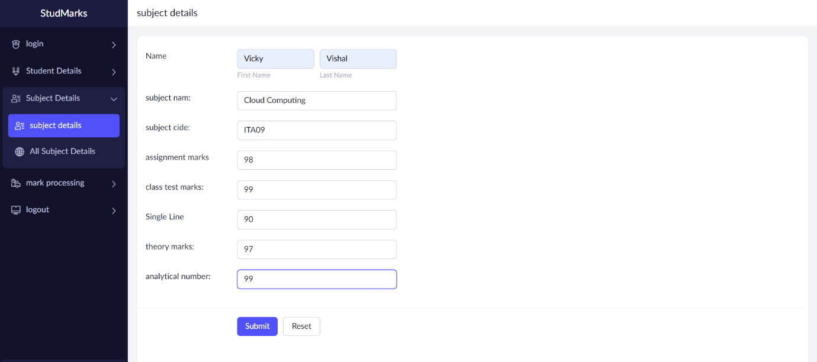

Form 4: Subject Details.