Assignment 11: Contacts, Messaging and Accessibility Settings (Victor Lee)
SWEN 661 Team 2 (The Acuity Health Group). This is Victor's part of the team's Assignment 11 Word document. It covers the Contacts, Messaging (conversation) and Accessibility Settings screens of the React web app. The headings follow the submission's sections, so each part can be pasted into the matching section of the team document. Every screenshot is in screenshots/.
Item | Where
Source | src/pages/Contacts.tsx, src/pages/MessageThread.tsx, src/pages/AccessibilitySettings.tsx, and the components in src/components/contacts/, messaging/ and settings/
State | src/context/MessagesContext.tsx, src/context/SettingsContext.tsx (Context API)
Custom hooks | useLocalStorageState, useOnlineStatus
Domain logic | src/models/, src/utils/
Unit and component tests | 160 Jest tests in 14 suites (listed in §3)
E2E tests | e2e/ (Playwright), 9 tests covering 5 critical flows, run in 4 browser projects
Coverage | coverage/lcov-report/index.html

1. Completed responsive application

What was built
The web app had a Contacts page that was a list of tel: "Call" buttons, and it had no Messaging or Accessibility Settings screens. Those screens existed only in the desktop (Electron) and mobile clients. This week I ported all three to React so the web version has the same features. I also rebuilt Contacts around CareConnect's main rule: anything the app communicates through sound must also be communicated visually or in text.
Screen | Route | What it does
Contacts | /app/contacts | Lists everyone, with the primary contact first. Each row is a link to a written conversation, never a voice call. A row shows a preview of the last message and a "n waiting" badge. Search matches name, relationship or role (for example, "doctor" finds Dr. Sharma).
Conversation | /app/contacts/:contactId | Shows the message history grouped under "Today" and "Yesterday" headings. A voicemail is shown as its transcript, a video message says whether captions are attached, and delivery state is written as a word ("Delivered"), not shown as a tick alone. The Alert button sends a silent visual flash and vibration instead of a ring. Other features: a captioned video-call request, a message form with validation, and offline queueing.
Accessibility Settings | /app/settings | Visual alert banners (shown but locked on), smart escalation, captions on/off, caption size and colour with a live preview, alert volume and left/right balance sliders, vibration on/off with the three alert rhythms (played as a visual pulse, and as a real vibration on phones that support it), and an Account section with Sign out behind a confirmation dialog.

Requirements met in this part:
Requirement | How
React Router | New routes contacts/:contactId and settings under /app/*. The Contacts, Conversation and Settings pages are loaded with React.lazy, so each builds as its own chunk (Contacts-*.js 5.5 kB, MessageThread-*.js 12.6 kB, AccessibilitySettings-*.js 12.3 kB) and loads on first visit, not with the home screen.
State management | Context API. MessagesProvider holds contacts, conversations, read state and the offline queue. SettingsProvider holds the accessibility preferences. Each context object and its use… hook live in a separate module (messages.ts, settings.ts), so React Fast Refresh keeps working and ESLint passes with no new warnings.
Custom hooks | useLocalStorageState(key, initial, revive) is useState that is saved to localStorage. It checks and repairs whatever is stored (bad JSON or the wrong types fall back to safe values), and it keeps working when storage is blocked. useOnlineStatus() uses useSyncExternalStore on the browser's online and offline events.
Reusable components | ContactRow, MessageBubble, MessageComposer, NotifyButton, VisualFlash, SettingsSection, SettingsSwitchRow, SettingsSliderRow, SegmentedChoice and VibrationPatternRow, plus the team's existing Banner, Button and ConfirmDialog.
Form handling and validation | The message form is a real <form> with a labelled <textarea>. Ctrl/⌘+Enter or the Send button submits it. An empty message, or one over 500 characters, is refused with a written reason (role="alert", linked to the field with aria-describedby, and the field gets aria-invalid). Focus returns to the field. A live counter shows the characters left.
Offline functionality | Conversations and settings are kept in localStorage, so nothing is fetched and both screens work with no connection. A message written offline is kept, marked "Sending" in words, and sent automatically when the connection returns. A banner explains this while offline. The team's service worker serves the app shell and the cached lazy chunks, so the screens also open from cold while offline. This is verified by an E2E test.
PWA | Uses the team's manifest and service worker. My screens add the offline behaviour above.

Matching the desktop and mobile apps
The three web screens follow the versions the team built in earlier weeks: the Electron desktop app (Weeks 8–9) and the React Native and Flutter phone apps. All three of those already agree with each other, so they are the reference.
Same as desktop and mobile | Detail
Data and rules | The contact, message and accessibility-settings models are the desktop and mobile files, copied unchanged with their unit tests. The contacts and conversations are the same Week 3 prototype data (Joyce as primary, Dr. Sharma, Maria, James, NHS 111).
Contacts | One list, primary first. Each card shows initials, name, a Primary badge, the relationship, a preview of the last message, and a waiting count drawn as a circle with the word "waiting" under it. The "Getting someone's attention" banner. No call button.
Conversation | The header shows the name and relationship with its role icon. Captioned video call ("Call Joyce now", which asks for live captions). "Captions are turned off" warning with Open settings. Day headings. Transcripts and caption labels. The Alert button with the same two lines of text. A worded flash, and a short confirmation buzz on the sender's own phone (mobile's notifyBuzz, using the browser's Vibration API where it exists).
Settings | The same five sections in the same order, with the same wording: Visual Alerts (banners locked on), Captions (size, colour and preview), Audio (volume and balance), Vibration (switch and three rhythms), and Account ("Margaret Whitfield · Care Recipient" with Sign out).

Different on the web, on purpose | Why
Contacts are links, not buttons | On a website, something that goes to another page is a link. Browsers then offer open-in-new-tab and history for free.
Search box, opened with "/" | Desktop has search opened with Ctrl+F. Browsers already use Ctrl+F for find in page, and "/" is the usual web shortcut for a page's search.
Sign out asks for confirmation first | On desktop it runs straight away. On mobile it isn't built yet ("Sign out is not ready yet"). On the web it really signs out, so it asks first.
Offline queue | A website can lose its connection mid-conversation. Messages are kept as "Sending" and go out when the connection returns.
No Ctrl/⌘+Shift+N alert shortcut or system notification | These are desktop-only features with no browser equivalent the user would expect.

The header now matches too. The web header had a green Call my caregiver button that dialled Joyce's phone number (tel:). None of the other apps has a voice-call button, because a phone call is the one channel a deaf user can't rely on. It is now Message my caregiver, which opens the written conversation with Joyce. The footer's "View contacts" link also no longer reloads the whole page.

Screenshots at 375 / 768 / 1440 px
 | Mobile 375 px | Tablet 768 px | Desktop 1440 px
Contacts | top · bottom | full page | full page
Conversation | top · bottom | full page | full page
Accessibility Settings | top · bottom | full page | full page
Navigation | mobile | tablet | desktop

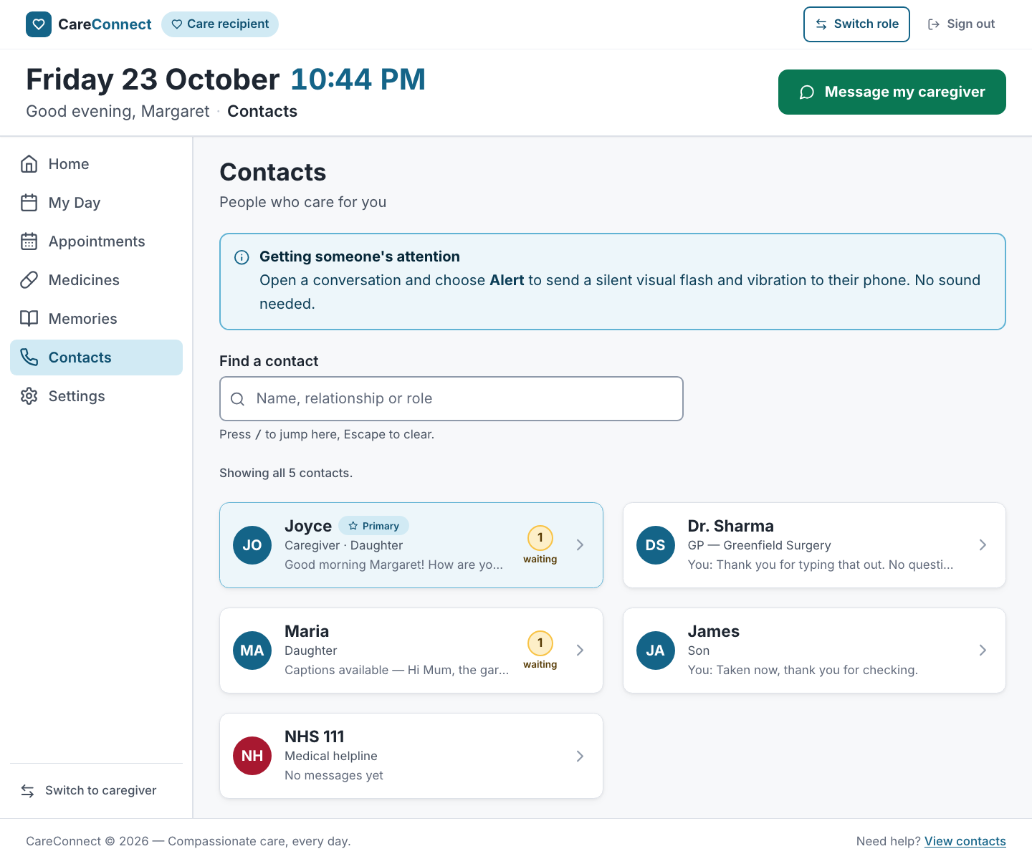
Contacts at 1440px
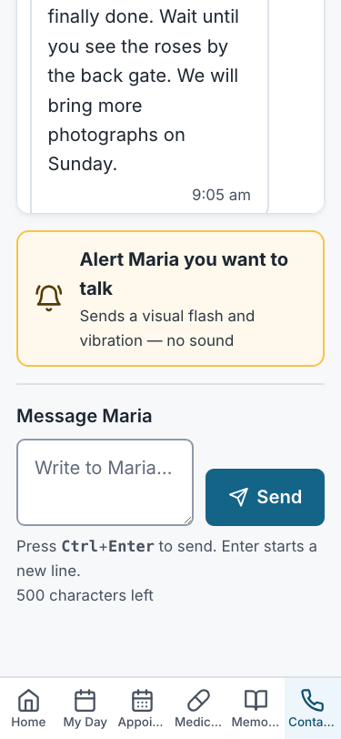
Conversation at 375px
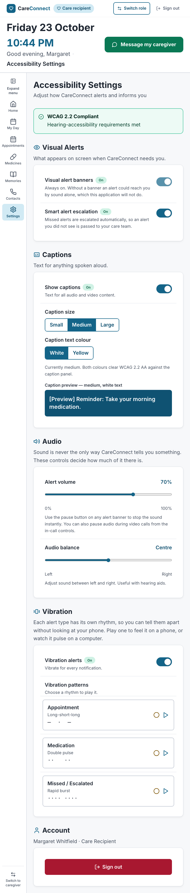
Accessibility Settings at 768px
Feature states: search, no match, voicemail transcript, form validation, alert flash, offline: queued → back online: sent, captions off → warning in a conversation with a video.

How the layout adapts
- Contacts. One column on mobile and two from 768 px, using the team's .card-grid. The preview line is cut off with an ellipsis instead of wrapping, and the waiting count is a small circle with "waiting" underneath (as on mobile), so the name and relationship keep their room at 375 px.
- Conversation. Bubbles take up to 85% of the width on mobile and 70% from 768 px. The "Call name" button sits beside the name on wider screens and drops to its own full-width row below 640 px. The page is capped at a readable width on desktop.
- Settings. A single readable column at every width. The size and colour choices wrap rather than overflow at 320 px. On phones, each vibration rhythm's dotted pattern sits under its name instead of beside it, so the name doesn't wrap one word per line.
- Navigation. Settings appears in the sidebar from 768 px. The care recipient's mobile bottom bar holds six tabs at 375 px, so it does not get a seventh. Instead, the mobile header shows a labelled Settings link, and the bottom bar filters on inBottomBar: false in navItems.ts, the one list every navigation surface reads.
- Touch and click targets. Every control is at least 44 × 44 px. Contact rows are 72 px or taller, and the Alert button is at least 56 px. The switch hit area covers the whole visible track, not just the hidden checkbox.
- No horizontal scrolling at 375, 768 or 1440 px. This is checked by an E2E test, and there are no console errors or warnings.
Shared-layout fix found by my tests. At 375 px the team's sticky header (date, time, greeting and "Call my caregiver") is about 360 px tall, more than half the screen. Pinned in place, it covered the conversation's Send button, which also fails WCAG 2.4.11 (Focus Not Obscured). The mobile Safari E2E run caught this. The header is now sticky only from 768 px (md:sticky md:top-0 in Layout.tsx).

2. Accessibility implementation

Semantic HTML, names and ARIA
Native elements are used wherever they already provide the behaviour. ARIA is added only where HTML has no element for the job.
Element | Markup | Why
Contact row | <a href> (React Router <Link>) inside <ul aria-label="Your contacts"> | It goes somewhere, so it is a link. Its name is the printed text in printed order ("Joyce Primary Caregiver · Daughter …"), which satisfies WCAG 2.5.3. "Urgent care service" is added in sr-only text because the screen shows it only through colour.
Search | <label> + <input type="search">, hint linked with aria-describedby | Exposed as a named searchbox.
Search result count | <p role="status"> | Reads out "2 contacts match 'daughter'", because rows disappearing is invisible to a screen-reader user.
Conversation history | <div role="region" aria-label="Conversation with Maria" tabindex="0"> containing a <ul>, with day headings as <h2> | Keyboard users can scroll it (WCAG 2.1.1), and screen-reader users can jump by heading.
Message bubble | Plain text: author, "Transcript · Voicemail · 0:34", body, time, "Delivered" | Nothing is folded into an aria-label. Icons are aria-hidden and each sits next to the word it stands for.
Alert button | <button> whose name is its two printed lines | No aria-label, so what is announced matches what is shown.
Alert flash | Shown inside a role="status" region that is always present | The words "Alert sent to Joyce…" are announced. A flash with no words would only tell a deaf user that something happened.
Message form | <form aria-label>, <label for>, <textarea>, <button type="submit">. On error: aria-invalid and aria-describedby pointing to the role="alert" message | Standard form semantics. The error is announced and tied to its field.
Character counter | role="status" (polite) | A polite region waits for a pause, so it does not interrupt the user's typing.
Settings groups | <section aria-labelledby> + <h2> | Each group is both a heading and a landmark.
On/off settings | <input type="checkbox" role="switch"> with <label for> and a description linked by aria-describedby. The locked banner switch is natively disabled and its description says why. The word "On" or "Off" is printed next to it. | A real checkbox brings Space-to-toggle and the platform's "switch, on" announcement. The printed word means the state is not shown by colour or position alone.
Caption size and colour | <fieldset> + <legend> + native <input type="radio"> | One Tab stop, arrow keys to change, and "2 of 3" announced, all from the browser.
Volume and balance | <input type="range"> + <label for> + aria-valuetext ("70 per cent", "50% left") | Arrow, Home, End and Page keys come from the browser. The value is read as words, not "0.7".
Vibration rhythms | <button> with the description in aria-describedby. The lamp is aria-hidden. role="status" says "Playing the Double pulse rhythm." once | Avoids announcing nine blinks in two seconds.
Sign out | The team's ConfirmDialog (role="dialog", aria-modal, aria-labelledby) | Focus moves into the dialog and returns to the trigger when it closes.

jest-axe runs the axe-core rules on all three routes inside the real app shell, with no violations. The routes are in the team's src/accessibility.test.tsx route table, which also checks one <main>, one <h1>, the skip link and a unique page title per route.

Keyboard operation
Key | Contacts | Conversation | Settings
Tab / Shift+Tab | Search → each contact row in list order | Back → Call → history region → Alert → message field → Send | Each switch → caption size group → caption colour group → sliders → vibration switch → rhythm buttons → Sign out
Enter | Opens the focused conversation | Activates Back, Call, Alert or Send. In the field, Enter starts a new line | Activates rhythm buttons and Sign out
Ctrl/⌘ + Enter | — | Sends the message from the field | —
Space | — | Activates buttons | Toggles a switch, activates buttons
Arrow keys | — | Scroll the focused history region (as do Page Up/Down) | Change the caption size or colour, move a slider
Escape | Clears the search | Returns to Contacts, except in the message field, where it would throw away a draft | Closes the Sign out dialog and returns focus to the Sign out button
/ | Jumps to the search box from anywhere on the page, but not while typing in a field | — | —

Focus management. After any in-app navigation the team's layout moves focus to <main>, so a screen reader announces the new page. The page title also changes ("Conversation — CareConnect"). After sending, focus stays in the message field so the next message can be typed straight away. After a refused send, focus returns to the field next to the error. "Clear search" puts focus back in the search box. The Sign out dialog traps focus and returns it to the button that opened it.
Visible focus. The team's 3 px calm-600 outline is applied to every focused element. The two custom-styled controls carry it explicitly: the switch track (peer-focus-visible:outline) and the selected radio segment (has-[:focus-visible]:outline, drawn inside the segment so it stays clear of its neighbours). The alert overlay is pointer-events: none, so it can never take focus or block a click.
Motion. The alert flash is one slow fade, never a strobe (WCAG 2.3.1). Under prefers-reduced-motion it is shown as a steady panel for the same 1.6 seconds. Before this fix, the global reduced-motion rule jumped the animation straight to its invisible last frame, so the words were never seen.

Keyboard testing results
The keyboard paths are automated with real key presses in Playwright (e2e/settings-keyboard.spec.ts, Chromium, WebKit and mobile Safari) and in React Testing Library with user-event. Everything in the table above passes. The screenshots below were captured from real key presses by scripts/week11-victor-evidence.mjs.
Victor, before submitting: do a manual keyboard pass in Chrome and in Safari (with Full Keyboard Access on) and add one sentence here confirming it.
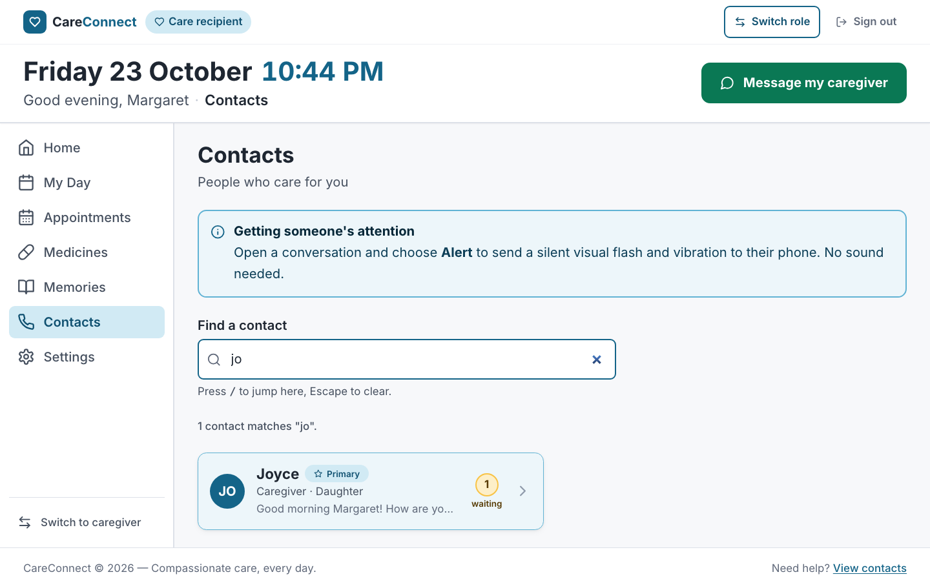  "/" jumps to the search box | 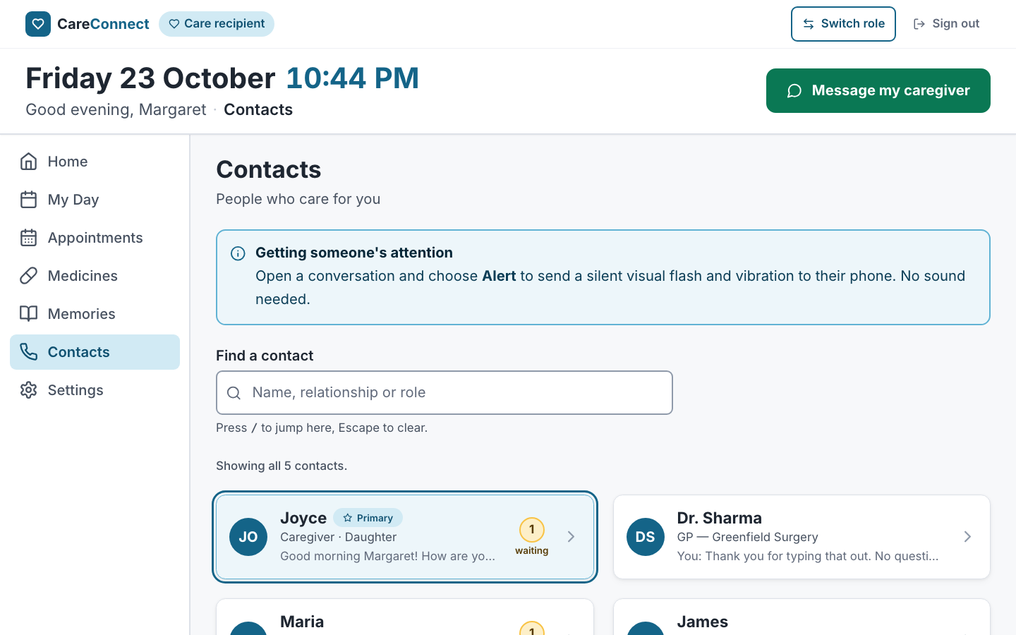  Tab reaches the first contact; Enter opens it
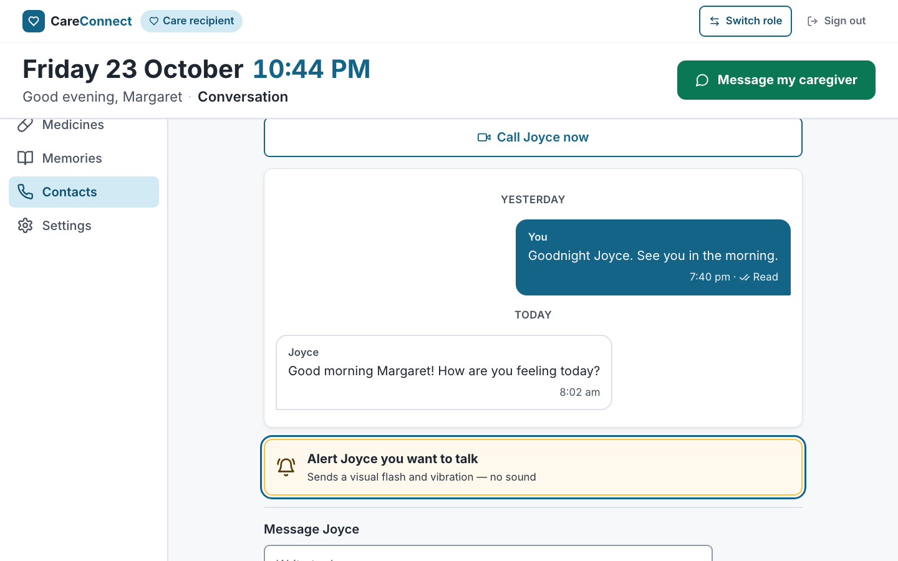  Tab from the history to the Alert button | 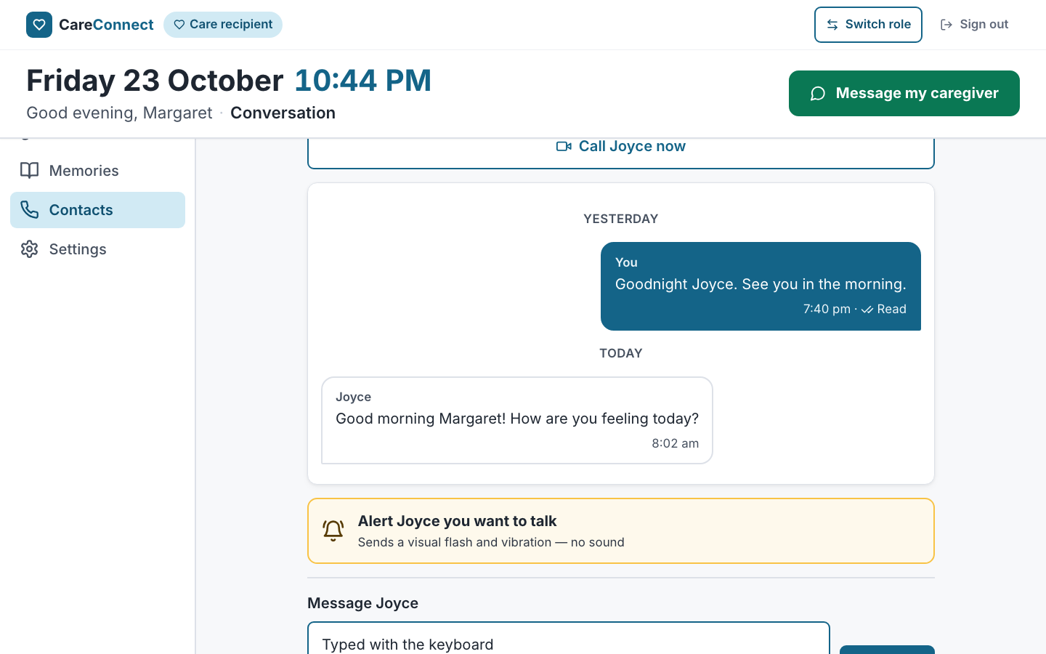  Typing in the message field
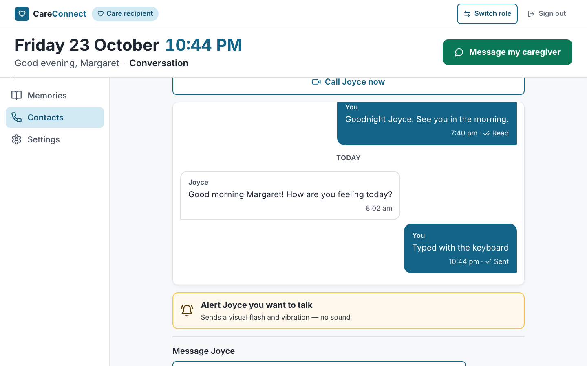  Ctrl+Enter sent it; focus stays in the field | 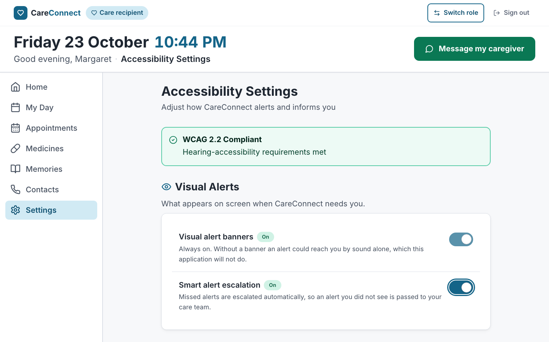  Focus ring on a switch
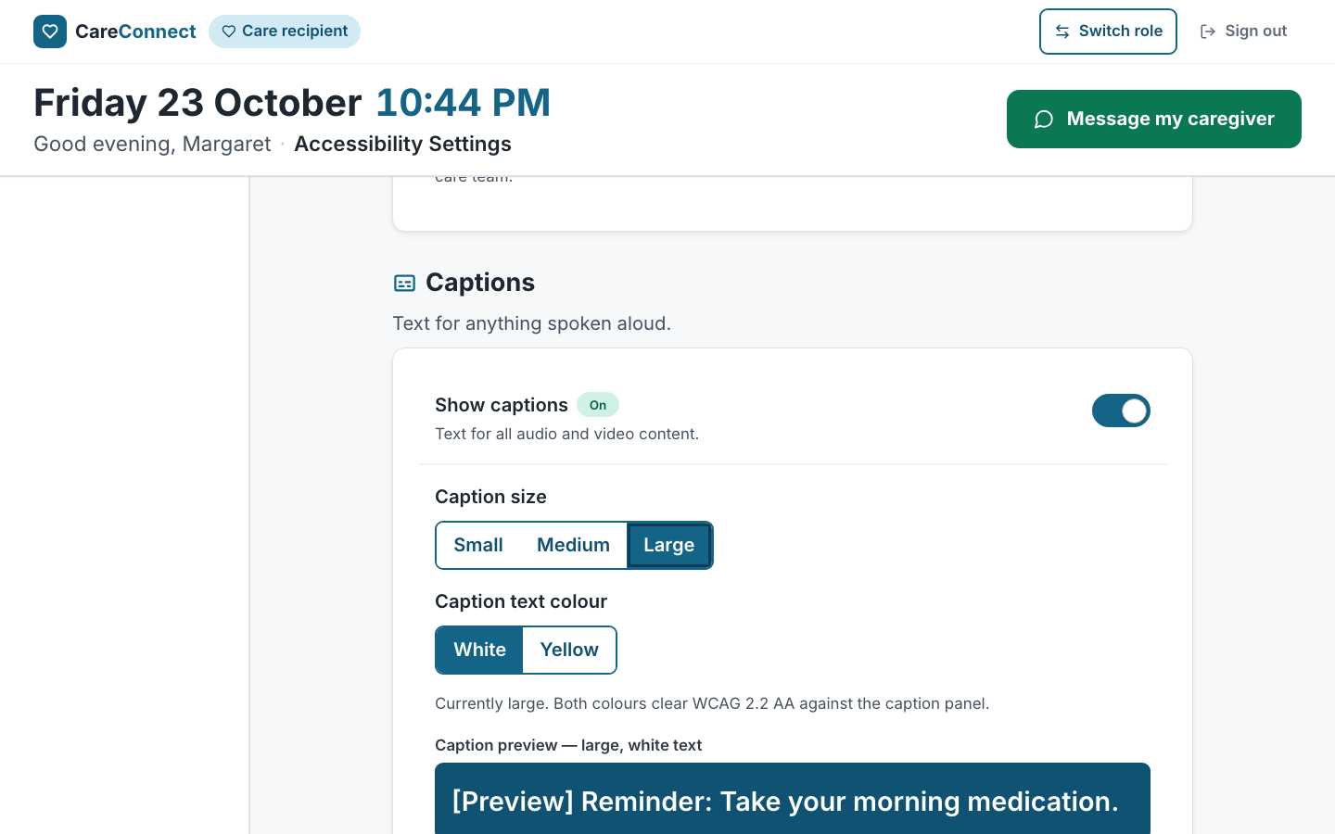  ArrowRight selects "Large"; the preview updates | 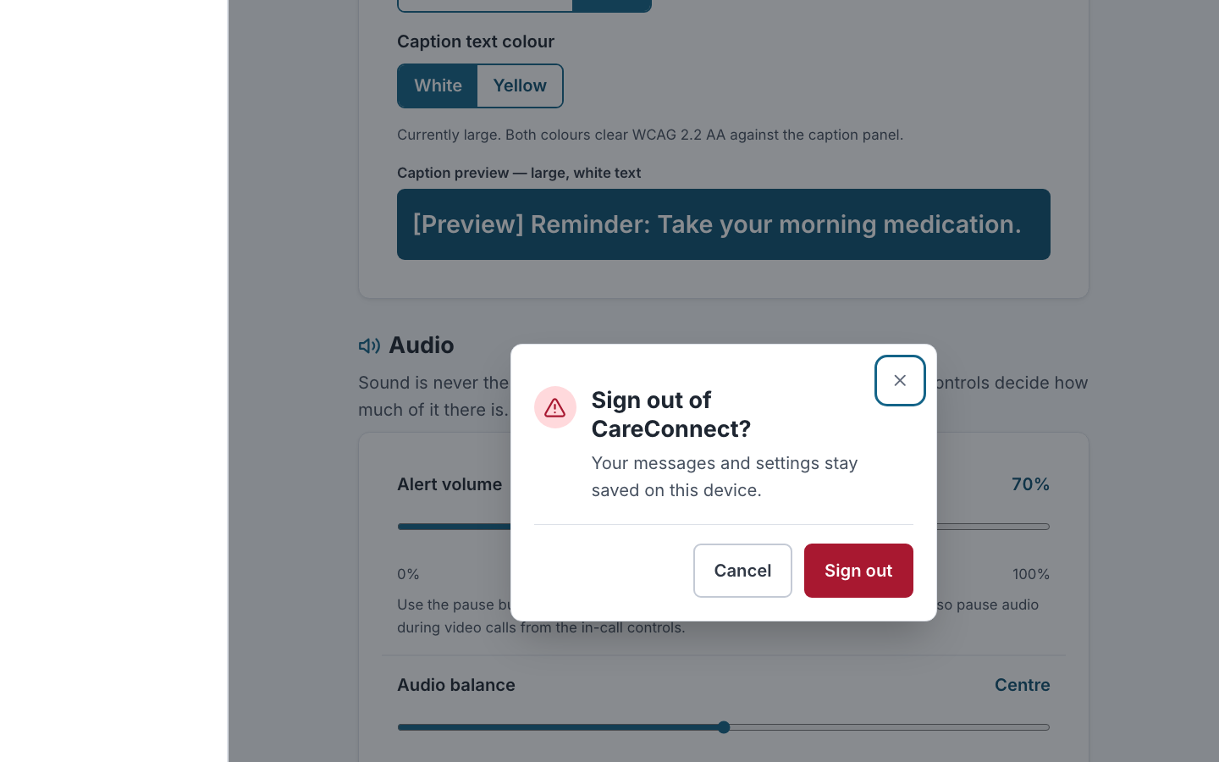  Enter on Sign out opens the confirmation dialog
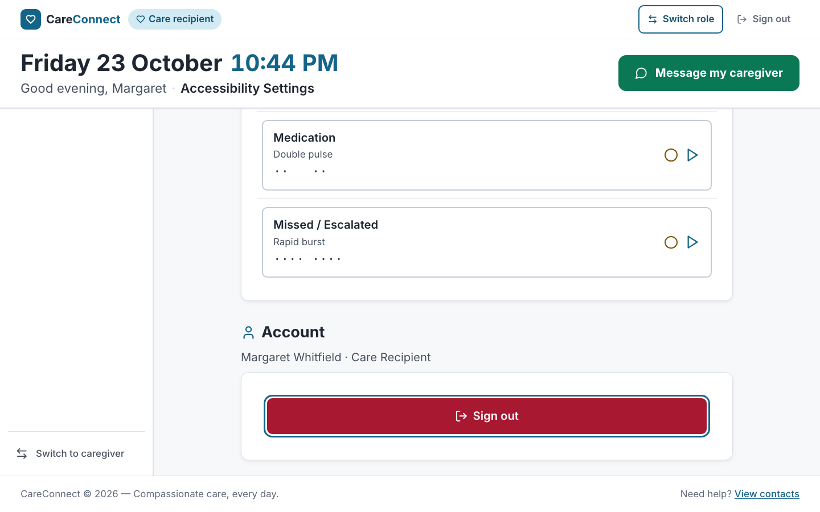
Escape closes it; focus is back on Sign out

One browser difference: Safari on macOS skips form controls on Tab unless Full Keyboard Access is turned on in System Settings. This is a platform setting, not an app defect. The WebKit E2E test therefore focuses the radio group directly, while Chromium and mobile Safari use Tab.

3. Testing implementation

Strategy
These were the biggest risks: losing a hearing-accessibility guarantee (for example, a voice-only path or a wordless alert), losing data (offline messages, saved settings) and keyboard dead ends. The tests are split across three levels:
- Unit tests (Jest). Pure rules with no React. Previews and "waiting" counts, transcript and caption headings, setting clamps and the locked banner, repairing corrupt saved data, search matching (including ignoring accents), message validation, date and time formatting, and vibration timing.
- Component tests (React Testing Library and user-event). Each screen rendered with its real providers and router. Interactions are driven the way a user would (typing, clicking, Tab, Space, arrows, Escape, Ctrl+Enter), and queries use roles and accessible names, so a test that passes also shows the screen is labelled correctly. The Context providers and both hooks are tested with renderHook, including offline/online events and storage that refuses writes.
- End-to-end tests (Playwright). Run against the production build (vite preview, with the service worker active) in Chromium, Firefox, WebKit (desktop Safari) and mobile Safari at 375 px.

Unit tests: 101 tests, 7 suites
src/models/__tests__/{contact,message,accessibilitySettings,vibrationPattern}.test.ts, src/utils/__tests__/{search,validators,formatters}.test.ts
// src/models/__tests__/accessibilitySettings.test.ts
it('never honours a request to switch the visual banner off', () => {
expect(withSettings(defaultSettings, { visualAlertBanners: false }).visualAlertBanners).toBe(true);
});

Component tests: 59 tests, 7 suites
Suite | Tests | Covers
src/pages/Contacts.test.tsx | 9 | No tel: links anywhere, previews and waiting badges, search with the announced result count, Escape clears, "/" focuses, empty state, Enter opens a conversation
src/pages/MessageThread.test.tsx | 20 | Transcript and caption headings, relationship shown in words, day headings, send with the button and with Ctrl+Enter, Enter adds a new line, empty-message error linked to the field, counter, alert flash and written record, confirmation buzz (and none when vibration is off), vibration-off wording, captioned call request, captions-off warning, offline queue → sent, Escape behaviour, unknown contact
src/pages/AccessibilitySettings.test.tsx | 12 | Named regions and switches, locked banner switch with its reason, Space toggles, captions-off conformance warning, radio group and arrow keys, slider value text, vibration rhythm (fake timers and navigator.vibrate), Account section and sign out through the dialog, repair of corrupt saved data
src/context/*.test.tsx | 13 | Seeding, read state, blank-message guard, alert record, corrupt storage, offline queue, error outside the provider, clamping
src/hooks/*.test.ts | 5 | Saving and repairing stored values, storage that refuses writes, online/offline switching
src/accessibility.test.tsx (team suite) | +9 | axe, landmark and title checks on my three routes. The header test now also checks there is no tel: link

// src/pages/MessageThread.test.tsx
it('queues messages written offline and sends them when the connection returns', async () => {
const user = userEvent.setup();
renderThread('c1');
setOnline(false);
expect(screen.getByText('You are offline')).toBeInTheDocument();

await user.type(screen.getByRole('textbox', { name: 'Message Joyce' }), 'Written offline');
await user.click(screen.getByRole('button', { name: 'Send' }));
expect(screen.getByText('Sending')).toBeInTheDocument();

setOnline(true);
expect(screen.queryByText('Sending')).not.toBeInTheDocument();
});

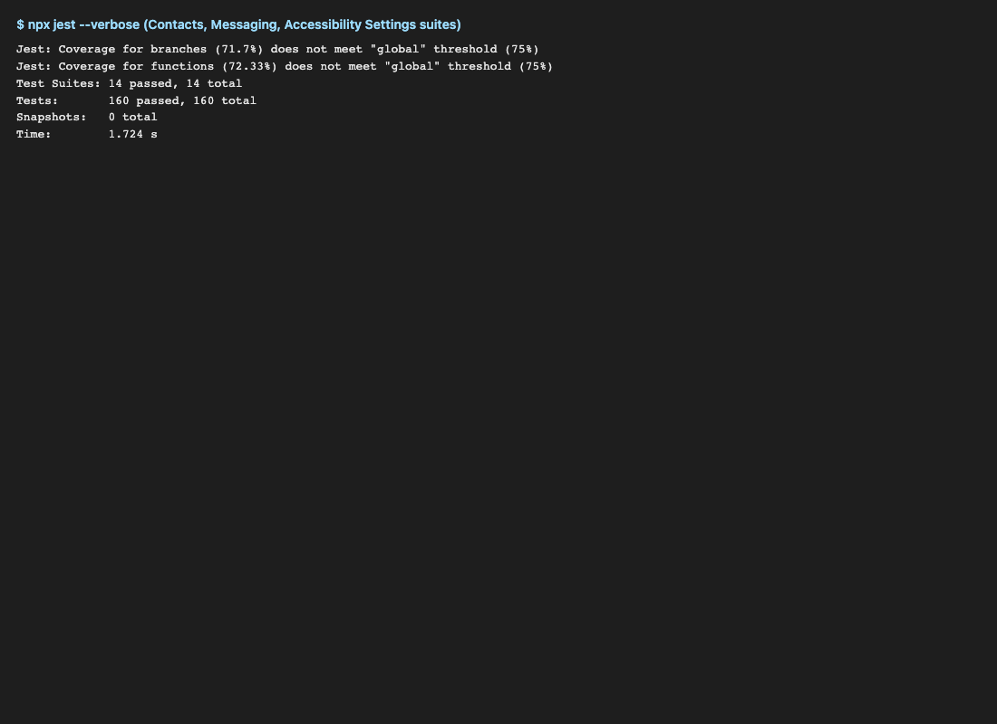
Jest results for Victor's suites
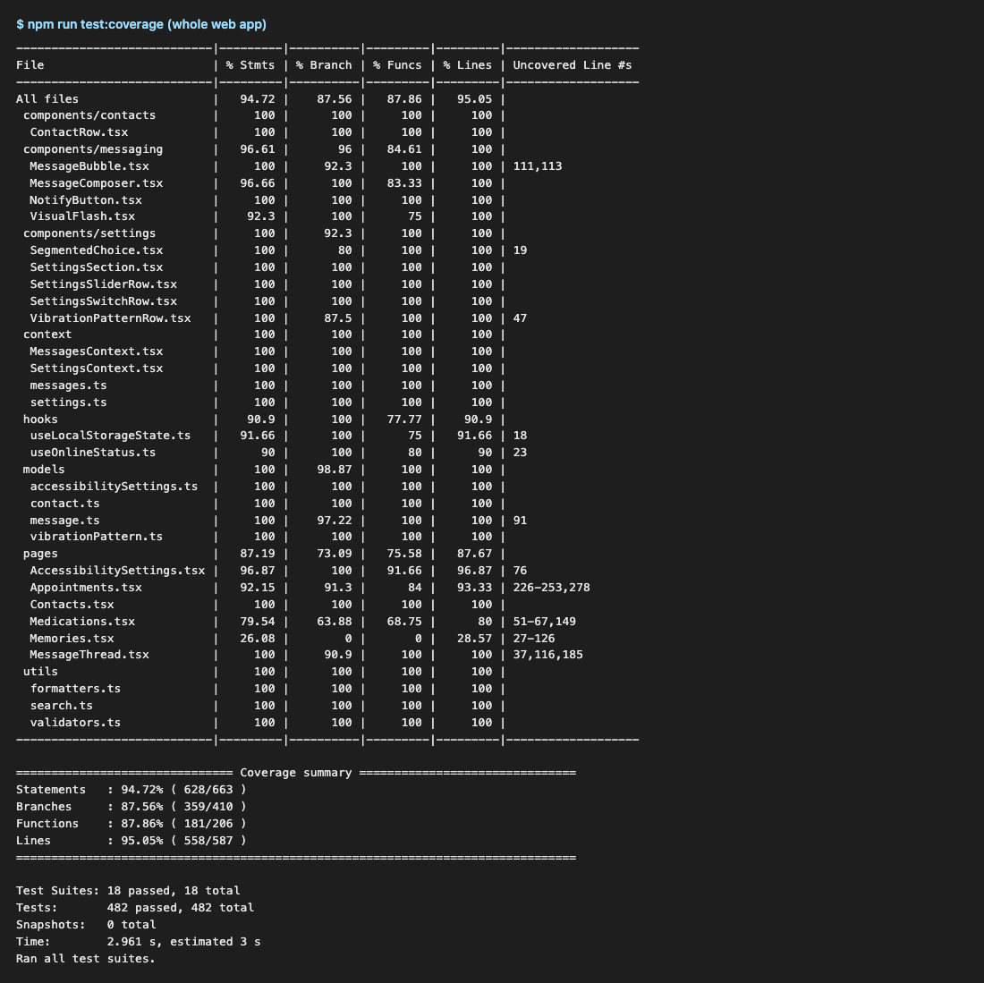
Whole web app: 482 tests passing

End-to-end tests (Playwright): 5 critical flows
e2e/contacts-messaging.spec.ts, e2e/settings-keyboard.spec.ts, config in playwright.config.ts.
- Find → open → send → reload. Search "son", open James, send a message, reload, and see it saved and shown as the preview on Contacts.
- Silent alert. The worded flash appears and the written record lands in the conversation. Also: a voicemail shows as a transcript, and an empty send is refused with a reason.
- Offline. context.setOffline(true) → the message shows "Sending" → back online → it is sent. With the service worker active, Contacts and a conversation also open from cold while offline (Chromium).
- Settings by keyboard only. Space on a switch, Tab into the radio group, arrows, arrow keys on a slider, then a reload confirms everything was saved. The Sign out dialog closes with Escape and returns focus, and confirming it really signs out.
- Settings across screens and widths. Captions turned off → a warning in a conversation with a video message, which links back to Settings. Settings is reachable at every width, with no horizontal scroll.
// e2e/contacts-messaging.spec.ts
test('messages written offline are queued and sent when the connection returns', async ({ page, context }) => {
await signInAsPatient(page, '/app/contacts/c3');
await context.setOffline(true);
await page.getByRole('textbox', { name: 'Message Maria' }).fill('Sent from the garden');
await page.getByTestId('composer-send').click();
const list = page.getByRole('list', { name: 'Messages with Maria' });
await expect(list.getByText('Sending')).toBeVisible();
await context.setOffline(false);
await expect(list.getByText('Sending')).toBeHidden();
});

Results: 25 passed, 2 skipped by design, 0 failed across Chromium, WebKit (Safari) and mobile Safari. The two skips are the service-worker offline test on WebKit, where Playwright cannot emulate it reliably.
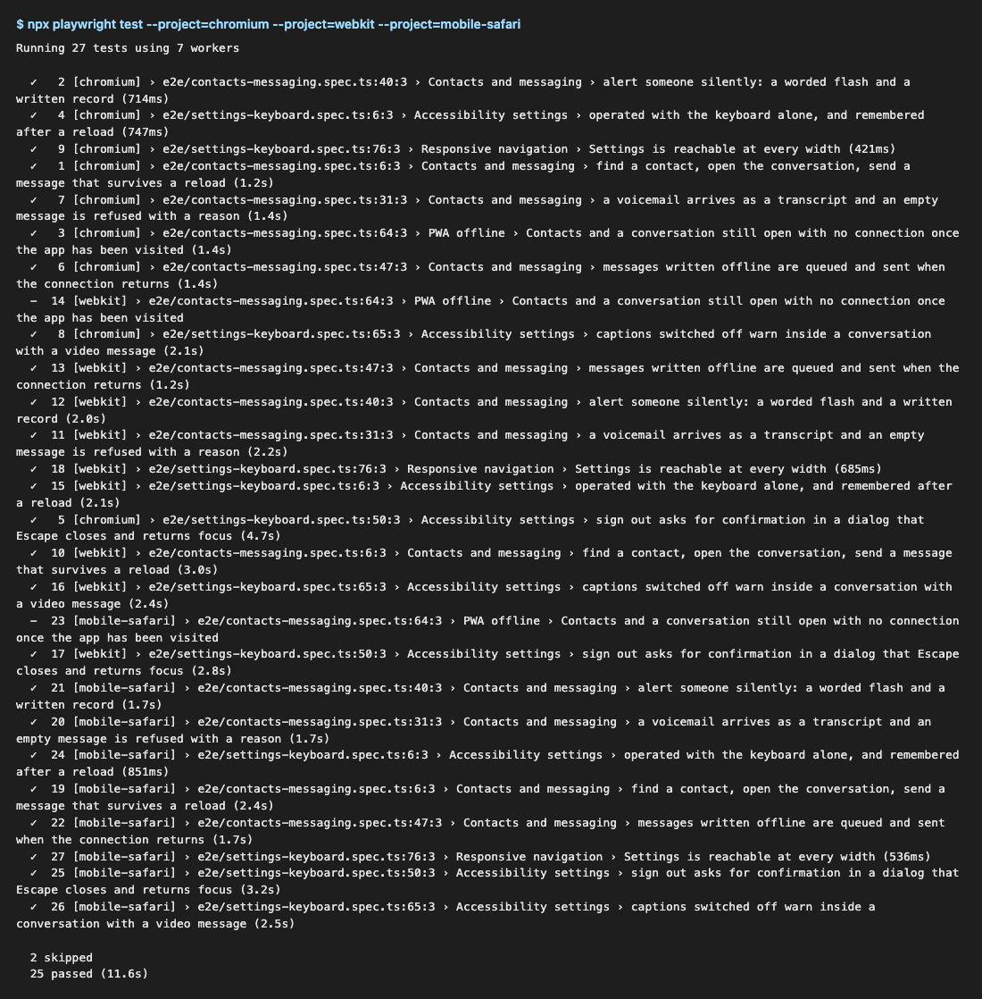
Playwright run
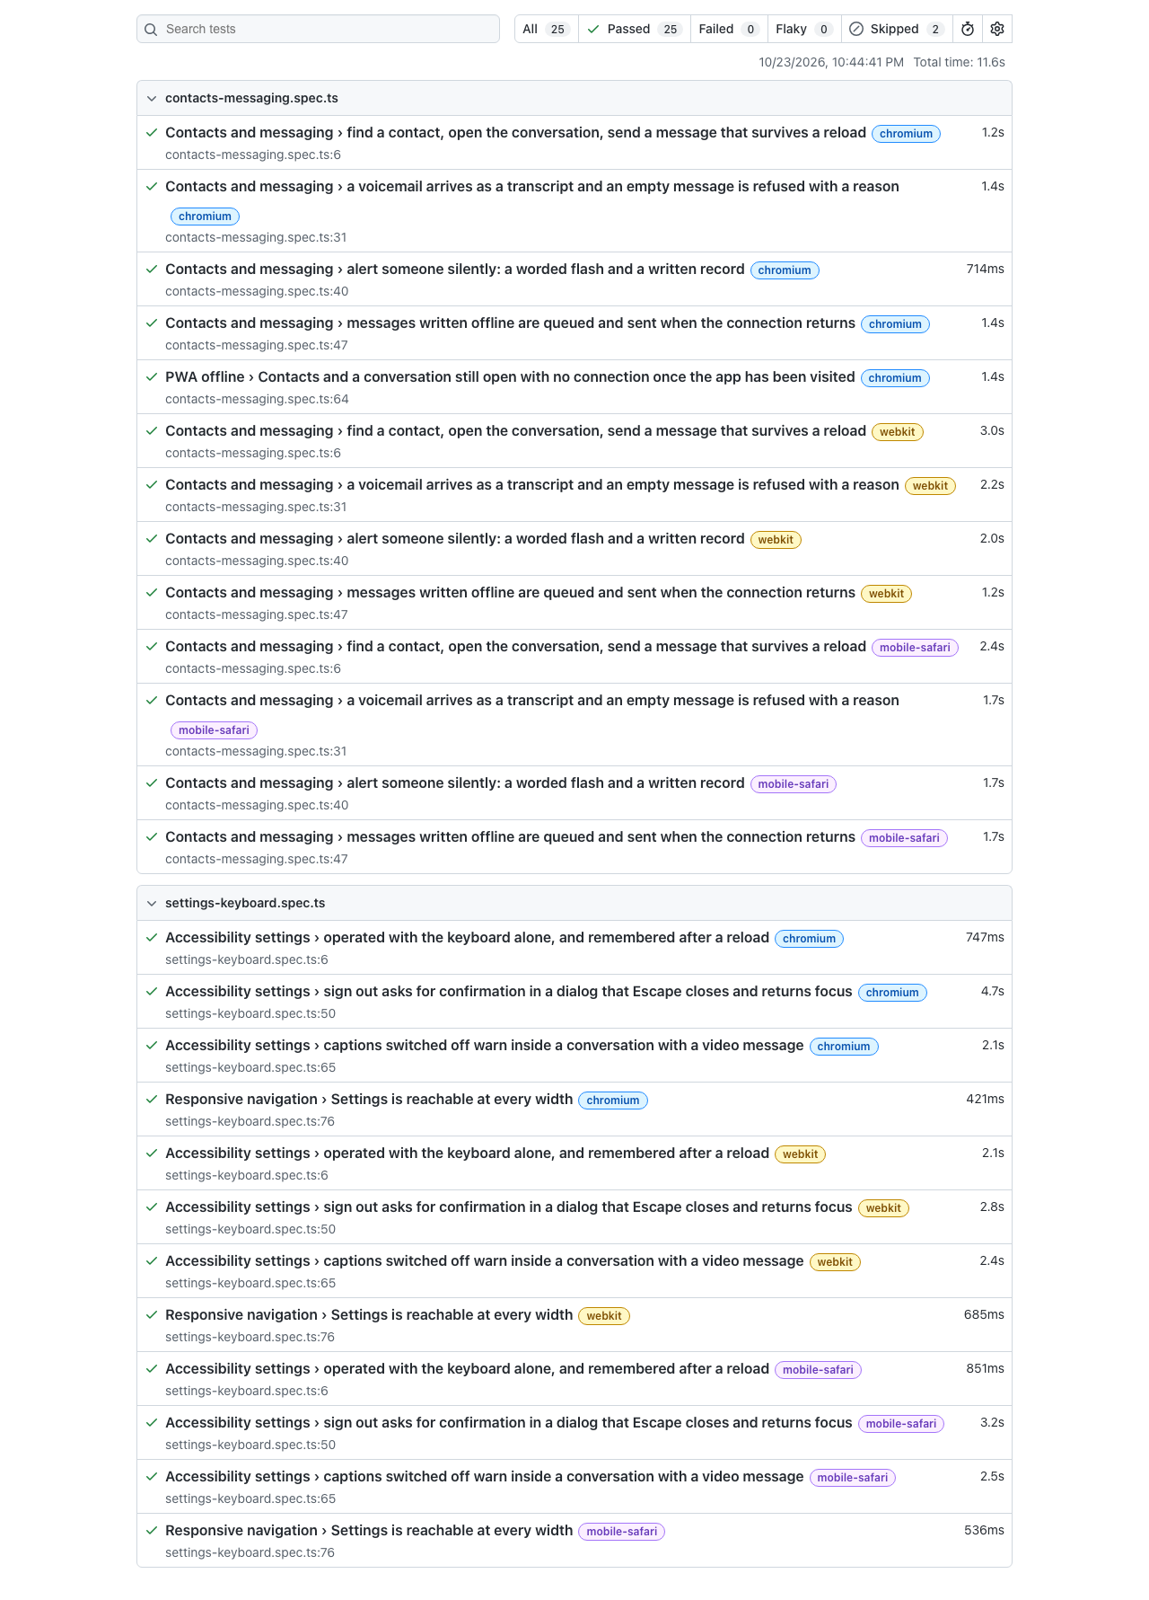
Playwright HTML report
Firefox. The firefox project is configured, but Playwright's Firefox build (v1522) hangs at launch on this development Mac (macOS 27.0.1). It fails with sandbox_extension_issue_file_to_process … Operation not permitted before any page loads, even with the sandbox turned off, so this is a local platform problem and not an app or test failure. To still get Firefox coverage, .github/workflows/web-tests.yml runs lint, typecheck, Jest with coverage and all four Playwright projects, including Firefox, on Ubuntu for every push to main and every pull request. It uploads the coverage and Playwright reports as artifacts.

Finding the evidence in the repository
What | Where
Test files | src/**/*.test.ts(x), src/models/__tests__, src/utils/__tests__, e2e/
Shared render helper | src/test-utils/renderWithProviders.tsx
Screenshot scripts | scripts/week11-victor-evidence.mjs

4. Coverage report
npm run test:coverage writes coverage/lcov-report/index.html, which is committed so it can be read from the repository. Coverage is measured on the files listed in collectCoverageFrom in jest.config.cjs, and a coverageThreshold of 75% on statements, branches, functions and lines makes the run fail if any of them drops below that.
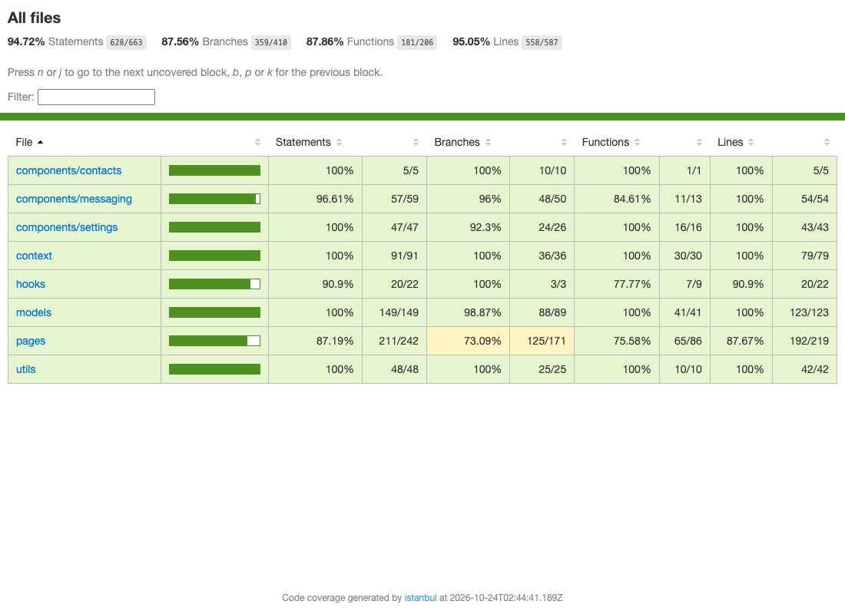
Coverage summary
Measured scope | Statements | Branches | Functions | Lines
All measured files (Victor's plus the Appointments, Medicines and Memories pages already listed) | 94.72% | 87.56% | 87.86% | 95.05%
Contacts.tsx | 100% | 100% | 100% | 100%
MessageThread.tsx | 100% | 90.9% | 100% | 100%
AccessibilitySettings.tsx | 96.9% | 100% | 91.7% | 96.9%
components/contacts, messaging, settings | 96.6–100% | 92–100% | 84.6–100% | 100%
context, models, utils | 100% | 98.9–100% | 100% | 100%
hooks | 90.9% | 100% | 77.8% | 90.9%

Exclusions and why.
- src/**/__tests__/** and *.test.*: test code is not measured.
- src/data/contactsData.ts and messagesData.ts: static seed data with no branches to test.
- src/test-utils/: a test helper.
- The only uncovered lines in my files are the getServerSnapshot fallback in useOnlineStatus, which runs only during server-side rendering (this app renders in the browser only), and useLocalStorageState's default revive callback, which the providers always replace with their own.

6. Project links and running instructions (for my part)
npm install
npm run dev # http://localhost:5173 — sign in with any email, choose care recipient
npm test # Jest + React Testing Library
npm run test:coverage # + coverage/lcov-report/index.html (fails under 75%)
npx playwright install chromium firefox webkit # once
npm run test:e2e # builds, starts vite preview on :4173, runs every browser
npm run test:e2e -- --project=chromium # one browser
npm run test:e2e:report # opens the HTML report
npm run lint && npm run typecheck

AI usage (my part)
I used Claude (Anthropic) in Claude Code as a pair programmer for this part. It ported the existing desktop TypeScript models and screens to React with Tailwind, drafted the component and Playwright tests, and wrote the screenshot scripts and this write-up. I checked the output in four ways:
- Every test was run and had to pass. The coverage threshold is enforced.
- I compared the screens by eye against the 375, 768 and 1440 px screenshots.
- I ran the keyboard paths with real key presses in Playwright and user-event.
- I kept the failures the tests found, which led to real fixes: the header covering Send on mobile, and the alert flash being invisible under reduced motion.
npm run lint reports 0 errors and no new warnings, and npm run typecheck is clean.

Notes for the team
- Shared files I changed:
- Layout.tsx: the header is sticky only from 768 px; the mobile header has a Settings link; added screen titles for Conversation and Settings.
- navItems.ts and BottomNav.tsx: added Settings, with an inBottomBar flag.
- App.tsx: added my routes, lazy-loaded, and the two providers.
- index.css: flash and lamp styles.
- Layout.tsx header: Call my caregiver (a tel: link) is now Message my caregiver, which opens Joyce's conversation, to match the desktop and mobile apps. The footer link uses the router.
- ConfirmDialog.tsx: more room on the right of the title (pr-12), so a long title no longer runs under the × button.
- jest.config.cjs: .test.ts files, roots: ['src'] (stops Jest picking up .claude/worktrees), my files in coverage, and the 75% threshold.
- Removed the old Contact type and contacts mock data, which only the old Contacts page used.
- Coverage gap that isn't mine: src/pages/Memories.tsx is at about 26% in the same report. It doesn't threaten the 75% total, but more tests there would help.
- New dev dependencies: @playwright/test and @testing-library/user-event. The new CI workflow runs Firefox, which can't launch locally on macOS 27.

Appendix — screenshots

Mobile — 375 px
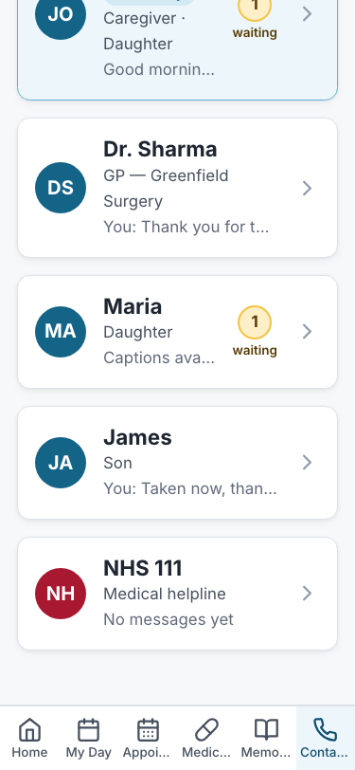
Mobile — 375 px: contacts bottom
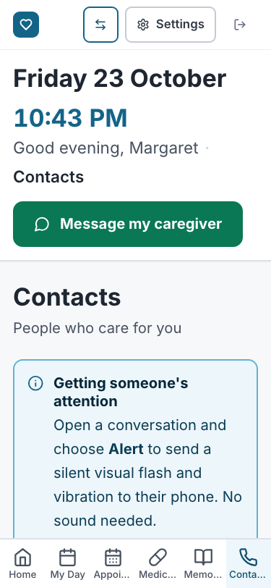
Mobile — 375 px: contacts top
Mobile — 375 px: conversation bottom
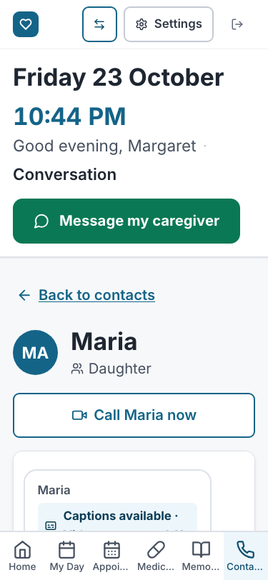
Mobile — 375 px: conversation top
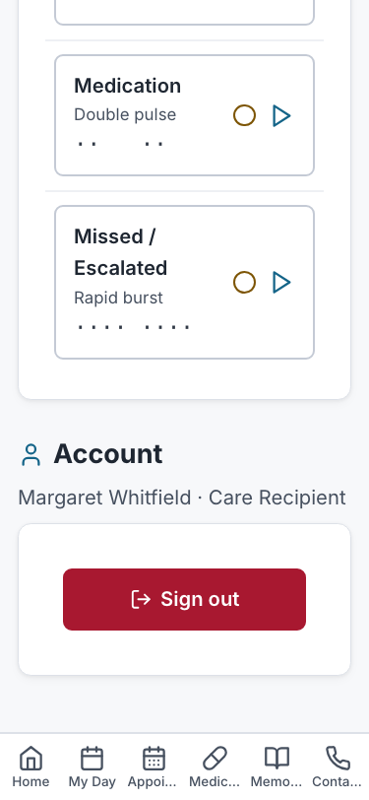
Mobile — 375 px: settings bottom
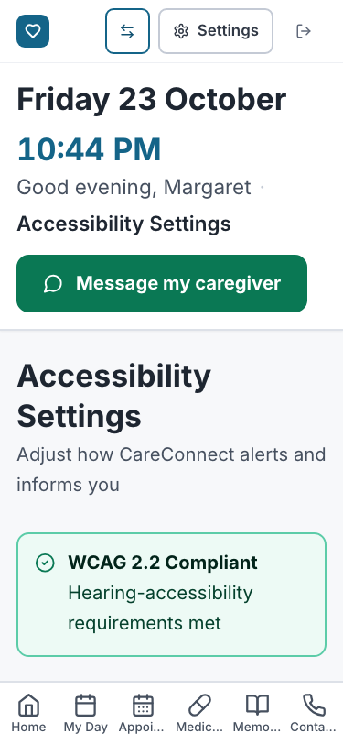
Mobile — 375 px: settings top
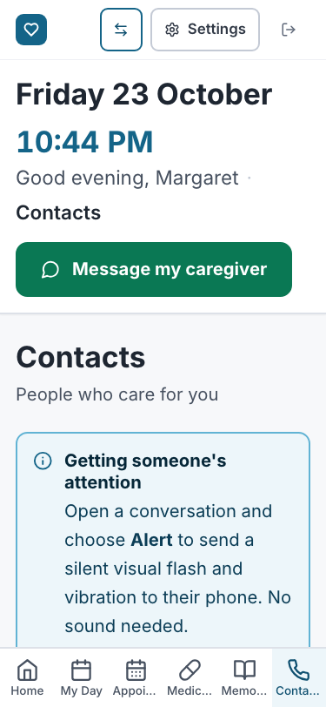
Mobile — 375 px: navigation

Tablet — 768 px
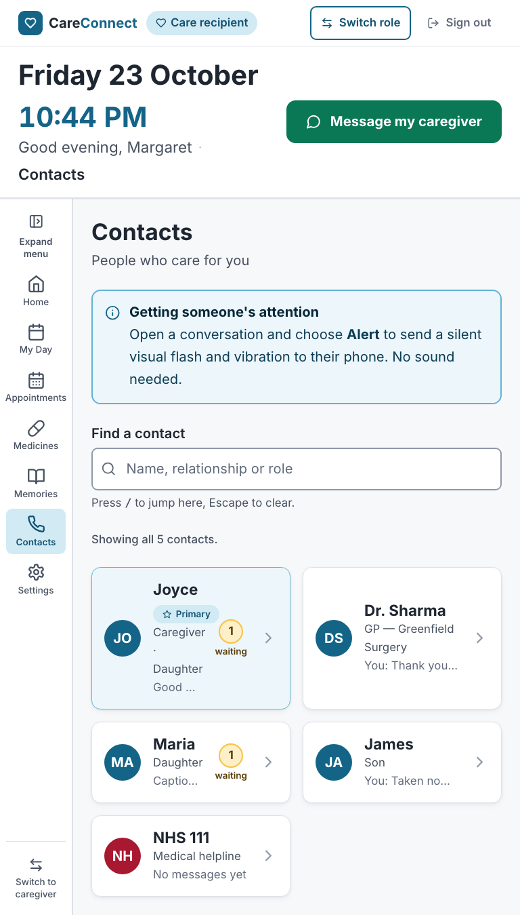
Tablet — 768 px: contacts
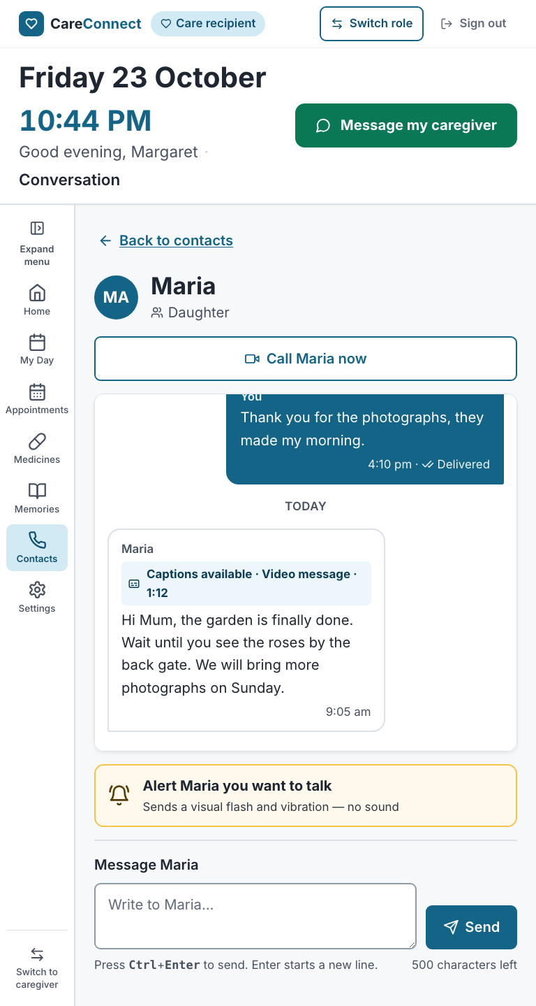
Tablet — 768 px: conversation
Tablet — 768 px: settings
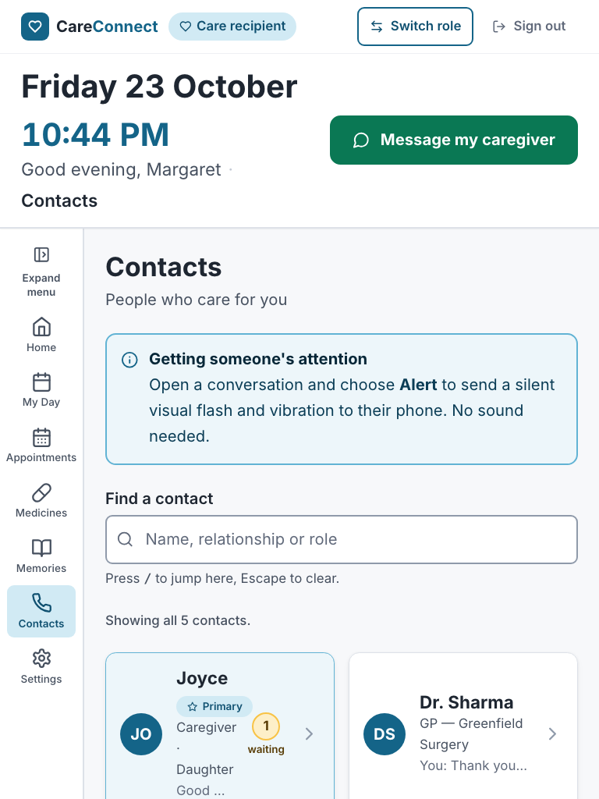
Tablet — 768 px: navigation

Desktop — 1440 px
Desktop — 1440 px: contacts
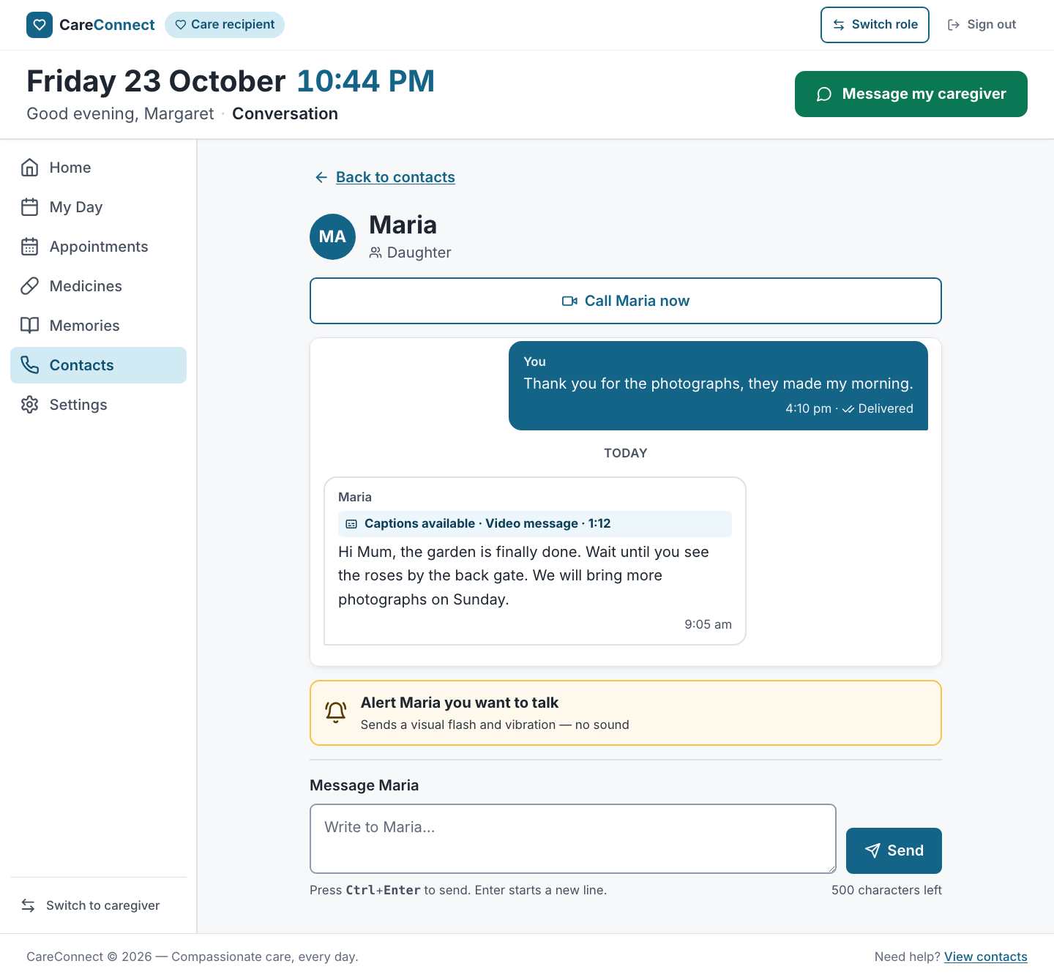
Desktop — 1440 px: conversation
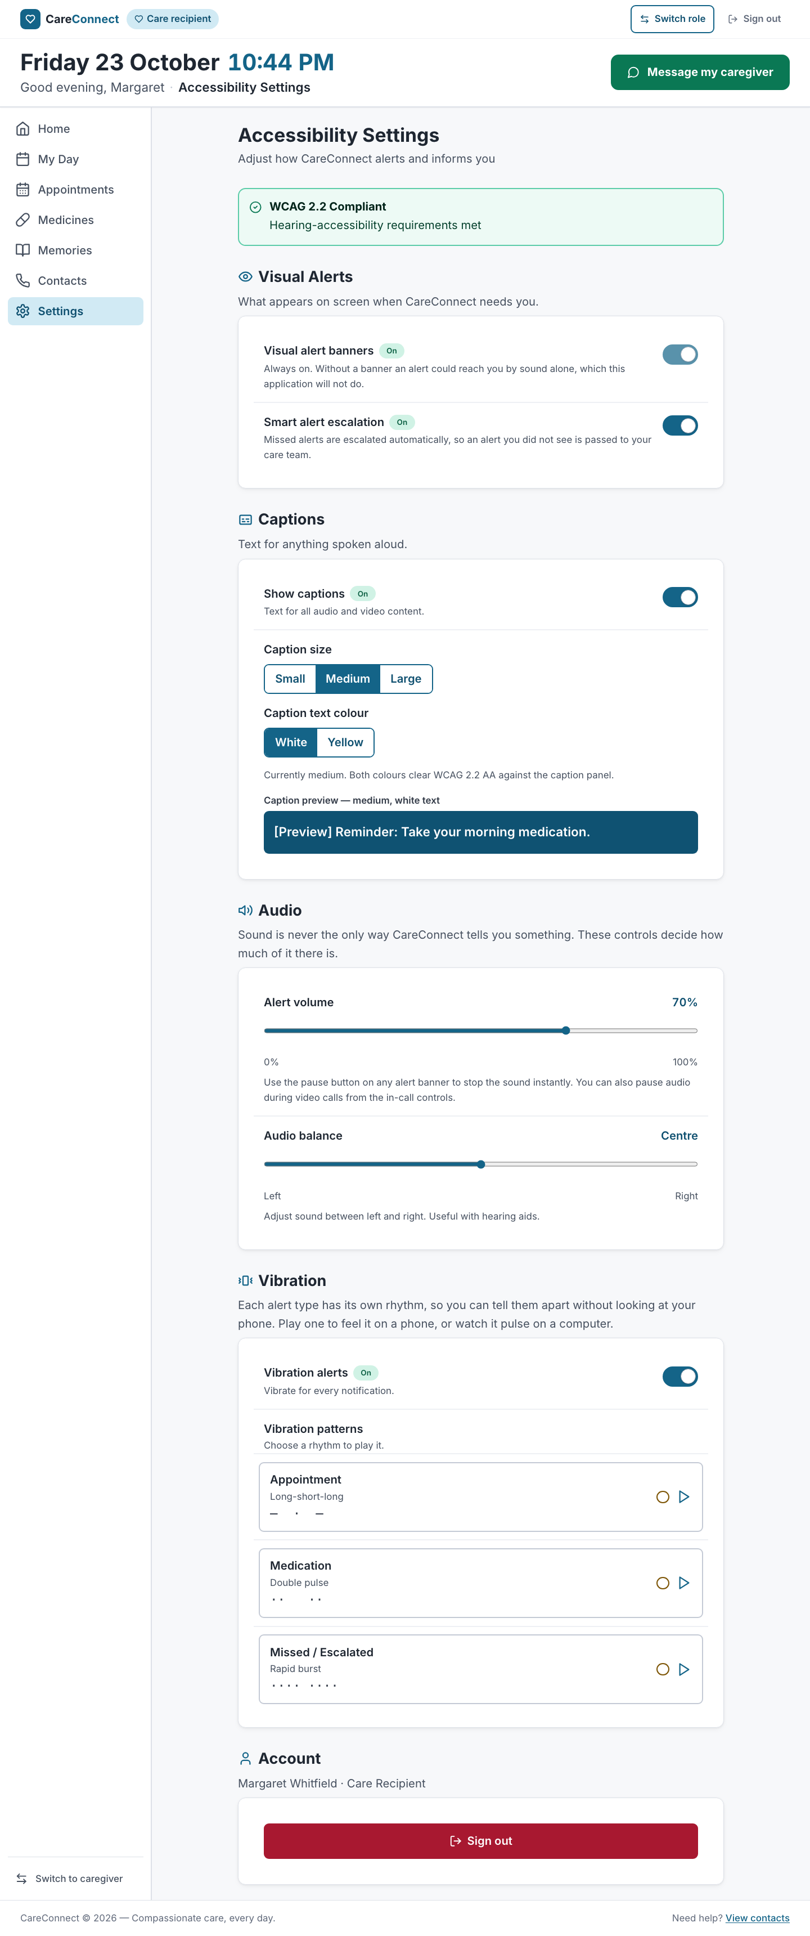
Desktop — 1440 px: settings
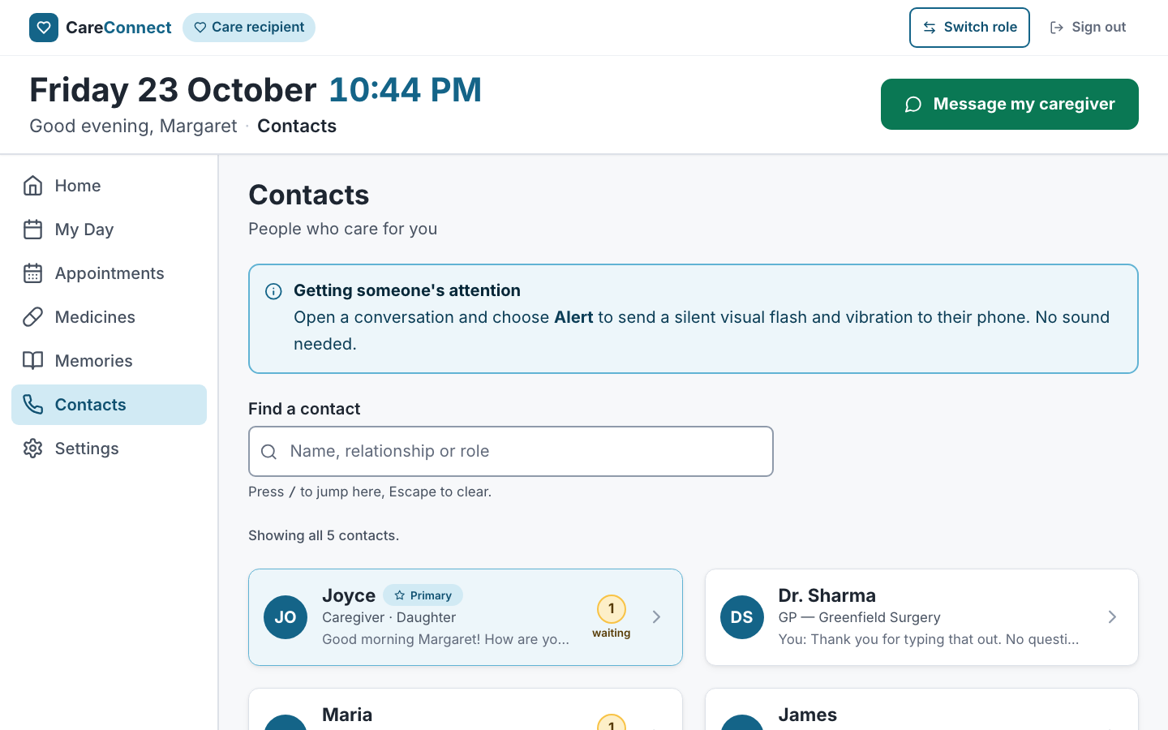
Desktop — 1440 px: navigation

Feature states (desktop)
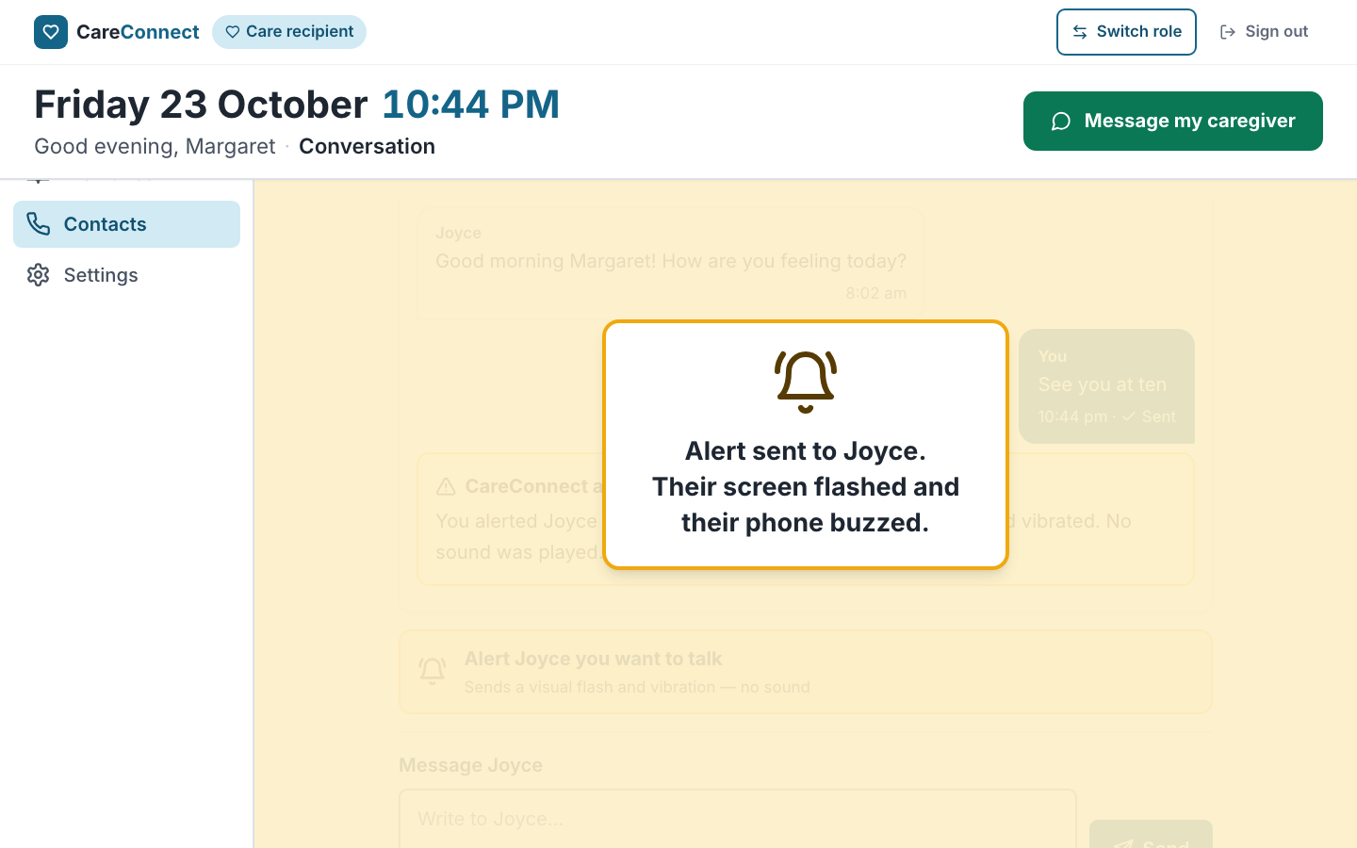
Feature states (desktop): alert flash
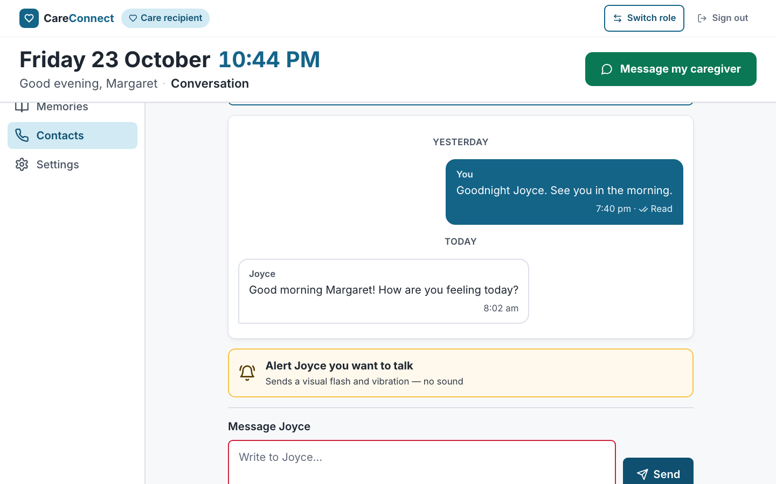
Feature states (desktop): composer validation
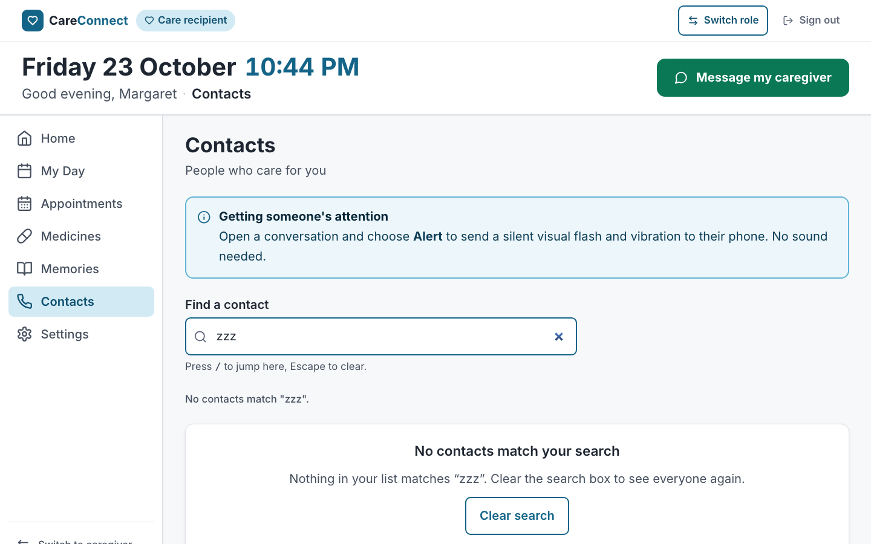
Feature states (desktop): contacts no match
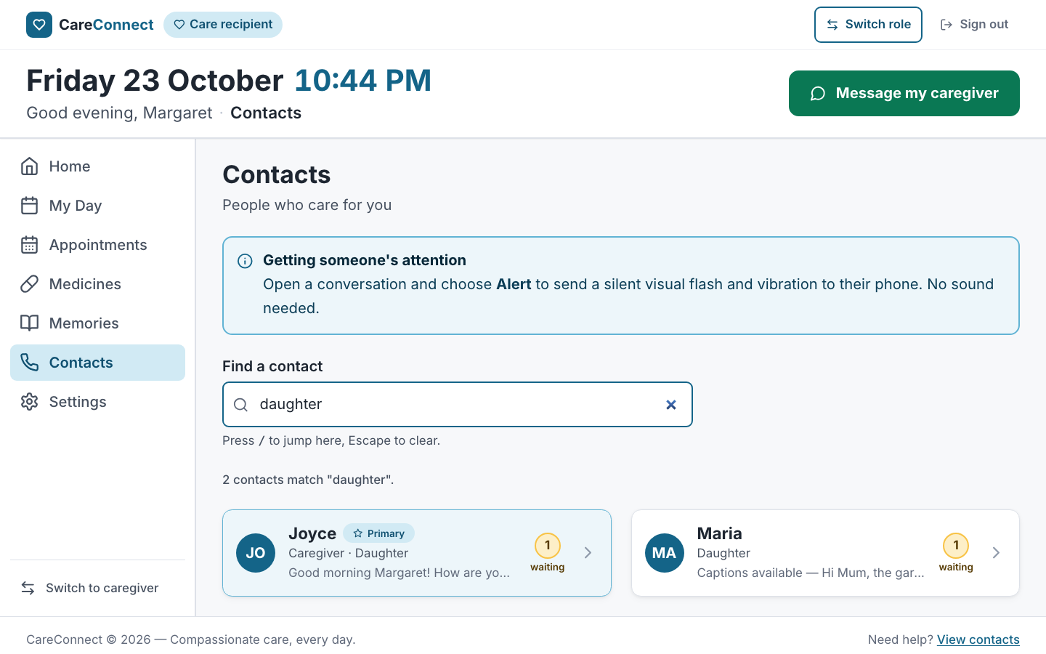
Feature states (desktop): contacts search
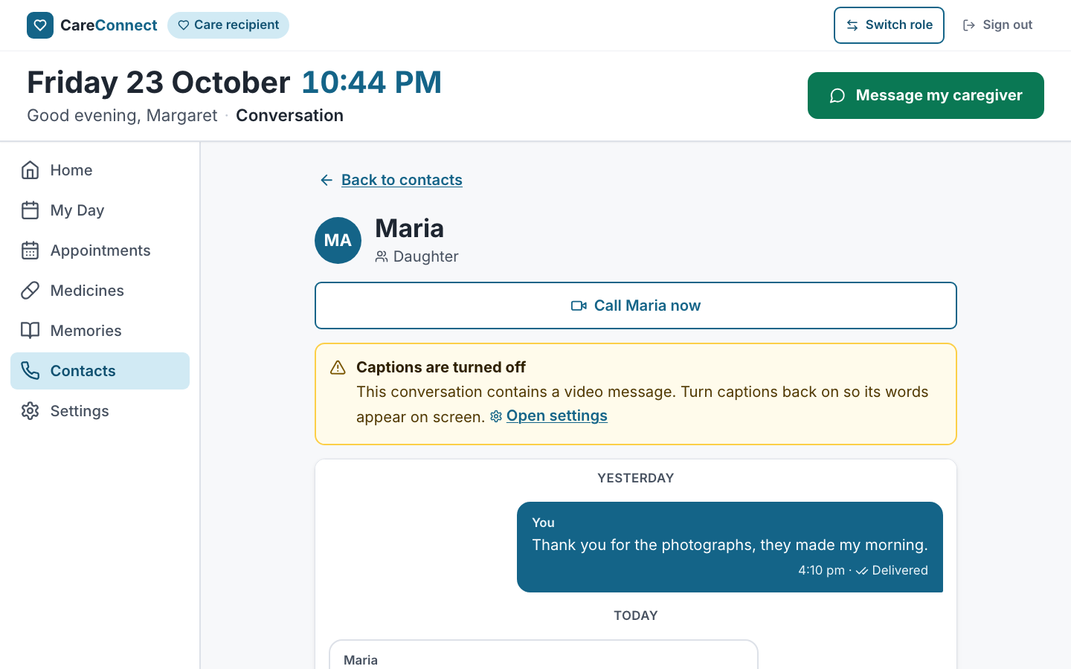
Feature states (desktop): conversation captions warning
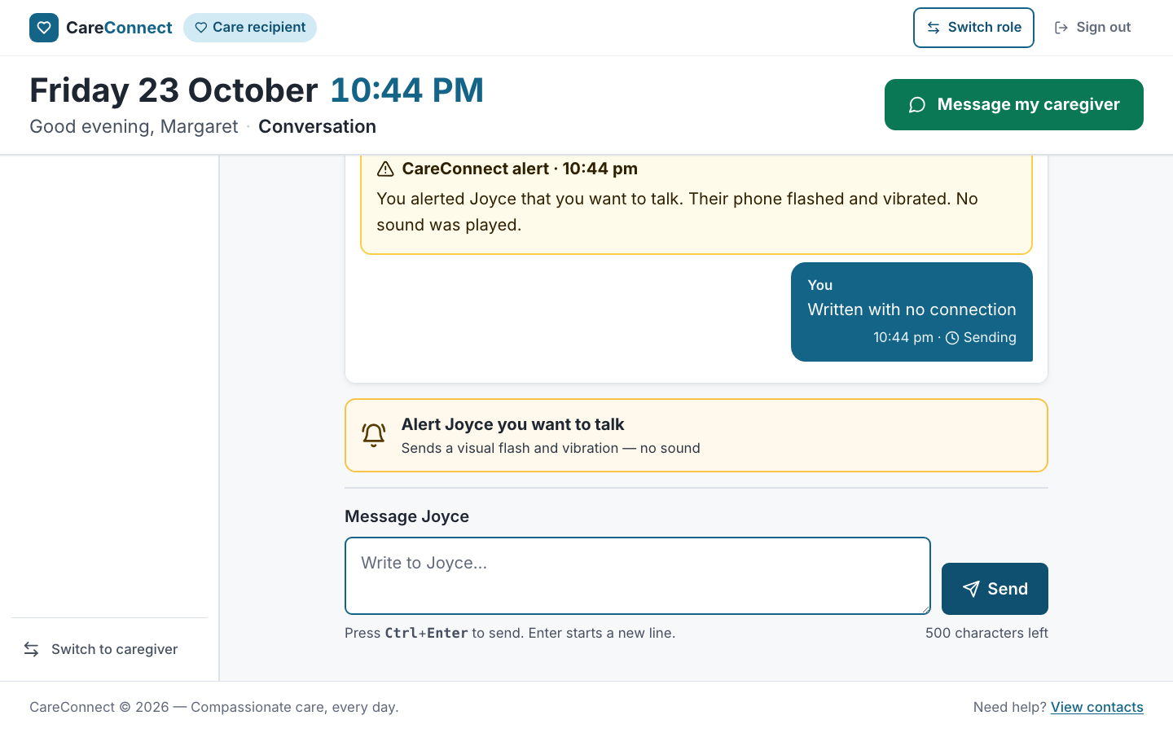
Feature states (desktop): offline queued
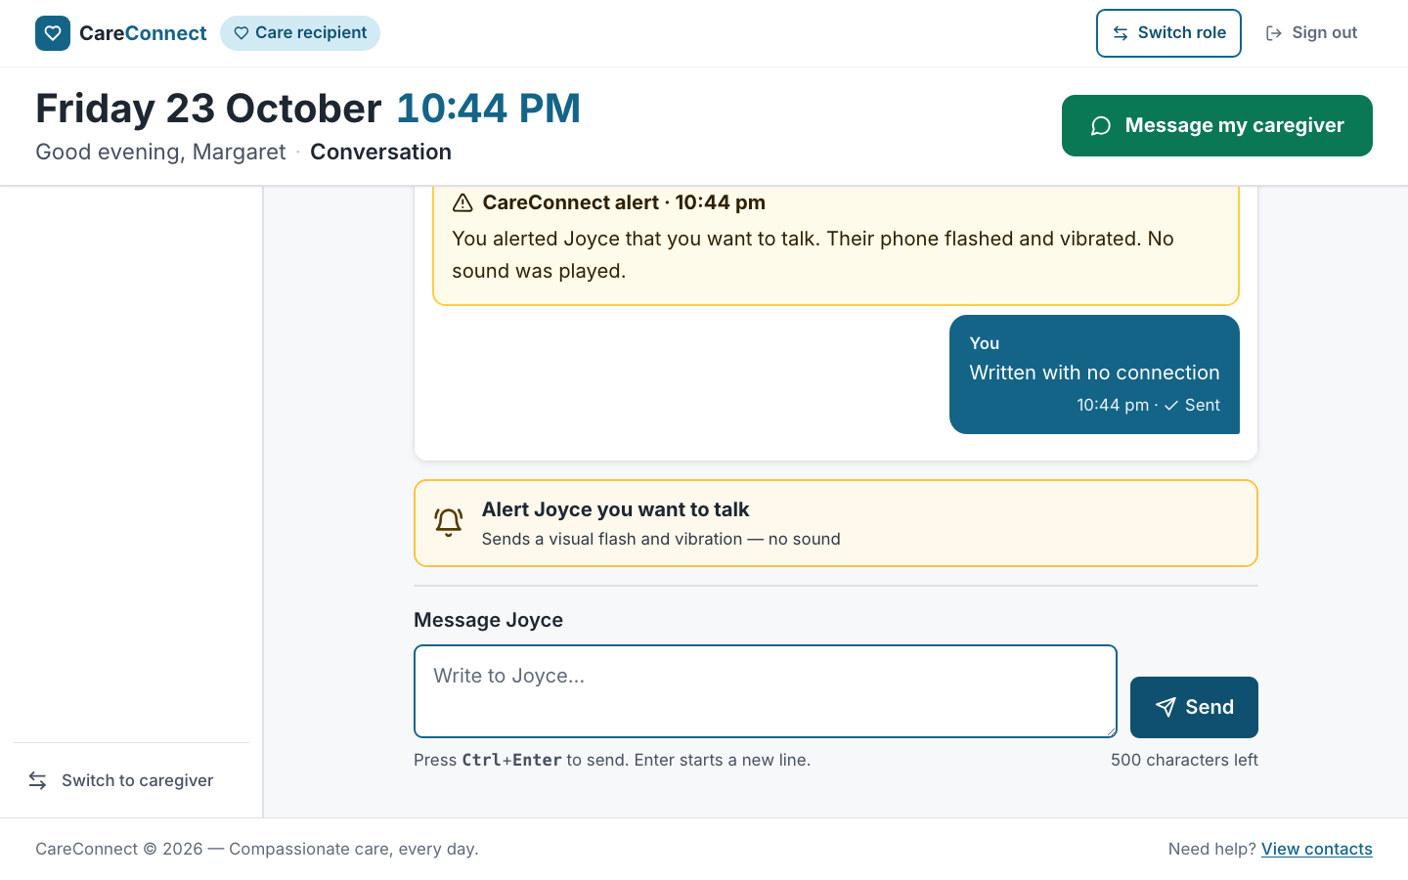
Feature states (desktop): offline sent
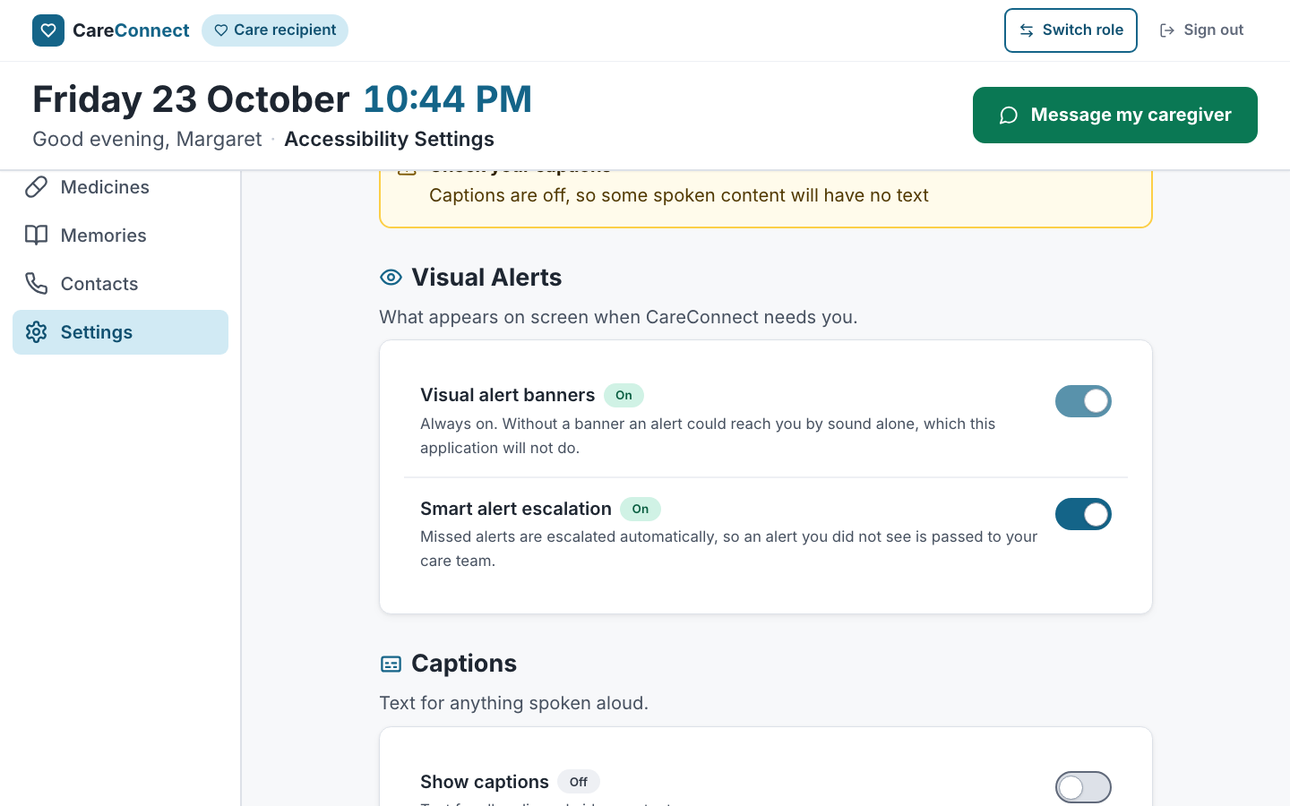
Feature states (desktop): settings captions off
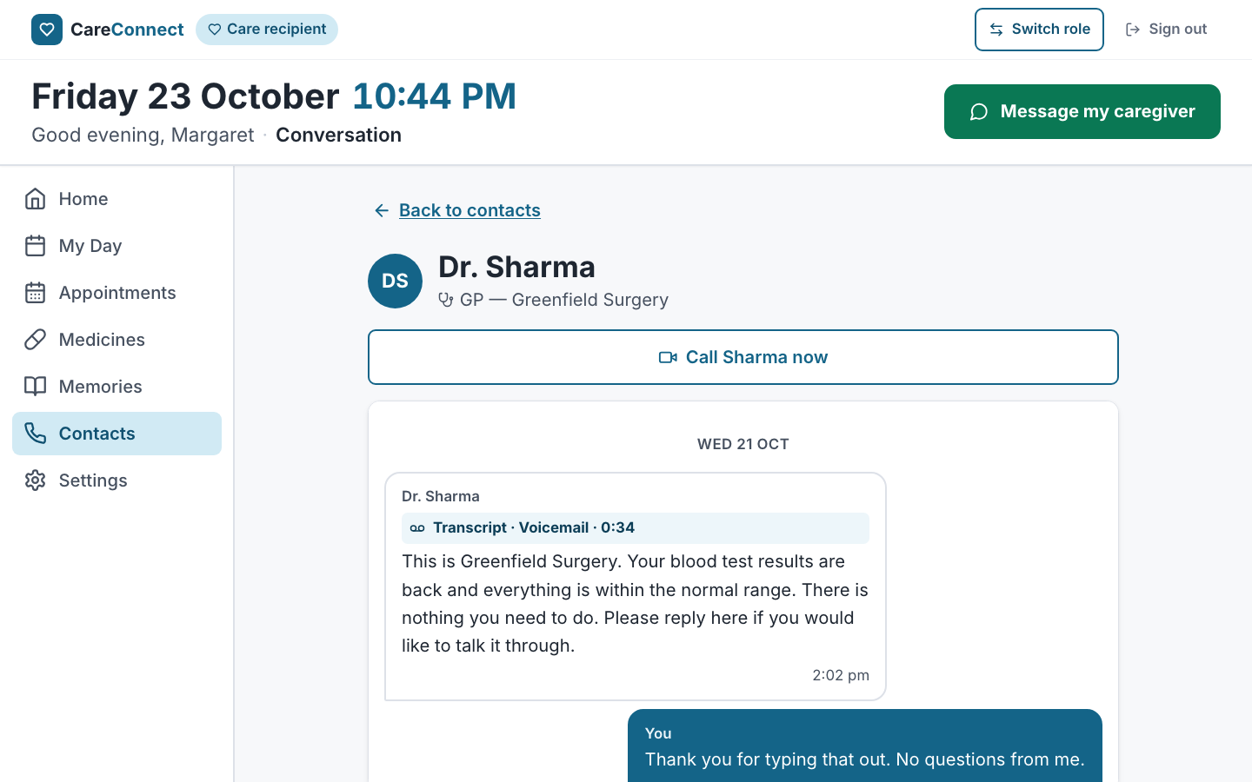
Feature states (desktop): voicemail transcript

