On my Outlook Express, I have open directories as such :

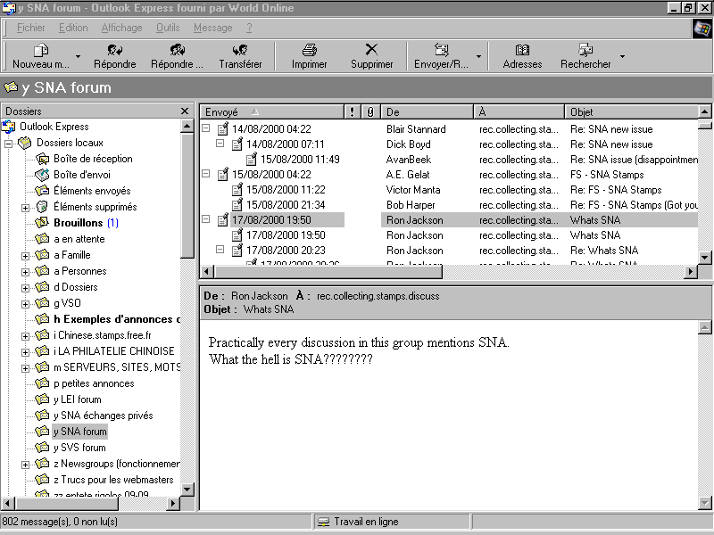

One is named "y SNA forum".
When I read the rcsd I push there all SNA POSTS.

If I right click on the subdirectory name, then click on "Properties" it reads where on my Hard Drive the file is stored; in my case :

c:\windows\application data\identities\{a long serial number, probably my OE5 licence #}\microsoft\outlook express\y sna forum.dbx
In fact in that directory I find ALL .dbx files : one file per directory or subdirectory that I have created in my Outlook Express.

What I have done is just Zipped that file and send it to you.

I thought it was easy for you to place it in the similar directory, then read it through your OE. It seems it is not, since after I have read you, I did not succeed either to do a similar operatioon.

Maybe you can find some help at the : microsoft.public.ch.outlookexpress newsgroup.

Regards,

Didier

