Mr Victor Manta
President
Philatelic Webmasters Organization
By eMail

October 16, 2021

Re: Planning for the PWO Exhibition

Dear Victor,

Many thanks for your last message dated October 13. It’s very encouraging to see that we agree on 99% of the details. Below, I will just respond to the few remaining items under discussion:

Exhibition name and logo

I’m glad you liked my idea for the title of the expo. Hopefully, you will also like my idea for the logo:



If you like this, I will make various versions for promotional purposes.

I have also recreated the original PWO logo in a much larger version that I can use for the expo web pages:

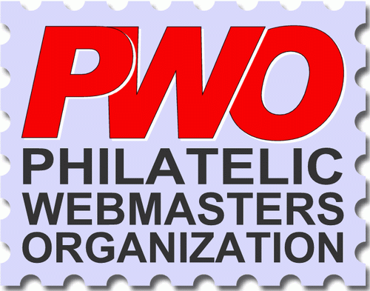

I think is a reasonably faithful reproduction of the original design. If you want some copies in various sizes, for your own use, please let me know.

Language

VM: For the “competitional” sites I suggest that we limit ourselves to languages that the jury understands.
NM: I don’t think I would be able to make that restriction, but in any event, I don’t think it’s needed because the two most popular website browsers in the world both have built-in language tools with inline translations. I use these tools all the time and I am easily able to read websites in any language, even Russian and Chinese. I would not have any concerns about this.

Key dates / Calendar

VM: IMO, and especially is because it’s a new and unusual expo / contest, the participants should have at least 6 months to enrol. Everything else is OK.
NM: OK, you make a sensible point. Lets be cautious and change the calendar as below:

Opening date for exhibitor applications | 1 January 2022
Closing date for exhibitor applications | 30 June 2022 | 6 months
Closing date for exhibitor applications acceptance/rejection by OC | 5 July 2022
Exhibition opening date for public viewing and popular voting and commencement of jury work | 10 July 2022
Closing date for popular voting and jury work | 10 September 2022 | 2 months
Date for publication of jury and popular voting results (Palmares) | 12 September 2022

Organizing Committee and Expo Management

VM: I suggest the terms OC General Manager (me) and OC Executive Manager (you). Dislike “Chief” ☺ .
NM: Hmmm… that’s going to be difficult since the term “Chief” in built into the system. I actually dislike the term “President” which is most commonly used and that’s why I changed to “Chief” (a little more informal). OK, I will see if I can make modifications to designate specific titles to personnel but I cannot guarantee this. Leave it with me.

Eligible participants

VM: (referring to: “Participants can be individuals or organizations such as clubs, societies and national postal operators.) These organizations can participate only as non-competitive.
NM: This might be a difficulty. Can you explain to me why you want to introduce this restriction? I don’t really see the point of this. A philatelic website is either good or bad (according to our established criteria) regardless of the owners or authors or the resources available to them. For example, the FIP has huge resources but their website is severely lacking.

Finally:

All other matters seem to be agreed. I await your comments and feedback regarding the above.

Best regards,
Niall

