Introduction

The underlying process of classifying through the overall sentiment can be difficult due to its multiple variables and its complex process of contextualizing and understanding of language documents. Finding the correct classifiers with relative of different feature selection, feature size, cross validation and ways of preprocessing data can drastically change accuracy and efficiency of the model. We will be using different classifiers and combination to establish an efficient model, best fitted for determining a positive and negative data.

Problems and major applications

The biggest obstacle in sentiment analysis is examining the context of the document data. For instance, multiple complications such as sarcasm, navel gazing, relative sentiment, conditional sentiment, ambiguous negative words, contain biases and multiple perception to understand the sentiment of the data. For example, obstacle such as sarcasm is one of the most difficult sentiments interpretation of whether it is a positive or negative response due to its inverse context meaning such as “it was awesome for the week that it worked.”

Major techniques and data sets

The data sets we will be using are 1000 positive and 1000 negative document of movie reviews from IMDb. We will be using three different classifier, logistic regression, random forest classifier, and

linear support vector classifier to train the data sets. We will be using different combination of feature size from 500 to 3000 in an increment of 500 sizes for each test with 5 and 10 stratified k-fold cross validation to make sure that the model is not under-fitting or over-fitting when it is creating an assumption.

Technique Descriptions

Logistic Regression

Regression analysis is a statistical model that in basic form use a logistic function to model a binary dependent variable. When there are one or more than one independent variable exists, it can be used to determine output or result from the multiple variables in the binary form of 0 or 1. The goal is to find the best a function which best correlates with the dataset. For instance, if we have a data sets containing n number of datapoints where X = (x₁, x₂, x₃, … x_{n}), in each of the inputs there exist a correspond output of y-value, the independent variables are x-datapoints results, and the dependent variable is y. Thus, y depends on x value. The objective is the to find the best regression function of f(x) that best correlates X with Y called hypothesis function:
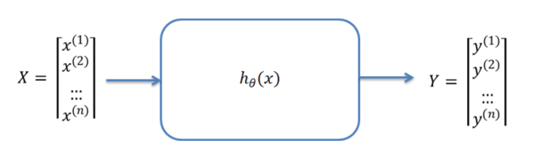
(Figure 1)
Furthermore, if we are trying to predict model for the success of a positive feedbacks in reviews. We would have Y datasets containing final feedback rating of n students and the independent value would be the X datasets:

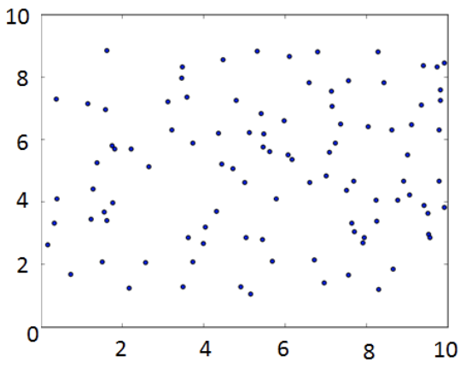
(Figure 2)

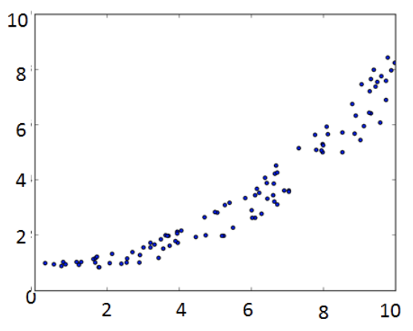
(Figure 3)

The figure 2 shows inconsistent distribution, which shows no correlation between X and Y. The figure 3 is the ideal distribution where there is a strong correlation occurred, this is where we want to see.

A logistic regression is a regression but with the motive of classifications where you must iteratively apply gradient descent of the cost function to approximate the value of the parameter. Cost function is given by the squared error of difference between the y and hypothesis function, with the form also known as logistic function:
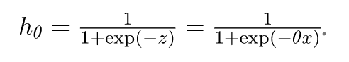
With the function you can bound the y-direction by 1 and 0. It will strict the value to prevent beyond or below of 1 and 0. For example if z is negative value the function will go towards reaching 0 but will not pass below it, same goes with positive value reaching towards 1 as shown figure 4 below, however, we have to create a decision boundary, which separate the positive and negative class:

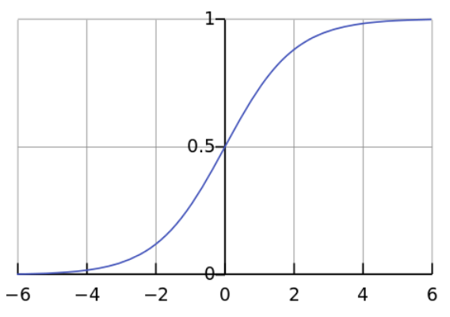
(Figure 4)

The advantage of logistic regression is that it is very efficient and does not requires large computation. Hence, it is widely used technique, where the method can be interpreted easily, easy to regularize, does not need input features to scale, no tuning required and decent predication with probabilities.

Due to its simplicity, where it is easy and quick to implement, the disadvantage is that it is hard to solve a non-linear problem. It is also not the most powerful algorithm, there are other more complex algorithm that can easily outperformed it. Logistical regression is known with weakness of being overfitting.

Multinomial Naïve Bayes

Multinomial Naïve Bayes is a baseline classification solution for most cases for sentiment analysis. The methods of Multinomial Naïve Bayes are based on a Naïve Bayes technique by finding probability of classes through a joint probability of the word terms and its classes. Given the dependent vector C_{k} = (x₁, x₂, x₃, … x_{n}) the theorem stated with mathematical relation:
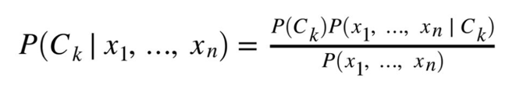
It is assumed that given class C_{k,} each vector feature of x₁ is conditionally independent of each and every other feature.
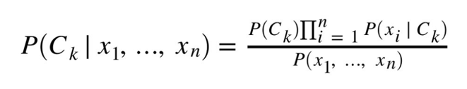
However, to avoid underflow, we can use the sum of logs:
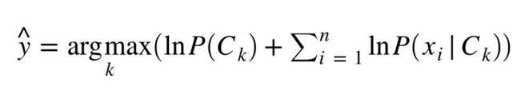
Although it is not a simple approach, the advantage of using Naïve Bayes is that it is fast method for prediction, it has low cost of computation, perform wells in discrete response variable in contrast to the continuous variable. Can be used for multi-class perditions, and lastly, in some cases if the independents hold the assumptions in most cases it performs better in comparison to other baseline classifier like logistic regression.

However, in most cases it is very hard that the model will have a set of entirely independent predictors, hence it can perform very poorly. Moreover, if there is no training of the correlated pair of class can hinder a great low probability, making it hard to construct proper predictions, which is known problem called the zero probability/frequency problem.

Linear support vector classifier

Linear support vector classifier, also known as SVM is a classification solution of a machine learning algorithm that is capable of solving regression or classification problems. SVM performs classifications by finding the hyper-plane where it can distinguish classes in n-dimensional space:

Implementation Highlights

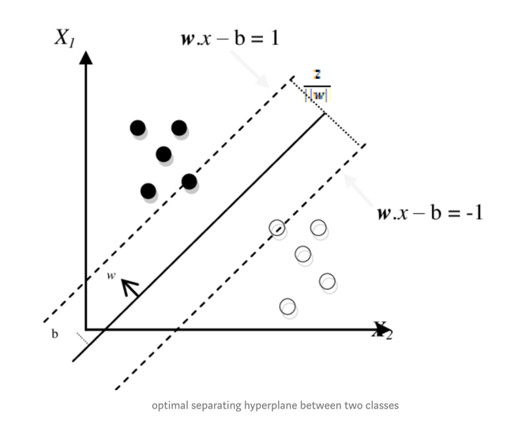

Steps

Problems in sentiment analysis
https://www.adweek.com/digital/37705-sentiment-analysis/

