**Android Virtual Device**

**OS:** Win 7 / XP

**Step-by-step Installation:**

1. Download JRE (h)

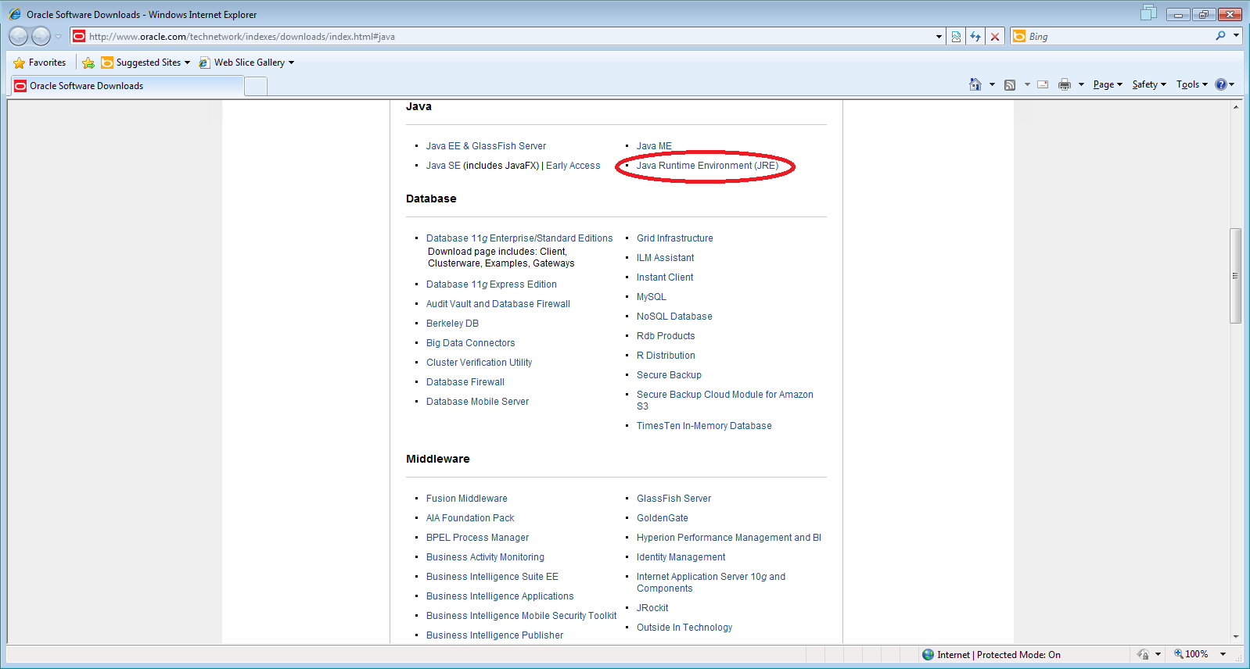

1. Install JRE
2. Download SDK (<http://developer.android.com/sdk/index.html> )

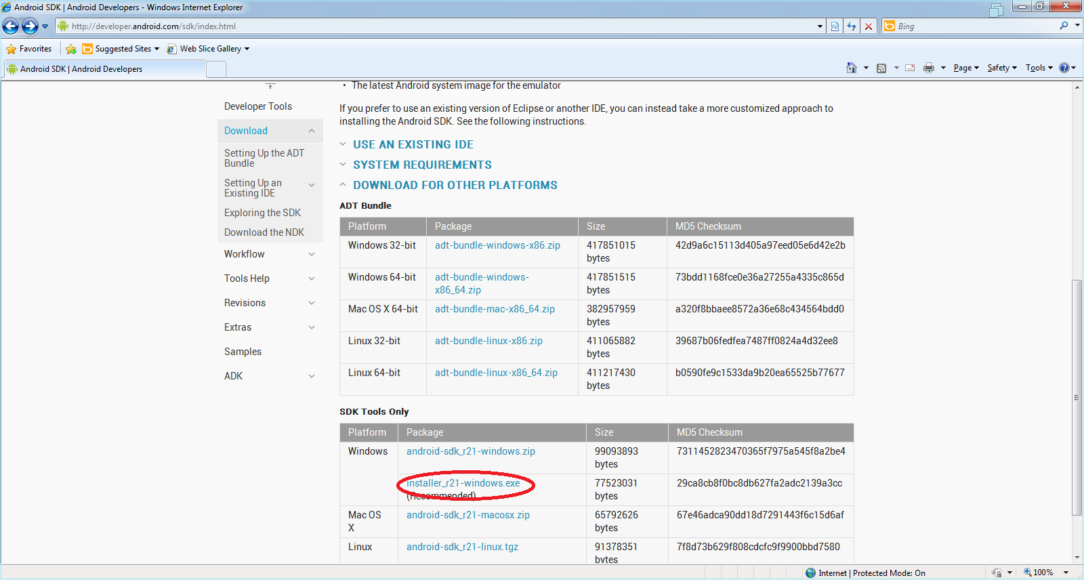

1. Install SDK

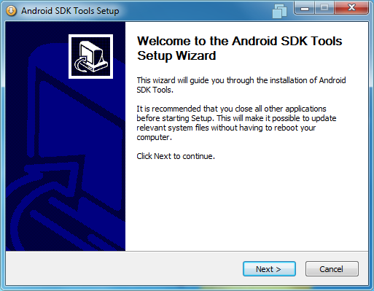

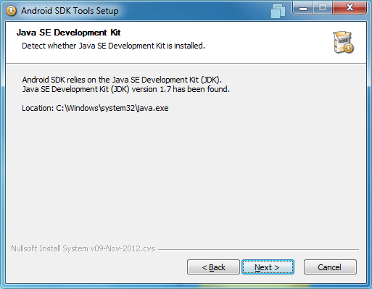

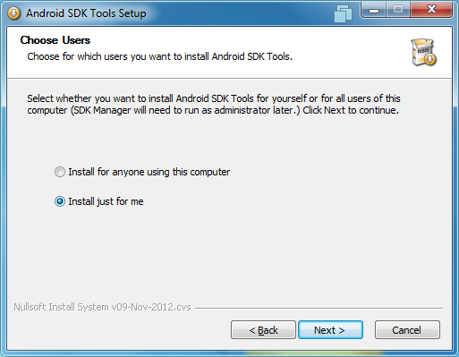

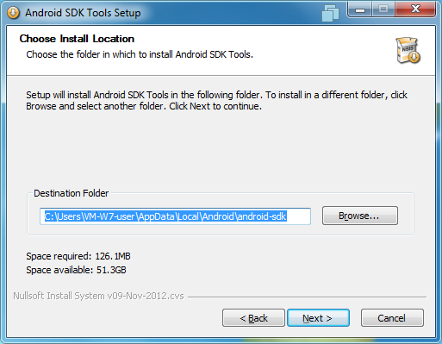

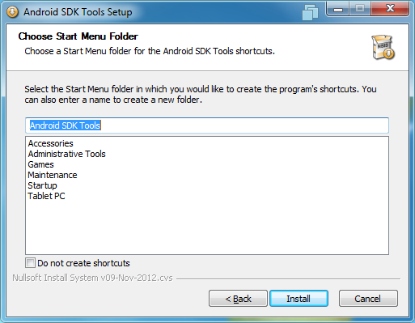

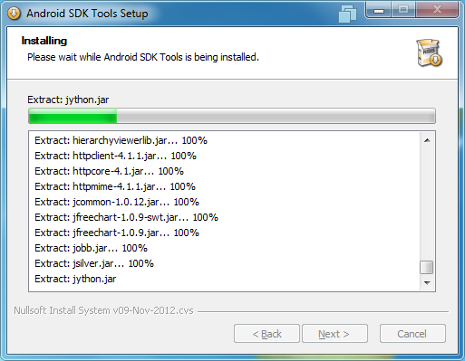

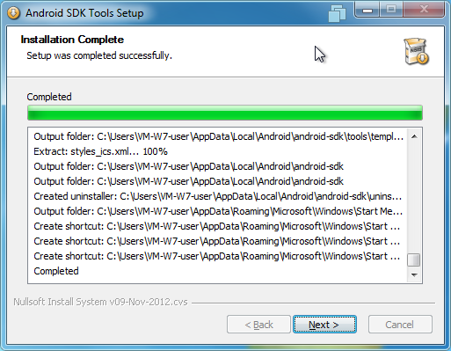

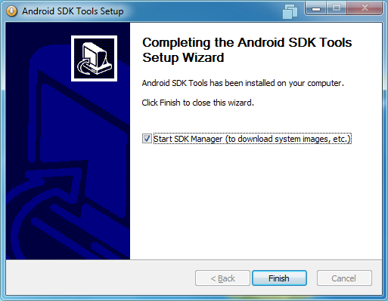

1. Run SDK Manager.

Select SDK-> Android SDK Tools, Android 4.1.2, and Android SDK Platform- tools.

Install packages

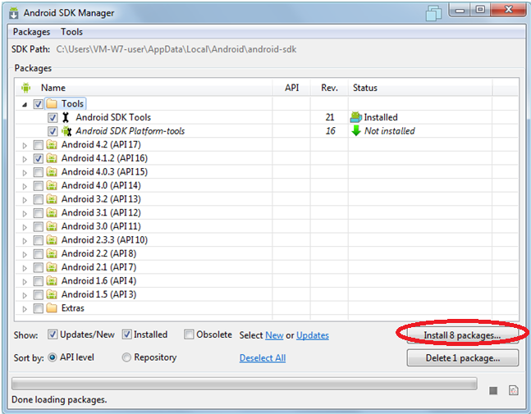

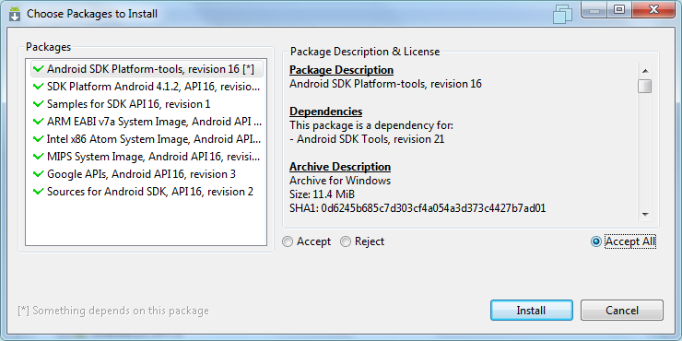

1. Restart your computer
2. Run SDK Manager (C:\AndroidStudio\android-sdk-windows)

Select Tools –Manage AVDs

Click New… button

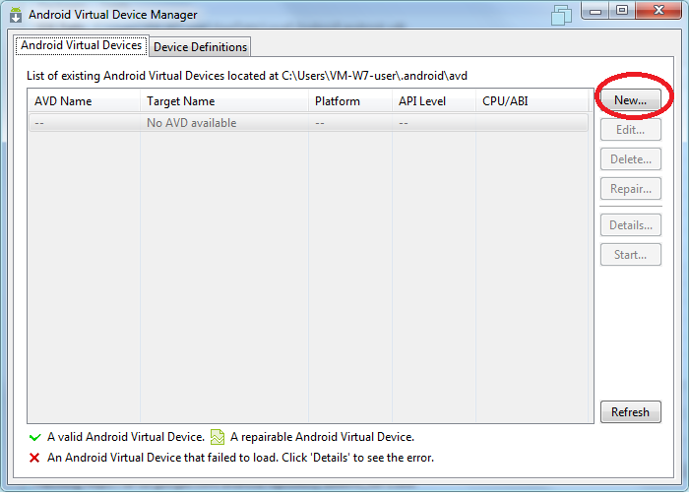

1. Create New Android virtual Device and push Ok button

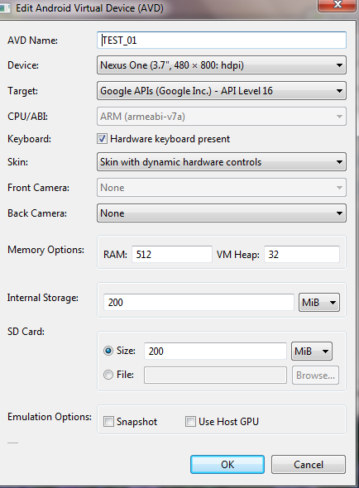

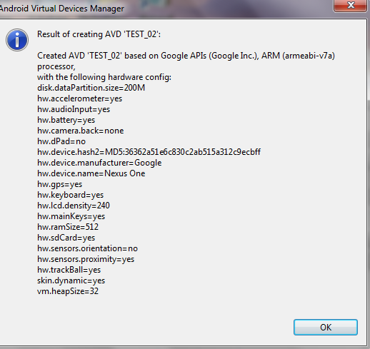

1. Now you can run your virtual device. Select it and click Start… button. **Wait for loading the virtual device** – it may take a couple of minutes.

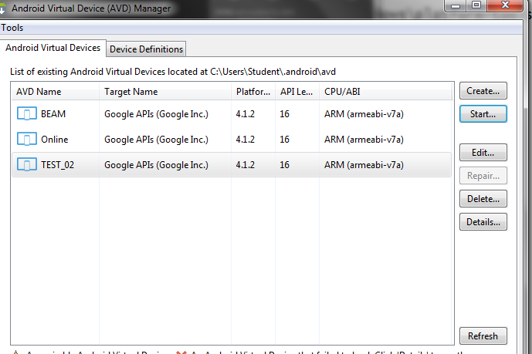

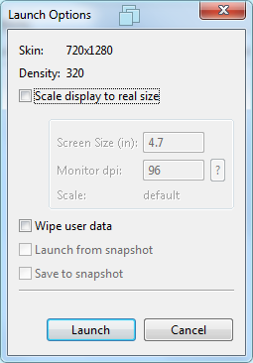

1. Next step: Change directory

Open Windows command line.

Change directory (cd) to the directory where you installed Android SDK by providing the complete path to your Android SDK directory.

(example: cd “C:\Program Files (x86)\Android\android-sdk\platform-tools”)

**Enter**

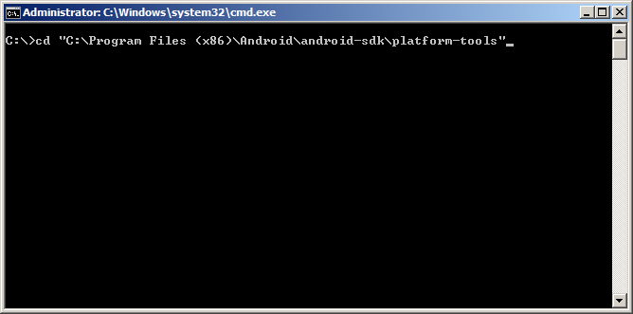

1. Issue **adb devices** command to see the list of virtual devices.

You will see the following output

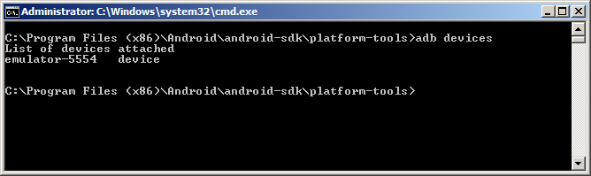

1. Download the Beam-0.1.42.3320.apk file from Google DRIVE

to the C:\Program Files (x86)\Android\android-sdk\platform-tools directory

1. Install an .apk file on a virtual device by running the following command:

**adb install <full file path to the** xxxxxx.apk file **>**

Example:

adb install "C:\Program Files (x86)\Android\android-sdk\platform-tools\Beam-0.1.42.3320.apk"

You’ll see the confirmation of successful installation.

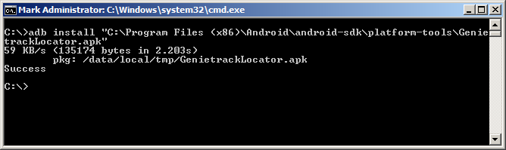

1. Check the application on the virtual device

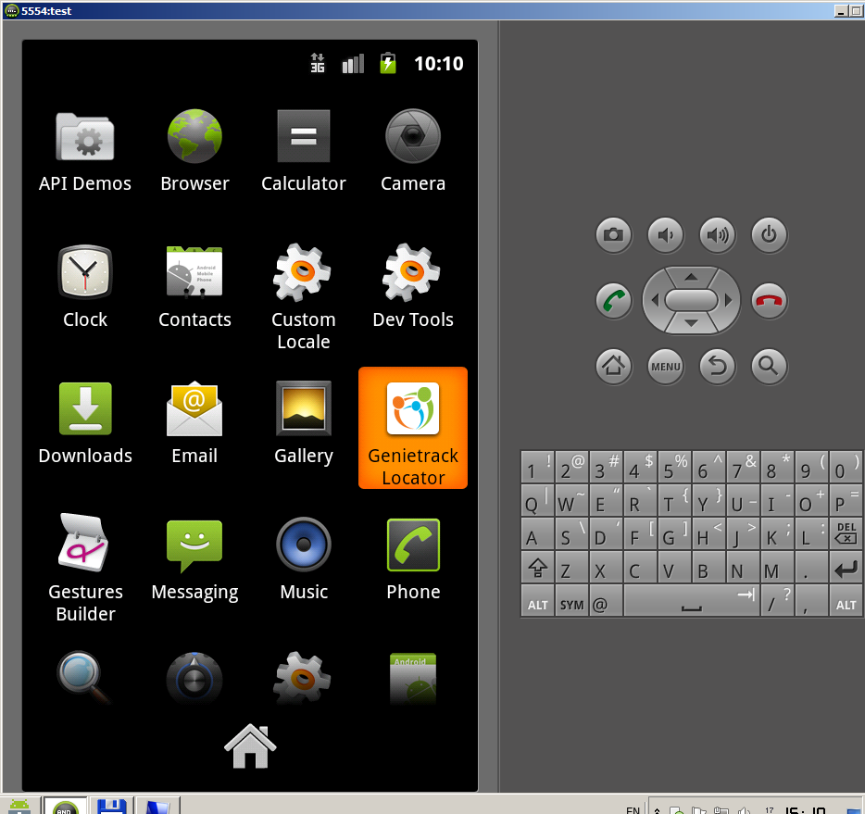

1. Change directory: c:\AndroidStudio\Android-Sdk-Windows\

2. Run AVD Manager.exe

3. cd C:\AndroidStudio\android-sdk-windows\platform-tools

4. Move Beam.apk to this derectory

5. Open Command Prompt:

cd C:\AndroidStudio\android-sdk-windows\platform-tools

adb devices

adb install "C:\AndroidStudio\android-sdk-windows\platform-tools\Beam.apk"