

Item 7 Report

CSV and Jmete

Grupo 33
Víctor Rosa
Martín Ordoño

Table of Content

1. Introduction
JMeter is an open source load testing tool which has been highly used in testing the performance of any software program or website. This helps us to write load tests using different types of test elements like thread group, samplers, config elements and controllers etc.
While writing automated load tests using JMeter it might be required to load data from a CSV file. JMeter has a CSV data set config element to read the data from file system. This element can be used to iterate over all lines of CSV one by one and each line can be fed to different types of samplers in a single thread group.
We are going to present an example use case for this, usesr loging in our system. We wanted to run a CSV based load test for JMeter. CSV file contained data in two columns named as username and password as follows.

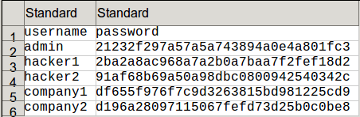
csv file

2. Add the Thread Group
At this moment we are prepare to open jmeter applicationa and add the thread group.

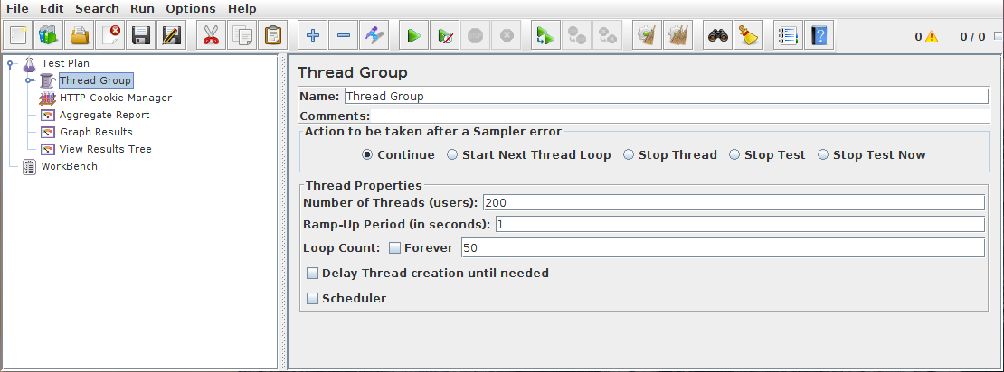

We want simulate an scenario where, 200 users loging and the test will be repeted 50 times.

3. Adding the Http resquest
Now that we have defined our users, it is time to define the task that we will be performing. In our Test Plan, we need to make two HTTP requests. The first one is for the JMeter home page (http://jmeter.apache.org/), and the second one is for the Changes page (http://jmeter.apache.org/changes.html).

