
PERFORMANCE report
D04 – Acceptance Testing

1 de ABRIL de 2019
Acme-HACKER-RANK
GRUPO 33
Martín Ordoño Caro | Víctor Rosa Serrano


Contenido
1.Introducción 5
2.Ordenadores 5
3.Resultados 6
4.Tabla de requisitos 7
5. Análisis por caso de uso 8
5.1 Actor display/delete message 8
5.1.1 Aggregate Result 8
5.1.2Graph Result 8
5.2 Actor list/create message 9
5.2.1 Aggregate Result 9
5.2.2 Graph Result 9
5.3 Actor manage social profile 10
5.3.1 Aggregate Result 10
5.3.2 Graph Result 10
5.4 Admin spammer process 11
5.4.1 Aggregate Result 11
5.4.2 Graph Result 11
5.5 Admin audit score 12
5.5.1 Aggregate Result 12
5.5.2 Graph Result 12
5.6 Admin ban/unban actors 13
5.6.1 Aggregate Result 13
5.6.2 Graph Result 13
5.7 Admin broadcast 14
5.7.1 Aggregate Result 14
5.7.2 Graph Result 14
5.8 Admin create Admin 15
5.8.1 Aggregate Result 15
5.8.2 Graph Result 15
5.9 Admin create auditor 16
5.9.1 Aggregate Result 16
5.9.2 Graph Result 16
5.10 Admin dashboard 17
5.10.1 Aggregate Result 17
5.10.2 Graph Result 17
5.11 Admin rebranding procedure 18
5.11.1 Aggregate Result 18
5.11.2 Graph Result 18
5.12 Auditor self-assign position 19
5.12.1 Aggregate Result 19
5.12.2 Graph Result 19
5.13 Company edit personal data 20
5.13.1 Aggregate Result 20
5.13.2 Graph Result 20
5.14 Company manage applications 21
5.14.1 Aggregate Result 21
5.14.2 Graph Result 21
5.15 Company manage positions 22
5.15.1 Aggregate Result 22
5.15.2 Graph Result 22
5.16 Company manage problems 23
5.16.1 Aggregate Result 23
5.16.2 Graph Result 23
5.17 Rookie edit personal data 24
5.17.1 Aggregate Result 24
5.17.2 Graph Result 24
5.18 Rookie manage applications 25
5.18.1 Aggregate Result 25
5.18.2 Graph Result 25
5.19 Rookie manage curricula 26
5.19.1 Aggregate Result 26
5.19.2 Graph Result 26
5.20 Rookie manage finder 27
5.20.1 Aggregate Result 27
5.20.2 Graph Result 27
5.21 Listing companies (Unauthenticated) 28
5.21.1 Aggregate Result 28
5.21.2 Graph Result 28
5.22 Listing position (Unauthenticated) 29
5.22.1 Aggregate Result 29
5.22.2 Graph Result 29
5.23 Provider create item 30
5.23.1 Aggregate Result 30
5.23.2 Graph Result 30
5.24 Provider delete item 31
5.24.1 Aggregate Result 31
5.24.2 Graph Result 31
5.25 Provider display item 32
5.25.1 Aggregate Result 32
5.25.2 Graph Result 32
5.26 Provider edit item 33
5.26.1 Aggregate Result 33
5.26.2 Graph Result 33
5.27 Provider list item 34
5.27.1 Aggregate Result 34
5.27.2 Graph Result 34
5.28 Register as a company 35
5.28.1 Aggregate Result 35
5.28.2 Graph Result 35
5.29 Register as a rookie 36
5.29.1 Aggregate Result 36
5.29.2 Graph Result 36

Introducción
En este documento se van a exponer los resultados de los test de rendimiento del sistema. Estas pruebas se han realizado de forma exitosa para medir la capacidad del sistema en un entorno simulado.

Ordenadores
Se ha usado un ordenador de escritorio con sistem opertaivo Ubuntu 16.04 con las siguientes características:

Prestaciones | Escritorio
CPU | i7 6700
RAM | 16 GB
Tipo de almacenamiento | SSD M.2
Sistema Operativo | Ubuntu 16.04 lts

Resultados

En base a esta gráfica donde se confrontan casos de usos y carga de trabajo, hay que concluir que la carga máxima de trabajo del sistema es de 100 usuarios. Aunque en algunos momentos el systema llega a soportar hasta 300 usuarios sólo se puede garantizar un buen funcionamiento para todos los casos de usos con un máximo de 100.

Tabla de requisitos

Requisito | Caso de uso
Actor display/delete message | UC 1
Actor list/create message | UC 2
Actor manage social profile | UC 3
Admin spammer process | UC 4
Admin audit score | UC 5
Admin ban/unban actors | UC 6
Admin broadcast | UC 7
Admin create admin | UC 8
Admin create auditor | UC 9
Admin dashboard | UC 10
Admin Rebranding Procedure | UC 11
Auditor self-assign position | UC 12
Company edit personal data | UC 13
Company manage applications | UC 14
Company manage positions | UC 15
Company manage problems | UC 16
Rookie edit personal data | UC 17
Rookie manage applications | UC 18
Rookie manage curricula | UC 19
Rookie manage finder | UC 20
List companies (Unauthenticated) | UC 21
List positions (Unauthenticated) | UC 22
Provider Creating Item | UC 23
Provider delete Item | UC 24
Provider display Item | UC 25
Provider edit Item | UC 26
Provider list Item | UC 27
Register as company | UC 28
Register as hacker | UC 29

Análisis por caso de uso

5.1 Actor display/delete message

5.1.1 Aggregate Result
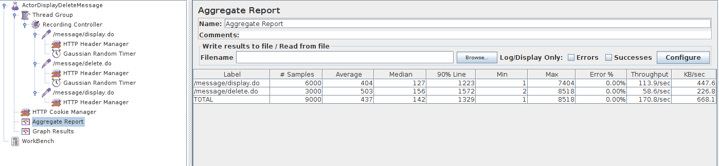

5.1.2Graph Result

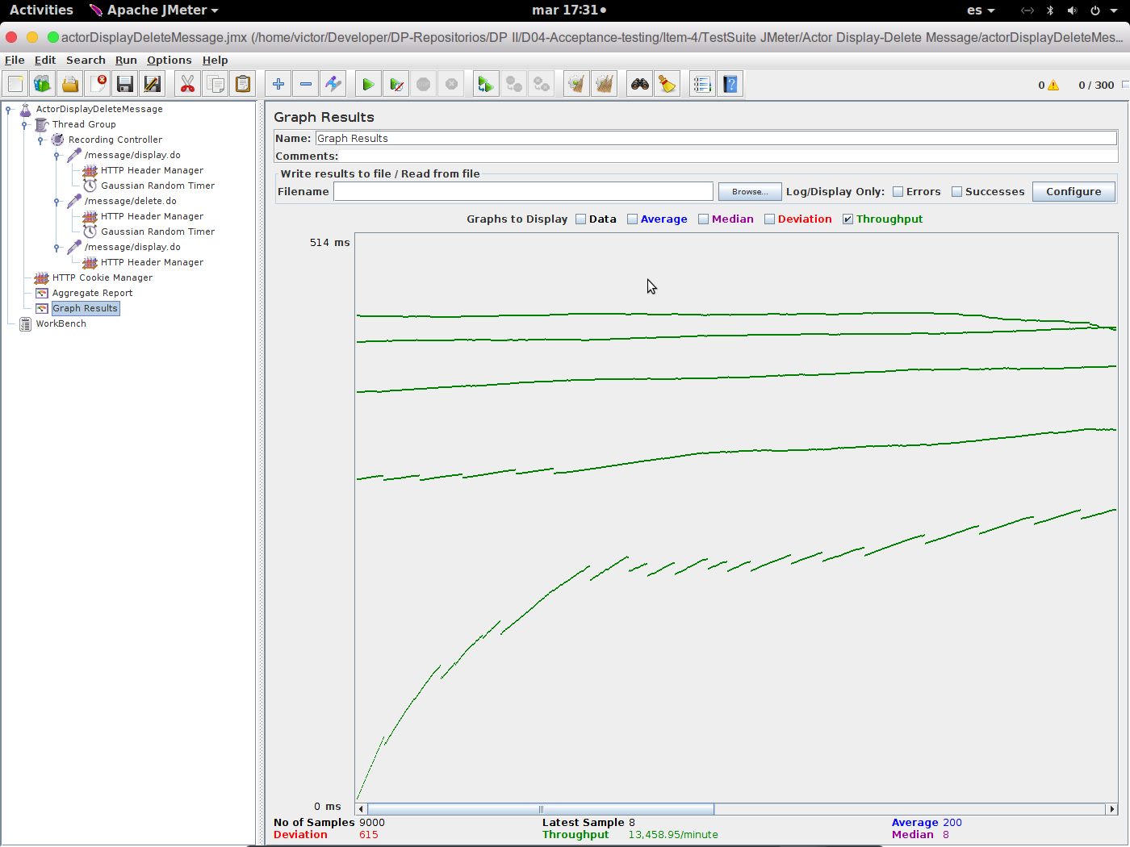

5.2 Actor list/create message

5.2.1 Aggregate Result

5.2.2 Graph Result

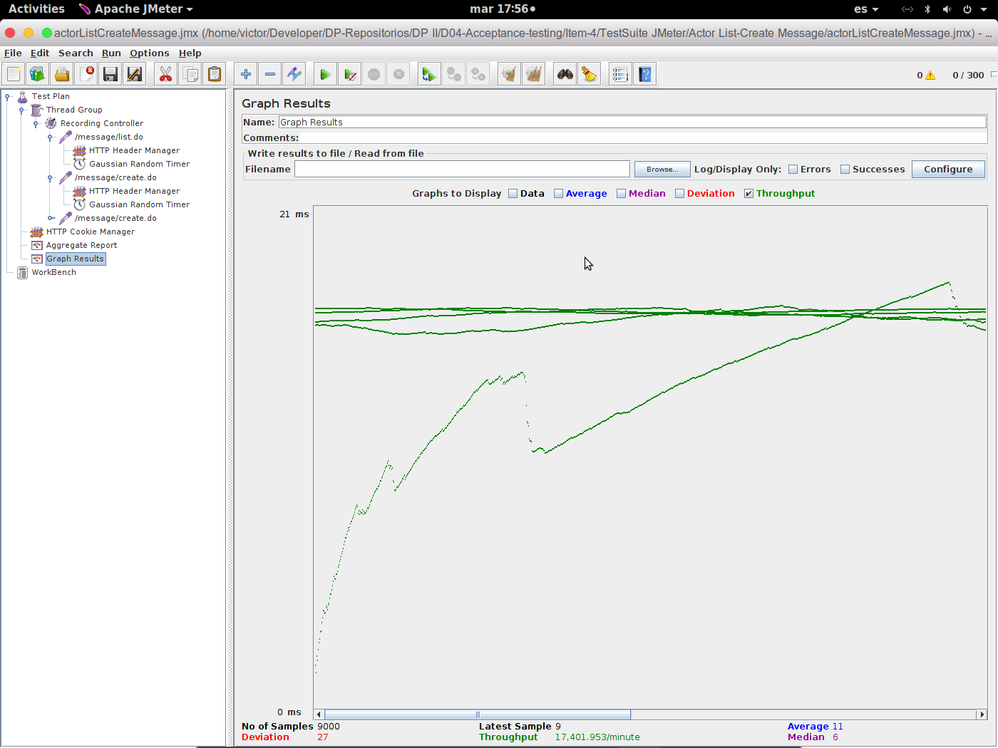

5.3 Actor manage social profile

5.3.1 Aggregate Result
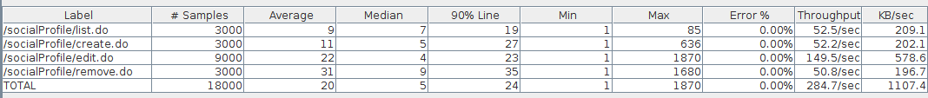

5.3.2 Graph Result
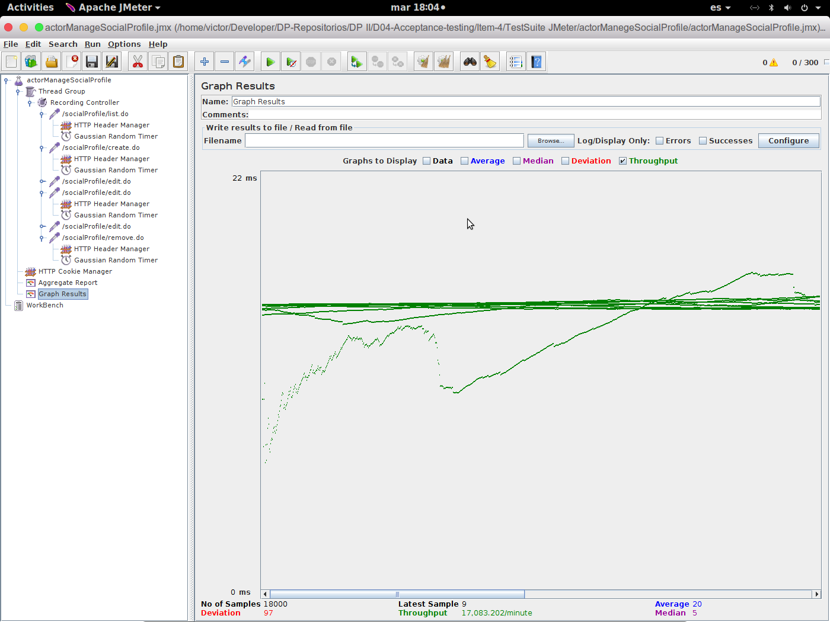

5.4 Admin spammer process

5.4.1 Aggregate Result

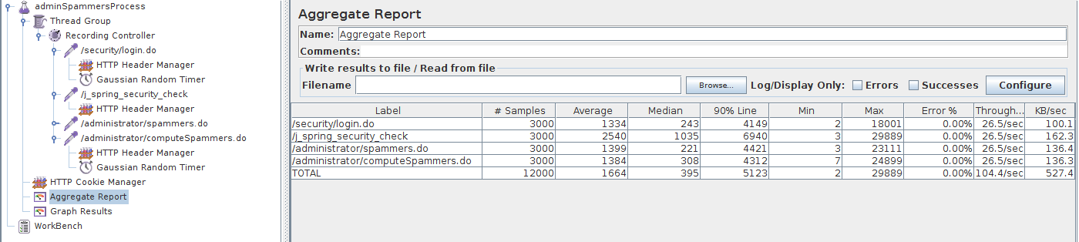

5.4.2 Graph Result
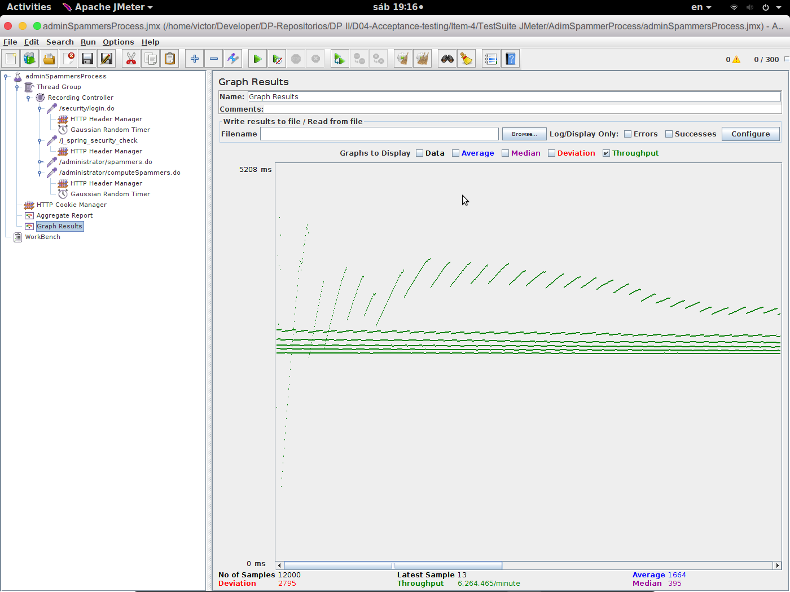

5.5 Admin audit score

5.5.1 Aggregate Result
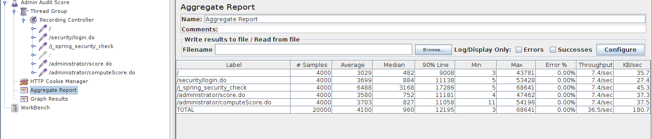

5.5.2 Graph Result
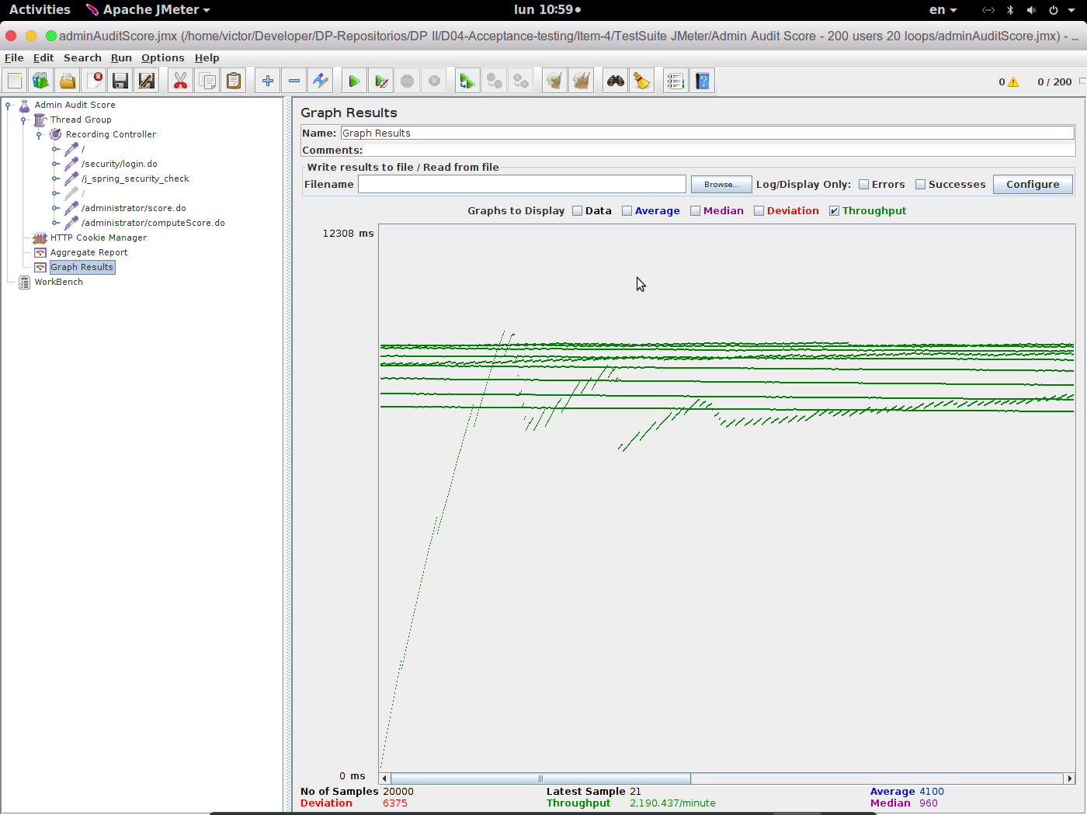

5.6 Admin ban/unban actors

5.6.1 Aggregate Result

5.6.2 Graph Result

5.7 Admin broadcast

5.7.1 Aggregate Result
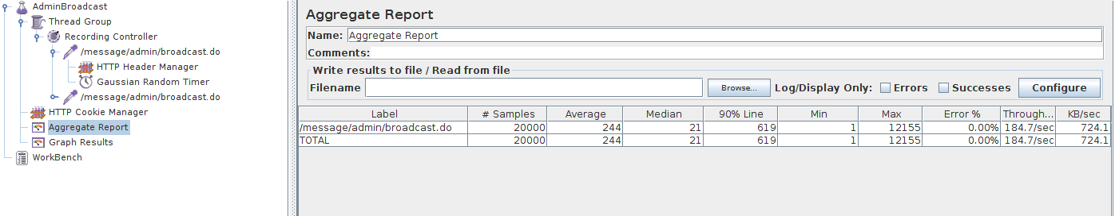

5.7.2 Graph Result

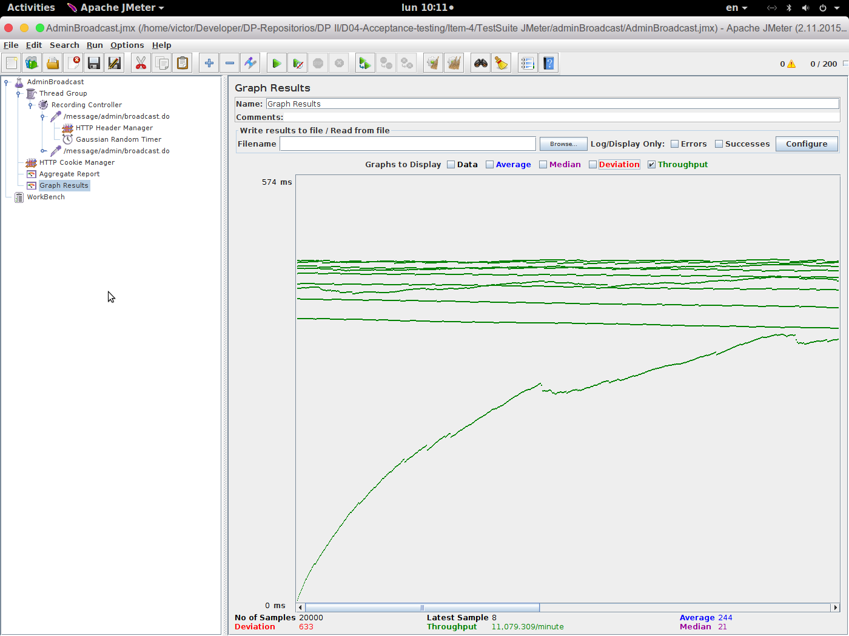

5.8 Admin create Admin

5.8.1 Aggregate Result
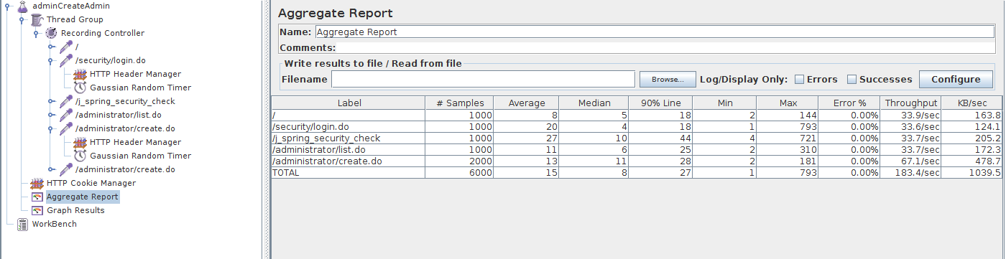

5.8.2 Graph Result

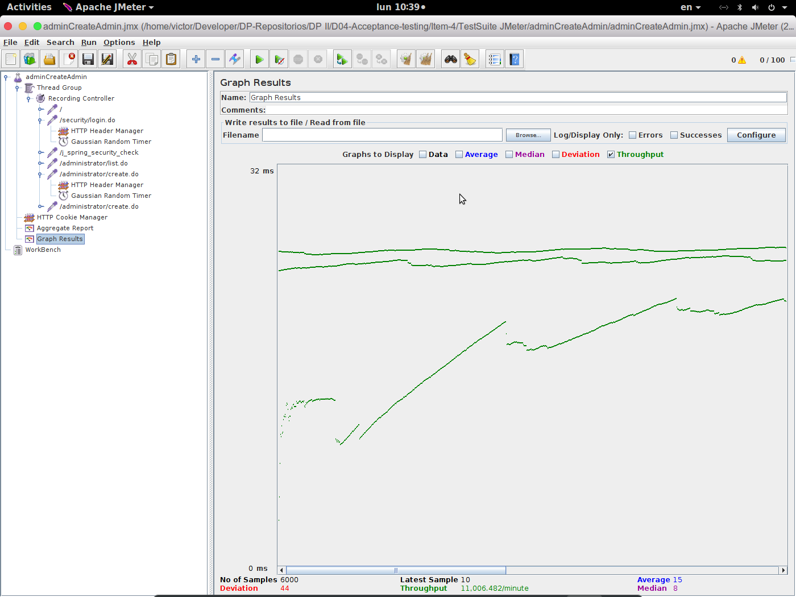

5.9 Admin create auditor

5.9.1 Aggregate Result
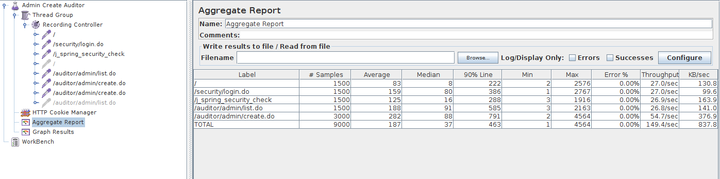

5.9.2 Graph Result

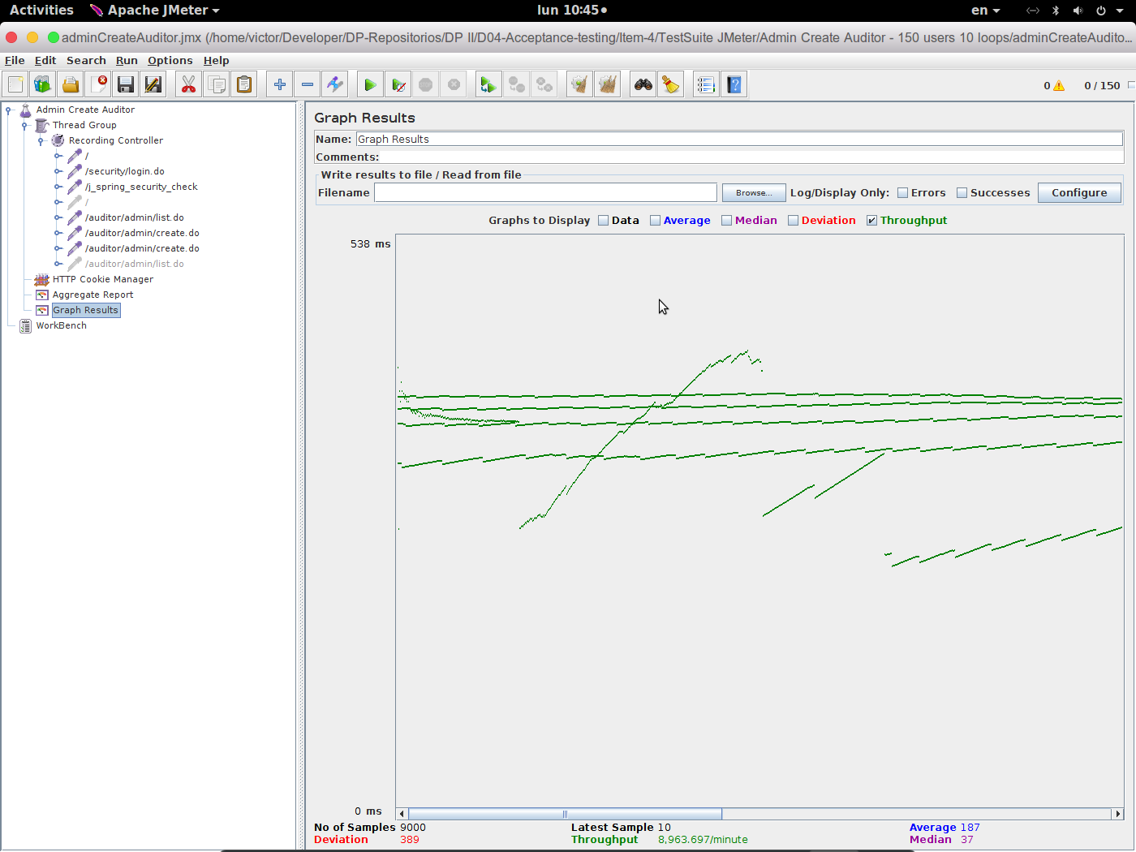

5.10 Admin dashboard

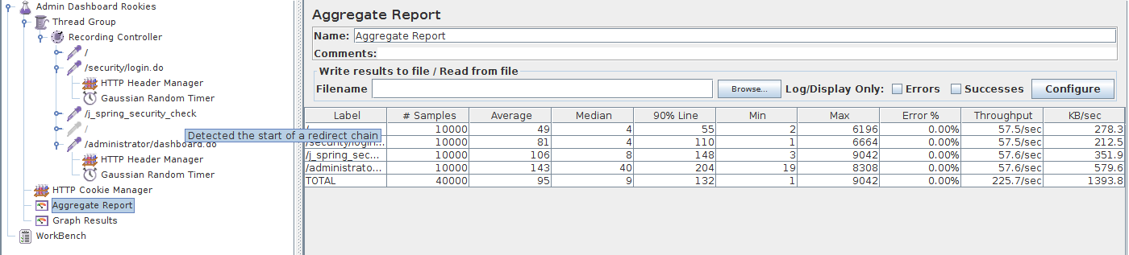
5.10.1 Aggregate Result

5.10.2 Graph Result

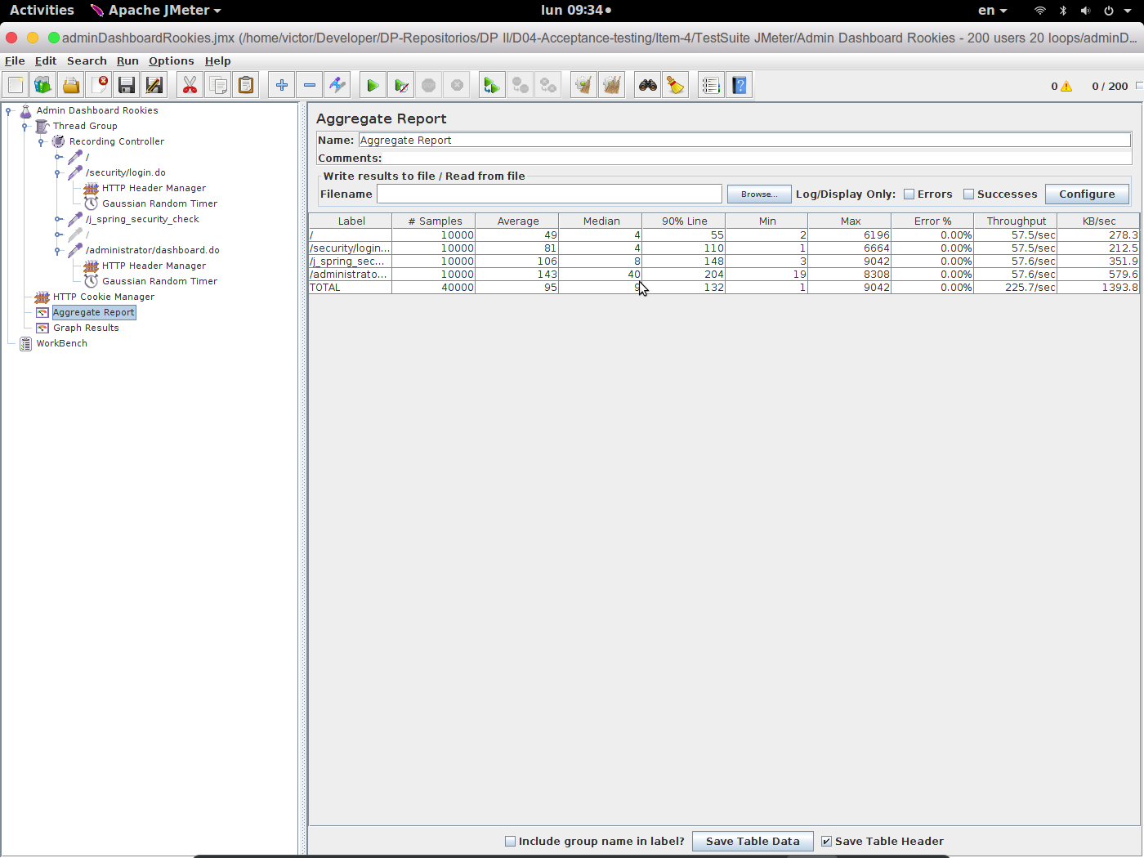

5.11 Admin rebranding procedure

5.11.1 Aggregate Result
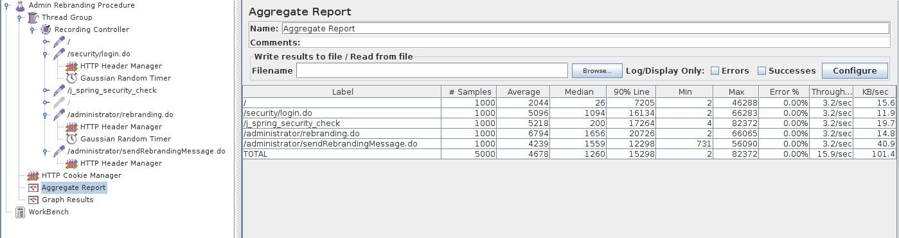

5.11.2 Graph Result
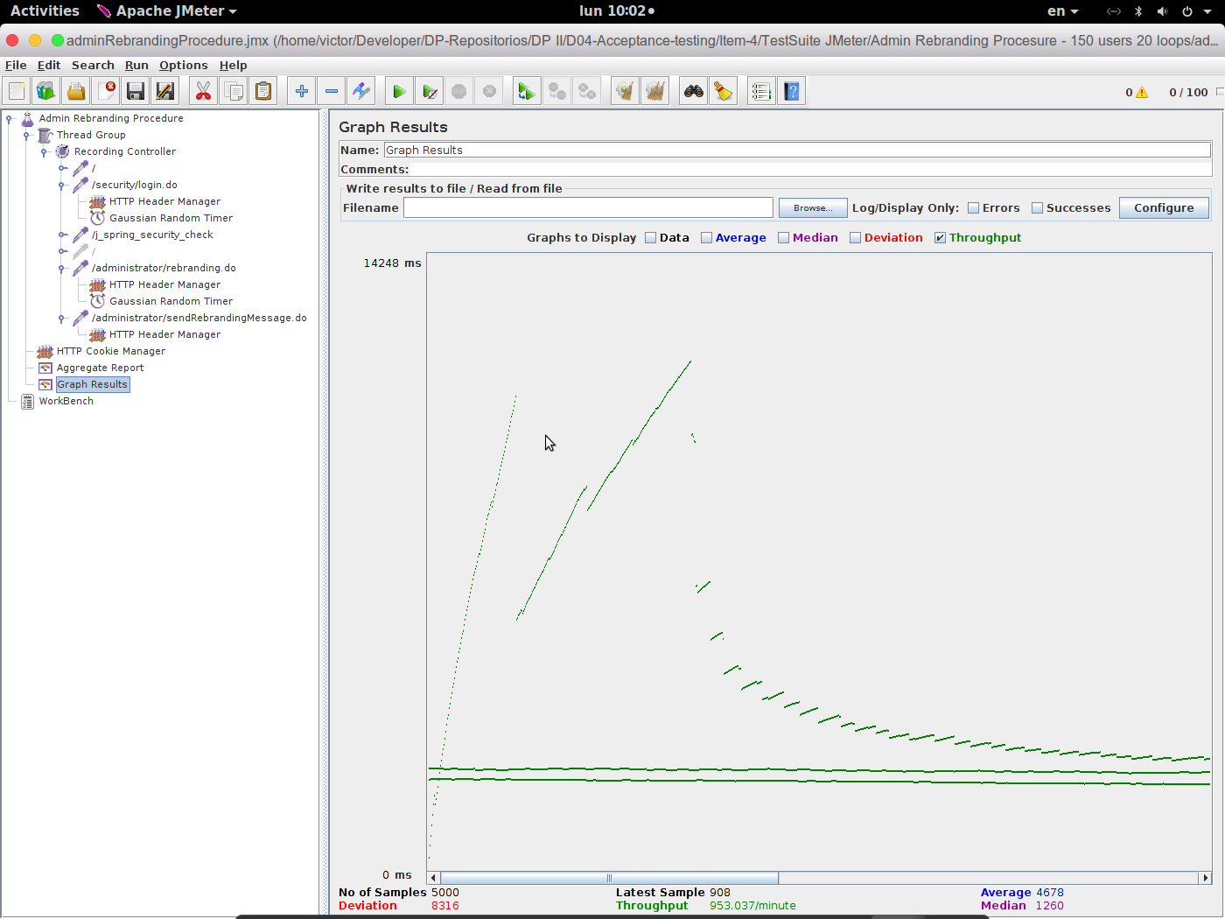

5.12 Auditor self-assign position

5.12.1 Aggregate Result
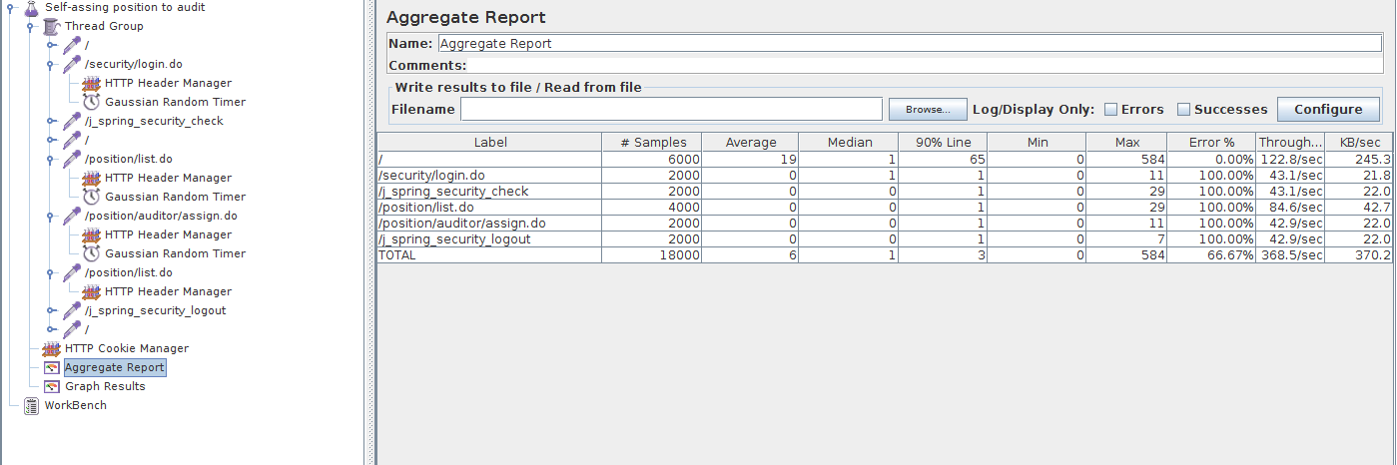

5.12.2 Graph Result
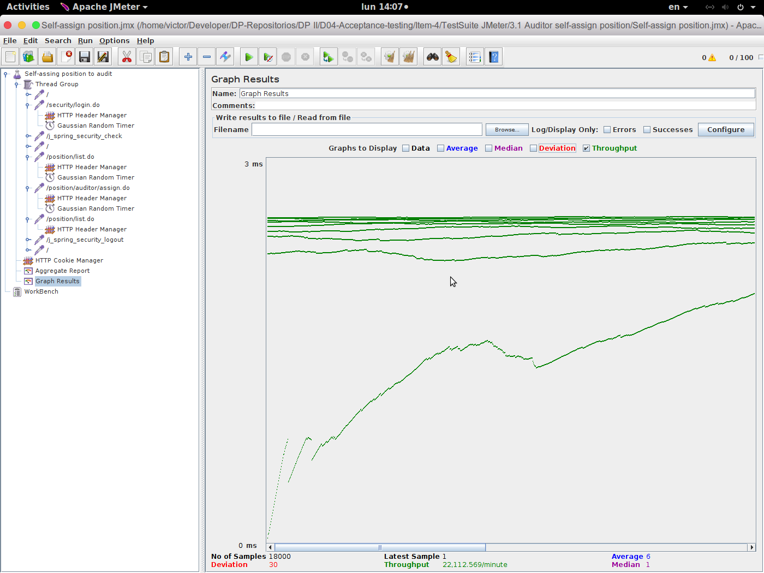

5.13 Company edit personal data

5.13.1 Aggregate Result
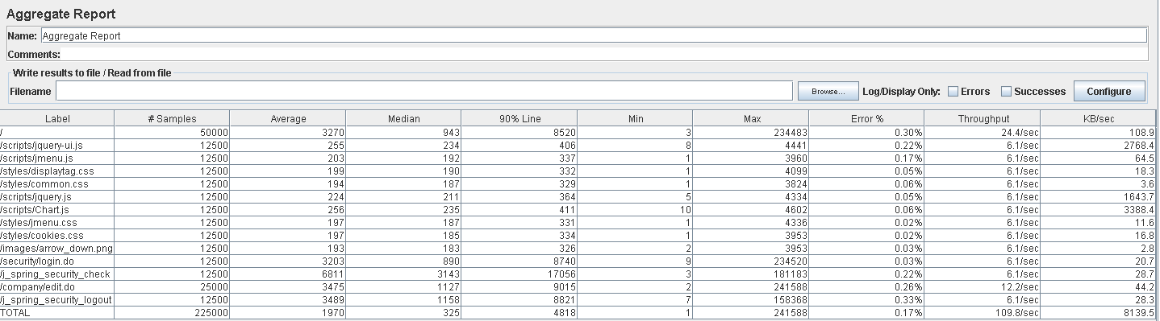

5.13.2 Graph Result
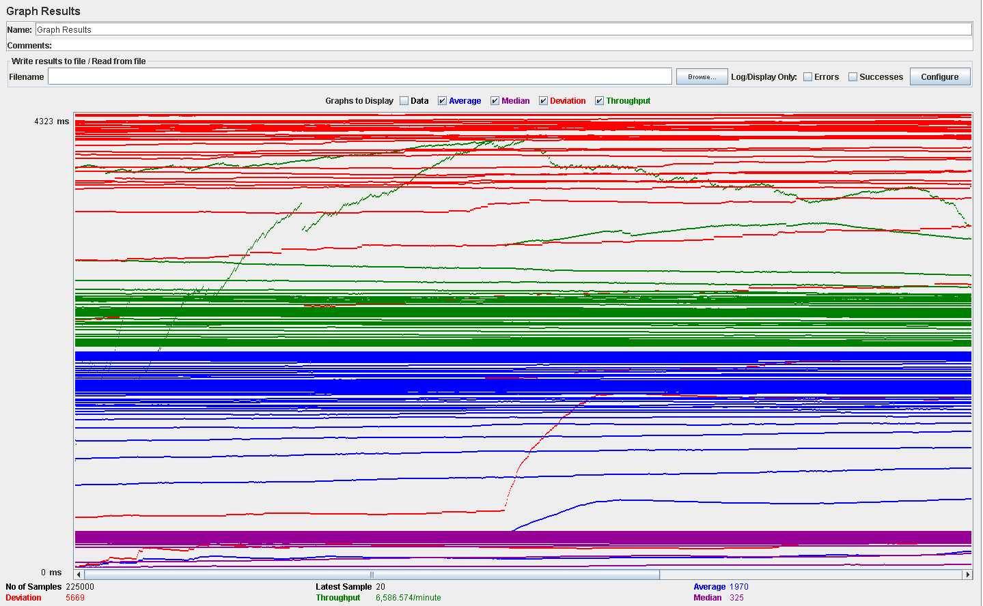

5.14 Company manage applications

5.14.1 Aggregate Result
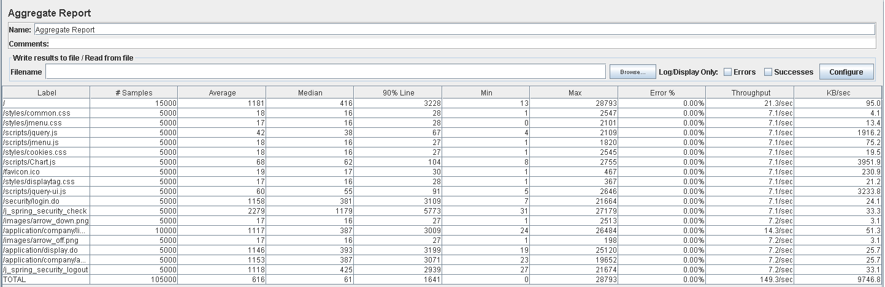

5.14.2 Graph Result

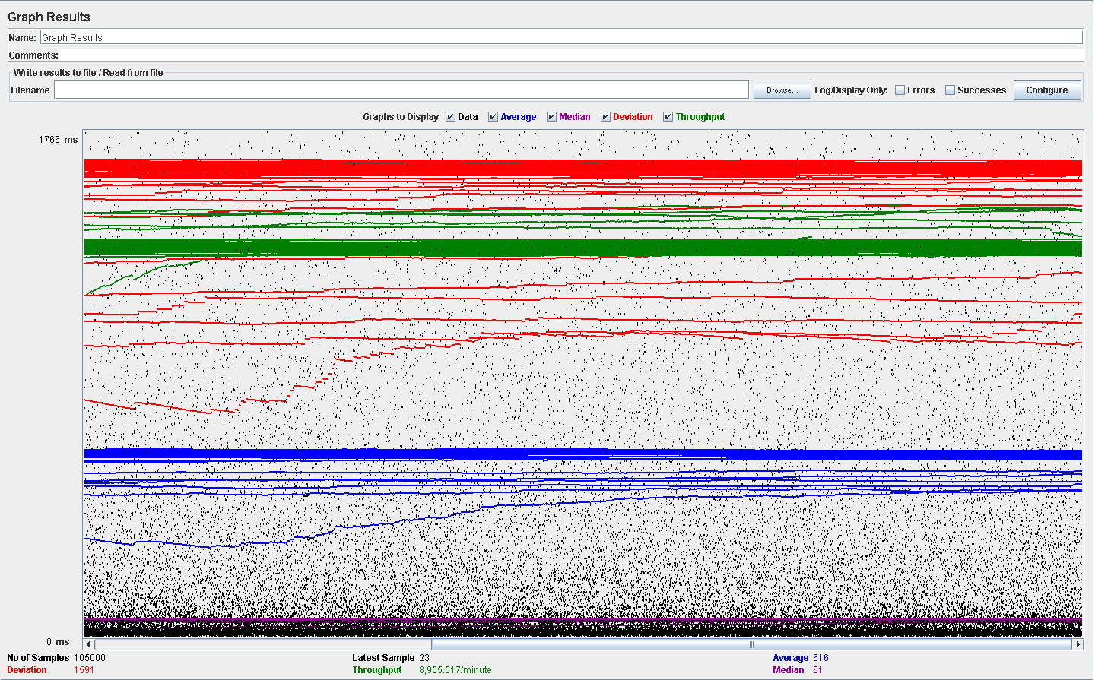

5.15 Company manage positions

5.15.1 Aggregate Result
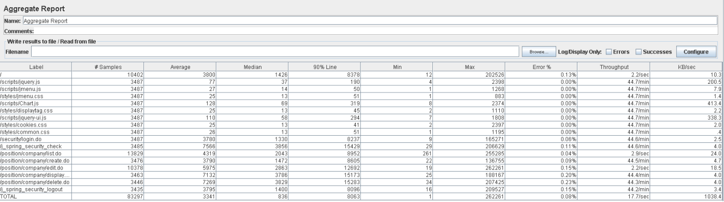

5.15.2 Graph Result
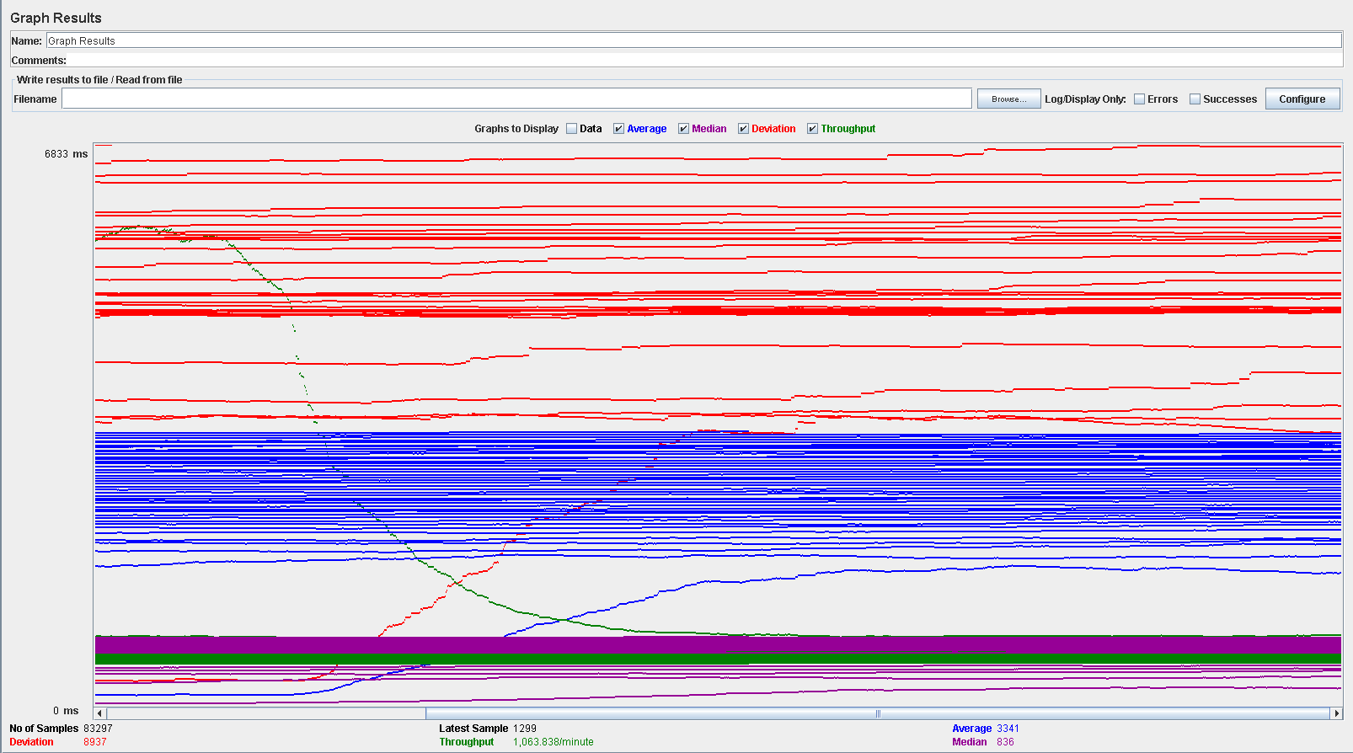

5.16 Company manage problems

5.16.1 Aggregate Result
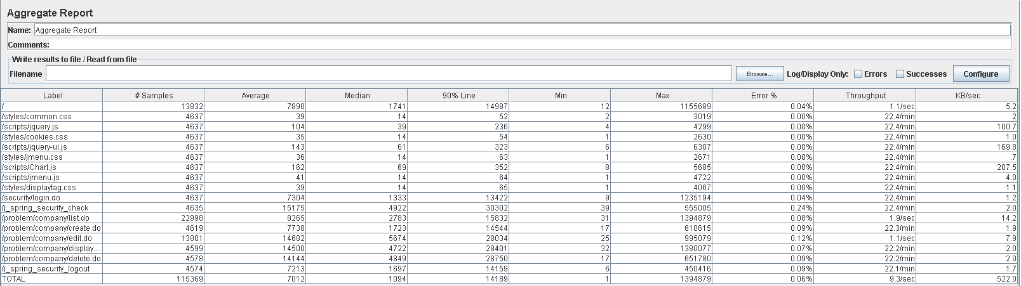

5.16.2 Graph Result
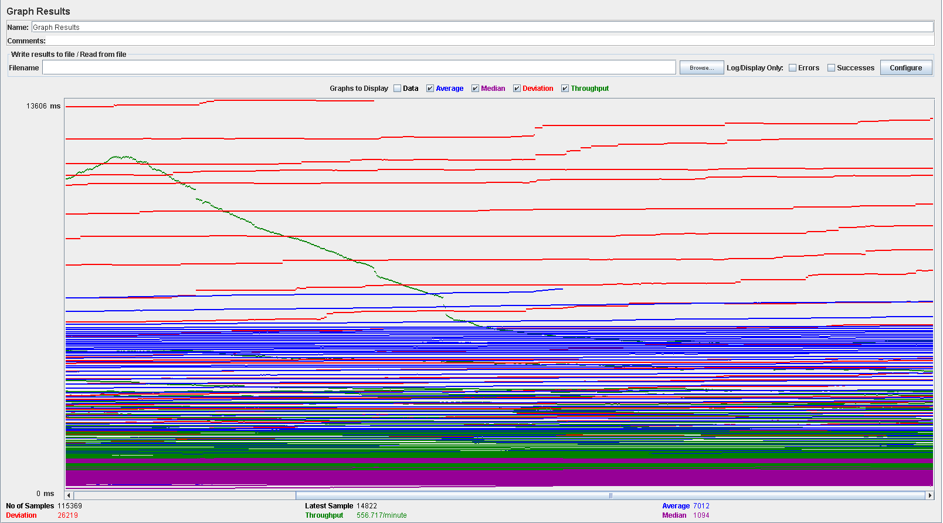

5.17 Rookie edit personal data

5.17.1 Aggregate Result

5.17.2 Graph Result

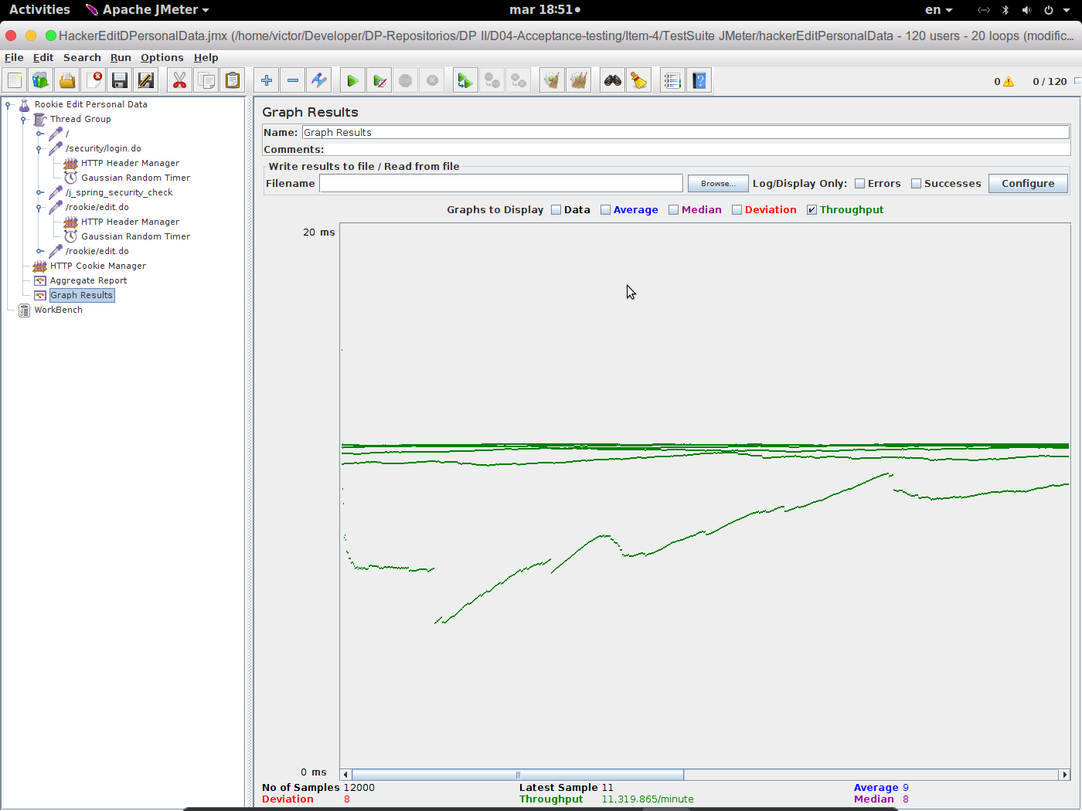

5.18 Rookie manage applications

5.18.1 Aggregate Result
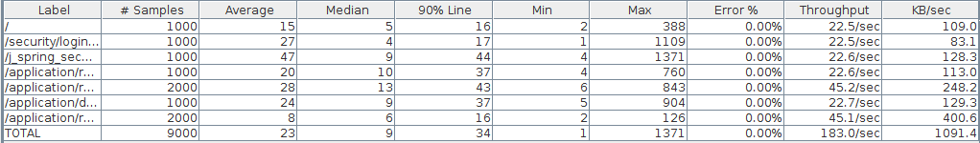

5.18.2 Graph Result

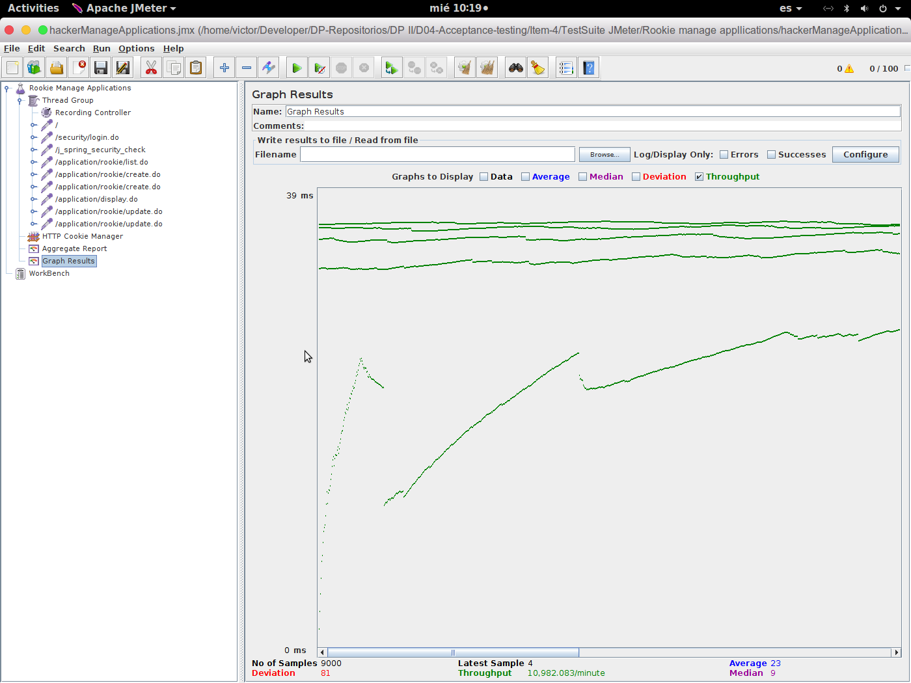

5.19 Rookie manage curricula

5.19.1 Aggregate Result
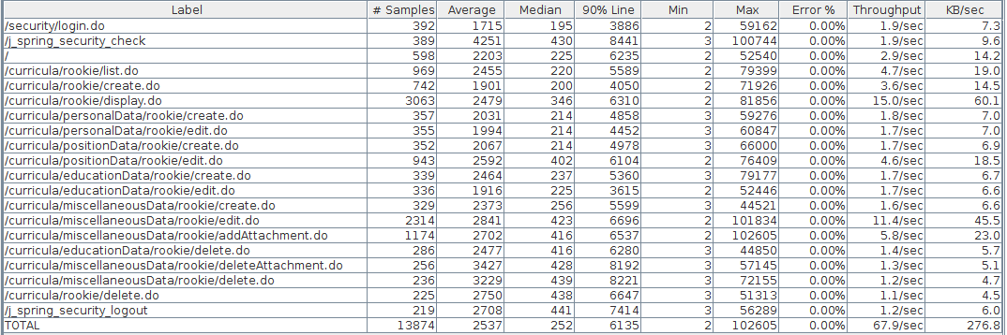

5.19.2 Graph Result

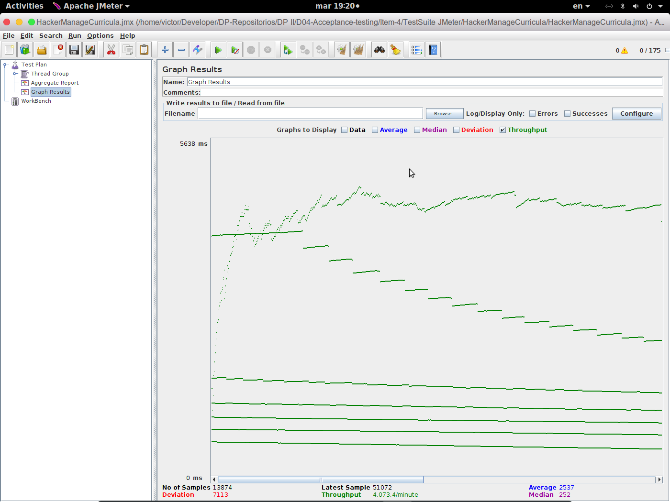

5.20 Rookie manage finder

5.20.1 Aggregate Result

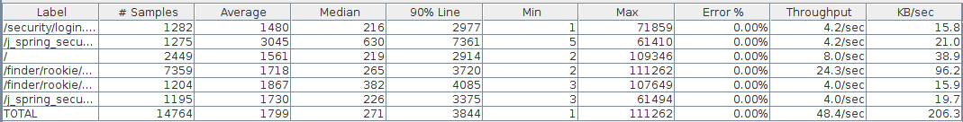

5.20.2 Graph Result

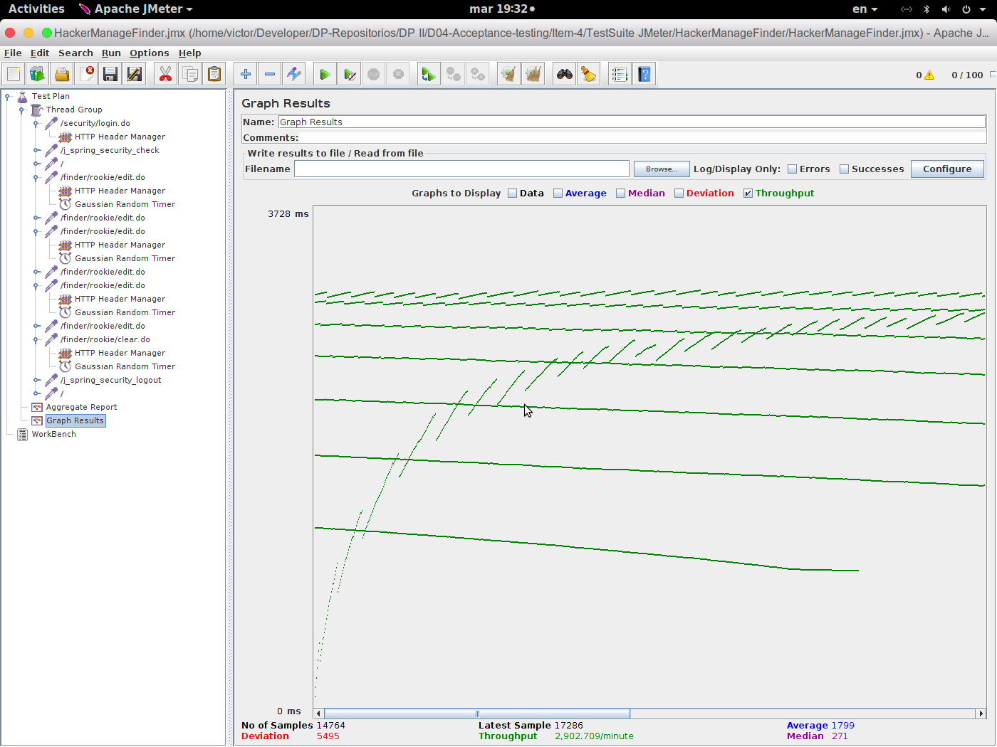

5.21 Listing companies (Unauthenticated)

5.21.1 Aggregate Result
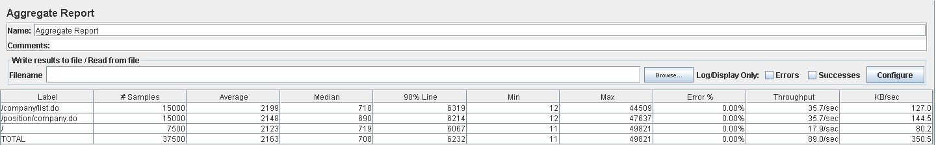

5.21.2 Graph Result

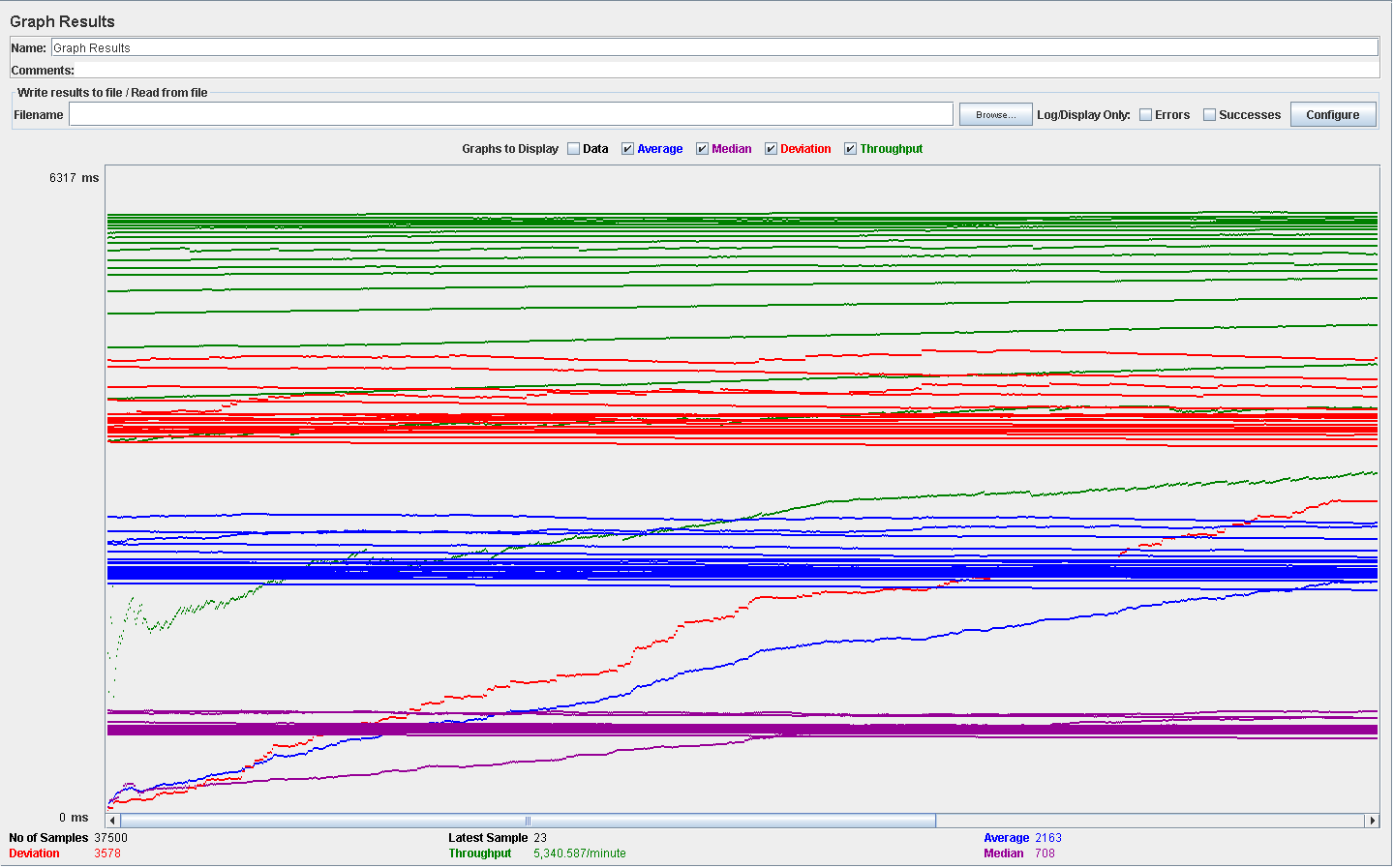

5.22 Listing position (Unauthenticated)

5.22.1 Aggregate Result

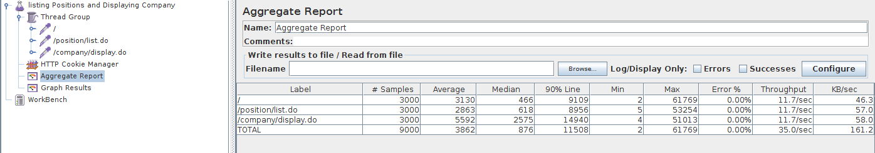

5.22.2 Graph Result

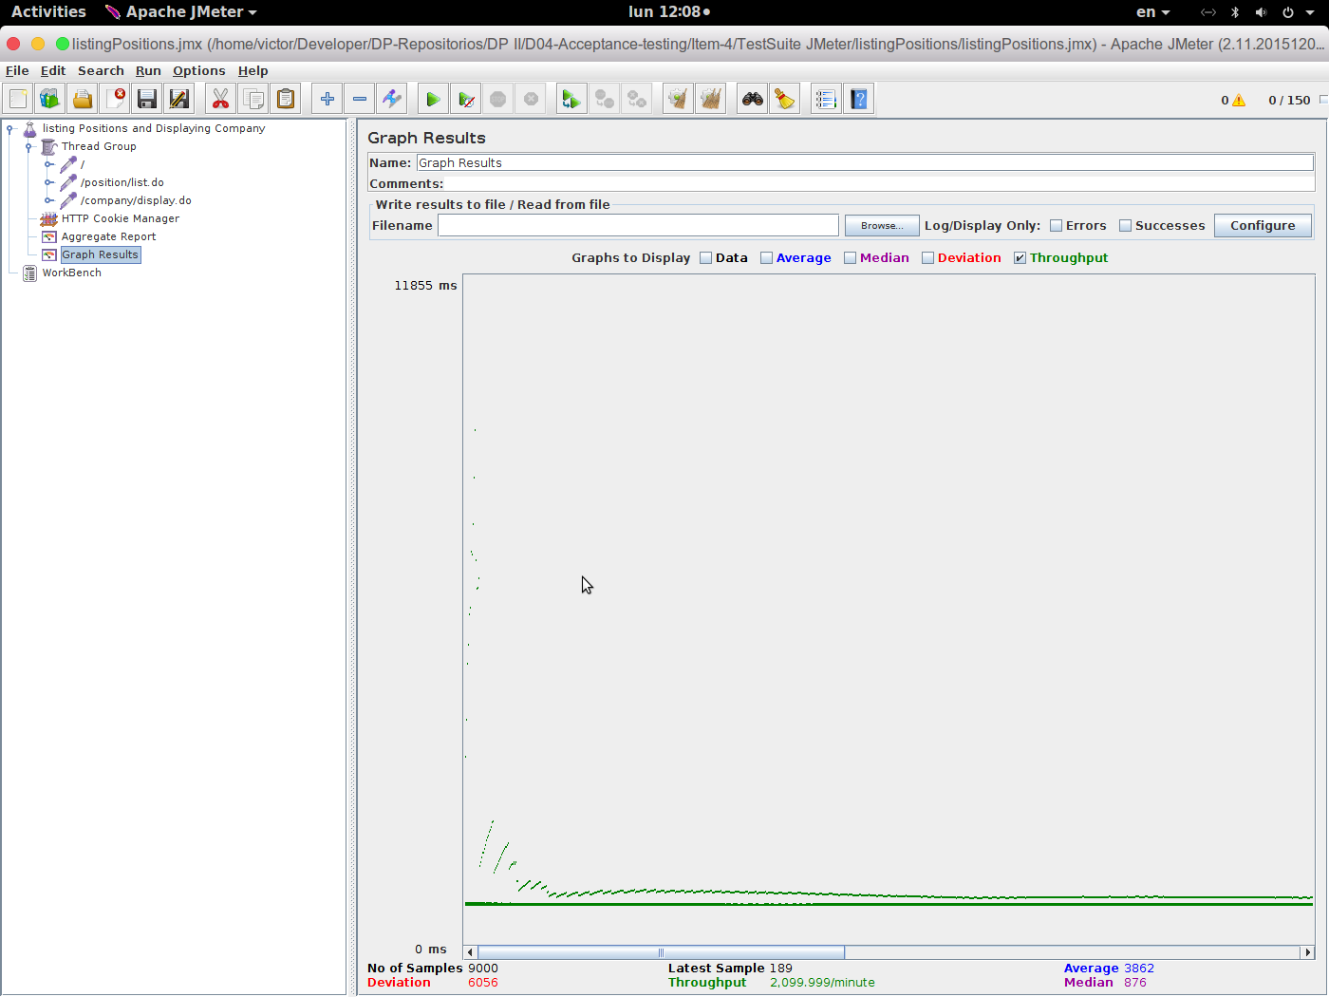

5.23 Provider create item

5.23.1 Aggregate Result
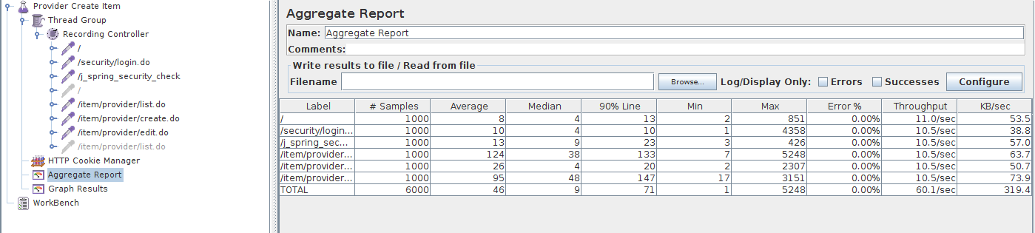

5.23.2 Graph Result

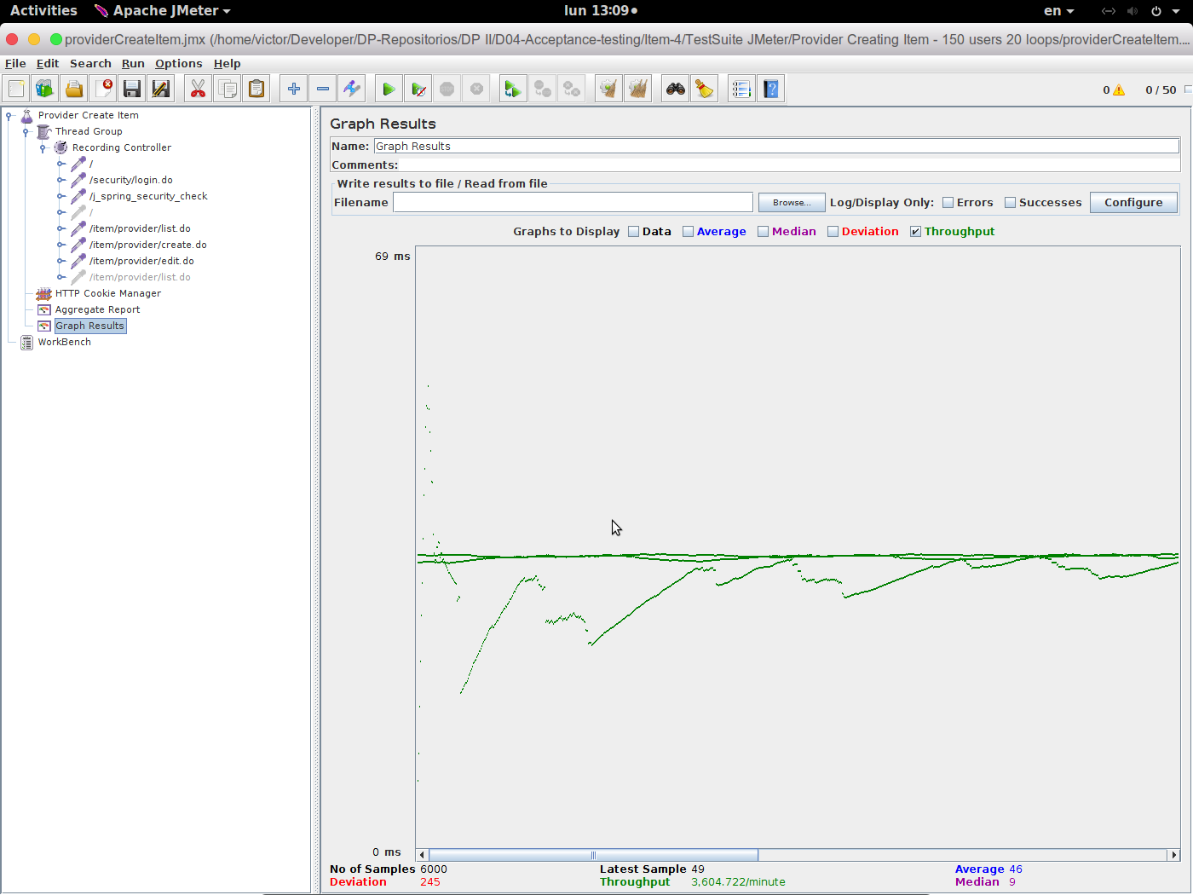

5.24 Provider delete item

5.24.1 Aggregate Result
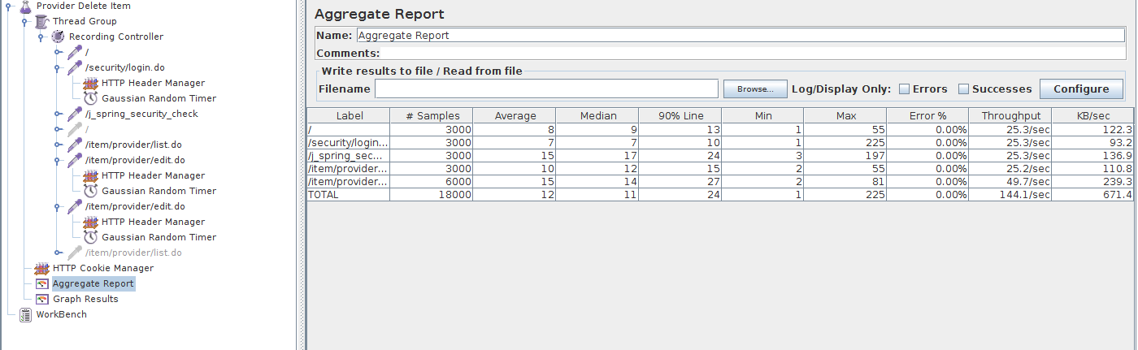

5.24.2 Graph Result
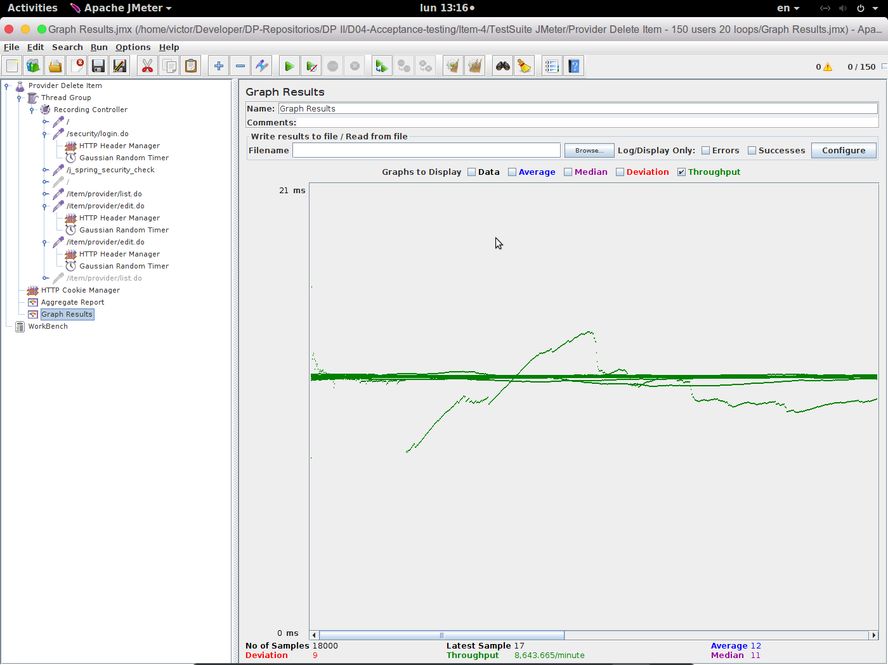

5.25 Provider display item

5.25.1 Aggregate Result
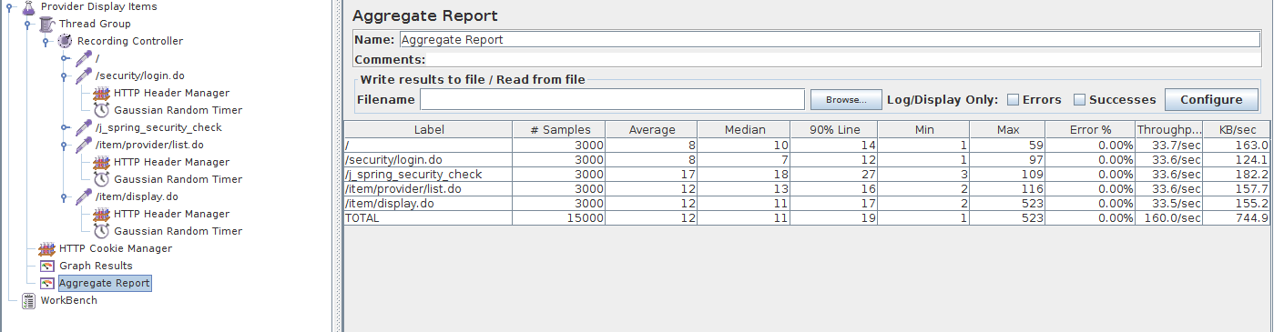

5.25.2 Graph Result

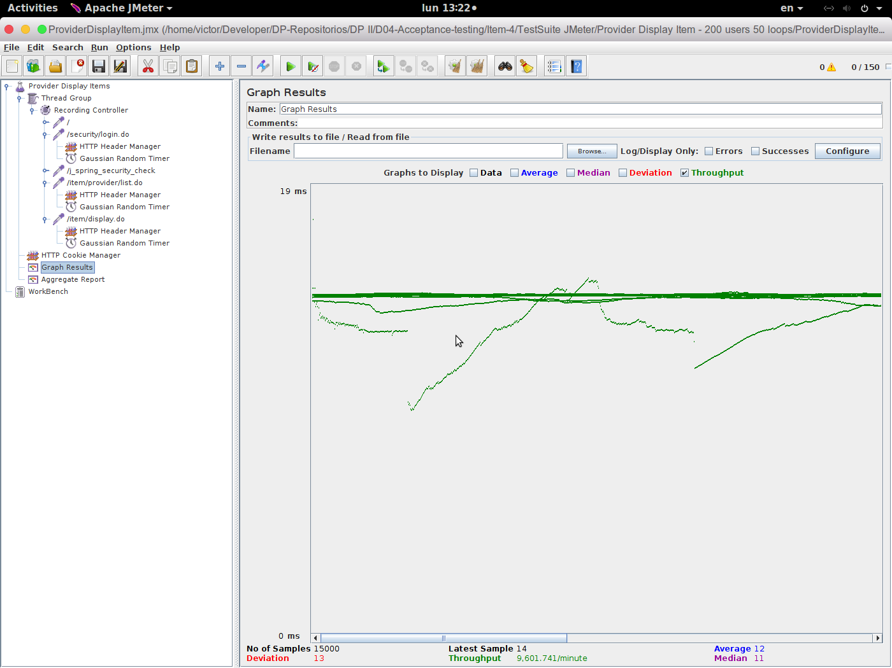

5.26 Provider edit item

5.26.1 Aggregate Result
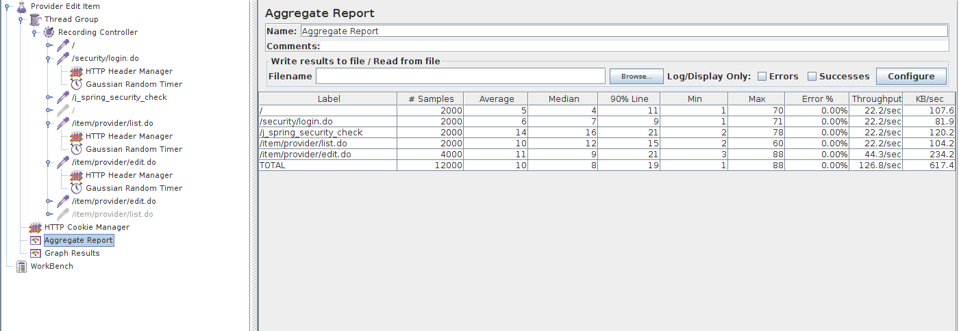

5.26.2 Graph Result

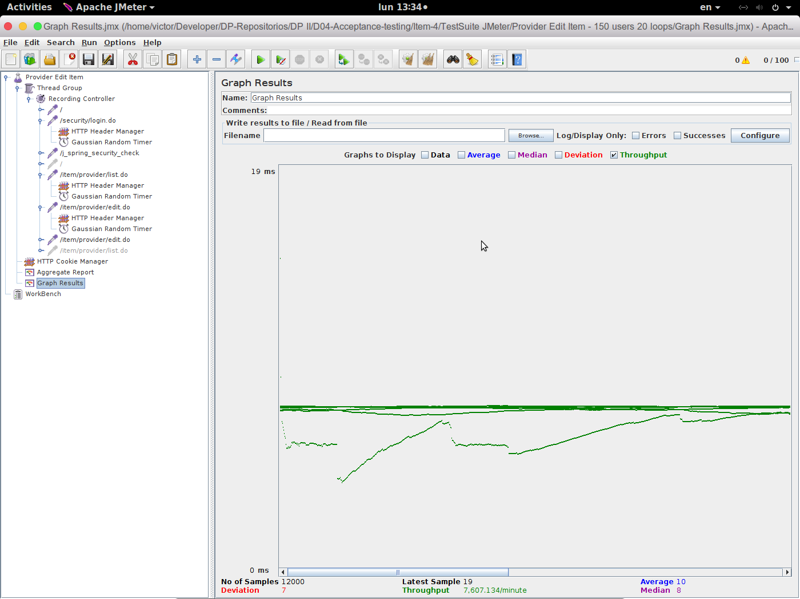

5.27 Provider list item

5.27.1 Aggregate Result
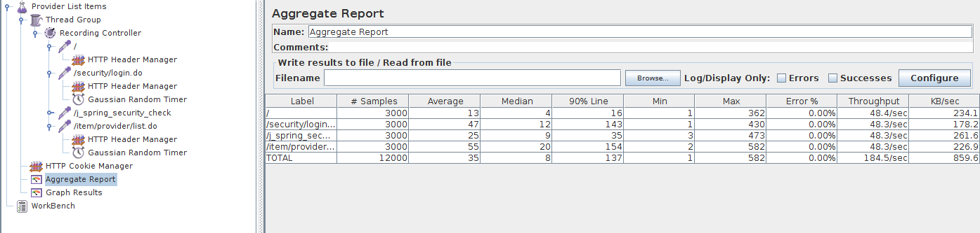

5.27.2 Graph Result

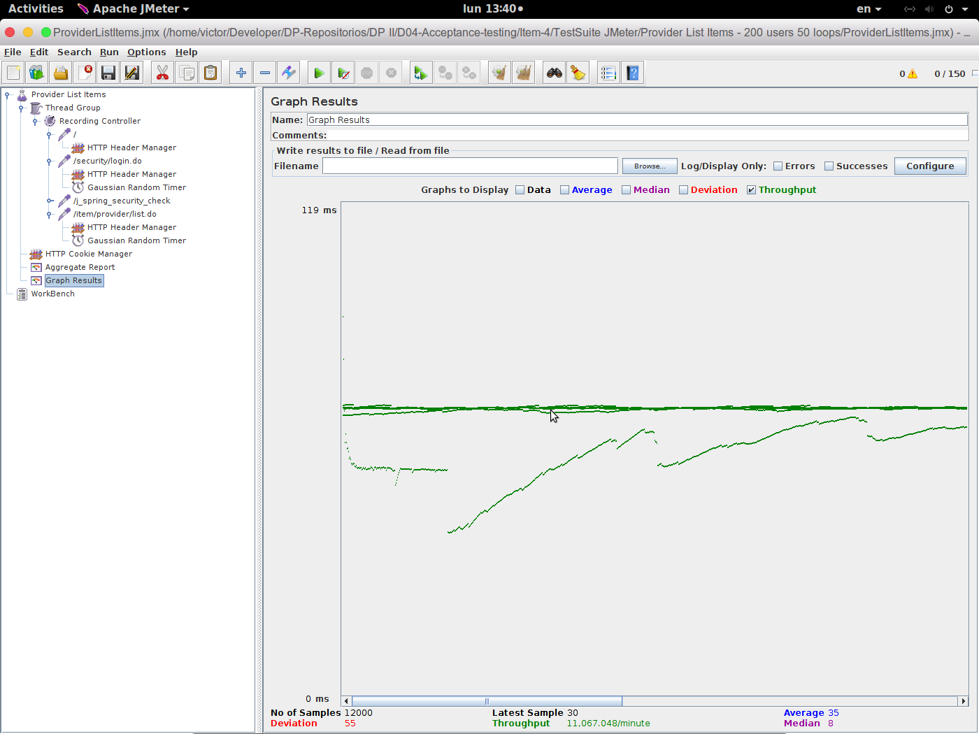

5.28 Register as a company

5.28.1 Aggregate Result

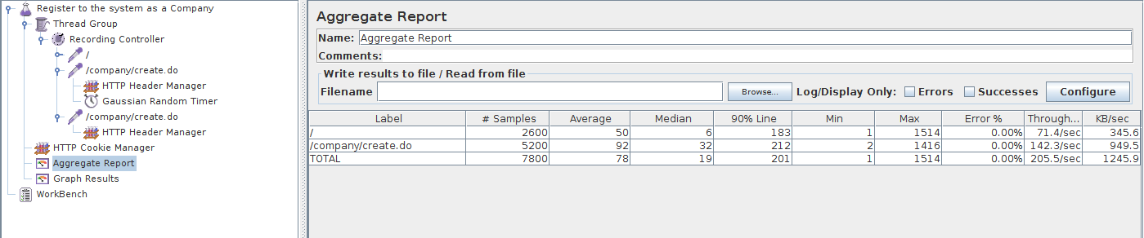

5.28.2 Graph Result

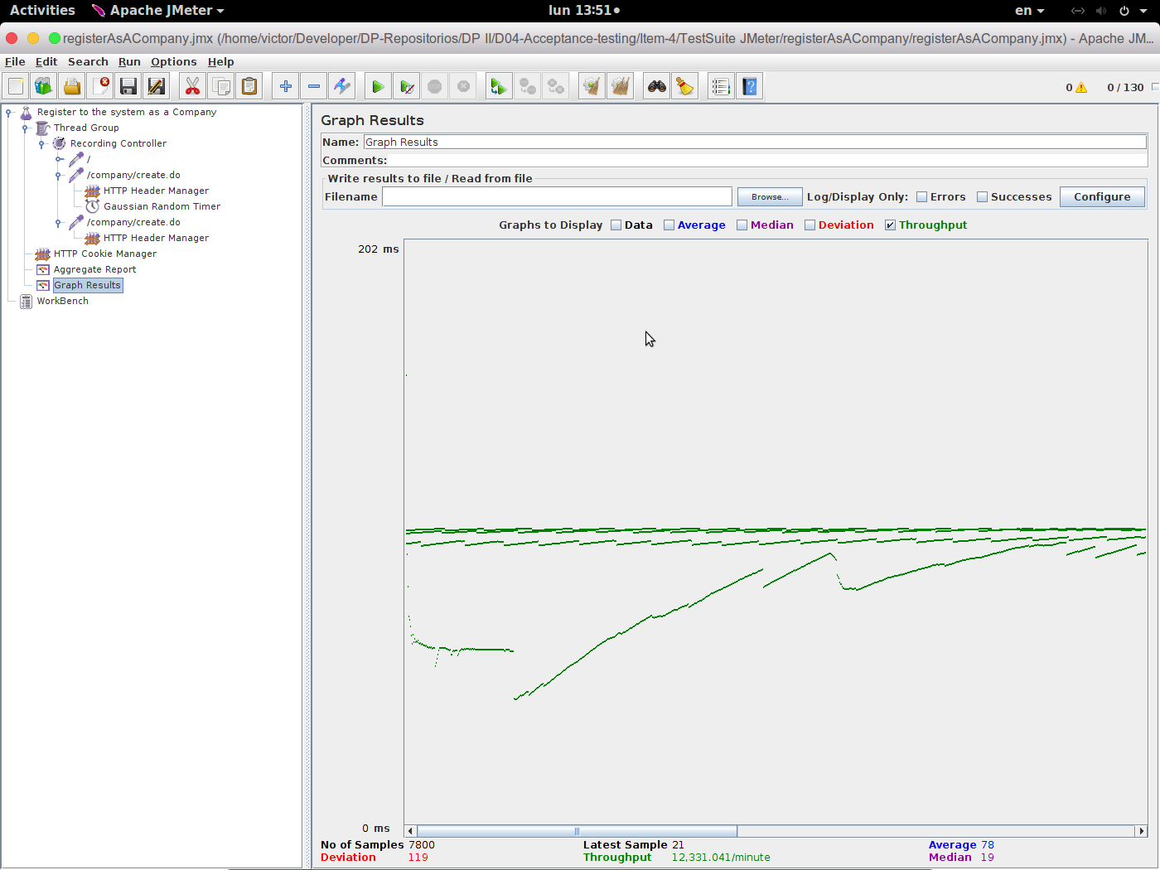

5.29 Register as a rookie

5.29.1 Aggregate Result

5.29.2 Graph Result
