Team Members: Raymond Zhang, Vishal Singh

CSCI-526: Assignment 2
Paired Prototype
Descriptive Document

1) Logline (Genre + Twist)

Split Rush is a two-player competitive 2D platform racer where players automatically race on separate but interconnected tracks, using physical impact moves and collectible abilities to directly influence each other’s race.

2) Genre tropes research and twist
a) Research at least three games from the genre and identify what they share in common (tropes)

1) SpeedRunners
SpeedRunners is a competitive 2D platformer where players race through obstacle-filled environments. Players use movement abilities, power-ups, and interactive parts of the environment to gain an advantage over their opponents.
Important genre elements found in SpeedRunners include:
- Fast side-scrolling movement
- Direct competition between players
- Platforming obstacles
- Power-ups and attacks
- Maintaining speed and momentum
- Clearly displaying which player is ahead

2) Ultimate Chicken Horse
Ultimate Chicken Horse is a competitive party platformer where players place platforms, traps, and hazards before attempting to reach the goal. Its main twist is that the players help construct the level that they must later complete.
Important genre elements found in Ultimate Chicken Horse include:
- Obstacle-course platforming
- Jumping and avoiding hazards
- Sabotaging other players
- Combining strategy with mechanical skill
- Reaching the end of the level
- Creating situations that are difficult but still possible to survive

3) Move or Die
Move or Die is a fast multiplayer party game in which players must constantly move while the rules and challenges change between rounds. Its short rounds and simple controls make the game easy to understand, while its speed creates pressure and unpredictability.
Important genre elements found in Move or Die include:
- Constant movement
- Fast reactions
- Simple player controls
- Short and re-playable matches
- Direct player competition
- Rapidly changing gameplay conditions

b) Come up with a twist and justify that it is innovative based on the genre research
The main twist of Split Rush is that the players race on separate tracks but can still affect each other during the race.
The screen is horizontally divided, with one player racing on the upper track and the other player racing on the lower track. Although the players cannot normally enter each other’s lanes, their actions and items can pass through the boundary between the tracks.
For example, the lower player can perform a powerful upward jump and hit the bottom of the upper track. This produces an earthquake that shakes the upper player’s path which can have different effects such as stunning, slowing down the player.
The upper player can have a corresponding downward attack, such as a ground slam. When the upper player lands with enough force, the impact affects the lower track by shaking the ceiling, dropping debris, or stunning/slowing the lower player.
Because these attacks are part of normal movement, players can interfere with each other without stopping the race.
Collectible items
Movement-based attacks are supported by collectible items placed above the players’ paths. Because the game moves quickly, players may not be able to collect every item.
Items can include:
- Mine: Places an additional hazard on the opponent’s track
- Laser: Fires an attack toward the opponent
- Nitro: Temporarily increases the player’s speed
- Reverse: Temporarily changes the opponent’s controls
- Blind: Temporarily reduces the opponent’s speed and blocks vision
The item system creates indirect interaction, while earthquakes and ground slams create direct interaction.

Why the twist is innovative
In many competitive platform racers, players interact because they occupy the same physical environment. They may collide, use an item, or push each other away from the shared screen.
In Split Rush, the players are visually and physically separated, but their tracks remain connected through movement and environmental reactions. A jump is therefore not only a way to avoid an obstacle. It can also become an attack on the player above.
Likewise, a ground slam can serve two purposes:
- Helping the player land quickly
- Creating a disturbance on the lower track
This changes the purpose of familiar platforming actions. Players must consider both their own movement and how that movement might affect the opponent.
The game’s innovation comes from combining:
- Fast automatic movement
- Horizontally split racing tracks
- Movement-based attacks that cross track boundaries
- Environmental effects such as earthquakes
- Elevated item selection
- Real-time sabotage
- Constant visibility of the opponent
Unlike Ultimate Chicken Horse, where traps are generally placed before the platforming attempt, Split Rush allows players to modify or disturb the opponent’s experience during the race. Unlike SpeedRunners, the players do not need to occupy the same lane to attack each other.

3) Short Prototype description
Split Rush is a two-player competitive platform racer where both characters automatically run through separate obstacle courses. Players jump and slide to avoid hazards while using earthquakes, ground slams, and collectible items to affect the opponent’s track, forcing them to balance platforming, attacking, defending, and watching the other player.

4) Mechanic Matrices - Twist & Mechanics Matrix
Twist: Two separate racing tracks that players can influence in real time through physical moves and collectible items.
Mechanics | Description | Interaction with Twist | Affected Genre Elements | Type of Genre Innovation | Supports
Interconnected track interaction (Core mechanic) | Players influence the opponent’s race while continuing to move through their own track. They can use direct physical actions and collected items such as mines, Nitro, and Swap. | Although the players occupy separate tracks, their actions create effects across the split screen. Physical impacts can disturb the opposing track, mines create new hazards, Nitro increases the user’s speed, and Swap changes the players’ positions or controls. | Player movement, platforming, combat, power-ups, obstacle navigation, speed, level environment, and player interaction | Addition and emphasis | Automatic running, jumping, item collection, obstacle system, stun effects, split-screen presentation

5) GitHub repository listed for the project
Link: https://github.com/victelepa/CTIN526-Prototype

6) Sketch or diagram

Mechanic Flow Chart

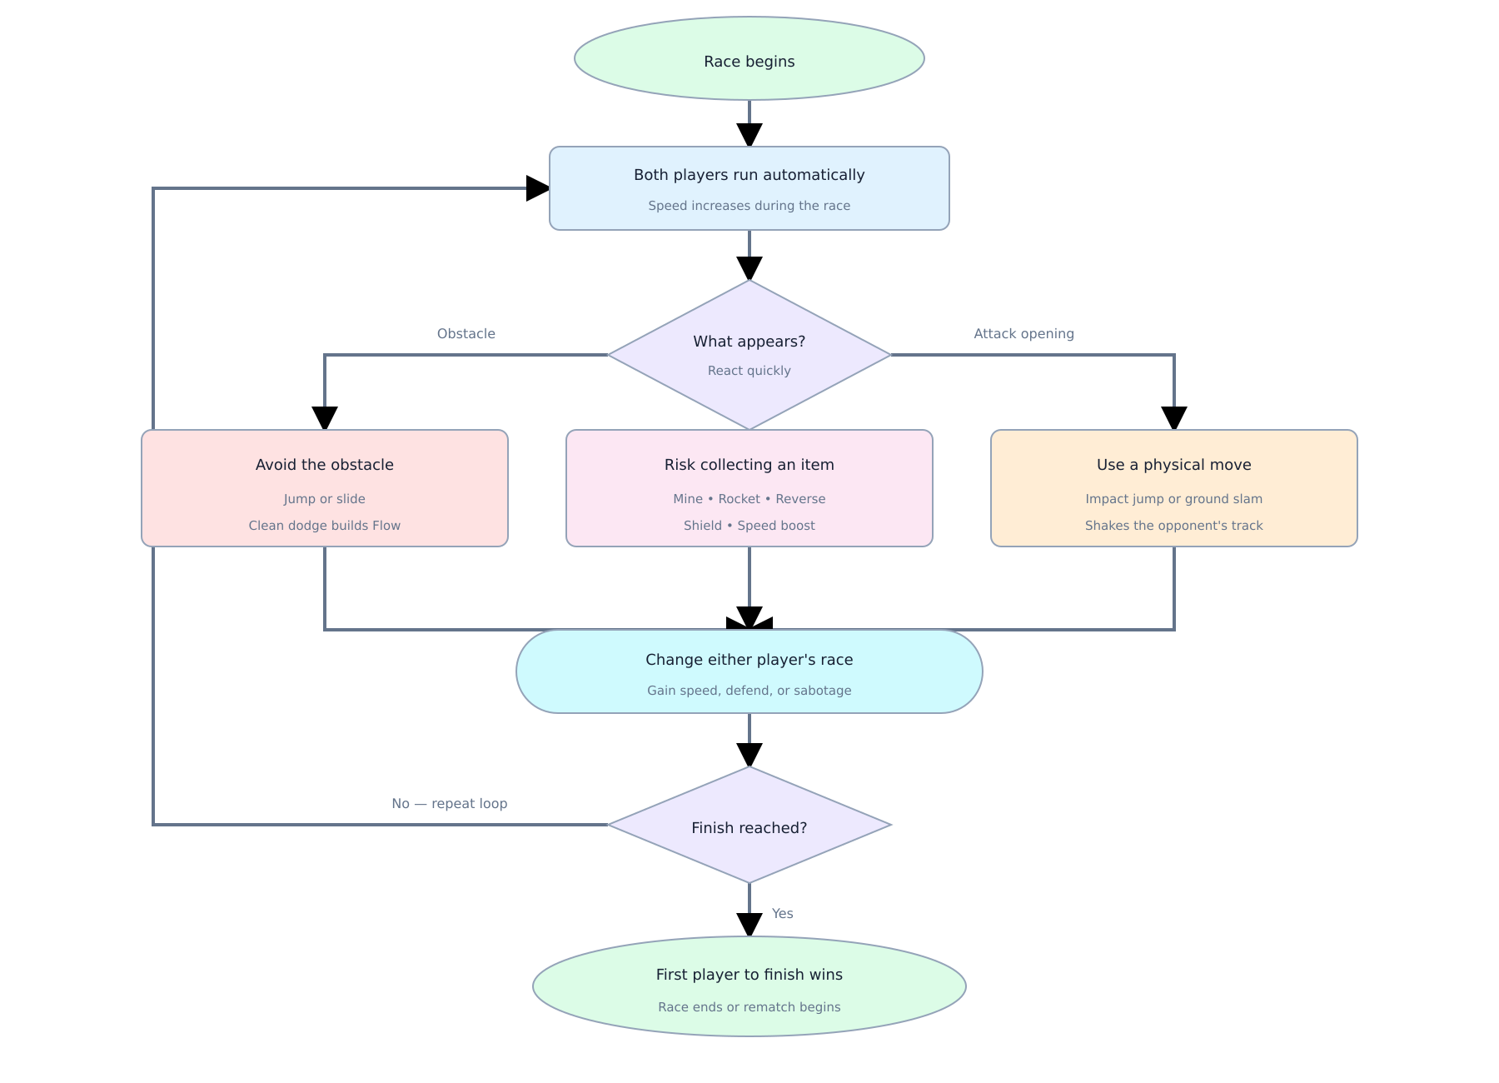

7) Individual contributions listed
Raymond Zhang: Designed and developed the racing phase, including the horizontally split tracks, automatic movement, obstacles, progress system, shops, and finish conditions. They also designed Mine, laser, Nitro items and researched one to two similar games to identify relevant competitive mechanics and possible genre innovations. They contributed to playtesting, balancing, debugging, and documentation.
Vishal Singh: Designed and developed the coin-collection phase, including the shared arena, coin placement, collection mechanics, timer, and transition into the race. They also designed Reverse and blind items and researched one to two similar games to identify relevant platform-racing mechanics and genre conventions. They contributed to playtesting, balancing, debugging, and documentation.

Both team members worked together on the interconnected-track twist, control scheme, integration between the collection and racing phases, item balancing, and final design decisions.

8) AI Usage:
We used AI as a brainstorming and guidance tool throughout development. It helped us better understand Unity concepts, explore possible approaches to technical problems, and learn how different systems could be implemented. We also used AI for guidance when implementing the specific nuances of our game, such as the coin-collection phase and item interactions. All design decisions, coding, and implementation approaches were reviewed, tested, modified, and integrated by the team.

