**Section 2: Tableau Basics: First Bar Chart**

***Connecting Tableau to a Data File***

csv belongs to txt file

***Create calculated Field***

**calculated fields*:*** custom variables you create from fields provided the data

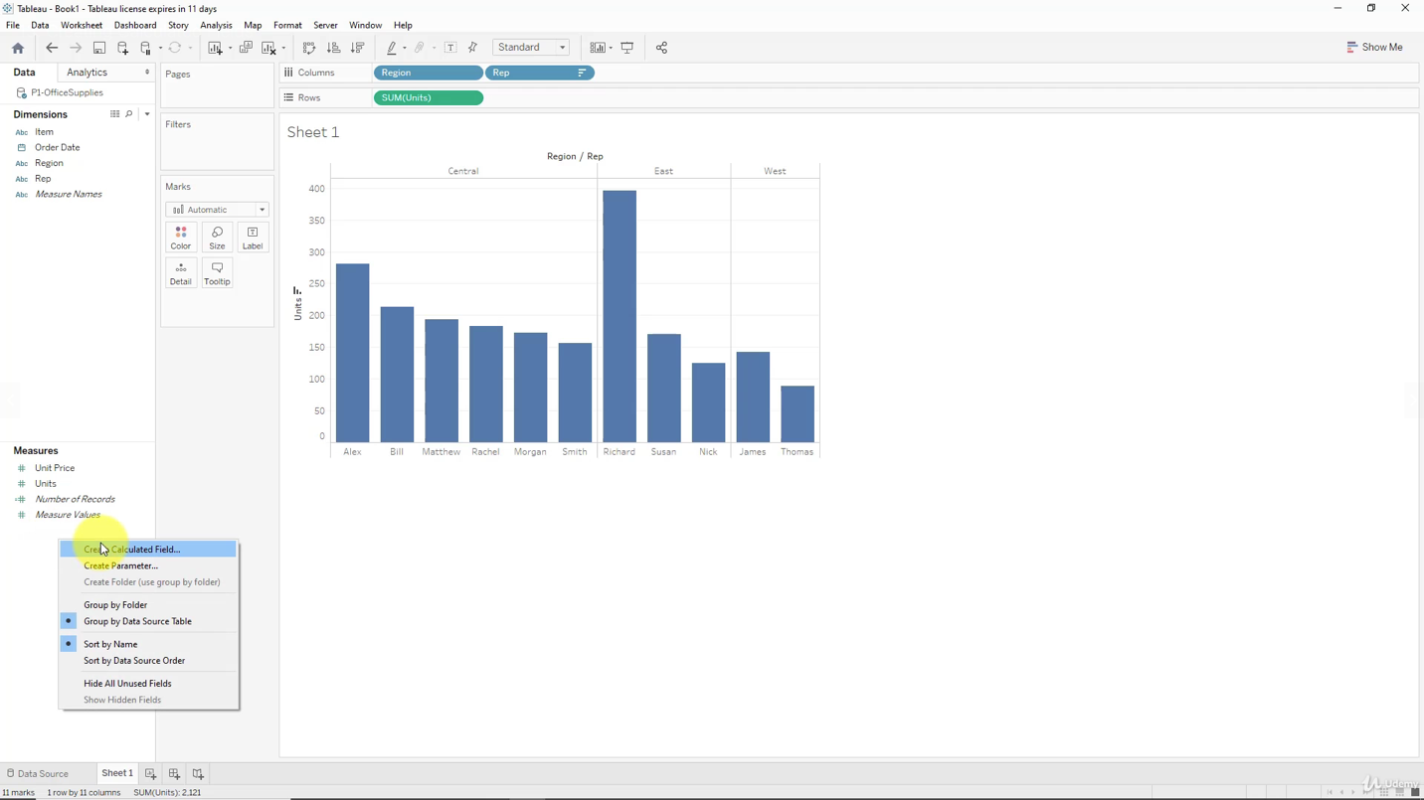

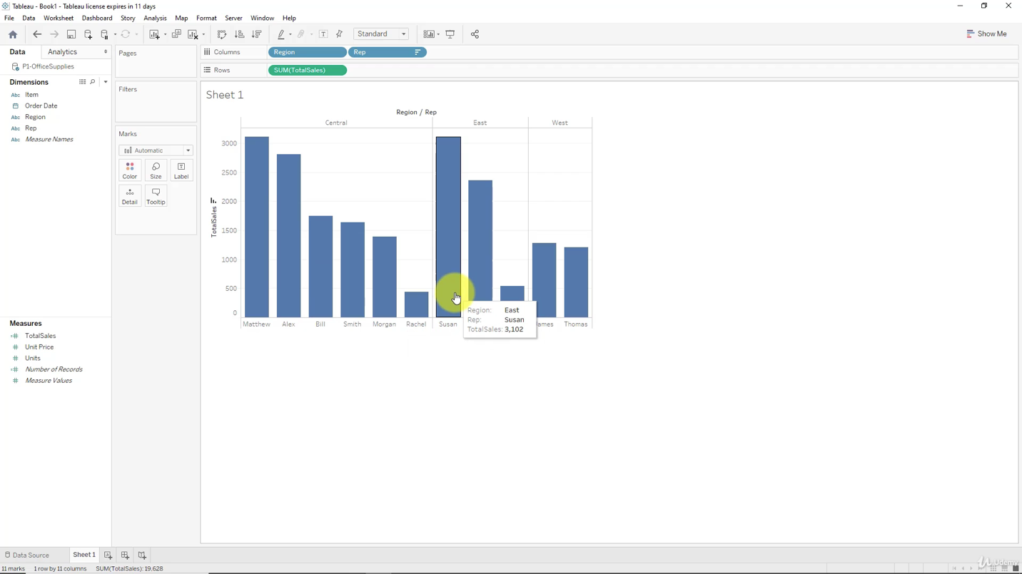

***Adding colors***

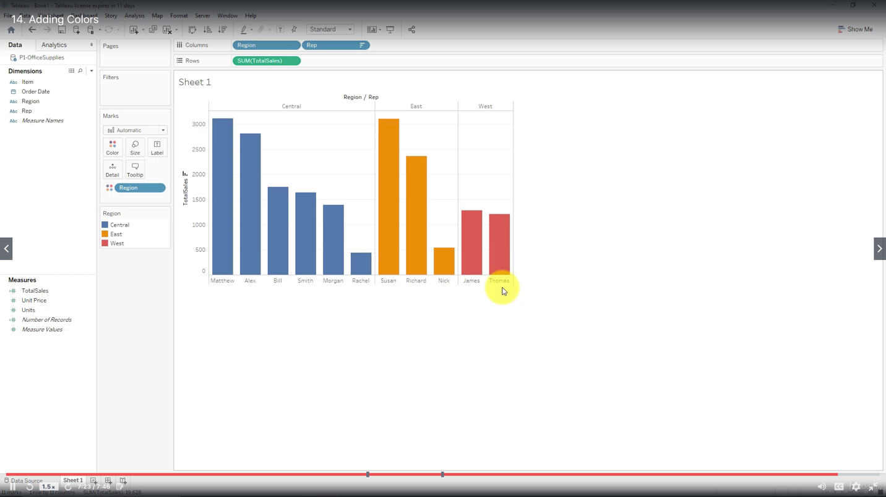

***Adding labels and formatting***

There is no limit on how many fields you can add to be shown in the label.

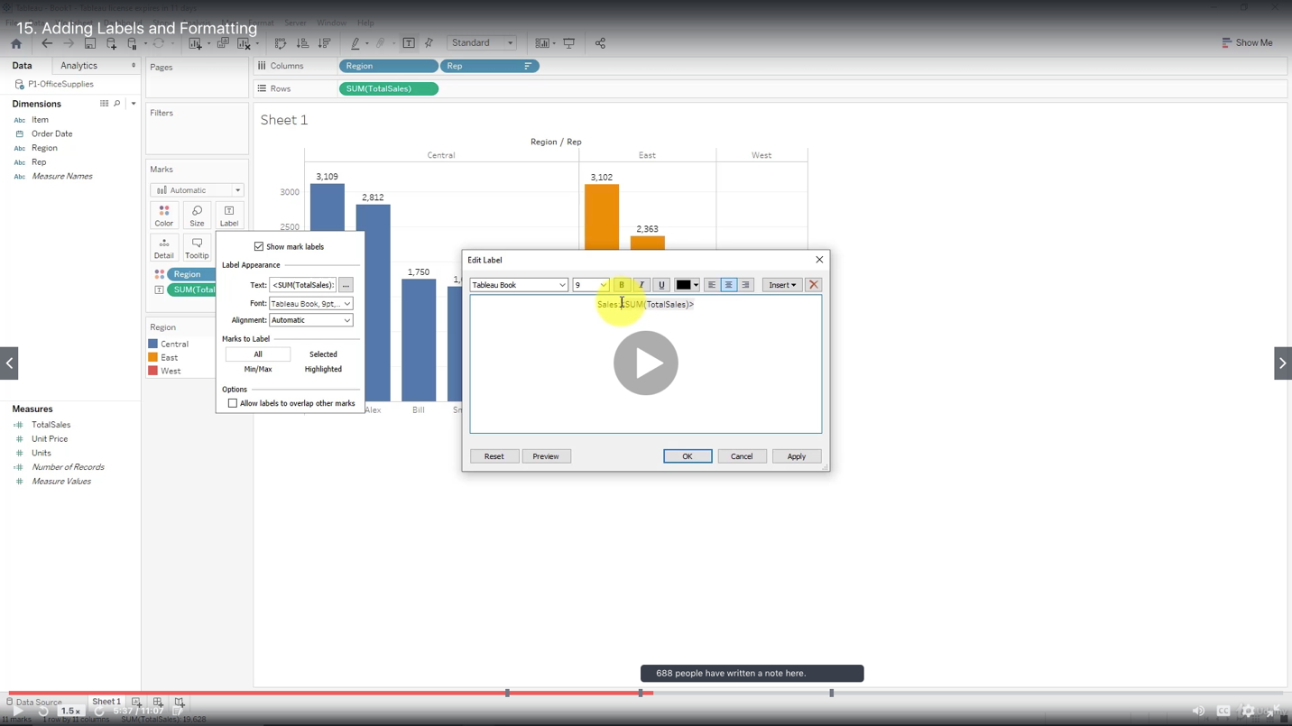

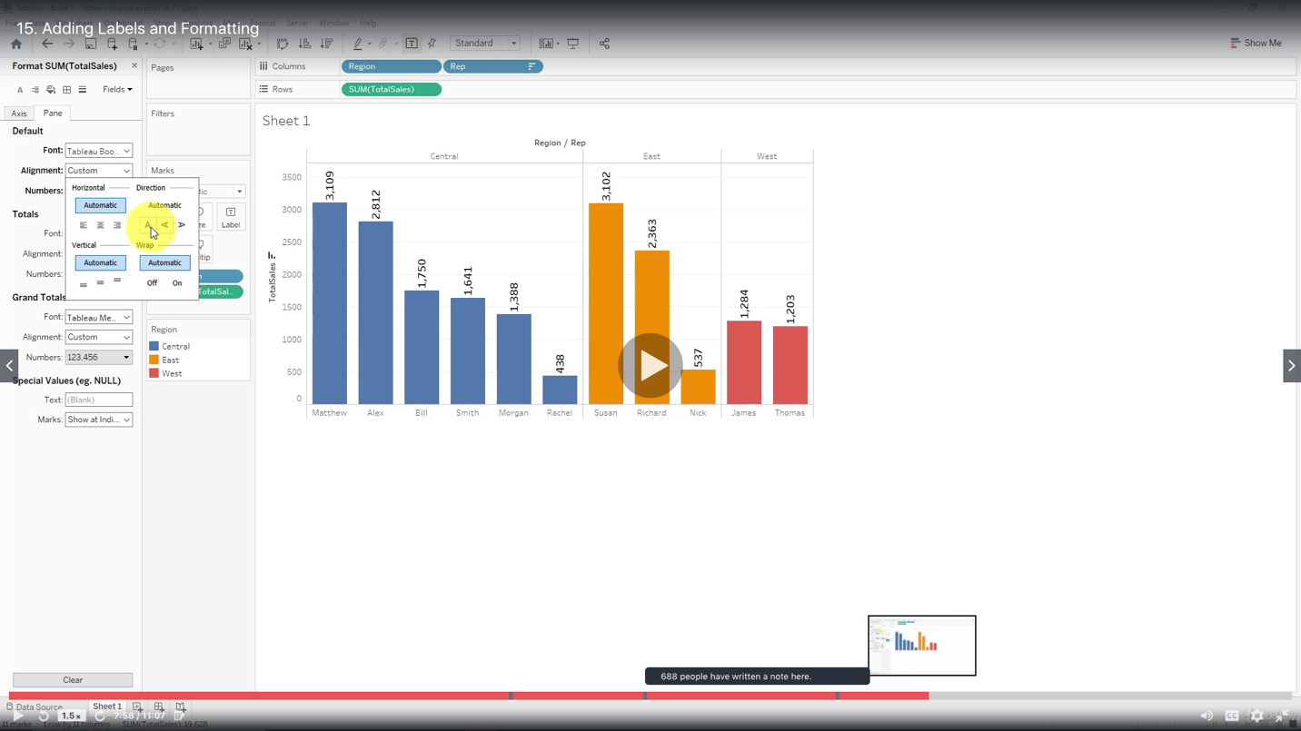

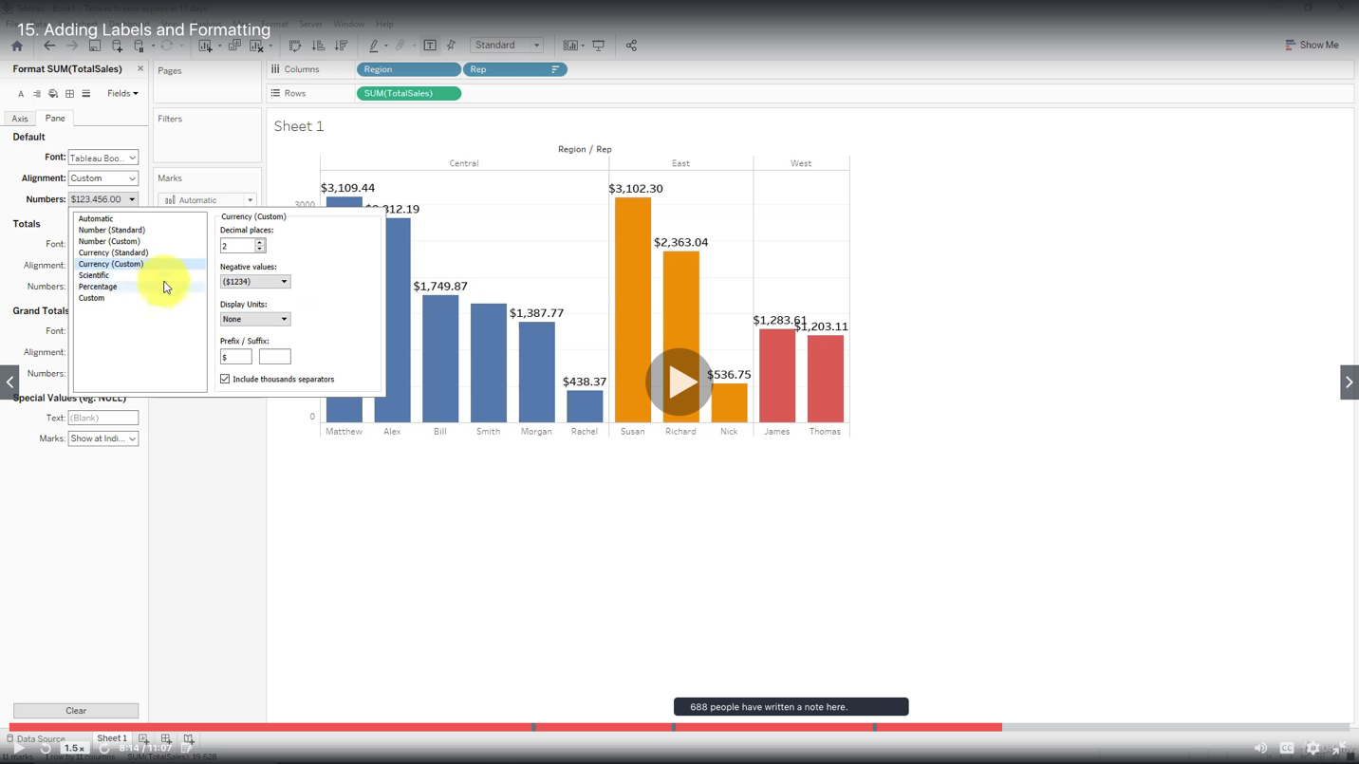

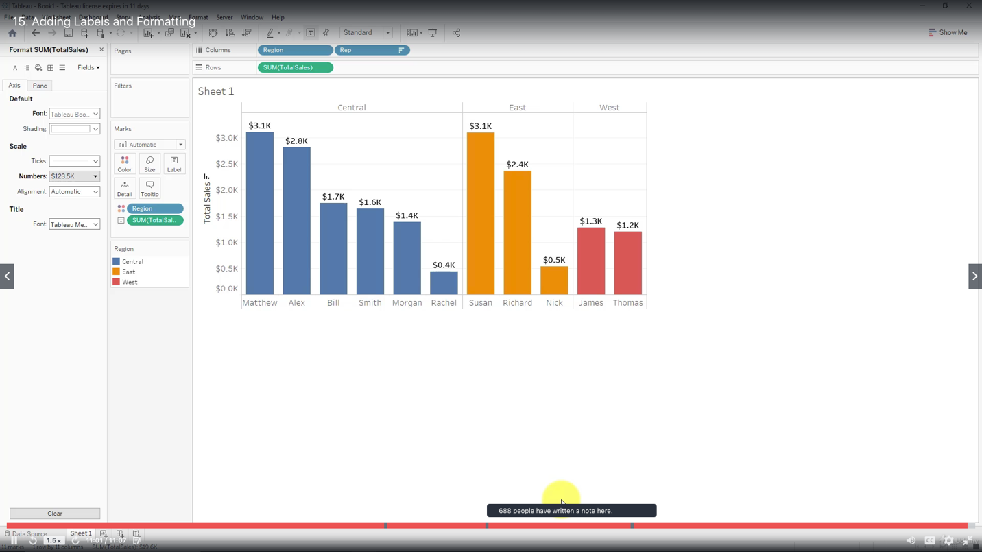

***Exporting your worksheet***

