Section 6

Mapping: How to set Geographical Roles

Right click the appropriate field and select the appropriate geographic role

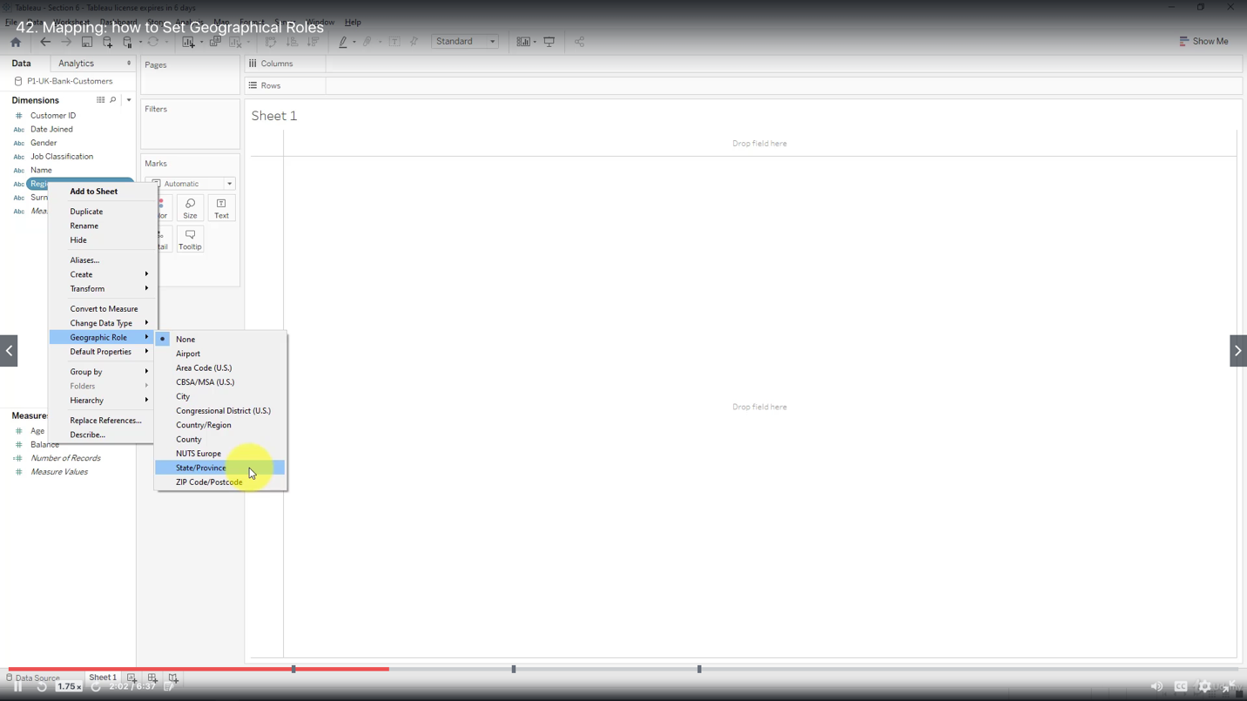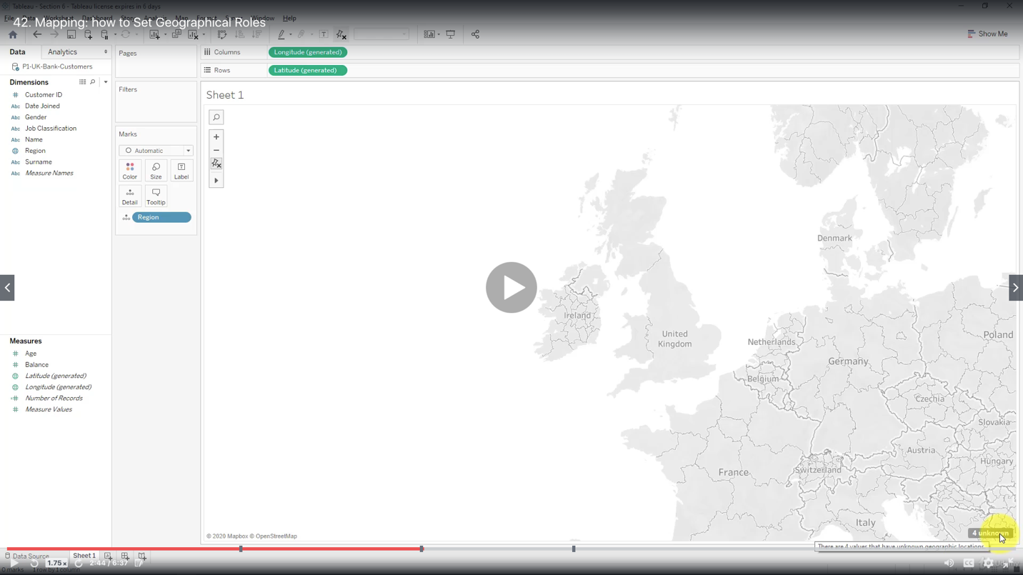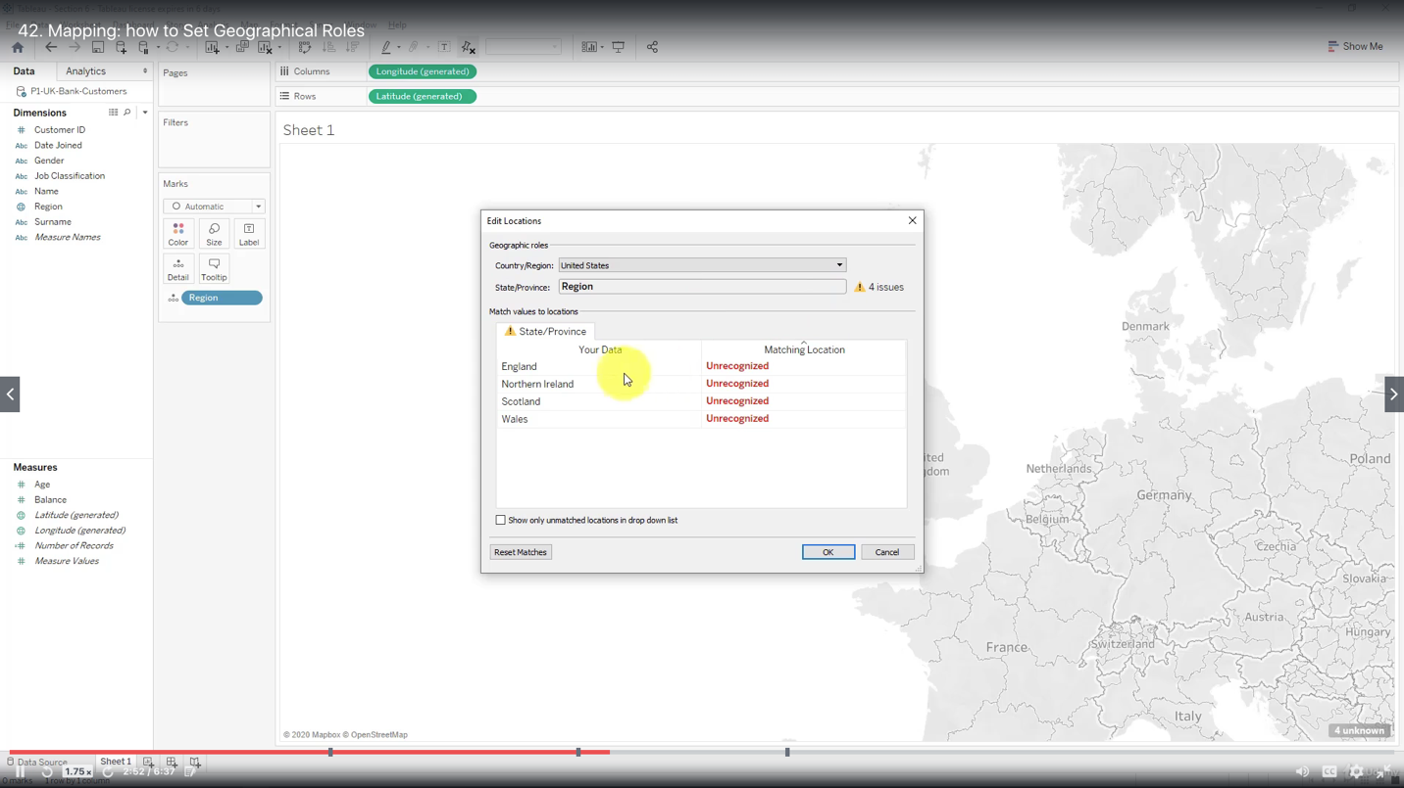

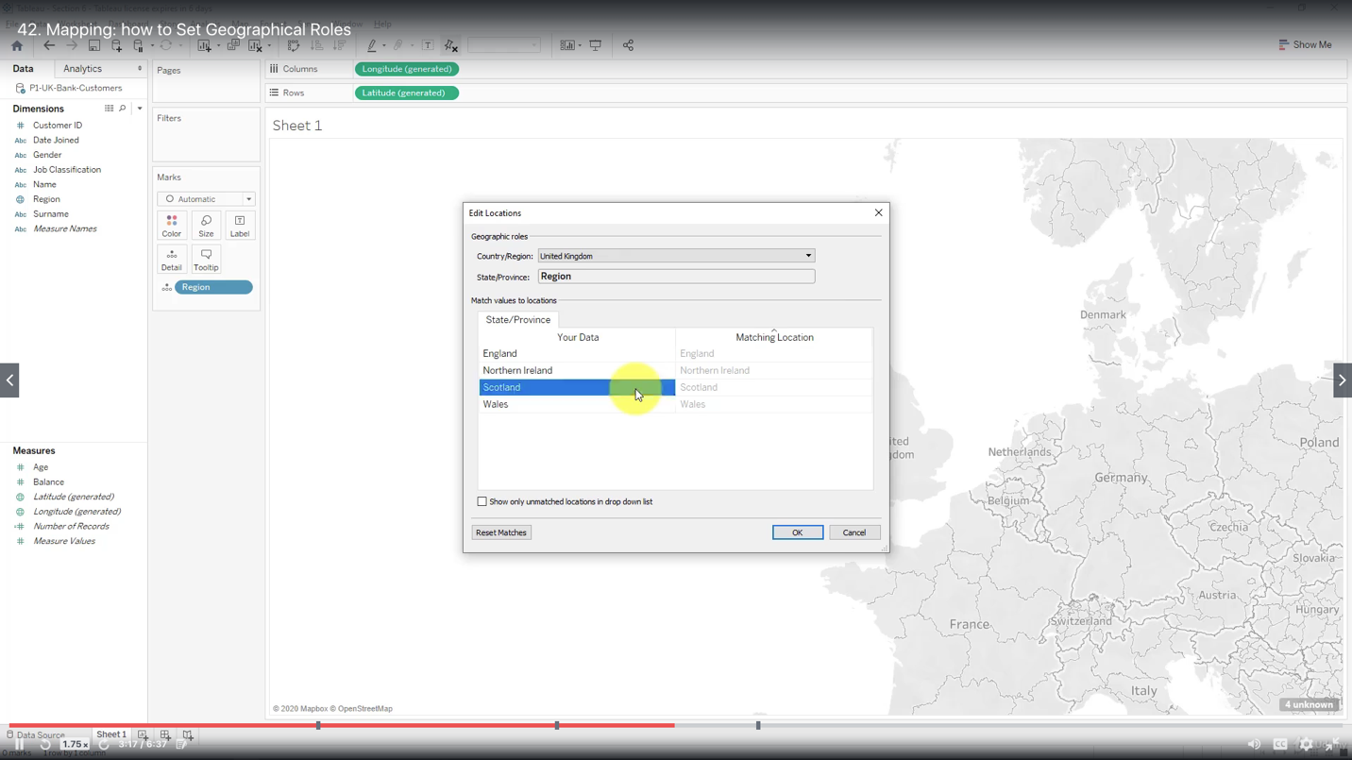

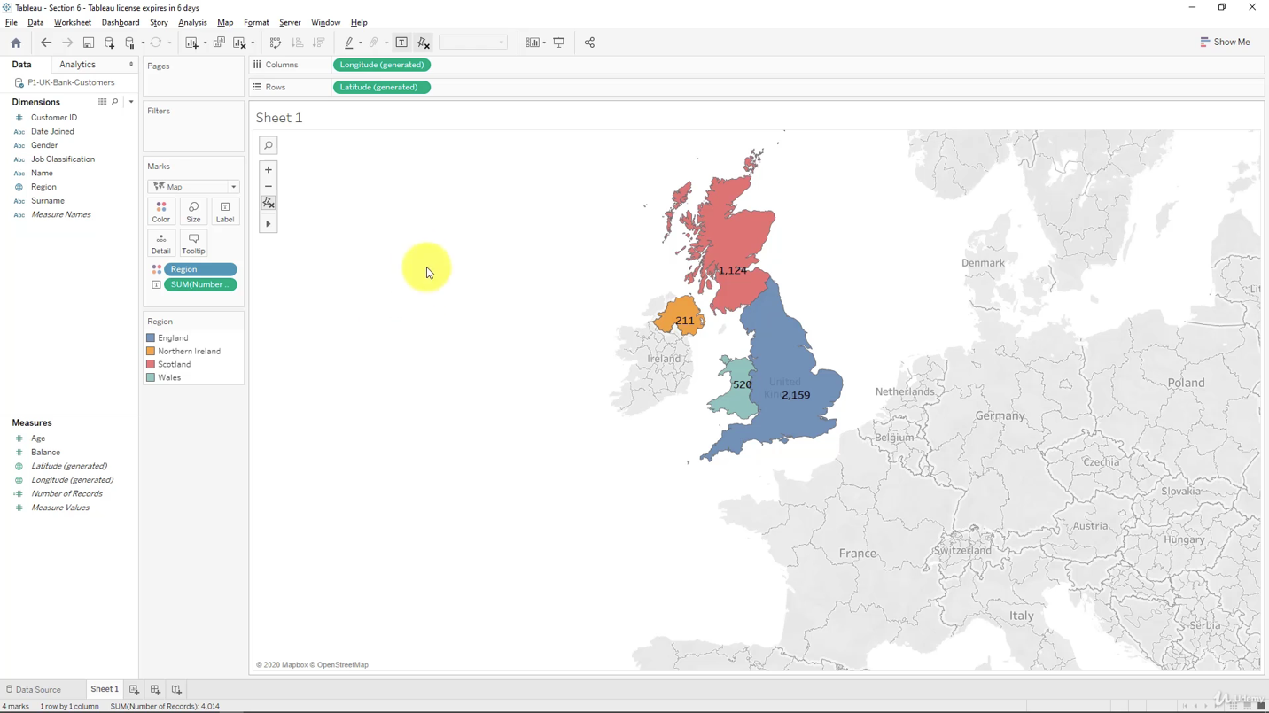

Creating Table calculations for Gender

Quick Table Calculation includes:

- Percent of Total

- Running Total

- Difference

- Percent Difference

- Rank

- Percentile

- Moving Average

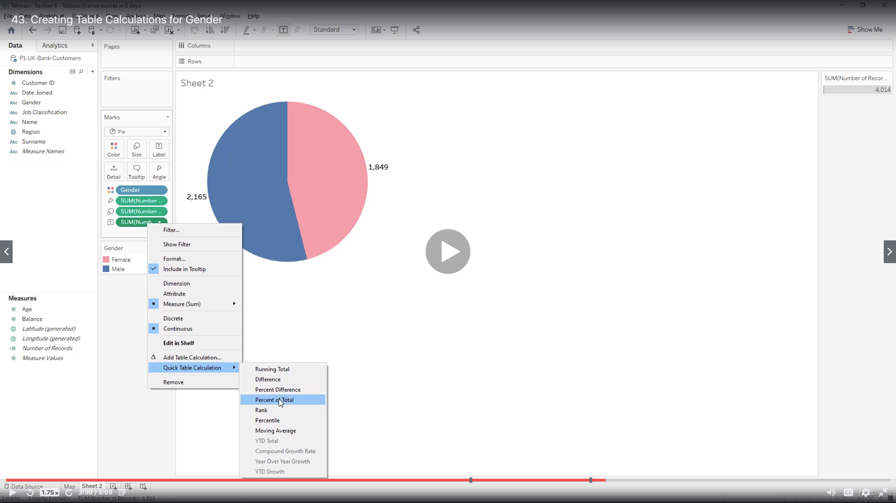

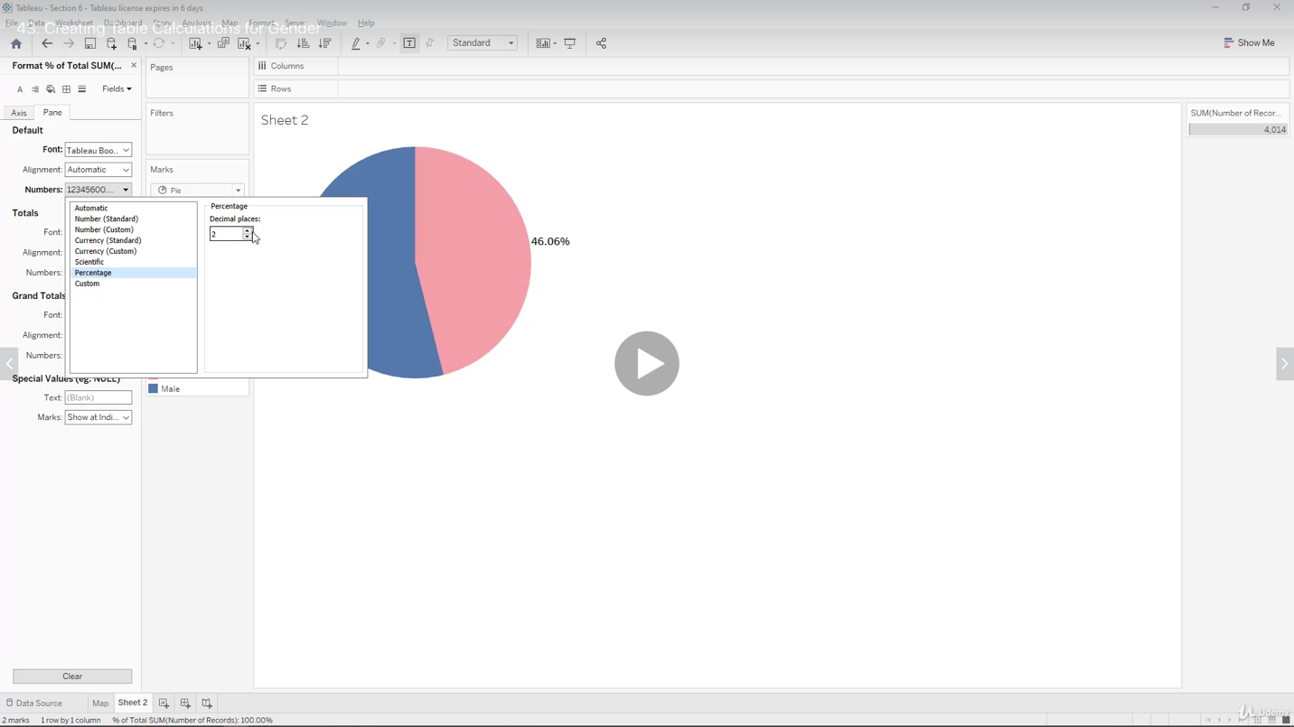

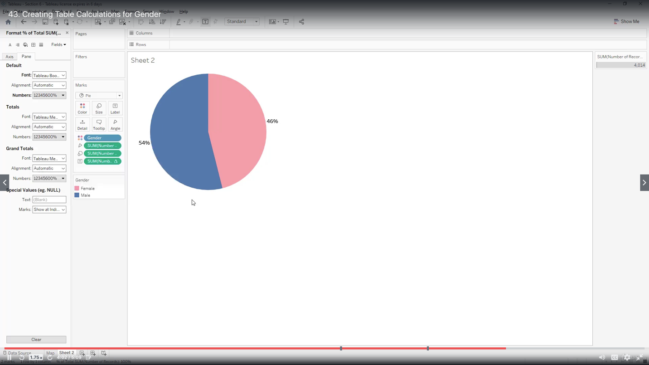

Creating Bins and Distributions for Age

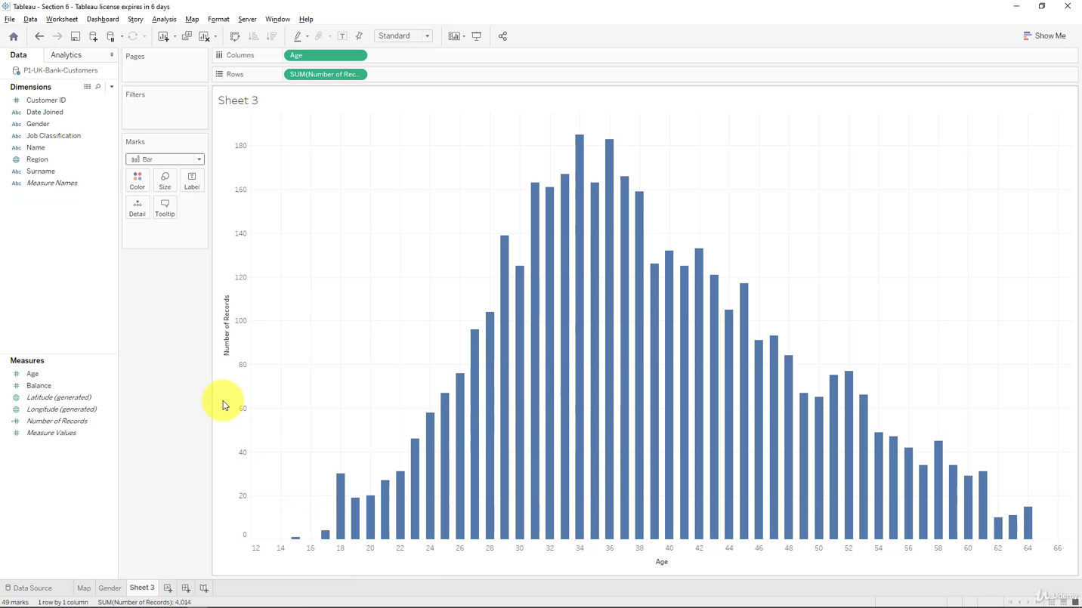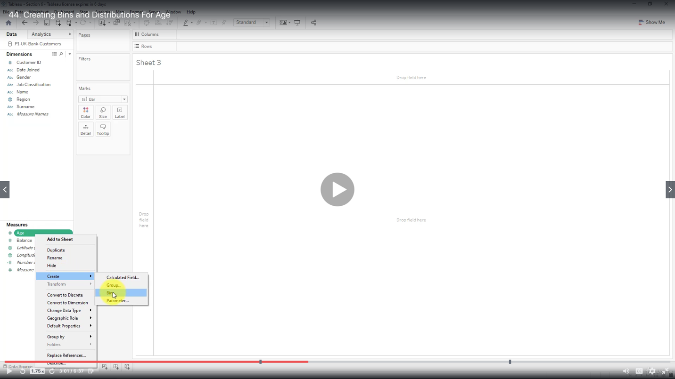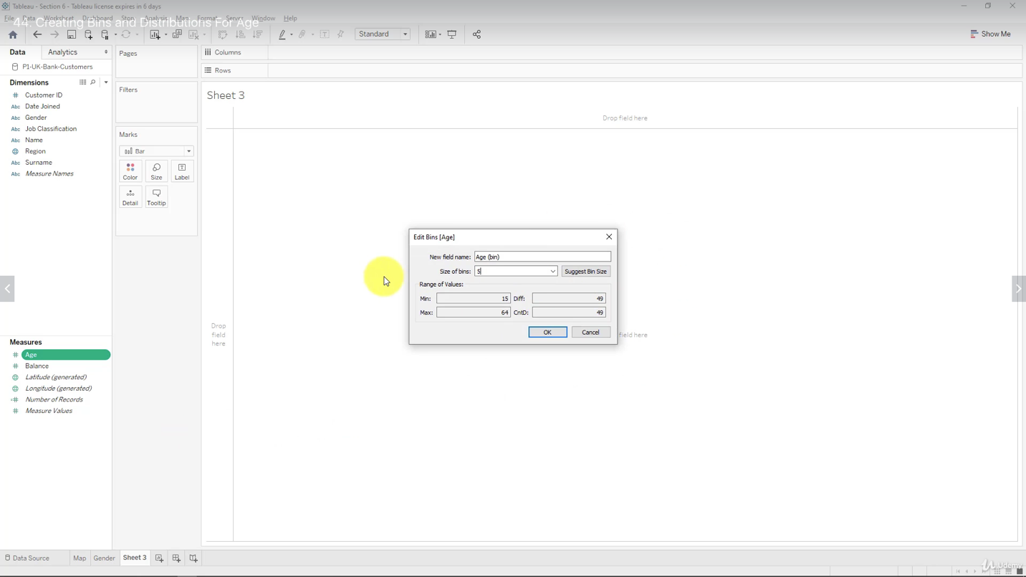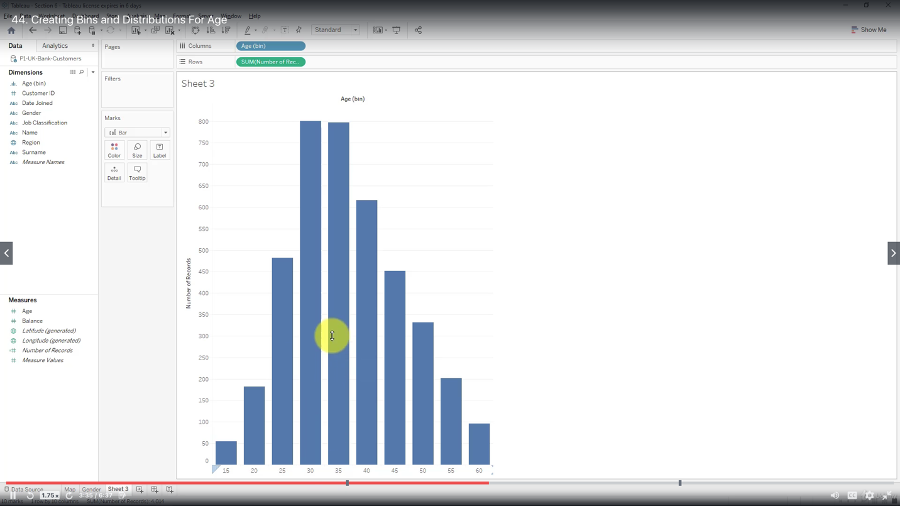

Leveraging the Power of Parameters

Type of allowable values for any parameter:

“All”

“List”

“Range”

Creating a Tree Map Chart

The main visual element of a treemap is called “Box”

Creating a Customer Segmentation Dashboard

- To understand how customers are segmented across different geographies

- To understand how customers are segmented across different demographics

- To deliver a better customer experience making it tailored and relevant

Advanced Dashboard Interactivity

Analyzing the Customer Segmentation Dashboard

Creating a Storyline

Both worksheets and dashboards can be used as pages in a storyline, but cannot be combined on one page

When you change the value of a parameter on one page of the storyline, it does not change on all other pages of that storyline