UNIVERSITY OF LAY ADVENTISTS OF KIGALI
Faculty of Computing and Information Sciences
DPR400210 — Database Programming with Oracle Database
BITE & GRILL
Oracle-Based Restaurant Ordering & Management System
Final Examination — Capstone Project Report
Student Name: [Your Full Name]
Student ID / DB naming: 2210_2025_[YourName]_Restaurant_DB
Course: DPR400210 – Database Programming with Oracle Database
Academic Year: 2025–2026
Instructor: Eric Maniraguha
Submission Date: 15-07-2026

Phase I — Problem Statement

1.1 Problem Definition
Small independent restaurants in Rwanda (and similar markets) typically take orders by phone or in person, then record them on paper or in a notebook. This creates slow order capture, frequent transcription errors, no reliable record of what was actually ordered, no audit trail when an order is changed or cancelled, and no easy way to see daily sales. Bite & Grill is a fictional restaurant used as the basis for a real Oracle database system that solves this problem end to end: menu management, order capture, order-status tracking, auditing, and business-rule enforcement, all backed by a normalized Oracle schema and PL/SQL business logic.

1.2 Context of Use
The system is used inside a single restaurant location. A customer-facing web page lets a customer browse the live menu and place an order; the order is written straight into the Oracle database through a PL/SQL package rather than through raw SQL from the application, so every business rule and audit trigger applies uniformly no matter which client submits the order.

1.3 Target Users
- Customers — browse the menu and place orders online
- Restaurant staff / cashier — review incoming orders and progress them through their lifecycle
- Restaurant manager — reviews sales totals and the audit trail; is the only role that needs direct table access
- Database administrator (the student) — owns the schema, the package, and the security model

1.4 Project Objectives
- Design a normalized (3NF) relational schema for menu, customers, orders, and auditing
- Implement all order logic through PL/SQL procedures, functions, packages and cursors
- Enforce a business rule that blocks order changes on weekdays and public holidays
- Provide a full audit trail of every order creation and status change
- Restrict direct table DML so all writes are forced through the package (security control)
- Demonstrate the system through a working web ordering interface (innovation component)

1.5 Expected Benefits
- Faster, error-free order capture compared to a paper ticket system
- A verifiable audit trail for every order and every status change, with who changed it and when
- Consistent enforcement of restaurant policy (e.g. no changes outside opening rules) at the database layer, not just in application code that could be bypassed
- Real-time visibility into sales totals and order status for staff

Phase II — Business Process Modeling

2.1 System Scope
The process covers the full order lifecycle: a customer browses the menu, places an order, the order is validated against business rules and written to the database, kitchen/front-of-house staff progress the order through its states, and the customer can check the order status at any time. Every insert and status change is captured by database triggers into an audit table, independent of which actor performed the action.

2.2 Actors / Swimlanes
- Customer — browses the menu, submits the order, checks status
- Web App (app.py) — renders the menu, forwards requests to the database over SQL*Plus
- Oracle Package (order_management_pkg) — the only code path allowed to write to ORDERS
- Triggers / Audit — restrict_weekday_dml enforces the business rule; order_insert_audit and order_audit_trigger log every change
- Restaurant Staff — reviews new orders and updates their status (CONFIRMED → PREPARING → READY → DELIVERED, or CANCELLED)

2.3 Workflow Diagram (Swimlane)
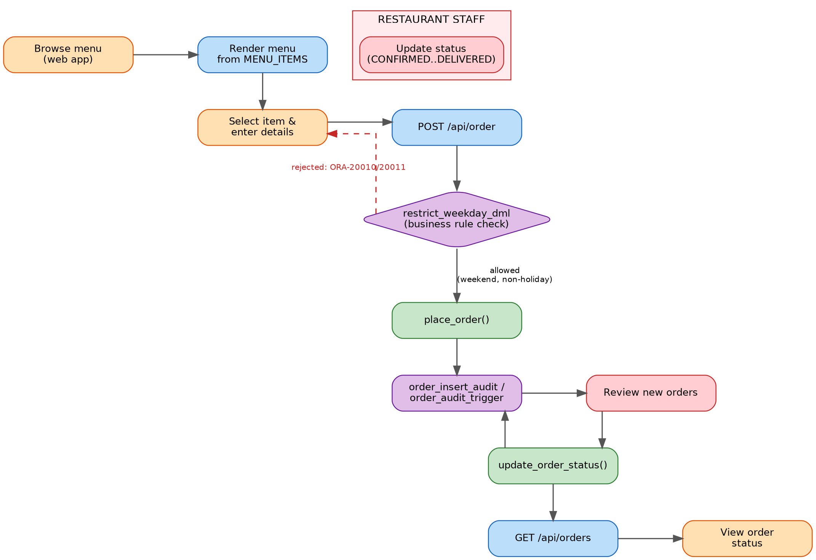
Figure 1 — Order lifecycle swimlane diagram, from menu browsing to delivery, showing the business-rule checkpoint and the audit trigger.

2.4 One-Page Explanation
The workflow begins when a customer opens the web app and browses the live menu, which the app renders directly from the MENU_ITEMS and CATEGORIES tables. When the customer places an order, the web app calls order_management_pkg.place_order() rather than issuing a raw INSERT — this is a security control described in Phase VII. Before the row is written, the restrict_weekday_dml trigger fires and checks the current day against the weekday rule and against the HOLIDAYS reference table; if either condition matches, the trigger raises an application error (ORA-20010 or ORA-20011) and the whole transaction is rejected, so no order can ever be recorded outside the allowed window regardless of which client tried to write it. If the check passes, the row is inserted, order_insert_audit fires automatically and writes an ORDER_CREATED row into ORDER_AUDIT, and the new order_id is returned to the customer. Restaurant staff then see the pending order and move it through its lifecycle using order_management_pkg.update_order_status(); every status change fires order_audit_trigger, which records the old status, the new status, who made the change, and when. The customer can poll /api/orders at any time to see the current status of their order. Because the audit triggers are AFTER triggers on the base table rather than logic bolted onto the application, the audit trail is complete even if a different client bypassed the web app and called the package directly from SQL*Plus.

Phase III — Logical Database Design

3.1 Entity–Relationship Diagram
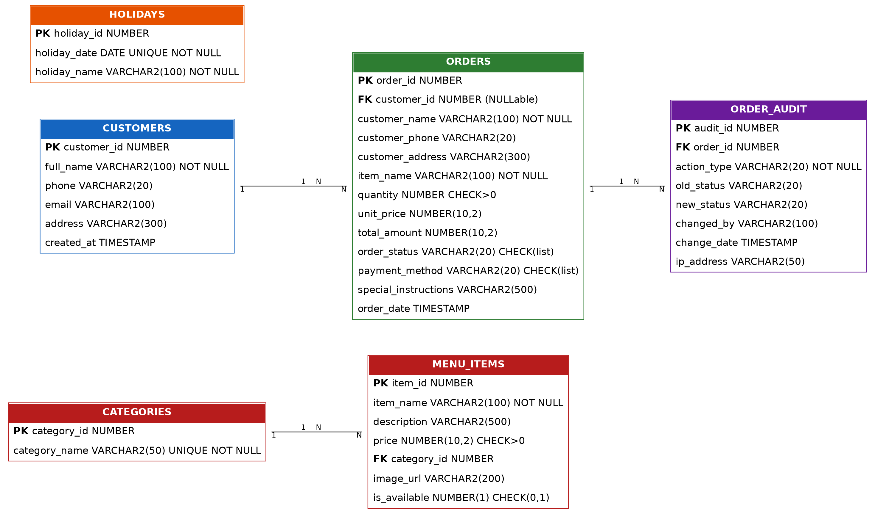
Figure 2 — ERD for the Bite & Grill schema. Crow's-foot style 1..N relationships are labelled on each edge.

3.2 Entities, Attributes, Keys and Relationships
Entity | Key attributes | Relationship
CATEGORIES | PK category_id; UNIQUE category_name | 1 category → N menu_items
MENU_ITEMS | PK item_id; FK category_id → CATEGORIES | N menu_items belong to 1 category
CUSTOMERS | PK customer_id | 1 customer → N orders (optional)
ORDERS | PK order_id; FK customer_id → CUSTOMERS (ON DELETE SET NULL) | N orders → 1 customer; 1 order → N audit rows
ORDER_AUDIT | PK audit_id; FK order_id → ORDERS | N audit rows belong to 1 order
HOLIDAYS | PK holiday_id; UNIQUE holiday_date | Reference table read by the business-rule trigger

3.3 Normalization to 3NF
Every table has a single-column surrogate primary key (IDENTITY column), so 1NF (atomic values, no repeating groups) and 2NF (no partial dependency on a composite key, since no table has a composite PK) are satisfied automatically. For 3NF, every non-key attribute depends only on its own table's primary key: for example, category_name depends only on category_id and not on anything in MENU_ITEMS, and order_status/total_amount depend only on order_id. The one deliberate denormalization is that ORDERS stores customer_name, customer_phone and customer_address directly instead of only a customer_id — this is intentional so that a walk-in or one-off order that never creates a CUSTOMERS row (customer_id is nullable, ON DELETE SET NULL) still keeps a complete, permanent record of who the order was for, which matters for an audit trail. This trade-off should be stated explicitly during the presentation since a strict-3NF purist would flag it.

Phase IV — Database Creation
The project was developed against an Oracle 19c instance (see app.py, which connects as system/****@localhost:1521/orcl during development). Per the course naming convention, the dedicated application schema/user should be created as follows before final submission:
CREATE USER 2210_2025_YourName_Restaurant_DB IDENTIFIED BY "SomeStrongPass1";
GRANT CONNECT, RESOURCE TO 2210_2025_YourName_Restaurant_DB;
GRANT restaurant_app_role TO 2210_2025_YourName_Restaurant_DB;
The restaurant_app_role (created in business_rules_and_security.sql) is granted EXECUTE on order_management_pkg and SELECT on ORDERS, and is the role this dedicated user should hold — see Phase VII for the full security rationale.

Phase V — Table Implementation
Six tables implement the schema, all created in 01_create_database.sql and business_rules_and_security.sql, with constraints enforced at the database level rather than only in application code:
Table | Constraints
categories | PK, NOT NULL + UNIQUE on category_name
menu_items | PK, NOT NULL, CHECK (price > 0), CHECK (is_available IN (0,1)), FK → categories
customers | PK, NOT NULL on full_name
orders | PK, NOT NULL, CHECK (quantity > 0), CHECK on order_status and payment_method value lists, FK → customers (ON DELETE SET NULL)
order_audit | PK, NOT NULL on action_type
holidays | PK, NOT NULL, UNIQUE on holiday_date
Indexes were added on the columns most queried by the application (idx_orders_customer, idx_orders_status, idx_orders_date, idx_order_audit_order) to keep status and history lookups fast as order volume grows. The menu was seeded with 5 categories and 11 realistic menu items with prices, descriptions and availability flags so the system demonstrates real data end to end rather than empty tables.

Phase VI — PL/SQL Programming
All order logic lives in the order_management_pkg package (02_plsql_packages.sql), so the same validated code path is used no matter which client (the web app, SQL*Plus, or another future client) is writing to the database:
Program unit | Purpose
place_order() — function | Parameterized insert of a new order; computes total_amount, returns the new order_id, COMMITs on success and ROLLBACKs on any exception
update_order_status() — procedure | Validates the order exists (NO_DATA_FOUND handling with RAISE_APPLICATION_ERROR -20001), then updates order_status
get_order_details() — function | Returns a SYS_REFCURSOR with full details for one order
get_total_sales() — function | Aggregates total revenue, excluding CANCELLED orders
get_orders_by_status() — function | Returns a SYS_REFCURSOR of orders filtered by status, most recent first
get_daily_orders_report() — procedure | Uses an explicit CURSOR to loop today's orders and print a DBMS_OUTPUT summary with order count and total sales
Exception handling follows the WHEN OTHERS → ROLLBACK → RAISE pattern in every DML-performing unit, so a failed write never leaves a half-committed order, and a specific NO_DATA_FOUND handler gives a meaningful application error instead of an unhandled Oracle exception when an order ID doesn't exist.

Phase VII — Advanced Database Programming

7.1 Triggers
Trigger | Fires on | Purpose
order_insert_audit | AFTER INSERT ON orders | Writes an ORDER_CREATED row to order_audit for every new order
order_audit_trigger | AFTER UPDATE OF order_status ON orders | Writes a STATUS_CHANGE row capturing :OLD and :NEW status plus who changed it
restrict_weekday_dml | BEFORE INSERT OR UPDATE OR DELETE ON orders, FOR EACH ROW | Business rule enforcement — see 7.2

7.2 Business Rule: Weekday & Holiday Restriction
Per the exam specification, orders cannot be inserted, updated, or deleted on weekdays (Monday–Friday) or on a public holiday. The final version of restrict_weekday_dml (business_rules_and_security.sql) checks TO_CHAR(SYSDATE,'DY') against Mon–Fri and separately checks the new HOLIDAYS reference table for the current date; either condition raises a distinct application error (ORA-20010 for weekdays, ORA-20011 for holidays) so the offending transaction is rolled back automatically. Note that the version in 02_plsql_packages.sql was an intentional placeholder (an IF that does nothing) built first to prove the trigger fires without blocking demo data entry; business_rules_and_security.sql replaces it with the real enforcing version — this progression is worth explaining live, since it shows iterative development rather than a rule that was simply copy-pasted.

7.3 Security: Forcing Access Through the Package
REVOKE INSERT, UPDATE, DELETE ON orders FROM PUBLIC removes direct write access to the base table entirely. A new role, restaurant_app_role, is granted only EXECUTE on order_management_pkg and SELECT on orders. Because the package is owned by the schema that owns the table, its procedures run with definer's rights, so a session holding only restaurant_app_role can still place and update orders — but only by going through place_order() and update_order_status(), which means every write is guaranteed to pass through the weekday/holiday check and to be captured by the audit triggers. This is the auditing-and-security control required by the marking scheme: it is enforced by grants, not by convention.

Phase VIII — Innovation Component
Beyond the required PL/SQL and triggers, the project includes a working Python-based web ordering interface (app.py) that is demonstrated live: it renders the live menu and category data straight from Oracle, submits new orders through order_management_pkg.place_order() (never with a raw INSERT), and displays each customer's order history and live status by calling the package's read paths. It uses only the Python standard library (http.server + subprocess) to drive sqlplus directly, with no external web framework or ORM in between — a deliberate choice that keeps every database interaction visible and attributable to the PL/SQL package rather than hidden inside a framework, which was the differentiator prioritized over adding an ORM- or Flask-based layer for this submission.

Conclusion
Bite & Grill demonstrates a complete Oracle database solution for a real restaurant ordering problem: a normalized 3NF schema, parameterized PL/SQL procedures and functions packaged into a single controlled API, simple and compound trigger logic that enforces both an audit trail and a genuine business rule, and a role-based security model that forces every write through that API. The Python web interface shows the system working end to end and gives the marking panel a concrete, demonstrable innovation component beyond the required PL/SQL scope.

