The same model evaluating the same skill is like a student grading their own homework. And getting an A every time.
In my previous post, I ran a controlled experiment: 3 skills, 18 runs, same model, same tasks — and measured 𝟬% 𝗹𝗶𝗳𝘁 on correctness. Skills didn't make the output more correct because the model already knew the patterns.
This article is about 𝘸𝘩𝘺 that happened — and what I built instead. Three layers. One model. No external judge required.
I hit this wall three weeks into building skills for OpenCode. Anton Gulin's skill-creator was the obvious starting point — ★123 on GitHub, eval-driven pipeline, clean architecture. It works beautifully when you have an external judge: another LLM, a human reviewer, a test suite.
But most teams don't have that luxury. You have one model. And that model needs to evaluate its own skill output. This is where the architectural assumptions break.
So I spent the last month building 8 skills with a fundamentally different structure. Instead of one layer (SKILL.md + external eval), I built three: Context → Skill → Validation. Along the way, I borrowed patterns from three people who never met each other — and ended up with something that looks nothing like the original.
✅ What Gulin Gets Right
Anton Gulin has the right thesis. Skills should be:
- 𝗘𝘃𝗮𝗹-𝗱𝗿𝗶𝘃𝗲𝗻 — not "vibe-coded" prompts, but measurable output
- 𝗦𝗵𝗮𝗿𝗲𝗮𝗯𝗹𝗲 — packages that travel across projects
- 𝗧𝗼𝗼𝗹-𝗶𝗻𝘁𝗲𝗴𝗿𝗮𝘁𝗲𝗱 — Claude Code, Copilot, MCP servers as first-class citizens
His 3-Layer Architecture (Orchestration → Execution → Evidence) is foundational. The 6 quality gates (Scope, Data, State, Run, Evidence, Review) are the closest thing we have to a standard for agentic testing.
His opencode-skill-creator at ★123 proves the market wants this. And his background — Apple SDET, CooperVision Lead, Fortune 500 consultant — means he's not theorizing. He's shipping.
Minimize image

Edit image

Delete image

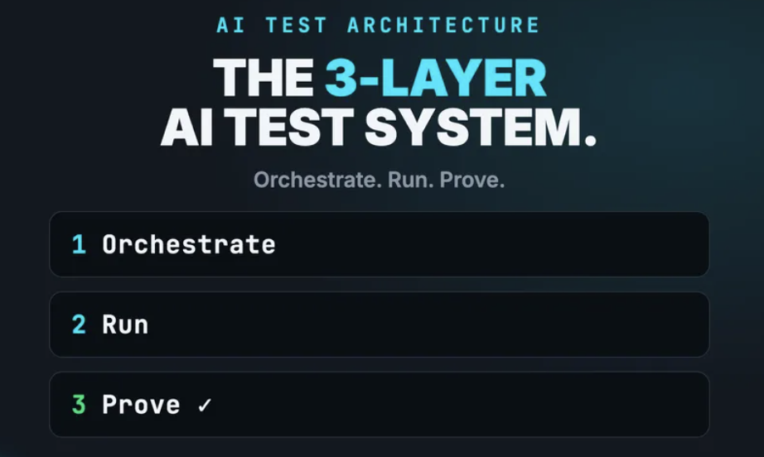

But there's a difference between "I ship Playwright frameworks with AI tools" and "I design how AI agents behave." Gulin's implementation is tools-first: MCP servers, Copilot integration, self-healing locators. It augments human testers.
What I needed was something different: agents that make decisions, with built-in guardrails, that can validate themselves.
🧠 The Lean Judgement Problem
Here's the uncomfortable truth no one talks about:
When you load a skill in OpenCode, the same model that runs the skill evaluates the skill's output.
- Nemotron writes the mutation test.
- Nemotron says it passed.
- Nemotron gives itself 9/10.
This is exactly the pattern Autonoma identified: "AI verification is only trustworthy when it is independent of the thing being verified." (#ref1)
This isn't dishonesty. It's an architectural gap. The skill-creator assumes an external judge. In production, there is none.
Minimize image

Edit image

Delete image

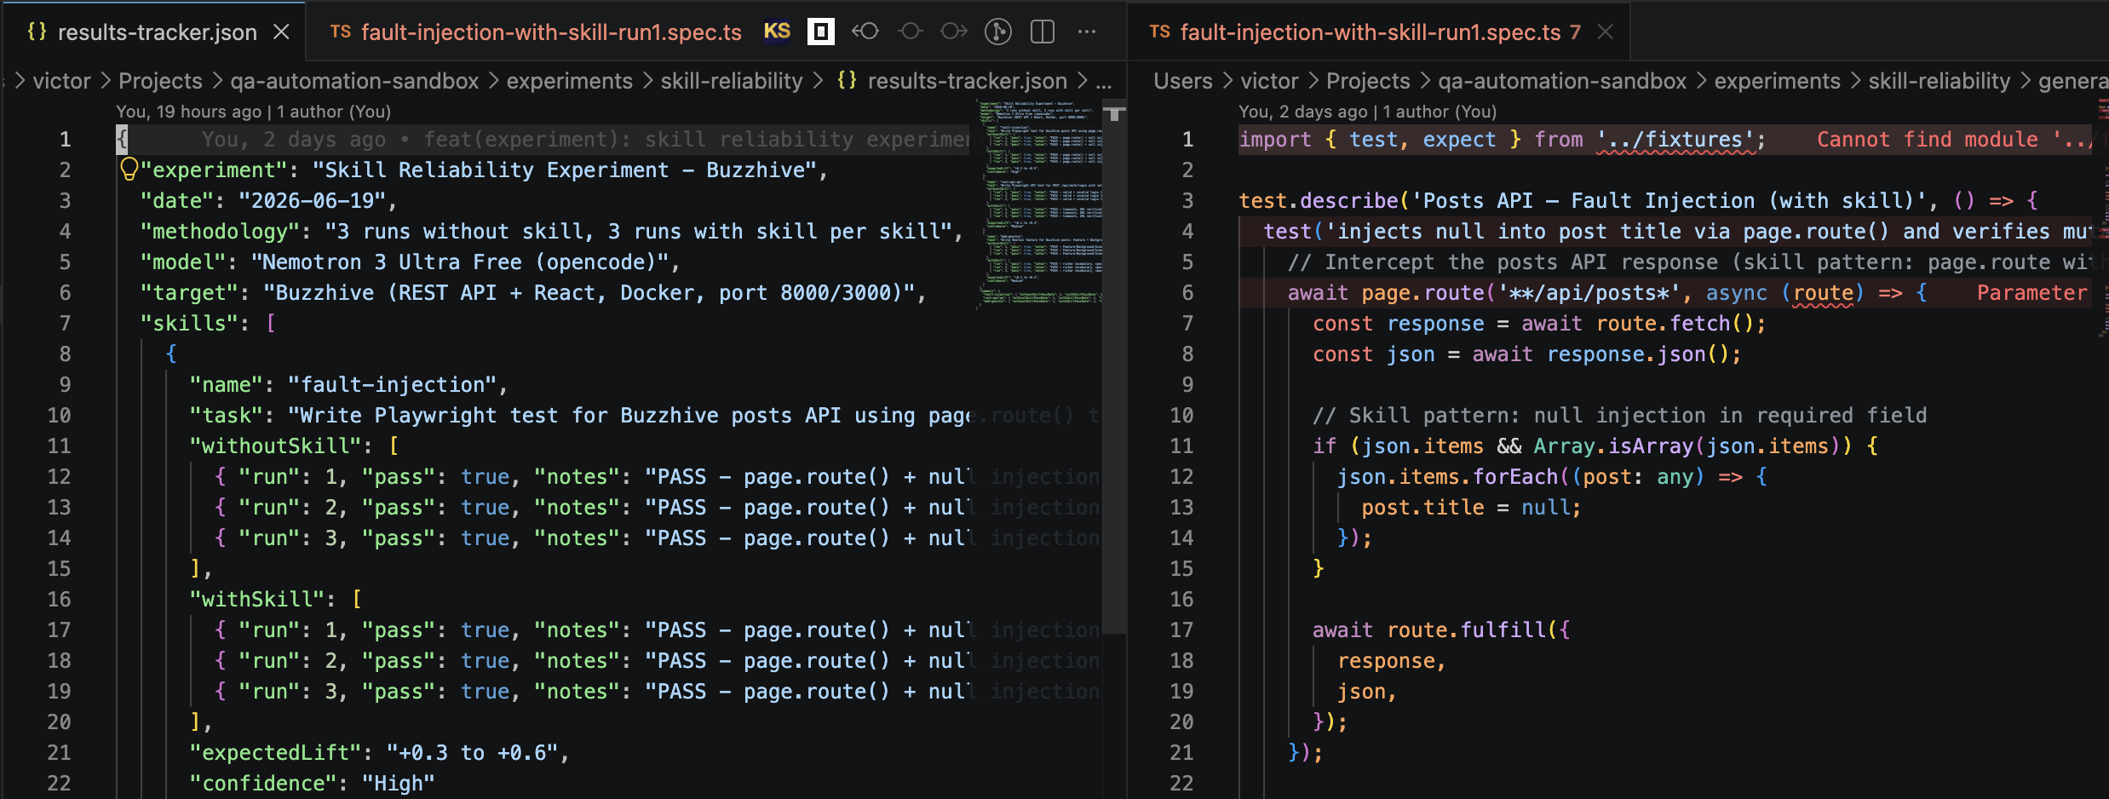

I saw this pattern across all 8 skills. Without an independent validation layer, skills produce confident garbage.
🧱 Three Layers Instead of One
Here's the architecture I ended up with — and it's nothing like the original:
Minimize image

Edit image

Delete image

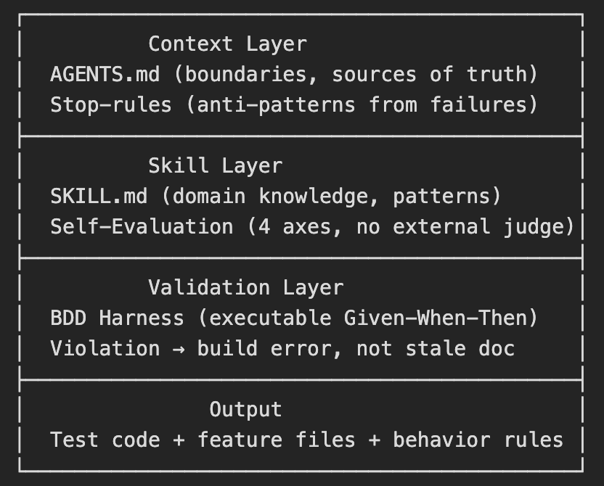

Three layers. One model. No external judge required.
🧱 Layer 1: Context (What Gulin's Model Misses)
Every skill in our stack starts with two files, not one:
𝗔𝗚𝗘𝗡𝗧𝗦.𝗺𝗱 — project-level rules: what the agent can edit, what it must ask about, what it must never touch. Sources of truth in priority order. Session procedures.
𝗦𝘁𝗼𝗽-𝗿𝘂𝗹𝗲𝘀 — borrowed from BitGN PAC1 agent's RULES.md pattern. Not "how to write a good test" but "here's what breaks every time":
- Don't take dates from files — use context.time
- Don't count through recon (truncation miscounts)
- Don't scan partial files — scan all acct_*.json
- When two docs conflict — ask, don't choose
These came from real failures. The agent learned them via a learn "..." mechanism — the same way a junior engineer learns from code review.
⚡ Layer 2: Skill + Self-Evaluation
The skill layer has domain knowledge (SKILL.md) plus something Gulin's model doesn't have: 𝗲𝗺𝗯𝗲𝗱𝗱𝗲𝗱 𝘀𝗲𝗹𝗳-𝗲𝘃𝗮𝗹𝘂𝗮𝘁𝗶𝗼𝗻 𝗮𝗰𝗿𝗼𝘀𝘀 𝟰 𝗮𝘅𝗲𝘀.
Minimize image

Edit image

Delete image

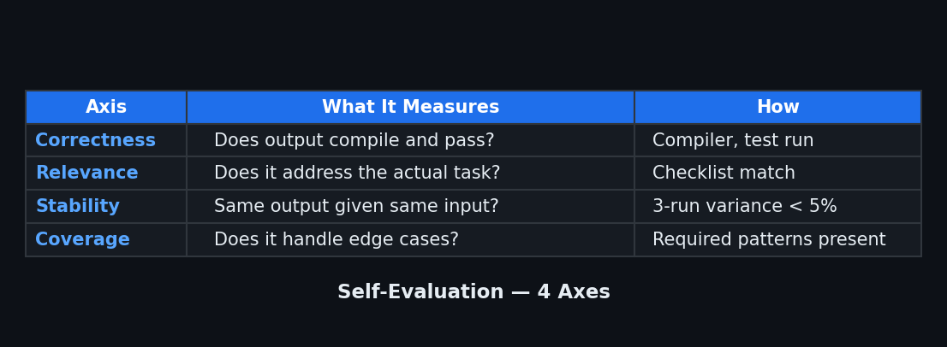

Each skill evaluates itself after generation. No external LLM. No human judge. The 4 axes are designed to catch the 4 ways skills fail in practice.
🔗 Layer 3: BDD Harness
This is the layer that makes everything executable.
AI researcher Rinat Abdullin mades the point that started this whole thread: BDD with Given-When-Then is the natural validation layer for AI-generated code. SDD (Spec-Driven Development) produces dead specs. BDD produces AI-𝗲𝘅𝗲𝗰𝘂𝘁𝗮𝗯𝗹𝗲 𝘀𝗽𝗲𝗰𝘀.
If the code violates the spec → build fails. Not "let's schedule an audit." Not "the document might be stale." The pipeline stops.
Minimize image

Edit image

Delete image

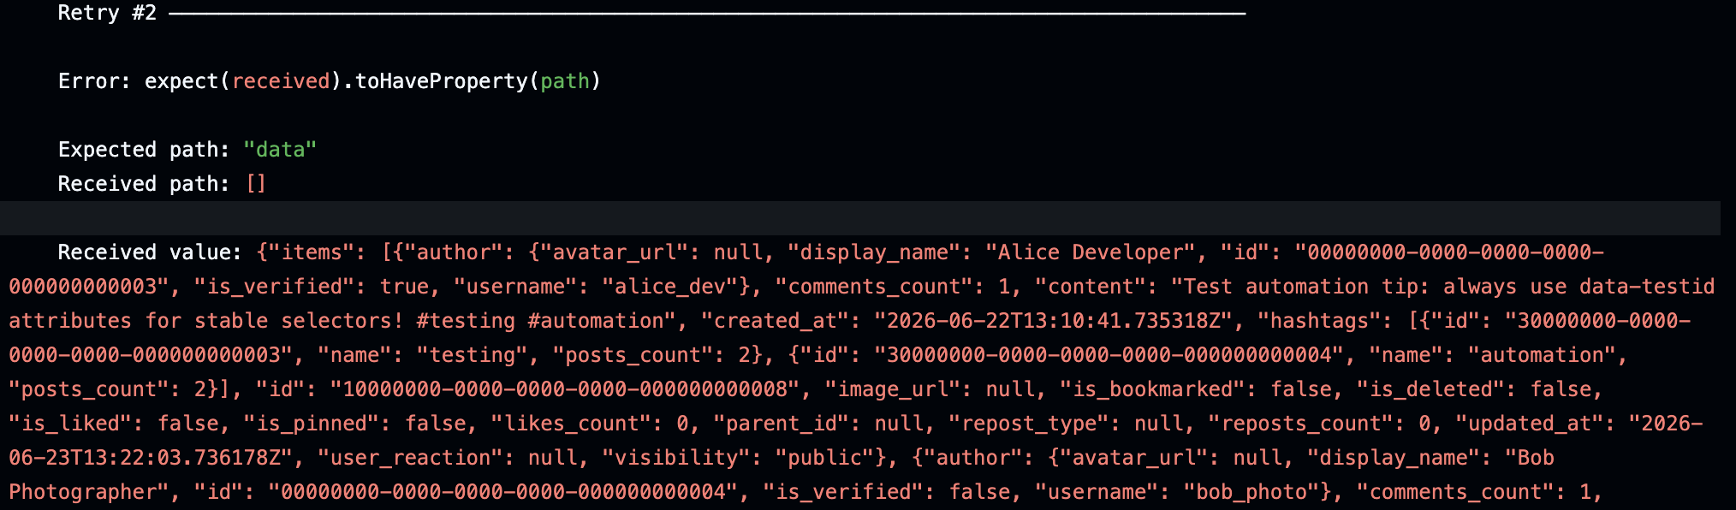

An agent can run this harness 100 times in a single session. Each run verifies that the output matches the spec. No drift. No stale documents. No confident garbage.
🏗️ From Code Generation to Behavior Design
This is the fundamental difference — and it came from an unexpected place.
AI-researcher @akoledachkin (built Magnum Studio: Jira → AI agent pipeline), put it this way:
"QA thinking is about designing agent behavior. It's the same muscle but on the other side."
He's right. Gulin treats skills as 𝗰𝗼𝗱𝗲 𝗴𝗲𝗻𝗲𝗿𝗮𝘁𝗶𝗼𝗻 𝗽𝗮𝗰𝗸𝗮𝗴𝗲𝘀: load the skill, generate a test, move on. We treat skills as 𝗮𝗴𝗲𝗻𝘁 𝗯𝗲𝗵𝗮𝘃𝗶𝗼𝗿 𝗯𝗹𝘂𝗲𝗽𝗿𝗶𝗻𝘁𝘀: load the skill, and the agent knows not just what to write, but what decisions to make, when to ask for help, and how to fail honestly.
Minimize image

Edit image

Delete image

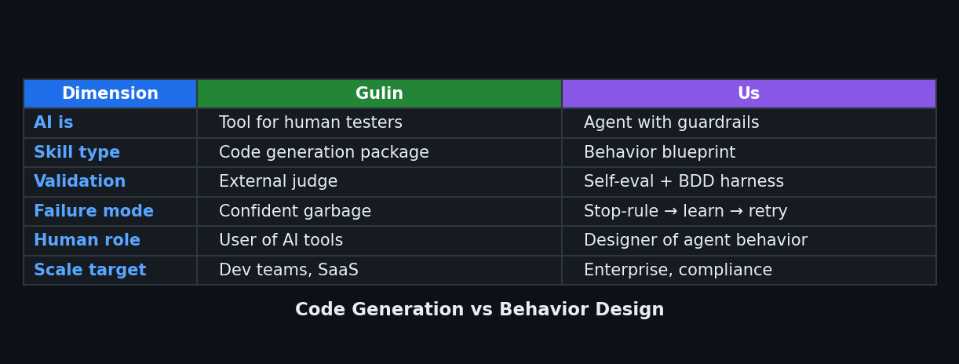

📊 The Numbers
8 skills. 4 self-evaluation axes. 6 stop-rules. All running on a single model with no external judge.
My previous article showed 0% lift on 𝗰𝗼𝗿𝗿𝗲𝗰𝘁𝗻𝗲𝘀𝘀 — skills don't help the model write more correct code on patterns it already knows. But that was the wrong metric. Skills help with 𝗰𝗼𝗻𝘀𝗶𝘀𝘁𝗲𝗻𝗰𝘆 — same patterns every time, vocabulary, hygiene. And they help with 𝗯𝗲𝗵𝗮𝘃𝗶𝗼𝗿 — what the agent does when it's uncertain, when it discovers a conflict, when it needs to fail honestly.
Gulin's skill-creator is at ★123 and growing. His approach works for teams with an external evaluation budget. For teams that need self-validating skills with enterprise guardrails — ours works.
Both approaches are valid. They solve different problems.
💬 What I'd Tell Anton
Your skill-creator is the best thing that happened to OpenCode skills. Your 3-Layer Architecture should be required reading. Your Apple story is earned, not branded.
But skills are not npm packages. They're behavior blueprints with context, self-evaluation, and executable validation.
The next evolution isn't better prompts. It's better architecture.
Which model fits your team — tools that augment human testers, or agents with built-in guardrails? Try both. The difference shows up in the second week.
References
[1] Tom Piaggio, "Mutation Testing vs Code Coverage: The Real Test-Quality Metric", Autonoma Blog, June 2026
Victor Ematin · AI Quality Engineering Lead · OpenCode Go
#TestAutomation #AIQA #AgenticTesting #Playwright #OpenCode

