MEDICAL MONITORING AND ADVANCED SENSOR DATA PROCESSING
TASK 01: TIME FREQUENCYANALYSIS
Emilio Borrelli, Victor Hug, Eva Pohlen
5-28-2025

Tasks
Q1 Consider a one-minute segment of two ECG signals, one with noise and the other without,
and for them

- Plot both signals and compute the following descriptive measures:

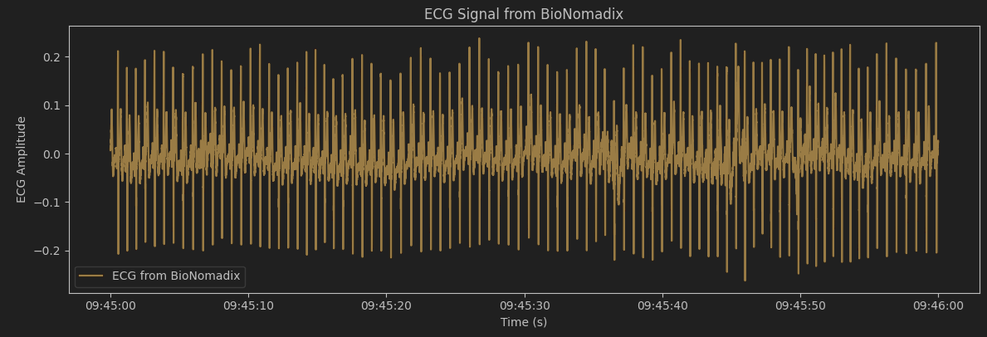
Figure 1: One-minute segment of ECG signal without added noise

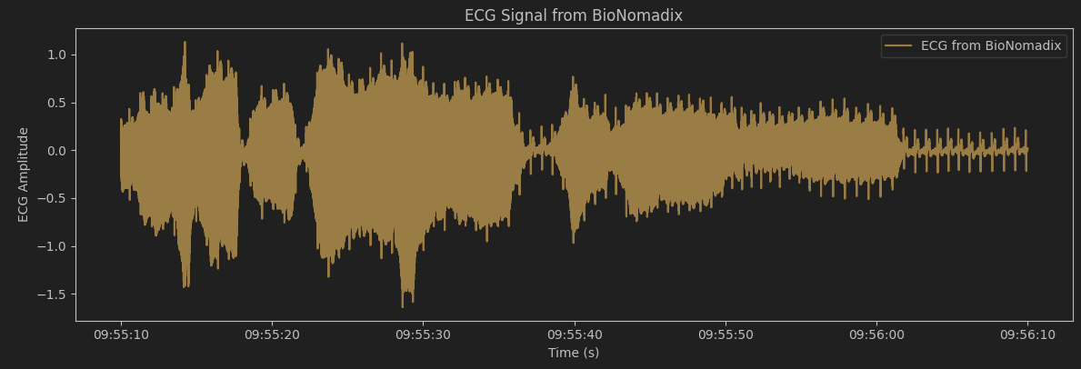
Figure 2: One-minute segment of ECG signal with added noise
 | Dataset Name | Mean | Median | Variance | Std Dev | Skewness | RMS | Zero-Crossing Rate | Energy | Power
1 | Clean BP | -0.001124 | -0.011291 | 0.002783 | 0.052757 | 0.690227 | 0.052768 | 0.0225 | 1.670717e^+02 | 2.784482e^-03
2 | Noisy BP | 0.001727 | 0.006714 | 0.135900 | 0.368646 | -0.462944 | 0.368647 | 0.0900 | 8.154151e^+03 | 1.359003e^-01

Discuss, in one paragraph, about what you observe from the descriptive measures computed from the signals with and without noise.

There are slight differences in mean and median between the clean and noisy data. More significantly though, the noisy data has a much higher variance, standard deviation, and RMS, as expected since these measures describe noise in data. The noisy data has lower positive skewness, probably because a clean ECG has positive skewness (most amplitudes that vary from the baseline are higher, not lower) and the noise added more lower amplitudes. The noisy data also has a higher zero-crossing rate, since the noise added amplitudes both higher and lower than the ground truth. We also observe higher energy and power in the noisy data.

b.

Overlapping Segments on clean ECG:
Segment | Mean | Median | Variance | Std Dev | Skewness | RMS | Zero-Crossing Rate | Energy | Power
1 | 0.001580 | -0.008545 | 0.002539 | 0.050392 | 0.765119 | 0.050414 | 0.0244 | 25.418013 | 0.002542
2 | 0.000752 | -0.009918 | 0.002645 | 0.051430 | 0.798605 | 0.051433 | 0.0199 | 26.456432 | 0.002645
3 | -0.006209 | -0.017395 | 0.002703 | 0.051989 | 0.855083 | 0.052355 | 0.0159 | 27.413609 | 0.002741
4 | -0.009176 | -0.019531 | 0.002555 | 0.050551 | 0.798503 | 0.051374 | 0.0153 | 26.395971 | 0.002639
5 | -0.001878 | -0.012360 | 0.002563 | 0.050629 | 0.808040 | 0.050662 | 0.0212 | 25.668619 | 0.002567
6 | 0.003915 | -0.005341 | 0.002565 | 0.050650 | 0.865878 | 0.050798 | 0.0303 | 25.807196 | 0.002580
7 | -0.000960 | -0.007324 | 0.002743 | 0.052372 | 0.647487 | 0.052378 | 0.0276 | 27.437615 | 0.002743
8 | -0.005093 | -0.013275 | 0.002821 | 0.053110 | 0.578511 | 0.053351 | 0.0203 | 28.466241 | 0.002846
9 | -0.000647 | -0.011139 | 0.003216 | 0.056707 | 0.545286 | 0.056708 | 0.0219 | 32.161129 | 0.003216
10 | 0.003436 | -0.004883 | 0.003393 | 0.058253 | 0.392948 | 0.058352 | 0.0262 | 34.052659 | 0.003405
11 | 0.00137 | -0.00824 | 0.002896 | 0.053813 | 0.58877 | 0.053828 | 0.024 | 28.977349 | 0.002897

Overlapping segments on noisy ECG:
Segment | Mean | Median | Variance | Std Dev | Skewness | RMS | Zero-Crossing Rate | Energy | Power
1 | -0.005123 | 0.042572 | 0.135223 | 0.367727 | -1.583331 | 0.367744 | 0.0892 | 1352.495245 | 0.135236
2 | -0.001635 | 0.065308 | 0.157946 | 0.397424 | -0.665202 | 0.397408 | 0.0992 | 1579.486693 | 0.157933
3 | 0.001202 | 0.065002 | 0.212098 | 0.460541 | -0.458970 | 0.460520 | 0.0989 | 2120.998723 | 0.212079
4 | 0.007151 | 0.028381 | 0.233814 | 0.483543 | -0.343120 | 0.483571 | 0.0972 | 2338.646717 | 0.233841
5 | 0.002909 | 0.061035 | 0.311566 | 0.558181 | -0.404182 | 0.558161 | 0.0982 | 3115.747787 | 0.311544
6 | -0.002672 | 0.105591 | 0.298978 | 0.546789 | -0.372323 | 0.546768 | 0.0999 | 2989.853058 | 0.298955
7 | 0.003540 | 0.017395 | 0.136620 | 0.369621 | -0.305735 | 0.369620 | 0.0943 | 1366.323689 | 0.136619
8 | 0.001528 | 0.015564 | 0.083000 | 0.288098 | -0.364476 | 0.288087 | 0.0944 | 830.025924 | 0.082994
9 | -0.009747 | 0.035553 | 0.104304 | 0.322962 | -0.262383 | 0.323093 | 0.1001 | 1043.993423 | 0.104389
10 | -0.001286 | -0.003510 | 0.070052 | 0.264673 | -0.200434 | 0.264663 | 0.0996 | 700.535436 | 0.070047
11 | 0.008232 | -0.016174 | 0.042147 | 0.205298 | 0.147684 | 0.205453 | 0.0997 | 422.151076 | 0.042211

Non-overlapping segments on clean ECG:
Segment | Mean | Median | Variance | Std Dev | Skewness | RMS | Zero-Crossing Rate | Energy | Power
1 | 0.001580 | -0.008545 | 0.002539 | 0.050392 | 0.765119 | 0.050414 | 0.0244 | 25.418013 | 0.002542
2 | -0.006209 | -0.017395 | 0.002703 | 0.051989 | 0.855083 | 0.052355 | 0.0159 | 27.413609 | 0.002741
3 | -0.001878 | -0.012360 | 0.002563 | 0.050629 | 0.808040 | 0.050662 | 0.0212 | 25.668619 | 0.002567
4 | -0.000960 | -0.007324 | 0.002743 | 0.052372 | 0.647487 | 0.052378 | 0.0276 | 27.437615 | 0.002743
5 | -0.000647 | -0.011139 | 0.003216 | 0.056707 | 0.545286 | 0.056708 | 0.0219 | 32.161129 | 0.003216
6 | 0.001370 | -0.008240 | 0.002896 | 0.053813 | 0.588770 | 0.053828 | 0.0240 | 28.977349 | 0.002897

Non-overlapping segments on noisy ECG:
Segment | Mean | Median | Variance | Std Dev | Skewness | RMS | Zero-Crossing Rate | Energy | Power
1 | -0.005123 | 0.042572 | 0.135223 | 0.367727 | -1.583331 | 0.367744 | 0.0892 | 1352.495245 | 0.135236
2 | 0.001202 | 0.065002 | 0.212098 | 0.460541 | -0.458970 | 0.460520 | 0.0989 | 2120.998723 | 0.212079
3 | 0.002909 | 0.061035 | 0.311566 | 0.558181 | -0.404182 | 0.558161 | 0.0982 | 3115.747787 | 0.311544
4 | 0.003540 | 0.017395 | 0.136620 | 0.369621 | -0.305735 | 0.369620 | 0.0943 | 1366.323689 | 0.136619
5 | -0.009747 | 0.035553 | 0.104304 | 0.322962 | -0.262383 | 0.323093 | 0.1001 | 1043.993423 | 0.104389
6 | 0.008232 | -0.016174 | 0.042147 | 0.205298 | 0.147684 | 0.205453 | 0.0997 | 422.151076 | 0.042211

The overlapping windows give a more fluid representation of the data. In praxis, the non-overlapping windows hold the same values, with every second window removed, since a five second overlap in each direction on a ten second window means that there is no datapoint that is not represented in two windows.

Literature
[1] 02 Monitoring fundamentals.pdf (Lecture Slides)

