MEDICAL MONITORING AND ADVANCED SENSOR DATA PROCESSING
TASK 03: REAL-WORLD DATA ACQUISITION AND HANDLING
Emilio Borrelli, Victor Hug, Eva Pohlen
7-2-2025

Tasks
Q1 Consider the data “Stairs”. Resample the smartwatch signals to 1000 Hz and
synchronize all signals using the artifact you created at the beginning of your measurement.
Cut the signals in order that it only contains the exercise. Plot the PPG (biopac), PPG
(smartwatch), ECG (biopac), Acceleration data (smartwatch) each in an own plot (4 plots) with
corresponding time axis. Mark the transition between walking and resting in your plots.

TODO: mark transitions

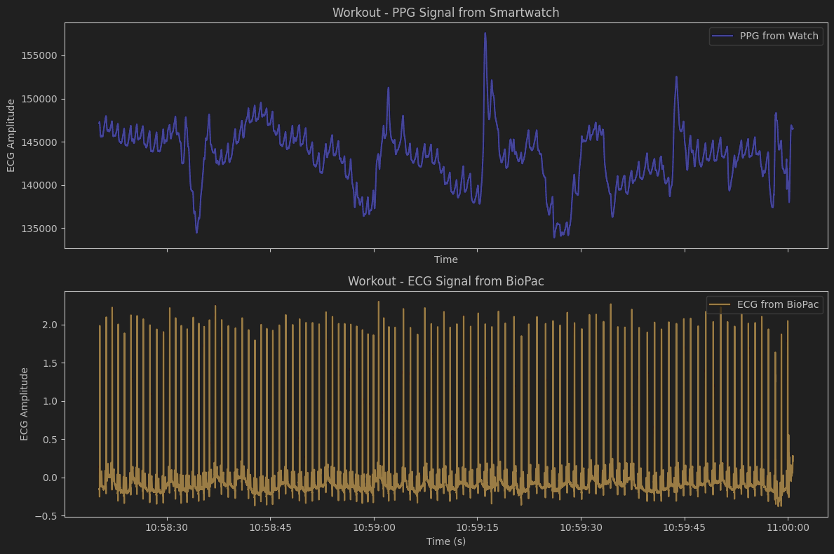
Figure 1: PPG containing only the exercise from Smartwatch (top) and ECG containing the same exercise from BioPac (bottom)

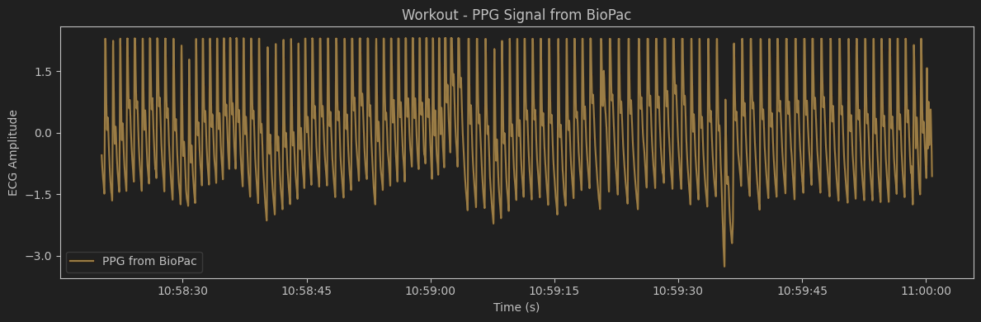
Figure 2: PPG containing only the exercise from BioPac
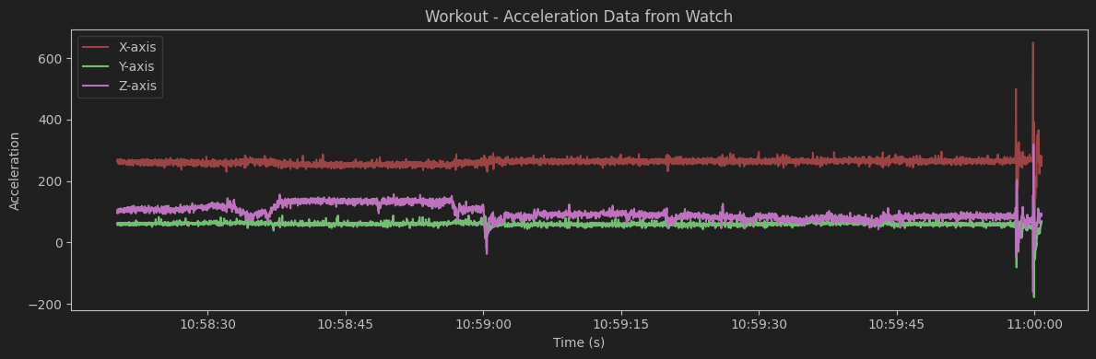
Figure 3: Acceleration Data from Smartwatch during exercise

Q2 Consider the data “Workout”. Resample the smartwatch signals to 1000 Hz
and synchronize all signals using the artifact you created at the beginning of your
measurement. Cut the signals in order that it only contains the exercise. Plot the PPG (biopac),
PPG (smartwatch), ECG (biopac), Acceleration data (smartwatch) each in an own plot (4 plots)
with corresponding time axis. Mark the transitions between exercise and resting.

TODO: mark transitions

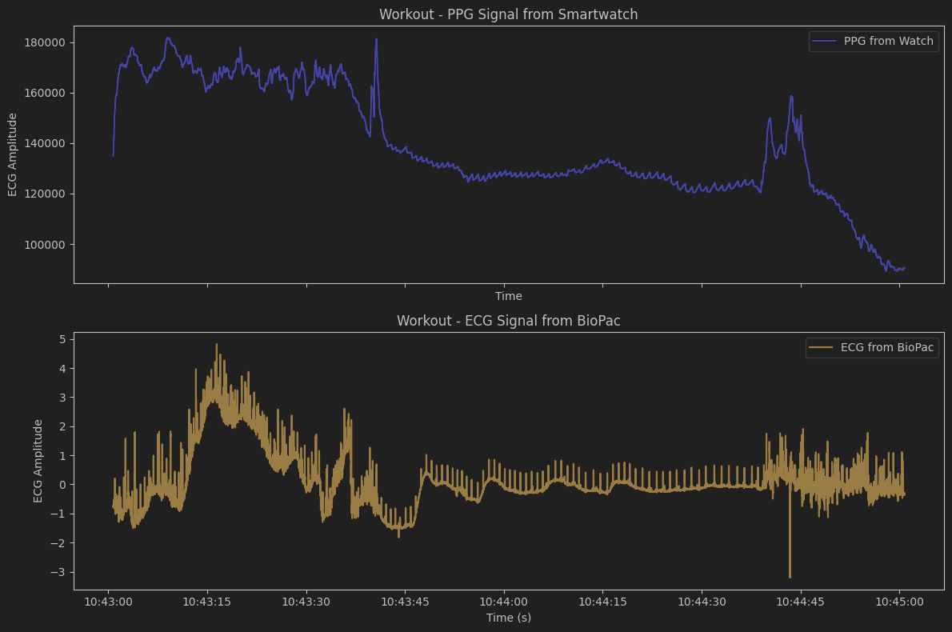
Figure 4: PPG containing only the exercise from Smartwatch (top) and ECG containing the same exercise from BioPac (bottom)

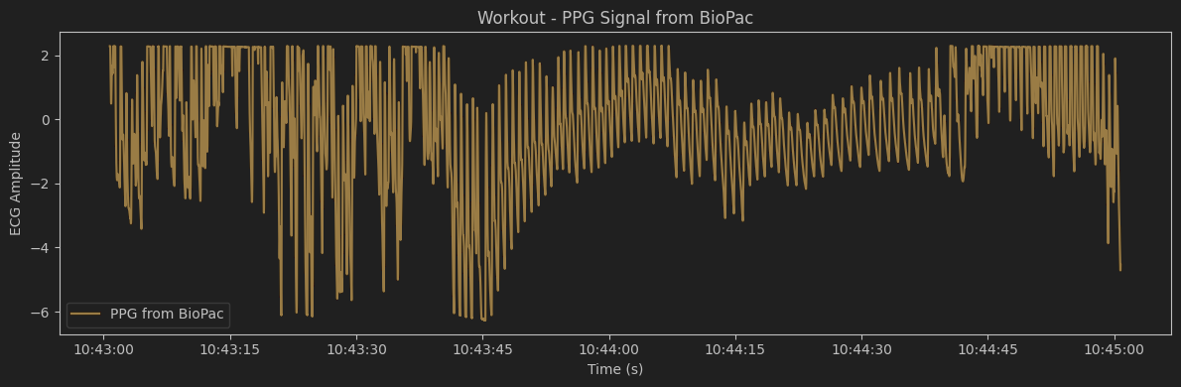
Figure 5: PPG containing only the exercise from BioPac

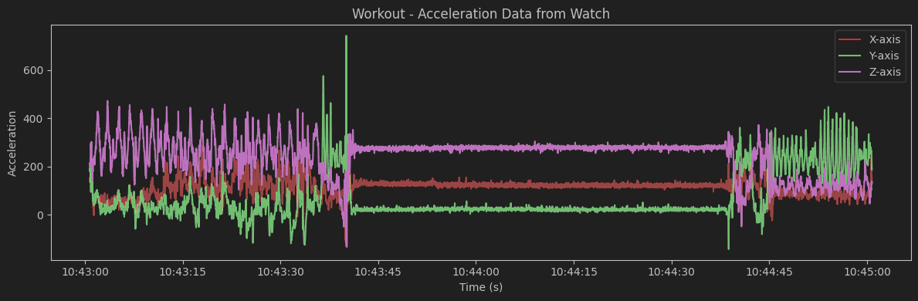Figure 6: Acceleration Data from Smartwatch during exercise

Q3 Consider the data “Stairs”. Use the neurokit2 toolbox [3] to perform R-peak
detection of the ECG.
Then calculate the instantaneous heart rate (i.e. the heart rate for each detected beat)
without (!) the help of the toolbox.
Calculate a smoothed heart rate by taking the median per 10s window sliding it by 1s and
assign the calculated value to the middle of the window. That way you have one heart rate per
second.
Plot a 20s segment of the ECG with the corresponding R-peak detections, where the detection
worked well.
Plot a 20s segment of the ECG with the corresponding R-peak detections, where the detection
was faulty.
Plot the course of the instantaneous heart rate over time together with the course of the
smoothed heart rate where you used sliding windows.
Discuss differences that occur between the two heart rates (10 sentences max)

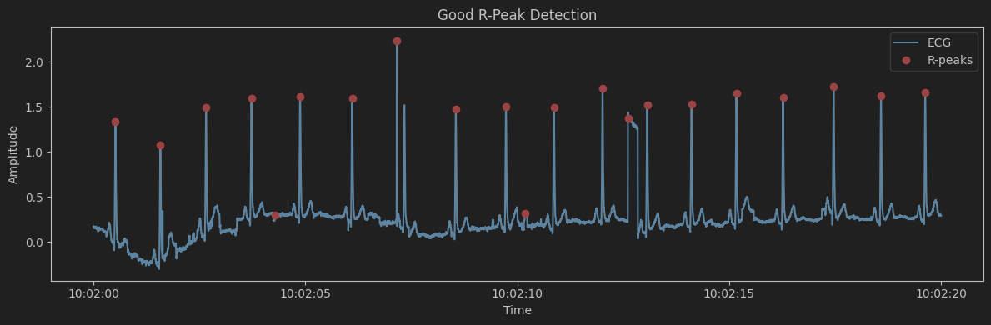
Figure 7: R-Peak Detection that worked well on BioPac ECG

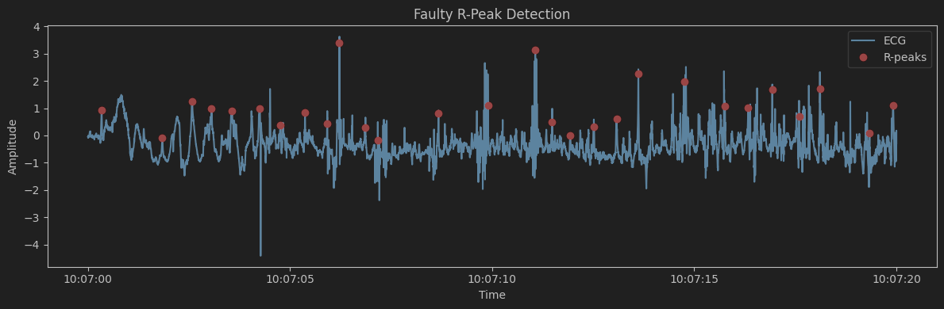
Figure 8: R-Peak Detection that worked poorly on BioPac ECG

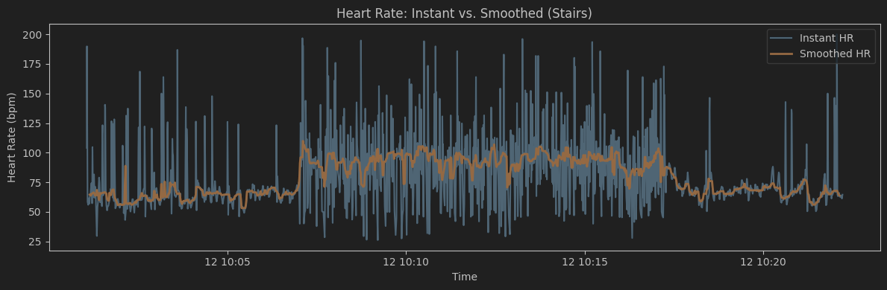
Figure 9: Derived heart rate during the exercise: instant heart rate (blue) and smoothed heart rate (orange)

The instant heart rate shows extremely sharp peaks and declines that realistically do not give meaningful information about the heart rate. For instance, at the beginning of the measurement, before the start of the exercise (during rest), the instant heart rate hits almost 200 for an instance, and drops to 30 just a few heart beats later. This is not in any way descriptive of the heart rate we want to analyze, as those peaks and drops are most likely artefacts of measuring intervals or slight irregularities in the heart rate. If two heart beats are slightly further apart than usual, but only those two heartbeats, the instant heart rate infers from that measurement that the heart rate suddenly dropped to 25 for just that one instance, which is not what happens if you consider a longer time frame. The smoothed heart rate takes the average measurements over a 10s window instead, which yields a much more reasonable representation of the heart rate. As the heart rate describes “the number of heart beats in a minute” (bpm = beats per minute), making assumptions on its value on just one instance is always going to be much further from the truth than a smoothed average, and trying to derive it in real time, beat for beat, will always yield noise above anything else.

Q4 Consider the data “Workout”. Use the neurokit2 toolbox [3] to perform R-peak
detection of the ECG.
Then calculate the heart rate for each detected beat without(!) the help of the toolbox.
Calculate a smoothed heart rate by taking the mean per 10s window sliding it by 1s and assign
the calculated value to the middle of the window. That way you have one heart rate per second.
Plot a 20s segment of the ECG with the corresponding R-peak detections, where the detection
worked well.
Plot a 20s segment of the ECG with the corresponding R-peak detections where the detection
was faulty.
Plot the course of the instantaneous heart rate over time together with the course of the
smoothed heart rate where you used sliding windows.
Do you notice any differences between the two heart rate courses?

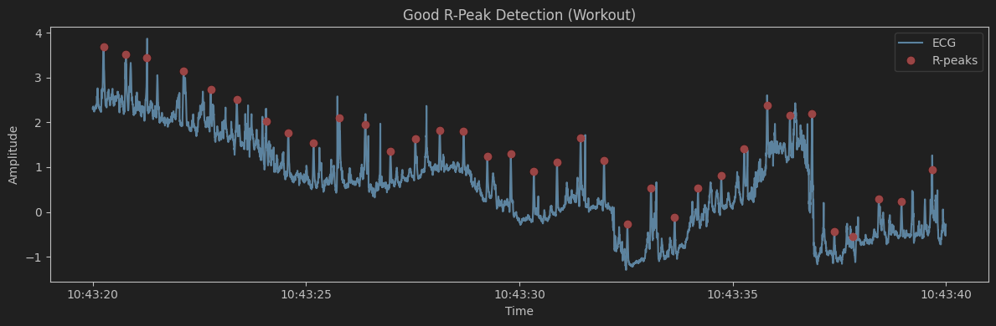
Figure 10: R-Peak Detection that worked well on BioPac ECG

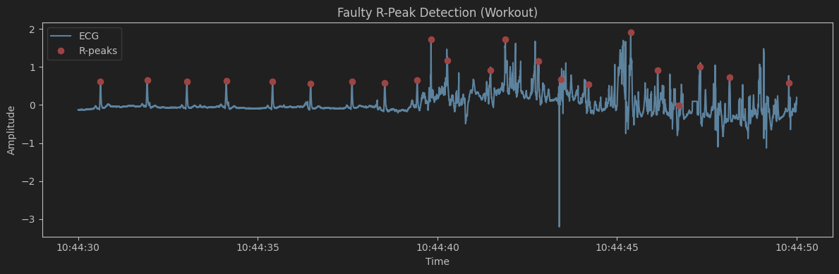
Figure 11: R-Peak Detection that worked poorly on BioPac ECG

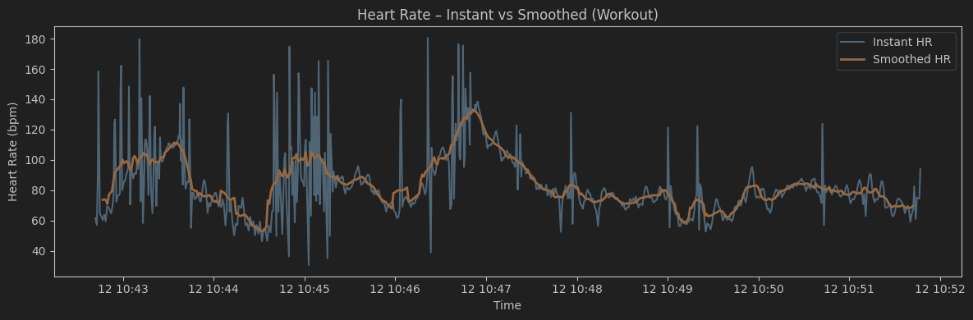
Figure 12: Derived heart rate during the exercise: instant heart rate (blue) and smoothed heart rate (orange)

The smoothed heart rate is more resistant to irregularities and therefore much more readable. It is much easier to track where the subject was doing exercises and where the subject was resting in the smoothed heart rate. Notably, periods of higher smoothed heart rates largely overlap with more sharp spikes and drops in the instant heart rate. The instant heart rate appears more irregular when the subjects heart beast faster.

Q5 Consider the data “Stairs” and use the smartwatch PPG data. Use the
neurokit2 toolbox [3] to perform PPG peak detection.
Then calculate the heart rate for each detected beat without(!) the help of the toolbox.
Calculate a smoothed heart rate by taking the mean per 10s window sliding it by 1s and assign
the calculated value to the middle of the window. That way you have one heart rate per second
starting at 5s.
Plot a 20s segment of the PPG with the corresponding beat detections, where the detection
worked well.
Plot a 20s segment of the PPG with the corresponding beat detections, where the detection
was faulty.
Plot the course of the instantaneous heart rate over time together with the course of the
smoothed heart rate where you used sliding windows.
Do you notice any differences between the two heart rate courses?

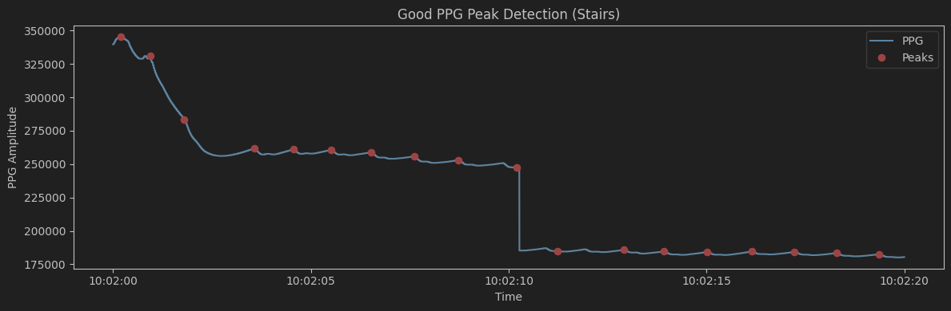
Figure 13: R-Peak Detection that worked well on Smartwatch PPG

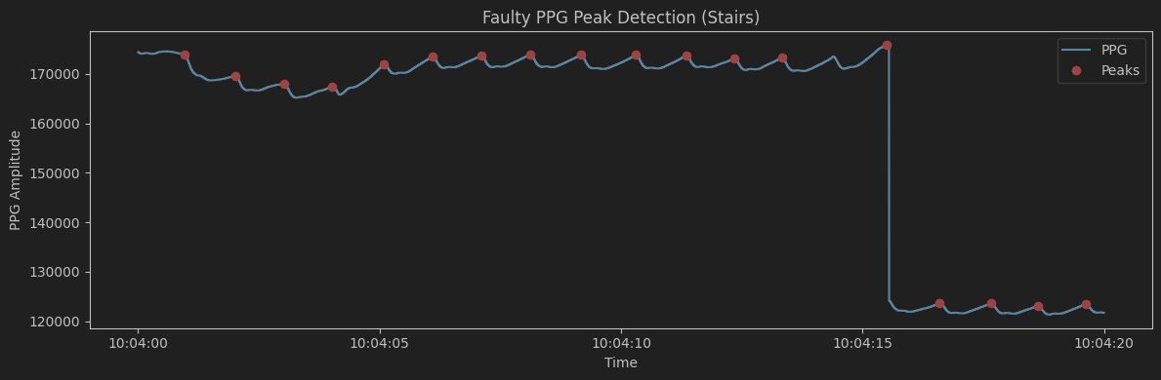
Figure 14: R-Peak Detection that worked poorly on Smartwatch PPG

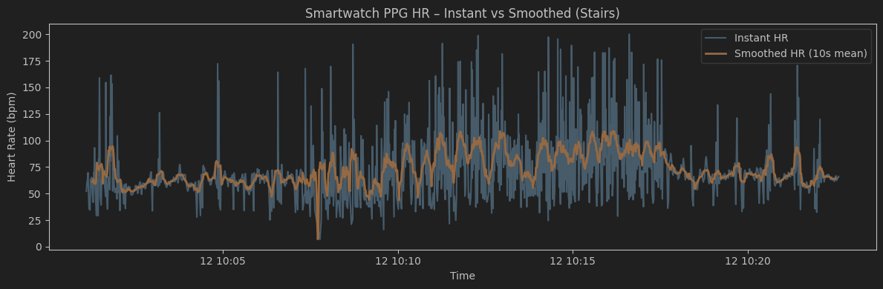
Figure 15: Heart rate during the exercise: instant heart rate (blue) and smoothed heart rate (orange)

The differences are the same as for the previous two questions. However it is notable that the subjects heart rate does not appear to rise as much as it did during this exercise when the heart rate was derived from the BioPac ECG data, and the smoothed heart rate is also much more prone to change. (Compare Figure 9)

Q6 Consider the data “Stairs” and use the biopac PPG data. Document which one
you are using in order to allocate the data to the correct tracks above. Use the neurokit2 toolbox
to perform PPG peak detection.
Then calculate the heart rate for each detected beat without (!) the help of the toolbox.
Calculate in 10s windows sliding it by 1s the mean heart rate and assign the calculated value
to the middle of the window. That way you have one heart rate per second starting at 5s.
Use the same segments as in Q5:
Plot a 20s segment of the PPG with the corresponding beat detections, where the detection
worked well.
Plot a 20s segment of the PPG with the corresponding beat detections, where the detection
was faulty.
Plot the course of the instantaneous heart rate over time together with the course of the
smoothed heart rate where you used sliding windows.
Do you notice any differences between the courses in Q5 and Q6?

TODO: Everything

Q7 Consider the smartwatch PPG and choose either “Workout” or “Stairs” data for
this Question. Document which one you are using in order to allocate the data to the correct
tracks above. Use the same 10s windows and sliding as before, but this time for each window
identify the heart rate in the frequency domain, i.e. do a fast fourier transform for heart rate
extraction. Before transforming the window into the frequency domain you should do some
preprocessing for the 10 s window (e.g. highpass filtering at a meaningful frequency (e.g. using
for example butterworth) or detrending). Then find a way to algorithmically detect the heart rate
in the spectrum and assign the detected heart rate to the middle of the window. That way you
have one heart rate per second starting at 5s. Describe how you did your preprocessing and
heartrate extraction.

TODO: Everything

Q8 Consider the ECG heart rate being ground truth. Calculate the mean absolute
error (MAE) and the Pearson correlation coefficient (only using numpy for both!) of the
smartwatch PPG HR with and without smoothing for all measurements (You have to do that
for all measurements, including those that haven’t been addressed in Q1- Q7 so far). Write
down the equations for MAE and person correlation coefficient. Also calculate the MAE and
Pearson correlation coefficient for each phase of your exercise (‘walking stairs’, ‘resting’,
12.06.2025 Task 3 – Real-world data acquisition and handling 8
‘squats’, ‘jumping jacks’, ‘rotate wrist, ‘circle arms’). Report the quantitative results as table.
Discuss the differences that might occur (one paragraph, 15 lines max).
Repeat Q8 for the biopac PPG and discuss any differences.
Add MAE and Pearson correlation coefficient for the HR extracted from the frequency domain
in your table.
Which results are the best? Discuss differences and possible reasons (one paragraph, 15 lines
max).

TODO: Everything

Q9 Do some research on Bland Altmann plots. Consider the ECG heart rate being
ground truth. Plot the biopac PPG heart rate with the ground truth as a Bland Altmann plot for
both smoothed and not smoothed heart rate and also for “Stairs” and “Workout” data (you can
choose one measurement, but document which one).
Plot the smartwatch PPG heart rate with the ground truth as a Bland Altmann plot for both
smoothed and not smoothed heart rate and also for “Stairs” and “Workout” data (you can
choose one measurement, but document which one).
Also do a Bland Altmann plot on the frequency based heart rate extraction.
Using one of your Bland Altmann plots (you choose) explain the principle of this plot. What is
seen and how can you interpret it in this context? (one paragraph, 15 lines max).
Discuss differences that might occur in the plots (one paragraph, 15 lines max).

TODO: Everything

Literature
[1] 02 Monitoring fundamentals.pdf (Lecture Slides)

