MEDICAL MONITORING AND ADVANCED SENSOR DATA PROCESSING
TASK 03: REAL-WORLD DATA ACQUISITION AND HANDLING
Emilio Borrelli, Victor Hug, Eva Pohlen
7-2-2025

Tasks
Q1 (1 Point)
a) Synchronize your signals. Detect beats in all PPG and ECG signals and calculate the
instantaneous heart rate (HR) (i.e. HR per beat) in beats per minute. Normalize the HR
signals. Use the median smoother for all HR signals.
b) For the filters you’ll need ONE signal that represents the motion of the sensor (noise).
Think about a way to combine the three acceleration channels into a single signal.
Describe how you combined the channels by equations and a short description. Then,
normalize the channel combination and each channel separately. Use your median
smoother in order to have your motion signals corresponding to your HR signals (i.e.
each s one value starting at second 5).

We used the same function that someone uses to get the distance of a vector. This gives an accurate array of distances from the point 0 in the acceleration signals. (Single Distance calculated of all 3 values)

For those who do not understand what x,y,z and c mean:
c is obviously the resulting signal
x is obviously the x acceleration signal
y is obviously the y acceleration signal
z is obviously the z acceleration signal
Duh

$$c_{i}= \sqrt{x_{i}^{2}+y_{i}^{2}+z_{i}^{2}}$$

Q2 (1.5 Points)
a) Implement a Least Mean Squares (LMS) adaptive filter on your own solely using
NumPy. Consider this task as the application of interference cancellation. What is your
“Reference Signal”? What is your “System Input”? Choose your learning rate (typically
below 0.1) and the number of filter coefficients. The equations from the lecture will help
implement the filter.
b) Filter all smoothed HR signals, denormalize (reverse your normalization) signals in
order that the HR courses and MAE are back to interpretable values, plot HR courses
in two plots, one for each measurement and calculate the MAE and Pearson correlation
coefficient for all HR and for each workout/stair phase. Collect the results in a table.
What differences do you notice? Discuss them.

a)
Reference Signal: Combined Motion Signal
System Input: ECG Smoothed HR

b)
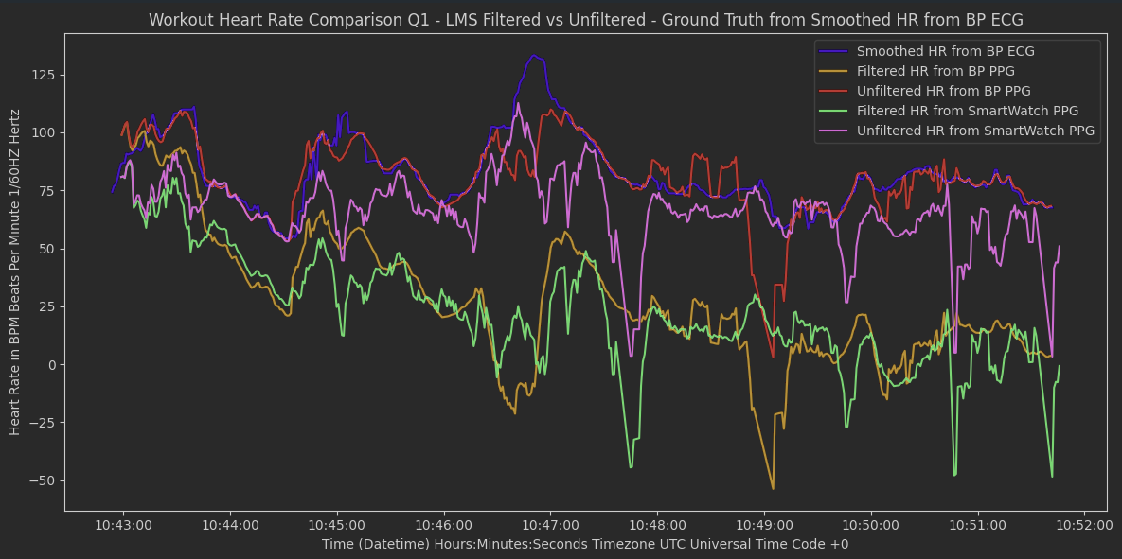

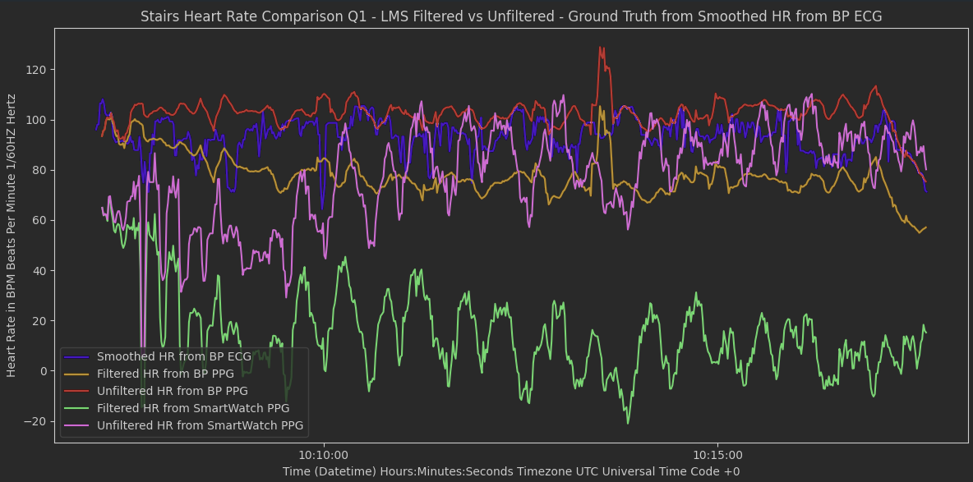

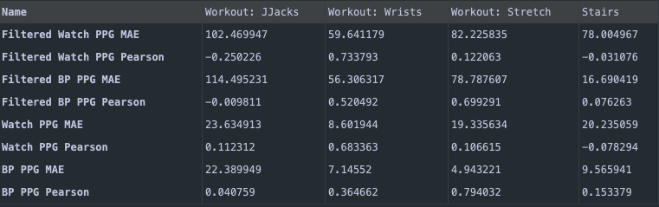

The results indicate that filtering the signals using Least Mean Squares (LMS) improves Pearson correlation values in most workout types, particularly for the Watch PPG signal (e.g., from 0.112 to 0.733 in Wrists, and from -0.250 to 0.733 in JJacks). However, Filtered MAE values remain high, especially for BP PPG, suggesting that LMS filtering repositions signals rather than smoothing out abrupt changes. This means while correlation improves, the absolute error magnitudes remain significant, as extreme and sudden fluctuations are not effectively attenuated by LMS filtering.

Q3 (1.5 Points)
a) Implement a Recursive Least Squares (RLS) adaptive filter on your own solely using
NumPy. Consider this task as the application of interference cancellation. The
equations from the lecture will help implement the filter.
b) What happens if you choose low values for the forgetting factor λ and the scaling factor
δ? What happens if you choose high values for forgetting factor λ and scaling factor δ?
Implement the filter and vary each parameter individually. Document your tests (you
don’t have to test the parameters using all data sets. Choose one) and discuss the
results.
c) Filter all smoothed HR signals, denormalize (reverse your normalization) signals in
order that the HR courses and MAE are back to interpretable values, plot HR courses
in two plots, one for each measurement and calculate the MAE and Pearson correlation
coefficient for all HR and for each workout/stair phase. Extend the table with these
results. What differences do you notice? Discuss them.

Q4 (2 Points)
a) Implement a one-dimensional Kalman filter using only NumPy. The HR is the
measurement you want to filter. You may assume that the initial uncertainty of system
P is 1 at time 0, and that the process noise Q is very low (e.g., 0.001). Your model
assumes that the HR does not change over time. Use the combined motion signal as
the measurement noise (uncertainty of measurement) R.
b) Filter all smoothed HR signals, denormalize (reverse your normalization) signals in
order that the HR courses and MAE are back to interpretable values, plot HR courses
in two plots, one for each measurement and calculate the MAE and Pearson correlation
coefficient for all HR and for each workout/stair phase. Extend the table with these
results. What differences do you notice? Discuss them.
c) Choose one signal type (Biopac or Watch) and one measurement (Workout or Stairs)
where you believe the Kalman filter performs well. Remember that you previously
combined three motion signals into one. Now, take each of the original (normalized)
motion signals individually and use them to filter the HR signal using the Kalman filter.
Next, consider a scenario where no motion signals are available. In this case, generate
a random noise signal and treat it as a substitute for the motion signal. Use it as the
measurement noise and filter the HR signal. Plot the HR signals filtered with each
individual motion signal and with the random noise, along with the corresponding ECG
signal. Then, calculate the MAE and Pearson correlation coefficient for all HR signals,
and separately for each phase. Summarize the results in a new table (it does not need
to match the previous one). What differences do you notice? Discuss your findings.
Can random noise effectively replace actual motion measurements?

Literature

[1] 02 Monitoring fundamentals.pdf (Lecture Slides)

