# Project : Transdisciplinary project S1 – Bsc Computer Science

You now have some good skills, taken independently, in the fundamentals of computer science:

* Modeling data,
* Querying data,
* Programming using python,
* Static web development.

The goal of this project is to make you use all those different skills to realize a website generator application.

# Summary

The goal of this project is to automatically build the student’s transcripts of the school management database you received from the Introduction to relational database class.

Follow the specifications precisely to implement this application.

# Specifications

## Global logic

The EPITA International Programs Staff wants to have a simple way to extract data from the School Management System application.

As it is not directly extendable (no way to modify the School Management App), some development is required to extract data from the database and to present them appropriately.

The website should have the following pages:

## Welcome page

1. Presentation of the different population lists with count of student per track
2. Presentation of overall attendance (percentage)
3. Date of the last website construction

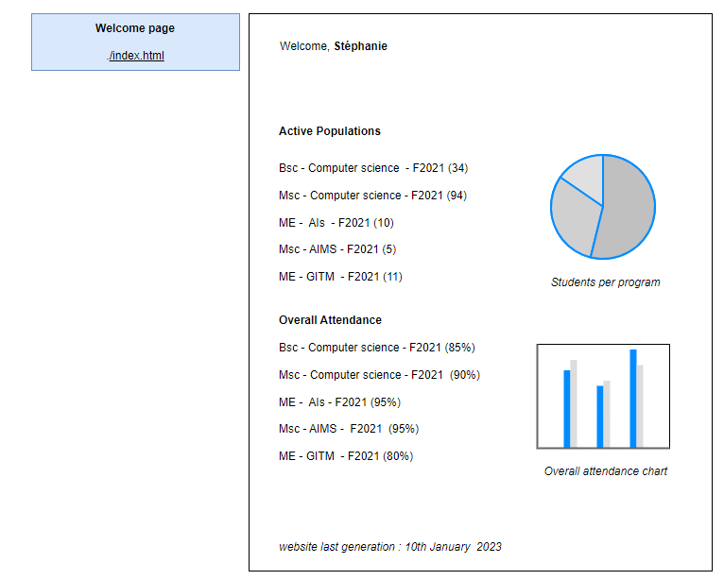

The items presented in point a. are clickable and allow to access to the specific population page. It means that your program has to generate a population page per track with the following content:

### Population page

1. Presentation of the students composing this population. For each student, there is an information of number of passing or failed courses.
2. Presentation of courses assigned to this population.

Each item listed in point b. is clickable and allows to have the grading detail for the clicked course for the population. Your program has then to generate a web page for each course grades for the given population

### Course grade page

1. List of the students with their associated grade per course

## Bonus

Generate the charts in the welcome page based on the database.

# Development Guidelines

## DR1 - Data retrieval - methodology

Prepare the queries from the database using select queries. Identify when you have counters and lists to fetch from the database.

For instance in the first page, we need to have a “group by count” to list all the populations student count.

## DR2 – Data retrieval – source code organization

* Make sure all your queries are stored under a folder,
* one query per file.
* Pay attention to the file names so that one can easily understand what is this query doing.

## HF1- Html formatting

First prepare the html and css for one population with hardcoded data, then identify where those data should be dynamically replaced by data coming from the database. When a pattern is repeated (for instance within lists), extract an html fragment which represents the repeated pattern in a dedicated file in your project.

You can use wildcards to be replaced later by real data (a common wildcard format is %key%, this value will be later replaced by a real data).

Example: course_row_fragment.html



## PY1 - Python orchestration

When database queries and html formatting are ready, you can use python to trigger those queries from your python program and then use the returned data to fill-in the required data for the current web page.

# Deliverables – PAY ATTENTION

The expected deliverables are:

* doc: The technical documentation of your project : what are the different big components you use,
* src : The complete source code of your project,
* site: The website generated by your tool.

The deliverables should be zipped and submitted through teams. The structure of your zip file should be like in the following screenshot:

If you do not enforce this layout for the submission, you will be penalized.

# Help

To connect through python to an h2 database (need to install JayDeBeApi - pip install JayDeBeApi==1.2.3)

|  |
| --- |
|  |

***Code 1****. Connect to h2 and run an SQL query*