# Social-ecological networks of perception

Rapport d’avancement, 29/07/2020

## 1. Introduction

* /Problem statement/ => Environmental issues are the result of interactions between people and natural elements and involve a wide array of actors, ecosystems, institutions, perceptions, etc. As these issues are now justifying political decisions, hence calling for inclusiveness and equity, it is necessary to be able to reveal where actors are standing in these systems in terms of resources they depend upon, perception of issues and solutions, values or aspirations for their future related to nature.
* /Research gap/ => Studies on social-ecological systems usually focus on the top down study of links between resources, users and institutions, leaving little space for actors to define their own issues while including their perception on these issues. Research on ecosystem services also tends to have a fix understanding of what can constitute benefits flowing from ecosystems to people. Culture and perceptions are often secondary in these reflections. More specifically, studies that use network analysis to study social-ecological systems, usually focus on few dimensions: for example, ecosystem services, or the links between natural resource and users.
* /Research questions/ => How can we reveal multidimensional social-ecological interactions using the perception of people? What are the similarities and differences in the perceptions of people related to shared environmental issues, and what are the implications for locally adapted decision-making? What are the links between perceived threats, solutions and values?
* /Filling the gap/ => Shark Fin Bay, Palawan, many pressures on ecosystems and high reliance on fishing, projects of MPAs and role of an NGO. Based on open-ended interviews, we map and study the perception of people on these questions using networks analysis.

## 2. Materials and methods

* /Site selection/ => Shark Fin Bay, five villages, representative of this relationship of dependence and threats to ecosystems; actions initiated by an NGO including the creation of MPAs are generating public debate.
* /Sampling/ => Open-ended interviews with random/snowball sampling. 66 respondents -> 59 people from villages and 7 scientists/decision-makers. Authorization asked beforehand to each village mayor and each respondent. Most interviews conducted in Filipino, except for people who felt more comfortable with English.
* /Data collected/ => Interviews recorded, open-ended questions in six categories: environmental issues, solutions to these issues, values associated with marine ecosystems, perception of MPAs, perception of the NGO, and perspectives for the future.
* /Analyses/ => Interviews are transcribed and translated to English. Thematic coding to extract people’s individual answers. Coded in a matrix. Bipartite networks to link each respondent with the answers he or she gave. Cluster analysis to identify groups of people + answers, groups of people and groups of answers. Quotes are extracted from interviews to support analyses and the system’s comprehension.



*Fig 1. Conceptual diagram of the method designed to build networks of perception using open-ended interviews.*

## 3. Results

=> Combining the results of networks, and quotes from interviews to respond to research questions.

* /Content of answers/ Global network provides an overview of the most common and central (hence shared) answers. It shows what matters most to respondents.
* /Groups of respondents/ Decision-makers or scientists, and people from other villages tend to be separated, meaning they gave different answers. Groups of people belonging to the same villages also tend to appear, indicating the scale of village as an important determinant of people’s perceptions, as well as actual differences in issues faced.



*Fig 2. Network representing both respondents and their replies. Respondents from Taytay and Puerto Princesa (Purple and green triangles) are decision-makers and scientists. We hence observe that Depla and Sandoval respondents tend to give close answers, and they are also more closely related to scientists and decision makers.*

* *Polarization of responses/respondents that we can split in two groups.*



*Fig 3. Network labelling most commonly given answers (degree > 30 meaning they were given by more than 15 people)*



*Fig 4. Network labelling second mostly common answers, given by between 8 and 15 people).*



*Fig 5. Network labelling least common answers, given by less than 8 people, exluding answers given by only one respondent.*

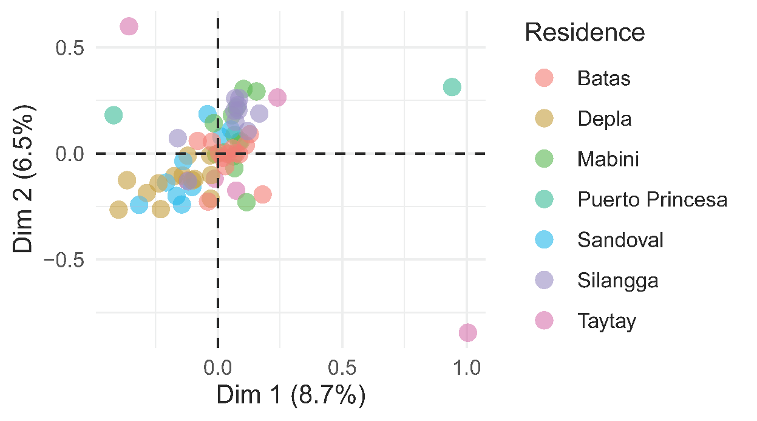

*Fig 6. Result of Multiple Correspondence Analysis (MCA) plotting individual respondents. Low % of variance explained, though some groups are still emerging. However, the group of scientists/decision makers is shown on the opposite, and not related to Sandoval and Depla. Depla and Sandoval respondents still appear to be closer to each other.*



*Fig 7. Bipartite projection linking respondents together. At the center lie the most average respondents, and on the exterior of the network, respondents giving fewer common answers. Close respondents have given close answers.*



*Fig 8. Bipartite projection linking answers together. At the center lie the most shared answers, and on the edges, answers shared by fewer common people hence more marginal. Answers with a bigger degree at the exterior are interesting as they will only be common in certain groups hence potentially conflictual or at least discerning groups. Answers at the center will be more consensual among groups.*

* *Respondents tend to give different answers depending on their village. Hence, answers that are close to each other are given by people from different villages. A bigger point located at the exterior of the network such as “Mpa_need_noidea”, or “issue_no”, or “solution_no_idea” will hence*