# Alignments and divergences between actors in defining the objectives of coastal management

**Authors:** Victor Brun, John R. Madarcos, Lota A. Creencia, Frédérique Chlous, Joachim Claudet

**Main message:**

**Abstract:**

Social and ecological interventions are being proposed to reduce the threats faced by marine ecosystems and ensure a continuity in the ocean’s contribution to human wellbeing. Many of these tools are to be implemented on a local-level with the objective to represent a “win-win” for ecosystems, local resource users and non-user residents. Making explicit the objectives of these interventions – their expected outputs both for people, nature and the interaction between the two – therefore represents a necessary yet often overlooked, constitutive element of coastal management. The Shark Fin Bay of Palawan, Philippines, is currently seeing the birth of such interventions and especially the creation of marine protected areas (MPAs). Using open-ended questionnaires, thematic coding and network analysis we demonstrate how the objectives of coastal management can be investigated based on people’s representations of: i) environmental issues, ii) solutions to these issues, iii) the contribution of marine ecosystems to their wellbeing, iv) representations of specific management tools and actors, and v) visions for the future. Specifically, we establish a narrative for these interventions’ expected inputs and outputs and show how numerous alignments should not hide some divergences in the potential objectives as stated by different actors.

## 1. Introduction

* While the well-being of any human ultimately relies on marine ecosystems, some people depend on them more directly than others, making them more vulnerable to the increasing degradation of marine ecosystems.
* A wide array of “eco-centric” and “socio-centric” interventions are being developed by a global community of scientists, practitioners, decision-makers and citizens with the objective to maintain a synergy between human well-being and the functioning of marine ecosystems.
* The diversity of global issues manifesting in a wide spectrum of local declinations has made defining these interventions’ objectives and measures of success – hence adapting them – a tremendous challenge.
* Non-governmental organizations (NGOs) are prominent actors of these interventions, and studying both the reception of their actions and their potential effects on people’s representations is often neglected, potentially undermining a proper adaptation of interventions.
* Our paper aims at participating to this “global-local” effort by demonstrating how a bottom-up narrative can be built to make explicit the expected objectives of more top-down coastal management interventions, while studying the effects of some local initiatives on people’s discourses, and potential alignments and divergences between actors.
* This study shows i) how the local definition of environmental issues and interventions can align with and diverge from global ones, ii) how specific local divergences can alter the nature of these interventions, and iii) how local interventions have themselves the potential to affect discourses and hence the objectives of coastal management as delimited by resource users.

## 2. Framework

2.1. Case study

2.2. Open-ended questionnaires

2.3. Content analysis and thematic coding

2.4. Statistical analyses

2.5. Network representation and cluster analysis

## 3. Operationalization

3.1 Themes identified & main codes: a common narrative

* 174 individual codes were identified and then grouped in 22 themes. Table 1 lists some example of codes and their classification in different overarching themes.
* A difference between few codes identified by most respondents and many marginal codes.
* A common narrative emerges: depletion of resources linked to destructive practices, for which interventions would help including social interventions and MPAs. It situates MPAs, for local people, as fishery management tools.

|  |  |  |  |
| --- | --- | --- | --- |
| **Category** | **Theme** | **Example of individual code** | **Number of respondents** |
| Issues | Depletion of resources | *An issue here is the decrease in fish stocks.* | 44 |
| Destructive fishing practices | *An issue here is illegal fishing.* | 47 |
| No issue identified | *I cannot identify any environmental or fishery issue here.* | 15 |
| Solutions | Alternative livelihoods | *A solution to environmental issues here is alternative livelihoods.* | 11 |
| No solution identified | *I cannot identify any solution for environmental issues.* | 13 |
| Socio-centric coercive intervention | *A solution to environmental issues here is patrolling.* | 17 |
| Values | Food | *The marine environment is valuable for the food it brings us.* | 35 |
| Livelihood | *The marine environment is valuable for our livelihoods.* | 50 |
| MPAs | MPAs for fish | *MPAs (can) produce benefits for fish.* | 44 |
| MPAs for local people | *MPAs (can) produce benefits for local people.* | 45 |
| MPAs for fisheries | *The goal of MPAs is to improve fisheries.* | 25 |
| MPAs as coercive instruments | *MPAs need patrolling to be efficient.* | 25 |
| Future | Alternative livelihoods | *In the future, there will be other livelihood options.* | 11 |
| Future unsustainability | *In the future, I am afraid that there are no more fish.* | 17 |

*Table 1. Examples of categories, themes and codes used to analyze the answers to open-ended questionnaires.*

3.2 Difference in discourses between people involved in the NGO’s initiatives

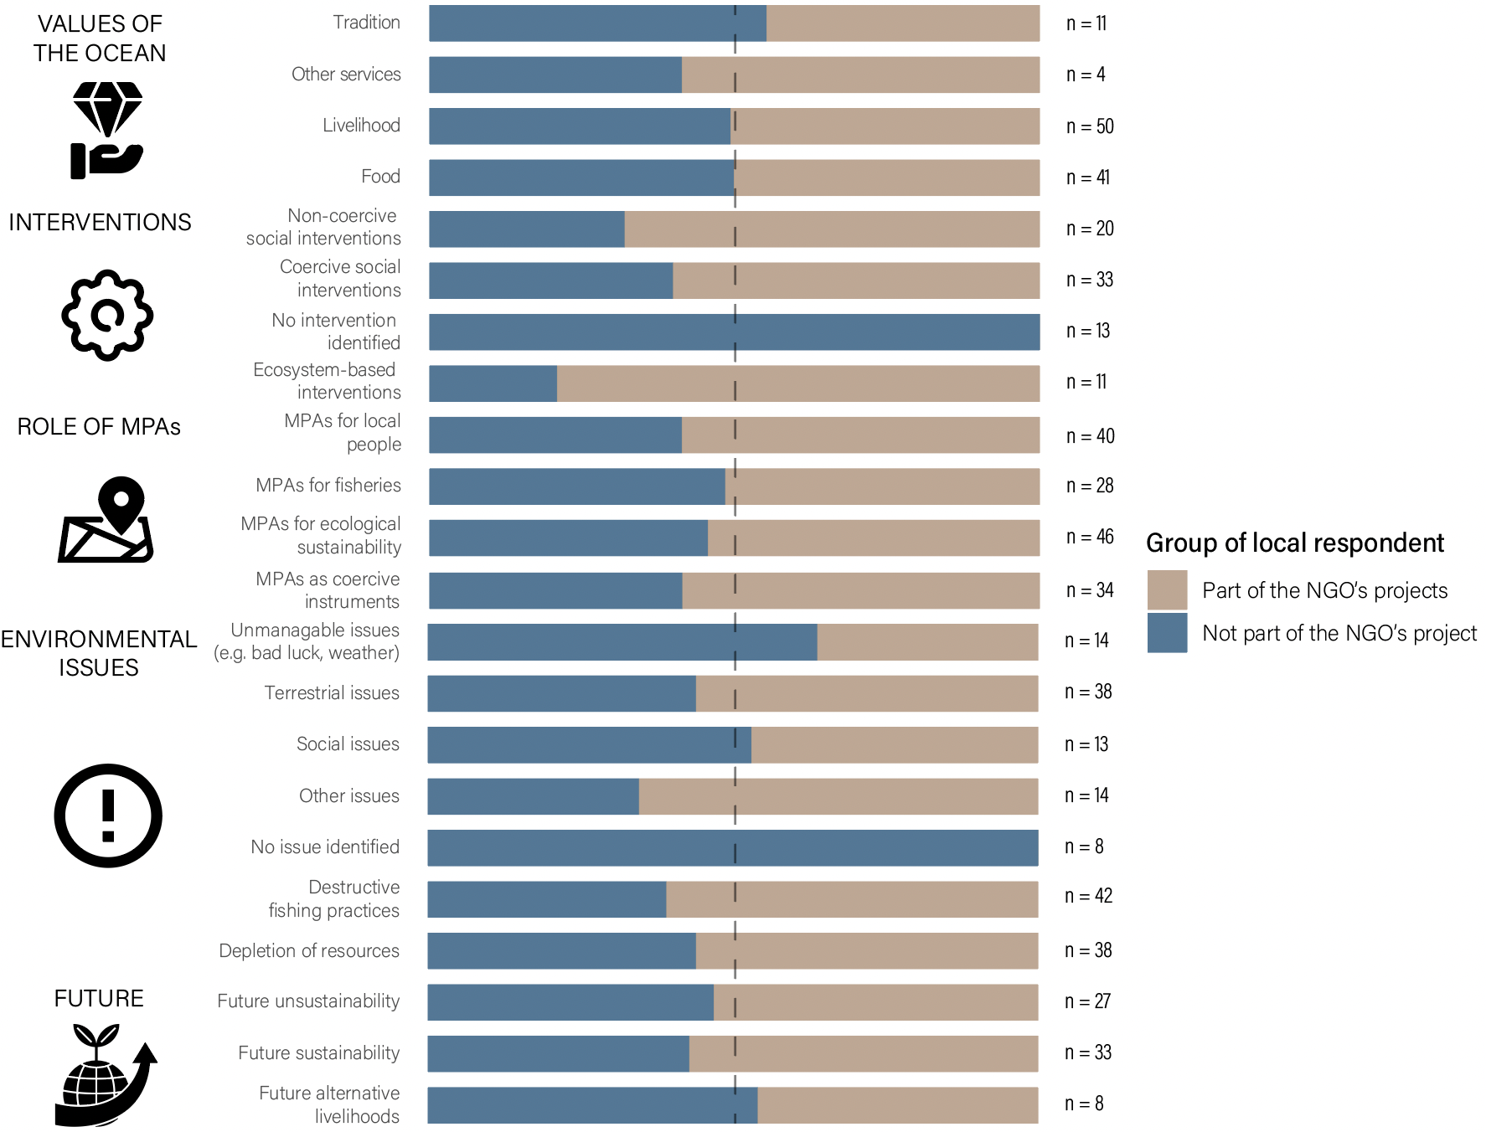

*Fig 1. Themes identified and their repartition among residents who took part to a local NGO’s project and people who did not.*

* Few differences were observed between groups of respondents, yet a somehow higher emphasis on ecosystem-based interventions, in particular MPAs.

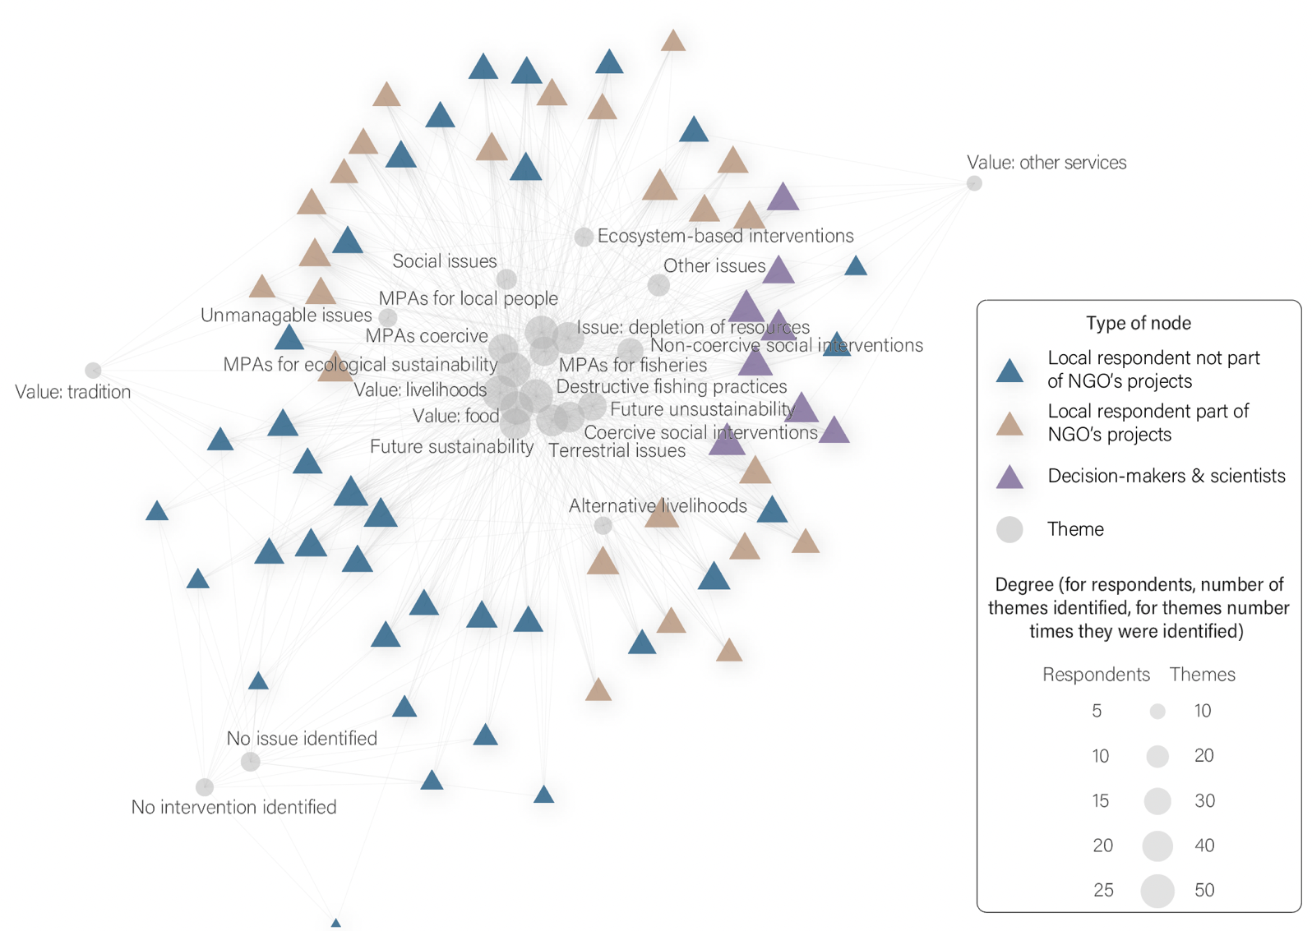

*Fig 2. Network linking respondents and the themes each of them identified. The size of each node is proportional to a) the number of themes each respondent identified, or b) the number of times each theme was identified.*

3.3 Conflicting representations among other groups

* Respondents from Silanga and Batas had different views on the role of coastal management than others: for most people in Batas, MPAs are made to expel fishermen from other areas; while in Silanga, MPAs are more designed for tourism rather than a fishery management tool.
* Scientists and decision maker have a larger vision of “ecosystem services” that is not much shared among a population emphasizing the nutrition and livelihood benefits obtained from the ocean.
* Fishers appear more supportive of MPAs as fishery management tools, particularly emphasizing the importance to protect nurseries and the benefits of adult spillover.

## 4. Discussion

4.1 Agreement on the factors of vulnerability

* The most common elements identified in the discourses of people is a narrative linked to resource depletion, which we can view similar to the narrative of vulnerability.

4.2 The influence of local context on discourse

4.3 High expectations for coastal management

## 5. Conclusion