# Implementing marine conservation: bridging local knowledge and external expertise

Other tentative titles (90 characters with spaces):

* Marine conservation: bridging local knowledge and external expertise
* Implementing sustainability: bridging local knowledge and external expertise
* Implementing marine conservation: bridging local discourse and external expertise

**Authors:** Victor Brun, John R. Madarcos, Lota A. Creencia, Frédérique Chlous, Joachim Claudet

**Abstract** (150 words)**:**

To counteract the degradation of ecosystems and their subsequent threats to human wellbeing, social-ecological interventions are pushed as “win-win” solutions for people and nature. Adapting these tools, often proposed and implemented by external actors, remains a challenge. Making explicit the objectives of these interventions – their expected outputs for people and ecosystems – also represents an often overlook necessity. Using a marine conservation project in the Philippines as a case study, we introduce a method to determine these objectives and adapt interventions to local contexts by assessing six dimensions: i) environmental well-being, ii) visions for the future, iii) environmental issues, iv) available options, v) external actors and tools, and vi) possible solutions. We demonstrate how to investigate alignments and divergences in the perceptions of these dimensions. Making a synthesis of these synergies and potential conflicts is a way to adapt the implementation of planned interventions and measure their future benefits.

## 1. Introduction (500 words)

While the well-being of people and their health ultimately rely on the health of ecosystems (Hopkins et al., 2020), fishing communities depend on the ocean more directly and vitally than others, making them particularly vulnerable to the increasing degradation of coastal habitats (Ban, 2019). Decreasing fish stocks and the effects of global warming are causing important changes to which coastal populations must adapt (Cinner et al., 2018) (Kleisner et al 2021). Other drivers, including terrestrial ones are adding to these and globally increasing (Halpern et al., 2015).

To promote the sustainability of marine social-ecological systems, management tools (thereafter termed “interventions”) are being developed by a large community of scientists, practitioners, decision-makers and citizens (Reimer et al., 2020). These interventions can be “ecocentric” and include the implementation of marine protected areas (MPAs), or “sociocentric” and include, for example, alternative livelihoods for fishers (Thiault et al., 2019). Many involve external actors pushing for the implementation of such measures and providing technical and financial assistance (REF). The “human dimension” of fisheries management is increasingly becoming a topic of attention for practitioners formerly more preoccupied by ecological concerns (Barreto et al., 2020).

With the realization that these interventions “coming from outside” must be fit with the complexity of local sustainability problems (Sterling et al., 2017) (Oldekop et al 2016), the co-construction of social-ecological interventions is proposed as a way to assess where conservation needs meet opportunities (Sykora-Bodie et al., 2021). Systematic approaches to conservation can reconcile community-based and science-based approaches to conservation (Ban et al., 2009). On the other hand, without a proper involvement local communities, external actors can fail at implementing interventions and these can result in equity issues and conflicts (Ban et al., 2019; Gill et al., 2019; Id et al., 2021).

Specifically, adapting interventions and making them relevant at their scale of implementation requires the often-neglected task to question whether or not their objectives and expected results truly fit with the social system of concerned communities, and their representations of what issues and solutions might be (Aswani et al., 2017) (Lee 2015, Melnychuk 2021). With these objectives clearly stated, only then can the outcomes of interventions be assessed. This last step also constitutes a common gap in marine conservation (Gill et al., 2019) and can only be overcome with a proper involvement of communities in the early stages of marine conservation planning.

In this paper, we present a method to investigate the implementation of conservation measures using both options made available by external actors and the discourses of local people to reveal the variety of local objectives in link with marine sustainability. We then apply this method to investigate the alignments and divergences between the perceptions of actors in a project of marine conservation implemented in the Shark Fin Bay of Palawan, Philippines.

## 2. Results

Our method, based on open-ended questionnaires, is designed to determine the objectives of social-ecological interventions and investigate their reception by local people. The following sections give details on the six dimensions this method explores: 1) environmental well-being, 2) local communities’ vision for the future, 3) environmental issues, 4) available options, 5) external interventions, 6) possible solutions (figure 1).

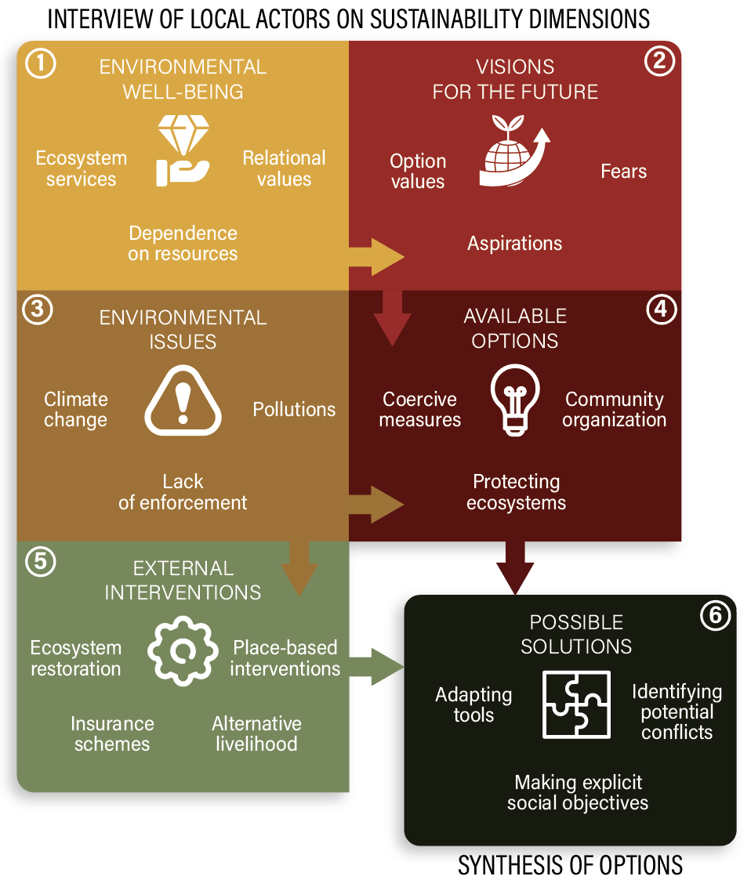

*Figure 1. Conceptual diagram representing our method designed to identify solutions to sustainability issues through the interview of diverse stakeholders on chosen themes.*

**2.1. Environmental well-being**

A first dimension to be explored is how the well-being of local communities depends on the environmental features subject to interventions (*e.g.* a forest, a watershed, particular species). How to frame these values has caused intense debate (Ishihara, 2018; Peterson et al., 2018); but the different definitions hold in common the idea that disrupting ecological processes, or managing ecosystems will in turn affect human well-being (Voyer et al 2021). Nature’s contribution to the well-being of people justifies social-ecological interventions and locates their expected social outcomes, hence constituting locally relevant goals.

Methods to investigate the contribution of ecosystems to subjective well-being include focus group discussions, semi-structured interviews, or questionnaires (Bryce et al., 2016). Here, we propose to ask people to describe in words why marine ecosystems are important to them (see the questionnaires used in Appendix).

**2.2. Visions for the future**

In a project, asking stakeholders their vision of the future is a way to reveal their objectives, expectations, and fears (Wiek & Iwaniec, 2014). When it comes to sustainability issues, these questions are particularly important: they aim at revealing individual and collective goals, as well as predictions about potential ways forward: these are hence both ends and means. In visioning exercises, participants are defining an end-goal and use step-by-step approaches to reveal possible ways to reach this goal.

**2.3. Environmental issues**

The term « environmental issues » is large and its meaning can vary between cultures and knowledge systems. By employing it, we precisely aim at collecting a wide range of information on what different stakeholders consider as an issue to the environment and the resources on which they depend. Interventions are meant to target particular problems, specific issues; questioning if what people consider as an issue fits their perimeter of action is a way to ensure that no one expects more than what is possible, or that potential benefits are not ignored. For instance, the ability of MPAs to prevent coral bleaching has been questioned (Bruno et al., 2018). People expecting them as a protection against warming temperatures could potentially be disappointed in the future and a well thought project lose its credibility.

**2.4. Available options**

We call « available options » what different stakeholders can bring up in the discussion as a solution to the environmental issues designated. Once they have identified a range of issues, we can then question them on the solutions they imagine are possible. If external interventions are planned, this is a way to ensure people bring them in the discussion and consider them as viable options. It also gives the opportunity to describe stakeholder’s understanding of these interventions and refine their objectives (Pajaro et al., 2010).

**2.5. External interventions**

External interventions are the ones promoted by actors external to the system studied; in our case study, an NGO promoting the creation of MPAs. What is “internal” or “external” can be subject to debate and could also be seen as a continuous scale with resource users being considered the closest groups to the implementation measures, and national agencies, scientists, and NGOs being the most external groups involved. In the middle we could find provincial or municipal authorities, or residents of nearby villages.

Understanding how people perceive these proposed or implemented interventions allows to directly question potential oppositions and conflicts, as well as refining what is held as an objective by implementation bodies. In the case of an MPA, we know that many objectives would be proposed, such as improving the ecological resilience or promoting eco-tourism (REF). Depending on the cases, though, we can imagine that few only of these will be relevant to local communities (REF).

**2.6. Possible solutions**

Building on the five precedent dimensions, the last step is to integrate these results and build a narrative for conservation. This narrative should include present objectives, future ones, means, actors, and consider potential conflicts. As we will discuss in our case study, we must note that this narrative has the potential to evolve and should hence be questioned regularly to promote adaptive management (REF).

Different visions should not always mean potential conflicts, but they should always be examined to stay assured that different objectives are compatible. For instance, if a group of actors values a project of fishery management to improve ecological resilience, and another group values it for its potential to increase catch, these divergent views are compatible and should not bring conflict. However, if the second group considers this project as potentially harmful to local fisheries, when the first argues it will benefit them, conflict might arise when it is time for implementing the measures. In this case, the implementation bodies should hold back and open discussions to understand the actual content of these divergences.

The method we propose is therefore exploratory and should guide later decision stages that would otherwise be potentially disorganized and blind. The way we chose to synthetize these results is to examine both alignments, building a shared narrative for these objectives, and divergences, pushing for further discussions between actors based on their potential conflicting visions.

## 3. Case-study: creating a network of marine protected areas in Palawan, Philippines

In Palawan, as elsewhere in the Philippines and South-East Asia, most of the population is coastal and depends on decreasing fish coral reefs for their nutritional security and livelihoods (Cabral & Geronimo, 2018). To prevent the depletion of coastal resources, administrations and non-governmental organizations (NGOs) have long promoted the implementation of local fishery management tools. Among these, community-based marine protected areas (MPAs) have long been presented as particularly relevant, benefitting both coastal ecosystems and fishers (Alcala, 1998). Projects in the Philippines are usually initiated by NGOs in partnership with local governments.

The Shark Fin Bay of Palawan hosts five coastal villages where fishing is with farming the main livelihood, and an NGO, the Sulubaai Environmental Foundation (SEF). SEF has been active in the area since 2011 and already promoted the creation of an MPA in 2017. It then started a “Sea Academy” project promoting the creation of MPAs, environmental education in schools, alternative livelihoods and activities of ecological restoration.

Using open-ended questionnaires, we investigated the discourses of 66 local people, decision-makers and scientists pertaining to local sustainability issues. After a content analysis, 174 individual answers were identified as codes and grouped in 21 themes (see details of thematic coding in Appendix). We summarized them using a network approach (figure 2) and analyzed the differences in answers between local people part of the NGO’s project and those of neighbor villages who had never heard of the NGO (figure 3) in order to study potential differences in their discourses. (We present these results in three sub-sections: first, alignments, the themes on which stakeholders usually agreed. Second, divergences, those where there seem to be potential conflicts of vision. Third, we present the differences in the discourses of people part of the project and those who have not taken part in activities yet.)

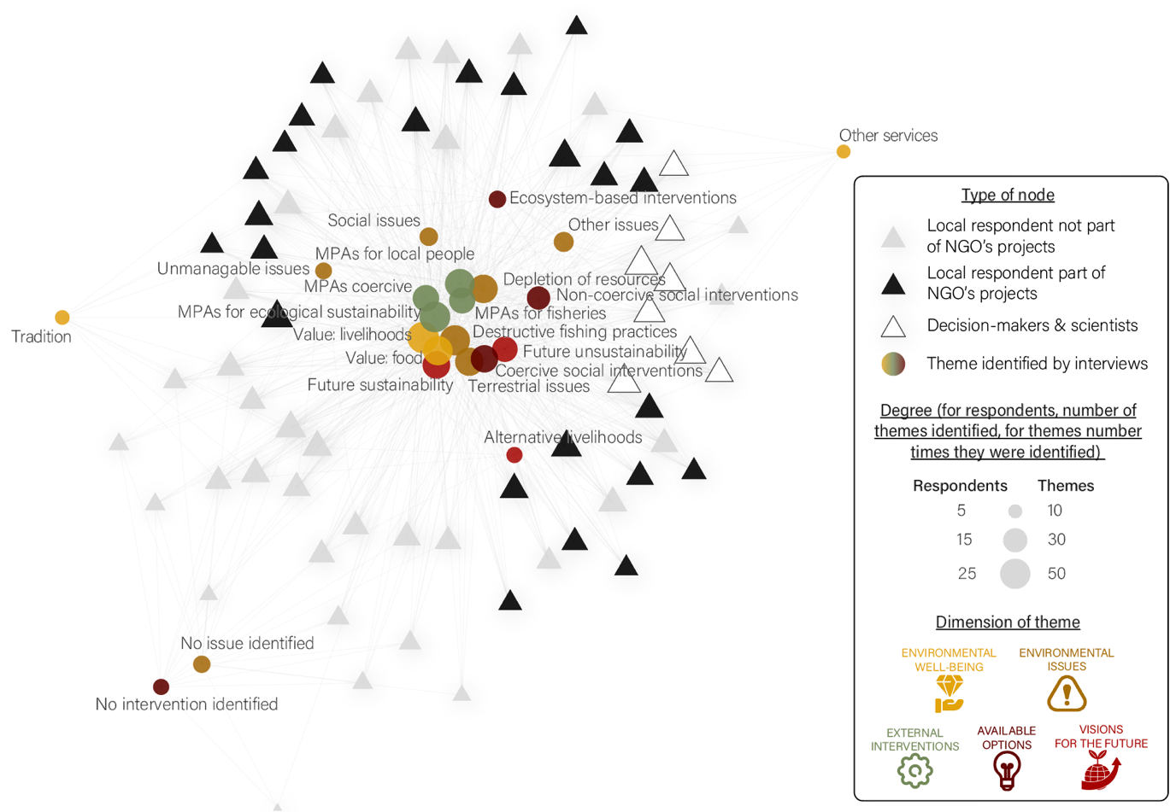

*Figure 2. Network linking respondents to the different themes they identified. Most themes identified, and the most commonly identified ones appear central. Some themes appear on the network’s edge: this shows they were more marginally chosen and can help identify groups of respondents. We can also observe the relative position of respondents’ groups: here, local people tend to be closer to the perceptions of decision-makers and scientists when they were involved in the NGO’s projects.*

**3.1. Alignments: when stakes and objectives meet**

Most themes identified were shared among stakeholders (figure 2). Using them, we can build a general narrative for the Shark Fin Bay’s conservation project. The most central values identified were the contribution of marine ecosystem to people’s food and livelihood security. It contextualizes the need for conservation that should therefore be targeted to people’s nutrition and income through the activity of fishing; it also demonstrates the central position fishers should occupy in such a project. Their views of the future were varied and consisted mainly of fears of future unsustainability (*e.g.* the depletion of fish stocks), ideas for a sustainable future, and hope for the next generation. Then, respondents aligned on the issues they identified: mostly, a depletion of marine resources linked to overfishing and illegal activities – blast and cyanide fishing remain frequent practices in the region (Hampton-Smith et al., 2021). The interventions proposed also generally aligned with planned ones and mainly consisted of ecosystem-based measures (*e.g.* MPAs), coercive (*e.g.* improve patrolling) and non-coercive socio-centric ones (*e.g.* alternative livelihoods). Respondents insisted on the role of MPAs both for ecological sustainability – with a strong emphasis on the importance to protect nursery grounds – and for their potential benefits to local people. Many of them showed a feeling of ownership to their fishing grounds, and described MPAs as “made for local people”.

**3.2. Divergences: compatibilities or potential conflicts?**

Respondents who identified a lot of themes displayed discourses close from the ones of scientists and decision-makers. On the other hand, respondents who had less interaction with the local NGO identified less themes. An important divergence hence came from people who did not identify any issue or intervention. There should therefore be further discussions to understand if respondents that did not identify any issue would agree with others talking for instance about illegal fishing. In this project, such discussions occurred during local public hearings for the designation of MPAs (authors’ personal observations). Some respondents also argued others could avoid talking about illegal fishing because of a personal involvement in such activities.

The second main set of divergences were found in the definition of what MPAs are and their objectives. Most respondents conceptualized them as fishery management tools, made to replenish fishing grounds through spillover. However, two villages showed significant exceptions. First, several respondents from Batas stated MPAs are made only to restrict outsiders from fishing, hence allowing local fishing in their sanctuary. Second, respondents from Silanga stated that MPAs were “made for tourists” and did not consider any potential benefits for fishing and non-fishing local people; this could be explained by the presence of nearby private MPAs created by island-resorts.

**3.3. The potential influence of external actors on discourses**

Observing local stakeholders describing sustainability issues in a way closer to scientists and decision-makers when they were involved in projects of SEF should question us on how external actors can shape discourses and the implication in can have. In other contexts, explicit education and awareness rising campaigns had similar effects (REF). While it is common knowledge that converging positive perceptions of management tools can improve their efficiency (REF), these campaigns should always be made in ethical ways and follow existing local norms and values.

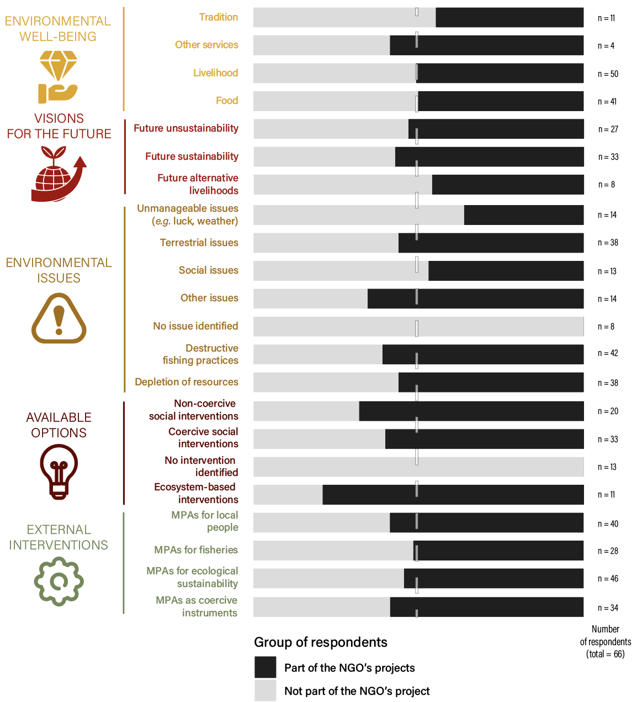

*Figure 3. Differences in the perceptions of local people depending on their knowledge of the NGO, considered as a proxy to measure if they have been involved in its early projects*

## 4. Discussion

* Our questionnaire was deliberately set from the side of intervention planned; the side of conservation. The reason was that interventions were already planned, and we wanted to understand how people were responding. If possible, interventions should include discussions with stakeholders prior to deciding implementation and designing tools, in order to leave more freedom for people to express their worldviews.
* This should be placed under a reflection of what it means for NGOs to disseminate knowledge and worldviews.
* Questions of scale between values, where should decisions be made, who is inside a system or external? Who do marine resources belong to?
* Not identifying issues when other respondents tend to agree => not thinking about them, ignoring them, protecting oneself (dynamite fishing), or having a completely different vision and maybe different use of ecosystems.

## 5. Methods

5.1 Study site

5.2 Open-ended questionnaire

5.3 Content analysis

5.4 Network representation

## Bibliography

Alcala, A. C. (1998). Community-based coastal resource management in the Philippines: a case study. *Ocean & Coastal Management*, *38*, 179–186.

Aswani, S., Albert, S., & Love, M. (2017). One size does not fit all: Critical insights for effective community-based resource management in Melanesia. *Marine Policy*, *81*(March), 381–391. https://doi.org/10.1016/j.marpol.2017.03.041

Ban, N. C. (2019). Fishing communities at risk. *Nature Climate Change*, *9*(7), 501–502. https://doi.org/10.1038/s41558-019-0506-9

Ban, N. C., Gurney, G. G., Marshall, N. A., Whitney, C. K., Mills, M., Gelcich, S., Bennett, N. J., Meehan, M. C., Butler, C., Ban, S., Tran, T. C., Cox, M. E., & Breslow, S. J. (2019). Well-being outcomes of marine protected areas. *Nature Sustainability*, *2*(6), 524–532. https://doi.org/10.1038/s41893-019-0306-2

Ban, N. C., Picard, C. R., & Vincent, A. C. J. (2009). Comparing and integrating community-based and science-based approaches to prioritizing marine areas for protection. *Conservation Biology*, *23*(4), 899–910. https://doi.org/10.1111/j.1523-1739.2009.01185.x

Barreto, G. C., Di Domenico, M., & Medeiros, R. P. (2020). Human dimensions of marine protected areas and small-scale fisheries management: A review of the interpretations. *Marine Policy*, *119*(June), 104040. https://doi.org/10.1016/j.marpol.2020.104040

Bruno, J. F., Isabelle, M. C., & Toth, L. T. (2018). Climate Change, Coral Loss, and the Curious Case of the Parrotfish Paradigm: Why Don’t Marine Protected Areas Improve Reef Resilience ? *Annual Review of Marine Science*, *11*(August), 14.1-14.28. https://doi.org/10.1146/annurev-marine-010318-095300

Bryce, R., Irvine, K. N., Church, A., Fish, R., & Ranger, S. (2016). Subjective well-being indicators for large-scale assessment of cultural ecosystem services. *Ecosystem Services*, *21*(July), 258–269. https://doi.org/10.1016/j.ecoser.2016.07.015

Cabral, R. B., & Geronimo, R. C. (2018). How important are coral reefs to food security in the Philippines? Diving deeper than national aggregates and averages. *Marine Policy*, *91*(December 2017), 136–141. https://doi.org/10.1016/j.marpol.2018.02.007

Cinner, J. E., Adger, W. N., Allison, E. H., Barnes, M. L., Brown, K., Cohen, P. J., Gelcich, S., Hicks, C. C., Hughes, T. P., Lau, J., Marshall, N. A., & Morrison, T. H. (2018). Building adaptive capacity to climate change in tropical coastal communities. *Nature Climate Change*, *8*(2), 117–123. https://doi.org/10.1038/s41558-017-0065-x

Gill, D. A., Cheng, S. H., Glew, L., Aigner, E., Bennett, N. J., & Mascia, M. B. (2019). Social Synergies, Tradeoffs, and Equity in Marine Conservation Impacts. *Annual Review of Environment and Resources*, *44*(1), 347–372. https://doi.org/10.1146/annurev-environ-110718-032344

Halpern, B. S., Frazier, M., Potapenko, J., Casey, K. S., Koenig, K., Longo, C., Lowndes, J. S., Rockwood, R. C., Selig, E. R., Selkoe, K. A., & Walbridge, S. (2015). Spatial and temporal changes in cumulative human impacts on the world’s ocean. *Nature Communications*, *6*(May), 1–7. https://doi.org/10.1038/ncomms8615

Hampton-Smith, M., Bower, D. S., & Mika, S. (2021). A review of the current global status of blast fishing: Causes, implications and solutions. *Biological Conservation*, *262*(August), 109307. https://doi.org/10.1016/j.biocon.2021.109307

Hopkins, S. R., Sokolow, S. H., Buck, J. C., De Leo, G. A., Jones, I. J., Kwong, L. H., LeBoa, C., Lund, A. J., MacDonald, A. J., Nova, N., Olson, S. H., Peel, A. J., Wood, C. L., & Lafferty, K. D. (2020). How to identify win–win interventions that benefit human health and conservation. *Nature Sustainability*, *4*(April). https://doi.org/10.1038/s41893-020-00640-z

Id, S. E., Hausner, V. H., Gurney, G. G., Broderstad, E. G., Keller, R., Kristine, A., Id, L., Javier, F., Murguzur, A., Salminen, E., Raymond, C. M., Falk-andersson, J., & Fauchald, P. (2021). *Blue justice : A survey for eliciting perceptions of environmental justice among coastal planners ’ and small-scale fishers in Northern-*. 1–20. https://doi.org/10.1371/journal.pone.0251467

Ishihara, H. (2018). Relational values from a cultural valuation perspective: how can sociology contribute to the evaluation of ecosystem services? *Current Opinion in Environmental Sustainability*, *35*, 61–68. https://doi.org/10.1016/j.cosust.2018.10.016

Pajaro, M. G., Mulrennan, M. E., Alder, J., & Vincent, A. C. J. (2010). Developing MPA Effectiveness Indicators: Comparison Within and Across Stakeholder Groups and Communities. *Coastal Management*, *38*(2), 122–143. https://doi.org/10.1080/08920751003633094

Peterson, G. D., Harmáčková, Z. V., Meacham, M., Queiroz, C., Jiménez-Aceituno, A., Kuiper, J. J., Malmborg, K., Sitas, N., & Bennett, E. M. (2018). Welcoming different perspectives in IPBES: “Nature’s contributions to people” and “Ecosystem services.” *Ecology and Society*, *23*(1), art39. https://doi.org/10.5751/ES-10134-230139

Reimer, J. M., Devillers, R., & Claudet, J. (2020). Benefits and gaps in area-based management tools for the ocean Sustainable Development Goal. *Nature Sustainability*, *20*(Umr 228). https://doi.org/10.1038/s41893-020-00659-2

Sterling, E. J., Filardi, C., Toomey, A., Sigouin, A., Betley, E., Gazit, N., Newell, J., Albert, S., Alvira, D., Bergamini, N., Blair, M., Boseto, D., Burrows, K., Bynum, N., Caillon, S., Caselle, J. E., Claudet, J., Cullman, G., Dacks, R., … Jupiter, S. D. (2017). Biocultural approaches to well-being and sustainability indicators across scales. *Nature Ecology and Evolution*, *1*(12), 1798–1806. https://doi.org/10.1038/s41559-017-0349-6

Sykora-Bodie, S. T., Álvarez-Romero, J. G., Adams, V. M., Gurney, G. G., Cleary, J., Pressey, R. L., & Ban, N. C. (2021). Methods for identifying spatially referenced conservation needs and opportunities. *Biological Conservation*, *260*(April). https://doi.org/10.1016/j.biocon.2021.109138

Thiault, L., Gelcich, S., Marshall, N., Marshall, P., Chlous, F., & Claudet, J. (2019). Operationalizing vulnerability for social–ecological integration in conservation and natural resource management. *Conservation Letters*, *September*, 1–13. https://doi.org/10.1111/conl.12677

Wiek, A., & Iwaniec, D. (2014). Quality criteria for visions and visioning in sustainability science. *Sustainability Science*, *9*(4), 497–512. https://doi.org/10.1007/s11625-013-0208-6

## Methods (3000 words)

**Open-ended questionnaires**

**Thematic coding**