# A rationale for conservation: alignments and divergences in defining the objectives of marine protected areas

Other tentative titles (90 characters with spaces):

* Marine conservation: bridging local knowledge and external expertise
* Implementing sustainability: bridging local knowledge and external expertise

Target journals:

* People and Nature
* Ambio
* Sustainability

**Authors:** Victor Brun, John R. Madarcos, Lota A. Creencia, Joachim Claudet

Affiliations:

Victor Brun, J. Claudet: National Center for Scientific Research, PSL Université Paris, CRIOBE, USR 3278 CNRS-EPHE-UPVD, Maison de l’Océan, 195 rue Saint-Jacques, 75005 Paris, France

**Abstract**

To halt the degradation of ecosystems and their subsequent impacts to human wellbeing, social and ecological interventions are proposed as “win-win” solutions for people and nature. Among them, marine protected areas are among the most commonly implemented in order to promote the sustainability of coastal social-ecological systems. Locally adapting these tools, often proposed and implemented by external actors, remains a challenge. Making explicit the objectives of these interventions – their expected outputs for people and ecosystems – also represents an often overlook necessity. Using a marine conservation project in the Philippines as a case study, we introduce a method to determine these objectives and build a rationale for these interventions. To do so, based on the literature on marine conservation, we assess the alignments and divergences of key stakeholders’ perceptions on four dimensions: i) environmental well-being, ii) environmental stressors, iii) available options, and iv) perception of marine protected areas. Making a synthesis of these synergies and potential conflicts is a way to define clearer objectives, adapt the implementation of planned interventions and measure their future benefits.

## 1. Introduction

Human health and well-being rely on ecosystems functioning (Hopkins et al., 2020), with some communities depending more directly on a healthy environment than others. Coastal fishing communities can be highly dependent on marine ecosystem services, making them particularly vulnerable to environmental degradation due to resources overexploitation, unsustainable coastal development or climate change (Ban, 2019; Cinner et al., 2018). Coral reefs social-ecological ecosystems (SESs) represent an ideal-type of high social dependence –especially for food and livelihoods – on highly threatened ecosystems (Cinner et al., 2016; Hughes et al., 2012; Williams et al., 2019).

A great variety of approaches to support the sustainability of coastal social-ecological systems (SESs) have been identified including the use of area-based management tools (Reimer et al., 2020), vulnerability-based intervention portfolios (Thiault et al., 2019) or strategies to support adaptation (Cinner et al., 2018). However, there is an increasing recognition that success is lagging behind. Many of the proposed solutions to sustainability problems are designed externally and do not capture adequately the local complexity of the social-ecological system (Oldekop et al., 2016; Sterling et al., 2017). Without a proper involvement of local communities, external actors can fail at implementing interventions and these can result in inequity among beneficiaries and conflicts (Aswani et al., 2017; Ban et al., 2019, 2009; Bennett, 2022; Costello et al., 2016; Gill et al., 2019; Id et al., 2021; Melnychuk et al., 2021; Sykora-Bodie et al., 2021). Understanding the reasons behind support or opposition to marine conservation offers a way to ensure the relevance of actions undertaken (Bennett and Dearden, 2014; Teuea and Nakamura, 2020).

Marine protected areas (MPAs) are among the most common of all interventions dedicated to improve the sustainability of coastal SESs. MPAs are often proposed and managed by external actors, in particular non-governmental organizations (NGOs). These actors can be helpful to improve community participation in resource governance while also enhancing the financial and legal capacity of MPAs (Andrachuk et al., 2022; Gill et al., 2017). However, tradeoffs exist and MPAs can become or be perceived as a factor of vulnerability when preventing fishers from accessing their fishing grounds (Cánovas‐Molina and García‐Frapolli, 2022). Top-down approaches have often been pointed as exclusionary; to be efficient where communities highly rely on marine resources, MPAs must be accepted by local users and their objectives should therefore have a sufficient degree of alignment with those of fishers and their communities. As the global coverage of MPAs is increasing and could reach 30% of the global ocean (Jefferson et al., 2022; Zhao et al., 2020), improving the way MPAs are planned, created and managed in accordance to local social stakes will constitute a pillar of ocean justice and equity (Bennett, 2022).

In this paper, we propose a framework to assess how planned MPAs are, or not, tailored to local stakes and social-ecological context. Using perception surveys, we apply it to study a conservation project undertaken in Palawan, Philippines where an NGO is promoting the creation of several community-based MPAs. The Philippines have a long history of community-based marine conservation (Muallil et al., 2019; Pomeroy and Carlos, 1997; Weeks et al., 2010). However, as elsewhere, many conservation projects lack specific objectives clearly stating what they aim to tackle or achieve beyond broad ecological targets or generic social benefits (e.g. improving livelihoods, securing food security, raising awareness). In many cases, even if the stated objectives of sustainability interventions are primarily socio-economic, they do not necessarily translate in ecological benefits (Tolentino-Zondervan and Zondervan, 2022), which can make their actual social benefits questionable. Based on the inputs of local resource users, scientists and decision-makers, the goal of our framework is therefore to explore local environmental issues, their implications for wellbeing, and the way conservation measures are expected to tackle them in order to have both environmental and social benefits.

* Systematic conservation planning (McIntosh et al 2017, Alvarez-Romero et al 2018). + Absence of evidence of the benefits of conservation planning? (McIntosh et al 2018)
* Congruence of perceptions already studied by Giglio et al 2019, but it is about the effectiveness more than the objectives. Our goal is to define the underlying objectives.

## Methods

**2.1. Framework**

In order to explore and classify the perceptions of local actors on marine conservation, we first built a framework including six dimensions important to define the objectives of marine conservation and assess future outcomes (Figure 1). To do so, we used literature focusing on the outcomes and drivers of success of environmental conservation. In particular, we used Ban et al. (2019) and Gill et al*.* (2019) as a rationale to capture the links between human well-being and marine conservation. In our framework, we termed those categories “environmental well-being” (1), “available options (4), and “external interventions” (5). Other studies such as highlighted the potential of perception to assess what we termed “environmental issues” (3), sometimes referred to as “stressors”, as in (Bennett et al., 2015), and their link with ecosystem services (Cárcamo et al., 2014). Then, we developed the category “visions for the future” based on the visioning literature applied to sustainable development (Wiek and Iwaniec, 2014). Finally, the category “possible solution” represents a summary of the last categories and a rationale for conservation as an answer to the following question: *what is conservation supposed to tackle, and how will it benefit to the well-being of local communities?*

**2.2. Study site**

In Palawan, as elsewhere in the Philippines and South-East Asia, most of the population is coastal and depends on coral reefs for their nutritional security and livelihoods (Cabral and Geronimo, 2018). To prevent the depletion of coastal resources, administrations and non-governmental organizations (NGOs) have long promoted the implementation of local fishery management tools. Among these, community-based marine protected areas (MPAs) have been presented as particularly relevant, benefitting both coastal ecosystems and fishers (Alcala, 1998). Such projects in the Philippines are usually initiated by NGOs in partnership with local governments.

The Shark Fin Bay of Palawan hosts five coastal villages where fishing is with farming the main livelihood. An NGO, the Sulubaai Environmental Foundation (SEF), has been active in the area since 2011 and already helped the creation of an MPA around Pangatalan Island in 2016. It then started the “Sea Academy” project promoting the creation of new MPAs, environmental education in schools, alternative livelihoods and activities of ecological restoration. This project and the context make our case study representative of other situations in which coastal fishing communities are facing a depletion of their resources and are proposed to implement marine conservation.

**2.3. Open-ended questionnaire**

We developed an open-ended questionnaire in order to collect the perceptions of local people on environmental vulnerability, ecosystem well-being and marine conservation (see questionnaire in Appendix). 60 local respondents were randomly selected through snow-ball sampling in five villages (*barangay*): Batas, Depla, Mabini, Sandoval and Silanga, as well as 6 decision-makers and scientists from the municipalities of Taytay and Puerto Princesa. The interviews were conducted in Filipino or English depending on the respondent. All interviews were recorded with the prior informed consent of participants, then transcribed and translated in English.

**2.4. Content analysis**

We performed an inductive content analysis based on the transcripts of the interviews (REF). Individual codes, that represent a specific perception of a matter, were progressively identified and classified in the categories of our framework (see Appendix for a detail account of all codes and example of quotes). Then, these individual codes were grouped in themes (Table 1). This way, we could quantify the number of respondents that expressed a particular perception.

## 2. A framework to assess the congruence between objectives of sustainability interventions and local expectations

The framework we develop is based the literature on sustainability and marine conservation. It is designed to assess the congruence between the objectives of marine protected areas and local expectations. It is structured around four dimensions: i) environmental well-being, ii) environmental stressors, iii) proposed options, and iv) external interventions.

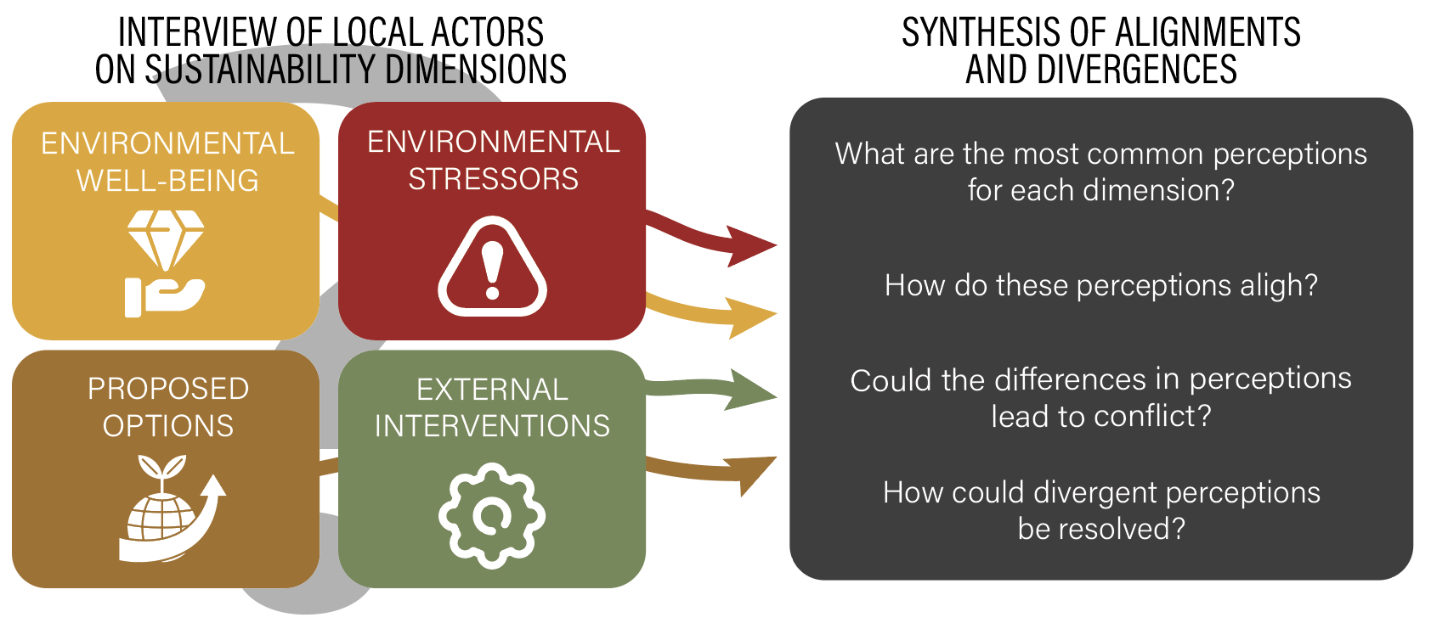

*Figure 1. Conceptual diagram representing the framework to assess the congruence between objectives of sustainability interventions and local expectations.*

**2.1. Environmental dependance and attachment**

A first dimension we propose to explore is how the well-being of local communities depends on the environmental features subject to interventions (*e.g.*, a forest, a watershed, particular species). How to frame these values has caused intense debate (Betley et al., 2021; Ishihara, 2018; Peterson et al., 2018); but the different definitions hold in common the idea that disrupting ecological processes, or managing ecosystems will in turn affect human well-being. Many conservation initiatives have the objective to sustain or improve human well-being. In the case of MPAs, economic, governance and health benefits have been demonstrated, while negative effects have also been documented (Ban et al., 2019). The perspective we adopt here on well-being is one directly questioning the link between environmental features and elements of human well-being (Betley et al., 2021).

**2.2. Environmental stressors**

What is considered to constitute « environmental issues » is large and can vary between cultures and knowledge systems. By employing it, we precisely aim at collecting a wide range of information on what different stakeholders consider as an issue to the environment and the resources on which they depend. These can comprise stressors such as climate change, or various pollutions, but also the root-causes of these threats: more distal drivers such as urbanization, or poverty. Sustainability interventions are meant to target specific issues; questioning if what people consider as an issue fits their perimeter of action is a way to ensure that no one expects more than what is possible, or that potential benefits are not ignored.

**2.3. Proposed options**

We call « proposed options » what different stakeholders can bring up in the discussion as a solution to the environmental issues previously defined. Once they have identified a range of issues, we can then question them on the solutions they imagine are possible. If external interventions are planned, this is a way to ensure people bring them in the discussion and consider them as viable options. It also gives the opportunity to describe stakeholder’s understanding of these interventions and refine their objectives (Pajaro et al., 2010).

+ Here we can add that available options are measures of integrated coastal management that can complement MPAs, or different visions about MPAs.

**2.4. External interventions**

External interventions are the ones promoted by actors external to the system studied; in our case study, an NGO promoting the creation of MPAs. What is “internal” or “external” can be subject to debate and could also be seen as a continuous scale with resource users being considered the closest groups to the implementation measures, and national agencies, scientists, and NGOs being the most external groups involved. In the middle we could find provincial or municipal authorities, or residents of nearby villages.

Understanding how people perceive these proposed or implemented interventions allows to directly question potential oppositions and conflicts, as well as refining what is held as an objective by implementation bodies. In the case of an MPA, we know that many objectives would be proposed, such as improving the ecological resilience or promoting eco-tourism. Our goal is to question if the perception of these external interventions can match with other proposed options and efficiently tackle the environmental issues identified.

**2.5. Possible solutions: a synthesis of alignments and divergences**

Building on the five prior dimensions, the last step we propose is to integrate these results and build a rationale for conservation. This rationale, or narrative should include present objectives, future ones, resources, actors, and consider potential conflicts and trade-offs. Different visions should not always mean potential conflicts, but they should always be examined to stay assured that different objectives are compatible.

The method we propose is therefore exploratory and should guide later decision stages that would otherwise be potentially disorganized and blind. The way we propose to synthetize these results is to examine both alignments, building a shared narrative for these objectives, and divergences, pushing for further discussions between actors based on their potential conflicting visions.

## 3. Case-study: implementing a network of marine protected areas in Palawan, Philippines

Using open-ended questionnaires, we investigated the perceptions of 66 local people, decision-makers and scientists of Palawan, Philippines, on local sustainability issues. After a content analysis, 174 perceptions were identified and grouped in 22 themes (Table 1, see Appendix for a list of perceptions identified). We analyzed the differences in perceptions between: i) local residents and external actors; ii) local residents from different villages and iii) local residents who were familiar with the projects of SEF, and those who were not in order to study the similarities and differences in their discourses. Due to relatively small sample size, quantitative analyses could only be performed for ii) and iii).

|  |  |  |  |
| --- | --- | --- | --- |
| Category | Theme | Description | Number of respondents |
| Environmental well-being | Livelihood | Marine ecosystems are valuable because people get their livelihoods and income from their resources. | 55 |
| Food and nutrition | Local people get affordable and healthy food from the sea, mostly fish but also shells, shrimps or seaweeds. | 47 |
| Tradition | People value marine ecosystems for their contribution to local traditions, for religious reasons and as a responsibility for future generations. | 11 |
| Other services | Other ecosystem services mentioned by respondents such as coastal protection, tourism, or charismatic species. | 10 |
| Environmental issues | Destructive fishing practices | A threat to marine ecosystems is the use of destructive fishing practices such as cyanide, dynamite, small-meshed nets or compressors. | 50 |
| Depletion of resources | Fishery resources have decreased and habitats noticeably damaged because of the increasing number of fishermen and use of destructive practices. | 46 |
| Terrestrial issues | On top of marine issues, people are facing terrestrial issues such as deforestation, invasions by pests, or the loss of terrestrial fauna. | 43 |
| Unmanageable issues | Unmanageable issues such as weather patterns, climatic events, or luck are other problems fishers have to face. | 14 |
| Other pressures | Diverse other pressures to marine ecosystems exist such as wastewater, other pollutions, climate change, or tourism. | 20 |
| Social issues | Environmental issues have root causes that can be found in social issues such as poverty, the lack of education and opportunities, or demography. | 17 |
| No issue identified | No environmental issue could be identified by the respondent. | 15 |
| Proposed options | Coercive social interventions | Coercive social interventions can be put in place such as reinforcing patrolling and arresting offenders. | 40 |
| Non-coercive social interventions | Non-coercive social interventions include the increase of education, better cooperation between stakeholders, or capacity building. | 28 |
| Ecosystem-based interventions | Ecosystem-based interventions such as marine reserves and ecosystem restoration activities can be efficient. | 15 |
| No option identified | No option to face environmental issues could be identified by the respondent. | 13 |
| External interventions | MPAs for ecological sustainability | The role of MPAs is to improve the state of ecological habitats, of their components including fishes, corals, shells, and functions such as nursery. | 52 |
| MPAs for local people | MPAs are made to benefit to local resource users. | 48 |
| MPAs as coercive instruments | The role of MPAs is to be coercive instruments facilitating patrolling and the enforcement of existing laws, for instance, on illegal fishing practices. | 37 |
| MPAs for fishery | The role of MPAs is to improve the state of fisheries through spillover and the protection of nursery grounds. | 36 |

*Table 1. List of the themes identified through content analysis and total number of respondents that quoted these themes (n = 66).*

**4.1. Alignments: when stakes and objectives meet**

Several themes identified were more commonly shared among all stakeholders (Table 1). Looking at them provides an idea on what are the more consensual elements of perception regarding marine conservation. The most common environmental well-being factors identified by respondents were linked to the contribution of marine ecosystem to people’s food and livelihood security (respectively by 41 and 50 respondents). In terms of environmental issues, destructive fishing practices were the most commonly identified, linked with their effect in depleting resources (42 and 38 respondents). Finally, the most common interventions identified were coercive ones (*e.g.*, more efficient patrolling) and marine reserves to promote ecological sustainability (33 and 46 respondents).

Identifying these conspicuous elements provides a rationale for future conservation measures, their objectives and expected outputs. We can contextualize the perceived local needs for conservation that should therefore target the nutrition and income of local people through regulating the activity of fishing; it also demonstrates the central position fishers should occupy in such a project.

**4.2. Divergences and potential conflicts of perceptions**

Local respondents who were aware of SEF projects, as well as scientists and decision-makers had significantly different and more diverse perceptions on marine conservation themes (PERMANOVA result p<0.05). These respondents also identified, on average, more themes (ANOVA & Tukey test p<0.05). A first divergence in perceptions can therefore be found in the degree of familiarity with marine conservation themes, with some respondents adopting a discourse closer to the perceptions of scientists and decision-makers. To ensure a more consistent rationale for conservation and equity, management plans should include further discussions to understand if respondents that identified relatively less familiar with conservation matters would agree with the perceptions of others. In the project we studied, such discussions occurred during local public hearings for the designation of MPAs. These events showed that illegal fishing was conspicuous in discourses, while they confirmed a broad support for MPAs.

We found a second set of divergences in the definition of what MPAs are and their objectives. Most respondents conceptualized them as fishery management tools, made to replenish fishing grounds through adult and larval spillover. However, two villages showed significant exceptions. First, several respondents from Batas stated MPAs are made only to restrict outsiders from fishing, hence allowing locals to fish in their “own” sanctuary. Second, respondents from Silanga perceived that MPAs are made for tourists and did not immediately consider potential benefits for fishing and non-fishing local people; this could be explained by the presence of several nearby private MPAs created by island-resorts.

**4.3. Summary of options: a rationale for marine conservation**

We classified the different themes and codes identified in four categories (Appendix) as many elements feeding the local discussions on marine conservation, its objectives and expected outputs. The last category of our framework, “possible solution”, is a synthesis of these information into what we call a “rationale for marine conservation”. This rationale, or narrative, is a simple statement of what local actors expect from marine conservation in relation to environmental threats and well-being.

In our case study, we investigated how MPAs can fit to the local context in which they are supposed to be established. We could establish the following rationale:

*In the Shark Fin Bay, food security, livelihoods and local traditions depend on increasingly depleted marine resources. Destructive fishing practices, such as the use of dynamite and cyanide, but also overfishing are to blame for this decline. Social issues like poverty and the lack of livelihood opportunities represent root causes for these practices. Terrestrial issues including pollution and deforestation should also be considered as a threat to ecosystems and well-being. A desirable future would be one with productive fisheries; on the opposite, their decline would hinder the contribution of marine ecosystems to the wellbeing of future generations. Local actors identify several options to face that situation: non-coercive interventions (*e.g.*, alternative livelihood projects), coercive interventions (*e.g.*, patrolling and fines), and ecosystem-based interventions (*e.g.*, marine reserves). The specific role of MPAs, in order to fit with the objectives of local resource-users, must be to preserve fishery from illegal activities and help restoring stocks, not only for livelihoods, but also for food and nutrition security. These dimensions should be included in the management plan of the future MPAs in order to monitor their outcomes.*

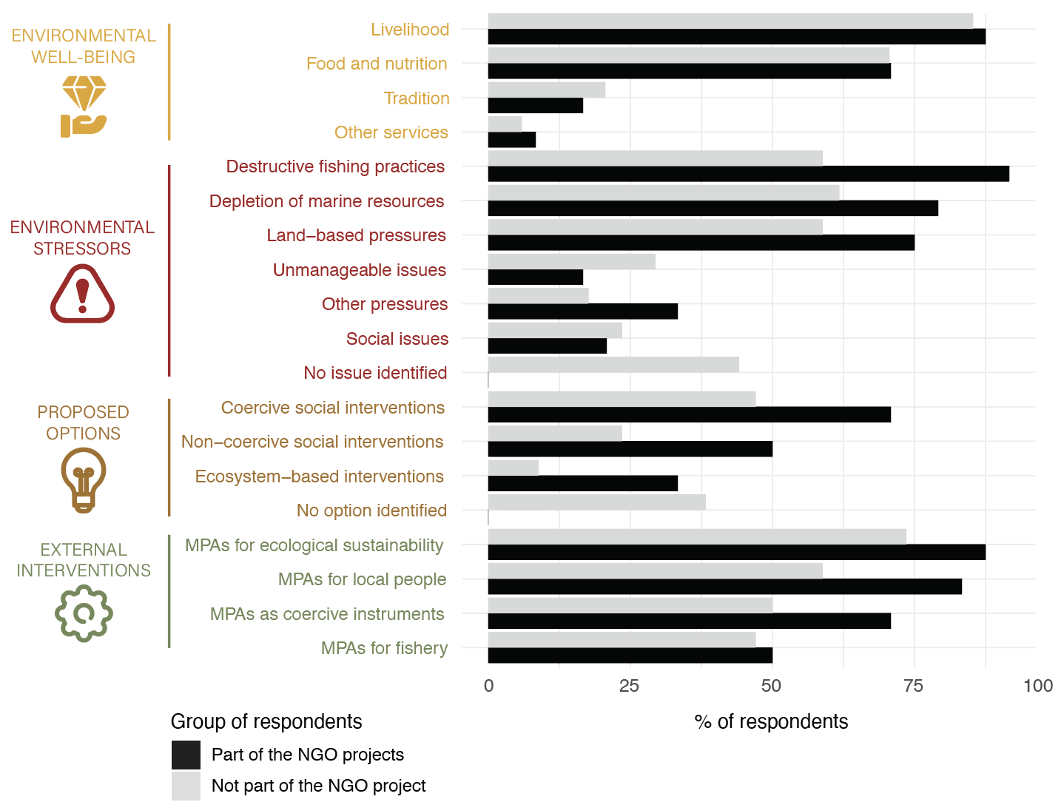

*Figure 3. Differences in the perceptions of local people (n = 60) depending on their familiarity with the NGO and its projects.*

## 4. Discussion

**4.1. Overall convergence on management needs**

**4.2. Tailoring solutions to local contexts**

**4.3. Benefits of the framework**

* When asking residents to elaborate on the value of ecosystems in open-ended discussions, we can let them evaluate the contribution of ecosystems not only to their wellbeing but also to the wellbeing of other people. Common when asking an NGO representative to explain their action but can also be applied to a local public servant, or any other resident. (Quote to give an example)
* Welfare policies must include nature (Sangha 2019)

**4.4. Opportunities from the support of external actors**

* Community-government collaboration (Ross et al 2019), NGOs as a bridge (REF?).
* Schluter et al 2021 on the benefits of external support, external interventions.

**4.5. Risks faced with external interventions**

* Most people and studies focus on food and in particular food production (Gelcich 2019 + Hicks 2011 Coastal Management)
* What is a community? What boundaries? Gurney et al 2017.
* Sense of place => understanding why people participate or not in management (Gurney et al 2017). Here we could say that a reason for participation, or non-participation, would be the alignment between external and local objectives.
* Urbanization changes preferences in ES (Lapointe et al 2020)

## Bibliography

Alcala, A.C., 1998. Community-based coastal resource management in the Philippines: a case study. Ocean Coast. Manag. 38, 179–186.

Andrachuk, M., Epstein, G., Andriamalala, G., Bambridge, T., Ban, N., Cunningham, E., Darling, E., Gurney, G.G., Litsinger, E., McIntosh, E., Mills, M., Morrison, T., Mangubhai, S., Oates, J., Pietri, D., Ruano-Chamorro, C., Tirona, R.S., Wabnitz, C., Young, J., 2022. CORAL REEF GOVERNANCE: STRENGTHENING COMMUNITY AND COLLABORATIVE APPROACHES 17.

Aswani, S., Albert, S., Love, M., 2017. One size does not fit all: Critical insights for effective community-based resource management in Melanesia. Mar. Policy 81, 381–391. https://doi.org/10.1016/j.marpol.2017.03.041

Ban, N.C., 2019. Fishing communities at risk. Nat. Clim. Change 9, 501–502. https://doi.org/10.1038/s41558-019-0506-9

Ban, N.C., Gurney, G.G., Marshall, N.A., Whitney, C.K., Mills, M., Gelcich, S., Bennett, N.J., Meehan, M.C., Butler, C., Ban, S., Tran, T.C., Cox, M.E., Breslow, S.J., 2019. Well-being outcomes of marine protected areas. Nat. Sustain. 2, 524–532. https://doi.org/10.1038/s41893-019-0306-2

Ban, N.C., Picard, C.R., Vincent, A.C.J., 2009. Comparing and integrating community-based and science-based approaches to prioritizing marine areas for protection. Conserv. Biol. 23, 899–910. https://doi.org/10.1111/j.1523-1739.2009.01185.x

Bennett, N.J., 2022. Mainstreaming Equity and Justice in the Ocean. Front. Mar. Sci. 9, 873572. https://doi.org/10.3389/fmars.2022.873572

Bennett, N.J., Dearden, P., 2014. Why local people do not support conservation: Community perceptions of marine protected area livelihood impacts, governance and management in Thailand. Mar. Policy 44, 107–116. https://doi.org/10.1016/j.marpol.2013.08.017

Bennett, N.J., Dearden, P., Peredo, A.M., 2015. Vulnerability to multiple stressors in coastal communities: a study of the Andaman coast of Thailand. Clim. Dev. 7, 124–141. https://doi.org/10.1080/17565529.2014.886993

Betley, E.C., Sigouin, A., Pascua, P., Cheng, S.H., MacDonald, K.I., Arengo, F., Aumeeruddy-Thomas, Y., Caillon, S., Isaac, M.E., Jupiter, S.D., Mawyer, A., Mejia, M., Moore, A.C., Renard, D., Sébastien, L., Gazit, N., Sterling, E.J., 2021. Assessing human well-being constructs with environmental and equity aspects: A review of the landscape. People Nat. 1–18. https://doi.org/10.1002/pan3.10293

Cabral, R.B., Geronimo, R.C., 2018. How important are coral reefs to food security in the Philippines? Diving deeper than national aggregates and averages. Mar. Policy 91, 136–141. https://doi.org/10.1016/j.marpol.2018.02.007

Cánovas‐Molina, A., García‐Frapolli, E., 2022. A review of vulnerabilities in worldwide small‐scale fisheries. Fish. Manag. Ecol. fme.12538. https://doi.org/10.1111/fme.12538

Cárcamo, P.F., Garay-Flühmann, R., Squeo, F.A., Gaymer, C.F., 2014. Using stakeholders’ perspective of ecosystem services and biodiversity features to plan a marine protected area. Environ. Sci. Policy 40, 116–131. https://doi.org/10.1016/j.envsci.2014.03.003

Cinner, J.E., Adger, W.N., Allison, E.H., Barnes, M.L., Brown, K., Cohen, P.J., Gelcich, S., Hicks, C.C., Hughes, T.P., Lau, J., Marshall, N.A., Morrison, T.H., 2018. Building adaptive capacity to climate change in tropical coastal communities. Nat. Clim. Change 8, 117–123. https://doi.org/10.1038/s41558-017-0065-x

Cinner, J.E., Pratchett, M.S., Graham, N.A.J., Messmer, V., Fuentes, M.M.P.B., Ainsworth, T., Ban, N., Bay, L.K., Blythe, J., Dissard, D., Dunn, S., Evans, L., Fabinyi, M., Fidelman, P., Figueiredo, J., Frisch, A.J., Fulton, C.J., Hicks, C.C., Lukoschek, V., Mallela, J., Moya, A., Penin, L., Rummer, J.L., Walker, S., Williamson, D.H., 2016. A framework for understanding climate change impacts on coral reef social–ecological systems. Reg. Environ. Change 16, 1133–1146. https://doi.org/10.1007/s10113-015-0832-z

Costello, C., Ovando, D., Clavelle, T., Kent Strauss, C., Hilborn, R., Melnychuk, M.C., Branch, T.A., Gaines, S.D., Szuwalski, C.S., Cabral, R.B., Rader, D.N., Leland, A., 2016. Global fishery prospects under contrasting management regimes. Proc. Natl. Acad. Sci. U. S. A. 113, 5125–5129. https://doi.org/10.1073/pnas.1520420113

Gill, D.A., Cheng, S.H., Glew, L., Aigner, E., Bennett, N.J., Mascia, M.B., 2019. Social Synergies, Tradeoffs, and Equity in Marine Conservation Impacts. Annu. Rev. Environ. Resour. 44, 347–372. https://doi.org/10.1146/annurev-environ-110718-032344

Gill, D.A., Mascia, M.B., Ahmadia, G.N., Glew, L., Lester, S.E., Barnes, M., Craigie, I., Darling, E.S., Free, C.M., Geldmann, J., Holst, S., Jensen, O.P., White, A.T., Basurto, X., Coad, L., Gates, R.D., Guannel, G., Mumby, P.J., Thomas, H., Whitmee, S., Woodley, S., Fox, H.E., 2017. Capacity shortfalls hinder the performance of marine protected areas globally. Nature 543, 665–669. https://doi.org/10.1038/nature21708

Hopkins, S.R., Sokolow, S.H., Buck, J.C., De Leo, G.A., Jones, I.J., Kwong, L.H., LeBoa, C., Lund, A.J., MacDonald, A.J., Nova, N., Olson, S.H., Peel, A.J., Wood, C.L., Lafferty, K.D., 2020. How to identify win–win interventions that benefit human health and conservation. Nat. Sustain. 4. https://doi.org/10.1038/s41893-020-00640-z

Hughes, S., Yau, A., Max, L., Petrovic, N., Davenport, F., Marshall, M., McClanahan, T.R., Allison, E.H., Cinner, J.E., 2012. A framework to assess national level vulnerability from the perspective of food security: The case of coral reef fisheries. Environ. Sci. Policy 23, 95–108. https://doi.org/10.1016/j.envsci.2012.07.012

Id, S.E., Hausner, V.H., Gurney, G.G., Broderstad, E.G., Keller, R., Kristine, A., Id, L., Javier, F., Murguzur, A., Salminen, E., Raymond, C.M., Falk-andersson, J., Fauchald, P., 2021. Blue justice : A survey for eliciting perceptions of environmental justice among coastal planners ’ and small-scale fishers in Northern- 1–20. https://doi.org/10.1371/journal.pone.0251467

Ishihara, H., 2018. Relational values from a cultural valuation perspective: how can sociology contribute to the evaluation of ecosystem services? Curr. Opin. Environ. Sustain. 35, 61–68. https://doi.org/10.1016/j.cosust.2018.10.016

Jefferson, T., Palomares, M.L.D., Lundquist, C.J., 2022. Safeguarding Seafood Security, Marine Biodiversity and Threatened Species: Can We Have Our Fish and Eat It too? Front. Mar. Sci. 9, 826587. https://doi.org/10.3389/fmars.2022.826587

Melnychuk, M.C., Kurota, H., Mace, P.M., Pons, M., Minto, C., Osio, G.C., Jensen, O.P., de Moor, C.L., Parma, A.M., Richard Little, L., Hively, D., Ashbrook, C.E., Baker, N., Amoroso, R.O., Branch, T.A., Anderson, C.M., Szuwalski, C.S., Baum, J.K., McClanahan, T.R., Ye, Y., Ligas, A., Bensbai, J., Thompson, G.G., DeVore, J., Magnusson, A., Bogstad, B., Wort, E., Rice, J., Hilborn, R., 2021. Identifying management actions that promote sustainable fisheries. Nat. Sustain. 4, 440–449. https://doi.org/10.1038/s41893-020-00668-1

Muallil, R.N., Deocadez, M.R., Martinez, R.J.S., Campos, W.L., Mamauag, S.S., Nañola, C.L., Aliño, P.M., 2019. Effectiveness of small locally-managed marine protected areas for coral reef fisheries management in the Philippines. Ocean Coast. Manag. 179, 104831. https://doi.org/10.1016/j.ocecoaman.2019.104831

Oldekop, J.A., Holmes, G., Harris, W.E., Evans, K.L., 2016. A global assessment of the social and conservation outcomes of protected areas. Conserv. Biol. 30, 133–141. https://doi.org/10.1111/cobi.12568

Pajaro, M.G., Mulrennan, M.E., Alder, J., Vincent, A.C.J., 2010. Developing MPA Effectiveness Indicators: Comparison Within and Across Stakeholder Groups and Communities. Coast. Manag. 38, 122–143. https://doi.org/10.1080/08920751003633094

Peterson, G.D., Harmáčková, Z. V., Meacham, M., Queiroz, C., Jiménez-Aceituno, A., Kuiper, J.J., Malmborg, K., Sitas, N., Bennett, E.M., 2018. Welcoming different perspectives in IPBES: “Nature’s contributions to people” and “Ecosystem services.” Ecol. Soc. 23, art39. https://doi.org/10.5751/ES-10134-230139

Pomeroy, R.S., Carlos, M.B., 1997. Community-based coastal resource management in the Philippines: A review and evaluation of programs and projects, 1984–1994. Mar. Policy 21, 445–464. https://doi.org/10.1016/S0308-597X(97)00016-X

Reimer, J.M., Devillers, R., Claudet, J., 2020. Benefits and gaps in area-based management tools for the ocean Sustainable Development Goal. Nat. Sustain. 20. https://doi.org/10.1038/s41893-020-00659-2

Sterling, E.J., Filardi, C., Toomey, A., Sigouin, A., Betley, E., Gazit, N., Newell, J., Albert, S., Alvira, D., Bergamini, N., Blair, M., Boseto, D., Burrows, K., Bynum, N., Caillon, S., Caselle, J.E., Claudet, J., Cullman, G., Dacks, R., Eyzaguirre, P.B., Gray, S., Herrera, J., Kenilorea, P., Kinney, K., Kurashima, N., MacEy, S., Malone, C., Mauli, S., McCarter, J., McMillen, H., Pascua, P., Pikacha, P., Porzecanski, A.L., De Robert, P., Salpeteur, M., Sirikolo, M., Stege, M.H., Stege, K., Ticktin, T., Vave, R., Wali, A., West, P., Winter, K.B., Jupiter, S.D., 2017. Biocultural approaches to well-being and sustainability indicators across scales. Nat. Ecol. Evol. 1, 1798–1806. https://doi.org/10.1038/s41559-017-0349-6

Sykora-Bodie, S.T., Álvarez-Romero, J.G., Adams, V.M., Gurney, G.G., Cleary, J., Pressey, R.L., Ban, N.C., 2021. Methods for identifying spatially referenced conservation needs and opportunities. Biol. Conserv. 260. https://doi.org/10.1016/j.biocon.2021.109138

Teuea, T., Nakamura, N., 2020. Motivations to Support Marine Conservation Projects in North Tarawa, Kiribati. Conserv. Soc. 18, 161. https://doi.org/10.4103/cs.cs_19_51

Thiault, L., Gelcich, S., Marshall, N., Marshall, P., Chlous, F., Claudet, J., 2019. Operationalizing vulnerability for social–ecological integration in conservation and natural resource management. Conserv. Lett. 1–13. https://doi.org/10.1111/conl.12677

Tolentino-Zondervan, F., Zondervan, N.A., 2022. Sustainable fishery management trends in Philippine fisheries. Ocean Coast. Manag. 223, 106149. https://doi.org/10.1016/j.ocecoaman.2022.106149

Weeks, R., Russ, G.R., Alcala, A.C., White, A.T., 2010. Effectiveness of Marine Protected Areas in the Philippines for Biodiversity Conservation. Conserv. Biol. 24, 531–540. https://doi.org/10.1111/j.1523-1739.2009.01340.x

Wiek, A., Iwaniec, D., 2014. Quality criteria for visions and visioning in sustainability science. Sustain. Sci. 9, 497–512. https://doi.org/10.1007/s11625-013-0208-6

Williams, G.J., Graham, N.A.J., Jouffray, J.-B., Norström, A.V., Nyström, M., Gove, J.M., Heenan, A., Wedding, L.M., 2019. Coral reef ecology in the Anthropocene. Funct. Ecol. 33, 1014–1022. https://doi.org/10.1111/1365-2435.13290

Zhao, Q., Stephenson, F., Lundquist, C., Kaschner, K., Jayathilake, D., Costello, M.J., 2020. Where Marine Protected Areas would best represent 30% of ocean biodiversity. Biol. Conserv. 244, 108536. https://doi.org/10.1016/j.biocon.2020.108536

# Appendix

Table A1. Open-ended questionnaire used to collect the perceptions of local actors on marine conservation.

Table A2. List of individual perceptions identified in content analysis (n=174) and quotes supporting them.

Figure A1. NMDS to ordinate the respondents and their responses. Two groups emerge and the difference in the composition of their perceptions is significant (PERMANOVA p<0.05)