DESIGN IMPLEMENTATION GUIDE — v2 REBRAND
LegalCore West Africa — Warm Pan-African Palette + Africa Map
Prepared for amaratech-legalcoreliberia.vercel.app • September 2026
This revision rebrands the site's color system to something warmer and friendlier, and replaces the abstract hero graphic with an actual map of Africa — the ECOWAS member states plotted at their real positions along the West African coast. Both changes are original illustration assets, built to size, ready to drop into the existing page structure with no other layout changes.
What changed from the first draft: (1) the palette moves from a near-black forest green to a brighter, warmer green paired with gold and a terracotta red — deliberately drawn from the green–gold–red family shared by ECOWAS members' own flags (Ghana, Senegal, Mali, Guinea, Guinea-Bissau, Benin, Cameroon); (2) the hero and jurisdiction diagram now use a real, recognizable Africa/West Africa coastline instead of an abstract hub-and-spoke network.

1. Color System — Rebranded
The previous palette (dark forest green, muted gold) was accurate to the current site but read as somber. This version keeps the same three-color family the site already uses — green, gold, and (new) a terracotta red — but lifts the tone: a brighter mid-green background, a warmer sunrise gold, and a red accent pulled directly from the flags of ECOWAS member states, where green-gold-red is the region's own visual language.
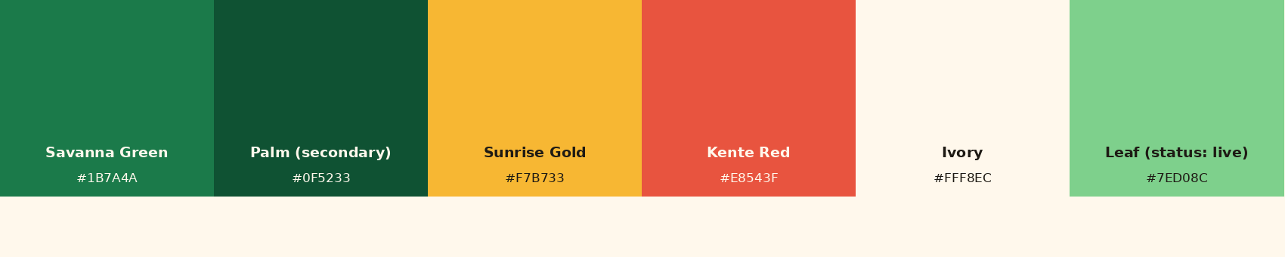
Figure 1 — Rebranded palette: warmer, brighter, and explicitly Pan-African in origin.

Where to use the new red
Kente Red is intentionally not used as a status color (see Figure 4) so it doesn't compete with the phase legend — reserve it for calls-to-action, links, and small brand accents (e.g., the underline beneath the hero stat line), the way it's used sparingly in Figure 2.

2. Hero Section — Now with an Africa Map
Proposed change: the hero background is now a large, low-opacity silhouette of the African continent, with the 12 ECOWAS member states plotted as small dots at their real relative positions along the coast — colored by rollout phase, exactly as in the roadmap section below. A small scales-of-justice badge remains as a legal-identity mark, moved to a corner so it no longer competes with the map. Nothing about the existing headline copy or layout changes — only the background layer.
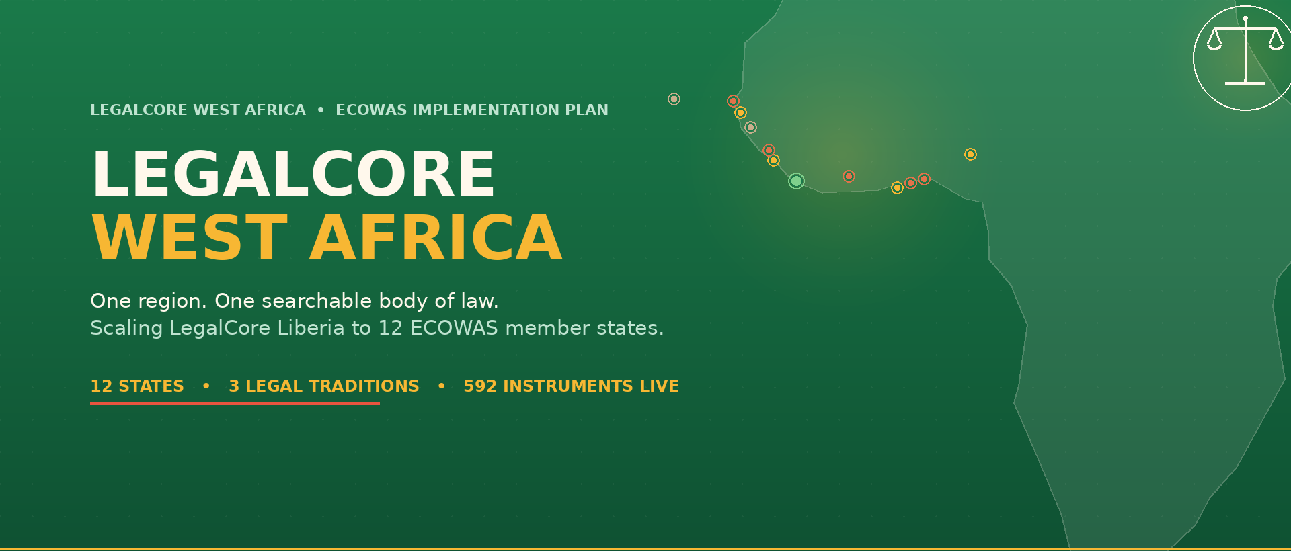
Figure 2 — Hero section with the Africa-map background composed under the existing headline text (mockup).

Implementation notes
Asset file | hero_bg_asset.png (text-free version, 1920×820)
Placement | CSS background-image on the hero <section>, background-size: cover, background-position: right center
Existing text/CTA | No change — keep as live HTML so it stays accessible and searchable, not baked into the image
What's on the map | Full Africa silhouette at ~10% opacity; West Africa bulge lifted with a soft gold glow; 12 ECOWAS states as small dots, color-coded by phase
Responsive | On narrow viewports, crop to the map's left edge or swap to a cropped version that keeps just the West Africa bulge, so the continent shape doesn't get cut off mid-way

3. “Who It's For” Section
Current state: this section (citizens, students, lawyers, institutions) is headline text only, four bullet-style blocks with no visual anchor. Proposed change: pair each audience with a simple flat-icon badge, drawn in the new gold-on-green language.
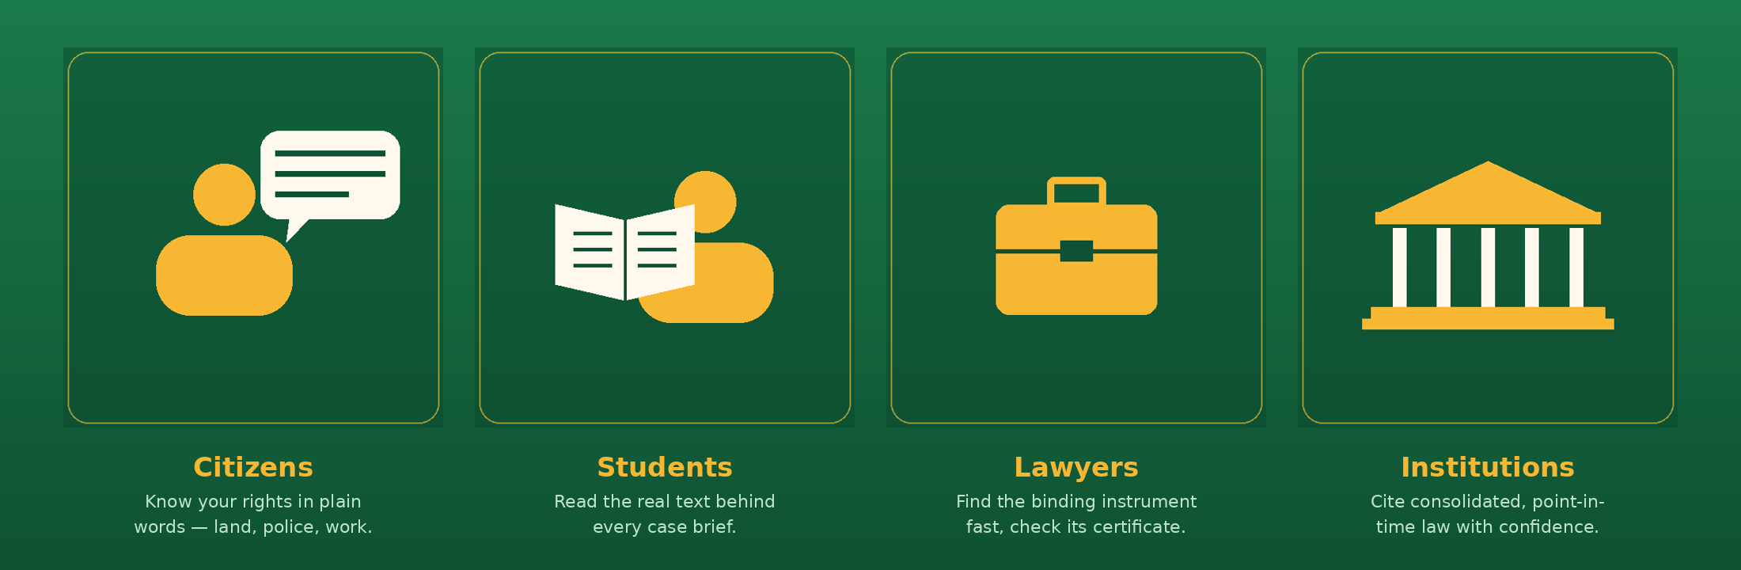
Figure 3 — Proposed four-card layout with icon badges, using the site's existing copy.

Implementation notes
Asset files | icon_citizens.png, icon_students.png, icon_lawyers.png, icon_institutions.png (520×520 each, transparent-ready)
Card layout | 4-column grid ≥768px; stack to 2-column or 1-column below that, icon size ~96–120px
Copy | Reuse the existing site copy for each card — icons are additive, not a content change
Extendability | Same icon style can extend to future sections (e.g., "OHADA", "Community Court") by reusing the badge template

4. West Africa Regional Map
Current state: the 12 member states are shown only as flag icons plus a text table. That's accurate but hard to scan at a glance, and it doesn't show real geography. Proposed change: a zoomed-in map of the West African coastline — the same coastline used in the hero, cropped tighter — with every ECOWAS state labeled and colored by rollout phase. This replaces the earlier abstract hub-and-spoke diagram with something a visitor can actually read as a place.
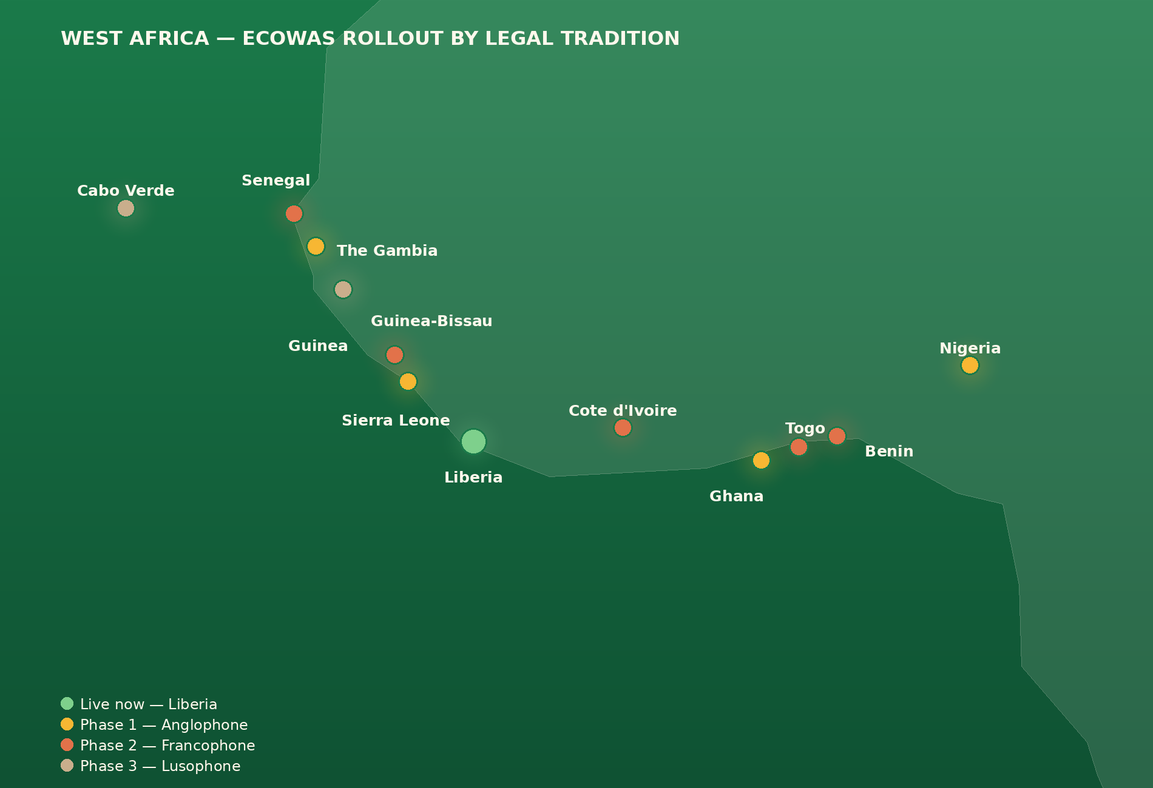
Figure 4 — West Africa regional map: Liberia (live), Phase 1 Anglophone, Phase 2 Francophone, Phase 3 Lusophone.

Implementation notes
Asset file | west_africa_map.png (1900×1300)
Placement | Directly above the existing “Choose your ECOWAS country” flag grid, as a visual summary of the phased rollout
Status colors | Leaf green = live, Sunrise gold = Phase 1, Terracotta = Phase 2, Warm taupe = Phase 3 — matches the phase labels already used in the roadmap section
Maintenance | Regenerate from the source script when a country's phase changes, so the map never drifts from the roadmap table
Note on accuracy: both maps are stylized illustrations built from a simplified coastline, sized to read clearly at small sizes — not survey-grade GIS data. That's appropriate for a decorative/orientation graphic; don't use it for anything requiring precise borders.

5. Asset Manifest
All files below are original illustrations generated for this project — free to use with no license or attribution required.
hero_bg_asset.png | Hero background layer (text-free), 1920×820
hero_mockup_composed.png | Hero preview with headline composited in, for reference only
icon_citizens.png / icon_students.png / icon_lawyers.png / icon_institutions.png | “Who it's for” badge icons, 520×520 each
who_its_for_row.png | Composed 4-card preview, for reference only
west_africa_map.png | West Africa regional map, all 12 states labeled, 1900×1300
palette.png | Rebranded color reference strip

Appendix — Adding Real Photography Later
The illustrations above are ready to ship now and avoid any licensing question. If you'd like to layer in real photography later (e.g., a photo of a courtroom, a law library, or someone using the platform on a phone), a few guidelines:
- Keep it specific to West Africa, not generic “Africa” stock imagery — search for the actual city or institution (e.g., “Monrovia courthouse,” “Accra law library,” “ECOWAS Commission Abuja”) rather than savanna or wildlife photos, which read as off-topic for a legal-tech product.
- Good free sources: Unsplash, Pexels, and Nappy.co (free photos of Black and African subjects, by African and Black creators).
- Best single addition: one hero-width photo (courthouse, law library, or a person consulting the platform) can sit behind or beside the illustration layer without replacing it — treat the illustration as the permanent brand layer and the photo as a seasonal/contextual accent.
- Rights check: if a photo shows an identifiable government building (e.g., Liberia's Temple of Justice) or officials, confirm usage rights and avoid implying official endorsement.
This document and all image assets referenced above are included as separate files alongside this guide.

