VISTORA ASSIGNMENT  
RISHIKESH DWIVEDI

(BT22CSA027)

# 1. Introduction to Feature Engineering

Feature engineering is the process of selecting, modifying, or creating new features (columns) from raw data to help a machine learning model learn better. Think of it like preparing the ingredients before cooking — better prep usually leads to better results.

Why is it important?  
Because even the best model won’t perform well if the data it learns from isn't well-prepared. Good features make it easier for the model to understand patterns and make accurate predictions.

Types of Feature Engineering Techniques:

* - Normalization/Scaling
* - Encoding (e.g., One-hot, Label)
* - Time-Based Aggregations
* - Handling Missing Data
* - Binning/Bucketing

# 2. Using Snowflake for Data Storage & Processing

Snowflake is a cloud-based data platform used for storing and processing both structured and semi-structured data. It allows you to work with tables and also JSON-like data using the VARIANT type.

# 3. Feature Store Concepts

A Feature Store is a system that stores and manages machine learning features. It helps data scientists and ML engineers share and reuse features efficiently.

Why is it needed?

* - Keeps features consistent across training and inference
* - Avoids duplication and errors
* - Promotes collaboration by sharing features

Comparison of Feature Stores:

* - AWS SageMaker Feature Store: Fully managed, integrates with AWS
* - Snowflake Feature Store: SQL-based, good for analysts
* - Databricks Feature Store: Works well with Spark and MLflow

# 4. Implementing Feature Engineering with Snowflake & Feature Store

## Step 1: Extract

## Step 2: Transform

## Step 3: Load into Feature Store

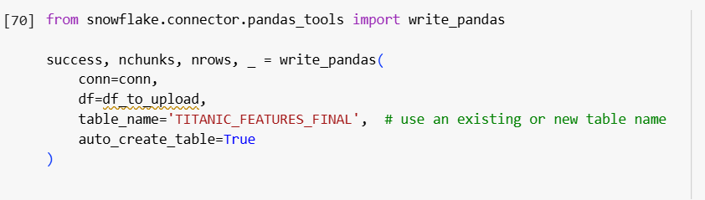Once features are created, you can save them back into Snowflake as a table or push them into an external Feature Store like SageMaker or Databricks using their respective APIs.

## Step 4: ML Model

