

RĪGAS TEHNISKĀ UNIVERSITĀTE

Datorzinātnes un informācijas tehnoloģijas fakultāte

3.praktiskais darbs

mācību priekšmetā

“Pēcrelāciju datu bāzes sistēmas(DB2)”

**XML datu bāzes sistēmas.**

Izstrādāja: Viktors Stepičevs

III.kurss RDBD0, 4.grupa, 191RDB100

Pārbaudīja: Prof. J. Eiduks

**2021./22/māc.gads**

**Darba saturs**

**Darba uzdevumi** 3

**Anotācija** 4

**XML dokumentu failu un shēmu izveide** 5

**XMLType tipa tabulu izveidošana un datu ievade tabulās** 8

**Binārais glabāšanas veids bez shēmas** 8

**Binārais glabāšanas veids ar shēmas** 9

**Strukturētais glabāšanas veids** 14

**Tabula ar lielo objektu kolonam** 15

**XMLTable vaicājumu izpilde** 18

**XMLQuery vaicājumu izpilde** 20

**XMLCast vaicājumu izpilde** 23

**XML datu izvadīšana relāciju datu veidā** 24

**Relāciju datu izvadīšana XML datu formātā** 25

**Secinājumi** 26

**Literatūra** 27

**Pielikumi** 28

**Darba izmantotas datu bāzes SQL kods** 28

**SQL*Loader data file** 35

**SQL*Loader command file** 35

**XML fails Championships** 35

**XML faila Championships atbilstoša shēma** 43

**XML fails Seasons** 49

**XML faila Seasons atbilstoša shēma** 52

# **Darba uzdevumi**

1. Ar izvēlētu XML redaktoru jāizveido divi XML dokumenta faili un tiem atbilstošie shēmu faili.  
2. XMLType tipa tabulu izveidošana:  
1) binārā veidā bez shēmas un ar shēmu. Tagad šis XML datu glabāšanas veids ir galvenais (sākot ar Oracle 11.2 versiju).  
2) strukturētā jeb relāciju – objektu (object – relational) veidā ar shēmu (bez shēmas nav domāts variants). Lai to izdarītu, jāveic XML redaktorā iegūtās shēmas anotēšana.

To var izdarīt Oracle datu bāzes sistēmā un un arī ALTOVA XMLSpy redaktorā. Šī punkta izpilde nav obligāta, bet ja izpildīsiet, papildus atzīmei tiks pielikti 1.5 punkti.  
3. Datu ievade izveidotajās tabulās (tekstveida, lielo objektu BLOB un SQL*Loader izmantošana).  
4. XMLTable vaicājumu izpilde (2 vaicājumi).  
5. XMLQuery vaicājumu izpilde (4 vaicājumi).  
6. XMLCast vaicējumu izpilde (2 vaicājumi)  
7. XML datu izvadīšana relāciju datu veidā.  
8. Relāciju datu izvadīšana XML datu formātā.  
9. Secinājumi (kas labs, kas slikts, kas noskaidrots, XML izmantošanas iespēju izvērtējums).

# **Anotācija**

Darbā tiks apskatītas XML un datu bāzes sistēmu saistības pamatjēdzieni, XML struktūras glābāšanas veidi, kā arī vairākas SQL iebūvētās XML funkcijas. XML dokumenti un shēmas tika izstrādātas ar ALTOVA XMLSpy redaktoru, bet datu bāze pilnība tika izstrādāta Oracle SQL Developer vidē.

# **XML dokumentu failu un shēmu izveide**

Pirms uzsākot pildīt darba uzdevumus, pirmais ko ir jāizdara ir XML redaktora instalēšana. Darba izstrādei es izvēlējos ALTOVA XMLSpy redaktoru, ar kuru palīdzību tiks izstrādāti divi XML dokumentu faili un tiem atbilstošie shēmu faili. Runājot par darba novirzi, kā ierasts paliku pie tās pašas tematikas kā iepriekšējos darbos – futbola komandas.

Kā arī minēju, darba gaitā tika izstrādāti divi XML dokumenta faili Championships un Seasons, un tiem atbilstošas shēmas Championships_Schema un Seasons_Schema. Dokuments Championships būtībā glāb līdzīgo informāciju, ka datu bāze manā pagājušajā darbā – informācija par 6 komandām no 3 dažādām valstīm, kur katrai ir iezīmēti 3 spēlētāji un viens treneris, savukārt, failā Seasons varētu būt atrasta informācija par komandu spēlēm savā starpā, atspoguļojot iegūtus vārtus, bumbas kontroles procentu un sitienu daudzumu, arī ņēmot vērā, ka komandas savā starpā čempionātā spēlē mājās un viesos. Dati par spēlēm tika atspoguļoti ar 2 gadu periodiku. Pabeidzot definēt visas iezīmēs, ALTOVA XMLSpy redaktorā ir iespēja aplūkot datu “grid” tabulas versiju. Šeit es ievietoju tikai pamata iezīmju attēlojumu, jo izvirzot shēmu plašāk, diez vai bildē kaut kas salasāms, bet pamata informācija ir redzama, ka iezīmē <championships> iekšā ir trīs “bērnu” <champioship> iezīmes ar atribūtu id, kurās katra satur informāciju par 2 komandām. Darba XML dokumenti un shēmas ir pieejamas darba pielikumos.

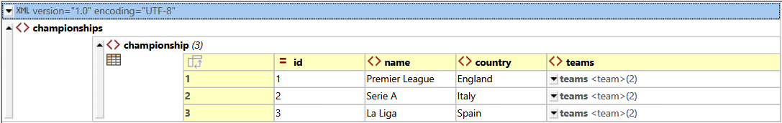

ALTOVA XMLSpy vidē arī ir iespēja uzģenerēt savam XML dokumentam attiecīgo shēmu. Uzģenerējot shēmu, ar shēmas attēlojuma nodaļu ir iespējams iegūt strukturētu faila diagrammu.

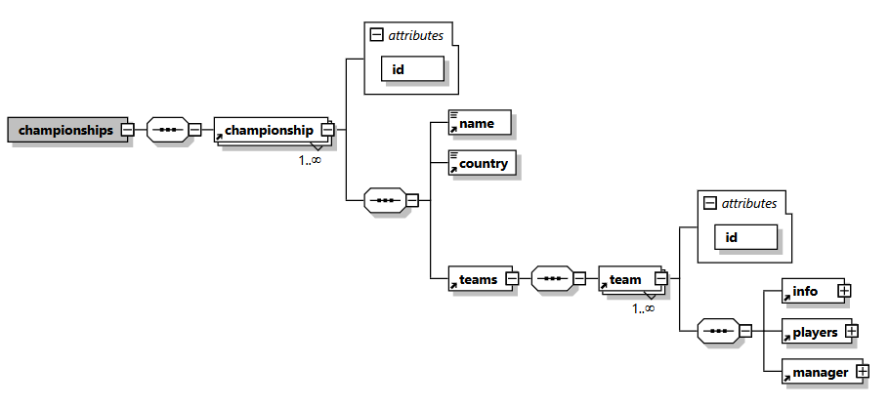

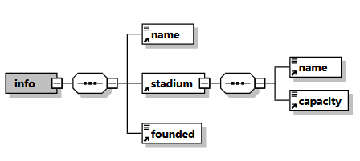

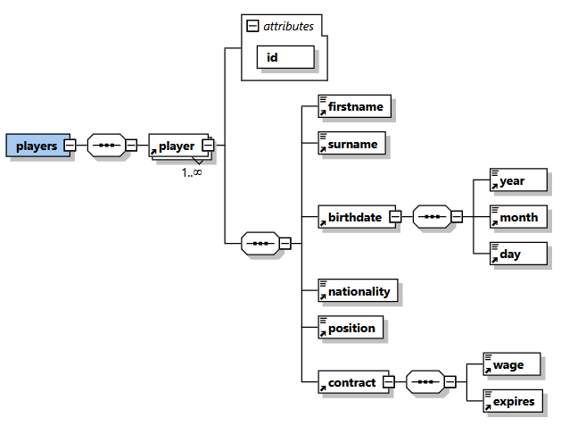

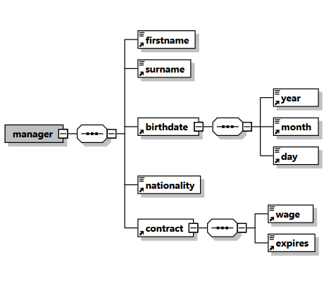

Savukārt, līdzīgs attēlojums ir pieejams arī Seasons dokumentam.

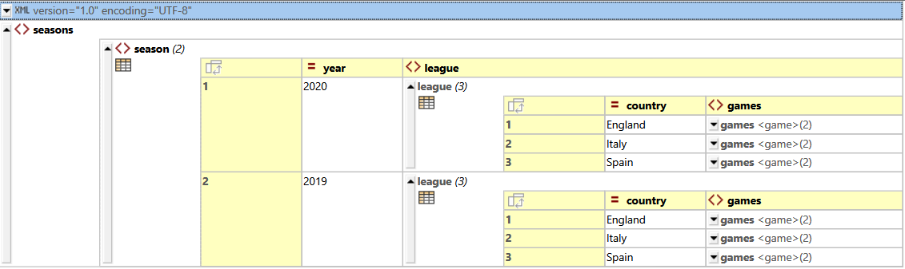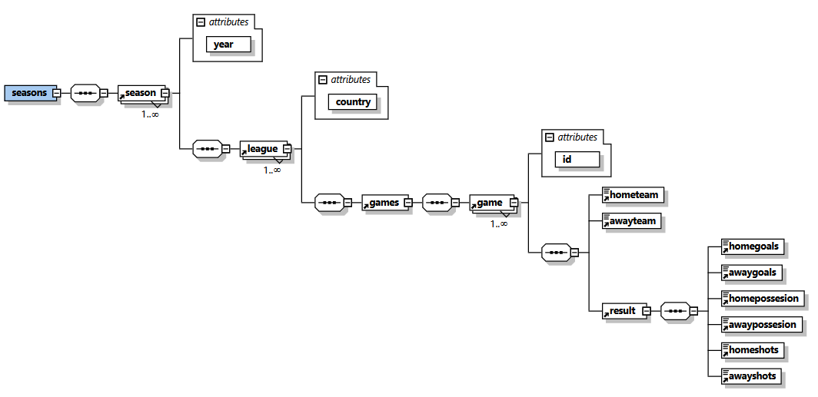

# **XMLType tipa tabulu izveidošana un datu ievade tabulās**

Uzsākot darbu ar izveidotājiem failiem Oracle SQL Developer, vispirms, lai tiktu klāt visiem darbā izmantotājiem failiem ir jādefinē direktoriju, kurā tie atrodas.



## **Binārais glabāšanas veids bez shēmas**

Tātad, vispirms tika izveidota XMLTYPE tabula Championships_Bin ar vienkāršo CREATE TABLE vaicājumu. Gadījuma, kad tabulai nav norādīta XML dokumenta shēma un glabāšanas opcijas, pēc noklusējuma dati tiks glabāti kā binārs XML.



Šajā tabulā dati tika ievadīti ar INSERT INTO palīdzību, pielietojot XMLTYPE, ievietojot datus tieši no izveidotājā XML dokumenta, norādot direktoriju, faila nosaukumu un simbolu formātu.

**INSERT INTO Championships_Bin VALUES(XMLTYPE(Bfilename('XML_DIR', 'Championships.xml'),nls_charset_id('AL32UTF8')));**

Rezultātā izvadot tabulas vērtību, ir redzams, ka iekšā atrodas (XMLTYPE), kuru vērtību apskatoties ir redzams Championships XML fails.

**SELECT VALUE(x)**

**FROM Championships_Bin x;**

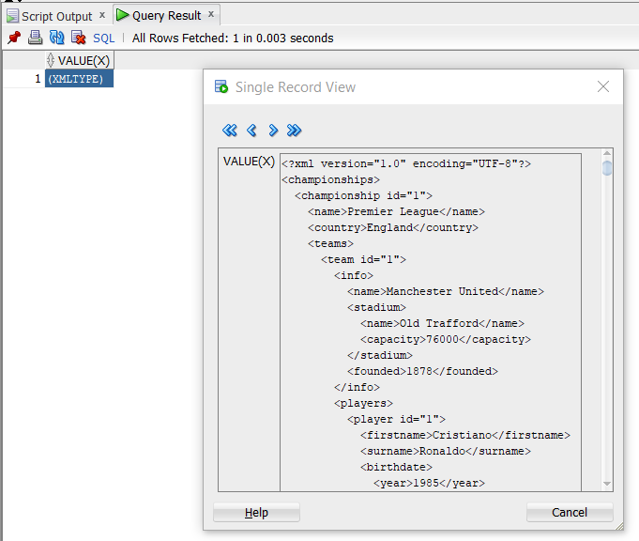

## **Binārais glabāšanas veids ar shēmas**

Pirmkārt, lai strādātu tālāk ir jādefinē XML faila shēmu binārai glabāšanai datu bāzes sistēmā.

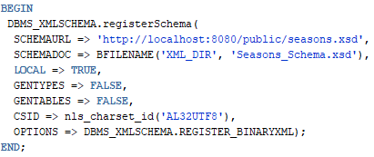

Pēc shēmas anotēšanas, tālāk tika izveidota tabulas Seasons_Bin, kurai tika norādīta XML faila shēma. To ir iespējams izdarīt kā ar XMLSCHEMA un ELEMENT iebūvēto funkciju konstrukciju(ko izmantošu vēlāk), kā arī izmantojot tikai ELEMENT, pielietojot XPointer notāciju, shēmas norādē specificējot saknes elementu.



Šajā tabulā datus es ievadīju tekstveidā, ievadot XML failu tieši datu bāzēs sistēmā. Ņemot vēra 4000 teksta simbolu ierobežojumu, faila saturu es sadalīju pa gadiem, ievadot tos ka divus atsevišķus ierakstus.

**INSERT INTO Seasons_Bin VALUES(XMLTYPE(**

**'<?xml version="1.0" encoding="UTF-8"?>**

**<seasons>**

**<season year="2020">**

**<league country="England">**

**<games>**

**<game id="1">**

**<hometeam>Manchester United</hometeam>**

**<awayteam>Liverpool</awayteam>**

**<result>**

**<homegoals>3</homegoals>**

**<awaygoals>2</awaygoals>**

**<homepossesion>45</homepossesion>**

**<awaypossesion>55</awaypossesion>**

**<homeshots>9</homeshots>**

**<awayshots>11</awayshots>**

**</result>**

**</game>**

**<game id="2">**

**<hometeam>Liverpool</hometeam>**

**<awayteam>Manchester United</awayteam>**

**<result>**

**<homegoals>0</homegoals>**

**<awaygoals>0</awaygoals>**

**<homepossesion>61</homepossesion>**

**<awaypossesion>39</awaypossesion>**

**<homeshots>8</homeshots>**

**<awayshots>4</awayshots>**

**</result>**

**</game>**

**</games>**

**</league>**

**<league country="Italy">**

**<games>**

**<game id="3">**

**<hometeam>AC Milan</hometeam>**

**<awayteam>Juventus</awayteam>**

**<result>**

**<homegoals>1</homegoals>**

**<awaygoals>1</awaygoals>**

**<homepossesion>48</homepossesion>**

**<awaypossesion>52</awaypossesion>**

**<homeshots>2</homeshots>**

**<awayshots>9</awayshots>**

**</result>**

**</game>**

**<game id="4">**

**<hometeam>Juventus</hometeam>**

**<awayteam>AC Milan</awayteam>**

**<result>**

**<homegoals>2</homegoals>**

**<awaygoals>0</awaygoals>**

**<homepossesion>45</homepossesion>**

**<awaypossesion>55</awaypossesion>**

**<homeshots>7</homeshots>**

**<awayshots>3</awayshots>**

**</result>**

**</game>**

**</games>**

**</league>**

**<league country="Spain">**

**<games>**

**<game id="5">**

**<hometeam>Real Madrid</hometeam>**

**<awayteam>FC Barcelona</awayteam>**

**<result>**

**<homegoals>3</homegoals>**

**<awaygoals>1</awaygoals>**

**<homepossesion>60</homepossesion>**

**<awaypossesion>40</awaypossesion>**

**<homeshots>8</homeshots>**

**<awayshots>5</awayshots>**

**</result>**

**</game>**

**<game id="6">**

**<hometeam>FC Barcelona</hometeam>**

**<awayteam>Real Madrid</awayteam>**

**<result>**

**<homegoals>1</homegoals>**

**<awaygoals>0</awaygoals>**

**<homepossesion>52</homepossesion>**

**<awaypossesion>48</awaypossesion>**

**<homeshots>7</homeshots>**

**<awayshots>7</awayshots>**

**</result>**

**</game>**

**</games>**

**</league>**

**</season>**

**</seasons>**

**'**

**));**

**INSERT INTO Seasons_Bin VALUES(XMLTYPE(**

**'<seasons>**

**<season year="2019">**

**<league country="England">**

**<games>**

**<game id="7">**

**<hometeam>Manchester United</hometeam>**

**<awayteam>Liverpool</awayteam>**

**<result>**

**<homegoals>1</homegoals>**

**<awaygoals>2</awaygoals>**

**<homepossesion>41</homepossesion>**

**<awaypossesion>59</awaypossesion>**

**<homeshots>3</homeshots>**

**<awayshots>9</awayshots>**

**</result>**

**</game>**

**<game id="8">**

**<hometeam>Liverpool</hometeam>**

**<awayteam>Manchester United</awayteam>**

**<result>**

**<homegoals>1</homegoals>**

**<awaygoals>1</awaygoals>**

**<homepossesion>65</homepossesion>**

**<awaypossesion>35</awaypossesion>**

**<homeshots>10</homeshots>**

**<awayshots>4</awayshots>**

**</result>**

**</game>**

**</games>**

**</league>**

**<league country="Italy">**

**<games>**

**<game id="9">**

**<hometeam>AC Milan</hometeam>**

**<awayteam>Juventus</awayteam>**

**<result>**

**<homegoals>1</homegoals>**

**<awaygoals>0</awaygoals>**

**<homepossesion>50</homepossesion>**

**<awaypossesion>50</awaypossesion>**

**<homeshots>5</homeshots>**

**<awayshots>9</awayshots>**

**</result>**

**</game>**

**<game id="10">**

**<hometeam>Juventus</hometeam>**

**<awayteam>AC Milan</awayteam>**

**<result>**

**<homegoals>0</homegoals>**

**<awaygoals>0</awaygoals>**

**<homepossesion>53</homepossesion>**

**<awaypossesion>47</awaypossesion>**

**<homeshots>6</homeshots>**

**<awayshots>6</awayshots>**

**</result>**

**</game>**

**</games>**

**</league>**

**<league country="Spain">**

**<games>**

**<game id="11">**

**<hometeam>Real Madrid</hometeam>**

**<awayteam>FC Barcelona</awayteam>**

**<result>**

**<homegoals>1</homegoals>**

**<awaygoals>1</awaygoals>**

**<homepossesion>41</homepossesion>**

**<awaypossesion>59</awaypossesion>**

**<homeshots>4</homeshots>**

**<awayshots>5</awayshots>**

**</result>**

**</game>**

**<game id="12">**

**<hometeam>FC Barcelona</hometeam>**

**<awayteam>Real Madrid</awayteam>**

**<result>**

**<homegoals>0</homegoals>**

**<awaygoals>2</awaygoals>**

**<homepossesion>63</homepossesion>**

**<awaypossesion>37</awaypossesion>**

**<homeshots>8</homeshots>**

**<awayshots>7</awayshots>**

**</result>**

**</game>**

**</games>**

**</league>**

**</season>**

**</seasons>**

**'**

**));**

**SELECT VALUE(x)**

**FROM Seasons_Bin x;**

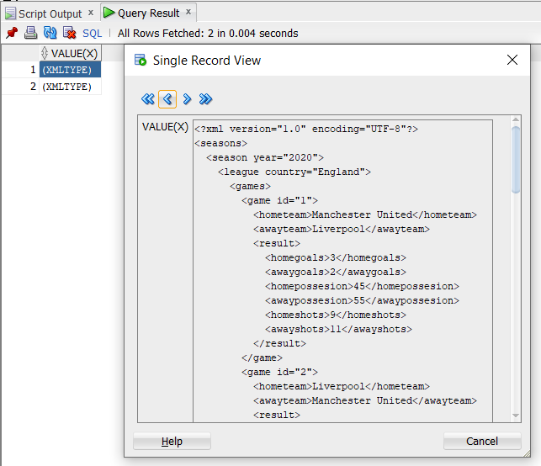

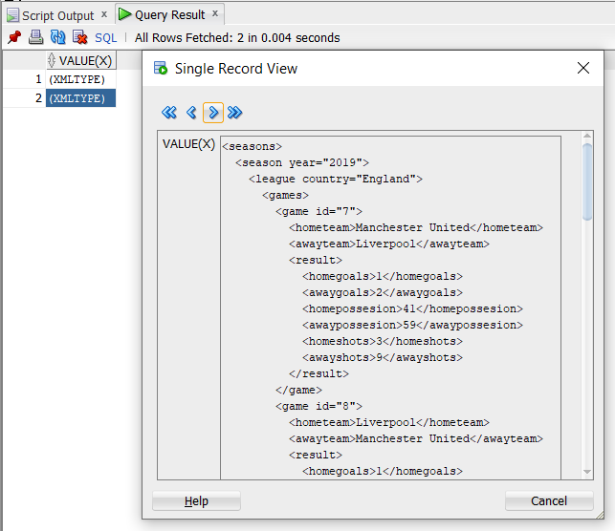

Lai pārbaudītu, vai izveidotās tabulas tieši tika izveidotās ar bināro glabāšanas tipu tika palaists sekojošais vaicājums.

**SELECT x.TABLE_NAME, x.XMLSCHEMA, x.STORAGE_TYPE**

**FROM USER_XML_TABLES x**

**ORDER BY x.TABLE_NAME DESC;**

Kā arī un ir redzams, tabulu STORAGE_TYPE ir binary, kā ari Seasons_Bin tabulai ir norādīta XML shēma, bet tabulai Championships_Bin – nav.

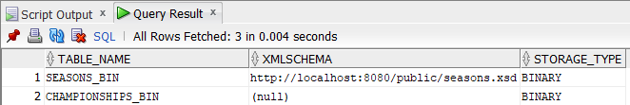

## **Strukturētais glabāšanas veids**

Tātad, tagad ir jādefinē shēma strukturētajam glabāšanas veidam. Būtībā, tas tika panākts izdzēšot OPTIONS parametru, kur bija specificēts glabāšanas tips.

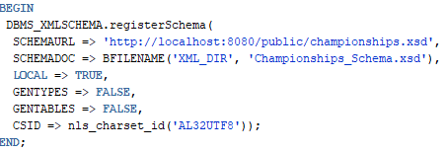

Lai apskatītu shēmas tipus tika izdarīts sekojošais vaicājums.

**SELECT SCHEMA_URL, HIER_TYPE, BINARY**

**FROM USER_XML_SCHEMAS;**

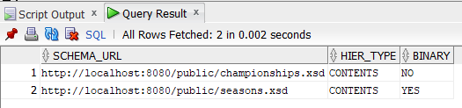

Tālāk, uz definētās shēmas pamata tika izveidota tabula ar XMLType tipa kolonu Championships_Str. Līdzīgi Championships_Bin tabulai dati tika ievietoti tieši no XML dokumenta.

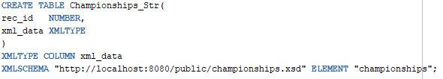

**INSERT INTO Championships_Str VALUES(1, XMLTYPE(BFILENAME('XML_DIR', 'Championships.xml'),nls_charset_id('AL32UTF8')));**

**SELECT x.\***

**FROM Championships_Str x;**

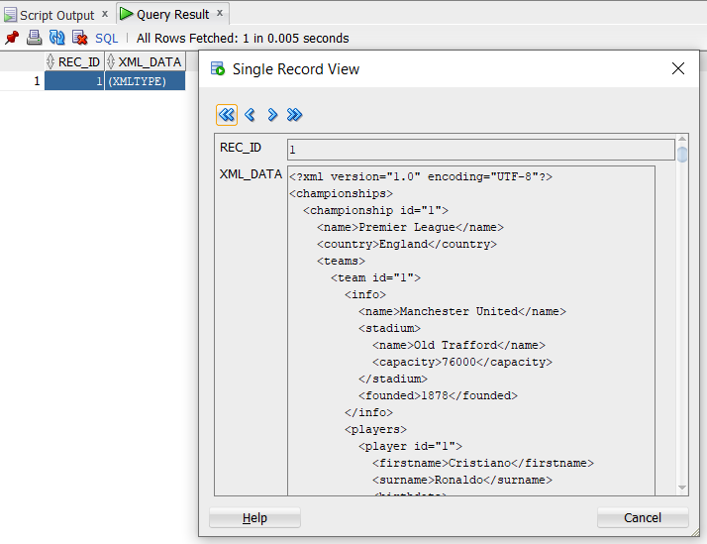

## **Tabula ar lielo objektu kolonam**

Tālāk tika izveidota tabula Seasons_C_B ar CLOB un BLOB lieliem objektiem. CLOB ir Character Large Object, kas ir domāts lieliem tekstiem vai teksta dokumentiem, bet BLOB ir Binary Large Object kas ir piemērots multimediju datiem.

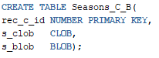 

Tātad, tabulā dati tika ievietoti izmantojot SQL*Loader palīdzību, līdzīgi ka tas arī bija pirmā darbā. Tika izveidoti command un data teksta faili. Command fails norada uz datu failu, kas satur tabulā ievadītus datus, norāda kurā tabulā tiks ievadīti dati un kolonu sadalīšanas simbols. Lai viss strādātu korekti, visiem izmantotiem failiem ir jābūt zem vienas direktorijas. Dati tiek ievietoti palaižot Command Prompt tajā mapē un norādot izmantoto lietotāju un command faila nosaukumu.

Command faila saturs:

**LOAD DATA**

**INFILE 'data.txt'**

**INTO TABLE Seasons_C_B TRUNCATE**

**fields terminated by "|"**

**(**

**rec_c_id,**

**xml_file FILLER,**

**picture_file FILLER,**

**s_clob LOBFILE(xml_file) TERMINATED BY EOF,**

**s_blob LOBFILE(picture_file) TERMINATED BY EOF**

**)**

Datu faila saturs:

**1|Seasons.xml|ball.jpg**

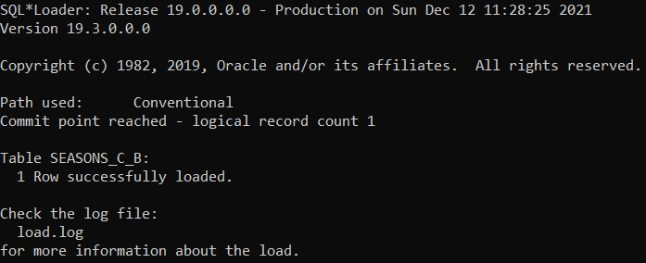

Izvadot informāciju ir redzams, ka kolona s_clob iekšā tiešam satur Seasons.xml failu, bet s_blob kolona BLOB objektu.

**SELECT a.\***

**FROM Seasons_C_B a;**

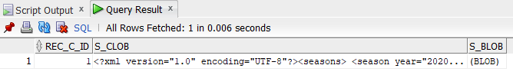

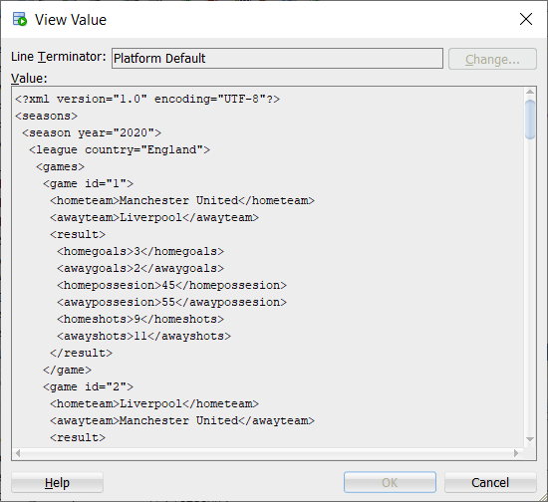

Atvērot rediģēšanas režīmu ir iespējams izvēlēties attēlošanas režīmu, savukārt pie View As izvēlējoties Image, ievietotu attēlu ir iespējams apskatīt datu bāzes sistēmā.

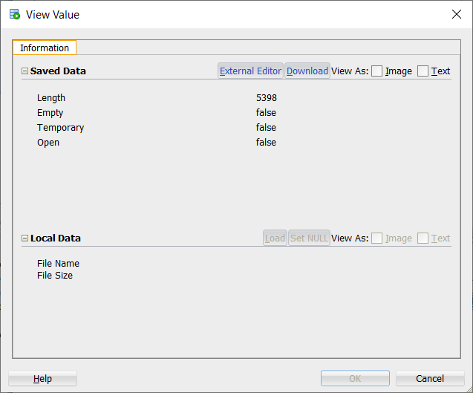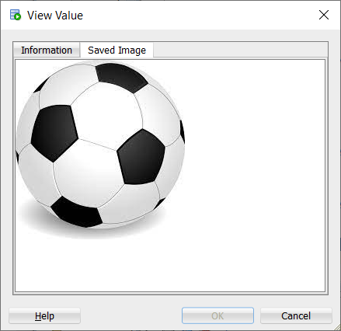

# **XMLTable vaicājumu izpilde**

Tātad, būtībā XMLTable funkcija jēdzīgi atbilst XPath izteiksmei. Noteicot ceļu pēc iezīmju nosaukumiem ir iespējams aplūkot objektus, kuri atrodas zem tā ceļa.

**SELECT c.COLUMN_VALUE**

**FROM Championships_Bin obj, XMLTable('/championships/*' PASSING obj.OBJECT_VALUE)c;**

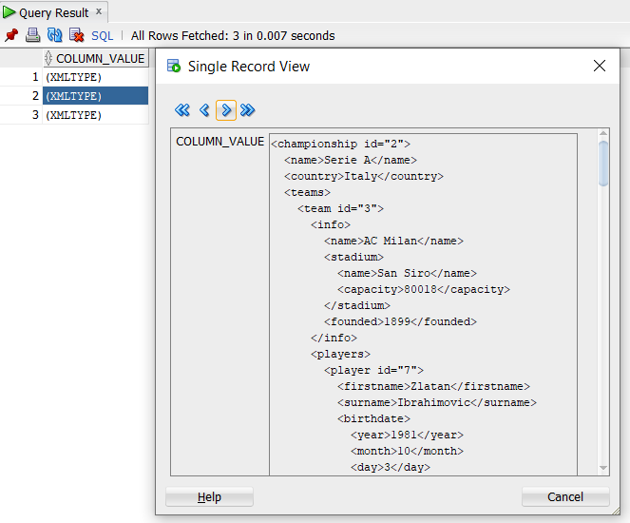

**SELECT s.COLUMN_VALUE**

**FROM Seasons_Bin obj, XMLTable('/seasons/*' PASSING obj.OBJECT_VALUE)s;**

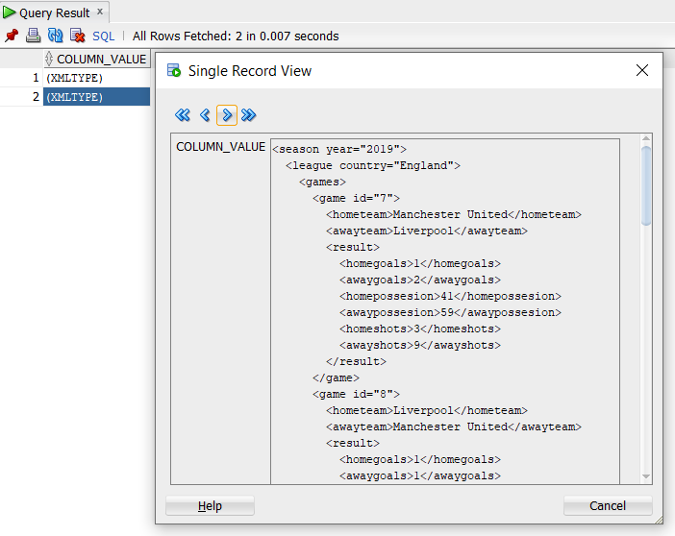

Ar XMLTable klauzulas COLUMNS palīdzību attiecīgi norādītājām ceļam ir iespējams sadalīt nosacītus datus un atspoguļot tos relāciju veidā. Sekojošajā vaicājumā tiek izvadīti visi spēlētāji no visām komandām.

**SELECT c.\***

**FROM Championships_Bin, XMLTable('/championships/championship/teams/team/players/player'**

**PASSING OBJECT_VALUE**

**COLUMNS Name VARCHAR2(50) PATH 'firstname',**

**Surname VARCHAR2(50) PATH 'surname',**

**Wage NUMBER PATH 'contract/wage',**

**Expires NUMBER PATH 'contract/expires') c;**

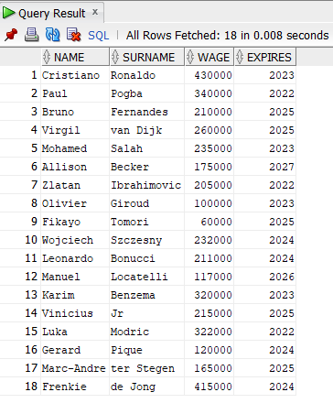

# **XMLQuery vaicājumu izpilde**

Ar XMLQuery funkcijas palīdzību tiešā veidā ir iespējāms izvilkt mezglus, kuri atbilst XPath izteiksmei.

Ar nākamo vaicājumu tika iegūti visi komandu nosaukumi.

**SELECT XMLQuery('/championships/championship/teams/team/info/name' PASSING OBJECT_VALUE RETURNING CONTENT)**

**AS Teams**

**FROM Championships_Bin;**

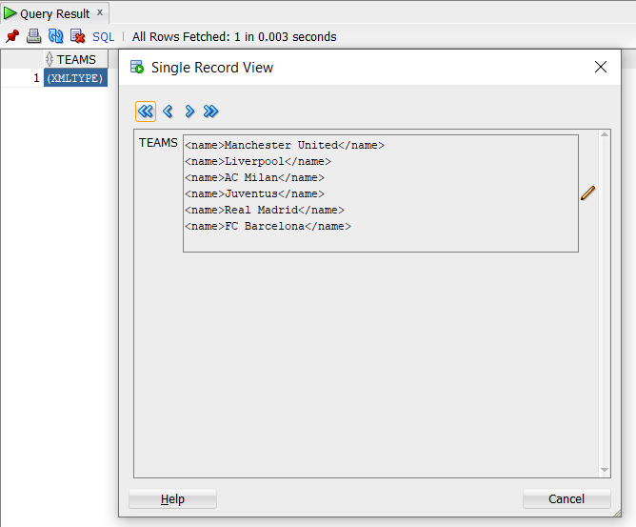

Izmantojot XQuery konstrukciju ar sekojošo vaicājumu tika iegūts spēlētāju uzvārds, norādot viņa vārdu.

**SELECT XMLQuery(**

**'for $i in /championships/championship/teams/team/players/player**

**where $i/firstname = "Cristiano"**

**return $i/surname'**

**PASSING OBJECT_VALUE RETURNING CONTENT) AS Player**

**FROM Championships_Bin;**

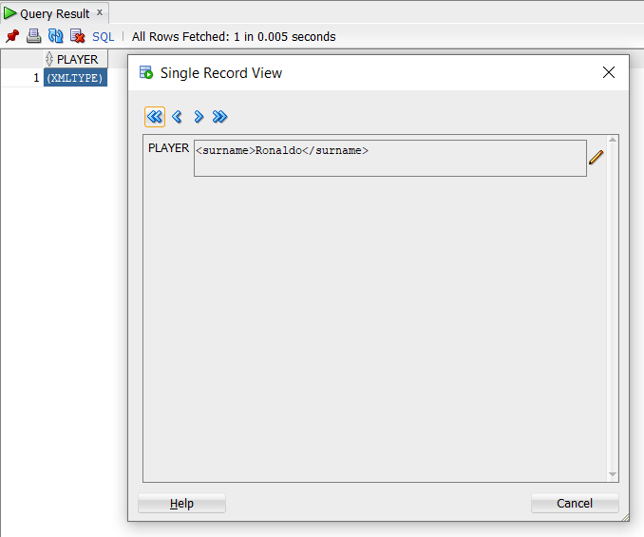

Nākamais vaicājums izvada uzvārdus tiem spēlētājiem, kuriem atalgojums ir lielāks par 250000 un ņemot vērā, ka championship id atribūta vērtība ir 1, savukārt tas nozīmē, ka spēlētāji ir tika no pirmās līgās.

**SELECT XMLQuery(**

**'for $i in /championships/championship[@id="1"]/teams/team/players/player**

**where $i/contract/wage > "250000"**

**return $i/surname'**

**PASSING OBJECT_VALUE RETURNING CONTENT) AS Player**

**FROM Championships_Bin;**

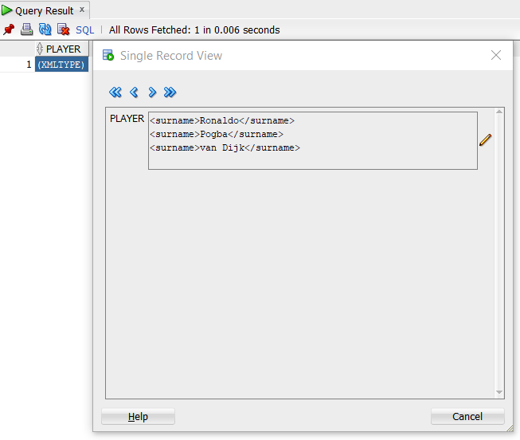

Sekojošais vaicājums papildus iezīmē <shots> atgriež cik vārtu ir ieguvusi komanda Manchester United spēlējot mājās.

**SELECT XMLQuery(**

**'for $i in /seasons/season/league/games/game**

**where $i/hometeam = "Manchester United"**

**return <shots>**

**{$i/result/homegoals}**

**</shots>'**

**PASSING OBJECT_VALUE RETURNING CONTENT) Result**

**FROM Seasons_Bin;**

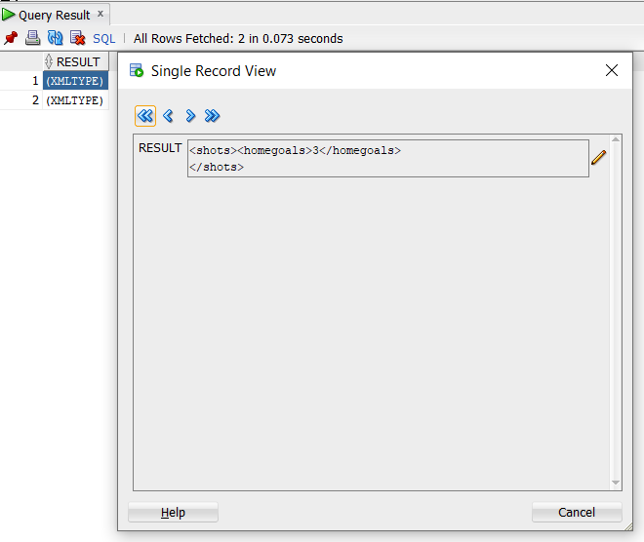

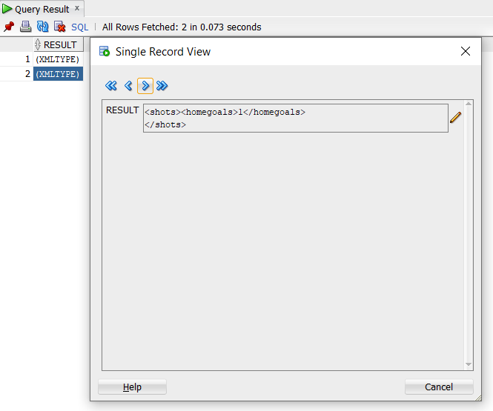

# **XMLCast vaicājumu izpilde**

XMLCast tipa vaicājums būtībā palīdz iegūt “reālas” XMLQuery vaicājuma rezultātus, izvadot datus tieši izveidotājā kolonā. Nākamajos divos vaicājumos esmu pārtaisījis 2 vaicājumus no iepriekšējas nodaļās.

**SELECT XMLCast(XMLQuery(**

**'for $i in /championships/championship/teams/team/players/player**

**where $i/firstname = "Cristiano"**

**return $i/surname'**

**PASSING OBJECT_VALUE RETURNING CONTENT) AS VARCHAR2(100))"Player"**

**FROM Championships_Bin;**

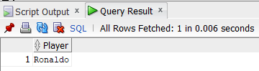

**SELECT XMLCast(XMLQuery(**

**'for $i in /championships/championship[@id="1"]/teams/team/players/player**

**where $i/contract/wage > "250000"**

**return $i/surname'**

**PASSING OBJECT_VALUE RETURNING CONTENT)AS VARCHAR(100))"Players"**

**FROM Championships_Bin;**

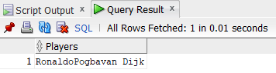

# **XML datu izvadīšana relāciju datu veidā**

Būtībā, ar extractValue funkcijas palīdzību ir iespējams iegūt un izvadīt datus relāciju veidā no XML struktūras. Sekojošais vaicājums izvada stadionu komandai ar atribūta id vērtību 3.

**SELECT extractValue(OBJECT_VALUE, '/championships/championship/teams/team[@id="3"]/info/stadium/name') AS Stadiums**

**FROM Championships_Bin;**

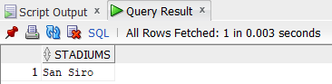

Nākamais vaicājums atrod komandas nosaukumu, kura tika dibināta 1878. gadā.

**SELECT extractValue(OBJECT_VALUE, '/championships/championship/teams/team/info[founded=1878]/name') AS Teams**

**FROM Championships_Bin;**

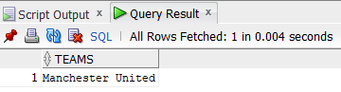

Gadījumā, ja pēc definētiem ierobežojumiem rezultāta būs divas vai vairākās vērtības, tad tie tiks izvadīti secīgi vienā rindā.

**SELECT extractValue(OBJECT_VALUE, '/championships/championship/teams/team/info[founded=1899]/name') AS Stadiums**

**FROM Championships_Bin;**

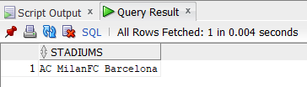

# **Relāciju datu izvadīšana XML datu formātā**

Lai panāktu visu izdarīto iepriekšējā nodaļā, bet citā virzienā vispirms, lai iegūtu datus transformēšanai ir jāizveido relācijas tabulu un jāievada tā datus.

**CREATE TABLE Teams(**

**team_name VARCHAR2(30),**

**player_surname VARCHAR2(30),**

**manager_surname VARCHAR2(30)**

**);**

**INSERT INTO Teams VALUES('Manchester United', 'Ronaldo', 'Rangnick');**

**INSERT INTO Teams VALUES('Liverpool', 'Salah', 'Klopp');**

**INSERT INTO Teams VALUES('AC Milan', 'Ibrahimovic', 'Pioli');**

**INSERT INTO Teams VALUES('Juventus', 'Locatelli', 'Allegri');**

SQL ir vairākās iebūvētas funkcijas, ar kuru palīdzību ir iespējams izveidot XML struktūru un pielīdzināt tabulas kolonu vērtības XML glabāšanas struktūrām. Ar funkcijas xmlElement() palīdzību tika definēts XML elements “team” no relāciju team_name tabulas Teams kolonas. Tālāk, ar xmlAttributes() elementam ”team” tika definēt atribūts name, kurš arī un glabā komandas nosaukums. Pēc tām, ar xmlForest() funkcijas palīdzību tika definēti divi “bērnu” elementi “player” un manager, kuru satur informāciju no relācijas tabulas kolonam player_surname un manager_surmane attiecīgi.

**SELECT xmlElement("team",**

**xmlAttributes(t.team_name AS "name"),**

**xmlForest(t.player_surname AS "player"),**

**xmlForest(t.manager_surname AS "manager")**

**).EXTRACT('/*') AS XML**

**FROM Teams t;**

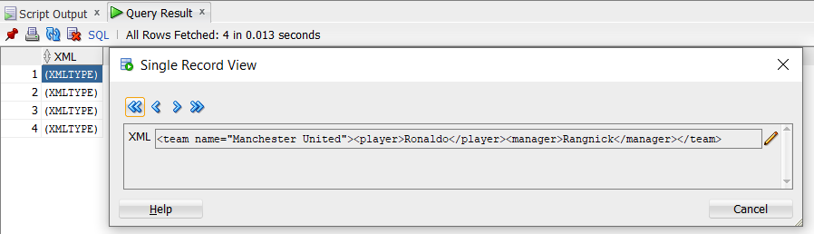

# **Secinājumi**

Analizējot sava darba gaitu un rezultātu, kopumā es varu teikt, ka izpildīt visus darba uzdevumus man veiksmīgi sanāca. Pirms darba uzsākšanas es biju zināju pamata lietas saistītās ar XML sintaksi un struktūru, bet savā prakse pielietot XML valodu kombinācijā ar datu bāzes sistēmu man pienācas pirmo reizi.

Pēc paveikta darba runājot par grūtībām un problēmam, vairāk tās bija saistītas ar XML vālodas īpašībam, kā piemērām definējot XMLQuery struktūras vaicājumus sākumā pielietoju FOR, WHERE klauzulas ar lielo burtu, kas rezultējā izpildes kļūdā, jo XML valoda ir “case-sensitive”. Tādās kļūdas ir diezgan grūti atrast, jo it kā viss ir kārtībā un visam ir jāstrādā, bet atrisināt tādās problēmas var tikai mācoties un detalizētāk analizējot konspektus. Runājot par apskatītiem glābāšanas veidiem tika apskatīti binārais veids ar shēmu un bez, kā arī strukturētais glābāšanas veids. Galvenā strukturēta glābāšanas veida priekšrocības ir ātrdarbība, bet binārājam glābāšanas veidam ir efektivitāte, jo piemērām ir iespējāms aprakstīt vairākās shēmas vienas tabulas ietvaros, un tātad ar tiem savstārpēji darboties. Par jaunumiem runājot, arī esmu apskatījis lielo objektu CLOB un BLOB darbības principu, arī ievietojot un atvērot bildi datu bāzēs sistēmā.

Butībā, darbs man aizņēma mazāk laika nekā iepriekšējais, bet dēļ tā, kā gadījās tāda situācija, ka aizkavējos ar iepriekšējo darbu, darboties un apskatit šo tematu es arī uzsāku vēlāk, par ko es arī atvainojos. Kopumā, izpildot šo darbu es noteikti esmu ieguvis jaunas prasmes, uz kuru pamatā man būs vieglāk arī darboties nākotnē.

# **Literatūra**

1. Prof. J. Eiduks. Lekciju konspekti priekšmetā “Pēcrelāciju datu bāzes sistēmas (DB2)”
2. <https://datubaze.wordpress.com/>
3. <https://docs.oracle.com/database/121/ADXDB/toc.htm>

# **Pielikumi**

## **Darba izmantotas datu bāzes SQL kods**

CREATE OR REPLACE DIRECTORY XML_DIR AS 'C:\Users\testdb\Desktop\3. pr\XML';

------------------------Binara tabula bez shemas--------------------------------

CREATE TABLE Championships_Bin OF XMLTYPE;

INSERT INTO Championships_Bin VALUES(XMLTYPE(Bfilename('XML_DIR', 'Championships.xml'),nls_charset_id('AL32UTF8')));

CREATE TABLE Seasons_C_B(

rec_c_id NUMBER PRIMARY KEY,

s_clob CLOB,

s_blob BLOB);

SELECT x.TABLE_NAME, x.XMLSCHEMA, x.STORAGE_TYPE

FROM USER_XML_TABLES x

ORDER BY x.TABLE_NAME DESC;

SELECT x.TABLE_NAME, x.XMLSCHEMA, x.STORAGE_TYPE

FROM USER_XML_TABLES x;

SELECT a.*

FROM Seasons_C_B a;

SELECT VALUE(x)

FROM Championships_Bin x;

--------------------------------------------------------------------------------

------------------------Shemu definejums----------------------------------------

BEGIN

DBMS_XMLSCHEMA.registerSchema(

SCHEMAURL => 'http://localhost:8080/public/championships.xsd',

SCHEMADOC => BFILENAME('XML_DIR', 'Championships_Schema.xsd'),

LOCAL => TRUE,

GENTYPES => FALSE,

GENTABLES => FALSE,

CSID => nls_charset_id('AL32UTF8'));

END;

BEGIN

DBMS_XMLSCHEMA.registerSchema(

SCHEMAURL => 'http://localhost:8080/public/seasons.xsd',

SCHEMADOC => BFILENAME('XML_DIR', 'Seasons_Schema.xsd'),

LOCAL => TRUE,

GENTYPES => FALSE,

GENTABLES => FALSE,

CSID => nls_charset_id('AL32UTF8'),

OPTIONS => DBMS_XMLSCHEMA.REGISTER_BINARYXML);

END;

SELECT SCHEMA_URL, HIER_TYPE, BINARY

FROM USER_XML_SCHEMAS;

--------------------------------------------------------------------------------

------------------------Binara tabula ar shemu---------------------------------

CREATE TABLE Seasons_Bin OF XMLTYPE

XMLTYPE STORE AS BINARY XML

ELEMENT "http://localhost:8080/public/seasons.xsd#seasons";

INSERT INTO Seasons_Bin VALUES(XMLTYPE(

'<?xml version="1.0" encoding="UTF-8"?>

<seasons>

<season year="2020">

<league country="England">

<games>

<game id="1">

<hometeam>Manchester United</hometeam>

<awayteam>Liverpool</awayteam>

<result>

<homegoals>3</homegoals>

<awaygoals>2</awaygoals>

<homepossesion>45</homepossesion>

<awaypossesion>55</awaypossesion>

<homeshots>9</homeshots>

<awayshots>11</awayshots>

</result>

</game>

<game id="2">

<hometeam>Liverpool</hometeam>

<awayteam>Manchester United</awayteam>

<result>

<homegoals>0</homegoals>

<awaygoals>0</awaygoals>

<homepossesion>61</homepossesion>

<awaypossesion>39</awaypossesion>

<homeshots>8</homeshots>

<awayshots>4</awayshots>

</result>

</game>

</games>

</league>

<league country="Italy">

<games>

<game id="3">

<hometeam>AC Milan</hometeam>

<awayteam>Juventus</awayteam>

<result>

<homegoals>1</homegoals>

<awaygoals>1</awaygoals>

<homepossesion>48</homepossesion>

<awaypossesion>52</awaypossesion>

<homeshots>2</homeshots>

<awayshots>9</awayshots>

</result>

</game>

<game id="4">

<hometeam>Juventus</hometeam>

<awayteam>AC Milan</awayteam>

<result>

<homegoals>2</homegoals>

<awaygoals>0</awaygoals>

<homepossesion>45</homepossesion>

<awaypossesion>55</awaypossesion>

<homeshots>7</homeshots>

<awayshots>3</awayshots>

</result>

</game>

</games>

</league>

<league country="Spain">

<games>

<game id="5">

<hometeam>Real Madrid</hometeam>

<awayteam>FC Barcelona</awayteam>

<result>

<homegoals>3</homegoals>

<awaygoals>1</awaygoals>

<homepossesion>60</homepossesion>

<awaypossesion>40</awaypossesion>

<homeshots>8</homeshots>

<awayshots>5</awayshots>

</result>

</game>

<game id="6">

<hometeam>FC Barcelona</hometeam>

<awayteam>Real Madrid</awayteam>

<result>

<homegoals>1</homegoals>

<awaygoals>0</awaygoals>

<homepossesion>52</homepossesion>

<awaypossesion>48</awaypossesion>

<homeshots>7</homeshots>

<awayshots>7</awayshots>

</result>

</game>

</games>

</league>

</season>

</seasons>

'

));

INSERT INTO Seasons_Bin VALUES(XMLTYPE(

'<seasons>

<season year="2019">

<league country="England">

<games>

<game id="7">

<hometeam>Manchester United</hometeam>

<awayteam>Liverpool</awayteam>

<result>

<homegoals>1</homegoals>

<awaygoals>2</awaygoals>

<homepossesion>41</homepossesion>

<awaypossesion>59</awaypossesion>

<homeshots>3</homeshots>

<awayshots>9</awayshots>

</result>

</game>

<game id="8">

<hometeam>Liverpool</hometeam>

<awayteam>Manchester United</awayteam>

<result>

<homegoals>1</homegoals>

<awaygoals>1</awaygoals>

<homepossesion>65</homepossesion>

<awaypossesion>35</awaypossesion>

<homeshots>10</homeshots>

<awayshots>4</awayshots>

</result>

</game>

</games>

</league>

<league country="Italy">

<games>

<game id="9">

<hometeam>AC Milan</hometeam>

<awayteam>Juventus</awayteam>

<result>

<homegoals>1</homegoals>

<awaygoals>0</awaygoals>

<homepossesion>50</homepossesion>

<awaypossesion>50</awaypossesion>

<homeshots>5</homeshots>

<awayshots>9</awayshots>

</result>

</game>

<game id="10">

<hometeam>Juventus</hometeam>

<awayteam>AC Milan</awayteam>

<result>

<homegoals>0</homegoals>

<awaygoals>0</awaygoals>

<homepossesion>53</homepossesion>

<awaypossesion>47</awaypossesion>

<homeshots>6</homeshots>

<awayshots>6</awayshots>

</result>

</game>

</games>

</league>

<league country="Spain">

<games>

<game id="11">

<hometeam>Real Madrid</hometeam>

<awayteam>FC Barcelona</awayteam>

<result>

<homegoals>1</homegoals>

<awaygoals>1</awaygoals>

<homepossesion>41</homepossesion>

<awaypossesion>59</awaypossesion>

<homeshots>4</homeshots>

<awayshots>5</awayshots>

</result>

</game>

<game id="12">

<hometeam>FC Barcelona</hometeam>

<awayteam>Real Madrid</awayteam>

<result>

<homegoals>0</homegoals>

<awaygoals>2</awaygoals>

<homepossesion>63</homepossesion>

<awaypossesion>37</awaypossesion>

<homeshots>8</homeshots>

<awayshots>7</awayshots>

</result>

</game>

</games>

</league>

</season>

</seasons>

'

));

SELECT x.TABLE_NAME, x.XMLSCHEMA, x.STORAGE_TYPE

FROM USER_XML_TABLES x;

SELECT VALUE(x)

FROM Seasons_Bin x;

--------------------------------------------------------------------------------

------------------------Struktureta tabula--------------------------------------

CREATE TABLE Championships_Str(

rec_id NUMBER,

xml_data XMLTYPE

)

XMLTYPE COLUMN xml_data

XMLSCHEMA "http://localhost:8080/public/championships.xsd" ELEMENT "championships";

INSERT INTO Championships_Str VALUES(1, XMLTYPE(BFILENAME('XML_DIR', 'Championships.xml'),nls_charset_id('AL32UTF8')));

SELECT x.*

FROM Championships_Str x;

--------------------------------------------------------------------------------

SELECT c.COLUMN_VALUE

FROM Championships_Bin obj, XMLTable('/championships/*' PASSING obj.OBJECT_VALUE)c;

SELECT s.COLUMN_VALUE

FROM Seasons_Bin obj, XMLTable('/seasons/*' PASSING obj.OBJECT_VALUE)s;

SELECT c.*

FROM Championships_Bin, XMLTable('/championships/championship/teams/team/players/player'

PASSING OBJECT_VALUE

COLUMNS Name VARCHAR2(50) PATH 'firstname',

Surname VARCHAR2(50) PATH 'surname',

Wage NUMBER PATH 'contract/wage',

Expires NUMBER PATH 'contract/expires')c;

--------------------------------------------------------------------------------

SELECT XMLQuery('/championships/championship/teams/team/info/name' PASSING OBJECT_VALUE RETURNING CONTENT)

AS Teams

FROM Championships_Bin;

SELECT XMLQuery(

'for $i in /championships/championship/teams/team/players/player

where $i/firstname = "Cristiano"

return $i/surname'

PASSING OBJECT_VALUE RETURNING CONTENT) AS Player

FROM Championships_Bin;

SELECT XMLQuery(

'for $i in /seasons/season/league/games/game

where $i/hometeam = "Manchester United"

return <shots>

{$i/result/homegoals}

</shots>'

PASSING OBJECT_VALUE RETURNING CONTENT) Result

FROM Seasons_Bin;

SELECT XMLQuery(

'for $i in /championships/championship[@id="1"]/teams/team/players/player

where $i/contract/wage > "250000"

return $i/surname'

PASSING OBJECT_VALUE RETURNING CONTENT) AS Player

FROM Championships_Bin;

--------------------------------------------------------------------------------

SELECT XMLCast(XMLQuery(

'for $i in /championships/championship/teams/team/players/player

where $i/firstname = "Cristiano"

return $i/surname'

PASSING OBJECT_VALUE RETURNING CONTENT) AS VARCHAR2(100))"Player"

FROM Championships_Bin;

SELECT XMLCast(XMLQuery(

'for $i in /championships/championship[@id="1"]/teams/team/players/player

where $i/contract/wage > "250000"

return $i/surname'

PASSING OBJECT_VALUE RETURNING CONTENT)AS VARCHAR(100))"Players"

FROM Championships_Bin;

--------------------------------------------------------------------------------

SELECT extractValue(OBJECT_VALUE, '/championships/championship/teams/team[@id="3"]/info/stadium/name') AS Stadiums

FROM Championships_Bin;

SELECT extractValue(OBJECT_VALUE, '/championships/championship/teams/team/info[founded=1878]/name') AS Teams

FROM Championships_Bin;

SELECT extractValue(OBJECT_VALUE, '/championships/championship/teams/team/info[founded=1899]/name') AS Stadiums

FROM Championships_Bin;

SELECT Home_Team, Home_Goals, Away_Goals, Away_Team

FROM

(SELECT extractValue(OBJECT_VALUE, '/seasons/season/league/games/game[@id="1"]/hometeam') AS Home_Team

FROM Seasons_Bin),

(SELECT extractValue(OBJECT_VALUE, '/seasons/season/league/games/game[@id="1"]/result/homegoals') AS Home_Goals

FROM Seasons_Bin),

(SELECT extractValue(OBJECT_VALUE, '/seasons/season/league/games/game[@id="1"]/awayteam') AS Away_Team

FROM Seasons_Bin),

(SELECT extractValue(OBJECT_VALUE, '/seasons/season/league/games/game[@id="1"]/result/awaygoals') AS Away_Goals

FROM Seasons_Bin);

--------------------------------------------------------------------------------

CREATE TABLE Teams(

team_name VARCHAR2(30),

player_surname VARCHAR2(30),

manager_surname VARCHAR2(30)

);

INSERT INTO Teams VALUES('Manchester United', 'Ronaldo', 'Rangnick');

INSERT INTO Teams VALUES('Liverpool', 'Salah', 'Klopp');

INSERT INTO Teams VALUES('AC Milan', 'Ibrahimovic', 'Pioli');

INSERT INTO Teams VALUES('Juventus', 'Locatelli', 'Allegri');

SELECT xmlElement("team",

xmlAttributes(t.team_name AS "name"),

xmlForest(t.player_surname AS "player"),

xmlForest(t.manager_surname AS "manager")

).EXTRACT('/*') AS XML

FROM Teams t;

## **SQL*Loader data file**

1|Seasons.xml|ball.jpg

## **SQL*Loader command file**

INFILE 'data.txt'

INTO TABLE Seasons_C_B TRUNCATE

fields terminated by "|"

(

rec_c_id,

xml_file FILLER,

picture_file FILLER,

s_clob LOBFILE(xml_file) TERMINATED BY EOF,

s_blob LOBFILE(picture_file) TERMINATED BY EOF

)

## **XML fails Championships**

<?xml version="1.0" encoding="UTF-8"?>

<championships>

<championship id="1">

<name>Premier League</name>

<country>England</country>

<teams>

<team id="1">

<info>

<name>Manchester United</name>

<stadium>

<name>Old Trafford</name>

<capacity>76000</capacity>

</stadium>

<founded>1878</founded>

</info>

<players>

<player id="1">

<firstname>Cristiano</firstname>

<surname>Ronaldo</surname>

<birthdate>

<year>1985</year>

<month>2</month>

<day>5</day>

</birthdate>

<nationality>Portugese</nationality>

<position>Forward</position>

<contract>

<wage>430000</wage>

<expires>2023</expires>

</contract>

</player>

<player id="2">

<firstname>Paul</firstname>

<surname>Pogba</surname>

<birthdate>

<year>1993</year>

<month>3</month>

<day>15</day>

</birthdate>

<nationality>French</nationality>

<position>Midfielder</position>

<contract>

<wage>340000</wage>

<expires>2022</expires>

</contract>

</player>

<player id="3">

<firstname>Bruno</firstname>

<surname>Fernandes</surname>

<birthdate>

<year>1994</year>

<month>9</month>

<day>8</day>

</birthdate>

<nationality>Portugese</nationality>

<position>Midfielder</position>

<contract>

<wage>210000</wage>

<expires>2025</expires>

</contract>

</player>

</players>

<manager>

<firstname>Ralf</firstname>

<surname>Rangnick</surname>

<birthdate>

<year>1958</year>

<month>6</month>

<day>26</day>

</birthdate>

<nationality>German</nationality>

<contract>

<wage>200000</wage>

<expires>2022</expires>

</contract>

</manager>

</team>

<team id="2">

<info>

<name>Liverpool</name>

<stadium>

<name>Anfield</name>

<capacity>53394</capacity>

</stadium>

<founded>1892</founded>

</info>

<players>

<player id="4">

<firstname>Virgil</firstname>

<surname>van Dijk</surname>

<birthdate>

<year>1991</year>

<month>7</month>

<day>8</day>

</birthdate>

<nationality>Dutch</nationality>

<position>Defender</position>

<contract>

<wage>260000</wage>

<expires>2025</expires>

</contract>

</player>

<player id="5">

<firstname>Mohamed</firstname>

<surname>Salah</surname>

<birthdate>

<year>1992</year>

<month>6</month>

<day>15</day>

</birthdate>

<nationality>Egyptian</nationality>

<position>Forward</position>

<contract>

<wage>235000</wage>

<expires>2023</expires>

</contract>

</player>

<player id="6">

<firstname>Allison</firstname>

<surname>Becker</surname>

<birthdate>

<year>1992</year>

<month>10</month>

<day>2</day>

</birthdate>

<nationality>Brazilian</nationality>

<position>Goalkeeper</position>

<contract>

<wage>175000</wage>

<expires>2027</expires>

</contract>

</player>

</players>

<manager>

<firstname>Jurgen</firstname>

<surname>Klopp</surname>

<birthdate>

<year>1967</year>

<month>6</month>

<day>16</day>

</birthdate>

<nationality>German</nationality>

<contract>

<wage>230000</wage>

<expires>2024</expires>

</contract>

</manager>

</team>

</teams>

</championship>

<championship id="2">

<name>Serie A</name>

<country>Italy</country>

<teams>

<team id="3">

<info>

<name>AC Milan</name>

<stadium>

<name>San Siro</name>

<capacity>80018</capacity>

</stadium>

<founded>1899</founded>

</info>

<players>

<player id="7">

<firstname>Zlatan</firstname>

<surname>Ibrahimovic</surname>

<birthdate>

<year>1981</year>

<month>10</month>

<day>3</day>

</birthdate>

<nationality>Swedish</nationality>

<position>Forward</position>

<contract>

<wage>205000</wage>

<expires>2022</expires>

</contract>

</player>

<player id="8">

<firstname>Olivier</firstname>

<surname>Giroud</surname>

<birthdate>

<year>1986</year>

<month>9</month>

<day>30</day>

</birthdate>

<nationality>French</nationality>

<position>Forward</position>

<contract>

<wage>100000</wage>

<expires>2023</expires>

</contract>

</player>

<player id="9">

<firstname>Fikayo</firstname>

<surname>Tomori</surname>

<birthdate>

<year>1997</year>

<month>12</month>

<day>19</day>

</birthdate>

<nationality>English</nationality>

<position>Defender</position>

<contract>

<wage>60000</wage>

<expires>2025</expires>

</contract>

</player>

</players>

<manager>

<firstname>Stefano</firstname>

<surname>Pioli</surname>

<birthdate>

<year>1965</year>

<month>10</month>

<day>20</day>

</birthdate>

<nationality>Italian</nationality>

<contract>

<wage>135000</wage>

<expires>2022</expires>

</contract>

</manager>

</team>

<team id="4">

<info>

<name>Juventus</name>

<stadium>

<name>Allianz Stadium</name>

<capacity>41507</capacity>

</stadium>

<founded>1897</founded>

</info>

<players>

<player id="10">

<firstname>Wojciech</firstname>

<surname>Szczesny</surname>

<birthdate>

<year>1990</year>

<month>4</month>

<day>18</day>

</birthdate>

<nationality>Polish</nationality>

<position>Goalkeeper</position>

<contract>

<wage>232000</wage>

<expires>2024</expires>

</contract>

</player>

<player id="11">

<firstname>Leonardo</firstname>

<surname>Bonucci</surname>

<birthdate>

<year>1987</year>

<month>5</month>

<day>1</day>

</birthdate>

<nationality>Italian</nationality>

<position>Defender</position>

<contract>

<wage>211000</wage>

<expires>2024</expires>

</contract>

</player>

<player id="12">

<firstname>Manuel</firstname>

<surname>Locatelli</surname>

<birthdate>

<year>1998</year>

<month>1</month>

<day>8</day>

</birthdate>

<nationality>Italian</nationality>

<position>Midfielder</position>

<contract>

<wage>117000</wage>

<expires>2026</expires>

</contract>

</player>

</players>

<manager>

<firstname>Massimiliano</firstname>

<surname>Allegri</surname>

<birthdate>

<year>1967</year>

<month>8</month>

<day>11</day>

</birthdate>

<nationality>Italian</nationality>

<contract>

<wage>140000</wage>

<expires>2025</expires>

</contract>

</manager>

</team>

</teams>

</championship>

<championship id="3">

<name>La Liga</name>

<country>Spain</country>

<teams>

<team id="5">

<info>

<name>Real Madrid</name>

<stadium>

<name>Estadio Santiago Bernabeu</name>

<capacity>81044</capacity>

</stadium>

<founded>1902</founded>

</info>

<players>

<player id="13">

<firstname>Karim</firstname>

<surname>Benzema</surname>

<birthdate>

<year>1987</year>

<month>8</month>

<day>19</day>

</birthdate>

<nationality>French</nationality>

<position>Forward</position>

<contract>

<wage>320000</wage>

<expires>2023</expires>

</contract>

</player>

<player id="14">

<firstname>Vinicius</firstname>

<surname>Jr</surname>

<birthdate>

<year>2000</year>

<month>7</month>

<day>12</day>

</birthdate>

<nationality>Brazilian</nationality>

<position>Forward</position>

<contract>

<wage>215000</wage>

<expires>2025</expires>

</contract>

</player>

<player id="15">

<firstname>Luka</firstname>

<surname>Modric</surname>

<birthdate>

<year>1985</year>

<month>9</month>

<day>9</day>

</birthdate>

<nationality>Croatian</nationality>

<position>Midfielder</position>

<contract>

<wage>322000</wage>

<expires>2022</expires>

</contract>

</player>

</players>

<manager>

<firstname>Carlo</firstname>

<surname>Anchelotti</surname>

<birthdate>

<year>1959</year>

<month>6</month>

<day>10</day>

</birthdate>

<nationality>Italian</nationality>

<contract>

<wage>200000</wage>

<expires>2024</expires>

</contract>

</manager>

</team>

<team id="6">

<info>

<name>FC Barcelona</name>

<stadium>

<name>Camp Nou</name>

<capacity>99354</capacity>

</stadium>

<founded>1899</founded>

</info>

<players>

<player id="16">

<firstname>Gerard</firstname>

<surname>Pique</surname>

<birthdate>

<year>1987</year>

<month>2</month>

<day>2</day>

</birthdate>

<nationality>Spanish</nationality>

<position>Defender</position>

<contract>

<wage>120000</wage>

<expires>2024</expires>

</contract>

</player>

<player id="17">

<firstname>Marc-Andre</firstname>

<surname>ter Stegen</surname>

<birthdate>

<year>1992</year>

<month>4</month>

<day>20</day>

</birthdate>

<nationality>German</nationality>

<position>Goalkeeper</position>

<contract>

<wage>165000</wage>

<expires>2025</expires>

</contract>

</player>

<player id="18">

<firstname>Frenkie</firstname>

<surname>de Jong</surname>

<birthdate>

<year>1997</year>

<month>5</month>

<day>12</day>

</birthdate>

<nationality>Dutch</nationality>

<position>Midfielder</position>

<contract>

<wage>415000</wage>

<expires>2024</expires>

</contract>

</player>

</players>

<manager>

<firstname>Xavi</firstname>

<surname>Hernandez</surname>

<birthdate>

<year>1980</year>

<month>1</month>

<day>25</day>

</birthdate>

<nationality>Spanish</nationality>

<contract>

<wage>150000</wage>

<expires>2024</expires>

</contract>

</manager>

</team>

</teams>

</championship>

</championships>

## **XML faila Championships atbilstoša shēma**

<?xml version="1.0" encoding="UTF-8"?>

<!-- W3C Schema generated by XMLSpy v2022 (x64) (http://www.altova.com) -->

<xs:schema xmlns:xs="http://www.w3.org/2001/XMLSchema">

<xs:element name="birthdate">

<xs:complexType>

<xs:sequence>

<xs:element ref="year"/>

<xs:element ref="month"/>

<xs:element ref="day"/>

</xs:sequence>

</xs:complexType>

</xs:element>

<xs:element name="capacity">

<xs:simpleType>

<xs:restriction base="xs:int">

<xs:enumeration value="41507"/>

<xs:enumeration value="53394"/>

<xs:enumeration value="76000"/>

<xs:enumeration value="80018"/>

<xs:enumeration value="81044"/>

<xs:enumeration value="99354"/>

</xs:restriction>

</xs:simpleType>

</xs:element>

<xs:element name="championship">

<xs:complexType>

<xs:sequence>

<xs:element ref="name"/>

<xs:element ref="country"/>

<xs:element ref="teams"/>

</xs:sequence>

<xs:attribute name="id" use="required">

<xs:simpleType>

<xs:restriction base="xs:byte">

<xs:enumeration value="1"/>

<xs:enumeration value="2"/>

<xs:enumeration value="3"/>

</xs:restriction>

</xs:simpleType>

</xs:attribute>

</xs:complexType>

</xs:element>

<xs:element name="championships">

<xs:complexType>

<xs:sequence>

<xs:element ref="championship" maxOccurs="unbounded"/>

</xs:sequence>

</xs:complexType>

</xs:element>

<xs:element name="contract">

<xs:complexType>

<xs:sequence>

<xs:element ref="wage"/>

<xs:element ref="expires"/>

</xs:sequence>

</xs:complexType>

</xs:element>

<xs:element name="country">

<xs:simpleType>

<xs:restriction base="xs:string">

<xs:enumeration value="England"/>

<xs:enumeration value="Italy"/>

<xs:enumeration value="Spain"/>

</xs:restriction>

</xs:simpleType>

</xs:element>

<xs:element name="day">

<xs:simpleType>

<xs:restriction base="xs:byte">

<xs:enumeration value="1"/>

<xs:enumeration value="10"/>

<xs:enumeration value="11"/>

<xs:enumeration value="12"/>

<xs:enumeration value="15"/>

<xs:enumeration value="16"/>

<xs:enumeration value="18"/>

<xs:enumeration value="19"/>

<xs:enumeration value="2"/>

<xs:enumeration value="20"/>

<xs:enumeration value="25"/>

<xs:enumeration value="26"/>

<xs:enumeration value="3"/>

<xs:enumeration value="30"/>

<xs:enumeration value="5"/>

<xs:enumeration value="8"/>

<xs:enumeration value="9"/>

</xs:restriction>

</xs:simpleType>

</xs:element>

<xs:element name="expires">

<xs:simpleType>

<xs:restriction base="xs:short">

<xs:enumeration value="2022"/>

<xs:enumeration value="2023"/>

<xs:enumeration value="2024"/>

<xs:enumeration value="2025"/>

<xs:enumeration value="2026"/>

<xs:enumeration value="2027"/>

</xs:restriction>

</xs:simpleType>

</xs:element>

<xs:element name="firstname">

<xs:simpleType>

<xs:restriction base="xs:string">

<xs:enumeration value="Allison"/>

<xs:enumeration value="Bruno"/>

<xs:enumeration value="Carlo"/>

<xs:enumeration value="Cristiano"/>

<xs:enumeration value="Fikayo"/>

<xs:enumeration value="Frenkie"/>

<xs:enumeration value="Gerard"/>

<xs:enumeration value="Jurgen"/>

<xs:enumeration value="Karim"/>

<xs:enumeration value="Leonardo"/>

<xs:enumeration value="Luka"/>

<xs:enumeration value="Manuel"/>

<xs:enumeration value="Marc-Andre"/>

<xs:enumeration value="Massimiliano"/>

<xs:enumeration value="Mohamed"/>

<xs:enumeration value="Olivier"/>

<xs:enumeration value="Paul"/>

<xs:enumeration value="Ralf"/>

<xs:enumeration value="Stefano"/>

<xs:enumeration value="Vinicius"/>

<xs:enumeration value="Virgil"/>

<xs:enumeration value="Wojciech"/>

<xs:enumeration value="Xavi"/>

<xs:enumeration value="Zlatan"/>

</xs:restriction>

</xs:simpleType>

</xs:element>

<xs:element name="founded">

<xs:simpleType>

<xs:restriction base="xs:short">

<xs:enumeration value="1878"/>

<xs:enumeration value="1892"/>

<xs:enumeration value="1897"/>

<xs:enumeration value="1899"/>

<xs:enumeration value="1902"/>

</xs:restriction>

</xs:simpleType>

</xs:element>

<xs:element name="info">

<xs:complexType>

<xs:sequence>

<xs:element ref="name"/>

<xs:element ref="stadium"/>

<xs:element ref="founded"/>

</xs:sequence>

</xs:complexType>

</xs:element>

<xs:element name="manager">

<xs:complexType>

<xs:sequence>

<xs:element ref="firstname"/>

<xs:element ref="surname"/>

<xs:element ref="birthdate"/>

<xs:element ref="nationality"/>

<xs:element ref="contract"/>

</xs:sequence>

</xs:complexType>

</xs:element>

<xs:element name="month">

<xs:simpleType>

<xs:restriction base="xs:byte">

<xs:enumeration value="1"/>

<xs:enumeration value="10"/>

<xs:enumeration value="12"/>

<xs:enumeration value="2"/>

<xs:enumeration value="3"/>

<xs:enumeration value="4"/>

<xs:enumeration value="5"/>

<xs:enumeration value="6"/>

<xs:enumeration value="7"/>

<xs:enumeration value="8"/>

<xs:enumeration value="9"/>

</xs:restriction>

</xs:simpleType>

</xs:element>

<xs:element name="name">

<xs:simpleType>

<xs:restriction base="xs:string">

<xs:enumeration value="AC Milan"/>

<xs:enumeration value="Allianz Stadium"/>

<xs:enumeration value="Anfield"/>

<xs:enumeration value="Camp Nou"/>

<xs:enumeration value="Estadio Santiago Bernabeu"/>

<xs:enumeration value="FC Barcelona"/>

<xs:enumeration value="Juventus"/>

<xs:enumeration value="La Liga"/>

<xs:enumeration value="Liverpool"/>

<xs:enumeration value="Manchester United"/>

<xs:enumeration value="Old Trafford"/>

<xs:enumeration value="Premier League"/>

<xs:enumeration value="Real Madrid"/>

<xs:enumeration value="San Siro"/>

<xs:enumeration value="Serie A"/>

</xs:restriction>

</xs:simpleType>

</xs:element>

<xs:element name="nationality">

<xs:simpleType>

<xs:restriction base="xs:string">

<xs:enumeration value="Brazilian"/>

<xs:enumeration value="Croatian"/>

<xs:enumeration value="Dutch"/>

<xs:enumeration value="Egyptian"/>

<xs:enumeration value="English"/>

<xs:enumeration value="French"/>

<xs:enumeration value="German"/>

<xs:enumeration value="Italian"/>

<xs:enumeration value="Polish"/>

<xs:enumeration value="Portugese"/>

<xs:enumeration value="Spanish"/>

<xs:enumeration value="Swedish"/>

</xs:restriction>

</xs:simpleType>

</xs:element>

<xs:element name="player">

<xs:complexType>

<xs:sequence>

<xs:element ref="firstname"/>

<xs:element ref="surname"/>

<xs:element ref="birthdate"/>

<xs:element ref="nationality"/>

<xs:element ref="position"/>

<xs:element ref="contract"/>

</xs:sequence>

<xs:attribute name="id" use="required">

<xs:simpleType>

<xs:restriction base="xs:byte">

<xs:enumeration value="1"/>

<xs:enumeration value="10"/>

<xs:enumeration value="11"/>

<xs:enumeration value="12"/>

<xs:enumeration value="13"/>

<xs:enumeration value="14"/>

<xs:enumeration value="15"/>

<xs:enumeration value="16"/>

<xs:enumeration value="17"/>

<xs:enumeration value="18"/>

<xs:enumeration value="2"/>

<xs:enumeration value="3"/>

<xs:enumeration value="4"/>

<xs:enumeration value="5"/>

<xs:enumeration value="6"/>

<xs:enumeration value="7"/>

<xs:enumeration value="8"/>

<xs:enumeration value="9"/>

</xs:restriction>

</xs:simpleType>

</xs:attribute>

</xs:complexType>

</xs:element>

<xs:element name="players">

<xs:complexType>

<xs:sequence>

<xs:element ref="player" maxOccurs="unbounded"/>

</xs:sequence>

</xs:complexType>

</xs:element>

<xs:element name="position">

<xs:simpleType>

<xs:restriction base="xs:string">

<xs:enumeration value="Defender"/>

<xs:enumeration value="Forward"/>

<xs:enumeration value="Goalkeeper"/>

<xs:enumeration value="Midfielder"/>

</xs:restriction>

</xs:simpleType>

</xs:element>

<xs:element name="stadium">

<xs:complexType>

<xs:sequence>

<xs:element ref="name"/>

<xs:element ref="capacity"/>

</xs:sequence>

</xs:complexType>

</xs:element>

<xs:element name="surname">

<xs:simpleType>

<xs:restriction base="xs:string">

<xs:enumeration value="Allegri"/>

<xs:enumeration value="Anchelotti"/>

<xs:enumeration value="Becker"/>

<xs:enumeration value="Benzema"/>

<xs:enumeration value="Bonucci"/>

<xs:enumeration value="Fernandes"/>

<xs:enumeration value="Giroud"/>

<xs:enumeration value="Hernandez"/>

<xs:enumeration value="Ibrahimovic"/>

<xs:enumeration value="Jr"/>

<xs:enumeration value="Klopp"/>

<xs:enumeration value="Locatelli"/>

<xs:enumeration value="Modric"/>

<xs:enumeration value="Pioli"/>

<xs:enumeration value="Pique"/>

<xs:enumeration value="Pogba"/>

<xs:enumeration value="Rangnick"/>

<xs:enumeration value="Ronaldo"/>

<xs:enumeration value="Salah"/>

<xs:enumeration value="Szczesny"/>

<xs:enumeration value="Tomori"/>

<xs:enumeration value="de Jong"/>

<xs:enumeration value="ter Stegen"/>

<xs:enumeration value="van Dijk"/>

</xs:restriction>

</xs:simpleType>

</xs:element>

<xs:element name="team">

<xs:complexType>

<xs:sequence>

<xs:element ref="info"/>

<xs:element ref="players"/>

<xs:element ref="manager"/>

</xs:sequence>

<xs:attribute name="id" use="required">

<xs:simpleType>

<xs:restriction base="xs:byte">

<xs:enumeration value="1"/>

<xs:enumeration value="2"/>

<xs:enumeration value="3"/>

<xs:enumeration value="4"/>

<xs:enumeration value="5"/>

<xs:enumeration value="6"/>

</xs:restriction>

</xs:simpleType>

</xs:attribute>

</xs:complexType>

</xs:element>

<xs:element name="teams">

<xs:complexType>

<xs:sequence>

<xs:element ref="team" maxOccurs="unbounded"/>

</xs:sequence>

</xs:complexType>

</xs:element>

<xs:element name="wage">

<xs:simpleType>

<xs:restriction base="xs:int">

<xs:enumeration value="100000"/>

<xs:enumeration value="117000"/>

<xs:enumeration value="120000"/>

<xs:enumeration value="135000"/>

<xs:enumeration value="140000"/>

<xs:enumeration value="150000"/>

<xs:enumeration value="165000"/>

<xs:enumeration value="175000"/>

<xs:enumeration value="200000"/>

<xs:enumeration value="205000"/>

<xs:enumeration value="210000"/>

<xs:enumeration value="211000"/>

<xs:enumeration value="215000"/>

<xs:enumeration value="230000"/>

<xs:enumeration value="232000"/>

<xs:enumeration value="235000"/>

<xs:enumeration value="260000"/>

<xs:enumeration value="320000"/>

<xs:enumeration value="322000"/>

<xs:enumeration value="340000"/>

<xs:enumeration value="415000"/>

<xs:enumeration value="430000"/>

<xs:enumeration value="60000"/>

</xs:restriction>

</xs:simpleType>

</xs:element>

<xs:element name="year">

<xs:simpleType>

<xs:restriction base="xs:short">

<xs:enumeration value="1958"/>

<xs:enumeration value="1959"/>

<xs:enumeration value="1965"/>

<xs:enumeration value="1967"/>

<xs:enumeration value="1980"/>

<xs:enumeration value="1981"/>

<xs:enumeration value="1985"/>

<xs:enumeration value="1986"/>

<xs:enumeration value="1987"/>

<xs:enumeration value="1990"/>

<xs:enumeration value="1991"/>

<xs:enumeration value="1992"/>

<xs:enumeration value="1993"/>

<xs:enumeration value="1994"/>

<xs:enumeration value="1997"/>

<xs:enumeration value="1998"/>

<xs:enumeration value="2000"/>

</xs:restriction>

</xs:simpleType>

</xs:element>

</xs:schema>

## **XML fails Seasons**

<?xml version="1.0" encoding="UTF-8"?>

<seasons>

<season year="2020">

<league country="England">

<games>

<game id="1">

<hometeam>Manchester United</hometeam>

<awayteam>Liverpool</awayteam>

<result>

<homegoals>3</homegoals>

<awaygoals>2</awaygoals>

<homepossesion>45</homepossesion>

<awaypossesion>55</awaypossesion>

<homeshots>9</homeshots>

<awayshots>11</awayshots>

</result>

</game>

<game id="2">

<hometeam>Liverpool</hometeam>

<awayteam>Manchester United</awayteam>

<result>

<homegoals>0</homegoals>

<awaygoals>0</awaygoals>

<homepossesion>61</homepossesion>

<awaypossesion>39</awaypossesion>

<homeshots>8</homeshots>

<awayshots>4</awayshots>

</result>

</game>

</games>

</league>

<league country="Italy">

<games>

<game id="3">

<hometeam>AC Milan</hometeam>

<awayteam>Juventus</awayteam>

<result>

<homegoals>1</homegoals>

<awaygoals>1</awaygoals>

<homepossesion>48</homepossesion>

<awaypossesion>52</awaypossesion>

<homeshots>2</homeshots>

<awayshots>9</awayshots>

</result>

</game>

<game id="4">

<hometeam>Juventus</hometeam>

<awayteam>AC Milan</awayteam>

<result>

<homegoals>2</homegoals>

<awaygoals>0</awaygoals>

<homepossesion>45</homepossesion>

<awaypossesion>55</awaypossesion>

<homeshots>7</homeshots>

<awayshots>3</awayshots>

</result>

</game>

</games>

</league>

<league country="Spain">

<games>

<game id="5">

<hometeam>Real Madrid</hometeam>

<awayteam>FC Barcelona</awayteam>

<result>

<homegoals>3</homegoals>

<awaygoals>1</awaygoals>

<homepossesion>60</homepossesion>

<awaypossesion>40</awaypossesion>

<homeshots>8</homeshots>

<awayshots>5</awayshots>

</result>

</game>

<game id="6">

<hometeam>FC Barcelona</hometeam>

<awayteam>Real Madrid</awayteam>

<result>

<homegoals>1</homegoals>

<awaygoals>0</awaygoals>

<homepossesion>52</homepossesion>

<awaypossesion>48</awaypossesion>

<homeshots>7</homeshots>

<awayshots>7</awayshots>

</result>

</game>

</games>

</league>

</season>

<season year="2019">

<league country="England">

<games>

<game id="7">

<hometeam>Manchester United</hometeam>

<awayteam>Liverpool</awayteam>

<result>

<homegoals>1</homegoals>

<awaygoals>2</awaygoals>

<homepossesion>41</homepossesion>

<awaypossesion>59</awaypossesion>

<homeshots>3</homeshots>

<awayshots>9</awayshots>

</result>

</game>

<game id="8">

<hometeam>Liverpool</hometeam>

<awayteam>Manchester United</awayteam>

<result>

<homegoals>1</homegoals>

<awaygoals>1</awaygoals>

<homepossesion>65</homepossesion>

<awaypossesion>35</awaypossesion>

<homeshots>10</homeshots>

<awayshots>4</awayshots>

</result>

</game>

</games>

</league>

<league country="Italy">

<games>

<game id="9">

<hometeam>AC Milan</hometeam>

<awayteam>Juventus</awayteam>

<result>

<homegoals>1</homegoals>

<awaygoals>0</awaygoals>

<homepossesion>50</homepossesion>

<awaypossesion>50</awaypossesion>

<homeshots>5</homeshots>

<awayshots>9</awayshots>

</result>

</game>

<game id="10">

<hometeam>Juventus</hometeam>

<awayteam>AC Milan</awayteam>

<result>

<homegoals>0</homegoals>

<awaygoals>0</awaygoals>

<homepossesion>53</homepossesion>

<awaypossesion>47</awaypossesion>

<homeshots>6</homeshots>

<awayshots>6</awayshots>

</result>

</game>

</games>

</league>

<league country="Spain">

<games>

<game id="11">

<hometeam>Real Madrid</hometeam>

<awayteam>FC Barcelona</awayteam>

<result>

<homegoals>1</homegoals>

<awaygoals>1</awaygoals>

<homepossesion>41</homepossesion>

<awaypossesion>59</awaypossesion>

<homeshots>4</homeshots>

<awayshots>5</awayshots>

</result>

</game>

<game id="12">

<hometeam>FC Barcelona</hometeam>

<awayteam>Real Madrid</awayteam>

<result>

<homegoals>0</homegoals>

<awaygoals>2</awaygoals>

<homepossesion>63</homepossesion>

<awaypossesion>37</awaypossesion>

<homeshots>8</homeshots>

<awayshots>7</awayshots>

</result>

</game>

</games>

</league>

</season>

</seasons>

## **XML faila Seasons atbilstoša shēma**

<?xml version="1.0" encoding="UTF-8"?>

<!-- W3C Schema generated by XMLSpy v2022 (x64) (http://www.altova.com) -->

<xs:schema xmlns:xs="http://www.w3.org/2001/XMLSchema">

<xs:element name="awaygoals">

<xs:simpleType>

<xs:restriction base="xs:byte">

<xs:enumeration value="0"/>

<xs:enumeration value="1"/>

<xs:enumeration value="2"/>

</xs:restriction>

</xs:simpleType>

</xs:element>

<xs:element name="awaypossesion">

<xs:simpleType>

<xs:restriction base="xs:byte">

<xs:enumeration value="35"/>

<xs:enumeration value="37"/>

<xs:enumeration value="39"/>

<xs:enumeration value="40"/>

<xs:enumeration value="47"/>

<xs:enumeration value="48"/>

<xs:enumeration value="50"/>

<xs:enumeration value="52"/>

<xs:enumeration value="55"/>

<xs:enumeration value="59"/>

</xs:restriction>

</xs:simpleType>

</xs:element>

<xs:element name="awayshots">

<xs:simpleType>

<xs:restriction base="xs:byte">

<xs:enumeration value="11"/>

<xs:enumeration value="3"/>

<xs:enumeration value="4"/>

<xs:enumeration value="5"/>

<xs:enumeration value="6"/>

<xs:enumeration value="7"/>

<xs:enumeration value="9"/>

</xs:restriction>

</xs:simpleType>

</xs:element>

<xs:element name="awayteam">

<xs:simpleType>

<xs:restriction base="xs:string">

<xs:enumeration value="AC Milan"/>

<xs:enumeration value="FC Barcelona"/>

<xs:enumeration value="Juventus"/>

<xs:enumeration value="Liverpool"/>

<xs:enumeration value="Manchester United"/>

<xs:enumeration value="Real Madrid"/>

</xs:restriction>

</xs:simpleType>

</xs:element>

<xs:element name="game">

<xs:complexType>

<xs:sequence>

<xs:element ref="hometeam"/>

<xs:element ref="awayteam"/>

<xs:element ref="result"/>

</xs:sequence>

<xs:attribute name="id" use="required">

<xs:simpleType>

<xs:restriction base="xs:byte">

<xs:enumeration value="1"/>

<xs:enumeration value="10"/>

<xs:enumeration value="11"/>

<xs:enumeration value="12"/>

<xs:enumeration value="2"/>

<xs:enumeration value="3"/>

<xs:enumeration value="4"/>

<xs:enumeration value="5"/>

<xs:enumeration value="6"/>

<xs:enumeration value="7"/>

<xs:enumeration value="8"/>

<xs:enumeration value="9"/>

</xs:restriction>

</xs:simpleType>

</xs:attribute>

</xs:complexType>

</xs:element>

<xs:element name="games">

<xs:complexType>

<xs:sequence>

<xs:element ref="game" maxOccurs="unbounded"/>

</xs:sequence>

</xs:complexType>

</xs:element>

<xs:element name="homegoals">

<xs:simpleType>

<xs:restriction base="xs:byte">

<xs:enumeration value="0"/>

<xs:enumeration value="1"/>

<xs:enumeration value="2"/>

<xs:enumeration value="3"/>

</xs:restriction>

</xs:simpleType>

</xs:element>

<xs:element name="homepossesion">

<xs:simpleType>

<xs:restriction base="xs:byte">

<xs:enumeration value="41"/>

<xs:enumeration value="45"/>

<xs:enumeration value="48"/>

<xs:enumeration value="50"/>

<xs:enumeration value="52"/>

<xs:enumeration value="53"/>

<xs:enumeration value="60"/>

<xs:enumeration value="61"/>

<xs:enumeration value="63"/>

<xs:enumeration value="65"/>

</xs:restriction>

</xs:simpleType>

</xs:element>

<xs:element name="homeshots">

<xs:simpleType>

<xs:restriction base="xs:byte">

<xs:enumeration value="10"/>

<xs:enumeration value="2"/>

<xs:enumeration value="3"/>

<xs:enumeration value="4"/>

<xs:enumeration value="5"/>

<xs:enumeration value="6"/>

<xs:enumeration value="7"/>

<xs:enumeration value="8"/>

<xs:enumeration value="9"/>

</xs:restriction>

</xs:simpleType>

</xs:element>

<xs:element name="hometeam">

<xs:simpleType>

<xs:restriction base="xs:string">

<xs:enumeration value="AC Milan"/>

<xs:enumeration value="FC Barcelona"/>

<xs:enumeration value="Juventus"/>

<xs:enumeration value="Liverpool"/>

<xs:enumeration value="Manchester United"/>

<xs:enumeration value="Real Madrid"/>

</xs:restriction>

</xs:simpleType>

</xs:element>

<xs:element name="league">

<xs:complexType>

<xs:sequence>

<xs:element ref="games"/>

</xs:sequence>

<xs:attribute name="country" use="required">

<xs:simpleType>

<xs:restriction base="xs:string">

<xs:enumeration value="England"/>

<xs:enumeration value="Italy"/>

<xs:enumeration value="Spain"/>

</xs:restriction>

</xs:simpleType>

</xs:attribute>

</xs:complexType>

</xs:element>

<xs:element name="result">

<xs:complexType>

<xs:sequence>

<xs:element ref="homegoals"/>

<xs:element ref="awaygoals"/>

<xs:element ref="homepossesion"/>

<xs:element ref="awaypossesion"/>

<xs:element ref="homeshots"/>

<xs:element ref="awayshots"/>

</xs:sequence>

</xs:complexType>

</xs:element>

<xs:element name="season">

<xs:complexType>

<xs:sequence>

<xs:element ref="league" maxOccurs="unbounded"/>

</xs:sequence>

<xs:attribute name="year" use="required">

<xs:simpleType>

<xs:restriction base="xs:short">

<xs:enumeration value="2019"/>

<xs:enumeration value="2020"/>

</xs:restriction>

</xs:simpleType>

</xs:attribute>

</xs:complexType>

</xs:element>

<xs:element name="seasons">

<xs:complexType>

<xs:sequence>

<xs:element ref="season" maxOccurs="unbounded"/>

</xs:sequence>

</xs:complexType>

</xs:element>

</xs:schema>